PHYSICO-CHEMICAL AND BIOLOGICAL CHANGES DURING
CO-COMPOSTING OF MODEL KITCHEN WASTE, RICE BRAN
AND DRIED LEAVES WITH DIFFERENT
MICROBIAL INOCULANTS

(Perubahan Fiziko-Kimia dan Biologi dalam Pengkomposan Bersama Sisa Dapur,

Dedak Padi dan Daun Kering dengan Mikrob Inokulan Yang Berbeza)

Yee Van Fan¹, Chew Tin Lee^{1*}, Chee Woh Leow¹, Lee Suan Chua², Mohamad Roji Sarmidi²

¹Faculty of Chemical Engineering,

Universiti Teknologi Malaysia, 81310 Johor Bahru, Johor, Malaysia

²Institute of Bioproduct Development,

Universiti Teknologi Malaysia, 81310 Johor Bahru, Johor. Malaysia

*Corresponding author: ctlee@utm.my

Abstract
Disposal of food waste either by land-filling or incineration will cause environmental pollution and engaged in high treatment costs. Composting can be a viable food waste management, however, less research works has focused on the degradation of small scale kitchen waste. In this study, co-composting of model kitchen waste, dried leaves and rice bran were inoculated with four different sources of microbial inoculants (MI) namely commercial Effective Microorganism (EM), Tempeh, Tapai, a mixture of Tempeh and Tapai and water as a control. It was found that the temperature of all four composting materials with MI can be heated up to a higher temperature (>50 ºC) than the control and produced less offensive smells. All composts ended with a neutral or weakly alkaline pH value (pH 7 – 8) and a C:N ratio of around 10 which indicating the maturation of composts. For enzymatic activities, the highest activity of amylase (73 – 129 U/g) and cellulase (75 – 148 U/g) occurred at the beginning of the composting process. The maximum activities of lipase (5 – 10 U/g) and protease (46 – 72 U/g) were at the middle stage of the composting process. The germination indexes of the five composts were larger than 100% indicating non-phytotoxic. Although the temperature profile and odour performance were outstanding in the presence of MI, most other parameters did not show significant differences when co-compositing of small scale model kitchen waste was carried out with an adequate initial C:N ratio and moisture content. Further study is needed to distinguish the potential beneficiary effects of MI for the composting of kitchen waste. Nevertheless, the comparable performance of Tempeh and Tapai with EM in composting suggested that Tempeh and Tapai can be used to substitute the function of EM as a cheaper and more available microbial source for the household.

Keywords: composting, kitchen wastes, effective microorganisms, tempeh, tapai

Abstrak
Pelupusan sisa makanan sama ada di tapak pelupusan atau pembakaran akan menyebabkan pencemaran alam sekitar dan menglibatkan kos rawatan yang tinggi. Pengkomposan merupakan cara pengurusan sisa makanan yang berpotensi tetapi kerja penyelidikan terkini kurang memberi tumpuan kepada degradasi sisa dapur yang berskala kecil. Melalui kajian ini, sisa model dapur, daun kering dan dedak padi telah dirawat dengan empat sumber mikrob yang berbeza iaitu komersial Mikroorganisma Efektif (EM), Tempeh, Tapai, campuran Tempeh dan Tapai dan air sebagai kawalan. Didapati bahawa suhu keempat – empat bahan kompos yang dirawat dengan inokulan mikrob boleh mencapai suhu yang lebih tinggi (>50 ºC) berbanding kawalan dan menghasilkan bau yang kurang busuk. Semua kompos telah berakhir dengan nilai pH yang neutral atau beralkali lemah (pH 7-8) dengan nisbah C:N lebih kurang 10 yang menunjukkan kematangan kompos. Untuk aktiviti enzim, aktiviti tertinggi amilase (73 – 129 U/g) dan selulase (75 – 148 U/g) berlaku pada awal proses pengkomposan. Manakala, aktiviti maksimum lipase (5 – 10 U/g) dan protease (46 – 72 U/g) berada di peringkat pertengahan proses pengkomposan. Indeks percambahan kelima – lima kompos adalah lebih besar daripada 100% menunjukkan ketiadaan fitotoksik. Walaupun profil suhu dan prestasi bau adalah cemerlang, inokulan mikrob tidak menunjukkan keperluannya dari segi aspek – aspek lain. Keperluan inokulan mikrob dalam proses pengkomposan sisa dapur perlu ditentusahkan secara lebih mendalam dengan analisis yang lain. Walau bagaimanapun, prestasi inokulasi yang disediakan daripada Tempeh dan Tapai adalah setanding dengan EM. Ini mencadangkan bahawa ia boleh menggantikan EM sebagai sumber yang lebih murah dan lebih tersedia kepada rumah tangga.

Kata kunci: pengkomposan, sisa makanan, mikroorganisma efektif, tempeh, tapai

Introduction
Malaysia has implemented mandatory separation of waste at source starting from September 2015 [1]. Households are required to separate their solid waste before disposal. This action was critical to support effective waste management in order to minimize the management cost, environment pollution and to converse energy. Landfilling and incineration are not suitable for the disposal of kitchen waste as kitchen waste contains high moisture and organic matter contents. Pay-as-you-throw food waste policy as implemented in other countries such as in the Northern Europe, Japan and Korea is a best practice to encourage food waste reducing and recycling. Composting provides an alternative way to convert organic waste into useable and saleable compost. Composting can be a lengthy process and with the possibility of producing immature or low-quality compost when the composting techniques are sub-optimal.

There are two extreme opinions on the uses of microbial inoculants (MI) during composting. Some of them stated that MI is able to increase enzymatic activities [2,3], promote biodegradation of organic matter [4,5] and accelerate the process [4,6]. In contrast, part of them suggests that microbial community naturally present in the wastes is able to carry out the degradation satisfactorily when optimum environmental conditions were given [7, 8,9]. In this study, co-composting of model kitchen waste, rice bran and dried leaves in the total size of 4 kg under five different treatments were used to study the necessity and effect of MI for composting. Four MI were tested, namely, the commercial Effective MicroorganismTM and three formulations of MI prepared accordingly to the concept of Takakura method [10] using locally available fermented food namely Tempeh, Tapai, and a mixture of Tempeh and Tapai where water was used as the control. Various parameters including temperature, moisture content, pH value, C: N ratio, odour performance as well as four enzymatic assays were monitored along the composting process and the resultant compost was evaluated by germination test.

Materials and Methods

Preparation of microbial inoculants (MI)
The microbial inoculants (MI) from Tempeh and Tapai were prepared as followed: An amount 200 g of brown sugar was dissolved in 3 L of distilled water and autoclaved at 121 ºC for 15 min. Next, 100 g of Tempeh and 100 g of Tapai was separately added into two 5 L containers each of which contained 3 L of brown sugar solution to produce the respective MI for Tempeh and Tapai. The containers were placed in room temperature at a static condition for 2 – 3 days until the optical density reading was 0.7 at 545 nm with the appearance of sweet and sour smells and a layer of mold which is an indicator of success fermentation as stated by Takakura [10, 11]. The commercial MI Effective MicroorganismTM (EMRO Malaysia Sdn Bhd, Johor, Malaysia) was activated according to the user manual where one part of EM stock was mixed with one part of molasses and twenty part of water for 5 – 7 days until the pH was below 3.5.

Composting of kitchen waste
Composting was carried out in plastic bins under static condition. Aeration of these passively aerated composting was improved with the use of shredded dried leaves as bulking agents, the breathable fabric was used to cover the plastic bin and controlled turning was conducted manually once in a week instead of using an air pump or blower. Each composting bin consists of a total of 4 kg composting materials (2 kg kitchen waste, 1 kg dried leaves,1 kg rice brain) with the initial C:N of around 25:1. Each bin was mixed with different compositions of microbial inoculants (MI) to prepare five composts (Te, Ta, Te+Ta, EM and water as a control) as summarised in Table 1. The model kitchen waste was prepared according to Hafid et al. [12]. The dried leave collected from the landscape within the campus of Universiti Teknologi Malaysia (UTM) was autoclaved before being mixed with the model kitchen waste and the rice bran as purchased from Syarikat Faiza Sdn. Bhd, Batu Pahat, Malaysia.

Each composting material (4 kg) as stated above was mixed with 1.2 L of MI or water (for control) to achieve the acceptable level of initial moisture content between 40 – 60% using the squeeze test [13]. The moisture content of the compost was also monitored weekly based on the dry oven method at 105 ºC for 24 hours [14]. The initial C:N ratio and the moisture content along the composting process were fixed within the suggested range for efficient composting [15].
Table 1. Composition of composting materials

Compost | Composition
Te | Composting material + MI (1.2 L Tempeh solution)
Ta | Composting material + MI (1.2 L Tapai solution)
Te+Ta | Composting material + MI (0.6 L Tempeh solution and 0.6 L Tapai solution)
EM | Composting material + MI (1.2 L commercial EM)
Wa (Control) | Composting material + 1.2 L distilled water

Physico-chemical analysis
The temperature of compost was determined daily using thermometer where three-points were measured at 50% depth [9]. Odour performance was examined by smelling [16]. Simple random sampling method [17] was used to obtained representative samples for laboratory analysis where five sub-samples [18] with a total weight of 50 – 70 g was selected. pH values were indicated using SI Analytics Handylab 680FK with the extraction ratio of 1 g of composts in 5 ml of distilled water [19]. For C:N ratio, it was firstly dried at 60 ºC, ground and analyzed using CHNS/O elemental analyzer [6].

Phytotoxicity was evaluated by the effects on seed germination and root growth of aqueous compost extracts prepared from 1.5 g of solid (dry basis) with 15 ml of distilled water (1:10), shake for one hour at room temperature before centrifuged for 20 min at 5000 rpm. The supernatant was filtered and 5 ml of extract was placed in a Petri dish with 10 radish seeds. Two replicates per sample were incubated at room temperature in dark condition for 72 h. A control test was prepared with distilled water. The number of germinated seeds and their root length was measured. The relative seed germination (RSG), relative root elongation (RRE) and germination index (GI) were calculated using the formulation (equation 1 – 3) as follow [6]:

$RSG \left(\%\right)=\frac{number of seeds germinated in the aqueous extract}{number of seeds germinated in control}×100\%$ (1)

$RRE \left(\%\right)=\frac{mean root length in the aqueous extract}{mean root length in control}×100\%$ (2)

$GI \left(\%\right)=\frac{RSG ×RRE}{100}$ (3)

Biological analysis
Enzymatic activities were evaluated weekly during the composting process. Amylase, cellulose, protease and lipase activity of all the five samples was determined using aqueous compost extracts extracted using different buffer solution. Amylase activity was evaluated using 1.1% w/v soluble starch as substrate [20]. The colorimetric determination of reducing sugar released from 2% w/v carboxymethyl cellulose was used to estimate the cellulase activity [21]. Glucose was used as a standard substrate for both assays. Protease activity was quantified using 0.65% casein as substrate and tyrosine as standard [22]. Lipase activity was analyzed using 10 µL of p-nitrophenyl butyrate as substrate and nitrophenol as standard [23]. All measurements were performed in duplicates and calculated in the unit of micrograms per minute per grams (U/g).

Result and Discussion

Temperature

The change of temperature during the composting process indicated the change of microbes in the composts. The high temperature is the results of the accumulation of microbial metabolic warmth and indicating the occurrence of degradation where organic matter was being transformed. Composting is required to go through a thermophilic phase to ensure the safety of compost from pathogens [24]. According to Sundberg et al., thermophilic temperatures are approximately from 45 to 70 ºC [25]. It was found that the temperature of all four composting materials with microbial inoculants (MI) can be heated up higher (>50 ºC) than the control as shown in Figure 1.

The control (composting materials without MI) was not heated up to 45 ºC for at least three days continuously. The maximum temperature was 46 ºC and appeared for only two days. This was probably that the compost contained less diverse communities of microorganisms compared to the inoculated composting materials [9,26]. The composting materials with MI produced from fermented food performed better than those inoculated with EM as their temperature rose higher and continued for a longer period. Among all, Te+Ta shows the best temperature profile. It has a longer thermophilic phase which has continued for 8 days and was heated up to 52 ºC.

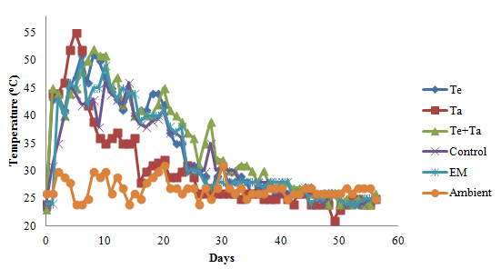

Figure 1. Temperature profile of the composting materials

In this study, the temperatures of the five composting materials started to or in cooling phase after 3 weeks of composting. This suggests that the maturation and stabilization of organic matter have been reached. However, the drop in temperature can be due to the lost of composts volume and lead to insufficient self-insulation as the composting scale in this study was initially undersized [26]. Consequently, it makes the use of temperature for predicting maturation less effective. Therefore, the temperature profile is employed together with other additional parameters to further determine the maturity and stability of composts. The ambient temperatures were ranged between 24 to 31ºC during the composting process.

pH value and odour
After 8 weeks, the pH values of all composts were approximately at neutral (7 – 8) as shown in Figure 2 which indicating the stability of organic matter [27]. There were no significant different (p >0.05) between the compost with and without microbial inoculants (MI) in term of pH. According to the pH profile, all of the five composting materials were no longer acidic in week 3.

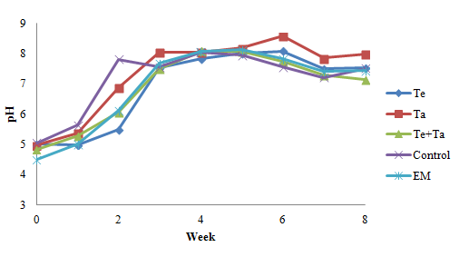

Figure 2. pH profile of the composting materials

In contrast, there are notable differences in term of the odour of the composts. Table 2 shows the summary of odour produced during the composting. The unpleasant smell of the composting materials decreased with time [16]. MI successfully suppressed the growth of bad microbes that contributed to foul smell by week 3. By comparison, control set produced very unpleasant smells which were pungent on week 1 and 2. These results correlate with the pH profiles where the pH values were higher than the others in the control samples. According to Miller et al., high pH leads to the loss of N through ammonia volatilization that was associated with the odour problem [28]. Besides, composts with MI produced earthy smells faster than the control. Among the compost treated with MI, Te+Ta produced earthy smell in the shortest time which was on week 4.

Table 2. Odour performance of composting materials

Week/ Sample | Te | Ta | Te + Ta | Control | EM
0 | +++ | +++ | +++ | +++ | +++
1 | ++ | ++ | ++ | ++ | ++
2 | ++ | ++ | ++ | + | ++
3 | +++ | +++ | +++ | + | +++
4 | ++++ | ++++ | +++ | ++ | +++
5 | ++++ | ++++ | +++ | +++ | ++++
6 | ++++ | ++++ | ++++ | +++ | ++++
7 | ++++ | ++++ | ++++ | ++++ | ++++
8 | ++++ | ++++ | ++++ | ++++ | ++++
+ very unpleasant, ++ moderate unpleasant, +++ odourless,
++++ earthy

C:N ratio
Figure 3 shows the changes of C:N ratio. For all samples including for the control, the C:N ratio decreased significantly with time and stabilized on week 2 which means that significant degree of degradation took place in the first 3 weeks. C:N ratio decreased as the carbon content in the compost valorised as carbon dioxide along the composting process. Although nitrogen might lose due to volatilization, it does not contribute to the increase of C:N ratio as the decrease of carbon is more markedly during the composting process. The values of C:N for all of the composts in week 8 was less than 10, indicating the approaching of the mature stage [29]. The C:N ratio of about 10 is the ideal ratio for well-matured compost [30] but as C:N ratio was highly depending on the initial and type of feedstock used, two or more parameters are needed to verify the maturity of compost. There was no significant different (p> 0.05) between the compost with and without microbial inoculants (MI) in term of C: N ratio. These phenomena might have suggested that the degradation rate was similar in all cases.

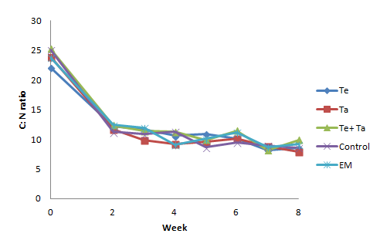

Figure 3. Changes of C: N ratio during the composting process

Enzymatic assays
Enzymes are the main mediators of degradation process and they control the degradation rates of different substrate [16]. Measurement of enzymatic activities illustrates the enzymes which participate in the bioconversion of the composting materials. In this study amylase, cellulase, lipase and protease were measured during composting due to the possible available inducers in the composting materials. The enzymatic assays (amylase, cellulose, lipase and protease) for all composts, namely Te, Ta, Te+Ta, EM and Wa (control), showed a similar ending trend as shown in Figure 4 to 7. The lower activity during the end phase indicated the completion of decomposition process [11]. The cellulase and protease activity decreased and stabilized on week 3 while amylase, lipase was on week 4 and 5, respectively. Figure 4 to 7 are plotted using the average values from the duplicated test.

Referring to Figure 4, the highest activity of amylase occurred at the beginning of the composting process and decreased gradually until a stabilized level. This trend was similar to the finding by Ismail et al., the high activity at the beginning could be due to the starchy materials available in the kitchen wastes which was easier to be degraded [16].
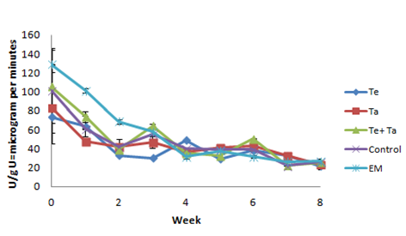

Figure 4. Amylase activity of composting materials

Cellulose activity also has an analogous trend with amylase, the maximum activity occurred at the beginning as shown in Figure 5. These findings agree with the result that has been stated by Gómez-Brandón et al. in the composting of cattle manure where the cellulase activity was low during the active and maturation stage [31]. However, the decline shown in the cellulase activity was sharper than that for the amylase activity. This was most probably due to the limited substrate (cellulose) in the composting materials.

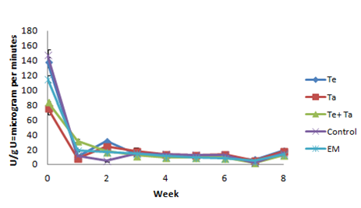

Figure 5. Cellulase activity of composting materials
The composting material used in this study was made up of kitchen waste, rice bran and dried leaves. These materials contained recalcitrant carbon due to the present of lignin. Lignin minimizes the accessibility of cellulose to microbial enzymes. Rice bran contains 27% cellulose, 37% hemicellulose, 5% lignin [32], the available and easier degradable cellulose was mainly from rice bran and kitchen waste. Therefore, the dramatic decrease in the cellulase activity was likely due to the fast degradation in the beginning contributed by the easier degrading cellulose materials and the low remaining cellulose content after one week. Moreover, the type of cellulase determined in this study is endoglucanase. The enzymatic hydrolysis of cellulose requires endoglucanase, exoglucanase and cellobiases to work together [33], the later composting process might be taken over by exoglucanase or cellobiases.

On the other hand, the lipase and protease activity shows a pattern that is normally obtained in the previous studies where the enzymatic activities increased with time as the composting proceeded until a maximum activity at the middle stage followed by a declining trend [11,34]. These results indicated the capability of microorganisms in synthesizing enzymes essential for hydrolysis of various complexes organic compounds. Figure 6 and 7 shows the lipase and protease activities respectively.
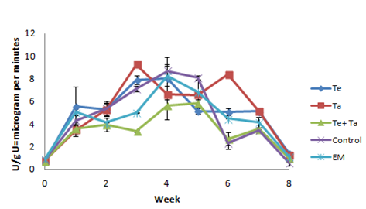

Figure 6. Lipase activity of composting materials

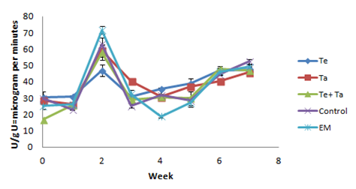

Figure 7. Protease activity of composting materials

No significant different was found among the composting materials inoculated with or without microbial inoculants (MI). The enzymatic activities of the composting materials treated with MI developed from the fermented food were almost the same as the composting materials treated with EM and also with bare water. In term of the total accumulated enzymatic activity along the whole composting process for a 8 weeks duration, EM has the highest amylase activity (510.47 U/g), Te has the highest cellulase (247.63 U/g) as well as protease activity (347.13 U/g) and Ta has the highest lipase activity (46.64 U/g). Table 3 shows the maximum enzymatic activity occurred during the composting process. The maximum amylase and cellulase activity occurred on the initial stage of composting process (week 0). While the maximum lipase and protease activities were observed on week 4 and week 2, respectively.

Table 3. Maximum enzymatic activity during the composting process

Maximum activity  (U/g) | Composts
Maximum activity  (U/g) | Te | Ta | Te+Ta | Water  (Control) | EM
Amylase | 73.23 | 83.03 | 105.48 | 101.2 | 128.82
Cellulase | 137.3 | 75.64 | 84.25 | 147.03 | 114.94
Protease | 46.87 | 58.98 | 57.86 | 63.06 | 71.5
Lipase | 8.01 | 9.23 | 5.62 | 8.69 | 8.24

Germination Index
All composts showed non-phytotoxic (> 80%) on germination test using radish seeds [29]. Table 4 shows the germination index of composts on week 8. Measurement of phytotoxic present in the compost is an accurate and efficient method to check the maturation of organic matter. The results obtained indicated that all composts have matured within two months time. By comparison, it was far faster than the normal duration of traditional composting (6 months to 1 year), vermicomposting (3 – 6 month) and Takakura home composting method (3 months).

Table 4. Germination index on week 8

Composts | Germination Index (%)
Te | 317.93 ± 23.06
Ta | 321.32 ± 7.47
Te+Ta | 323.37 ± 97.31
Control | 401.57 ± 86.92
EM | 306.05 ± 97.01

Conclusion

Based on the results, it shows the potential of using Tempeh and Tapai as microbial inoculants (MI) to degrade small scale kitchen waste especially the technique is user-friendly and the sources of MI are readily accessible by households. The temperature profile and odour performance of Te, Ta, Te +Ta were outstanding. Besides, the enzymatic assays are comparable with the composting performance of EM even though no difference can be indicated when compared with the control (water). In addition, the pH values, C: N ratio and germination index of the five composts under different treatments also showed satisfactory values. According to the examined parameter, all of the composts were in matured stage within two-month duration of composting or even earlier. The continuous study can be carried out on the humic acid content, nutrient content and pathogen analysis to further comparing the effectiveness of Tempeh and Tapai as MI against EM and water.

Acknowledgement

The authors are grateful to Universiti Teknologi Malaysia (UTM) and Ministry of Science, Technology and Innovation, Malaysia (MOSTI) for the financial grants of Vot 10H28 and Vot 4S058 respectively. This work was also partially funded by UTM Sustainability Flagship Project Vot No. 01G67 and UTM Research University Grant Vot No. 04H09.

References

- The Star (2014). Govt to gradually introduce mandatory waste separation from Sept 2015. The Star. www.thestar.com.my/News/Nation/2014/11/15/waste-sorting-mandatory-sept-2015/ [Assessed 28 April 2016].
- Hubbe, M. A., Nazhad, M. and Sánchez, C. (2010). Composting as a way to convert cellulosic biomass and organic waste into high-value soil amendments: A review. Bioresources, 5(4): 2808 – 2854.
- Payel, S., Mukesh, M. and Rajni, S. (2011). Microbial consortium: A new approach in effective degradation of organic kitchen wastes. International Journal of Environmental Science and Development, 2 (3): 170 – 174.
- Xi, B., Zhang, G. And Liu, H. (2005). Process kinetics of inoculation composting of municipal solid waste. Journal of Hazardous Materials, 124(1): 165 – 172.
- Patidar, A., Gupta, R. and Tiwari, A. (2012). Enhancement of bio-degradation of bio-solids via microbial inoculation in integrated composting and vermicomposting technology. Scientific Report, 1(5): 1 – 4.
- Saad, N. F. M., Ma’min, N. N., Zain, S. M., Basri, N. E. A. and Zaini, N. S. M. (2013). Composting of mixed yard and food wastes with effective microbes. Jurnal Teknologi, 65(2): 89 – 95.
- Stabnikova, O., Ding, H. B., Tay, J. H. and Wang, J. Y. (2005). Biotechnology for aerobic conversion of food waste into organic fertilizer. Waste Management and Research, 23(1): 39 – 47.
- Nair, J. and Okamitsu, K. (2010). Microbial inoculants for small scale composting of putrescible kitchen wastes. Waste Management, 30(6): 977 – 982.
- Abdullah, N., Chin, N. L., Mokhtar, M. N. And Taip, F. S. (2013). Effects of bulking agents, load size or starter cultures in kitchen-waste composting. International Journal of Recycling of Organic Waste in Agriculture, 2(1): 1 – 10.
- Norlidah, R. (2010). Home composting: Step-by-step guide to Takakura composting, The Star. [Assessed 28 April 2016].
- Ying, G. H. and Ibrahim, M. H. (2013). Local knowledge in waste management: A study of Takakura home method. Journal of Environmental Science, 2: 528 – 533.
- Hafid, H. S., Nor'Aini, A., Omar, F. N., Phang, L., Suraini, A. and Hassan, M. A. (2010). A comparative study of organic acids production from kitchen wastes and simulated kitchen waste. Australian Journal of Basic and Applied Sciences, 4(4): 639 – 645.
- The United States Department of Agriculture (1998). Estimating soil moisture by feel and appearance. Washington, D.C.
- Kutsanedzie, F., Rockson, G. N., Aklaku, E. D. and Achio, S. (2012). Comparisons of compost maturity indicators for two field scale composting systems. International Research Journal of Applied and Basic Science, 3(4): 713 – 720.
- Hubbe, M. A., Nazhad, M. and Sanchez, C. (2010). Composting as a way to convert cellulosic biomass and organic waste into high-value soil amendments: A review. Bioresources, 5(4): 2808 – 2854.
- Ismail, K. A., El-Din, H. M. S., Mohamed, S. M., Latif, A. B. M. A. and Ali, M. A. M. (2013). Monitoring of physical, chemical, microbial and enzymatic parameters during composting of municipal solid wastes: A Comparative Study. Journal of Pure Applied Microbiolology, 8(1): 211 – 224.
- Food and Agriculture Organization of the United Nations. (2000). Simple soil, water and plant testing techniques for soil resource management. Rome, Italy.
- Woods End Research Laboratory. (2000). Compost quality standard and guidelines. Compost quality in America.
- Shyamala, D. and Belagali, S. (2012). Studies on variations in physico-chemical and biological characteristics at different maturity stages of municipal solid waste compost. International Journal of Environmental Sciences, 2(4): 1984 – 1997.
- Mishra, S. and Behera, N. (2008). Amylase activity of a starch degrading bacteria isolated from soil receiving kitchen wastes. African journal of biotechnology, 7(18): 3326 – 3331.
- Ghose, T. (1987). Measurement of cellulase activities. Pure and Applied Chemistry, 59(2): 257 – 268.
- Cupp-Enyard, C. (2008). Sigma's non-specific protease activity assay-casein as a substrate. Journal of Visualized Experiments, 19: 1 – 2.
- Margesin, R., Feller, G., Hämmerle, M., Stegner, U. and Schinner, F. (2002). A colorimetric method for the determination of lipase activity in soil. Biotechnology Letters, 24(1): 27 – 33.
- Bernal, M. P., Alburquerque, J. A. and Moral, R. (2009). Composting of animal manures and chemical criteria for compost maturity assessment: A review. Bioresource Technology, 100(22): 5444 – 5453.
- Sundberg, C., Smårs, S. and Jönsson, H. (2004). Low pH as an inhibiting factor in the transition from mesophilic to thermophilic phase in composting. Bioresource Technology, 95(2): 145 – 150.
- Dickson, N., Richard, T., Kozlowski, R. and Sobel, P. L. (1991). Composting to reduce the waste stream: a guide to small scale food and yard waste composting. Northeast Regional Agricultural Engineering Service: pp 1 – 53.
- Pan, I. and Sen, S. (2013). Microbial and physico-chemical analysis of composting process of wheat straw. Indian Journal of Biotechnology, 12(1): 120 – 128.
- Miller, F. C., Macauley, B. J. and Harper, E. R. (1991). Investigation of various gases, pH and redox potential in mushroom composting Phase I stacks. Animal Production Science, 31(3): 415 – 423.
- Cheng, K. H., Huang, M. C., Lu, M. F., Chou, Y. J. and Lin, J. J. M. (2013). Assessment of degree of maturity of compost produced by different kitchen waste composting methods. Advanced Materials Research, 652: 1642 – 1651.
- Pathak, A. K., Singh, M. M. and Kumar, V. (2011). Composting of municipal solid waste: a sustainable waste management technique in Indian cities – A review. International Journal of Current Research, 3(12): 339 – 246.
- Gómez-Brandón, M., Lazcano, C. and Domínguez, J. (2008). The evaluation of stability and maturity during the composting of cattle manure. Chemosphere, 70(3): 436 – 444.
- Baig, M., Zetzl, C. and Brunner, G. (2005). Conversion of extracted rice bran and isolation of pure bio-ethanol by means of supercritical fluid technology. 10th European Meeting on Supercritical Fluids, N(3): 1 – 6.
- Zhang, Y. P., Hong, J. and Ye, X. (2009). Cellulase assays. Protocol biofuels. Springer, 581: 213 – 231.
- Raut, M., William, S. P., Bhattacharyya, J., Chakrabarti, T. and Devotta, S. (2008). Microbial dynamics and enzyme activities during rapid composting of municipal solid waste – a compost maturity analysis perspective. Bioresource Technology, 99(14): 6512 – 6519.

