OPTIMIZATION OF THERMOPHILIC BIOHYDROGEN PRODUCTION BY MICROFLORA OF PALM OIL MILL EFFLUENT: CELL ATTACHMENT ON GRANULAR ACTIVATED CARBON AS SUPPORT MEDIA

(Pengoptimuman Pengeluaran Biohidrogen Termofilik oleh Mikroflora

Efluen Kilang Minyak Sawit: Lampiran Sel Pada Karbon Berbutir Aktif

Sebagai Media Sokongan)

Nur Syakina Jamali ^{1,2} and Jamaliah Md Jahim¹

¹ Department of Chemical and Process Engineering, Faculty of Engineering and Built Environment,

Universiti Kebangsaan Malaysia, 43600 Bangi, Malaysia

² Department of Chemical and Environmental Engineering, Faculty of Engineering,

Universiti Putra Malaysia, 43400 Serdang, Malaysia

*Corresponding author: jamal@ukm.edu.my

Abstract

In this study, the biohydrogen production by microflora of palm oil mill effluent (POME) from glucose and xylose fermentation were investigated. Synthetic medium was prepared based on sugar composition present in POME at 7 g/L of glucose and 3 g/L of xylose was used as substrate carbon source. Prior to optimization, 10% of microflora POME was acclimatized in the synthetic medium with the help of granular activated carbon as their support media until consistent hydrogen percentage at 44±1.7% was obtained. Optimization that was conducted using response surface methodology (RSM) by quadratic model of central composite design was found to give optimum parameters of thermophilic microbial growth at pH 6, temperature 60 °C and 10% (v/v) of sludge percentage. Results obtained for hydrogen productivity (1.32 ± 0.01 mmol H₂/L.h, 32.36 ± 0.75 ml H₂/L.h) and hydrogen yield (1.22 ± 0.10 mol H₂/mol sugar consumed) from an average of experimental data reached small error of different (0.8%, 1.0% and 8.3%) to predicted RSM data at optimum condition respectively. The model provided a useful approach for biohydrogen production by POME microflora sludge by using granular activated carbon as their support media.

Keywords: biohydrogen, thermophilic, palm oil mill effluent, synthetic medium, optimization

Abstrak
Melalui kajian ini, penghasilan biohidrogen oleh mikroflora sisa kilang minyak sawit (POME) dari glukosa dan xilosa penapaian telah dikaji. Media sintetik telah disediakan berdasarkan komposisi gula yang terkandung dalam POME sebanyak 7 g/L glukosa dan 3 g/L xilosa telah digunakan sebagai sumber substrat karbon. Sebelum pengoptimuman dijalankan, 10% daripada mikroflora POME telah disesuaikan dalam media sintetik dengan bantuan karbon berbutir aktif sebagai media sokongan mereka sehingga peratusan hidrogen secara konsisten pada 43±2% telah diperolehi. Pengoptimuman yang dijalankan dengan menggunakan kaedah gerak balas permukaan (RSM) oleh model kuadratik reka bentuk komposit berpusat telah mendapati bahawa parameter optimum bagi pertumbuhan mikrob termofilik adalah pada pH 6, suhu 60 °C dan 10% (v/v) peratusan enapcemar. Keputusan yang diperolehi untuk pengeluaran hidrogen (1.32 ± 0.01 mmol H₂/L.h, 32.36 ± 0.75 ml H₂/L.H) dan hasil hidrogen (1.22 ± 0.11 mol H₂/mol gula yang dimakan) oleh nilai purata daripada kajian hanya memperolehi sedikit perbezaan (0.8%, 1.0% dan 8.3%) data perolehan saranan RSM pada keadaan optimum. Model ini telah menyediakan pendekatan yang berguna untuk penghasilan biohidrogen oleh enapcemar mikroflora POME dengan menggunakan karbon aktif berbutir sebagai media sokongan mereka.

Kata kunci: biohidrogen, termofilik, sisa kilang minyak sawit, media sintetik, pengoptimuman

Introduction

Dependent people on fossil fuel as main energy carrier in daily life is seem to be predicted lost when amount of fossil fuel depleted over years. Decreasing of fossil fuel over years is not only influences people demand but attracting world on the pollution generated by the processing of fossil fuel. All polluted gases produced harm to the environment especially on producing the carbon footprint. Therefore, researchers nowadays are looking forward for an alternative energy that not only replace demand in fossil fuel but give zero pollution to environment.

A hydrogen economy based on renewable sources, including biomass is one of the alternative switches from fossil fuel to green technology as it includes biological processes. Common biological techniques that have been used to produce hydrogen are through photo and dark fermentation. These utilize algae and bacteria in photo-bioreactors in the light, or bacteria growing through dark fermentation in bioreactors resembling the well-characterized anaerobic digestion process [1]. Dark fermentation is more towards green technology process where biomass is the main substrate to produce hydrogen [2]. Much attention has been focused on suspended cell cultures to examine the hydrogen production by dark fermentation [3] and less of researchers have explore on the thermophilic hydrogen production.

In this research, thermophilic fermentative hydrogen production was introduced using granular activated carbon (GAC) as microbial support carrier. The interest of uses of the support carrier is to enhance the microbial cell density and at the same time prevent from cell wash out at short retention time. These experiments were conducted to identify the optimum growth condition of thermophilic hydrogen production by using attached-biofilm mixed culture from palm oil mill effluent (POME) sludge using mixture of glucose and xylose as main carbon sources. This is the first attempt to study the optimum growth condition of the GAC-biofilm through cell attachment immobilization at thermophilic fermentation from synthetic mixture of glucose and xylose. The optimization studied was conducted to investigate the best growth condition for the thermophilic fermentation in order to achieve optimum hydrogen production.

Materials and Methods

Microorganism and medium

Microorganism used in this research study was obtained from mixed culture POME-sludge from the sludge pit at Sime Darby Plantation, West Oill Mill, Pulau Carey, Selangor, Malaysia. The synthetic medium used was slightly modified from [4] and contained (per litre of deionized water): NH₄Cl 1g, NaCl 2g, MgCl₂.6H₂O 0.5g, CaCl₂.2H₂O 0.05g, K₂HPO₄.3H₂O 1.5g, KH₂PO₄ 0.75g, NaHCO₃ 2.6g, yeast extract 2g. The mixed cultures sludge was cultivated in the synthetic medium contained glucose and xylose as the sole carbon and energy source.

Sludge growth conditions

The inoculums were grown in 200 ml working volume provided 10% (v/v) of sludge with 90% (v/v) of synthetic medium in batch cultivation in 250 ml modified Scott Duran. The opening mouth of 250 ml Scott Duran was fabricated by allowing the free flow of gas produced from fermentation medium to gas collection in inverted measuring cylinder which contained HCl solvent (pH 2). The HCl solvent was used to prevent biogas dissolved in the liquid and disappear to environment.

The carries used in the cultivation process were granular activated carbon (GAC) with particle size of 2 – 3 mm. The cell attachment were studied by adding 1 to 1 GAC weight (g) to heat treated POME sludge volume (ml) ratio as a support media for the inoculum sludge in the serum bottle. The pH of the cultures initially was adjusted to pH 6 and they were cultivated in a water bath shaker at a temperature of 60 °C and 200 rpm for 48 hours cultivation at 43±2% H₂ gas percentage (OD 0.7 – 0.8 at 600 nm).

Optimization in serum bottles

The optimization of growth parameters at thermophilic condition was designed based on response surface methodology by using Design Expert version 6.0.6. Central composite design was used to optimize the manipulating factors. A total of 20 experiments need to be carried out based on the 3 selected growth parameters namely pH, temperature (°C), and sludge composition (v/v) and resulting to hydrogen productivity rate, HPR (mmol H₂/L.h and ml H₂/L.h) and the hydrogen yield (mol H₂/mol substrate consumed) as the outcomes responses. pH and temperature are one of the most important factors to be regulated in anaerobic digestion processes [5,6]. {Chen, 2006 #54}

The optimum conditions were predicted using quadratic equation. Experiments were conducted in triplicates after the optimize parameters were obtained. Analyses of variances (ANOVA) was used as the chosen model to analysis the results obtained and generating the 3D plots. The center line of pH 6, temperature 60 °C and sludge percentage 10(%) was chosen based on thermophilic hydrogen production from sucrose fermentation [4].

The optimization experiments were conducted using 50 ml working volume in 100 ml anaerobic crimped-seal bottles with subsequent flushing of the headspace with nitrogen gas for 1 L/h to create an anaerobic condition. The fermentation was carried out in a water bath shaker by adjusting the temperature according to desire experimental temperature. Samples were analyzed at every 5 hours interval until stationary phase of growth profile was obtained and the cumulative hydrogen productivity was calculated.

Analysis of hydrogen production

Biogas productions were analyzed for CO₂ and H₂ by gas chromatography, using (GC, model SRI 8600C, USA) consist with two detectors, helium ionization detector (HID) and the thermal conductivity detector (TCD). Highly purity helium gas (MOX 99.99%) was used as carrier gas at 25 ml/min. The samples gases were injected to the GC using a gas-tight syringe (0.5 ml injection volume) at 43 °C temperature and pressure 2.7 psi initially and followed by a ramping of 30 °C per minute and been hold for 10 min once the temperature reached 220 °C.

A modified Gompertz equation was performed to quantify the cumulative hydrogen production in the batch experiment by using Matlab 7.9.0 (R2009b). Theoretically, the modified Gompertz equation used in this research was expressed as equation 1 below [5]:

Ht = Hm.exp {-exp[(Rm.e/Hm)(λ-t)+1]} (1)

where Ht is the cumulative hydrogen production (ml), Hm is the maximum hydrogen production (ml), Rm is the maximum hydrogen production rate (ml/h), e is euler number, λ is the lag phase time (h), and t is the incubation time (h). In this study, the data presented also considered the cumulative of total biogas to compare with the cumulative hydrogen production. Therefore the modified Gompertz was also applied to quantify the total biogas production.

Determination of sugar concentration

Samples were prepared by filtration through a 0.22 µm syringe filter in vials tube and sugar concentration and the soluble volatile fatty acids (VFAs) were quantified by HPLC analysis using an Agilent 1200 HPLC system (California, USA) with a REZEX ROA column (Phenomenex, USA) equipped with a refractive index detector (RID). The mobile phase used was 5 mM H₂SO₄ at a constant 0.6 mL min⁻¹ at room temperature. Standard curves of every peak detection were generated at different concentration until straight line R squared was obtained.

Yield and productivity

The amount of sugars consumed and the hydrogen productions obtained were used to calculate the hydrogen yields and the productivity. Yields were expressed as moles of hydrogen per moles of sugar consumed. The VTAs production were used to quantify the capability of the microorganism to reach highest theoretical yields. The maximal volumetric hydrogen productivity was calculated based on the highest percentage of hydrogen gas obtained during the exponential phase of the growth profile in the batch fermentation.

FESEM microbial morphology

The view image of the cell that attached on the surface of GAC after conducting the experimental model validation was further observed with Field Emission Scanning Electron Microscopy (FESEM). The GAC samples were prepared using a Critical Point Dryer (Model Leica EM CPD 300, Leica Microsystems, Germany) for 1 hour and 30 minute prior to be viewed with the FESEM. An amount of 4% glutaraldehyde was used to fix the samples of GAC-attached biofilm for 12 ̶ 24 hours at 4 °C. The samples were then washed with 0.1 M phosphate buffer solution three times per ten minutes each. A series of alcohol dilutions at 30, 50, 70, 80, 90, and 100% (w/w) alcohol were used to dehydrate the samples. The dehydrated samples were then transferred to the CPD and were sputter-coated with platinum before being analyzed with FESEM.

Result and Discussion

Optimization of biohydrogen production

Results of manipulating the selected key factors used during fermentation process towards the hydrogen productivity and yield for each experimental condition produced was shown in Table 1. Based from the experimental conditions shown in Table 1, the hydrogen productivity range from 0.01 to 1.70 mmol H₂/L.h, 0.14 to 41.69 ml H₂/L.h and the hydrogen yield range from 0.06 to 1.61 mol H₂/mol substrate consumed. Results obtained shown the variation of hydrogen production under similar fermentation conditions but with different variable parameters (pH, temperature and sludge percentage) were indicated the importance of each selected parameter on the thermophilic fermentative hydrogen production.

Table 1. Numeric factors of experimental designs with three independent variables and hydrogen productivity and hydrogen yield
Run |  | pH |  | Temp |  | Sludge |  | Hydrogen
 |  |  |  |  |  |  |  | Productivity |  |  |  | Yield
 |  |  |  | (°C) |  | (%) |  | (mmol H₂/L.h) |  | (ml H₂/L.h) |  | (mol H₂/mol substrate)
 | 1 |  | 6.00 |  | 60.00 |  | 10.00 |  | 1.21 |  | 29.50 |  | 1.18
 | 2 |  | 6.00 |  | 60.00 |  | 10.00 |  | 1.13 |  | 27.69 |  | 1.20
 | 3 |  | 6.84 |  | 60.00 |  | 10.00 |  | 0.42 |  | 10.22 |  | 0.73
 | 4 |  | 5.50 |  | 65.00 |  | 15.00 |  | 0.03 |  | 0.66 |  | 0.45
 | 5 |  | 6.50 |  | 65.00 |  | 15.00 |  | 0.94 |  | 22.89 |  | 0.98
 | 6 |  | 5.16 |  | 60.00 |  | 10.00 |  | 0.01 |  | 0.25 |  | 0.15
 | 7 |  | 6.00 |  | 68.41 |  | 10.00 |  | 0.15 |  | 3.61 |  | 0.45
 | 8 |  | 6.00 |  | 60.00 |  | 18.41 |  | 0.23 |  | 5.66 |  | 1.01
 | 9 |  | 6.00 |  | 60.00 |  | 10.00 |  | 1.36 |  | 33.39 |  | 1.35
 | 10 |  | 6.00 |  | 60.00 |  | 10.00 |  | 1.09 |  | 26.68 |  | 1.33
 | 11 |  | 6.00 |  | 60.00 |  | 10.00 |  | 1.43 |  | 34.97 |  | 1.31
 | 12 |  | 6.50 |  | 55.00 |  | 15.00 |  | 0.29 |  | 7.02 |  | 0.62
 | 13 |  | 6.00 |  | 60.00 |  | 1.59 |  | 0.17 |  | 4.22 |  | 0.57
 | 14 |  | 6.00 |  | 60.00 |  | 10.00 |  | 1.70 |  | 41.69 |  | 1.61
 | 15 |  | 5.50 |  | 55.00 |  | 5.00 |  | 0.70 |  | 17.21 |  | 0.82
 | 16 |  | 5.50 |  | 65.00 |  | 5.00 |  | 0.01 |  | 0.14 |  | 0.04
 | 17 |  | 6.00 |  | 51.59 |  | 10.00 |  | 0.03 |  | 0.85 |  | 0.06
 | 18 |  | 6.50 |  | 55.00 |  | 5.00 |  | 0.86 |  | 20.98 |  | 0.82
 | 19 |  | 6.50 |  | 65.00 |  | 5.00 |  | 0.18 |  | 4.38 |  | 0.48
 | 20 |  | 5.50 |  | 55.00 |  | 15.00 |  | 0.55 |  | 13.50 |  | 0.77

The predicted responses at centre point at pH 6, temperature 60 °C and sludge percentage 10(v/v) were 1.32 ± 0.23 mmol H₂/L.h, 32.32 ± 5.61 ml H₂/L.h and 1.33±0.15 mol H₂/mol substrate consumed (total of glucose and xylose consumed). The responses as a function of three independent factors are shown in the regression equation after performing the analysis of variances. The quadratic polynomial relating the factors and the responses are shown as equation 2, 3, 4, respectively.

HPR (mmol H₂/L.h):

1.31 + 0.12A – 0.08B + 0.01C – 0.32A2 – 0.36B2 – 0.32C2 + 0.15AB +0.04AC + 0.19BC (2)

HPR (ml H₂/L.h):

32.05 + 2.97A – 1.90B + 0.28C – 7.80A2 – 8.86B2 – 7.90C2 + 3.65AB + 0.97AC + 4.59BC. (3)

Hydrogen yield (mol H₂/mol substrate consumed):

1.33 + 0.13A – 0.03B + 0.10C – 0.28A2 – 0.34B2 – 0.15C2 + 0.14AB - 0.01AC + 0.14BC (4)

where A is the pH, B is the temperature (°C) and C is the sludge percentage (v/v).

Statistical analysis (ANOVA)

An analysis of variance (ANOVA) was conducted to investigate the significance of fit for the quadratic model based on experimental data Table 2 and 3, respectively. The p-value was used to investigate the significance of each coefficient and the degree of interaction between each of the independent factors studied. The independent variables of selected factors are more significant with greater F-value and small p-value [7]. From analysis of ANOVA for response data of hydrogen productivity (mmol H₂/L.h) as summarize in Table 2, the model F-value of 5.76 implies the model was significant. There was only a 0.57% chance that a model F-value this large could occur due to noise. Values of Prob > F of 0.0057 less than 0.05 indicated model terms were significant. The lack of fit F-value of 2.53 implies the lack of fit is not significant relative to the pure error. There is a 16.55% chance that a lack of fit F-value this large could occur due to noise.

Table 2. ANOVA for the response H2 productivity (mmol H₂/l.h)

Statistics
Source | Sum of Squares | DF | Mean Square | F-Value | Prob > F | Remark
Model | 4.81 | 9 | 0.53 | 5.76 | 0.0057 | Significant
A | 0.20 | 1 | 0.20 | 2.16 | 0.1720
B | 0.08 | 1 | 0.08 | 0.89 | 0.3677
C | 0.00 | 1 | 0.00 | 0.02 | 0.8931
A² | 1.46 | 1 | 1.46 | 15.78 | 0.0026
B² | 1.89 | 1 | 1.89 | 20.37 | 0.0011
C² | 1.50 | 1 | 1.50 | 16.21 | 0.0024
AB | 0.18 | 1 | 0.18 | 1.91 | 0.1966
AC | 0.01 | 1 | 0.01 | 0.13 | 0.7218
BC | 0.28 | 1 | 0.28 | 3.03 | 0.1122
Residual | 0.93 | 10 | 0.09
Lack of Fit | 0.66 | 5 | 0.13 | 2.53 | 0.1655 | Not Significant
Pure Error | 0.26 | 5 | 0.05
Cor Total | 5.74 | 19
Coefficient of determination, R² = 0.838; adjusted R² = 0.693

Table 3. ANOVA for the response H₂ yield (mol H₂/mol substrate consumed)

Statistics
Source | Sum of squares | DF | Mean Square | F-Value | Prob > F | Remark
Model | 3.41 | 9 | 0.38 | 8.19 | 0.0014 | Significant
A | 0.23 | 1 | 0.23 | 4.99 | 0.0495
B | 0.01 | 1 | 0.01 | 0.27 | 0.6136
C | 0.14 | 1 | 0.14 | 3.08 | 0.1100
A² | 1.12 | 1 | 1.12 | 24.10 | 0.0006
B² | 1.70 | 1 | 1.70 | 36.62 | 0.0001
C² | 0.34 | 1 | 0.34 | 7.41 | 0.0215
AB | 0.16 | 1 | 0.16 | 3.39 | 0.0952
AC | 0.00 | 1 | 0.00 | 0.01 | 0.9155
BC | 0.16 | 1 | 0.16 | 3.54 | 0.0893
Residual | 0.46 | 10 | 0.05
Lack of Fit | 0.34 | 5 | 0.07 | 2.87 | 0.1360 | Not Significant
Pure Error | 0.12 | 5 | 0.02
Cor Total | 3.88 | 19
Coefficient of determination, R² = 0.871 ; adjusted R² = 0.756

For hydrogen yield response, statistical ANOVA was shown that the model F-value of 8.19 implies the model was significant (Table 3). There was only a 0.14% chance that a model F-value this large could occur due to noise. Values of Prob > F of 0.0014 was shown less than 0.0500 indicated model terms were significant. The lack of fit F-value of 2.87 implies the lack of fit is not significant relative to the pure error. There is a 9.56% chance that a lack of fit F-value this large could occur due to noise. The model terms with p-value greater than 0.10 indicate they are insignificant. The large F-value clearly suggest that the variance in the response can be explained by the regression equation [8].

Effect of selected factors on response variables

3D plots are a useful approach in interpreting the response surface. Each 3D plot represent the effect of two independent variables at an optimum level at which the third variable was maintained as constant value. The 3D plot shape indicates whether the mutual interaction between the variables are significant or insignificant. Figure 1 shows the effect between two variables at which the third variable was constant. 3D plots are estimates and if data from repeated experiments were used in the same design, the response of the exchange will change to some extent [9,10].
(b)

9
(a)

9

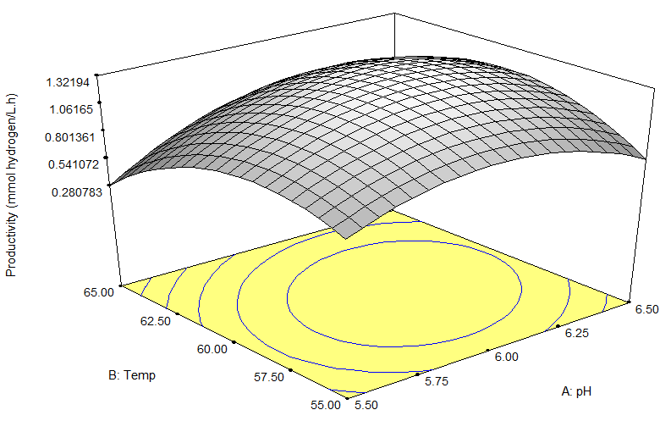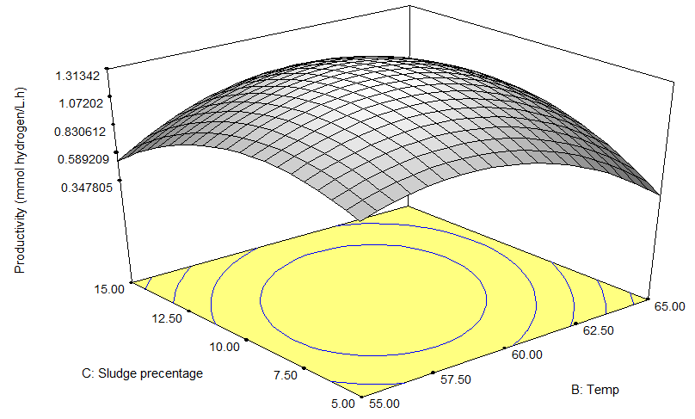

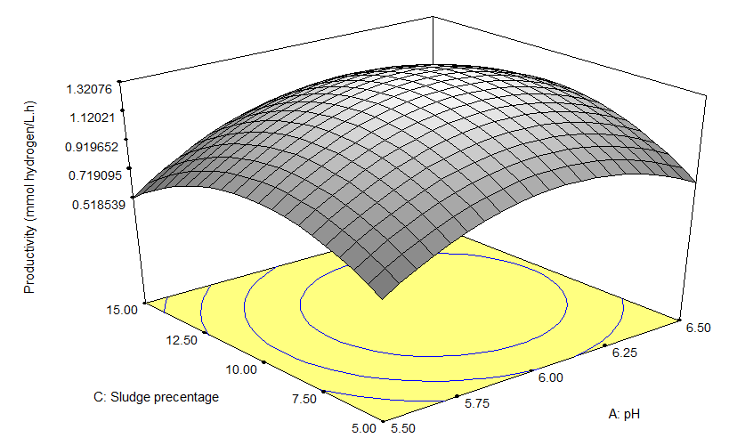
(c)

9

Figure 1. 3D plots for different experimental conditions. H₂ productivity (mmol H₂/l.h) as a function of (a) pH and temperature, (b) pH and sludge percentage and (c) temperature and sludge percentage.

Not much different for 3D plots of selected factors on response variable of hydrogen productivity in (ml H₂/L.h) compare to (mmol H₂/L.h). Figure 2 shows the 3D plot of hydrogen yield between two variables at which third variable was constant respectivly. The 3D plots was indicated that the mutual interaction between all variables are significance to each other.
(a)

9

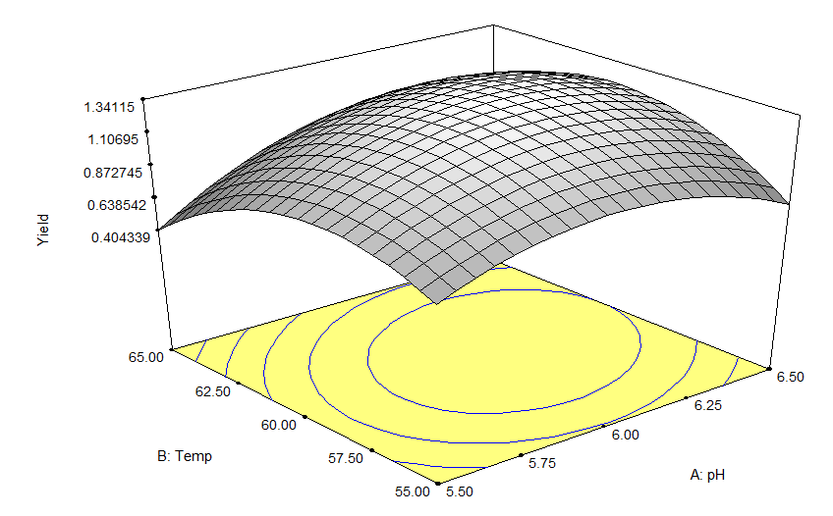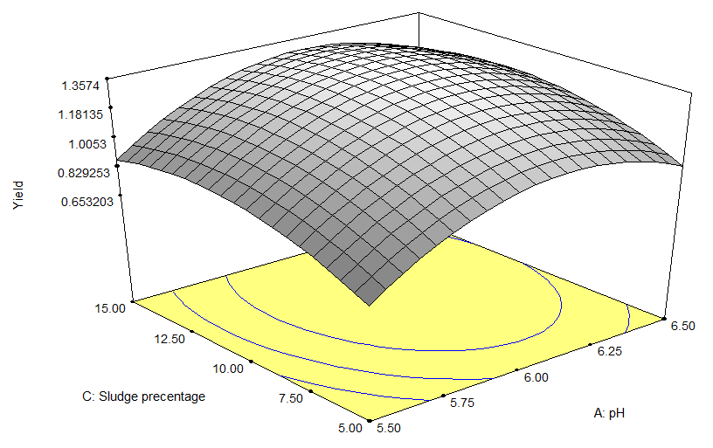
(b)

9

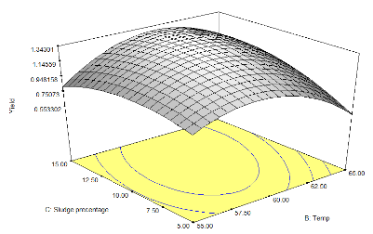
(c)

9

Figure 2. 3D plots for different experimental conditions. H₂ yield (mol H₂/mol substrate consumed) as a function of (A) pH and temperature, (B) pH and sludge percentage and (C) temperature and sludge percentage

Validation of the models

Three experimental replications from suggested optimum condition by RSM (pH 6, temperature 60 °C and sludge percentage 10% (v/v)) were conducted to confirm the model validity. From the RSM, the estimated responses of the hydrogen productivity and yield were 1.31 mmol H₂/L.h, 32.04 ml H₂/L.h and 1.33 mol H₂/mol sugar consumed in batch fermentation experiments respectively.

The actual experimental data obtained was tabulated in Table 4. From experimental data, the hydrogen productivity of 1.32 ± 0.01 mmol H₂/L.h obtained in this study was comparable to the predicted data by RSM with only up to 0.76% error of differences. Change in unit of productivity to ml H₂/L.h would not give much different of error compare in unit of mmol H₂/L.h. For yield of hydrogen, 4.4% error of different between the experimental of 1.27 ± 0.11 to predicted data by RSM of 1.33 (mol H₂/mol sugar consumed). Experimental data obtained was also analyzed by modified Gompertz equation as tabulated in Table 4.

Table 4. Confirmation of model validity based from optimum condition predicted by RSM

Model  experiment | Hydrogen |  |  | Modified Gomertz equation parameter values for H2 production  (per working volume)
 | Productivity |  | Yield | Hm | Rm | λ
 | mmol H₂/L.h | ml H₂/L.h | mol H₂/  mol sugar | ml | ml/h | h
Predicted Value | 1.31 | 32.04 | 1.33 | - | - | -
Experimental Value | 1.32 ± 0.01 | 32.36 ± 0.75 | 1.22 ± 0.10 | 44.17 ± 10.31 | 3.31 ± 0.39 | 4.90 ± 0.31
Error (%) | 0.8 | 1.0 | 8.3 | - | - | -

From the statistical quality of modified Gompertz equation, biohydrogen production from experimental data (R² = 0.982), it could be inferred that the predicted result are in good agreement with the experimental data. The maximum hydrogen production of 44.17 ± 10.31 ml H₂ and the hydrogen production rate based on the Gompertz equation was 3.31 ± 0.39 ml H₂/h with lag phase of 4.90 ± 0.31h has explained that at optimum condition of thermophilic fermentative hydrogen production, the hydrogen production rate obtained was capable to reach high hydrogen production rate.

Graph of cumulative biohydrogen and biogas production (ml) over fermentation time (hour) were plotted in Figure 3 by using Matlab 7.9.0 (R2009b). 42.0 ± 1.6% of hydrogen gas obtained (44.17 ± 10.31 ml) from total biogas produced (105.0 ± 20.81 ml).

Figure 3. Hydrogen and biogas production (ml) examined by using modified Gompertz equation

FESEM images

The images of microbial cell culture were further observed under Field Emission Scanning Electron Microscope (FESEM). Figure 4(a) represents clean GAC meanwhile 4(b) shows the image of attached cell on GAC after cultural at optimum conditions obtained from the RSM. Figure 4(a) shows that the porosity of clean GAC were acted as suitable place for sludge to self-attach in the pore provided thus forming high density of microbial population, while the images of 4(b) shows that the cells have been successfully adhered on the GAC surface, forming a biofilm attached cell.
(a)

(b)

Figure 4. FESEM images of 4(a) clean GAC, 4(b) attached cell on micro-pores GAC in the cultural medium at 10.00k x magnification

Conclusion

The present study emphasize the mutual effects of the selected parameters in thermophilic biohydrogen production. In this study, the optimum condition obtained from the selected growth parameters were identified to reach optimum through experimental data. The experimental data obtained for hydrogen productivity was 1.48 ± 0.27 in mmol H2/L.h, 36.14 ± 6.65 in ml H2/L.h, and hydrogen yield 1.27 ± 0.11 mol H2/mol sugar consumed at pH 6, temperature 60°C and sludge percentage 10% with error of different 11.3, 11.3 and 4.4% from estimated data by RSM respectively. Under high temperature at thermophilic condition, the hydrogen community producer become energetically favorable and hydrogen consuming reactions become less favorable. The quadratic design model from initial central composite design based on RSM for selected parameters and responses factors were significant to each other. The model provided a useful approach for biohydrogen production by POME microflora sludge by using granular activated carbon as their support media.

Acknowledgement

The authors wish to acknowledge the profound financial support from Sime Darby Plantation, Sdn Bhd under project Zero Waste Technology, Trust Area Biohydrogen (KK-2015-002).

References

- Levin, D. B., Pitt, L. and Love M. (2004). Biohydrogen production: prospects and limitations to practical applications. International Journal of Hydrogen Energy, 29: 173 – 185.
- Mohammed, M., Salmiaton. A., Azlina W. W., Amran M. M., Fakhru’l-Razi A. and Taufiq-Yap Y. (2011). Hydrogen rich gas from oil palm biomass as a potential source of renewable energy in Malaysia. Renewable and Sustainable Energy Reviews, 15: 1258 – 1270.
- Ismail, I., Hassan, M. A., Abdul Rahman, N. A. and Soon, C. S. (2010). Thermophilic biohydrogen production from palm oil mill effluent (POME) using suspended mixed culture. Biomass and Bioenergy, 34: 42 – 47.
- Lutpi, N. A. and Jahim, J. M. (2014). Thermophilic fermentative hydrogen production using granular activated carbon immobilized mixed microflora. Australian Journal of Basic and Applied Sciences, 8: 134 – 137.
- Chen, W. H., Chen, S.Y., Khanal S. and Sung S. (2006). Kinetic study of biological hydrogen production by anaerobic fermentation. International Journal of Hydrogen Energy, 31: 2170 – 2178.
- Espinoza-Escalante F. M., Pelayo-Ortiz C., Navarro-Corona J., Gonzalez-Garcia Y., Bories A. and Gutierrez-Pulido H. (2009). Anaerobic digestion of the vinasses from the fermentation of Agave tequilana Weber to tequila: The effect of pH, temperature and hydraulic retention time on the production of hydrogen and methane. Biomass and Bioenergy, 33(1): 14 – 20.
- Atkinson, A. C. (2011). Optimum experimental design. International Encyclopedia of Statistical Science. Springer Berlin Heidelberg, pp. 1037 – 1039.
- Kim, H. M., Kim, J, G., Cho, J. D. and Hong, J. W. (2003). Optimization and characterization of UV-curable adhesives for optical communication by response surface methodology. Polymer Testing, 22: 889 – 906.
- Myers, R. H., Douglas C., Montgomery, and Anderson-Cook, C. M. (2001). Response surface methodology: Process and product optimization using designed experiments. John Wiley & Sons.
- Montgomery D. C. (2001). Design and analysis of experiments. 5th ed. New York: John Wiley and Sons.

