SURFACE CHARACTERIZATION ON ALKALI-HEAT-TREATMENT ON TITANIUM ALLOY

(Pencirian Rawatan Alkali-Haba ke atas Permukaan Aloi Titanium)

Nurul Hazwani Hanib¹, Fazlena Hamzah^{1*}, Zarina Omar², Istikamah Subuki¹

¹Biocatalysis & Biobased Material Research Group Green Technology & Sustainable Development Research Community, Chemical Engineering Faculty, Universiti Teknologi MARA, 40450 Shah Alam, Selangor, Malaysia

²Chemical Engineering Faculty, Universiti Teknologi MARA,

23200 Bukit Besi, Dungun, Terengganu, Malaysia

*Corresponding author: fazlena@salam.uitm.edu.my

Abstract

Coating of apatite in a biomimetic fluid is an alternative technique for metallic coating. Key element for effective biomimetic apatite coating depends on the surface material that can be enhanced by physical and chemical pre-treatment process. Two different preparations of Titanium alloy (Ti6Al4V) have been studied namely as received (as-Ti) and abraded (ab-Ti) with SiC paper. Both samples were then immersed in 5M NaOH and 5M KOH at temperature of 60 °C for 24 hours. A passive oxide layer covered on the surface of Ti6Al4V generally changed to form alkali (Na/K) titanate layer which is mechanically unstable. Therefore, alkali-treated Ti6Al4V were heat-treated at 700 °C for 1 hour to consolidate a mechanically stable structure of amorphous alkali titanate layer. Both samples before and after heat treatment were characterized using field emission scanning electron microscope, 3D surface metrology, contact angle goniometry and X-ray diffraction. The result indicates that as-Ti treated in 5 M KOH showed an existence of porous network structure.

Keywords: titanium, active surface, alkali treatment, heat treatment

Abstrak
Penyalutan apatit dalam cecair biomimetik adalah teknik alternatif untuk salutan logam. Faktor utama dalam penyalutan logam dengan apatit secara biomimetik yang berkesan adalah bergantung kepada sifat permukaan bahan/logam. Sifat permukaan logam boleh ditambah baik melalui proses pra-rawatan secara fizikal dan kimia. Dua persediaan yang berbeza ke atas aloi Titanium (Ti6Al4V) telah dikaji iaitu seperti yang diterima (as-Ti) dan telah dilelas (ab-Ti) dengan kertas pasir silikon karbida (SiC). Kedua-dua sampel kemudiannya direndam ke dalam 5M NaOH dan 5M KOH pada suhu 60 °C selama 24 jam. Satu lapisan oksida pasif yang meliputi atas permukaan Ti6Al4V umumnya berubah untuk membentuk lapisan alkali (Na/K) titanat yang secara mekanikal adalah tidak stabil. Oleh itu, Ti6Al4V yang telah mengalami pra-rawatan alkali telah melalui proses pemanasan haba pada suhu 700 °C selama 1 jam untuk mengukuhkan kestabilan struktur mekanikal lapisan amorfus alkali titanat. Kedua-dua sampel sebelum dan selepas rawatan haba telah dianalisa menggunakan mikroskop elektron imbasan pancaran medan, metrologi permukaan 3D, sudut sentuhan goniometri dan pembelauan sinar-X. Hasil daripada kajian ini menunjukkan bahawa as-Ti yang dirawat dengan 5M KOH menunjukkan jelas kewujudan struktur jaringan berliang.

Kata kunci: Titanium, permukaan aktif, rawatan alkali, rawatan haba

Introduction
Titanium and its alloy are widely used as dental, orthopaedic and maxillofacial implant materials due to their mechanical properties. It has a good biocompatibility, high corrosion resistance and better strength to the weight ratio as compared to 316L stainless steel. However, bone tissue does not bond directly to these materials due to the micromotion which leads to the formation of fibrous tissue encapsulated after implantation and drove to the loosening effects [1].

Enhancement of cell attachment and bone ingrowth promotion between cell-implant can be improved by coating with a bioactive surface such as calcium phosphate based material (i.e. hydroxyapatite) [2]. Various methods were introduced in producing calcium phosphate/ hydroxyapatite coating on titanium such as electrochemical deposition [3], sol-gel precipitate [4] and plasma spray coating [5]. High processing temperature in plasma spray easily induced decomposition of hydroxyapatite[6]. Indeed, the biomimetic process is one of the promising techniques for bioactive coating which conducted at the ambient temperature by immersion in simulated body fluid (SBF). This technique has ability in promoting uniform coatings on the porous and complex metal surface.

For optimizing rate of hydroxyapatite coating on the implant surface, pre-treatment of the metal is required to initiate an active surface. Many methods of pre-treatment on titanium surface before immersion into SBF solution has been widely studied, including sandblasting [7], alkali or acid treatment [8,9], heat treatment [10] or in a combination of these three approaches [11]. Nucleation of apatite is observed on alkali-heat treated metal after 4 weeks immersion in SBF which improved surface bioactivity with the formation of alkali titanate layer [12,13]. Chemical surface treatment changed Ti implant surface to form hydrogel layer (alkali titanate layer).

Thus, the present study aimed to explore different Ti metal surface preparations with and without SiC paper abrasion towards the formation of alkali titanate layer.

Materials and Methods
Material and chemical selection
Titanium alloy Ti6Al4V ELI (Ti), ASTM F136, Grade 23 long cylinder rods was cut into a small disc samples with diameter 5.5 mm and thickness of 5mm. Samples received in a mirror-liked polished and were categorized into two (2) groups of as received (as-Ti) and treated surface (ab-Ti). ab-Ti surface were abraded with silicon-carbide (SiC) paper up to #1000 grit. Then, as-Ti and ab-Ti disc were cleaned in acetone, ethanol and distilled water for 10 minutes each, consecutively in the ultrasonic bath (NEYTech, 208H, USA).
Alkali and heat treatment
Surface modification of alkali-heat treatment was conducted using established method from Krupa et al. [11], Kim et al. [14] and Qu & Wei [15] with some modification. The alkali treatment is a process of surface etching and was performed by soaking both as-Ti and ab-Ti disc in 50 ml of 200g/L NaOH and 50 ml of 280.53g/L KOH aqueous solution for 24 hours at 60 °C for each group. After 24 hours soaking in a water bath of 60 °C, as-Ti and ab-Ti discs were then rinsed thoroughly with distilled water and dried overnight at room temperature. Then, as-Ti and ab-Ti discs were heat-treated at 700 °C for 1 hour dwelling time with the heating rate of 3 °C/min in a CARBOLITE furnace (CARBOLITE, ELF 11/14B, UK) and allowed to cool down in the furnace after the heating process. Surface morphology, crystallinity, topography and wettability of Ti6Al4V were examined and studied using field emission scanning electron microscope (FESEM), X-ray diffraction (XRD), 3D surface metrology and contact angle goniometry, respectively.

Surface characterization: Surface roughness
Roughness of as-Ti and ab-Ti was analysed using optical 3D surface metrology (Alicona, InfiniteFocus, Austria). 3D surface metrology system operated based on combination of small depth of focus of an optical microscope setting at 5X optical zoom with vertical scanning. The analysis was conducted on the total surface area of Ø5.5mm by setting at 3x3 scan frame. Roughness profile calculated automatically using its software based on a line drew across the 2D image of scan surface. Average roughness measurement was taken from 3 different drew lines.

Surface wettability
The wettability of as-Ti and ab-Ti was determined using contact angle goniometry (AST Products, Inc, VCA-3000S, Massachusetts USA). The contact angle was measured using distilled water drops at room temperature. The angle was calculated manually from the baseline of surface-water contact. Image of water droplet was captured for measurement at about 15 seconds after delivery by using static sessile drop method. Average of three readings of contact angle was taken from each sample.

Surface morphology
Morphology for all samples of Ti treated was observed by using field emission electron microscope, FESEM (Carl Zeiss, SUPRA 40VP, Germany). The images were captured at magnification of 1k, 5k and 20k at accelerating voltage of 10kV.

Surface structure
Surface structural changes on Ti6Al4V treated specimen were examined by using X-ray diffraction, XRD (Rigaku, D/Max 2200-PC, Japan). All specimens were analyzed at 2θ angles from 10° to 90° with scan speed of 1° per minute.

Result and Discussion
Surface roughness
The surface roughness of as-Ti and ab-Ti when treated with NaOH and KOH at ambient and high temperature is illustrated in Figure 1.

Figure 1. Mean surface roughness of alkali and alkali-heat treated on as-Ti and ab-Ti

The aim of the analysis is to determine the effect of alkali-heat treated as-Ti and ab-Ti render the resultant surfaces roughness. The results indicate that the mean value of surface roughness (Ra) on as-Ti and ab-Ti were 2.44±0.80µm and 1.44±0.40µm, respectively. Abrasion of SiC paper diminished uneven surface on as-Ti and lower the surface roughness of ab-Ti up to 41%. Initial soaking of as-Ti and ab-Ti in NaOH gave the Ra value ~0.3-0.5µm greater than Ra in KOH treatment. Alkali treatment leads to the development of submicron- or nano roughness on Ti surface[16] Theoretically, potassium was slightly reactive than sodium. This might cause the outer layer of oxide Ti surface to completely dissolved and activated to form a more homogeneous oxide film. The profile value of the surface roughness changed given a lower value as well. From the Figure 1, the surface roughness of as-Ti is decreased after treated with NaOH while it is increased slightly for the case of treating the ab-Ti with NaOH. Alkali etching is a process of corroding the surface of Ti. The even surface of ab-Ti after abraded with SiC paper was destroyed by NaOH etching process. Hence, Ra value after NaOH treatment is slightly increased. Meanwhile, for the case of as-Ti, the rough surface was attacked by NaOH etching reaction that attenuates surface roughness.

ab-Ti that start with lower Ra (1.44±0.40µm) apparently showed value is decreased to 0.83±0.01µm after alkali-heat treated. Heating changed the surface roughness concurrently with the change of surface morphology structure as per in FESEM image (Figure 3 and Figure 4). From the previous studies, a mean surface roughness of 1.38µm and 0.20µm did not differ significantly in the percentage of cell attachment [17]. On the other hand, the effect of SiC paper abrasion on the surface Ti did not show a significant impact in increasing the value of Ra as expected. Therefore, surface roughness value (Ra) range from 1.5µm to 2.0µm is a good start in promoting alkali titanate layer.

Surface wettability
Figure 2 shows the surface wettability study of as-Ti and ab-Ti. The contact angles of as-Ti and ab-Ti were 85.05±1.53° and 81.62±2.66°, respectively. A contact angle value indicates the affinity of the Ti surface work towards water molecules. As the contact angle value goes higher, the surface properties become more hydrophobic.

Figure 2. The contact angles measurement of alkali and alkali-heat treated on as-Ti and ab-Ti

Along the process treatment, as-Ti contact angles consistently decreased after alkali-heat treatment. Meanwhile, ab-Ti indicates otherwise, which ab-Ti after KOH etching is slightly hydrophobic than as-Ti with a difference of ~10°. On the other hand, NaOH etching as-Ti and ab-Ti, the water contact angles drastically reduced to 38.64±1.03° and 25.54±0.53° respectively. A similar result was reported by Zhou et al. [18]. In the case of NaOH etching, higher contact angle of as-Ti than ab-Ti is due to the presence of inhomogeneous porous network structure in the as-Ti surface (Figure 3b). A large clump cloud-like structure act as a multiscaled roughness of pillars forced the droplet of water to remain in Cassie state which increases the hydrophobicity of as-Ti [16]. Meanwhile in a KOH etching case, a porous network structure observed on the surface of as-Ti (Figure 3d) which contributed to geometrical air trapping effect due to wetting of hydrophilic pores [19]. Thus, lower the contact angle measurement. Analysis within as-Ti group found that KOH etching increased the wettability of the surface with contact angle value of 25.27±0.95° lower than NaOH etching of 38.64±1.03°. Similar results also reported by Kim et al. [16]. Potassium ion has a better reactivity compared to sodium ion. Hence, during the etching process, potassium ion etched and incorporated into the microstructure of passive oxide layer TiO₂ which slightly greater than sodium ion. Moreover, an attraction of hydroxyl group changed the wettability of treated Ti surfaces.

According to the result, chemical and heat treatment result in more hydrophilic surface of as-Ti and ab-Ti by lowering the contact angle. This can occur due to the reaction on the surface of Ti after chemical-heat treatment that creates the pores which contribute to the hydrophilic structure of Ti. This experiment had not shown obvious differences with the abrasion SiC paper on as-Ti surface. According to Rosales-Leal et al., the surface abraded with silicon carbide leaves an excess carbon which potentially modified surface energy[20].
Surface morphology
The surface morphology of as-Ti and ab-Ti before and after alkali-heat treatment is shown in Figure 3 and Figure 4 respectively. The visible abrasive mark on ab-Ti (Figure 4a) was affected the resultant surface structure after NaOH and KOH etching. The formation of porous network structure on ab-Ti surface was twice smaller than as-Ti. Clearly seen a porous structure on KOH treated at 60 °C with the presence of cloudy dense image (Figure 3d) compared with NaOH etching. However, ab-Ti alkali treated had not shown obvious different in morphology structure as shown in Figure 4b and Figure 4d.
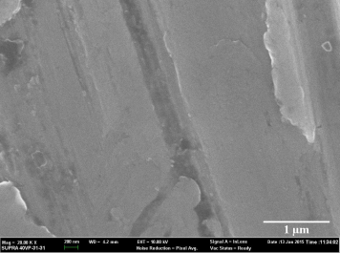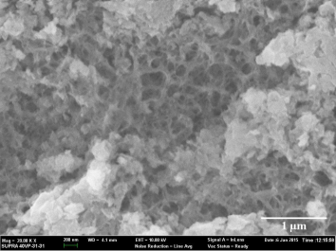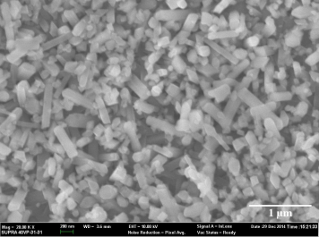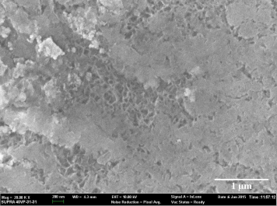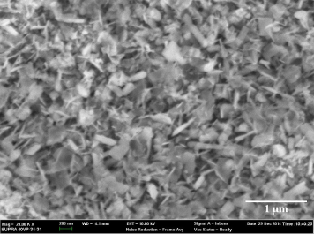
(a)
(b)
(c)
(d)
(e)
Figure 3. FESEM images at 20k magnification on the surface of as-Ti (a), after 5M NaOH-treated (b), after 5M NaOH-heat treated (c), after 5M KOH treated (d) and after 5M KOH-heat treated (e)
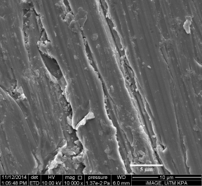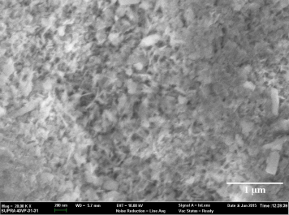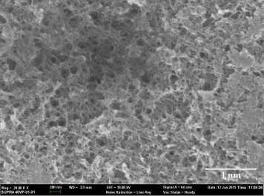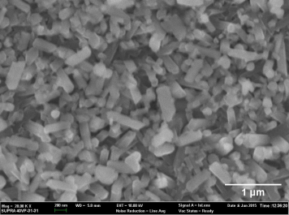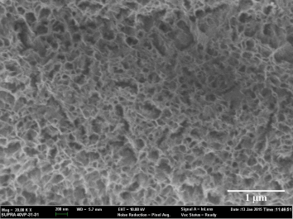
(a)
(b)
(c)
(d)
(e)
Figure 4. FESEM images at 10k magnification on the surface of ab-Ti (a); 20k magnification after 5M NaOH-treated (b), after 5M NaOH-heat treated (c), after 5M KOH treated (d) and after 5M KOH-heat treated (e)

Examination on as-Ti and ab-Ti surface revealed porous network structure was fully densified to form a homogenous flake-like shape structure (Figure 3c and Figure 4c) on its surface. According to Wei et al., no apatite formation on the flake-like structure of NaOH-heat treated at 700°C due to heat treatment had changed the surface structure [21]. On the other hand, Ciobanu et al. [22] and Qu & Wei [15] shared similar findings of uniform petal rose-like morphology on Ti surface. Both claimed that petal rose-like structure was HA layer that exhibited on the treated after soaking in modified supersaturated calcification solution (M-SCS) and SBF at medium pH, respectively. Petal rose-like structure of HA coating layer on Ti surface is believe could enhance the osteoinductive and biochemical properties of coating by modification of physical structure [22].

A homogenous rod-like shape structure was observed on heat treated surface after soaking in KOH for 24 hours at 60 °C (Figure 3e and Figure 4e). The porous structure of KOH-treated was fully densified after heat treatment at 700 °C. A potassium hexatitanate (K₂Ti₆O₁₃) rod-like structure was observed by Wang et al. [23] and Li et al. [24], which produced from a mixing of potassium carbonate/nitrate and titanium dioxide powder as initial.

Surface structure
Figure 5 and Figure 6 show the XRD patterns of the surfaces of as-Ti and ab-Ti subjected to heating process at 700°C after soaking in NaOH and KOH, respectively.

.
(a)

(b)

(c)

(d)

(e)
2θ
Figure 5. XRD pattern of as-Ti (a); after KOH treated at 60 °C (b); after NaOH treated at 60 °C (c); heat treated after soaking in KOH (d) and heat treated after soaking in NaOH (e)

(a)

(b)

(c)

(d)

(e)
2θ

Figure 6. XRD pattern of abraded Ti with SiC paper, as received Ti (a); after KOH treated at 60 °C (b); after NaOH treated at 60 °C (c); heat treated after soaking in KOH (d) and heat treated after soaking in NaOH (e)

The aim of XRD analysis is to determine surface structural changes or phase composition present on the treated Ti surface. A small bump was detected around 2θ = 21-22° in Figure 5 (b, c and d) on as-Ti. Results indicate a thin layer of either monoclinic phase of potassium titanate (K₂Ti₆O₁₃) [24] or sodium titanate (Na₂Ti₆O₁₃) depending on alkali solution that as-Ti was soaked in. Minor decrease of K₂Ti₆O₁₃ or Na₂Ti₆O₁₃ peak was hardly observable due to relatively high heating temperature (700 °C). However, neither potassium titanate nor sodium titanate major peak was detectable on ab-Ti surface as pattern on in Figure 6.

Meanwhile, at 2θ = 25-28° small amount of rutile (TiO₂) peak were detected for all specimens after heat treated except for ab-Ti after soaking in NaOH. These additional peaks indicate that titanium was further oxidized and formed oxide layers with a rutile structure. Other peaks most the same as initial Ti pattern for both as-Ti and ab-Ti which presenting the peaks of titanium. Intensity different from each treatment due to phase amount and sharp peak indicates phase crystallinity.

During the alkali (KOH/NaOH) etching at 60 °C for 24 hours, the passive oxide layer, TiO₂ partially dissolves into the alkaline solution because of hydroxyl group easily attacked hydrated TiO₂ which will produce negatively charged hydrates on the Ti specimen surface. Negatively charged species easily combined with alkali ions and result in the formation of alkali titanate hydrogel layer which then densified and dehydrated to form amorphous or crystalline alkali titanate layer after heat treatment [25].

Theoretically, Wei et al. [21] claimed that more sodium ions can be released from thicker sodium titanate layer. This leads to easily apatite formation in SBF by increase amount OH⁻ concentration that release from titanate layer. Hence, further study is suggested to investigate the effect of temperature after alkali treatment on as-Ti.

Conclusion
In this study, roughness, wettability, morphology structure and crystallinity of as-Ti and ab-Ti alkali treated at ambient and 700 °C does not show an obvious different measurement. In fact, as-Ti treated with KOH showed a better porous network structure which is required for good bonding of apatite formation. For the future study, the apatite formation ability on the treated Ti surface in SBF is suggested to be tested.

Acknowledgement
The present study was made possible through a Research Acculturation Grant Scheme by University Technology MARA (600-RMI/RAGS5/3(71/2013)) and also facilities and constant encouragement from Faculty of Chemical Engineering, University Technology MARA is gratefully acknowledged.

References

1. Viceconti, M., Muccini, R., Bernakiewicz, M., Baleani, M. and Cristofolini, L. (2000). Large-sliding contact elements accurately predict levels of bone–implant micromotion relevant to osseointegration. Journal of Biomechanics, 33 (12): 1611 – 1618.
2. Narayanan, R., Seshadri, S. K., Kwon, T. Y. and Kim, K. H. (2008). Calcium phosphate-based coatings on titanium and its alloys. Journal of Biomedical Material Research Part B: Applied Biomaterials, 85 (1): 279 – 299.
3. Zhang, Q. & Leng, Y. (2005). Electrochemical activation of titanium for biomimetic coating of calcium phosphate. Biomaterials, 26 (18): 3853–3859.
4. Liu, D., Yang, Q. and Troczynski, T. (2002). Sol–gel hydroxyapatite coatings on stainless steel substrates. Biomaterials, 23: 691 – 698.
5. Wang, H., Eliaz, N., Xiang, Z., Hsu, H. P., Spector, M. and Hobbs, L. W. (2006). Early bone apposition in vivo on plasma-sprayed and electrochemically deposited hydroxyapatite coatings on titanium alloy. Biomaterials, 27 (23): 4192 – 4203.
6. Jaworski, R., Pawlowski, L. and Petit, F. (2009). Suspension plasma sprayed titanium oxide and hydroxyapatite coatings in thermal spray 2009. Proceedings of the International Thermal Spray Conference,10: 156 – 162.
7. Li, P. (2002). Biomimetic nano-apatite coating capable of promoting bone ingrowth. Journal of Biomedical Materials Research, 66A (1): 79–85.
8. Bocardo, J. C. E., Heredia, M. A. L., Cortés, D. A., Ramírez, A. M. and Robles, J. M. A. (2005). Apatite formation on cobalt and titanium alloys by a biomimetic process. AZo Journal Materials Online, 1–15.
9. Müller, F. A., Bottino, M. C., Müller, L., Henriques, V. A. R., Lohbauer, U., Bressiani, A. H. and Bressiani, J. C. (2008). In vitro apatite formation on chemically treated (P/M) Ti-13Nb-13Zr. Dental Materials, 24 (1): 50 – 56
10. Rohanizadeh, R., Al-Sadeq, M. and Legeros, R. Z. (2004). Preparation of different forms of titanium oxide on titanium surface: Effects on apatite deposition. Journal of Biomedical Materials Research Part A, 71(2): 343 – 352.
11. Krupa, D., Baszkiewicz, J., Mizera, J., Borowski, T., Barcz, A., Sobczak, J. W., Biliński, A., Lewandowska-Szumieł, M. and Wojewódzka, M. (2009). Effect of the heating temperature on the corrosion resistance of alkali-treated titanium. Journal of Biomedical Materials Reserach Part A, 88(3): 589 – 598.
12. Kokubo, T. (1996). Formation of biologically active bone-like apatite on metals and polymers by a biomimetic process. Thermochimica Acta, 280/281: 479 – 490.
13. Kokubo, T., Kim, H.-M., Miyaji, F., Takadama, H. and Miyazaki, T. (1999). Ceramic–metal and ceramic–polymer composites prepared by a biomimetic process. Composite Part A: Applied Science and Manufacturing, 30 (4): 405 – 409.
14. Kim, H. M., Miyaji, F., Kokubo, T. and Nakamura, T. (1997). Bonding strength of bonelike apatite layer to Ti metal substrate. Journal of Biomedical Materials Reserach, 38 (2): 121 – 127.
15. Qu, H. and Wei, M. (2008). The effect of temperature and initial pH on biomimetic apatite coating. Journal of Biomedical Materials Research Part B: Applied Biomaterials, 87(1): 204 – 212.
16. Kim, C., Kendall, M. R., Miller, M. A., Long, C. L., Preston, R., Humphrey, M. B., Madden, A. S. and Tas, A. C. (2013). Comparison of titanium soaked in 5M NaOH or 5M KOH solutions. Materials Science and Engineering C, 33: 327 – 339.
17. Mustafa, K., Wennerberg, A., Wroblewski, J., Hultenby, K., Lopez, B. S. and Arvidson, K. (2001). Determining optimal surface roughness of TiO₂ blasted titanium implant material for attachment, proliferation and differentiation of cells derived from human mandibular alveolar bone. Clinical Oral Implants Research, 12 (5): 515 – 525.
18. Zhou, H., Nabiyouni, M. and Bhaduri, S. B. (2013). Microwave assisted apatite coating deposition on Ti6Al4V implants. Materials Science and Engineering C, 33(7): 4435 – 4443.
19. Whyman, G and Bormashenko, E. (2011). How to make the cassie wetting state stable? Langmuir, 27(13): 8171 – 8176.
20. Rosales-Leal, J. I., Rodríguez-Valverde. M. Mazzaglia, A., G., Ramón-Torregrosa, P. J., Díaz-Rodríguez, L., García-Martínez, O., Vallecillo-Capilla, M., Ruiz, C. and M. A. Cabrerizo-Vílchez, (2010). Effect of roughness, wettability and morphology of engineered titanium surfaces on osteoblast-like cell adhesion. Colloids Surfaces A Physicochemical and Engineering Aspects, 365 (1–3): 222 – 229.
21. Wei, M., Kim, H.-M., Kokubo, T. and Evans, J. H. (2002). Optimising the bioactivity of alkaline-treated titanium alloy. Materials Science and Engineering C, 20 (1–2): 125 – 134.
22. Ciobanu, G., Carja, G., Ciobanu, O., Sandu, I. and Sandu, A. (2009). SEM and EDX studies of bioactive hydroxyapatite coatings on titanium implants. Micron, 40 (1): 143 – 146.
23. Wang, X., Liu, S. J., Qi, Y. M., Zhao, L. C. and Cui, C. X. (2014). Behavior of potassium titanate whisker in simulated body fluid. Materials Letters, 135: 139 – 142.
24. Li, J., Zhang, Y. C. and Zhang, M. (2012). Low temperature preparation and optical properties of K2Ti6O13. Materials Letters, 79: 136–138.
25. Kim, H.-M. and Miyaji, F. (1996). Preparation of bioactive Ti and its alloys via simple chemical surface treatment. Journal of Biomedical and Materials Research, 32: 409 – 417.

