INFLUENCE OF HIGHLY CONCENTRATED SODIUM HYDROXIDE (NaOH) TOWARDS FORMATION OF HIGHLY ORDERED TIO₂ NANOTUBES (TNT) STRUCTURE

(Pengaruh Kepekatan Sodium Hidrosida (NaOH) yang Tinggi terhadap Pembentukan Struktur Bertertib Nanotiub TiO₂ (TNT))
Masturah Abdullah¹ and Siti Kartom Kamarudin^{1, 2}*

¹Fuel Cell Institute, Universiti Kebangsaan Malaysia,
43600 Bangi, Selangor, Malaysia.
²Department of Chemical and Process Engineering, Faculty of Engineering and Built Environment,
Universiti Kebangsaan Malaysia, 43600 Bangi, Selangor, Malaysia

*Corresponding author: ctie@vlsi.eng.ukm.my

Abstract

In this study, titanium dioxide nanotubes (TNT) were synthesis according to different concentration of sodium hydroxide (NaOH). The main purpose of this study was to investigate the effect of the high concentration NaOH towards formation of TiO₂ nanotubes structure. TNT was synthesized via hydrothermal method that was performed in a Teflon line stainless steel autoclave by using different concentration of NaOH (6 M to 12 M). The hydrothermal time and temperature is placed constantly for 24 hours and 110 ºC respectively. The characterization of TNT was performed by Field Emission Transmission Electron Microscopy (FESEM), X-ray Diffraction (XRD), Fourier Transform Infrared Spectroscopy (FTIR) and Energy Dispersive X-ray (EDX) analysis for better understanding of its nanotubes structure and the chemical bonding present. Based on characterization analysis, the formation of nanotubes was in systematic arrangement and makes it easier for loading of noble catalyst. Furthermore, the replacement of sodium content by hydrogen ion, H+ also seem to be increasing after the acid washing treatment. The investigation result proven that the best concentration of NaOH for TiO₂ nanotubes formation was 10 M (TNT-10).

Keywords: TiO₂ nanotubes, hydrothermal reaction, concentration of sodium hydroxide

Abstrak
Melalui kajian ini, nanotiub titanium dioksida disintesiskan mengikut kepekatan sodium hidrosida (NaOH) yang berbeza. Tujuan utama kajian ini adalah untuk mengkaji kesan kepekatan NaOH yang tinggi terhadap pembentukan struktur nanotiub. Nanotiub titanium dioksida (TNT) dihasilkan dengan menggunakan kaedah hidrotermal menggunakan turus teflon autoklaf keluli anti karat dengan mempelbagaikan kepekatan NaOH (6 M hingga 12 M). Tempoh dan suhu proses hidrotermal masing-masing dibiarkan sekata selama 24 jam dan 110 ºC. Pencirian TNT dijalankan dengan menggunakan Mikroskopi Elektron Pengimbasan Pancaran Medan (FESEM), Pembelauan Sinar X (XRD), Spektroskopi Inframerah Transformasi Fourier (FTIR) dan Tenaga Serakan Sinar X (EDX) bagi memahami dengan lebih mendalam mengenai struktur nano dan juga ikatan kimia yang wujud. Berdasarkan analisis yang dijalankan, didapati nanotiub berada dalam keadaan yang sistematik dan memudahkan penempatan pemangkin adi. Tambahan pula, penggantian kandungan sodium oleh H+ juga meningkat selepas proses pembasuhan menggunakan asid. Keputusan ujikaji menunjukkan kepekatan 10 M (TNT-10) adalah yang terbaik bagi menghasilkan nanotiub TiO₂.

Kata kunci: Nanotiub TiO₂, tindak balas hidrotermal, kepekatan sodium hidroksida

Introduction
Since the discovery of carbon nanotubes (CNT) in 1990s, researchers are eager to find and develop more nanotubular structures with different types of materials that can be used for variable purpose. Due to over corrosive of carbon based materials, it seems to be less interesting for catalytic application and alternative materials is needed for overcoming the crucial problem. Titanium dioxide nanotubes (TNT) are one of the exclusive nanomaterial with nanotubular shape that can provide large surface area for deposition of noble catalyst in catalytic system. Moreover, the non-corrosive, environmentally friendly and inexpensive materials are the factors that make it interesting for TNT to be suitable candidate among other nanostructure materials. The strong metal support and high-stability in elevated temperature make it more preferable as potential nanostructure for various applications in science and technology field. TNT is promising nanomaterial due to its high properties that suitable for various applications in fuel cell technology, solar cell, storage energy material [1] and also gas sensing properties [2]. TNT receives numerous attention in fuel cell technology as different roles for each type of fuel cell including as catalyst support for main catalyst [3-6], photocatalyst [7-10], gas sensor [2,11,12] and composite membrane [13,14]. For the synthesized method, TiO₂ nanotubes can be produced via three common methods: (i) electrochemical anodization, (ii) template assisted and (iii) hydrothermal method. Anodization employs the using of power source for obtaining steady current in which longer nanotubes were achieved with larger anodization voltage [15]. However, the higher fabrication cost make it less ideal as the best method for synthesizing TNT.
Template assisted method can be performed by using stabilize template that was already in tube form and nanotubes was grown by using chemical vapor deposition (CVD) system [16] but due to the product that was hard to remove and may damage the structure of nanotubes itself make it less favorable among researchers as it can waste the materials itself. For hydrothermal method, it is more favorable due to lower apparatus cost and high quality products [17] but limit by long operation hours which is take for 24 hours or longer for a complete hydrothermal reaction. Furthermore, in hydrothermal method, a highly concentrated NaOH (10 M ~ 11 M) was used for producing highly nanostructure nanotubes together with TiO₂ (Degussa P25) powder. Nanotubes of titanium dioxide from hydrothermal method was firstly reported in 1998 by Kasuga et al. [18] with large surface area of 400 m²/g and afterward research was still undergoing after that year for better quality of TiO₂ nanotubes by the same person [19,20]. In this research, hydrothermal method was applied in fabrication process of TiO₂ nanotubes and the brief method was discussed in the next section below.

Materials and Methods

Materials
For hydrothermal process, TiO₂ (P25 Degussa) powder with particle size of 21 nm was obtained from Sigma-Aldrich and NaOH in pellet form was purchased from Macron-USA. Hydrochloric acid with purity of 36.5 – 38% was purchased from J.T. Baker-USA for washing purpose to remove Na⁺ ions.

Synthesis of TiO₂ nanotubes
Hydrothermal method was used in the synthesis process of TNT. The synthesis of TiO₂ nanotubes was started by mixing 50 ml of highly concentrated solution of NaOH varied from 6 M to 12 M with TiO₂ powder (3.0 g) and stirred for two hours to allow dispersion. After that, the hydrothermal reaction was performed by using Teflon line stainless steel autoclave at 110 ºC for 24 hours. Next, the solution was collected and undergone washing process by using 0.1 M HCl and deionized water until pH 7. The crystal sample was then filtered and dried overnight at 80 ºC in order to obtain pure product of TNT. Lastly, the TiO₂ nanotubes in powder form were obtained by undergoing calcinations process at 400 ºC for 2 hours. The sample was then labeled as TNT-6, TNT-8, TNT-10 and TNT-12 based on the concentration of NaOH used which are 6 M, 8 M, 10 M and 12 M. The prepared samples were then characterized by FESEM, FTIR, EDX and XRD analysis for knowing the morphology, sodium content, crystal and bonding structure of TiO₂ nanotubes.

Characterization of TiO₂ nanotubes
The morphology structure of TiO₂ nanotubes was viewed by field emission scanning electron microscopy (FESEM) analysis. The structure of TiO₂ nanotubes (TNT) and chemical bonding present in the sample were examined by using X-ray diffraction (XRD) and Fourier Transform Infrared Spectroscopy (FTIR) analysis. The sodium content was obtained from Energy dispersive x-ray (EDX) analysis. The data was then analyzed for further understanding of its nanostructure.

Results and Discussion
In hydrothermal method, TiO₂ nanotubes was obtained during the reaction of high concentration of NaOH and pure TiO₂ powder in Teflon line stainless steel autoclave. The process of TiO₂ nanotubes generation can be defined by sequence reaction step below:
- High concentrated alkaline reaction
At the first reaction step, the high concentrated of NaOH (alkaline solution) will reacted with TiO₂ powder at temperature of 110ºC for 24 hours. The sodium titanate (Na₂Ti₂O₅.H₂O) was the main product.
2TiO₂ + 2NaOH Na₂Ti₂O₅.H₂O (1)
- Replacement of Na⁺ to H⁺
The hydrogenotitanate was formed during the ion exchange between Na⁺ and H⁺ that happened during the acid wash treatment.
Na₂Ti₂O₅.H₂O + xH⁺ HxNa_{2-x}Ti₂O₅.H₂O + xNa⁺, (0 ≤ x ≤ 2) (2)

- Dehydration process
The dehydration process is carried out by undergone drying process at 80 ºC and followed by calcination process at high temperature for two hours. The reaction consists of two steps which can be seen below:
H₂Ti₂O₅.H₂O H₂Ti₂O₅ + H₂O (3)
H₂Ti₂O₅ 2TiO₂ + H₂O (4)

Field emission scanning electron microscopy (FESEM)
The morphology structure of TiO₂ nanotubes was viewed by field emission electron microscopy (FESEM). Figure 1 shown the image of TNT by FESEM as the hydrothermal product with different concentration of sodium hydroxide used (6 M, 8 M, 10 M and 12 M). From the image, it can be seen that only TNT-10 shown the complete structure of nanotubes TiO₂ with random alignment. The nanotubes were likely formed in overlapping with each other. Furthermore, the smooth and well-forming shape of TNT can be seen clearly. The nanotubes structure of TNT-6 was not discovered but instead of aggregated solid granules of TiO₂ nanoparticles was detected. This formation was due to the fact that at low concentration (< 6 M), the rate of Ti ion diffusion was too low with low alkaline solution. As for TNT-8, the early stage formation of TNT can be seen with non-complete tube-structure with agglomerate product formed [21]. As for TNT-12, the tube structure was disappeared and amorphous nanoparticles was discovered. This result can be correlated with Huang et al. [22] that also get the same result in which at too high concentration of NaOH, the amorphous particle is formed. During that condition, the alkaline solution tend to be very viscous and thus limited the diffusion of Ti (IV) ion (equation 1) due to the dissolution of Titania precursor. Besides, the crystallite titanate formed are said to be unstable in extreme condition (high alkaline solution) and decomposition rate of the crystallite titanate was faster. From this analysis, we can say that the concentration of NaOH was strongly influenced the formation of nanotubes TiO₂. As the concentration of alkaline solution was low (< 6 M), the nanotubes structure does not form instead of nanogranules generated while at too high concentration of alkaline solution, the amorphous nanoparticles was discovered with packed agglomerate. The best condition of synthesis TiO₂ nanotubes was 10 M.

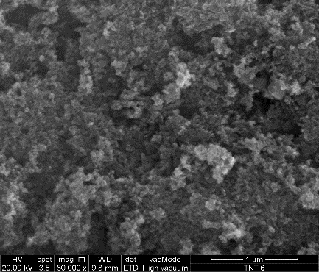
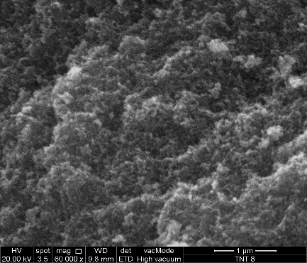
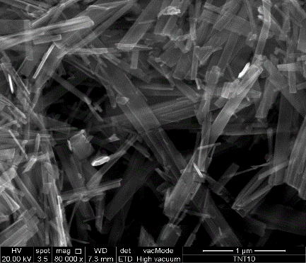
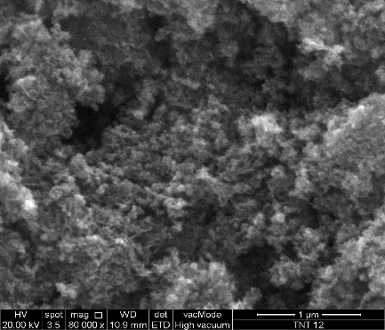
(a)
(d)
(c)
(b)

Figure 1. FESEM images of TNT after hydrothermal reaction at scale of 1 µm: (a) 6 M, (b) 8 M, (c) 10 M and (d) 12 M

X-ray diffraction (XRD)
The nanostructure of TiO₂ nanotubes was characterized by using X-ray diffraction (XRD) that were scanned from 10º to 90º at 2θ. Figure 2 illustrated the XRD pattern of titanium dioxide nanotubes that were fabricated by using different concentration of NaOH during hydrothermal treatment. Based on the XRD spectrum, the anatase peak of TiO₂ nanotubes for all concentrations can be detected at 2θ = 25º, 37º and 47º which mark as “A” and rutile phase at 2θ = 27º, 36º and 41º which mark as “R”. The result indicated that there is mixture of both anatase and rutile phases in the TiO₂ nanotubes for all types of concentration used. The XRD pattern for TNT-6 and TNT-12 exhibit the same pattern while TNT-8 and TNT-10 show a bit different pattern with almost same properties. Both TNT-8 and TNT-10 gave the highest intense peak around d₁₁₀ (25º) which means that the strong peak of TiO₂ nanotubes. In another word, it can be said that there are larger amount of Ti-O nanotubes bond at the peak compared to another two samples. The intense peak at d₁₁₀ (25º) shown that there is interlayer spacing in tetragonal system with lattice constant value tabulated in Table 1. Moreover, the intense peak at d₁₁₀ (25º) also decrease when approaching d₆₀₀ peak (27.4º). This proven that there was loss of water molecule during the dehydration process. The crystallite size for TNT-6, TNT-8, TNT-10 and TNT-12 were 140.2 A, 143.7 A, 137 A and 81.4 A respectively. Moreover, the relative ratio of d₁₁₀/d₆₀₀ peaks can determined the content of Na⁺ and was presented in Table 1 [23]. The ratio of d₁₁₀/d₆₀₀ in Table 1 was seem to be increase as the theta increase which indicated that the Na+ content was decreased because of the replacement of Na⁺ by H⁺ was happened during the acid washing treatment after the hydrothermal treatment [4]. XRD analysis suggested that the TNT-8 and TNT-10 exhibit almost similar properties to TiO₂ nanotubes by previous studies [3, 4, 23, 24].

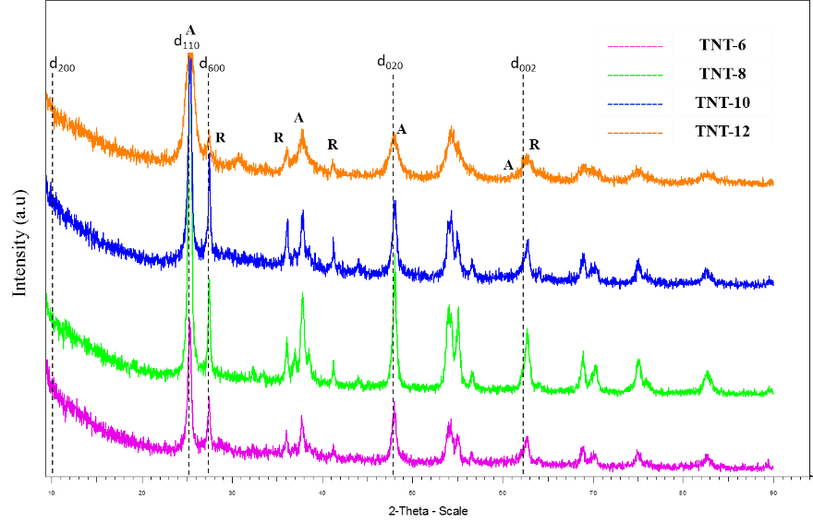

Figure 2. XRD spectrum for TNT-6, TNT-8, TNT-10 and TNT-12

Table 1. XRD data for TiO₂ nanotubes
Lattice Constant | d₁₁₀ (25º) | d₆₀₀ (27.4º) | d₁₁₀/d₆₀₀
a | 3.872 | 4.6257 | 0.84
b | 3.872 | 4.6257 | 0.84
c | 9.616 | 2.9806 | 3.23

Fourier transform infrared spectroscopy (FTIR)
The chemical bonding structure of prepared sample was checked by using FTIR analysis. Figure 3 present the FTIR spectra for TNT-6, TNT-8, TNT-10 and TNT-12. At 3200 to 3400 cm⁻¹ wavenumbers, the strong intensity peak was discovered which ensured that there was O-H bond (hydroxyl group) present for all NaOH concentrations [5]. This result shows that there was large amount of O-H group on the surface of TiO₂ nanotubes due to stretching mode of Ti-OH bond. The sample TNT-10 exhibits the greatest vibrational modes for OH groups. Besides, the strong peaks were also discovered at 1400 to 1600 cm-1 which corresponds to the TiO₂ nanotubes bond that was present [6]. For TNT-12, the peak at this point was not strong enough as it shown the lowest peak among another three samples. This is compatible with the previous analysis (FESEM and XRD) as there were no nanotubes detected instead of amorphous nanoparticles TiO₂ was detected. The discovery of TiO₂ nanotubes bond was also due to the fact that the Ti-O planes was started to scroll to be nanotubes and give rise to site of bronsted acid and at the same time, it tend to modify the Lewis acid site rapidly [25]. In general, pure TiO₂ which in anatase, rutile and brookite phase, Lewis acid site was majorly in it but after NaOH concentration was take into the pure TiO₂, the bronsted acid site was formed directly. As the larger bronsted acid site generated, better nanostructure of TiO₂ nanotubes was achieved and formed. The large amount of O-H group in the TiO₂ nanotubes can be enhance for the purpose of the deposition of metal particles that ease the process of the dispersion and conjunction of the particles in the nanotubes surface. As overall, it can be said that the 10 M (TNT-10) concentration of NaOH was the best result as it has the highest peak intensity for both types of functional group which are hydroxyl group and TiO₂ nanotubes. The result totally suggests that the formation of TiO₂ nanotubes was influenced by the concentration of NaOH used during the hydrothermal reaction.

Figure 3. FTIR analysis for TNT-6, TNT-8, TNT-10 and TNT-12
Energy dispersive X-ray (EDX)
The energy dispersive x-ray (EDX) analysis was studied to determine the sodium content in TiO₂ nanotubes. The EDX pattern of various TNTs synthesized can be seen in Figure 4. The amount of Ti, O and Na was obtained in atomic percentage. The atomic ratio of Na to Ti was calculated and shown in Figure 5. Based on the bar chart in Figure 5, TNT-10 presented the lowest value (0.0504) of atomic ratio Na/Ti which directly indicated that many sodium ions was replaced by hydrogen ions during acid washing process with HCl. The loss of Na+ could enhance the rolling process of TiO₂ nanosheet into TiO₂ nanotubes. As for TNT-12, it shown highest value (0.1511) of atomic ratio which means that there is still huge amount of sodium ions even after ther acid washing process which also conjugated that there was least amount of TiO₂ nanotubes formed during hydrothermal reaction. The result can be correlated with FESEM analysis as we can see that as amorphous nanoparticle TiO₂ was generated instead of TiO₂ nanotubes for TNT-12. The lower amount of sodium ions, the higher amount of H+ ions was replaces during ion exchange process. When this condition happened, it will tend to increase the process of TiO₂ nanosheet rolling into TiO₂ nanotubes [23]. The result from EDX was compatible with the previous analysis and ensured that TNT-10 shown the greatest feature of nanotubes.
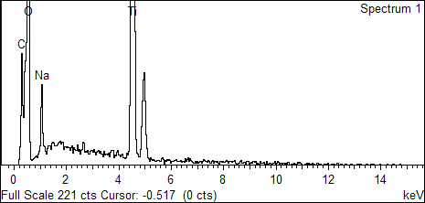
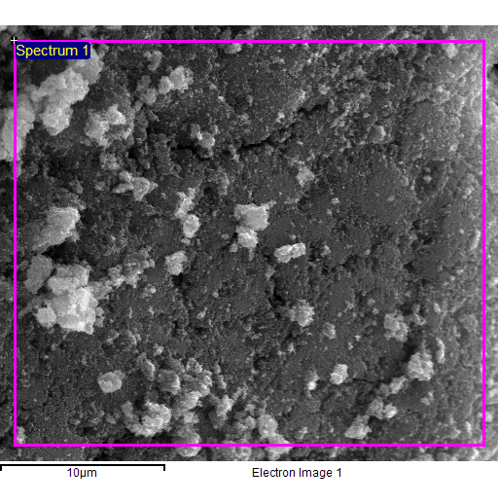
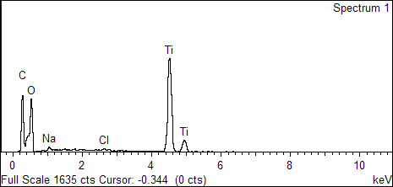
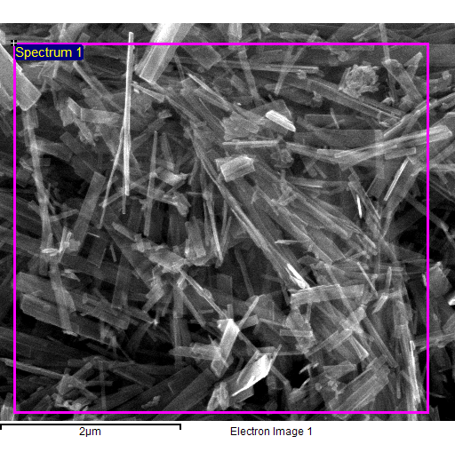
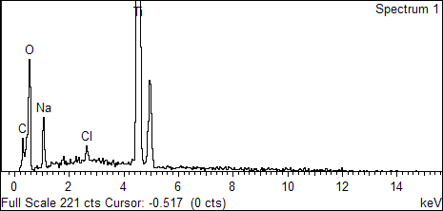
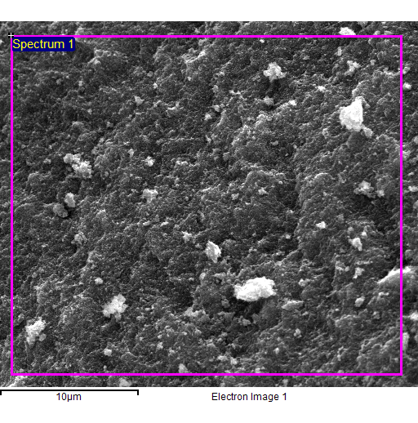
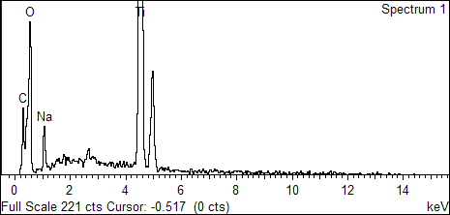
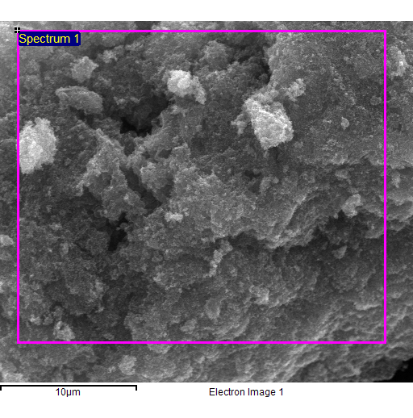
- TNT-12
- TNT-10
- TNT-8
- TNT-6

Figure 4. EDX pattern of various TNT synthesized

Figure 5. Value of atomic ratio of Na/Ti

Conclusion
The formation of TiO₂ nanotubes was successfully investigated by using different types of NaOH concentration (6 M, 8 M, 10 M and 12 M) during hydrothermal reaction. The effect of NaOH concentration was analyzed by using FESEM, XRD, FTIR and EDX analysis. Based on the four analysis, TNT-10 shown the best performance based on the FTIR, FESEM and EDX analysis while TNT-8 and TNT-10 was the best sample based on XRD analysis as it leads with high properties of TiO₂ nanotubes. In FESEM, only TNT-10 shown the greatest formation of TiO₂ nanotubes with clearly structure while for another samples do not show any clear tube formation. For FTIR analysis, the broad and strong vibrational peak was discovered on TNT-10 while for EDX analysis, the least amount of atomic ratio Na/Ti was obtained in TNT-10 sample which indicated that more Na+ ion was replaced by H+ ion during acid wash process with HCl. The result also suggests that the formation of TiO₂ nanotubes was strictly affected by the concentration of NaOH used in fabrication process during the hydrothermal reaction take places. The suitable concentration of NaOH for synthesized TiO2 nanotubes was 10 M which in moderate concentration. Too low concentration of alkaline solution does not help the TNT formation while too high concentration of alkaline solution lead to rupture structure of TiO₂ nanotubes with amorphous nanoparticle detected.

Acknowledgement
The authors gratefully acknowledge financial support for this work by Universiti Kebangsaan Malaysia under Grant No.: GUP-2014-071 and Malaysian of Education (MOE) for LRGS/2013/UKM-UKM/TP/01.

References

- Kim, J. H., Kang, H. K., Woo, S. G., Jeong, G., Park, M. S., Kim, K. J., Yu, J. S., Yim, T., Jo, Y. N., Kim, H. and Zhu, K. (2014). Oriented TiO₂ nanotubes as a lithium metal storage medium. Journal of Electroanalytical Chemistry, 726: 51 – 54.
- Perillo, P. M. and Rodriguez, D. F. (2012). The gas sensing properties at room temperature of TiO₂ nanotubes by anodization. Sensors and Actuators B: Chemical, 171: 639 – 643.
- Abida, B., Chirchi, L., Baranton, S., Napporn, T. W., Kochkar, H., Léger, J. M. and Ghorbel, A. (2011). Preparation and characterization of Pt/TiO₂ nanotubes catalyst for methanol electro-oxidation. Applied Catalysis B: Environmental, 106(3): 609 – 615.
- Abida, B., Chirchi, L., Baranton, S., Napporn, T. W., Morais, C., Léger, J. M. and Ghorbel, A. (2013). Hydrogenotitanates nanotubes supported platinum anode for direct methanol fuel cell. Journal of Power Sources, 241: 429 – 439.
- Dong, B., He, B. L., Chai, Y. M. and Liu, C. G. (2010). Novel Pt nanoclusters/titanium dioxide nanotubes composites for hydrazine oxidation. Materials Chemistry and Physics, 120: 404 – 408.
- Dong, B., He, B. L., Huang, J., Gao, G. Y., Yang, Z. and Li, H. L. (2008). High dispersion and electrocatalytic activity of Pd/titanium dioxide nanotubes catalysts for hydrazine oxidation. Journal of Power Sources, 175(1): 266 – 271.
- Gan, Y. X., Gan, B. J. and Su, L. (2011). Biophotofuel cell anode containing self-organized titanium dioxide nanotube array. Materials Science and Engineering: B, 176(15): 1197 – 1206.
- Liang, H-C., Li, X-Z. and Nowotny, J. (2010). Photocatalytical properties of TiO₂ nanotubes. Solid State Phenomena, 162: 295 – 328.
- Sun, Y., Wang, G. and Yan, K. (2011). TiO₂ nanotubes for hydrogen generation by photocatalytic water splitting in a two-compartment photoelectrochemical cell. International Journal of Hydrogen Energy, 36(24): 15502 – 15508.
- Sun, Y. and Yan, K. P. (2014). Effect of anodization voltage on performance of TiO 2 nanotube arrays for hydrogen generation in a two-compartment photoelectrochemical cell. International Journal of Hydrogen Energy, 39: 11368 – 11375.
- Han, C. H., Hong, D. W., Kim, I. J., Gwak, J., Han, S. D. and Singh, K. C. (2007). Synthesis of Pd or Pt/titanate nanotube and its application to catalytic type hydrogen gas sensor. Sensors and Actuators B: Chemical, 128(1): 320 – 325.
- Lee, J., Kim, D. H., Hong, S. H. and Jho, J. Y. (2011). A hydrogen gas sensor employing vertically aligned TiO₂ nanotube arrays prepared by template-assisted method. Sensors and Actuators B: Chemical, 160(1): 1494 – 1498.
- Jun, Y., Zarrin, H., Fowler, M. and Chen, Z. (2011). Functionalized titania nanotube composite membranes for high temperature proton exchange membrane fuel cells. International Journal of Hydrogen Energy, 36(10): 6073 – 6081.
- Matos, B. R., Isidoro, R. A., Santiago, E. I., Tavares, A. C., Ferlauto, A. S., Muccillo, R. and Fonseca, F. C. (2015). Nafion–titanate nanotubes composites prepared by in situ crystallization and casting for direct ethanol fuel cells. International Journal of Hydrogen Energy, 40(4): 1859 – 1867.
- Song, H., J. Shang, and C. Suo (2015). Fabrication of TiO₂ nanotube arrays by rectified alternating current anodization. Journal of Materials Science & Technology, 31(1): 23 – 29.
- Karaman, M., Sarıipek, F., Köysüren, Ö. and Yıldız, H. B. (2013). Template assisted synthesis of photocatalytic titanium dioxide nanotubes by hot filament chemical vapor deposition method. Applied Surface Science, 283: 993 – 998.
- Ju, J., Shi, Y. and Wu, D. (2012). TiO₂ nanotube supported Pd-Ni catalyst for methanol electro-oxidation. Powder Technology, 230: 252 – 256.
- Kasuga, T., Hiramatsu, M., Hoson, A., Sekino, T. and Niihara, K. (1998). Formation of titanium oxide nanotube. Langmuir, 14(12): 3160 – 3163.
- Kasuga, T. (2006). Formation of titanium oxide nanotubes using chemical treatments and their characteristic properties. Thin Solid Films, 496(1): 141 – 145.
- Kasuga, T., Hiramatsu, M., Hoson, A., Sekino, T. and Niihara, K. (1999). Titania nanotubes prepared by chemical processing. Advanced Materials, 11(15): 1307 – 1311.
- Liu, W., Sun, W., Han, Y., Ahmad, M. and Ni, J. (2014). Adsorption of Cu (II) and Cd (II) on titanate nanomaterials synthesized via hydrothermal method under different NaOH concentrations: Role of sodium content. Colloids and Surfaces A: Physicochemical and Engineering Aspects, 452: 138 – 147.
- Huang, J., Cao, Y., Deng, Z. and Tong, H. (2011). Formation of titanate nanostructures under different NaOH concentration and their application in wastewater treatment. Journal of Solid State Chemistry, 184(3): 712 – 719.
- Sui, X. L., Wang, Z. B., Li, C. Z., Zhang, J. J., Zhao, L. and Gu, D. M. (2014). Effect of pH value on H₂ Ti₂O₅/TiO₂ composite nanotubes as Pt catalyst support for methanol oxidation. Journal of Power Sources, 272: 196 – 202.
- Sui, X. L., Wang, Z. B., Yang, M., Huo, L., Gu, D. M. and Yin, G. P. (2014). Investigation on C–TiO 2 nanotubes composite as Pt catalyst support for methanol electrooxidation. Journal of Power Sources, 255: 43 – 51.
- Camposeco, R., Castillo, S., Mejia-Centeno, I., Navarrete, J. and Gómez, R. (2014). Effect of the Ti/Na molar ratio on the acidity and the structure of TiO₂ nanostructures: Nanotubes, nanofibers and nanowires. Materials Characterization, 90: 113 – 120.

