

MALAYSIAN JOURNAL OF ANALYTICAL SCIENCES
ISSN 1394 - 2506

Published by The Malaysian Analytical Sciences Society

OPTIMIZATION OF CHLOROPHYLL EXTRACTION FROM

Gynura procumbens

(Pengoptimuman Proses Pengekstrakan Klorofil daripada Gynura procumbens)

Zurina Zainal Abidin*, Wan Noraznorin Mohamad, Mahtab Samadi

Department of Chemical and Environmental Engineering, Faculty of Engineering,
Universiti Putra Malaysia, 43400 UPM Serdang, Selangor, Malaysia

*Corresponding author: zurina@upm.edu.my

Received: 21 October 2015; Accepted: 14 June 2016

Abstract
Gynura procumbens (Sambung nyawa) is a bicolor (green and red) herbal plant, which is widely grown in Asia. This herbs are famously used for medicinal purposes as a safe alternative to chemical-based medicine. Recent studies proved that this plant has anti-herpes simplex virus, anti-flammatory and anti-hyperglycaemic properties. This work investigates the extraction of chlorophyll a and b in Gynura procumbens using Solid liquid extraction method. The solid to solvent ratio, temperature, solvent used and extraction time were varied to determine the optimum conditions for extraction. It was found that at 80 °C in 90 minutes with 2:5 solid to solvent ratio was the most favorable condition to extract chlorophyll a and b. Five valuable compounds were found from GC-MS analysis, which are 2-hexanal, phenol, oleic acid, copaene and phytol. This implies that Gynura procumbens promises a good source of many useful bioactive compounds.

Keywords: Gynura procumbens, sambung nyawa, chlorophyll, extraction, optimization

Abstrak

Sambung Nyawa ialah pokok herba dwi-warna yang tumbuh secara meluas di Asia. Herba ini sangat popular digunakan sebagai bahan alternatif yang selamat bagi tujuan perubatan berbanding ubatan berunsurkan bahan kimia. Penyelidikan terbaru membuktikan bawaha pokok ini anti-virus herpes simplex, anti-keradangan dan anti-sifat hiperglisemia. Eksperimen ini menyiasat tentang pengekstrakan klorofil a dan b dalam Gynura procumbens. Menggunakan pengekstrakan cecair pepejal. Nisbah cecair pepejal, suhu, pelarut dan masa mengekstrak telah dimanipulasi untuk menentukan keadaan yang optimum untuk proses pengekstrakan tersebut. Keputusan eksperimen mendapati bahawa pengekstrakan selama 90 minit pada suhu 80°C serta nisbah cecair pepejal 2:5 merupakan kondisi yang paling sesuai untuk mengekstrak klorofil a dan b. Lima kompoun berharga telah ditemui melalui keputusan analisa GC-MS iaitu 2-heksanal, fenol, asid oleik, copaene and fitol. Keputusan ini mencadangkan potensi Gynura procumbens sebagai sumber yang baik kepada sebatian bioaktif.

Kata kunci: Gynura procumbens, sambung nyawa, klorofil, pengekstrakan, pengoptimuman

Introduction

For centuries, many plants have been used as a traditional medicine. However, the interest for natural products have grown significantly in recent years [1,2,3]. In the market, nowadays, there are tremendous numbers of natural products, which have a phyto origin such as food additives, cosmetics, and medicines [4]. One of the well-known medicinal plants in South-east Asia is Gynura procumbens (Lour.) Merr., which is locally known as Sambung nyawa in Malaysia. Gynura procumbens is a fast growing evergreen herb from family of Compositae or Asteraceae and it is mostly found in Thailand, Malaysia, Indonesia, and Philippines [1,5].

The leaves of Gynura procumbens have been traditionally used for the treatment of eruptive fevers, rashes, kidney diseases, migraines, constipation, hypertension, cancer and diabetes mellitus, inflammation, rheumatism, viral diseases of skin, migraine, and constipation [5 – 9]. Modern research also has provided evidence for the above-mentioned medicinal properties of Gynura procumbens. For instance, Rosidah et al. [10] maintained that the ethanolic extract of G. procumbens showed anti-hyperglycaemic and anti-hyperlipidaemic activities in diabetic rats [5,9, 11,12]. Furthermore, Gynura procumbens has been reported to possess anti-herpes simplex virus, anti-hyperglycemic, anti-hyperlipidemic [13], anti-hypertensive effects [8], anti-hyperlipidemic [12,13], anti-sterility, anti-oxidative capabilities, and it has been found to be useful for prevention of rheumatism [5 – 7,9,12,13]. In addition, ethanol and methanol extracts from the leaves of Gynura procumbens showed anti-diabetic effects in streptozotocin (STZ)-induced diabetic rats [12]. Rosidah et al. [10] also reported that Gynura procumbens leaves increase insulin secretion in the insulin-secreting cell line [14]. According to Zurina et al. [15], it was reported that the aqueous extract of Gynura procumbens not only decreases the blood glucose levels, but also increase the glucose uptake by muscle tissues in STZ-induced diabetic rats [14].

Strong body of research supported the fact that chemical contents of Gynura procumbens leaf are flavonoid, glycoside kuersetin, phenolate acid, triterpenoid, alkaloid, saponin, and tannin [7,14]. Generally, most of the green vegetables and fruits contain chlorophyll, which accounts for their green colour. Chlorophyll a and b are the major pigments that can be found in the extract of green plants [16]. The presence of chlorophylls has also been observed in the solvent extract from leaves of Gynura procumbens [17,18,19]. Chlorophylls have been used as a traditional medicine for therapeutic and as antioxidant [17, 20]. Kaewseejan, et al. [17] reported that the usage of chlorophylls in human diet has increased significantly in recent years. According to Guil-Guerrero et al. [20], chlorophylls have antioxidant, anticarcinogenic, and cytotoxic activity, so, they may ameliorate drugs’ side effects [17]. Chlorophyll has been used for many purposes. In chemical industry, chlorophylls have been used as natural dyes. Chlorophyll is registered as a food additive (colorant), and its E number is E140. Chefs use chlorophyll to colour a variety of foods and beverages such as pasta and absinthe. Other than that, in medical field chlorophyll has been introduced as bioactive compound which can help in blood production.

Hence, given the importance of chlorophylls and its beneficial compounds, the aim of this study is to extract the chlorophyll a and b in Gynura procumbens at optimum condition.

Materials and Methods

Sample preparation
The leaves of Gynura procumbens were bought from Pusat Herba, Taman Pertanian Universiti (TPU). The leaves were washed by distilled water to avoid contaminants on the surface of the leaves. After drying, the leaves were freshly stored at 4 °C for subsequent experiments.

Solvent extraction

The fresh leaves of Gynura procumbens were cut into small pieces before the extraction. Then, an amount 0.5 g of sample was used for each experiment and soaked in 5 ml of solvent in a test tube. In order to find the best solvent for this extraction, three different solvents (water, methanol, and ethanol) were used in each extraction. The conical flask was then covered with aluminum foil to avoid contamination and to protect from sunlight that may causes unwanted reaction. Water bath machine was used to heat the samples for extraction at different temperature and time. After each experiment, the extracts were filtered through a Whatman No.1 filter paper and the absorbance value measured by using Shimadzu UV-Vis spectrophotometer.

Ultraviolet visible spectrophotometer

In this study, Shimadzu ultraviolet visible (UV-Vis) spectrophotometer was used in determining chlorophyll content. The extract collected after filtration of samples through Whatman No.1 filter paper were filled in the cuvette. Chlorophyll-a showed maximum absorbance at 665 nm while chlorophyll-b at 652 nm. Then, the chlorophyll-a and chlorophyll-b content (µg/ mL) were calculated using equations 1 and 2 for ethanol-based extraction as reported by Kaewseejan et al. [17]:

Chlorophyll-a = 16.72 (A665) – 9.15 (A652) (1)

Chlorophyll-b = 34.09 (A652) – 15.28 (A665) (2)

The wavelengths used were at 666 nm for chlorophyll-a absorbance and 653nm for chlorophyll-b absorbance. The equations 3 and 4 were used for methanol-based extraction to determined chlorophyll-a and –b content:

Chlorophyll-a = 15.65 (A666) – 7.340 (A653) (3)

Chlorophyll-b = 27.05 (A653) – 11.21 (A666) (4)

Gas chromatography mass spectrometry

Extracted samples were analysed using Shimadzu gas chromatography mass spectrometry (GC/MS). A 30 m × 250 µm × 0.25 µm capillary column was used. The temperature used for this analysis was from 50 to 325 ˚C while the pressure was up to 10.5 psi. The injection volume was 3.0 µL. Split less mode was used and helium gas with the flow of 1mL/min and pressure of 10.5 psi was used as carrier gas. Response Surface Methodology software was used to obtain a mathematical model for extraction of chlorophylls.

Results and Discussion

The fresh leaves of Gynura procumbens were extracted by solvent extraction method, which is a traditional method to obtain chlorophylls.

Optimization of extraction method

The conventional extraction process can vary in different temperatures, solid/ liquid ratio, solvent, and time. So, the effect of these parameters was studied in order to find the optimum conditions, in which highest yield of chlorophylls was extracted.

Effect of solvents
As mentioned earlier, three different types of solvents of methanol, ethanol, and water were employed. The extractions were done at different times, from 5 to 30 minutes. The results from each solvent varied in the extracted amount of chlorophyll-a and chlorophyll-b. As Figure 1 depicts, one of the highest yield of chlorophyll-a was extracted using methanol as a solvent and followed by ethanol and water respectively. 30 minutes of extraction was found to be the best extraction time to obtain the highest amount of chlorophyll-a (34.63 µg/ml) by methanol. While the concentration of chlorophyll-a extracted by ethanol and water were 32.03µg/ml and 0.281µg/ml respectively.

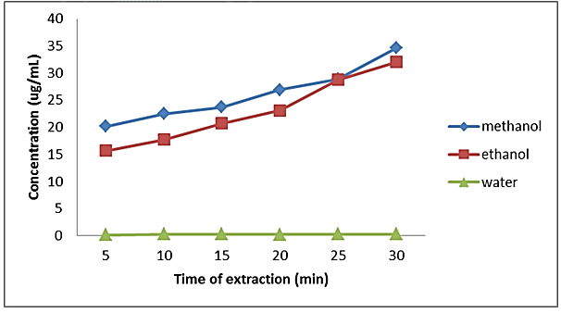

Figure 1. Concentration of chlorophyll-a against time of extraction at different solvents

Meanwhile, the highest yield of chlorophyll-b was extracted by using methanol as a solvent and followed by ethanol and water. After 30 minutes of extraction, the concentration of chlorophyll-b extracted by methanol was 6.82 µg/ml. While the concentration of chlorophyll-b extracted by ethanol and water was 6.08 µg/ml and 0.12 µg/ml respectively (Figure 2). Therefore, it clearly shows that methanol extracted the highest yield of chlorophylls compared to ethanol and water. The reason of these phenomena is because chlorophylls are readily soluble in alcohol, mostly insoluble in non-polar alkanes like butane and hexane, and has unique relationships with polar water, due to its polarity and the presence of ionic groups. Chlorophylls are basically composed of hydrocarbons, which are mostly insoluble in water.

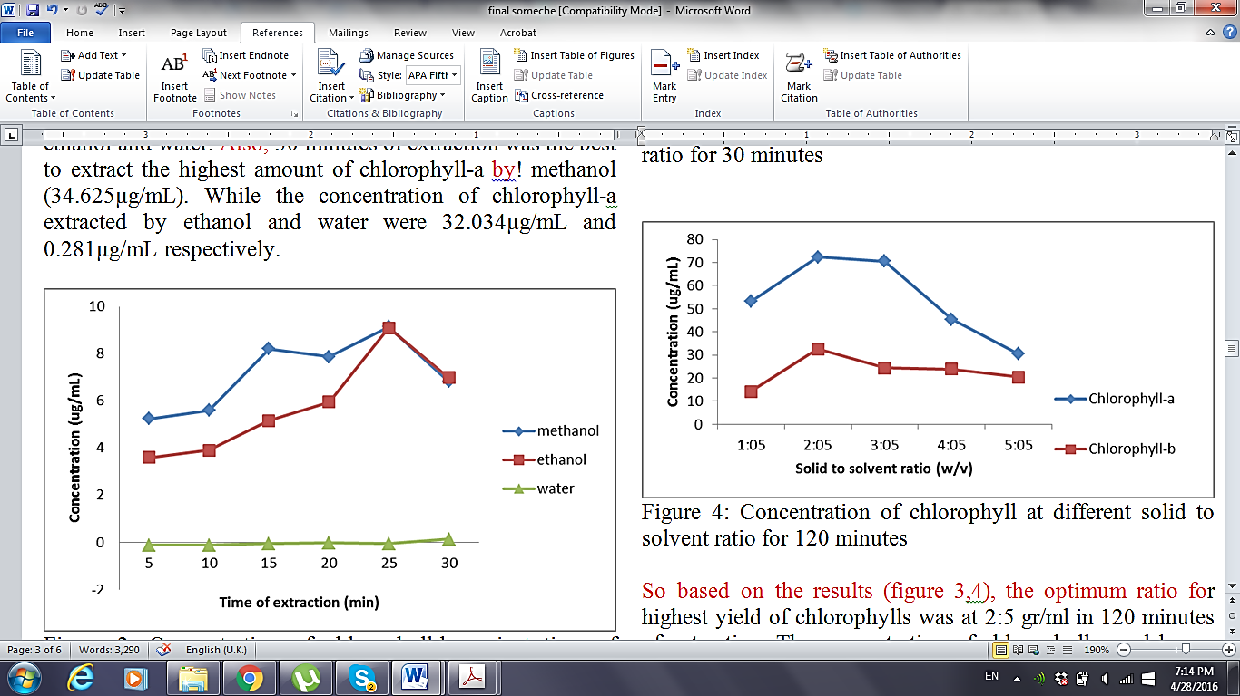

Figure 2. Concentration of chlorophyll-b against time of extraction of different solvent

Since the yield of chlorophylls were almost the same for ethanol and methanol extract, hence ethanol was chosen as solvent for the rest of experiments. This is because ethanol poses less threat to human consumption and health risks [21].

Effect of solid to solvent ratio
In this experiment, solid to solvent ratio was varied from 1:5 to 5:5 g/ml. The time of extraction was set to be at 30 minutes and 120 minutes. Figures 3 and 4 below shown the results obtained. As it is depicted in Figures 3 and 4, the optimum ratio for highest yield of chlorophylls was at 2:5 g/ml in 120 minutes of extraction. The concentration of chlorophyll-a and b was 72.32 µg/ml and 32.62 µg/ml respectively, while half of these amounts were extracted in 30 minutes. So, the result showed that the yield of chlorophylls doubled by increasing the time of extraction. The highest yield of chlorophylls at solid to liquid ratio of 2:5 mg/ml may be explained by the fact that at this ratio better mass transfer between sample and solvent occurs in comparison to other ratios.

Effect of extraction temperature
In this part, temperatures of extraction were varied from 40 to 80 ˚C at the constant solid to solvent ratio (2:5) and 30 minutes extraction time to find the optimum temperature. As it shows in Figure 5, the concentration of chlorophyll-a and b increase with respect to temperature from 41.47 µg/ml and 16.57 µg/ml to 84.78 and 77.63 µg/ml. At higher temperatures, plant cell wall, which is hydrocarbon chain and consists of phospholipid layer, breaks easier and the compounds in the leaf can leave the cell wall [22]. Higher temperatures also increase the solubility of sample in solvent and hence help to shorten the extraction time by increasing the mass transfer of solute into solvent. Based on the results, highest amount of chlorophylls was extracted at the 80 ˚C. The finding regarding the optimum temperature was consistent with the findings of other research such as Bucić-Kojić, et al. [23].

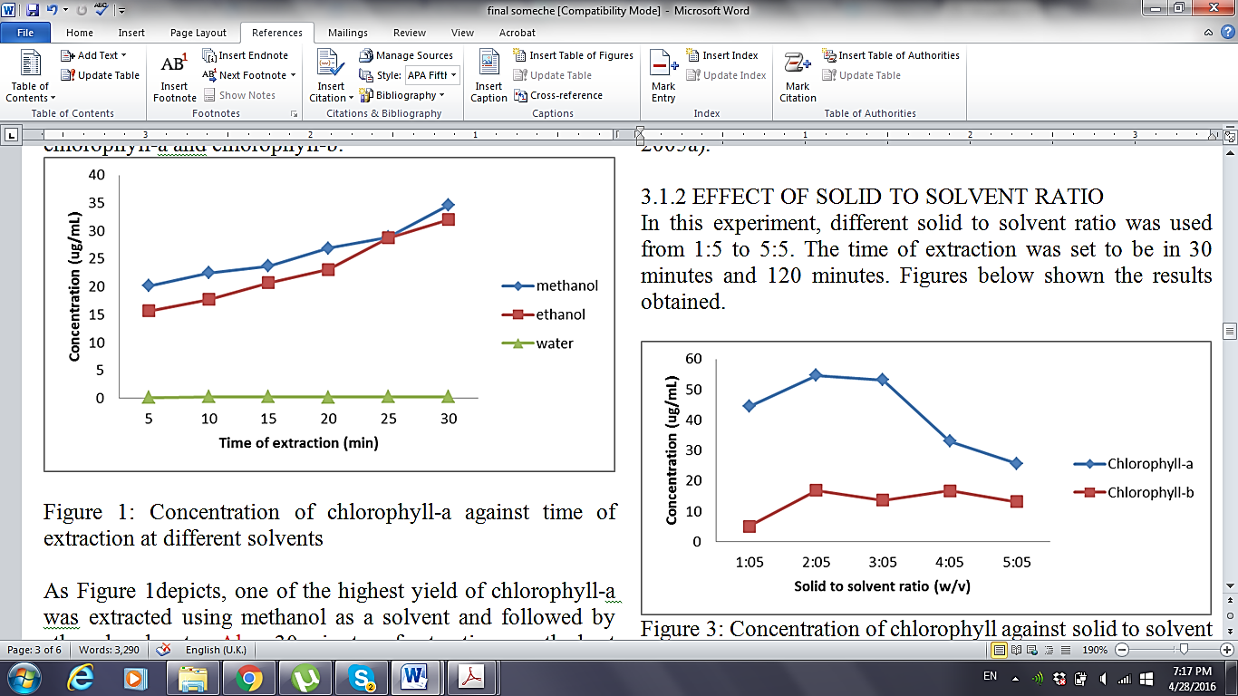

Figure 3. Concentration of chlorophyll against solid to solvent ratio for 30 minutes

Figure 4. Concentration of chlorophyll at different solid to solvent ratio for 120 minutes

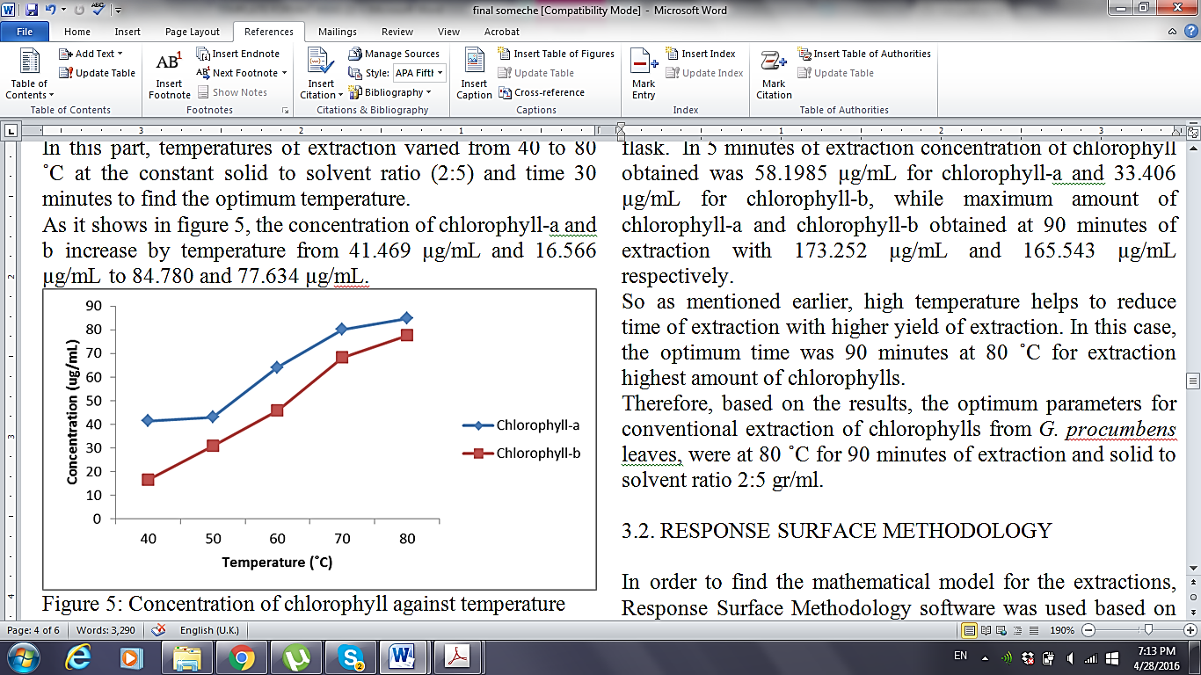

Figure 5. Concentration of chlorophyll against temperature

.

Effect of extraction time
In order to find the optimum time of extraction, constant amount of solid to solvent ratio and temperature was set at different times of extraction ranging from 5 to 120 minutes. Figure 6 shows results of concentration chlorophyll at constant temperature of 80 ˚C while the time of extraction was varied throughout the experiment. From the graph we can see that the concentration of chlorophyll increased as time of extraction increased. However, at 120 minutes of extraction the concentration decreased because the ethanol had vaporized totally and the mixture become dry in the conical flask. In 5 minutes of extraction concentration of chlorophyll obtained was 58.20 µg/ml for chlorophyll-a and 33.41 µg/ml for chlorophyll-b, while maximum amount of chlorophyll-a and chlorophyll-b obtained at 90 minutes of extraction with 173.25 µg/ml and 165.54 µg/ml respectively.

Thus as mentioned earlier, high temperature helps to reduce time of extraction with higher yield of extraction. In this case, the optimum time was 90 minutes at 80 ˚C for extraction highest amount of chlorophylls. Therefore, based on the results, the optimum parameters for conventional extraction of chlorophylls from G. procumbens leaves were at 80 ˚C for 90 minutes of extraction and solid to solvent ratio 2:5 g/ml.

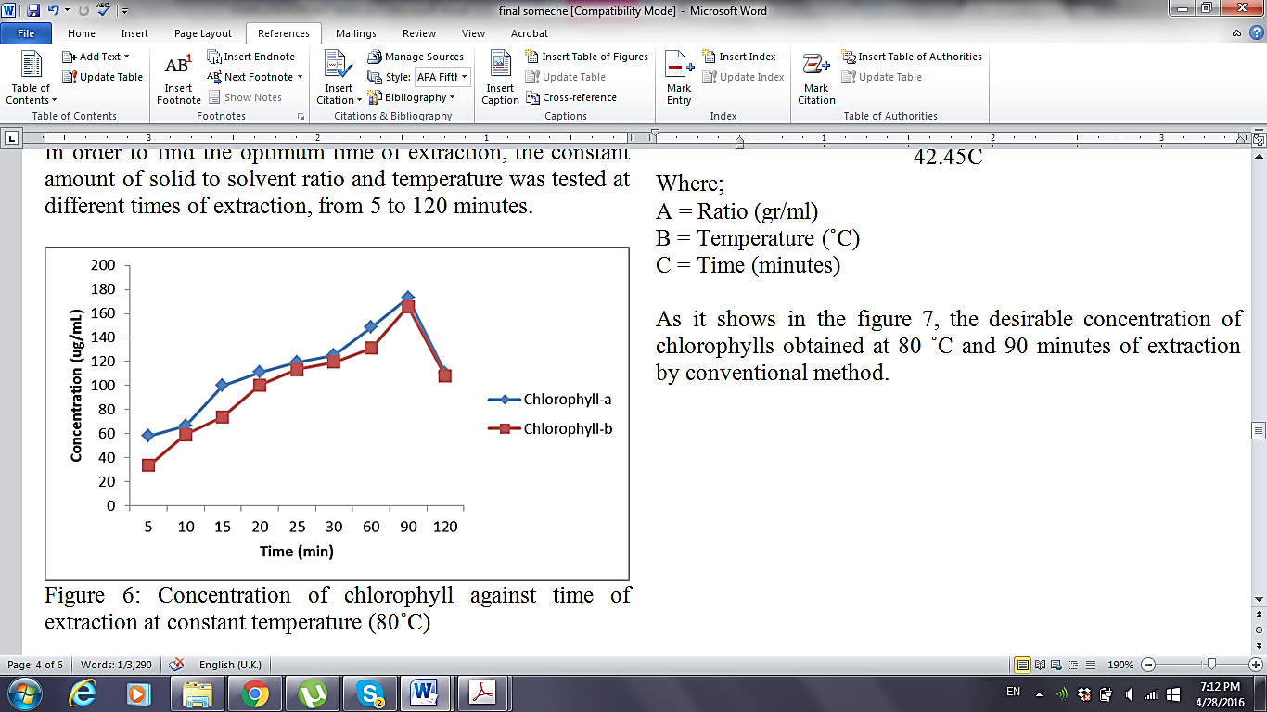

Figure 6. Concentration of chlorophyll against time of extraction at constant temperature (80˚C)

Response surface methodology

In order to find the mathematical model for the extractions, Response surface methodology software was used based on the obtained results for extraction of Chlorophylls at different solid to solvent ratio, temperature, and extraction time (three parameters). Central composite design and Box-Behnken design for historical data was used for each extraction method. Analysis of variance (ANOVA) was employed to evaluate the significance of each variable on the resulted model. Linear model was suggested for extraction of chlorophyll-a and chlorophyll-b by conventional method (equation 5 and 6).

Chlorophyll-a concentration = + 90.30 - 6.67A + 22.71B + 38.38C (5)

Chlorophyll-b concentration = + 19.21 + 6.05A + 31.83B + 42.45C (6)

where; A = Ratio (g/ml), B = Temperature (˚C) and C = Time (minutes)

As it shows in the Figure 7, the desirable concentration of chlorophylls obtained at 80 ˚C and 90 minutes of extraction by conventional method.

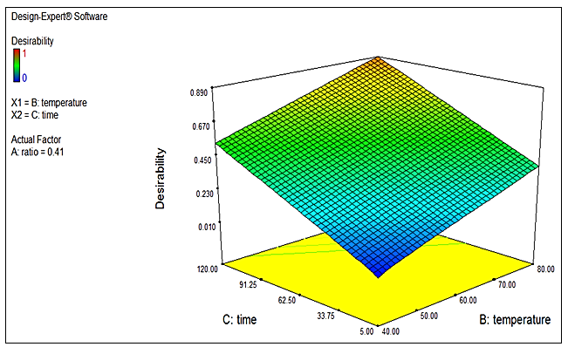

Figure 7. Desirability of concentration of chlorophyll for conventional extraction by optimization analysis

Gas chromatography-mass spectrometry analysis
The chemical compounds of ethanolic extracts obtained by solvent extraction from the leaves of Gynura procumbens were identified by GC-MS. The results showed five identified compounds. The identified compounds from solvent extraction sample were 2-hexenal, phenol, oleic acid, copaene and phytol. All the identified compounds are valuable and useful in medicine and they can be the reason of Gynura procumbens traditional medicinal usage, but further investigation is needed.

Conclusion
Based on the results, the highest yield of chlorophylls was extracted by conventional method at 80 ˚C with solid to solvent ratio of 2:5 mg/ml for 90 minutes. Also the samples extracted by conventional extraction method contained valuable compounds, which are useful in medicine. In short, the extract from leaves of Gynura procumbens has a promising medicinal potential and it can be used as a natural source of chlorophylls.

Acknowledgement
We would like to thank En Termizi Zakaria from Biochemical Engineering Laboratory for all his help.

References
- Abrika, O., Yam, M., Asmawi, M., Sadikun, A., Dieng, H. and Hussain, E. (2013). Effects of extracts and fractions of gynura procumbens on rat atrial contraction. Journal of Acupuncture and Meridian Studies, 6: 199 – 207
- Yesilada, E. (2005). Past and future contributions of traditional medicine in the health care system of the Middle-East. Journal of Ethnopharmacology, 100: 135 – 137.
- Stepp, J. R. and Moerman, D. E. (2001). The importance of weeds in ethnopharmacology. Journal of Ethno-pharmacol, 75: 19 – 23.
- Jiao, J., Gai, Q.-Y., Fu, Y.-J., Zu, Y.-G., Luo, M., Zhao, C.-J. and Li. C. Y. (2013). Microwave-assisted ionic liquids treatment followed by hydro- distillation for the e fficient isolation of essential oil from Fructus forsythiae seed. Separation & Purification Technology, 107: 228 – 237.
- Ng, H., Poh, T.-F., Lam, S.-K. and Hoe, S.-Z. (2013). Potassium channel openers and prostacyclin play a crucial role in mediating the vasorelaxant activity of Gynura procumbens. BMC Complementary Alternative Medicine, 13: 188 – 199 .
- Perry, L. (1980). Medicinal Plants of East and Southeast Asia. Cambridge: MIT Press.

- Lee, H.-W., Hakim, P., Rabu, A. and Abdullah Sani, H. (2011). Antidiabetic effect of Gynura procumbens leaves extracts involve modulation of hepatic carbohydrate metabolism in streptozotocin-induced diabetic rats. Journal of Medicinal Plants Research, 6(5): 796 – 812.
- Hoe, S. Z., Lee, C. N., Mok, S. L., Kamaruddin, M. Y. and Lam, S. K. (2011). Gynura procumbens Merr. Decreases blood pressure in rats by vasodilatation via inhibition of calcium channels. Clinics (Sao Paulo), 66(1): 143 – 150.
- Mahmood, A., Abdalbasit A., M., Fouad, A.-B. and Siddig Ibrahim, A.-W. (2010). Antiulcerogenic activity of Gynura procumbens leaf extract against experimentally-induced gastric lesions in rats. Journal of Medicinal Plants Research, 4(6): 685 – 691.
- Rosidah, Y., Sadikun, A., Ahmad, M., Akowuah, G. and Asmawi, M. (2009). Toxicology evaluation of standardized methanol extract of G. procumens. Journal of Ethnopharmacology, 123: 244 – 249.
- Chan, L., Lim, S. and Pan, L. (2009). Micropropagation of Gynura procumbens (Lour.) Merr. an important medicinal plant. Journal of Medicinal Plants Research, 3:105 – 111.
- Zhang, X. and Tan, B. (2000). Anti-diabetic property of ethanolic extract of Andrographis paniculata in streptozotocin-diabetic rats. Acta Pharmacology Sininca, 21(12):1157 – 1164.
- Zhang, X. and Tan, B. (2000). Effects of an ethanolic extract of Gynura procumbens on serum glucose, cholesterol and triglyceride levels in normal and steptozotocin-induced diabetic rats. Singapore Medical Journal, 41: 9 – 13.
- Ahmed Issa, I. and Bule, M. H. (2015). Hypoglycemic effect of aqueous and methanolic extract of Artemisia afra on alloxan induced diabetic swiss albino mice. Evidence-Based Complementary and Alternative Medicine, 2015: 1 – 5.
- Zurina, H., Mun, F. Y. and Mariam, A. (2010). Antidiabetic properties and mechanism of action of Gynura procumbens water extract in streptozotocin-induced diabetic rats, Molecules, 15: 9008 – 9023.
- Hojnik, M., Škerget, M. and Knez, Ž. (2007). Isolation of chlorophylls from stinging nettle (Urticadioica L.). Separation and Purification Technology, 57(1): 37 – 46.
- Kaewseejan, N., Puangpronpitag, D. and Nakornriab, M. (2012). Evaluation of phytochemical composition and antibacterial property of Gynura procumbens extract. Asian Journal of Plant Sciences, 11(2):77 – 82.
- Hew, C. and Gam, L. (2010). The identification of high abundant proteins in the leaves of Gynura procumbens. Biotechnology & Biotechnological Equipment, 24(4): 2132 – 2136.
- Bhore, S. J., Ravichantar, N. and Loh, C. Y. (2010). Screening of endophytic bacteria isolated from leaves of Sambung Nyawa (Gynura procumbens (Lour.) Merr.) for cytokinin-like compounds. Bioinformation, 5(5): 191–197.
- Guil-Guerrero, J. L., Rebolloso-Fuentes, M. M. and Isasa, M. T. (2003). Fatty acids and carotenoids from Stinging Nettle (Urticadioica L.). Journal of Food Composition and Analysis, 16(2): 111 – 119.
- Shi, L., Macinko, J., Starfield, B., Politzer, R., Wulu, J. and Xu, J. (2005a). Primary care, social inequalities, and all-cause, heart disease, and cancer mortality in U.S. Counties. American Journal of Public Health, 95: 674 – 680.
- Simon, E. (1974). Phospholipids and plantmembranepermeability. New Photologist, 73: 377 – 420.
- Bucić-Kojić, A., Planinić, M., Tomas, S., Jokić, S., Mujić, I., Bilić, M. and Velić, D. (2011). Effect of extraction conditions on the extractability of phenolic compounds from lyophilised fig fruits (Ficus carica L.). Polish Journal of Food and Nutrition Sciences, 61(3): 195 – 199.

