NEW PROCESS DEPROTENISED NATURAL RUBBER (PUREPRENA™): RAW RUBBER, PROCESSABILITY AND BASIC
PHYSICAL PROPERTIES

(Proses Baru Getah Asli Nyah Protein (Pureprena™): Getah Mentah, Kebolehprosesan dan Sifat Fizikal)

Rohaidah Abd Rahim*, Teku Zakwan Zaeimoedin, Ahmad Khairul Muhamad and Siti Salina Sarkawi

Malaysian Rubber Board,
Engineering & Technology Division, RRIM Research Station Sg. Buloh, 47000 Selangor, Malaysia

*Corresponding author: rohaidah@lgm.gov.my

Abstract
Malaysian Rubber Board has developed a new process deprotenised natural rubber (Pureprena™) by treating fresh natural latex with an industrial enzyme which hydrolyses all naturally-occuring proteins in the latex into water-soluble forms. Further research is carried out to determine the processability performance of Pureprena™ by Mooney viscometer, rubber process analyser and capillary rheometer. The Pureprena™ in bale form has low nitrogen, low ash and volatile matter contents as well as being lighter in color compared to commercial Standard Malaysian Rubber. The rheological results indicate that the Pureprena™ has a comparable rheological behavior with synthetic polyisoprene at low shear rate as determined by RPA and capillary rheometer curves. The measurement by viscometer confirms the rheological behavior at low shear rate. However, Pureprena™ has a faster mill breakdown rate compared to synthetic polyisoprene and SMR at 60 °C. All rubbers were compounded using the soluble efficient vulcanisation system especially for manufacturing engineering rubber products. It was found that Pureprena™ vulcanisate has comparable tensile strength, modulus, resilience and volume swelling in water compared to synthetic polyisoprene vulcanisate.

Keywords: deprotenised natural rubber, soluble efficient vulcanisation cure system, tangent delta, capillary rheometer, rubber process analyser

Abstrak
Lembaga Getah Malaysia telah membangunkan proses baru getah asli nyah protein (Pureprena™) dengan merawat getah asli segar menggunakan enzim perindustrian yang akan menghidrolisis semua protein semulajadi di dalam susu getah kepada bentuk larut-air. Penyelidikan lanjut dijalankan bagi menentukan prestasi kebolehprosesan Pureprena™ menggunakan viskometer Mooney, penganalisa proses getah dan reometer kapilari. Bandela Pureprena™ mempunyai kandungan nitrogen yang rendah, kandungan abu yang rendah dan kandungan jirim meruap serta warna yang lebih cerah berbanding getah komersial Getah Standard Malaysia. Keputusan reologi menunjukkan bahawa Pureprena™ mempunyai kelakuan reologi setanding dengan poliisoprena pada kadar ricih yang rendah dari ujian RPA dan keluk kapilari reometer. Pengukuran dari viskometer mengesahkan kelakuan reologi pada kadar ricih yang rendah ini. Walau bagaimanapun, Pureprena™ mempunyai kadar pecahan yang lebih pantas berbanding sintetik poliisoprena dan SMR pada suhu 60 °C. Penyebatian getah adalah menggunakan sistem pemvulkanan cekap larut khas bagi produk – produk getah kejuruteraan. Ia didapati bahawa Pureprena™ vulkanisat mempunyai kekuatan tensil, modulus, daya tahan dan pembengkakan dalam air yang setanding dengan vulkanisat sintetik poliisoprena.

Kata kunci: getah asli nyah protein, sistem pemvulkanan larut EV, tangen delta, reometer kapilari, penganalisa proses getah

Introduction
Rheological and processability properties of polymer melt are very important in processing of rubbers especially in extrusion and injection molding process due to the high shear rate and pressure involved during the process but are complicated by a number of factors such as flow rate, pressure and temperature. All these factors can affect the rheological properties of polymer and rubber melts [1, 2]. The rheology of polymer melts is considered to be one of the most important factors in determining the processability of a polymer especially for those which required good flow properties such as in calendaring, extrusion and moulding in tyre manufacturing process. Uniformity and consistency in the flow behaviour and processability of rubber are essential in providing the solution to the rubber industries in order to improve productivity, products quality and energy conservation [3]. Thus rubbers with good consistent flow and processability properties for extrusion process can improve productivity and product quality as well as reduce waste and rejects.

The new process deprotenised natural rubber (Pureprena™) has been produced through treating fresh natural latex with an industrial enzyme which hydrolyses all naturally-occuring proteins in the latex into water-soluble forms [4]. The rheological property of Pureprena™ was compared with Standard Malaysian Rubber (SMR), SMR CV which has been produced by Malaysian Rubber Board (LGM) and also synthetic polyisoprene. Both SMR grades of natural rubber were prepared from the same clonal of latex collected from the same field in Kota Tinggi Research Station, Kota Tinggi, Johor and then processed at LGM, Sg Buloh.

Therefore, this research is aim to evaluate the raw properties and processability performance of Pureprena™, SMR CV and synthetic polyisoprene in terms of raw and compound properties. Both rubbers were compounded based on a soluble efficient vulcanisation (EV) typical formulation.

Materials and Methods
Pureprena™ and SMR CV rubbers were produced by LGM. Synthetic polyisoprene, SK1-3 was supplied by Galin Enterprise. Zinc oxide, Permanax TMQ, sulphur, accelerator 1 and 2 were used as the compounding ingredients which act as activator, antioxidant, curing agent and accelerator respectively. Zinc-2-ethylhexanoate (ZEH) and Carbon black N774 were used as activator and filler purchased from Struktol and Cabot (Malaysia) Sdn Bhd., respectively.

Raw rubber properties
The raw rubber test was carried out according to Rubber Research Institute Malaysia (RRIM) internal procedure [5]. The testing were dirt content, ash content, volatile matter and nitrogen content. Ash and dirt content are a measurement of soluble and insoluble impurities in rubber. The presence of large amount of ash and dirt will affect the final rubber properties. Volatile matter determined moisture in raw rubber includes the amount of any material in the rubber which is volatile at 100 °C. A nitrogenous material in the rubber that occurs chiefly as proteins is determined through its nitrogen content. This parameter can provide an estimation of the protein content in the rubber even though it does not give a precise indication.

Processability of raw rubber
The processability study was carried out by using viscometer, Rubber Process Analyser (RPA) and capillary rheometer. The Mooney viscosity was known to be one of the instruments to measure the quality and processability of rubber by using Monsanto automatic Mooney viscometer (MV2000) at 100 °C conducted according to American Standard Testing Method (ASTM D 1646-06) [6, 7]. The viscosity was also measured after mill breakdown for 10 minutes. The effect of viscosity on high shear rate has been carried out by using capillary rheometer Rheograph 75. The capillary rheometer sample was collected after the raw rubber was passed through two roll mill for six times for homogenization and then sheeting out to 6 mm thickness. While for RPA study, the raw rubber in bale form was cut and determined based on frequency sweep mode at 100 °C, 7% strain and ranging of frequency from 0.1 to 20 Hz.

Preparation of compounds
The compounds used in this study are shown in Table 1. The compound with the soluble EV cure system were mixed in two stages in a Banbury internal mixer, BR1600 of capacity 1.6 liters at 70 rpm rotor speed and starting temperature of 70 °C and additives were added to the master batches by using a two-roll mill at roll temperature of 50 °C. Table 1 shows the formulation used throughout this study. For the evaluation of physical properties, all compounds were cured to their respective optimum cure time, t₉₅ at 150 °C by using compression moulding process.
Table 1. Typical formulation for soluble EV formulation

Ingredients | PHR
Rubber  N774 black  Zinc oxide  ZEH¹  Permanax TMQ²  Accelerator 1  Accelerator 2  Sulphur | 100  20  4  2  2  1.44  0.7  0.7
¹Zinc-2-ethylhexanoate, ²Polymerised 2,2,4-trimethyl-1,2-dihydroquinoline

Physical properties
All testing is done according to the International Organisation of Standardisation (ISO) procedure by using equipment available in the laboratory. The measurements are hardness (ISO 48), tensile properties (ISO 37), resilience (ISO 4662), compression set (ISO 815) and volume swelling (ISO 1817).

Results and Discussion
Raw rubber properties
The raw rubber properties were analysed and the data obtained are summarised in Table 2. It can be seen in Table 2 that Pureprena™ has a low dirt contents compared to synthetic polyisoprene rubber. Synthetic polyisoprene rubber which based on petroleum has low nitrogen content and volatile matter. A nitrogenous material in the rubber that occurs chiefly as proteins is determined through its nitrogen content. This parameter can provide an estimation of the protein content in the rubber. Result indicates that synthetic polyisoprene rubber has slightly lower protein level. It confirms that deprotenised process brings down the nitrogen content and also produced clean rubber compared to SMR rubber.

Table 2. Raw rubber properties

Property | Pureprena™ | Synthetic polyisoprene | SMR
Dirt retained on 44um aperture sieve (% wt, max) | 0.003 | 0.015 | 0.008
Ash content (%) | 0.14 | 0.26 | 0.12
Nitrogen content (% wt, max) | 0.07 | 0.04 | 0.38
Volatile matter (%wt, max) | 0.12 | 0.015 | 0.23

Mooney viscosity determination
Table 3 shows the Mooney viscosity (V_{R}) of the rubbers measured by MV2000 at temperature of 100 °C. The results show all rubbers exhibited comparable viscosity at 78.5 ± 1.5 MU. These Mooney viscosity results are in agreement with the viscosity results obtained from RPA discussed above which show that the rubbers did not show a significant difference in viscosity at low shear rate.

Table 3. Mooney viscosity of rubber

Rubber | Mooney viscosity,  ML(1+4)@100 °C, MU
Pureprena™ | 79
Synthetic polyisoprene | 77
SMR | 80

The effect of viscosity after mastication for 30 minutes showed in Figure 1. It can be seen that Pureprena™ exhibited lower viscosity for all tested time which indicates of easier processing even though, all rubbers have a similar initial viscosity.

Viscosity determination by RPA at low shear rate
The effect of shear rate on viscosity determined by RPA is showed in Figure 2. At low shear rate (0.05 – 9sec⁻¹) Pureprena™ , synthetic polyisoprene and SMR exhibited comparable viscosity. This confirms the viscosity behavior as measured by viscometer in Table 3.
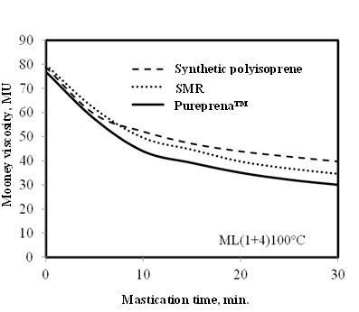

Figure 1. Mill breakdown viscosity of raw rubber determined using viscometer

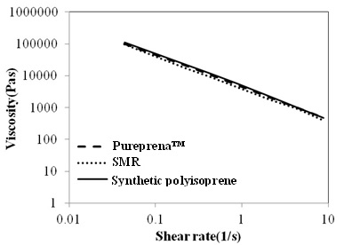

Figure 2. Viscosity responses from frequency sweep of rubbers at 7% strain at temperature of 100 °C

Tan delta and elastic modulus determination
The processability characteristics of rubbers can also be assessed by the results of tan delta and elastic torque properties obtained from RPA test. For this test, the values and trend of tan delta and elastic torque with variation in the applied frequency (Hz) was studied. Although the frequency was set from 0.1 to 20 Hz, due to the limitation of the instrument, the actual shear rates applied during the RPA testing was still considered very low that is less than 25 sec⁻¹ as compared to those obtained by using capillary rheometer (> 10,000 sec⁻¹). It is known that, the higher the tan delta value the better the processability of the rubber and vice versa [8]. It can be seen in Figure 3 that Pureprena™ and synthetic polyisoprene exhibited no significance difference in tan delta at low frequency and become significance as the frequency increased. The higher tan delta value for Pureprena™ indicates better processability than synthetic polyisoprene.
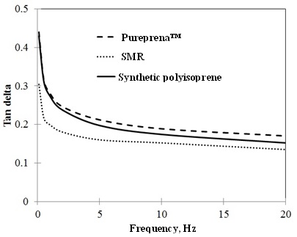

Figure 3. Tan delta response from frequency sweep of rubbers at 7% strain at temperature of 100°C

The elastic torque is the rotational force needed to deform the rubber shape. Normally, high values in elastic torque indicates poor processability of rubber and high energy is needed in its processing due to its high elastic property. As can be observed from the RPA results on raw rubbers as shown in Figure 3 Pureprena™ exhibits lower tangent delta for the range of shear rates tested as compared to synthetic polyisoprene. This is also due to lower elastic modulus of Pureprena™ compared to synthetic polyisoprena as seen in Figure 4.

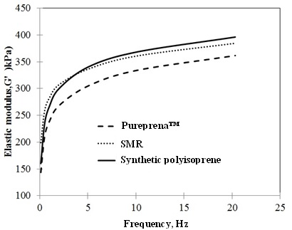

Figure 4. Elastic modulus response from frequency sweep of rubbers at 7% strain at temperature of 100 °C

Viscosity determination by capillary rheometer
The viscosity test was conducted using the capillary rheometer at 100 °C test temperature and employing high shear rates ranging from 100 to 100000 shear rate to study the actual flow behavior of rubbers when shear rate is increased. Viscosity is a measure of the resistance of a fluid (polymer) which is being deformed by shear stress. Low viscosity values indicate good processability and vice versa. For the viscosity results of raw rubber as shown in Figure 5, it can be observed that all rubbers possess comparable viscosity at low shear rate. However, at high shear rate, synthetic polyisoprene exhibits a lower viscosity curve as compared to Pureprena™ and SMR rubber. Due to its lower viscosity results, it can be deduced that synthetic polyisoprene has lower resistance to flow and hence better flow properties compared to Pureprena™ and SMR rubber.

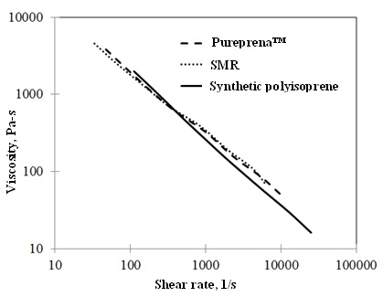

Figure 5. Viscosity of raw rubber determined using capillary rheometer

Basic physical properties of soluble EV vulcanisates
The Pureprena™ and SMR CV compounds were cured at temperature of 150 °C for 12 minutes at cure rate of 2.7 and 2.4 dNm/min, respectively. While, synthetic polyisoprene compound was cured at temperature of 150 °C for 18 minutes at cure rate of 1.6 dNm/min. The basic physical properties of the vulcanisates are shown in Table 4. It was observed that the Pureprena™ and synthetic polyisoprene exhibits almost similar tensile strength, hardness, modulus at 100% elongation, resilience and volume swelling in water. However, Pureprena™ exhibit slightly poor elongation at break and recovery behavior compared to synthetic polyisoprene. The Pureprena™ and SMR exhibited comparable basic physical properties.

Table 4. Basic physical properties of vulcanisates (cured to t₉₅ at 150 °C)

Property | Pureprena™ | Synthetic polyisoprene | SMR
Hardness, IRHD, 23°C | 42 | 40 | 41
M100, MPa | 0.82 | 0.83 | 0.81
M300, MPa | 2.60 | 2.52 | 2.59
Tensile strength, MPa | 24.29 | 22.64 | 26.10
Elongation at break, % | 700 | 730 | 700
Dunlop resilience, % at 23 °C | 84 | 84 | 85
Compression set, % at 22h/70 °C | 12 | 5 | 11
Swelling in water, Vol. change, %
168h/RT | 0.1 | 0.2 | 0.4
72h/100°C | 1.7 | 1.5 | 3.8

Conclusion
From the observations and results obtained in this study it showed that deprotenised process brings down the nitrogen content, dirt and volatile matter in the natural rubber. It also found that the new process deprotenised natural rubber produced a low dirt and ash contents compared to synthetic polyisoprene rubber. The RPA study determined that Pureprena™ exhibits better processability compared to synthetic polyisoprene through their higher tangent delta and lower elastic modulus at low shear rate. However, at high shear rate as measured by capillary rheometer, synthetic polyisoprene displayed slightly low viscosity that assumed to be better flow behaviour for the subsequent process. The Pureprena™ and synthetic polyisoprene vulcanisates exhibits comparable basic physical properties such as tensile strength, hardness, modulus at 100% elongation, resilience and water immersion.

Acknowledgement
The authors would like to thank the Management of Malaysian Rubber Board for permission to publish this paper. The assistance from staff of the Silica Dispersion Technology for Green Tyres Programme (GT) for samples preparation, mixing and processability test are gratefully acknowledged.

References

- Brydson, J. A. (1981). Flow properties of polymer melts. 2nd Ed., George Godwin Ltd, London.
- Wood, A. K., Read, A. G. G., Lovegrove, J. G. A. (1989). Effect of rheometer design on the measurement of the flow properties of polymer melts. Plastics and Rubber Processing and Applications, 12(1): 15 – 20.
- Rohaidah, A. R. and Teku, Z. Z. (2010). Processability, rheological and physical properties of new process natural rubber. Malaysian Science and Technology Congress, Crystal Crown Hotel, Petaling Jaya, Selangor.
- Muhamad, A. K., Nur Hidayaty, K. and Zairossani, M. N. (2008). Blue-print for Pureprena Production. Engineering & Technology Division, Malaysian Rubber Board.
- Tong, N. Y. (1992). RRIM test method for standard Malaysian rubbers in SMR Bulletin No. 7 Revised Edition 1992. Rubber Research Institute of Malaysia.
- Cantaloube, B. and Cocard, S. (2004). Revisiting the rheological characterisation of NR using Mooney Viscometer. KGK Kautschuk Gummi Kunststoffe, 57(4): 168 – 171.
- ASTM 1646 – 06, Test method for rubber – viscosity, stress relaxation and prevulcanisation characteristics (Mooney Viscometer).
- Teku, Z. Z., Rohaidah, A. R. and Che Su, M. S. (2011). Rheological and processability properties of new process natural rubber (NPR) for tyre application. Malaysian Rubber Technology Development (MRTD), 11: 3 – 16.

