

MALAYSIAN JOURNAL OF ANALYTICAL SCIENCES
ISSN 1394 - 2506

Published by The Malaysian Analytical Sciences Society

EFFECT OF pH ON THE PHYSICOCHEMICAL PROPERTIES AND REDUCIBILITY OF MoVTeNbOx CATALYSTS

(Kesan pH Terhadap Sifat Fizikokimia dan Kebolehturunan Mangkin MoVTeNbOx)

Syazwani Mohd Noor¹, Irmawati Ramli^{1,2}*, Taufiq Yap Yun Hin^{1,2}, Norhazlin Zainuddin²

¹Centre of Excellence for Catalysis Science and Technology, Faculty of Science
²Department of Chemistry, Faculty of Science
Universiti Putra Malaysia, 43400 UPM Serdang, Selangor, Malaysia

*Corresponding author: irmawati@upm.edu.my

Received: 17 August 2015; Accepted: 25 August 2016

Abstract
A range of MoVTeNbOx catalysts were synthesised by slurry method assisted with a microwave irradiation. The pH of the synthesis solution was varied at pH = 1, 3, 5, and 7 and the obtained solid were calcined in air at 553 K for 1 hour and followed in N₂ at 873 K for 2 hours. The calcined samples were characterised and their reduction properties were evaluated. The pH of the synthesis solution was shown to affect the physicochemical properties where the formation of orthorhombic M1 phase was obtained for catalysts prepared at pH 1 and 3. The reducibility of the catalyst is improved for catalyst prepared at pH 3 as compared to those prepared at pH 1. Although higher synthesised pH (5 and 7) gave much higher reducibility of the metal oxides, however the removable oxygen could be of the unselective ones.

Keywords: MoVTeNbOx catalysts, pH, reducibility, propane, acrylic acid

Abstrak
Satu siri mangkin MoVTeNbOx telah disintesis menggunakan kaedah buburan dibantu oleh radiasi gelombang mikro. Nilai pH bagi larutan sintesis telah dikaji pada pH = 1, 3, 5, dan 7 dan pepejal yang diperolehi telah dikalsin dalam udara pada 553 K selama 1 jam dan diikuti dalam nitrogen pada 873 K selama 2 jam. Sampel terkalsin telah dicirikan dan sifat kebolehturunan telah dikaji. Di dapati, pH bagi larutan sintesis memberi kesan kepada ciri fizikokimia di mana pembentukan fasa ortorombik M1 telah terjadi bagi mangkin yang disediakan pada pH 1 dan 3. Kebolehturunan mangkin ini dipertingkatkan bagi mangkin yang disediakan pada pH 3 berbanding yang disediakan pada pH 1. Walaupun mangkin yang disediakan pada pH yang lebih tinggi (5 dan 7) memberikan kebolehturunan logam oksida lebih tinggi, namun penyingkiran oksigen mungkin menjadi tidak selektif.

Kata kunci: mangkin MoVTeNbOx, pH, kebolehturunan, propana, asid akrilik

Introduction
MoVTeNbOx is a quaternary mixed metal oxide catalyst consists of four different elements which are molybdenum, vanadium, tellurium and niobium. The catalyst is reportedly the most effective catalyst system for the vapour phase catalytic oxidation of propane to form acrylic acid [1-6]. It is because the catalyst contains necessary active sites which is fundamental in propane oxidation [7]. The active MoVTeNbOx system possesses two crystalline phases which are orthorhombic M1 phase, Te₂M₂₀O₅₇ (M = Mo, V, Nb), and hexagonal M2 phase, Te_{0.33}MO_{3.33} (M = Mo, V, Nb) [8]. The significant difference exists among these two phases is that the M1 phase contains V⁵⁺ centres, as an agent for propane activation [4, 7]. Meanwhile, M2 is incapable of activating propane, but it does convert propylene. Figure 1 suggested the reaction pathway in oxidation of propane to acrylic acid. For the reaction to occur successfully, the catalyst need at least three important active sites. The first site is a V-Mo-O phase for the activation of propane. After hydrogen is successfully abstracted from propane to form propene, a second site which is a Te-Mo-O phase is needed to oxidise propene into aldehyde. Finally, a third site, a V-Mo-O phase is needed for another oxygen insertion to convert aldehyde into acrylic acid. It is recognized that the V⁵⁺ ion activates alkane by first H abstraction and followed by second H abstraction to produce the allylic radical before the insertion of oxygen [9].

It has been reported that the synthesis parameters affect the properties of the final catalyst. In this context the pH of synthesis solution is of high importance because the chemical composition and phase formation depend closely on it [10-12]. The catalyst precursors suggest the presence of Anderson-type heteropolyanion, (NH₄)₆TeM₆O₂₄.nH₂O in the samples prepared at pH > 3 and favouring the formation of amorphous materials at pH < 3 [12]. The acidity of the catalyst’s surface was suggested to affect the binding and reactivity of propene molecules which possess a basic character [13]. Higher synthesis pH promotes the formation of MoO₃ after heat treatment, which is known to be inactive in propane oxidation [10]. The heat-treated (873K in a N₂ stream) samples from precursors prepared at lower pH suggests the presence of Te₂M₂₀O₅₇, Te_{0.33}MO_{3.33} (M = Mo, V, Nb) and Mo_{5−x}(V/Nb)_{x}O₁₄ crystalline phases which possibly involved in the active and selective alkane activation to acrylic acid [12].

CH₃-CH₂-CH₃

CH₂=CH-CH₂•--H

H--CH₂•-CH=CH₂

CH₂=CH-CHO

CH₂=CH-COOH

- [H]

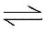

+ [O]

Figure 1. Reaction pathway in oxidation of propane to acrylic acid

In the present work, the MoVTeNbOx catalysts were prepared by using a slurry method assisted with microwave irradiation. During the synthesis, the pH of the solution was varied and its effect on the physicochemical properties and reducibility were studied.

Materials and Methods
Catalyst preparation
Mo_{1.0}V_{0.3}Te_{0.23}Nb_{0.12}O_{x} catalysts were prepared by a slurry method followed by microwave irradiation according to the patented procedure [14].

Commercial chemicals which were ammonium heptamolybdate tetrahydrate, (NH₄)₆Mo₇O₂₄.4H₂O (Merck), ammonium metavanadate, NH₄VO₃ (Merck), telluric acid, Te(OH)₆ (Sigma-Aldrich) and ammonium niobium oxalate, (NH₄)₂Nb₂(C₂O₄)₅ (Sigma-Aldrich), were used as the sources for Mo, V, Te and Nb respectively. The microwave used in this study was the conventional Panasonic microwave model no. NN-S554WF (750 W).

The synthesis process begun by dissolving ammonium heptamolybdate tetrahydrate in a 15 ml of irradiated deionised H₂O. The solution was irradiated before ammonium metavanadate was added. The solution was then irradiated, followed by the addition of telluric acid. The irradiated ammonium niobium oxalate solution was added to the MoVTe suspension that were separately prepared using ammonium niobium oxalate dissolved in 5 ml of deionised H₂O. Finally, the resulting orange slurry formed were irradiated for 3 min. The pH of resultant slurry precursor was recorded with the value of 4.5 (±0. 01) using Thermo-line PHS-3BW digital pH meter.

The pH of the final slurry was adjusted by using 1 M aqueous sulphuric acid for pH range 1 to 3 and 1 M of an aqueous ammonium hydroxide for pH 5 to 7. Then, the solution was left overnight and later dried using a rotary evaporator at 353 K. These samples were denoted as MVTN_{1p}, MVTN_{3p}, MVTN_{5p}, and MVTN_{7p} respectively.

The precursor samples were later calcined for 1 h in air at 553 K to remove the organic substances and followed by 2 h in the N₂ stream at 873 K to control the phase formation of the catalyst. These samples were denoted as MVTN_{1c}, MVTN_{3c}, MVTN_{5c}, and MVTN_{7c} respectively.

Catalyst characterisation
All the catalysts were characterised by the following analytical techniques. Powder X-ray diffraction patterns were collected by using a Shimadzu Model XRD 6000 Diffractometer equipped with CuK_{α} radiation with wavelength, λ= 1.542 Å which were continuously scanned in the range of 2θ = 2° - 60° at a scanning rate of 2° min⁻¹. Induced coupled plasma-atomic electron spectroscopy (ICP-AES) measurements of bulk MoVTeNbOx compositions were carried out using a model Perkin Elmer Emission Spectrometer Plasma 1000. Fourier Transform Infrared Spectroscopy (FTIR) were analysed using a Perkin Elmer 1725X spectrometer by employing the standard KBr method and the spectra were recorded in the 400 cm⁻¹ to 4000 cm⁻¹ regions. Field emission-scanning electron microscopy (FESEM) images were collected using Nova 200 NanoLab at an accelerating voltage of 5.0 kV. The aluminium stud was used with the carbon paint was tapped on the sample and coated with gold.

Reducibility study
Temperature programmed reduction in hydrogen (H₂-TPR) analysis was carried out by using ThermoFinnigan TPDRO 1110 Instrument. Before subjecting the catalyst to a reducing environment, it was pre-treated under a N₂ flow by heating sample to 423 K at a heating rate of 10 K min⁻¹. After which, the nitrogen gas was switched to hydrogen (5 % H₂ in Argon) and temperature programming up from 323 K to 1223 K at a heating rate of 10 Kmin⁻¹. The amounts of water, H₂O which was produced was flowed through the thermal conductivity detector.

Results and Discussion
Physicochemical properties of MoVTeNbOx catalysts
The XRD patterns of four precursors prepared at different pH are shown in Figure 2. At pH 1, there are no visible peaks due to metal oxide crystal phase can be observed. The MVTN_{1p} displays two humps at 2θ = 6°- 15° and 21° - 35° which reckons that the sample is amorphous due to randomly distributed of atoms in the solid particles [15]. As the pH of synthesis solution increases, the metal oxide peaks become apparent. All of the other three samples (MVTN_{3p}, MVTN_{5p}, and MVTN_{7p}) exhibited sharp peaks at 2θ = 10.3°, 12.5°, 13.1°, 16.0°, 18.1°, 23.2°, 25.0° and 27.8° suggesting the orderly arranged of the atoms. The peaks suggested the presence of Anderson-type heteropolyanion (NH₄)₆TeMo₆O₂₄.7H₂O and/or (NH₄)₇TeMo₅VO₂₄.8H₂O [15, 16]. A similar case has been reported, whereby an Anderson-type heteropolyanion, (NH₄)₆TeMo₆O₂₄.nH₂O was formed in samples prepared at pH 3.0– 4.5 whereby at pH < 3 the heteropolyanion partially decomposed with the formation of mostly amorphous materials and at a very low pH 1.0–1.5 indicates the present of polyoxovanadates in the precursors [12]. Therefore, as observed in this work at low pH the crystallinity of heteropolyanion compounds decreases and amorphous materials are observed due to the partial incorporation of heteroatoms or the heteroatoms are highly dispersed on the compounds. The results show that pH influences the incorporation of heteroatoms (V and Nb) on heteropolyanion which determines the formation of active crystalline phases.

The XRD patterns of calcined samples are shown in Figure 3. The peaks evolved for samples synthesised at pH 1 and 3 i.e. MVTN_{1c} and MVTN_{3c}, respectively suggests the presence of orthorhombic M1 and hexagonal M2 phases. The presence of both phases can be clearly indicated by 2θ = 6.6°, 7.9°, 9.0°, 22.1° and 45° which correspond to orthorhombic M1 (JCPDS: 58-790) meanwhile 2θ = 22.1°, 28.3°, 36.2° and 50° correlate to hexagonal M2 phase (JCPDS: 57-1099). On the other hand, the two other samples which are MVTN_{5c} and MVTN_{7c} synthesised at pH 5 and 7 respectively, show the occurrence of hexagonal M2 phase and the additional peaks at 2θ = 7.7°, 8.9°, 22.1°, 24.2° and 31.3° which can be correlated to the existence of tetragonal phase, (V_{0.07}Mo_{0.93})₅O₁₄ (JCPDS: 31-1437).

Figure 2. XRD patterns of precursor MoVTeNbOx catalysts (a) MVTN_{1p} (b) MVTN_{3p} (c) MVTN_{5p} (d) MVTN_{7p}

Figure 3. XRD patterns of calcined MoVTeNbOx catalysts (a) MVTN_{1c} (b) MVTN_{3c} (c) MVTN_{5c} (d) MVTN_{7c} [23].
It can be noted that orthorhombic M1, hexagonal M2 and tetragonal phases have the same diffraction peak of 22.1° which suggests that the mixture of phases in the samples [15]. The formation of these phases may be due to the formation of pseudo-amorphous or semi crystalline Anderson-type compound (ammonium containing phase) which has been observed during precursor stage [17].

The crystallite size of the calcined MoVTeNbOx catalysts can be determined by using the full width half maximum (FWHM) for three characteristic peaks of orthorhombic M1 phase at 2θ = 6.6°, 7.9°and 9.0°. The crystallite size was estimated by the using the Debye Scherrer equation as in (1).

$\text{t =}\frac{\text{0.9}\text{λ}}{{\text{β}}_{\text{hkl}}{\text{cos}{\text{θ}}}_{\text{hkl}} }$ (1)

where, t = crystallite size, λ = 1.5438 Å, θ = Bragg angle, β _{hkl} = the full width at half maximum (FWHM) of the peak in radian.

The value of crystallite size in Table 1 suggested that the crystallite size of the MVTN_{1c} and MVTN_{3c} samples are 35.12 nm to 36.42 nm respectively. The values are in the nanometer range, which gives a good indication of the pH influence on the catalyst particle size. However, there is no orthorhombic phase were present in MVTN_{5c} and MVTN_{7c}, therefore particle size for these samples were not calculated.

Table 1. Crystallite size and bulk composition of MVTN_{1c}, MVTN_{3c}, MVTN_{5c} and MVTN_{7c}
Sample | 2θ (°) | FWHM (°) | t  (nm) | Bulk composition¹  (Mo: V: Te: Nb)
MVTN_{1c} | 6.5 | 0.2005 | 39.8 | 1.0: 0.29: 0.17: 0.10
 | 7.7 | 0.2825 | 28.2
 | 8.6 | 0.2137 | 37.4
 |  |  | Average: 35.12
MVTN_{3c} | 6.6 | 0.2445 | 32.6 | 1.0: 0.29: 0.17: 0.09
 | 7.7 | 0.2550 | 31.3
 | 8.9 | 0.1760 | 45.4
 |  |  | Average: 36.42
MVTN_{5c} | NA² |  |  | 1.0: 0.29: 0.17: 0.09
MVTN_{7c} | NA² |  |  | 1.0: 0.29: 0.17: 0.09
Preparative composition of Mo: V: Te: Nb = 1.0: 0.3: 0.23: 0.12, ¹Determined by ICP-AES, ²NA: Not applicable

The bulk compositions of Mo-V-Te-Nb mixed oxide catalysts determined by ICP-AES are summarised in Table 1. The bulk compositions of all the oxides were not so different from the preparative compositions. The Mo element is justified in all samples as Mo is the main component in the mixture. For all samples, the V element obtained which is 0.29 are closely resemble to the theoretical value of 0.3. The molar ratio of the Mo and V element are important in the catalyst system because these elements are responsible for the structural formation of the MoVTeNbOx catalysts and M1 phase will be formed with Mo:V ratios higher than 0.14 [6,18].

The difference is found in the tellurium contents which were slightly lower in the bulk. A possible explanation for the loss of tellurium could be related to the presence of oxalate anions (reducing agent) from the starting material of niobium oxalate, which could facilitate the reduction of tellurium cations to metallic Te [19] that were detached away from the structure during calcination. The Nb content is also found lower after calcination in all samples. It has been reported that Nb play the same structural role as vanadium in order to obtain the mono-phasic orthorhombic M1 structure [20]. In the case of the catalyst in this work, the condition of lower amount of Nb gave MoVTeNbOx catalysts containing several phases as has been observed in the XRD analysis. Still, the presence of Nb despite of its amount is important for the stability of the element in the solid structure.

The FTIR spectra of the precursors are shown in Figure 4. The bands around 3178 cm⁻¹ and 1441 cm⁻¹ are due to the symmetric and asymmetric stretching vibrations of the tetrahedral ammonium cation [16]. The H–O–H bending mode is observed in the range 1668 cm⁻¹ and bands at 1301 cm⁻¹ could be attributed to stretching and vibration modes of C=O, a stretching combination of C–O and C–C associated with the oxalate anion [15]. Meanwhile, the absorption band at 1101 cm⁻¹ is discovered to only exist in sample MVTN_{1p} that can be related to the S=O stretching [21]. This is caused by the presence of sulphate group while incorporating H₂SO₄ during pH adjustment of precursor solution. In this case, only two samples required H₂SO₄ during pH adjustment, which are MVTN_{1p} and MVTN_{3p}. However, this peak only intense for MVTN_{1p} and almost unnoticeable for MVTN_{3p}. This is due to the reason that the pH of the solution before adjustment was around pH 4.3, so only little amount of H₂SO₄ ions present in the MVTN_{3p} solution, compared to MVTN_{1p}. In addition, the sharp peak detected around 884 cm⁻¹ corresponds to no vibrations and bands around 623 cm⁻¹ can be due to the Mo-O, Te–O and Mo–O–Te vibrations, since the different bands of these vibrations overlapped in this range [16]. The stretching of V=O group and V-O-Me (Me= Mo, Te, Nb) gave the absorption band around 449 cm⁻¹.

Figure 4. FTIR spectra of precursor MoVTeNbOx catalysts (a) MVTN_{1p} (b) MVTN_{3p} (c) MVTN_{5p} (d) MVTN_{7p}

For the calcined samples, there are no bands observed in the region above 1000 cm⁻¹ as can be seen in Figure 5, therefore it is sufficient to show spectra of low frequency region [15]. The disappearance of the high frequency region above 1000 cm⁻¹ indicates that all of the organic species functional groups such as hydroxyl, sulphate, ammonium and water are completely removed from the samples during calcination. The band at 861 cm⁻¹ and 699 cm⁻¹ are assigned to asymmetric stretching vibrations of bridging Mo-O-M bonds (M = Mo, Nb, Te) [12] which lies in the range of 800 – 1000 cm⁻¹. The bands around 530 cm⁻¹ and 431 cm⁻¹ can be assigned to V = O group and V-O-Me bonds (M = Mo, Te, Nb) in the range of 400 – 600 cm⁻¹ [16].

Figure 5. FTIR spectra of calcined MoVTeNbOx catalysts (a) MVTN_{1c} (b) MVTN_{3c} (c) MVTN_{5c} (d) MVTN_{7c}

The morphology of calcined catalysts was investigated by FE-SEM analysis. The images are shown in Figure 6. The micrographs display the formation of rod-shaped morphology in all of the samples. This kind of morphology is similar to the reported works [20, 22]. The formation of a rod-shaped morphology could be due to V⁵⁺ derived from ammonium metavanadate in the synthesis step which contribute to the formation of long and large needles during the slurry synthesis [22]. For catalyst synthesised at pH 1, it gives a more homogeneous and rather disperse particles as compared to catalysts prepared at higher pH. Not to be denied is the presence of other shaped particles, thus stating the mixture of phases in accordance with the XRD patterns which showed mixed phase of the calcined catalyst [12].

Reducibility properties
The study on the catalyst reducibility is important in a mixed metal oxide catalyst used for the oxidation reaction. It will give an indication of the availability of the oxygen for insertion into reactants. During the reduction process, hydrogen gas is in contact with the oxygen species from the surface of the catalyst. The hydrogen is consumed and formed water vapour in the gaseous state as a product, leaving an oxygen vacancy on the catalysts. The interaction of the gas phase hydrogen with catalyst can be represented as in equation (2).

${{\text{H}}_{\text{2}}}_{\left(\text{g}\right)}\text{+ }{\text{O}}_{\left(\text{surface}\right)} {{\text{H}}_{\text{2}}\text{O}}_{\left(\text{g}\right)}\text{+ □}$ (2)

where (g) = gaseous species, (s) = surface or lattice species and □ = oxygen vacancy.
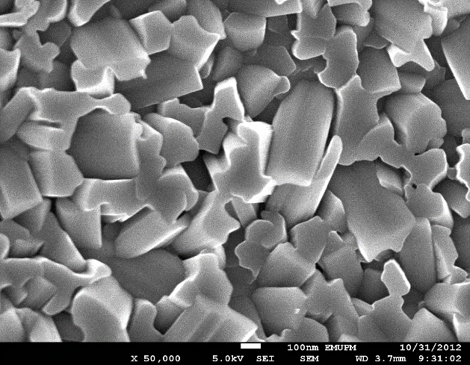
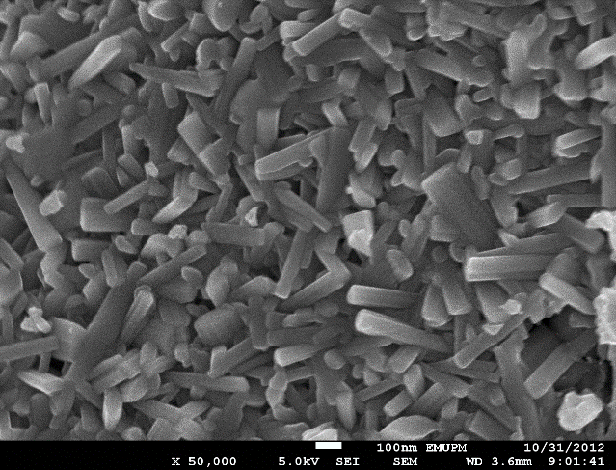
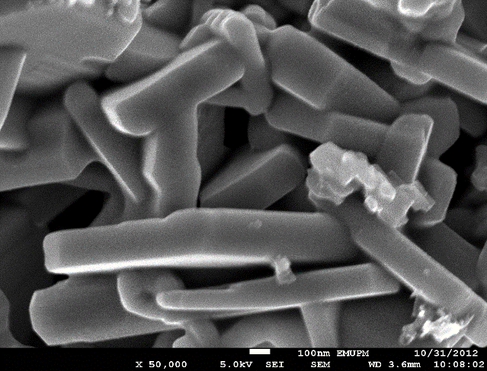
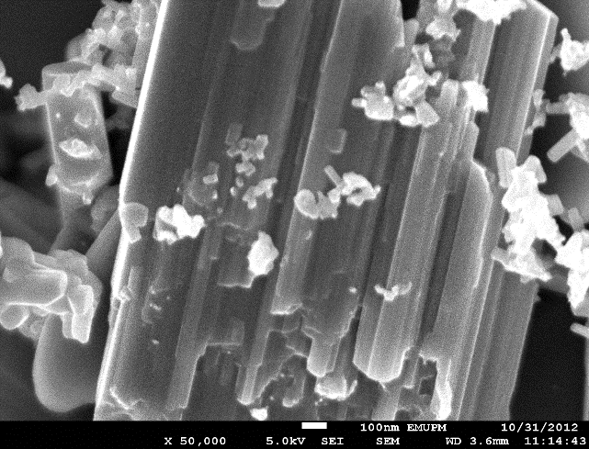
(a)
(d)
(c)
(b))

Figure 6. FESEM image of calcined MoVTeNbOx catalysts (a) MVTN_{1c} (b) MVTN_{3c} (c) MVTN_{5c} (d) MVTN_{7c}

The reduction profiles of MoVTeNbOx catalysts are shown in Figure 7. There are at least two peak maximum which are overlapped with each other are observed in all of the samples. The occurrence of multiple reduction peaks indicates the presence of a number of reducible metal oxide species present in the catalyst.

Figure 7. H₂-TPR profiles of calcined MoVTeNbOx catalysts (a) MVTN_{1c} (b) MVTN_{3c} (c) MVTN_{5c} (d) MVTN_{7c}

The reduction peak suggests reductive decomposition of metal oxides where MoO_{n} reduced at 948 K and 995 K for a stepwise reduction of Mo⁶⁺ → Mo⁴⁺ and Mo⁴⁺ → Mo⁰ under H₂-TPR, meanwhile VO_{n} reduced at temperature of 913 K and 943 K from V₂O₅ → VO₂ [24,25]. Additionally, reduction of Nb⁵⁺ to Nb⁴⁺ occur at around 1243 K [26].

The reduction activation energy of the catalysts can be calculated using the modified version of the Redhead equation as stated in equation (3). The results are summarised in Table 2.

$\frac{{\text{E}}_{\text{r}}}{{{\text{RT}}_{\text{m}}}^{\text{2}}}\text{= }\left(\frac{{\text{A}}_{\text{r}}}{\text{β}}\right){\left[{\text{H}}_{\text{2}}\right]}_{\text{m }}\text{exp }\left(\frac{{\text{-E}}_{\text{r}}}{{\text{RT}}_{\text{m}}}\right)$ (3)

where, E_{r} = reduction activation energy (kcal mol⁻¹), T_{m} = peak maximum temperature (K) in the rate of production of H₂, A_{r} = reduction pre-exponential term (cm³mol⁻¹s⁻¹) which is given a standard collision number of 10¹³ cm³ mol⁻¹s⁻¹, β = heating rate (Ks⁻¹) and [H₂]_{m} is the gas phase concentration of hydrogen (mole cm⁻³) at the peak maximum.

Table 2. The reduction activation energy, E_{r} and total O₂ removed determined from H₂-TPR
for (a) MVTN_{1c} (b) MVTN_{3c} (c) MVTN_{5c} (d) MVTN_{7c}
Sample | T_{max,} (K) | Reduction activation energy, E_{r} (kJ mol⁻¹) | O₂ removed  (atom g⁻¹) × 10²¹
MVTN_{1c} | 817 | 136.5 | 0.72
 | 883 | 147.5 | 1.67
 |  |  | Total = 2.39
MVTN_{3c} | 965 | 161.2 | 4.67
 | 1004 | 167.7 | 0.94
 |  |  | Total = 5.61
MVTN_{5c} | 980 | 163.7 | 8.39
 | 1008 | 168.4 | 7.26
 |  |  | Total = 15.65
MVTN_{7c} | 895 | 149.5 | 1.60
 | 927 | 154.9 | 1.05
 |  |  | Total = 2.65

The values of reduction activation energy, E_{r} for all samples is more than 100 kJ mol⁻¹ indicates that the oxygen species are strongly bonded. Thus, these strongly bonded oxygen species that has been removed in these samples may be originated from the surface and/ or lattice of the catalyst [27].

Interaction of hydrogen with MoVTeNbOx mixed oxides during H₂-TPR involves the adsorption of hydrogen on all active sites of the molybdenum oxide surface, taken up the oxygen species and caused the reduction of the MoO_{n} component. The higher amount of oxygen removed indicate the high activity of the catalysts. The amount of oxygen removed of each sample can be estimated by integrating the area under the peak. For catalyst prepared at pH 1, the total amount of removable oxygen is 2.39 x 10²¹ atom g⁻¹ whereas the amount is doubled to 5.61 x 10²¹ atom g⁻¹ when synthesised at pH 3. This is an indication of the high removable oxygen of the catalyst when prepared at pH 3 which was contributed by the formation of the much desired orthorhombic M1 phase. Although the catalyst prepared at pH 5 gives a much higher of removable oxygen species (15.65 x 10²¹ atom g⁻¹), nevertheless it could be the unselective oxygen species due to the catalyst does not contains the orthorhombic M1 but hexagonal M2 phase instead. The same goes with catalyst prepared at pH 7.

Conclusion
The results revealed that the pH of the slurry strongly influences the formation of crystalline Anderson-type heteropolyanions for catalysts prepared at pH 3, 5 and 7. While the as-synthesised sample at pH 1 showed the presence of pseudo-amorphous materials which allow for the formation of orthorhombic M1 phase upon calcination. The formation of orthorhombic M1 phase is also observed in pH 3 samples (after calcination), but none was found in the other samples. Therefore, high acidity condition is required for the formation of desired catalyst phase. Although, all of the catalysts give similar reduction profiles in the anaerobic hydrogen-TPR, the lattice oxygen that were removed in catalysts which contains orthorhombic M1 could be the selective ones. This is because, the catalysts with M1 phase can undergo charge transfer on the Mo and V sites with the lattice oxygen could be involved in the abstraction of H at the vanadium sites and oxygen insertion at the molybdenum sites. There is a clear relationship between synthesis pH and catalyst properties, suggesting that the reducibility of crystalline phases is a key factor in the propane selective oxidation into acrylic acid.

Acknowledgement
The authors would like to thank the Ministry of Higher Education Malaysia (Fundamental Research Grant Scheme (FRGS), grant number: 5523956) for their financial support.

References
- Lin, M. M. (2001). Selective oxidation of propane to acrylic acid with molecular oxygen. Applied Catalysis A: General, 207 (1-2): 1 – 16.
- Tu, X., Furuta, N., Sumida, Y., Takahashi, M. and Niiduma, H. (2006). A new approach to the preparation of MoVNbTe mixed oxide catalysts for the oxidation of propane to acrylic acid. Catalysis Today, 117 (1-3): 259 – 264.
- Yu, Z., Zheng, W., Xu, W., Zhang, Y., Fu, H. and Zhang, P. (2009). Effect of preparation conditions on selective oxidation of propane to acrylic acid. Transactions of Nonferrous Metals Society of China, 19 (2):476 – 479.
- Beato, P., Blume, A., Girgsdies, F., Jentoft, R.E., Schlögl, R., Timpe, O., Trunschke, A., Weinberg, G., Basher, Q., Hamid, F.A., Hamid, S.B.A., Omar, E. and Mohd Salim, L. (2006). Analysis of structural transformations during the synthesis of a MoVTeNb mixed oxide catalyst. Applied Catalysis A: General, 307 (1): 137 – 147.
- Ueda, W., Vitry, D., Katou, T., Watanabe, N. and Endo, Y. (2006). Key aspects of crystalline Mo-V-O-based catalysts active in the selective oxidation of propane. Research on Chemical Intermediates, 32 (3): 217 – 233.
- Ushikubo, T., Nakamura, H., Koyasu, Y. and Wajiki, S. (1995). Method for producing an unsaturated carboxylic acid. US Patent 5 380 933.
- Grasselli, R. K., Buttrey, D. J., DeSanto Jr, P., Burrington, J. D., P., Lugmair, C. G., Volpe Jr, A. F. and Weingand, T. (2004). Active centers in Mo–V–Nb–Te–O_{x} (Amm)oxidation catalysts. Catalysis Today, 91–92: 251 – 258.
- Ushikubo, T., Oshima, K., Kayou, A. and Hatano, M. (1997). Ammoxidation of propane over Mo-V-Nb-Te mixed oxide catalysts. Studies in Surface Science and Catalysis, 112: 473 – 480.
- Vedrine, J. C. (2016). Heterogeneous partial (Amm) oxidation and degydrogenation catalysis on mixed metal oxides. Catalysts, 6(2):1 – 26.
- Yu, Z., Zheng, W., Xu, W., Zhang, P., Fu, H. and Zhang, Y. (2011). Crystalline structure of mixed metal oxide catalysts for propane selective oxidation to acrylic acid. Transactions of Nonferrous Metals Society of China, 21 (2): 405 – 411.
- Guan, J., Wang, H., Yang, Y., Liu, B., Yu, X., Ma, Y. and Kan, Q. (2009). Effect of pH on the catalytic properties of Mo–V–Te–P–O catalysts for selective oxidation of isobutane. Catalysis Letters, 131 (3-4): 512 – 516.
- Oliver, J. M., López Nieto, J. M., Botella, P. and Mifsud, A. (2004). The effect of pH on structural and catalytic properties of MoVTeNbO catalysts. Applied Catalysis A: General, 257 (1): 67 – 76.
- Baca, M., Pigamo, A., Dubois, J. L. and Millet, J. M. M. (2005). Fourier transform infrared spectroscopic study of surface acidity by pyridine adsorption on the M1 active phase of the MoVTe(Sb)NbO catalysts used in propane oxidation. Catalysis Communications, 6 (3): 215 – 220.
- Irmawati, R., Muda, A. A., Ismail, A. Z. and Ahangar, H. A. (2016). Malaysian Patent MY 156457.
- Popova, G.Y., Andrushkevich, T.V., Chesalov, Y. A., Plyasova, L. M., Dovlitova, L. S., Ischenko, E.V., Aleshina, G. I. and Khramov, M. I. (2009). Formation of active phases in MoVTeNb oxide catalysts for ammoxidation of propane. Catalysis Today, 144 (3-4): 312 – 317.
- Botella, P., López Nieto, J. M., Solsona, B., Mifsud, A. and Márquez, F. (2002). The preparation, characterization, and catalytic behavior of MoVTeNbO catalysts prepared by hydrothermal synthesis. Journal of Catalysis, 209 (2): 445 – 455.
- Sanfiz, A. C., Hansen, T. W., Girgsdies, F., Timpe, O., Rodel, E., Ressler, T., Trunschke, A. and Schlogl, R. (2008). Preparation of phase-pure M1 MoVTeNb oxide catalysts by hydrothermal synthesis - influence of reaction parameters on structure and morphology. Topic in Catalysis, 50 (1-4): 19 – 32.
- Naraschewski, F. N., Kumar, C. N., Jentys, A. and Lercher, J. A. (2011). Phase formation and selective oxidation of propane over MoVTeNbOx catalysts with varying compositions. Applied Catalysis A: General, 391 (1-2): 63 – 69.
- Ivars, F., Solsona, B., Hernández, S. and López Nieto, J. M. (2010). Influence of gel composition in the synthesis of MoVTeNb catalysts over their catalytic performance in partial propane and propylene oxidation. Catalysis Today, 149 (3-4): 260 – 266.
- Vitry, D., Morikawa, Y., Dubois, J. L. and Ueda, W. (2003). Mo-V-Te-(Nb)-O mixed metal oxides prepared by hydrothermal synthesis for catalytic selective oxidations of propane and propene to acrylic acid. Applied Catalysis A: General, 251 (2): 411 – 424.
- Pavia, D. L., Lampman, G. M. and Kriz, G. S. (2001). Introduction to spectroscopy. United States of America: Thomson Learning, Inc.
- Lin, M. M. (2003). Complex metal oxide catalysts for selective oxidation of propane and derivatives: II. The relationship among catalyst preparation, structure and catalytic properties. Applied Catalysis A: General, 250 (2): 287 – 303.
- Syazwani M. N, Irmawati R, Taufiq-Yap Y. H, and Zainuddin, N. (2016). Effect of pH on the physicochemical properties of MoVTeNbOx catalysts for oxidation of propane to acrylic acid. International Journal of Scientific & Technology Research, 5(1): 40 – 45.
- Jiang, H. C., Lu, W. M. and Wan, H. L. (2004). The effect of MoV_{0.3}Te_{0.23}P_{x}O_{n} catalysts with different phosphorus content for selective oxidation of propane to acrolein. Journal of Molecular Catalysis A-Chemical, 208 (1-2): 213 – 217.
- Wong, M. S., Irmawati, R., Ahangar, H.A., Taufiq-Yap, Y. H, Tan, Y.P. and Muhamad E. N. (2012). Physicochemical studies of Ni-, Co-, Pt- promoted MoVNbOx catalysts synthesised by impregnation method. Oriental Journal of Chemistry, 28 (1): 59 – 65.
- Pereira, E. B., Pereira, M. M., Lam, Y. L., Perez, C. A. C. and Schmal, M., (2000). Synthesis and characterization of niobium oxide layers on silica and the interaction with nickel. Applied Catalysis A: General, 197 (1): 99 – 106.
- Woi, P. M., Irmawati, R. and Taufiq-Yap, Y. H. (2007). Influence of organic species on the characteristics of Mo-V oxides. Malaysian Journal of Analytical Sciences, 11(1): 160 – 165.

