

MALAYSIAN JOURNAL OF ANALYTICAL SCIENCES
ISSN 1394 - 2506

Published by The Malaysian Analytical Sciences Society

IMMOBILIZATION OF TYROSINASE IN Nanocrystalline Cellulose/Chitosan Composite Film for AMPEROMETRIC DETECTION OF PHENOL

(Pemegunan Tyrosinase dalam Filem Komposit Selulosa Nanokristalin/Kitosan untuk Pengesanan Amperometrik bagi Fenol)

Fariza Aina Abd Manan¹, Jaafar Abdullah^{1,2}*, Nur Nadziera Nazri¹, Izyan Nadira Abd Malik¹, Nor Azah Yusof^{1,2}, Ishak Ahmad³

¹Department of Chemistry, Faculty of Science
²Institute of Advanced Technology
Universiti Putra Malaysia,43400 UPM Serdang, Selangor, Malaysia
³School of Chemical Sciences and Food Technology, Faculty of Sciences and Technology,
Universiti Kebangsaan Malaysia, 43600 UKM Bangi, Selangor, Malaysia

*Corresponding author: jafar@upm.edu.my

Received: 17 August 2015; Accepted: 17 June 2016

Abstract
Nanocrystalline cellulose (NCC)/chitosan composite for immobilization of tyrosinase enzyme for the determination of phenol have been developed. The NCC/Chitosan composite film on screen printed carbon electrode (SPCE) was prepared by using drop casting technique. Characterization of the modified SPCE surface was investigated by using Transmission Electron Microscopy (TEM) and Fourier Transform Infrared (FTIR), respectively. Chronoamperometric (CA) technique is used to perform the electrochemical measurements. The detection of phenols by the developed system is derived on the direct electrochemical reduction of quinones produced by enzymatic reaction. The results demonstrated that the maximum response was observed at ratio of NCC/chitosan of 1 to 1 (v/v), tyrosinase concentration of 10 mg/mL and pH buffer of 7, respectively. It was found that the developed system gave linear response in the phenol concentration range of 0.39 – 7.74 µM (slope = 28.316, R² = 0.9808) with the detection limit of 0.38 µM. The reproducibility of the system was also estimated and the Relative Standard Deviation (RSD) was found to be at 4.27 %.

Keywords: nanocrystalline cellulose, nanocomposite, immobilization, electrochemical, phenol

Abstrak
Komposit selulosa nanokristalin/kitosan untuk pemegunan enzim tirosinase bagi penentuan fenol telah dibangunkan. Filem komposit NCC/Chitosan di atas elektod karbon skrin bercetak (SPCE) telah disediakan melalui kaedah penyalutan acuan. Pencirian permukaan SPCE dimodifikasi dikaji menggunakan Mikroskop Elektron Transmisi (TEM) dan Transformasi Fourier Inframerah (FTIR). Teknik kronoamperometri (CA) digunakan untuk menjalankan pengukuran elektrokimia. Pengesanan fenol oleh sistem yang dibangunkan ini adalah berasaskan penurunan langsung elektrokimia oleh kuinon yang dihasilkan daripada tindak balas enzim. Keputusan menunjukkan bahawa rangsangan maksimum diperhatikan pada nisbah NCC/kitosan adalah 1 kepada 1 (v/v), kepekatan tirosinase 10 mg/mL dan larutan penimbal pada pH 7. Didapati bahawa sistem yang dibangunkan memberi rangsangan linear dalam julat kepekatan fenol 0.39-7.74 µM (kecerunan = 28,316, R² = 0,9808) dengan had pengesanan 0.38 µM. Kebolehulangan sistem juga telah dianggarkan dan nilai sisihan piawai relatif (RSD) yang diperolehi ialah 4.27 %.

Kata kunci: selulosa nanokristalin, nanokomposit, pemegunan, elektrokimia, fenol

Introduction
Nanocrystalline cellulose (NCC) is a unique and sustainable nanomaterial obtained through acid hydrolysis of native cellulose, it has remarkable physical properties, such as biocompatibility, biodegradability and low toxicity as it originating from natural resources raw materials [1]. NCC has been studied to have a rigid rod-shape structure with 5 – 10 nm in diameter and 10 – 100 nm in length [2]. It can be extracted from native cellulose which is found in plants, animals and bacteria that composed of the nanoscaled structure material. Since nanocellulose is a natural nanoscaled material, it possesses varied characteristics different from traditional materials, as well as special morphology and geometrical dimensions like crystallinity, high specific surface area, rheological properties, liquid crystalline behaviour, alignment and orientation, mechanical reinforcement, barrier properties and surface chemical reactivity [1]. NCC is an attractive material for drug delivery excipients [3], support for immobilization of protein [4,5] and for applications of nanocomposite [4] because of its properties for instance high surface area, high aspect ratio, high and specific stiffness and strength, and low toxicity. Depending on the origin and method of extraction, the nano-dimensional cellulose might be in the form of rods, spheres, and have network morphology with an extremely high surface to volume ratio [6]. The presence of –OH groups on the NCC surface allow it to undergo further surface modification to alter its hydrophobicity, serve as a stable matrix that is compatible for widespread bioapplications, specifically in enzyme immobilization, antimicrobial and medical materials, green catalysis, biosensing and controlled drug delivery [5].

Chitosan is a natural biopolymer product found in the exoskeleton of crustaceans, in fungal cell wall and other biological materials. Chitosan is natural linear polysaccharide made primarily of glucosamine repeating units, partially deacetylated derivative of chitin and the second most abundant natural polysaccharide after cellulose [7]. Its properties of biodegradability, non-toxicity, biocompatibility, high mechanical strength and good adhesion make it a promising matrix for enzyme immobilization. In spite of its biodegradability, it has numerous reactive amino acid and hydroxyl groups that allows chemical modification possibilities, formation of a large variety of functional derivatives which are commercially available or can be made available through graft reactions and ionic interactions [8, 9]. The reaction of chitosan is considerably more versatile than cellulose as there is the presence of NH₂ groups.

Recently development of biosensor system with better sensitivity, selectivity and rapid detection is the key important step and gain much attention from many researchers. Among of that is the selection of new material for enzyme immobilization which offers good electronic properties, biocompatible, stable and easily accessible by the analyte and large surface area. However, it is difficult to find a single material that contains all these important characteristics. The use of composite materials made of two and more components has gotten increasing interest as a way to achieve adequate sensitivity and stability for biosensors development.

In this work, we explored the utilization of nanocrystalline cellulose (NCC) in combination with chitosan for biosensing application. The nanostructure of NCC could provide high surface to volume ratio and high surface activity, and thus possess unique advantages over other conventional materials in terms of enzyme immobilization and signal transduction. These biomaterials could preserve enzyme activity due to the desirable microenvironment and enhance the direct electron transfer between the enzyme active sites and the electrode.

Materials and Methods
Reagents
All chemicals used in this experiment were of analytical grade. Sodium phosphate dibasic, sodium phosphate monobasic, phenol and tyrosinase were obtained from Sigma Aldrich and Fluka (Switzerland). Sodium hydroxide was from Merck (Germany). Acetic acids and potassium chloride were obtained from R&M chemicals (United Kingdom). Chitosan powder was purchased from Chito-Chem (Malaysia) Sdn Bhd. Nanocrystalline cellulose (NCC) powder was acquired from Universiti Kebangsaan Malaysia. Deionized water was used throughout the experiment.

Preparation of NCC colloidal suspensions and chitosan solution
An amount 1 mg/mL or 0.1% (w/v) of NCC suspension was prepared by dissolving 0.025 g of NCC powder in 25 ml deionized water followed by sonication for 3 min. 1.0 % (w/v) of chitosan solution was prepared by dissolving 1.0 g of chitosan powder in 100 mL of acetic acid (1%, v/v). The viscous chitosan solution was stirred overnight at room temperature by using magnetic stirrer.

Immobilization of tyrosinase into NCC/Chitosan composite on SPCE
Preparation of NCC/Chitosan mixture was carried out by varying the ratio of NCC/Chitosan in the range of 1:3 to 3:1 (v/v). For immobilization of tyrosinase, 20 µL of NCC/Chitosan mixture with different ratio was mixed with 10 µL of tyrosinase (40 mg/mL) in eppendorf tube and stirred gently until homogeneous solution was obtained. Then 2 µL of the prepared mixture was deposited and spread onto SPCE. It was kept at 4 °C for drying process for overnight. All electrodes are stored at 4 °C prior to use.

Study the performance of NCC/Chitosan/tyrosinase composite electrode
An electrochemical measurement was performed by using Autolab potentiostat (Netherlands) controlled by GPES software connected to a PC and screen printed carbon electrode (Quasense, Thailand). Chronoamperometry method was used to record current-time activity. Two-electrode system was employed in this work with NCC/Chitosan/tyrosinase as a working electrode and an AgCl served as the reference/counter electrode.

Characterization of the SPCE modified with NCC/chitosan/tyrosinase composite was carried out using Transmission Electron Microscopy (TEM) and Fourier Transform Infrared (FTIR), respectively.

Results and Discussion
The morphology characterization of the composite film
Figure 1a depicts the TEM image of NCC showing agglomerated rod-like nanocrystals, ranging approximately 10 – 30 nm in diameter and corresponding length of about 100-300 nm. Similar observations were also reported by previous researchers which the NCC obtained was highly crystalline nanometer sized rod-like particle ranging from 50 – 60 nm that is obtained as a stable aqueous colloidal suspension [4,7]. Fig. 1b illustrates the image of NCC/chitosan with ratio of 1 to 1 (v/v). As can be seen the NCC/Chitosan appeared like a shiny dot which correspond to the transverse sections of the cellulose nanocrystals [10]. Fig. 1c exhibits the uniform distribution of tyrosinase on the NCC/Chitosan composite films.

FTIR analysis attempted to characterize the effect of NCC incorporation with chitosan and also to determine NCC-chitosan and NCC-chitosan-tyrosinase interactions from the infrared bands and related shifts. Fig. 2 shows the FTIR spectra recorded for NCC, chitosan, NCC-chitosan, and NCC-chitosan-tyrosinase. In the FTIR spectra of pure NCC film (Fig. 2a), the absorption band between 3600 and 3200 cm⁻¹ which is related to the O-H stretching vibrations. The broad peak recorded at 3348 cm⁻¹ may be attributed to the O-H vibrations because of the intramolecular hydrogen bonding [11]. The bands of absorption between 3000-2800 cm⁻¹ and 1500-1250 cm⁻¹ indicated the functional group of C-H and C-H₂ stretching and bending vibration, respectively [12]. The adsorption of C-H stretching was obtained at 2915 cm⁻¹ and the strongest band across NCC spectra is at 1447 cm⁻¹ which assigned to C-H₂ stretching. Other bands between 800-650 cm⁻¹ originated from O-H out of plane bending vibrations. The position of the peaks of chitosan film spectrum is similar to those described by Cao et al. [13]. The absorption peaks of the chitosan film in Fig.2b are due to the stretching of intra- and intermolecular O-H and CH₂OH vibrations at 3500-3250 cm⁻¹, overlapped with stretching –NH₂ (3500-3400 cm⁻¹) and –NH secondary amides vibrations (3300-3280 cm⁻¹). The band between 2960-2870 cm⁻¹ corresponds to symmetric and asymmetric C-H vibrations. Amide at 1557 cm⁻¹ was also been observed.

There are some differences can be observed in FTIR spectra of chitosan films in Fig. 2c because of the incorporation of NCC to the chitosan matrix. A broad peak appeared at 3287 cm⁻¹, which was not present in the control chitosan film. The band intensity 3287 cm⁻¹ increased suggesting hydrogen bonding which occurred between chitosan and NCC [14]. Band at 1569 cm⁻¹ and 1397 cm⁻¹, their intensity was increased after NCC addition due to the bending of C-H and –OH group. Furthermore, a drastic increased was observed in the intensity of the absorption band at 1063 cm⁻¹ due to incorporation of NCC which refer to C-H stretching vibration of C-O. An incorporation of tyrosinase enzyme in NCC-chitosan film (Fig. 2d) caused no changes in intensity of band spectra of NCC-chitosan which a broad peak appeared at 3286 cm⁻¹. Also, there was a decrease in intensity of bands at 1642 cm⁻¹ might be attributed to the amide I vibrations indicating that tyrosinase had been successfully attached on the membranes consisting of NCC/chitosan film.

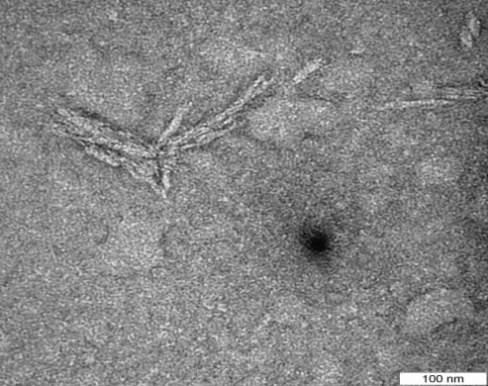
a

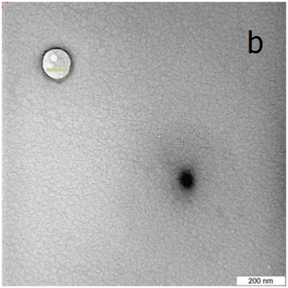
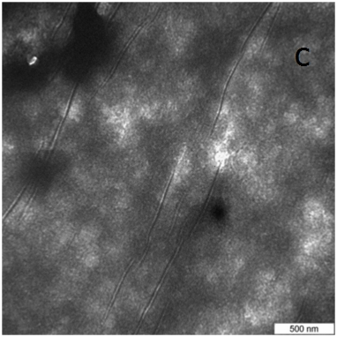
b
c

Figure 1. TEM images of (a) NCC (b) NCC/Chitosan

Figure 1. TEM images of (a) NCC, (b) NCC/Chitosan, (c) NCC/Chitosan/ tyrosinase

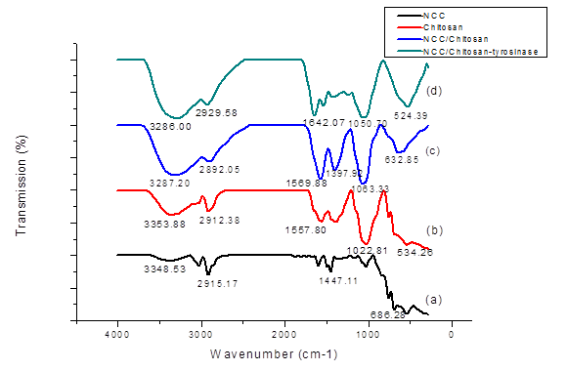

Figure 2. FTIR spectra of films based on NCC (a), chitosan (b), NCC/chitosan (c), and NCC/chitosan/ tyrosinase (d)

Principal of detection of phenol
In this work, the electrochemical measurements were performed using chronoamperometric technique. The electrochemical experiments were carried out with two-electrode system with NCC/Chitosan/tyrosinase on carbon electrode as a working electrode and an AgCl served as the reference/counter electrode. Tyrosinase is a copper containing enzyme, which catalyzes the oxidation of phenol group to o-quinone is commonly used in the detection of phenolic compounds. The oxidation of phenols by tyrosinase can be presented according to the following reactions:

The oxidation of phenol by tyrosinase has two steps: phenol is oxidized to catechol (o-benzenediol), which is consequently oxidized (by tyrosinase) to o-quinone [15]. The liberated quinone species catalytically oxidized by tyrosinase is electrochemically reduced and the reaction can be measured at low potential. Thus, this provides the additional advantages of the enzymatic/electrochemical recycling of the substrate, giving rise to signal amplification. In this work, effect of applied potential was investigated in the range of 0.0 V to -0.6 V and the optimum response of the immobilized tyrosinase in NCC/Chitosan composite film was observed at - 0.3 V vs AgCl. Thus, applied potential of - 0.3 V was chosen for further study.

Optimization parameter
Effect of ratio NCC/Chitosan on the sensing response was evaluated in this work by employing various ratios such as NCC, 1:3, 1:1, 3:1 and chitosan, respectively. As shown in Figure 3, the ratio of NCC/Chitosan of 1:1 (v/v) gave maximum current response. This shows that the NCC/Chitosan composite with composition of 1:1 gave relatively higher protein loading which might be attributable to the abundant active –OH groups and highly surface area of the NCC that contribute to the cross-linking of tyrosinase onto the composite film. However, pure NCC film gave the lowest current response due to the high solubility in water and hydrophilic character of NCC which caused the NCC to be easily detached from the surface of electrode and dissolved in buffer solution.

The zeta potentials of the NCC and chitosan were also evaluated to characterize the surface charge density of the material. The zeta potential was investigated at different pH value. It was observed that the zeta potential value at pH 3, 7, 9 were -27.50, -14.37, -16.78 for NCC and +36.87, +12.78, -4.04 for chitosan, respectively. Remarkably, NCC and chitosan carried opposite surface charges at the pH range from 3 to 7, indicated in this range electrostatic attraction occurred. In a previous work, NCC and chitosan film was also prepared via electrostatic self-assembly due to electrostatic interaction between negatively charged NCC and positively charged chitosan [16].

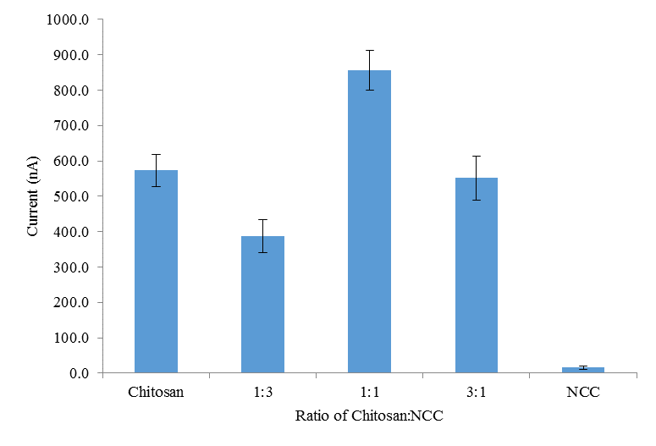

Figure 3. The effect of ratio of NCC/chitosan

The effect of a different amount of tyrosinase loading on the sensor response was also examined. As depicted in Figure 4, upon increasing the concentration, the biosensor response increased steeply to reach a maximum value when 10 mg/mL of enzyme concentration was utilized. Further increased in enzyme concentration, the sensor response decreased and thus concentration of 10 mg/mL was subsequently used for enzyme immobilization.

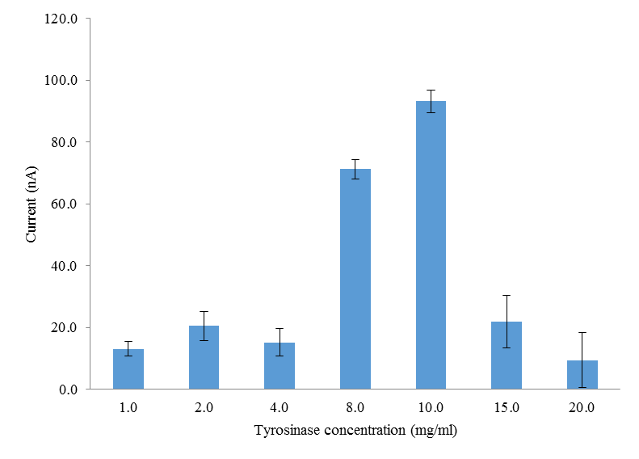

Figure 4. Effect of enzyme concentration used towards the response of the sensor

Influence of pH of the working buffer was also investigated by using 50 mM phosphate and acetate buffer. The buffering system covered over the range of pH 7.0 to 9.0. As shown in Figure 5, the sensor response increased drastically from pH 5.0 to 7.0. The optimum response was observed at pH 7.0. This indicates that the immobilization of enzyme does not alter its pH response characteristics [17]. Therefore, pH 7.0 was chosen for further studies.

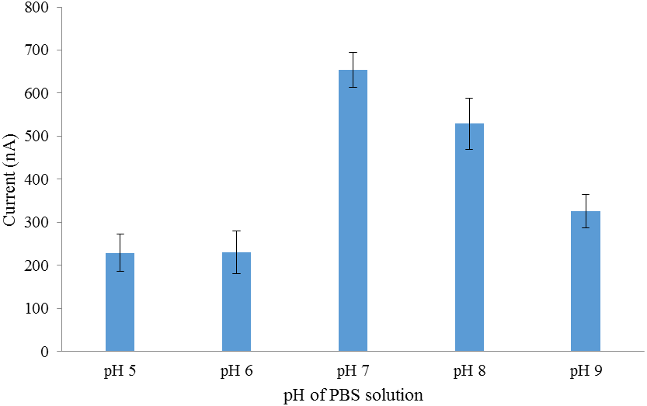

Figure 5. Influence of pH on the response of the immobilized tyrosinase in NCC/Chitosan composite film

Analytical performance
The dynamic range of the developed biosensor towards different phenol concentration was studied from the concentration range of 0.39 µM to 100 µM (Figure 6). The response was monitored by predicting the current of the composite films produced, which is proportional to the phenol concentration. As shown, a linear response of the biosensor was observed in the phenol concentration range of 0.39-7.74 µM (slope = 28.316, R² = 0.9808) with the detection limit of 0.379 µM. The reproducibility of the biosensor was estimated from the response of the electrode at 50 µM phenol. The relative standard deviation (R.S.D) obtained was 4.27 % (n = 10). This result shows a remarkable reproducibility of the proposed biosensor.

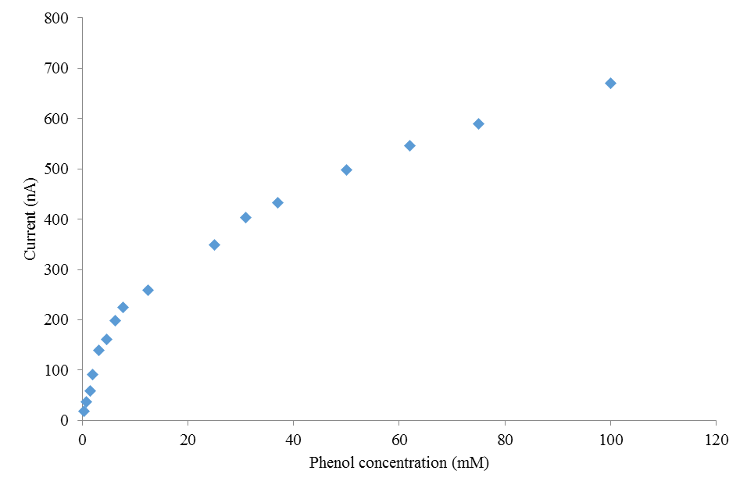
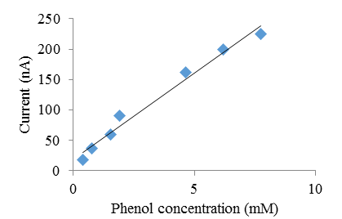

Figure 6. The dynamic calibration range of the sensor towards different concentration of phenol. Inset is the linearity range of the sensor

Conclusion
An amperometric biosensor based on the immobilized tyrosinase enzyme in a NCC/chitosan composite film has been successfully developed for the detection of phenol. The biosensor permits an attractive alternative to existing analysis methods in order to determine phenolic compounds as they offer advantages for instance minimal preparation of sample, good selectivity, better sensitivity, reproducibility, quick response time and easily for continuous analysis. The effect of immobilization of enzyme into nanocomposites material and its stabilization for sensing application have been extensively determined. The nanocomposites showed significant improvement in performance of the biosensors which is promising for developing dependable enzyme-biosensors which has good potential use in quantitative determination of phenolic compunds in industrial applications.

Acknowledgement
The authors are grateful for the financial support provided by the Malaysian Government through its Ministry of Education under Fundamental Research Grant Scheme (FRGS/1/2012/SG01/UPM/02/1).

References
- Lin, N. and Dufresne, A. (2014). Nanocellulose in biomedicine: Current status and future prospect. European Polymer Journal, 59: 302 – 325.
- Revol, J.-F., Bradford, H., Giasson, J., Marchessault, R. H. and Gray, D. G., (1992). Helicoidal self-ordering of cellulose microfibrils in aqueous suspension. International Journal of Biological Macromolecules, 14: 170 – 172.
- Zhang, X., Huang, J., Chang, P. R., Li, J., Chen, Y., Wang, D. and Chen, J. (2010). Structure and properties of polysaccharide nanocrystal-doped supramolecular hydrogels based on cyclodextrin inclusion. Polymer, 51 (19): 4398 – 4407.
- Mahmoud, K. A., Male, K. B., Hrapovic, S. and Luong, J. H. (2009). Cellulose nanocrystal/gold nanoparticle composite as a matrix for enzyme immobilization. ACS applied materials & interfaces, 1 (7), 1383 – 1386.
- Lam, E., Male, K. B., Chong, J. H., Leung, A. C. W. and Luong, J. H. T. (2012). Applications of functionalized and nanoparticle-modified nanocrystalline cellulose. Trends in Biotechnology, 30(5), 283 – 290.
- Hamad, W. (2006). On the development and applications of cellulosic nanofibrillar and nanocrystalline materials. The Canadian Journal of Chemical Engineering, 84 (5): 513 – 519.
- Khan, A., Khan, R. A., Salmieri, S., Le Tien, C., Riedl, B., Bouchard, J. and Lacroix, M. (2012). Mechanical and barrier properties of nanocrystalline cellulose reinforced chitosan based nanocomposite films. Carbohydrate Polymers, 90 (4): 1601 – 1608.
- Abdullah, J., Ahmad, M., Heng, L. Y., Karuppiah, N. and Sidek, H. (2006). Chitosan-based tyrosinase optical phenol biosensor employing hybrid nafion/sol–gel silicate for MBTH immobilization. Talanta, 70 (3), 527 – 532.
- Dutta, P. K., Dutta, J. and Tripathi, V. (2004). Chitin and chitosan: Chemistry, properties and applications. Journal of Scientific and Industrial Research, 63 (1): 20 – 31.
- Azizi Samir, M. A. S., Alloin, F. and Dufresne, A. (2005). Review of recent research into cellulosic whiskers, their properties and their application in nanocomposite field. Biomacromolecules, 6 (2): 612 – 626.
- Li, Q. and Renneckar, S. (2011). Supramolecular structure characterization of molecularly thin cellulose I nanoparticles. Biomacromolecules, 12 (3): 650 – 659.
- Nikonenko, N., Buslov, D., Sushko, N. and Zhbankov, R. (2005). Spectroscopic manifestation of stretching vibrations of glycosidic linkage in polysaccharides. Journal of Molecular Structure, 752 (1), 20 – 24.
- Cao, X., Dong, H. and Li, C. M. (2007). New nanocomposite materials reinforced with flax cellulose nanocrystals in waterborne polyurethane. Biomacromolecules, 8 (3), 899 – 904.
- Khan, R. A., Salmieri, S., Dussault, D., Uribe-Calderon, J., Kamal, M. R., Safrany, A., and Lacroix, M. (2010). Production and properties of nanocellulose-reinforced methylcellulose-based biodegradable films. Journal of Agricultural and Food Chemistry, 58 (13): 7878 – 7885.
- Švitel, J. and Miertuš, S. (1998). Development of tyrosinase-based biosensor and its application for monitoring of bioremediation of phenol and phenolic compounds. Environmental Science & Technology, 32 (6): 828 – 832.
- Cao, S. L., Li, X. H., Lou, W. Y. and Zong, M. H. (2014). Preparation of a novel magnetic cellulose nanocrystal and its efficient use for enzyme immobilization. Journal of Material Chemistry B, (2): 5522 – 5530.
- Wang, G., Xu, J.-J., Ye, L.-H., Zhu, J.-J. and Chen, H.-Y. (2002). Highly sensitive sensors based on the immobilization of tyrosinase in chitosan. Bioelectrochemistry, 57 (1): 33 – 38.

