

MALAYSIAN JOURNAL OF ANALYTICAL SCIENCES
ISSN 1394 - 2506

Published by The Malaysian Analytical Sciences Society

Effects of Fuel Concentrations, Catalyst loadings and Activation on the Performance of Direct Formic Acid Fuel Cell (DFAFC) Stack

(Kesan Kepekatan Bahan Api, Kandungan Mangkin dan Pengaktifan ke atas Prestasi Tindanan Sel Bahan Api Asid Formik Langsung (DFAFC))

Mohd Shahbudin Masdar^{1, 2}*, Nurulain Ngah¹, Norraihanah Mohamed Aslam², Dedikarni Panuh²,

Siti Kartom Kamarudin^{1,2}, Wan Ramli Wan Daud^{1,2}

¹Department of Chemical and Process Engineering, Faculty of Engineering & Built Environment

²Fuel Cell Institute

Universiti Kebangsaan Malaysia, 43600 UKM Bangi, Selangor, Malaysia

*Corresponding author: shahbud@ukm.edu.my

Received: 5 February 2016; Accepted: 22 April 2016

Abstract

An air-breathing stack for a direct formic acid fuel cell (DFAFC) was designed, fabricated and evaluated. The DFAFC stack consisted of six cells arranged in a hexagonal arrangement and each single cell contained a pair of stainless steel current collectors, a membrane electrode assembly (MEA) and a cathode end-plate. A fuel reservoir was located at the center which supplied formic acid supply to the anode of each cell. The effects of fuel concentration, palladium (Pd) loading at the anode and activation on DFAFC performance and long term operation were evaluated. DFAFC stack performance increased with increasing fuel concentration and a stable power up to 200 mW at 2.4 V was achieved for passive and ambient conditions at a 7 M fuel concentration. Catalyst loading had a slight effect on DFAFC performance, where 4 mg cm⁻² Pd loading was best for 7 M fuel operation. During long-term operation, the DFAFC stack could be operated for 27 hours without adding more fuel and less than a 20 % reduction in performance during operation. MEA reactivation with deionized water technique was required for immediate recovery of stack performance.

Keywords: stack, activation, passive direct formic acid fuel cell, membrane electrode assembly

Abstrak

Tindanan pasif udara bagi sel bahan api asid formik langsung (DFAFC) direka bentuk, difabrikasi dan diuji. Tindanan DFAFC mengandungi enam sel yang dibentuk secara susunan heksagon. Setiap sel mempunyai sepasang pengumpul arus, himpunan membran elektrod (MEA) dan plat penghujung katod. Takungan bahan api ditempatkan di tengah yang mana akan membekalkan asid formik ke setiap sel. Kesan kepekatan bahan api, kandungan palladium (Pd) di anod dan pengaktifan terhadap prestasi dan jangka masa panjang DFAFC dikaji. Prestasi tindanan DFAFC meningkat dengan peningkatan kepekatan bahan api dan kuasa yang stabil sehingga 200 mW dicapai pada 2.4 V dan 7 M kepekatan bahan api dalam keadaan pasif dan persekitaran. Kandungan mangkin mempunyai kesan minimum terhadap prestasi DFAFC yang mana kandungan Pd 4 mg cm⁻² merupakan kandungan terbaik bagi pengoperasian 7 M kepekatan asid formik. Sepanjang pengoperasian jangka masa panjang, tindanan DFAFC boleh beroperasi selama 27 jam tanpa menambah bahan api di dalam takungan dan kurang daripada 20 % pengurangan prestasi tindanan. Pengaktifan MEA menggunakan teknik nyahion air diperlukan bagi pemulihan segera prestasi tindanan DFAFC.

Kata kunci: tindanan, pengaktifan, sel bahan api asid formik langsung pasif, himpunan membran elektrod

Introduction

With respect to direct liquid fuel cells (DLFCs), a direct formic acid fuel cell (DFAFC) is a promising alternative to direct methanol fuel cell (DMFC) and direct ethanol fuel cell (DEFC) cells. The main advantages of DFAFC are a relatively high electro-catalytic oxidation rate [1, 2] and low crossover rate for the fuel [3 – 5] and has the potential to replace batteries in electronic devices [6]. Based on previous work, a Pd-based catalyst was used as the DFAFC anode due to better cell performance compared to other precious metals such as platinum (Pt). However, a disadvantage of electro-catalytic anodes is their activity decreases or they are rapidly deactivated with operation time. To address these issues, Zhu et al. reported a palladium DFAFC anode which could be recovered by applying a potential of 1.2V versus dynamic hydrogen electrode (DHE) to the anode for a few seconds [1], while Tsujiguchi et al. used a water-wash technique to reactivate the electrode [7].

Furthermore, one of the major issues for a DFAFC is the mass transport limitation of the anode electrode due to the hygroscopic characteristic of formic acid. Then, it would affect the hydrophobicity; for better gas transport, or even hydrophilicity characteristics in the electrode, specifically in diffusion layer. Therefore, the electro-structure of the anode electrode requires proper design with respect to Teflon or Nafion content as well as carbon or catalyst loading. Currently, there are a lot of studies focusing on the optimizing the MEA for the fuel cell [8 – 10]. Rice et al. discussed the constraints to formic acid mass transport to the anode side might be due to Nafion ® within the catalyst layer, Teflon on carbon cloth, or both [11]. Oedegaard et al. showed that without Teflon-loading, the membrane electrode assembly (MEA) had a maximum current density of 173 mA cm⁻², while at 15 wt. % and 30 wt. % Teflon-loading, 137 mA cm⁻² and 125 mA cm⁻² were observed, respectively [12]. Kim et al. reported that higher catalyst loading was needed at lower temperatures (i.e. 30 ºC), while low catalyst loading was suitable for high-temperature operation, (i.e. 70 ºC) [13]. These data indicated the anode side of the DFAFC has significant mass transfer limitations depending on the anode media diffusion properties and operating parameters such as temperature and fuel concentrations.

Review of published literature indicates researchers have focused on a single cell DFAFC either in passive, semi-passive or active modes in order to improve performance. However, little has been published on the development of a DFAFC stack [6, 14]. In reality, passive-mode DFAFCs are more attractive, since they eliminate auxiliary devices such pumps for feeding fuel or a blower to supply air, and a simplified stack configuration for a passive DFAFC is highly desirable for portable applications.

In this study, an air-breathing stack for a direct formic acid fuel cell (DFAFC) was designed, fabricated and evaluated. The effects of catalyst loading, fuel concentrations, and MEA reactivation will be addressed on the basis of stack performance.

Materials and Methods

DFAFC stack design

The DFAFC fuel cell stack consisted of six single cells, and each single fuel cell consisted of current collector plates, gaskets, membrane electrode assembly (MEA) and the end plate. Six single cells were combined to form a hexagon with the fuel reservoir located in the center of the stack, which allowed the formic acid fuel to be supplied passively to each cell (Figure 1). The dimensions of the polycarbonate stack holder, including fuel reservoir, were 143 mm x 124 mm x 30 mm stainless steel (SS, 316L), 1 mm in thickness was used as the current collector plate. Polycarbonate (5 mm thickness) was used as the end plate for each cell and silicone rubber was used as a gasket. At the top of the stack, the cover and holder were constructed from acrylic material (3 mm), and two 3.0 mm circular holes were located in the cover to release any CO₂ formed by the anode reaction. The plate had 12 small 3.1 mm holes which allowed passage of stainless steel bolts used to hold the cell components together. The overall weight of the stack was 560 g, without formic acid fuel.

MEA fabrication

A membrane electrode assembly (MEA) with an active area of 2.0 cm² was fabricated using the conventional brush painting technique. Commercial carbon fibre paper (E-TEK, USA) was used as a backing layer with a 2.0 mg cm⁻² of carbon black loading serving as a diffusion layer at the anode and cathode. Pd-black and Pt-black (Johnson-Matthey) were used as the catalyst at the anode and cathode, respectively. These catalysts were mixed with isopropyl alcohol and a Nafion solution 5 wt% (Wako Pure Chemical Industries, Ltd.) to produce catalyst ink which was used to prepare the catalyst layer for the anode and cathode electrodes. Catalyst loading was fixed at 10 mg cm⁻² for the cathode, while loading was 6, 8 and 10 mg cm⁻² at the anode. The MEA was assembled by sandwiching the NRE 212 electrolyte membrane (DuPont™) between the anode and the cathode and hot pressing at 135ºC and 4 MPa for 3 min.

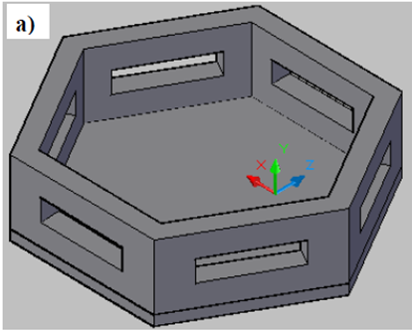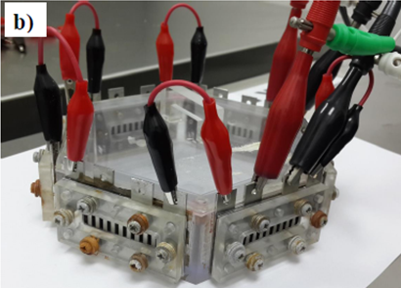

Figure 1. DFAFC fuel cell stack developed in this study: (a) stack holder and (b) fuel reservoir of the DFAFC stack during performance testing

DFAFC stack operation and long term performance

To activate the MEAs, the stack was flushed with pure hydrogen (H₂) gas at 500 ml min⁻¹ for one hour (pre-treatment mode). The DFAFC stack was then operated at ambient room conditions at various fuel concentrations and Pd loadings (for the MEA). Formic acid solution (2 to 10 M, 150 mL) was added to the reservoir and the cathode exposed to ambient air. Each cell (1 – 6) was connected in series in order to measure the performance of stack during operation and power generation was conducted at a 2.4 V for 2 hours. The electrochemical performance of the cell was measured using a Potentiostat/Galvanostat WMPG1000 model (WonATech, Korea) though only one cell of cell 1 could be measured due to a limited channel to measure the electrochemical performance and will be represented the performance profile for each single cell. Long-term performance testing (over 24 hours) was also conducted and after a certain time (nearly 27 hours), the cell was refueled, with or without reactivation of the MEAs by the water-washing technique. During washing, the cell or stack was washed several times (more than three times) using deionized water to eliminate or reduce adsorption of any impurities (such as carbon monoxide, CO).

Results and Discussion

Power profiles and effect of fuel concentration on performance

Figure 2 shows the power profiles obtained over 120 min for cell 1, while Figure 3 shows the power profiles for the direct formic acid fuel cell (DFAFC) using 10 mg cm⁻² Pd loading at the anode and formic acid concentrations varying from 2M to 10M. For all the cases in Figure 2 and Figure 3 (single cell or stack), at the beginning of cell operation, power values were unstable with largely decreasing from initial by two or three times larger than a stable power obtained before became nearly stable with time.

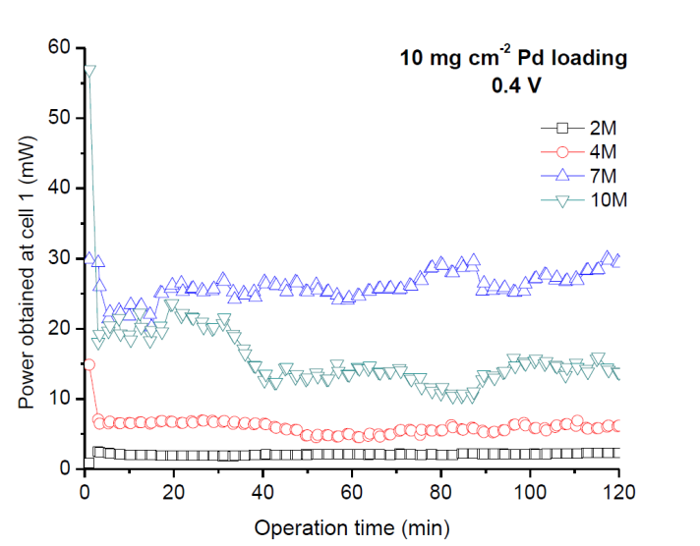

Figure 2. DFAFC power profiles for cell 1 at 10 mg cm⁻² Pd loading at anode and different formic acid concentrations

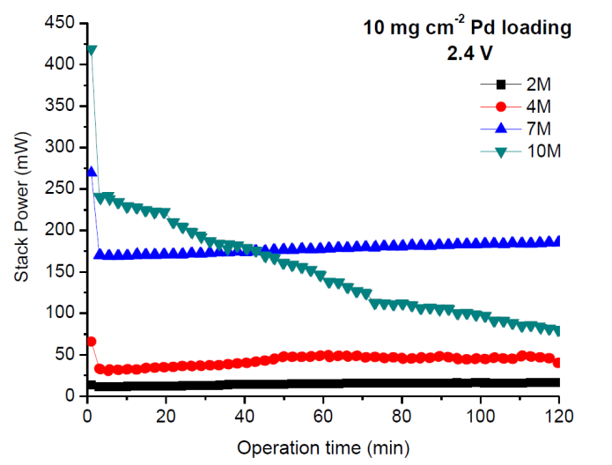

Figure 3. DFAFC power profiles for stack at 10 mg cm⁻² Pd loading at anode and different formic acid concentrations

The unstable power could be related to the conditions of cell 1 and due to mass transport limitations at the anode or water flooding at the cathode at high concentrations (7 M and 10 M). When fueled with 10 M formic acid, the power profile for the DFAFC stack rapidly decreased over 120 min from 240.8 mW to 80.5 mW. This could be due to high formic acid crossover from the anode to the cathode which directly affected the electrochemical DFAFC reaction, and decreased stack performance.

The power values measured at 60 min (Figures 2 and 3) are summarized in Table 1. The power obtained either from cell 1 or the stack increased as the formic acid concentration in the reservoir was increased from 2 M up to 7 M giving power values of 15.03 mW, 49.36 mW and 178.06 mW at 2M, 4M and 7M formic acid, respectively. These data indicated the 7 M concentration yielded the highest output, while operation at 10 M decreased stack performance (150.85 mW). This trend of increased DFAFC performance as formic acid concentrations increased (to a certain concentration limit) was similar to previous studies [1, 4]. Increasing fuel concentration could enhance formic acid mass transfer in terms of flux from the diffusion layer into the anode catalyst layer. For example, at a low formic acid concentration, mass transfer of formic acid was slow and directly can be influenced to no sufficient formic acid flux to maintain a stable electron movement for formic acid oxidation at anode.

Table 1. Stable power obtained at 60 min for cell 1 and stack using different formic acid concentrations
Formic Acid Concentration  (M) | Stable power at 60 min operation (mW)
Formic Acid Concentration  (M) | Cell 1 | Stack
2 | 2.08 | 15.03
4 | 4.52 | 49.06
7 | 24.64 | 178.06
10 | 14.33 | 150.85

Moreover, the trend could have contributed to the thermal effect of the stack. In general, fuel crossover increased as the fuel concentration increased, which contributed to increasing stack temperature due to the direct cathode reaction. Therefore, the electrochemical reaction at the anode would be improved with increased stack temperature (Table 1) at 7 M formic acid. Furthermore, at high concentrations (such as 10 M), mass transfer of formic acid was not the rate-controlling power generation step, though it could be controlled by the electrode reaction due to high formic acid crossover from the anode to the cathode rather than fuel supply to the anode.

Effect of anode catalyst loading on stack performance

To ensure the relationship between fuel mass transports and stack performance, membrane electrode assemblies (MEAs) with different Pd catalyst loadings at the anode layer were tested in the DFAFC stack. Figure 4 shows the DFAFC stack power output capacity profile at different catalyst loadings when 7M formic acid was used as fuel. For all the cases shown in Figure 4, the power profiles were similar to each other and similar to the trend seen in Figure 3.

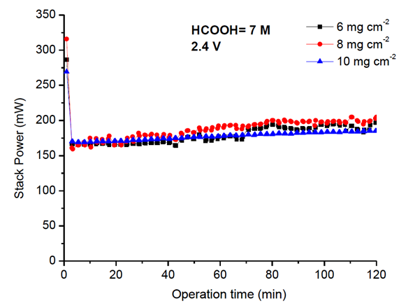

Figure 4. DFAFC power profiles at different anode catalyst loadings using a 7M concentration of formic acid

The power values obtained at 60 min are summarized in Figure 5, and additional data obtained from measurements at 2 M, 4 M and 10 M formic acid and 6, 8 and 10 mg cm⁻² Pd loadings at the anode are presented. For all Pd loadings, the power increased linearly with increasing formic acid concentrations up to 7 M and decreased when using 10 M, which were due to the rate controlling step (fuel mass transfer) at the anode. Meanwhile, the trend differed when Pd loading was compared to operation at different fuel concentrations. For an example, at 6 mg cm⁻² Pd loading, the power obtained over during stable 60 min was always lower or similar to that 8 and 10 mg cm⁻², respectively.

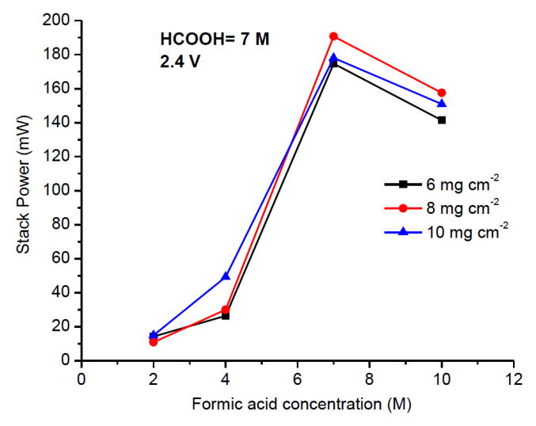

Figure 5. Stable power for the DFAFC stack at 1 h operation at various anode catalyst loadings using different concentrations of formic acid

For the power obtained at low concentrations (2 M and 4 M), high Pd loading (10 mg cm⁻²) was dominant, while 8 mg cm⁻² was dominant at 7 M and 10 M formic acid concentrations. These profiles could be related to the limitations in proton transfer through the electrolyte membrane. Kim et al. also linked the effect of catalyst layer thickness to proton transport through the Nafion membrane [13]. In this study, high catalyst loading would have resulted in increasing the thickness of the catalyst layer, and protons would need to be transported a greater distance (compared to the shorter distance at a low catalyst loading), which directly affected power generation. At this stage, design and optimization of the Nafion content of the catalyst layer at the anode could be important for proton transport. These results indicated the essential role of proper catalyst loading, as well as the importance of optimizing anode electrode fabrication, to enhancing anode mass transfer limitations.

Long term operation with and without reactivation

To explore the long-term operation of a DFAFC stack and the effect of reactivation by the water-washing technique, the stack was operated in two modes. Figure 6 shows the long-term performance testing for a DFAFC stack using 7 M formic acid with/without reactivation of the MEA with deionized water. In the first stage, the stack was operated nearly 27 hours after pre-treatment of MEAs (using pure H₂), while in second stage, fresh fuel (7M) was added to the fuel reservoir after the reactivation (or not) of MEA.

During the first stage (first 27 hours of operation) (Figure 6), stack power generation was similar and these data were good for comparison between first and second stages regions. The data showed that decreasing stack power over time (during the first 27 hours) was due to dilution of the formic acid fuel (i.e. fuel consumption for anode reaction). By focusing on the first stage region, the power produced by the DFAFC stack was nearly stable over the 27 hours of operation and the calculated reduction in performance was 20 %. These data suggested the DFAFC stack evaluated in this study had good stability for over a one-day period in a free-air breathing environment and could be used to power very low power electronic devices.

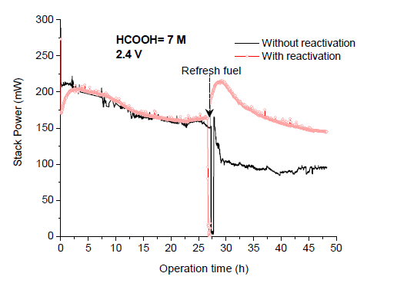

Figure 6. Long-term performance testing of the DFAFC stack using a 7 M concentration of formic acid, with and without membrane electrode assembly (MEA) reactivation with deionized water

In the second stage, when the MEAs were reactivated, the profiles and the magnitude of power produced were similar to the first stage. Without reactivation, the power increased slightly within five minutes of operation before significantly dropping to 80 mW and becoming stable, which could be due to deactivation of the Pd catalyst at the anode. Based on a literature review, deactivation of the Pd catalyst is due to adsorbed intermediates which form during the oxidation of formic acid at the anode (especially CO species) [3, 7]. Using a simple water-washing technique for MEA reactivation could eliminate or remove the poisoning species present at the anode catalyst layer. Therefore, MEA reactivation was an important step for DFAFC to recover their performance.

Conclusion

An air-breathing DFAFC stack with six cells was developed and evaluated in this study. The effect of formic acid concentration was investigated and 7 M formic acid yielded the best performance. The stable power achieved by the DFAFC stack was 200 mW and 2.4 V (16.7 mW cm⁻²) using the optimum concentration. Catalyst loading indicated optimization of electrode fabrication was important to power generation. Proper catalyst loading (8 mg cm⁻²) was achieved when the stack was operated at the optimum concentration (7 M) of formic acid. Furthermore, MEA reactivation was needed for long term operation to recover the electro-activity of the catalyst layer, while the performance and stability of DFAFC could be maintained by refueling with formic acid, and a high energy density could be achieved.

Acknowledgement

A part of this study was supported by FRGS/1/2013/TK 07/UKM/02/1 from Ministry of Education, Malaysia and GUP-2014-069, DLP-2013-026 from Universiti Kebangsaan Malaysia.

References
- Zhu, Y., Khan, Z. and Masel, R. I. (2005). The behavior of palladium catalysts in direct formic acid fuel cells. Journal of Power Sources, 139: 15 – 20.
- Cai, W., Liang, L., Zhang, Y., Xing, W. and Liu, C. (2013). Real contribution of formic acid in direct formic acid fuel cell: Investigation of origin and guiding for micro structure design. International Journal of Hydrogen Energy, 38: 212 – 218.
- Baik, S. M., Han, J., Kim, J. and Kwon, Y. (2011). Effect of deactivation and reactivation of palladium anode catalyst on performance of direct formic acid fuel cell (DFAFC). International Journal of Hydrogen Energy, 36: 14719 – 14724.
- Zhu, Y., Ha, S.Y. and Masel, R. I. (2004). High power density direct formic acid fuel cells. Journal of Power Sources, 130: 8 – 14.

- Aslam, N. M., Masdar, M. S. and Kamarudin, S. K. (2013). Effect of different types of microporous layer toward the performance of direct formic acid fuel cell. Jurnal Teknologi (Sciences & Engineering), 65: 41 – 45.
- Cai, W., Yan, L., Li, C., Liang, L., Xing, W. and Liu C. (2012). Development of a 30 W class direct formic acid fuel cell stack with high stability and durability. International Journal of Hydrogen Energy, 37: 3425 – 3432.
- Tsujiguchi, T., Hirano, S., Iwakami, T. and Nakagawa, N. (2013). The performance degradation of a passive direct formic acid fuel cell and its improvement by a hydrophobic filter. Journal of Power Sources, 223: 42 – 49.
- Ahmad, M. M., Kamarudin, S. K. and Daud, W. R. W. (2010). Design of and optimal micro direct methanol fuel cell for portable applications. Sains Malaysiana, 39(3): 467 – 472.
- Hashim, N., Kamarudin, S. K. and Daud, W. R.W. (2010). Design and development of micro direct methanol fuel cell. Sains Malaysiana, 39(6):1015 – 1023.
- Jaafar, J, Ismail, A. F., Matsuura, T. and Mohd Nordin, M. N. A. (2013). Stability of SPEEK-triaminopyrimide polymer electrolyte membrane for direct methanol fuel cell application. Sains Malaysiana, 42(11):1671 – 1677.
- Rice, C., Ha, S., Masel, R. I., Waszczuk, P., Wieckowski, A. and Barnard, T. (2002). Direct formic acid fuel cells. Journal of Power Sources, 111: 83 – 89.
- Oedegaard, A., Hebling, C., Schmitz, A., Møller-Holst, S. and Tunold, R. (2004). Influence of diffusion layer properties on low temperature DMFC. Journal of Power Sources, 127: 187 – 196.
- Kim, J. S., Yu, J. K., Lee, H. S., Kim, J. Y., Kim, Y. C., Han, J. H., Oh, I. H. and Rhee, Y. W. (2005). Effect of temperature, oxidant and catalyst loading on the performance of direct formic acid fuel cell. Korean Journal of Chem Engineering, 22: 661 – 665.
- Ping, H., Yiliang, Z., Shijun, L., Jianhuang, Z., Xueyi, L. and Wei, C. (2011). A 4-cell miniature direct formic acid fuel cell stack with independent fuel reservoir: Design and performance investigation. Journal of Power Sources, 196(14): 5913 – 5917.

