

MALAYSIAN JOURNAL OF ANALYTICAL SCIENCES
ISSN 1394 - 2506

Published by The Malaysian Analytical Sciences Society

CHEMICAL CHANGES IN SHORTFIN SCAD (Decapterus macrosoma) AT CHILLED (4 °C) AND FROZEN (-18 °C) STORAGE

(Perubahan Kimia dalam Ikan Selayang (Decapterus macrosoma) pada Penyimpanan Suhu Dingin (4 °C) dan Sejuk Beku (-18 °C))

Fazilah Fazilin Juhari, Norizzah Abd. Rashid*, Cheow Chong Seng, Anida Yusoff, Emilia Azrina Mohd Bakri

Department of Food Technology, Faculty of Applied Sciences,

Universiti Teknologi MARA, 40450 Shah Alam, Selangor, Malaysia

*Corresponding author: norizzah850@salam.uitm.edu.my

Received: 24 February 2015; Accepted: 27 October 2015

Abstract
The aim of this study was to determine the chemical changes in muscle tissue of shortfin scad during storage at chilled (4 °C) and frozen (-18 °C) conditions for 18 days. The chemical changes were monitored every three days for Thiobarbituric acid (TBA), Peroxide value (PV), Total Volatile Base Nitrogen (TVBN) and Trimethylamine (TMA) content. Results show that there was a significant difference (p<0.05) in peroxide and TBA values between chilled and frozen shortfin scad starting from day 3. The highest PV values occured in chilled and frozen shortfin scad at day 12 (1.57 mEq/kg and 1.13 mEq/kg, respectively), and then decreased due to decomposition of hydroperoxides to secondary products such as aldehydes, alcohols and ketones. In contrast, TBA reached the highest values at day 15 for both chilled and frozen shortfin scad. For TVBN content, only the chilled sample shows significant increased (p<0.05) with storage time. The TVBN values declined significantly (p<0.05) for frozen shortfin scad. The TMA values for both chilled and frozen shortfin scad increased during storage. However, the TMA values increased at a faster rate in chilled compared to frozen shortfin scad. Based on the PV, TBA, TVBN and TMA values, chilled shortfin scad undergoes spoilage at a faster rate compared to the frozen shortfin scad.

Keywords: shortfin scad, thiobarbituric acid, peroxide value, total volatile base nitrogen, trimethylamine

Abstrak
Matlamat kajian ini adalah untuk menentukan perubahan kimia dalam tisu otot ikan selayang semasa penyimpanan pada suhu dingin (4 °C) dan sejuk beku (-18 °C) selama 18 hari. Perubahan kimia dipantau setiap tiga hari melalui ujian Asid Tiobarbiturik (TBA), Nilai Peroksida (PV), Jumlah Bes Nitrogen Meruap (TVBN) dan Trimetilamina (TMA). Hasil kajian menunjukkan terdapat perbezaan ketara (p<0.05) nilai peroksida dan nilai TBA antara ikan selayang yang disimpan pada suhu dingin dan sejuk beku bermula dari hari ketiga. Nilai PV tertinggi bagi ikan selayang berlaku pada hari ke 12 (masing-masing 1.57 mEq/kg dan 1.13 mEq/kg) bagi penyimpanan suhu dingin dan sejuk beku, dan kemudian menurun disebabkan penguraian hidroperoksida kepada produk sekunder seperti aldehid, alkohol dan keton. Sebaliknya, TBA mencapai nilai tertinggi pada hari ke 15 untuk ikan selayang yang disimpan pada kedua–dua suhu. Bagi nilai TVBN, hanya sampel dingin menunjukkan peningkatan ketara (p <0.05) bagi masa penyimpanan. Nilai TVBN menurun dengan ketara (p<0.05) bagi ikan selayang yang disejukbekukan. Nilai TMA untuk ikan selayang yang didingin dan disejukbeku meningkat semasa penyimpanan. Walau bagaimanapun, nilai TMA ikan selayang meningkat pada kadar yang lebih cepat dalam suhu dingin berbanding suhu sejuk beku. Berdasarkan nilai PV, TBA, TVBN dan TMA, ikan selayang yang disimpan pada suhu dingin mengalami kerosakan pada kadar yang lebih cepat berbanding dengan ikan selayang yang disimpan pada suhu sejuk beku.

Kata kunci: ikan selayang, asid tiobarbiturik, nilai peroksida, jumlah bes nitrogen meruap dan trimetilamina

Introduction
Fish is an important source of protein and is increasingly marketed due its health benefit to consumer [1]. Even though fish contains high nutritional content, it is very perishable. Fish is susceptible to biochemical, microbiological, and physico-chemical changes because of the high protein content, essential amino acids and unsaturated fatty acids that can reduce the quality of fish during storage [2].

Lipid oxidation is one of the main causes for the decline in fish quality [3]. The process of oxidation occurs at the double bond and resulted in the formation of short-chain fatty acid, aldehyde or ketone compounds, giving rise to rancidity which can cause a decrease in the quality of fish [4]. Lipid hydroperoxides which is the primary product of lipid oxidation are generally considered not to have a flavour impact. Secondary oxidation compounds, such as aldehydes and ketones derived from breakdown of hydroperoxides and are responsible for rancid flavour and odour [5].

Total volatile base nitrogen (TBVN) and trimethylamine is a general term which includes the measurement of trimethylamine (produced by spoilage bacteria), dimethylamine (produced by autolytic enzymes during frozen storage), ammonia (produced by the deamination of amino-acids and nucleotide catabolites) and other volatile basic nitrogenous compounds associated with fish spoilage. The TVBN is a good indicator in fish quality assessment [6].Chemical analysis has been used to measure the amount of breakdown product derived from enzymatic, bacterial or oxidation activity. Among these, trimethylamine, hypoxanthine, ammonia, formaldehyde and several other breakdown products should be determined in order to evaluate the fish quality [7].

Hence, the objective this study was to determine the chemical changes in muscle tissue of shortfin scad which was monitored based on the thiobarbituric acid, peroxide value, total volatile base nitrogen and trimethylamine contents during storage at chilled (4 °C) and frozen (-18 °C) conditions for 18 days.

Materials and Methods
Raw materials
Shortfin scad was purchased from wet market, Kuala Pilah, Negeri Sembilan, Malaysia and placed in boxes filled with ice and brought to laboratory immediately. Shortfin scad with average weight of 65 – 85 g was eviscerated and cleaned prior to storage in plastic containers. The fish was then stored at chilled (4 °C) and frozen (-18 °C) storage conditions for 18 days and subjected to chemical analysis such as peroxide value, thiobarbituric acid, total volatile base nitrogen and trimethylamine every three days.

Chemical analysis
All the chemicals used were of analytical grade and were obtained from CHEMOLAB Supplies, Seri Kembangan, Selangor, Malaysia.

Peroxide value (PV)
Extraction of the fish oil was done according to method proposed by Razak et al. [8]. Fish oil was extracted using mixture of chloroform and methanol (1:1) followed by evaporation of the solvent. The PV value of fish oil was determined according to AOAC guideline [9]. The results were expressed in terms of milliequivalent of free iodine per kg of lipid.

Thiobarbituric acid (TBA)
The TBA was determined according to Tokur et al. [10] using distillation method. An amount 10 gram of fish muscle was homogenised with 0.2 N hydrochloric acid and distilled using distillation unit (behr Labor-Technik GmbH, Germany). Five mililiter of distillate was pipetted into test tube and 5 mL of TBA reagent was added. The sample was heated in boiling water for 35 minutes and was allowed to cool immediately. The absorbance of the pink solution was read at 538 nm using a single beam spectrophotometer (Genesys 20 Thermo Scientific, USA). The absorbance was measured against a corresponding blank. The results were expressed as mg malonaldehyde per kg sample.

Total Volatile Base Nitrogen (TVBN) and Trimethylamine (TMA)
The TVBN and TMA were determined according to Sallam et al. [11]. An amount 100 g of fish muscle was homogenised with 200 mL 7.5 % (v/v) aqueous trichloroacetic acid solution and centrifuge at 3000 rpm for 5 minutes. The supernatant was filtered through Whatman No.1 filter paper. The TVBN was measured by distillation method. Accurately, 25 mL of fish extracts and 5 mL of 10 % (w/v) sodium hydroxide was poured into Kjedahl flask and distilled for 3 minutes. The distillate was collected into conical flask containing 15 mL of 4 % (v/v) boric acid and 0.04 mL methyl red and bromocresol green indicator. The titration was allowed to run against aqueous 0.05 M sulfuric acid solution. The same experimental procedure of TVBN was used for TMA analysis. The difference in TMA analysis is the addition of 20 mL of 35 % (v/v) formaldehyde into Kjedahl flask. The results were expressed as mg nitrogen per hundred g of sample and calculated using equation 1 [6]:

14 (g/mol) x a x b x 300
TVBN/TMA = (1)
Volume of filtrate

where, a is defined as volume (mL) of sulfuric acid and b is defined as normality of sulfuric acid

Statistical analysis
All the analysis was performed in triplicate and data were expressed as mean ± standard deviation. Data were analysed using SPSS 15.0. Duncan’s multiple-range test was used to determine the difference between means. A significant difference was considered at the level of p<0.05.

Results and Discussion
Figure 1 shows the changes of PV, TBA, TVBN and TMA in shortfin scad muscle during chilled (4 °C) and frozen (-18 °C) storage. A significant increased (p<0.05) in PV was observed in shortfin scad muscle up to 12 days at both chilled and frozen conditions (Figure 1a). The initial PV was 0.38 mEq/kg and reached up to 1.54 mEq/kg and 1.15 mEq/kg for shortfin scad stored and chilled and frozen temperature, respectively. The decreased in PV was noticeable at day 15 for both conditions. Chaijan et al. [12] reported the decreased in PV occurred with extended storage time due to decomposition of hydroperoxide into aldehydes. The same trend was reported when sardine was stored at 0 °C up to 15 days. From the results, PV increase slowly at both conditions. The release of non-heme iron in fish muscle during prolonged chilled and frozen storage might influence the oxidation process in the fish muscle [12]. Based on Orak et al. [13] the accepted PV to indicate good quality of fish is below 2 mEq/kg. The PV was used to determine the formation of primary oxidation products during the storage period of fish [14]. Lipid oxidation is a process by which molecular oxygen reacts with unsaturated lipids to form lipids peroxide [7].

Thiobarbituric acid (TBA) was used to determine fat oxidation based on total malonaldehyde in fish muscle which is a by-product of lipid oxidation. Figure 1b shows there was significant differences (p<0.05) between chilled and frozen shortfin scad started from day 3 where TBA value in chilled condition was 3.05 mg malonaldehyde/kg, while for frozen was 0.25 mg malonaldehyde/kg. The TBA values in shortfin muscle increased from day 12 to day 15 at both storage conditions. The TBA increased from 4.01 mg malonaldehyde/kg to 5.46 mg malonaldehyde/kg at chilled and from 0.69 mg malonaldehyde/kg to 1.06 mg malonaldehyde/kg at frozen storage but decreased at day 18 (4.68 and 0.46 mg malonaldehyde/kg, respectively). The decreased in TBA values might be as a result from interaction of malonaldehyde with other components of fish muscle [13]. The TBA value increased during storage due to breakdown of primary fat oxidation product to secondary oxidation which produce rancid odour [2]. These same trend was reported by Kilinc et al. [15] for sardine when stored at chilled and frozen temperatures. The maximum level of TBA value indicating good quality of frozen fish is 5mg malonaldehyde/kg [15]. Malonaldehyde and fat oxidation are not stable and very reactive towards protein content and amino acid in fish muscle [2]. The TBA value revealed an increase rate of lipid oxidation during chilled condition. It is also important to note that TBA value may not reveal the actual rate of lipid oxidation since malonaldehyde can interact with other components of fish body such as amines, nucleosides and nucleic acid, proteins, amino acids of phospholipids, or other aldehydes that are end products of lipid oxidation and this interaction may vary greatly with species of fish [5].

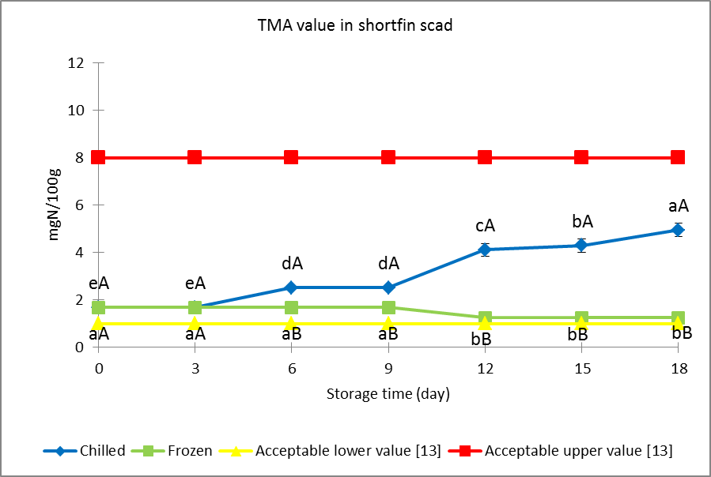
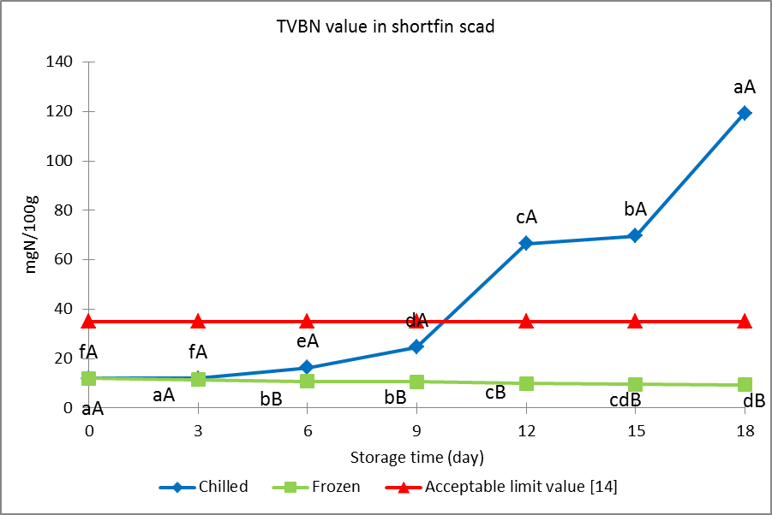
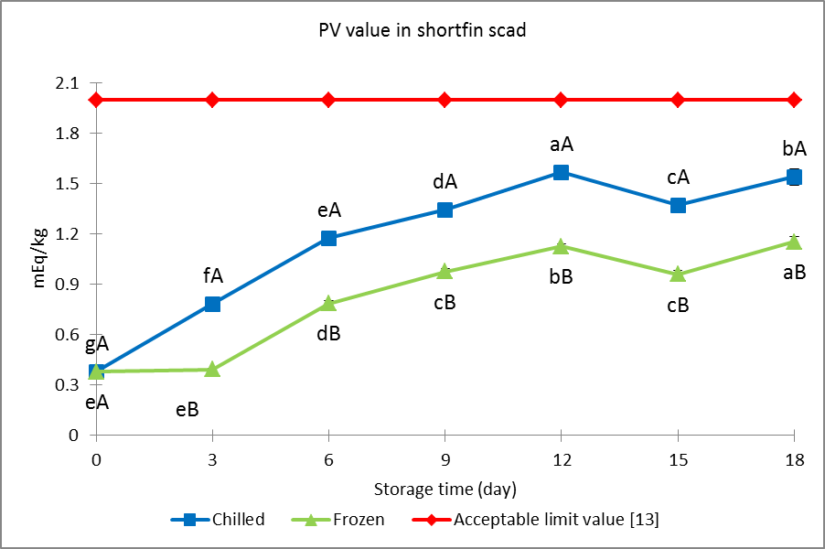
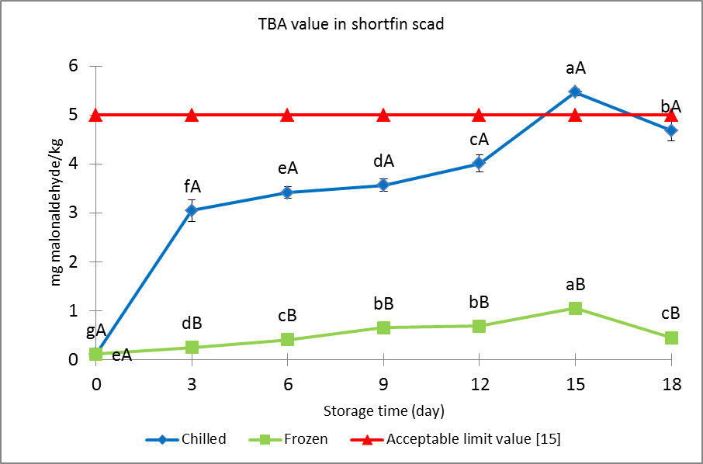
c
b
a
d
Figure 1. Changes in PV, TBA, TVBN and TMA for shortfin scad muscle at chilled (4 °C) and frozen (-18 °C) storage conditions for 18 days. *Values are expressed as mean (A, B) and (a, b, c) marked with different letters were significantly different at the level of p<0.05. Lower case letter indicate the effect of storage period of shortfin scad by day while upper case letter indicate the effect of storage condition at chilled (4°C) and frozen (-18 °C).

Figure 1c indicates there was significant differences (p<0.05) in TVBN between chilled and frozen shortfin scad started from day 3 up to day 18. The TVBN value in chilled condition increased rapidly from 11.95 mgN/100 g to 119.37 mgN/100 g and started to reach the upper limit at day 12, which was 66.55 mgN/100 g. This increased trend may be due to the production of amines by autolytic processes. The increment in TVBN in fish muscles during chilled condition is generally associated with activity of microorganisms during later stages of deterioration. This increase may be attributed essentially to ammonia produced from bacterial catabolism of nitrogen-containing compounds [6]. The TVBN are indices of the spoilage level of fish during the storage period [13, 15] and are affected by fish species [6, 16]. Based Ozyurt et al. [14] the TVBN value shall be less than 35mgN/100g to indicate the good quality for fishery product. Furthermore, Ozyurt et al. [14] reported that the TVBN value of red mullet at chilled condition increased from 26.19 mgN/100 g at day 8 to 47.18 mgN/100 g at day 11 of storage. For frozen condition TVBN value decreased slowly from 11.95 mgN/100 g to 9.33 mgN/100 g. Frozen fish quality can be determined from the amounts of TVBN, which is a product of proteolytic changes in fish meat. This decreased trend may due to prevention of changes in fish muscle caused by proteolysis. This same trend was reported by Jezek and Buchtova [17] that throughout the storage period of silver carp, no significant differences (p>0.05) in TVBN concentrations were found, and the TVBN concentration ascertained after 12 months of frozen storage was decreased from 15.99 mgN/100 g to 15.73 mgN/100 g. Hence frozen storage of fish is a reliable technique for prevention of changes in fish muscle caused by proteolysis.

Figure 1d reveals that there was significant difference (p<0.05) between chilled and frozen shortfin scad started from day 6 for TMA values. The TMA at chilled condition increased slowly from 1.68 mgN/100 g to 4.95 mgN/100 g during storage. For frozen shortfin scad, no significant difference (p>0.05) in TMA values was observed. The TMA values from day 0 to day 9 remained unchanged (1.68 mgN/100 g). The TMA value started to increase at day 12 (p<0.05) which was 1.25 ± 0.00 mgN/100g and also remained unchanged until day 18 (p>0.05). Temperature is very important in influencing TMA value. Natseba et al. [18] indicated that freezing inhibit bacterial activity and TMA accumulation. The TMA formation is due to activity of bacterial enzymatic decomposition of trimethylamine oxide (TMAO) and this occurs to a significant level only during logarithmic phase microbial growth [13]. The level of TMA in fish muscle depends on the species of fish and storage conditions [19]. According Orak et al. [13] TMA must be between 1 mg/100 g and 8 mg/100g to indicate good quality of fish.

Conclusion
The rate of chemical changes in muscle tissues of chilled and frozen shortfin scad differ significantly throughout 18 days of storage. Frozen storage delayed the spoilage of the fish due to oxidative and microbial activities compared to chilled storage. Hence, frozen storage is a reliable technique to preserve the quality of shortfin scad fish.

Acknowledgement
The authors would like to thank the European Commission (EU Grant no. 289282) for providing financial aid and Universiti Teknologi MARA (UiTM) for technical support and facilities.

References
- Nurnadia, A. A., Azrina, A. and Amin, I. (2011). Proximate composition and energetic value of selected marine fish and shellfish from the West Coast of Peninsular Malaysia. International Food Research Journal, 18, 137- 148.
- Rosari, M. I., Ma’arut, W. F., and Agustini, T. W. (2014). Pengaruh ekstrak kasar buah mahkota dewa (Phaleria macrocarpal) sebagai antioksidan pada fillet ikan bandeng (Chanos chanos forsk) segar. Jurnal Pengolahan dan Bioteknologi Hasil Perikanan, 3(2), 34-43.
- Azhar, K. F. and Nisa, K. (2006). Lipid and their oxidation in Seafood. Journal of The Chemical Society of Pakistan, 28(3): 289-305.
- Yuanita, L. (2006). Oksidasi asam lemak daging sapi dan ikan pada penggunaan natrium c tripolifosfat pemasakan dan penyimpanan. Jurnal Ilmu Dasar, 7(2): 194-200.
- Simeonidou, S., Govaris, A., and Vareltzis, K. (1998). Quality assessment of seven Mediterranean fish species during storage on ice. Food Research International, 7: 479-484.
- Zeway, A. L. A. (2013). Microbiological and chemical changes of nile tilapia (Oreochromis niloticus L.) fillet during ice storage: effect of age and sex. Advance Journal of Food Science and Technology, 5(10): 1260-1265.
- Bouriga, N., Selmi, S., Faure, E. and Trabelsi, M. (2008). Changes in proximate composition and lipid quality of atherina (Atherina Sp.) during sun drying process. Bulletin Institute National Science Technology 35: 69-72.
- Razak, Z. K. A., Basri, M., Dzulkefly, K., Razak, C. N. A. and Salleh, A. B. (2001). Extraction and characterization of fish oil from monopterus albus. Malaysian Journal of Analytical Science, 7(1): 217-220.
- Association of Official Analytical Chemist, AOAC. (1990). Official Methods of Analysis of the Association of Official Analytical Chemists (15 edition). Washington D.C
- Tokur, B., Korkmaz, K. and Ayas, D. (2006). Comparison of two thiobarbituric acid (TBA) method for monitoring lipid oxidation in fish. E.U. Journal of Fisheries & Aquatic Sciences, 23(3-4): 331 – 334.
- Sallam, K. I. (2007). Chemical, sensory and shelf life evaluation of sliced salmon treated with salts of organic acids. Food Chemistry, 101(2): 592-600.
- Chaijan, M., Benjakul, S., Visessanguan, W. and Faustman, C. (2006). Changes of lipids in sardine (Sardinilla gibbosa) muscle during iced storage. Food Chemistry, 99: 83-91.
- Orak, H. and Kayisoglu, S. (2008). Quality changes in whole, gutted and filleted three fish spesies (Gadus euxinus, Mugil cephalus, Engraulis encrasicholus) at frozen storage period (-26°C). ACTA Scientiarum Polonorum Technologia Alimentaria, 7(3): 15-25.
- Ozyurt, G., Kuley, E., Ozkutuk, S. and Ozogul, F. (2009). Sensory, microbiological and chemical assessment of the freshness of red mullet (Mullus barbatus) and goldband goatfish (Upeneus moluccensis) during storage in ice. Food Chemistry, 114(2): 505 – 510.
- Kilinc, B., Cakli, S. and Kisla, D. (2003). Quality changes of sardine (Sardina pilchardus) during frozen storage. E.U. Journal of Fisheries & Aquatic Sciences, 20: 139 – 146.
- Fan, W., Sun, J., Chen, Y., Qiu, J., Zhang, Y. and Chi, Y. (2009). Effect of chitosan coating on quality and shelf life of silver carp during frozen storage. Food Chemistry, 115(1): 66 – 70.
- Jezek, F. and Buchtova, H. (2011). Monitoring of physicochemical changes in frozen fish muscle tissue. Agriculturae Conspectus Scientificus, 76(3): 201 – 204.
- Natseba, A., Lwalinda, I., Kakura, E., Muyenja, C. K. and Muyong, J. H. (2005). Effect of pre freezing icing duration on quality changes in frozen nile perch (Lates nitoticus). Food Research International, 35: 469 – 474.
- Robertson, G. L. (2010). Food packaging and shelf life: A practical Guide. Boca Raton: CRC Press.

