OXIDATION OF COMMERCIAL PETRONAS DIESEL WITH

TERT-BUTYL HYDROPEROXIDE OVER POLYMOLYBDATE

ALUMINA SUPPORTED CATALYST MODIFIED WITH

ALKALINE EARTH METALS

(Pengoksidaan Diesel Komersial Petronas dengan Tert-Butil Hidroperoksida bersama Pemangkin Polimolibdenum Diubahsuai dengan Logam Alkali)

Wan Nazwanie Wan Abdullah, Rusmidah Ali*, Wan Azlee Wan Abu Bakar

Department of Chemistry, Faculty of Science,

Universiti Teknologi Malaysia,

81310 UTM Johor Bahru, Johor, Malaysia

*Corresponding author: rusmidah@kimia.fs.utm.my

Abstract

Due to strict environmental legislation for ultra-low sulfur diesel fuels, increasing technical and operational challenges are imposed to conventional hydrodesulfurization (HDS) technology. Therefore, catalytic oxidative desulfurization (Cat-ODS) has been suggested to be an alternative method to replace a conventional method which is hydrodesulfurization. In this study, catalytic oxidation of commercial diesel was performed using an oil-soluble oxidant, tert-butyl hydroperoxide (TBHP), over polymolybdate supported on alumina MoO₃-PO₄/Al₂O₃ catalyst. A commercial Petronas diesel with 440 ppmw of total sulfur was employed to evaluate the elimination of sulfur compounds. Besides, the percentage of sulfur removal was measured by (GC-FPD). Alkaline earth metals, such as Calcium (Ca), Barium (Ba) and Strontium (Sr) were introduced on the surface of MoO₃-PO₄/Al₂O₃. The results showed that the catalytic activity decreased in the order, Ca/MoO₃-PO₄/Al₂O₃>Sr/MoO₃-PO₄/Al₂O₃> Ba/MoO₃-PO₄/Al₂O₃. The Ca/MoO₃-PO₄/Al₂O₃ catalyst was characterized by XRD and FESEM. XRD results showed that the best catalyst was highly amorphous while FESEM micrograph illustrated an aggregation and agglomeration of various particle sizes. The catalytic activity of Ca/MoO₃-PO₄/Al₂O₃ catalyst with various Ca/Mo ratios were also studied. When the Ca/Mo ratio was 15:85, the sulfur removal was the highest (79%) at 45ºC, 30 min and O/S molar ratio 3.0 with solvent = dimetylformamide (DMF), diesel/solvent ratio = 1.0.

Keyword: Oxidative desulfurization, commercial diesel, tert-butyl hydroperoxide, alkaline earth metals, polymolybdate, dimetylformamide

Abstrak
Disebabkan undang-undang alam sekitar yang ketat untuk bahan api sulfur diesel ultra-rendah, peningkatan cabaran teknikal dan operasi dikenakan kepada hydropenyahsulfuran konvensional teknologi (HDS). Oleh itu, penyahsulfuran oksidatif mengunakan pemangkin (Cat-ODS) telah dicadangkan untuk menjadi satu kaedah alternatif untuk menggantikan kaedah konvensional iaitu hydopenyahsulfuran. Dalam kajian ini, pengoksidaan diesel komersial telah dijalankan menggunakan oksida larut minyak, tert-butil hidroperoksida (TBHP) dan mangkin molibdena berpenyokong alumina, MoO₃-PO₄/Al₂O₃. Diesel komersial Petronas yang mengandungi sulfur 440 ppmw telah digunakan untuk menilai penyahsulfuran. Selain itu, peratusan penyingkiran sulfur telah diukur menggunakan (GC-FPD). Logam alkali, seperti Kalsium (Ca), Barium (Ba) dan Strontium (Sr) telah dicelup pada permukaan MoO₃-PO₄/Al₂O₃ pemangkin. Hasil kajian menunjukkan bahawa aktiviti pemangkin menurun mengikut susunan, Ca/MoO₃-PO₄/Al₂O₃ > Sr/MoO₃-PO₄/Al₂O₃ > Ba/MoO₃-PO₄/Al₂O₃. Pemangkin Ca/MoO₃-PO₄/Al₂O₃ telah dicirikan menggunakan XRD dan FESEM. Keputusan XRD menunjukkan pemangkin yang terbaik adalah sangat amorfus manakala FESEM mikrograf menggambarkan satu aglomerasi dalam pelbagai saiz zarah. Aktiviti pemangkin Ca/MoO₃-PO₄/Al₂O₃ dengan pelbagai nisbah Ca/Mo telah juga dikaji. Apabila nisbah Ca/Mo adalah 15:85, penyingkiran sulfur adalah tertinggi (79%) pada keadaan optimum: 45ºC, 30 min dan nisbah O/S molar = 3.0 dengan pelarut = dimetilformamida (DMF), nisbah diesel/pelarut = 1.0.

Kata kunci: penyahsulfuran oksidatif, diesel komersial, tert-butil hidroperoksida, logam alkali, polimolibdena, dimetilformamida.

Introduction

Sulfur in transportation fuels is a major source of air pollution. Ultra-deep desulfurization of fuels is a matter of major interest not only because of increasing environmental concern and legal requirements, but also because ultra-low-sulfur fuel is a key requirement for fuel cell applications [1]. In the near future, the requirements for sulfur content in the fuel will become more stringent – with zero sulfur emission from the transport fuel, which calls for the development of advanced technologies for ultra clean fuel. Thus, great efforts have been made todecrease the content of sulfur in diesel oil [2]. HDS can produce lower sulfur level diesel oil, but this technology needs heavy cost in operating and capital. Therefore, oxidative desulfurization (ODS) has been considered as a further new technology for deep desulfurization of light oil [3]. This desulfurization process includes two stages: (i), oxidation in a first step; and (ii), liquid extraction at the end [4]. It is evident that the greatest advantages of the ODS process are low reaction temperature and pressure, and the expensive hydrogen gas is not used in the process. Most of the studies have been concentrated on heterogeneous molybdenum and tungsten supported on alumina. Recently, Wan Abu Bakar et al. [5], reported that MoO₃/Al₂O₃ was an active catalyst for the oxidation of dibenzothiophenic compounds. Therefore, it is interesting to explore the behavior of polymolybdate based catalyst doped with alkaline earth metal as dopant in the ODS reaction of commercial diesel in this paper.

Materials and Methods

Materials

All solvents and reactants were purchased and used without further purification. Phosphomolybdic acid hydrate (Across Organic), magnesium nitrate hexahydrate (Sigma-Aldrich), barium nitrate (Sigma-Aldrich), calcium nitrate tetrahydrate (Sigma-Aldrich) and strontium nitrate (Sigma-Aldrich), λ- Al₂O₃ beads 3-5 mm diameter (Sigma-Aldrich), tert-butyl hydroperoxide 70 wt.% in water (Acros Organic), dimethylformamide (MERCK) were used in this research. The fuel tested was a commercial diesel fuel from Petronas, Malaysia with 440 ppmw of sulfur content.

Preparation and characterization of catalysts

Calcium, barium, and strontium-doped MoO₃-PO₄/Al₂O₃ were prepared at ratio 15:85 by dissolving phosphomolybdic acid either with barium nitrate or calcium nitrate tetrahydrate or strontium nitrate in the sufficient volume of water and the solution were used for impregnation of Al₂O₃ (surface area: 292 m²/g) at room temperature. The wet sample was dried overnight at room temperature before it was calcined at various temperatures for 5 h in air. XRD analysis was conducted by using Siemens D5000 crystalloflex X-Ray diffractometer equipped with 40 kV and 40 mA Cu target (λ CuKα) = 1.54Á) radiation. Using a step scan of 0.050° and a step time of a second per step, data were collected over the range of 2θ from 20° to 80°. FESEM-EDX analysis was accomplished by using Philips XL 40 microscope with energy of 15.9 kV coupled with EDX analyzer and bombarded using electron gun with tungsten filament under 25 kV resolutions to get the required magnification image.

Catalytic oxidative desulfurization

All oxidative desulfurization (ODS) reactions were conducted in a 100 mL round-bottom flask, equipped with a magnetic stirrer and fitted with condenser. In a typical run, the oil bath was first heated and stabilized at a constant temperature (45°C). Then, 10 ml of commercial diesel (440 ppmw) was added to the flask, followed by the addition of sulfur/TBHP in the ratio of 3 and 0.12 g catalyst. The mixture was refluxed for 30 minutes under vigorous stirring at atmospheric pressure. The oxidized diesel was extracted with DMF at ratio diesel/solvent = 1.0. The extraction process was conducted by vigorous stirring for 30 minutes followed by phase separation between diesel and solvent. The treated diesel was analyzed by gas-chromatography (Agilent 6890N GC) equipped with FPD detector.

Result and Discussion

Catalytic Evaluation: Effect of alkaline earth metal dopants

Malka and Tatibouet [6] reported that Ca was a promoter of MoO₃-PO₄/Al₂O₃ catalyst in the oxidation of methanol. In the present study, several alkaline earth metals were used to modify MoO₃-PO₄/Al₂O₃ catalysts. Figure 1 shows that the activity of catalysts for oxidation of commercial diesel with TBHP decreased in the order: Ca/MoO₃-PO₄/Al₂O₃ >Sr/MoO₃-PO₄/Al₂O₃ > Ba/MoO₃-PO₄/Ba/Al₂O₃. As reported by Chang et al. [7], molybdenum oxide was a typical example of poorly dispersed catalyst, because molybdenum oxide, such as MoO₃, and alumina are considered to have an acidic character, thus weak interaction between molybdenum oxide and alumina is expected. Since alkaline earth metals possess strong basic characters, therefore it is possible to improve the dispersion of MoO₃ on the alumina by the introduction of alkaline earth metals.

Figure 1. Effect of alkaline earth metal dopants on MoO₃-PO₄/Al₂O₃ catalyst calcined at 500 ºC for 5 h in the ODS reaction of commercial diesel

Effect of calcination temperature

Figure 2 shows the effect of calcination temperatures on Ca/MoO₃-PO₄/Al₂O₃ catalyst, calcined at 400, 500 and 600 ºC. The catalytic activity increase as the calcinations temperature was increased but further increase to 600 ºC would cause the decreasing of catalytic activity. This is because, the calcination temperature of 600 ºC could cause agglomeration of the catalyst particles thus decreasing the surface area consequently produces less active catalyst [8]. The optimum calcinations temperature obtained was 500 ºC.

Figure 2. Effect of calcination temperature on Ca/MoO₃-PO₄/Al₂O₃ catalyst in the ODS reaction of commercial diesel

Effect of Ca loading

The effect of Ca loading was carried out in order to investigate the optimum loading towards the performance of sulfur removal as shown in Figure 3. It clearly showed that an appropriate amount of Ca would increase the catalytic activity of the catalyst. The optimum calcium loading was 15 %. The excessive addition of Ca into the catalyst decreases the sulfur removal. It was due to the excess amount of Ca on the catalyst surface will cause the agglomeration to occur that reduced amount of active size.

Figure 3. Effect of Ca loading on Ca/MoO₃-PO₄/Al₂O₃ catalyst calcined at 500 ºC for 5 h in the ODS reaction of commercial diesel

Characterization of Catalyst

Table 1 shows the textural properties of the bimetallic oxide catalysts, obtained by EDX analysis. EDX confirmed the presence of Mo, P, and Ca in the catalyst. It can be seen that by increasing the calcination temperatures from 400 to 600 ºC, the composition of Ca element was getting lower. It was probably due to the agglomeration of Mo which will hinder the Ca species, hence decrease the composition of this element and also diminished the catalytic activity. As shown in Figure 4, increase the calcination temperature from 400 to 600 ºC leads to the formation of aggregates and agglomerates with undefined shapes and mixture of larger and smaller particles size.

Table 1. Elemental analysis of the monometallic and bimetallic oxide catalysts

Catalysts | Calcination T (°C) | Loading Mo (wt. %) | Loading  P (wt.%) | Loading  Ca (wt.%)
MoO₃-PO₄/Al₂O₃ | 500 | 15 | 0.63 | -
Ca/MoO₃-PO₄/Al₂O₃ | 400 | 16.30 | 2.16 | 0.5
Ca/MoO₃-PO₄/Al₂O₃ | 500 | 15 | 3.10 | 0.33
Ca/MoO₃-PO₄/Al₂O₃ | 600 | 16 | 3.3 | 0.14

The XRD diffraction patterns of the Ca/MoO₃-PO₄/Al₂O₃ catalysts (Figure 5) indicate that the catalyst calcined at 500 °C and 700 °C possess amorphous structure which made the molybdenum phase undetectable suggesting the presence of high dispersion monolayer of Mo on the catalyst. This phenomenon could be the reason of higher catalytic activity of Ca/MoO₃-PO₄/Al₂O₃ (15:85) catalyst calcined at 500 ºC .The oxide peak does not appear in the diffractogram probably due to the small particle size of Ca (<4 nm) which is beyond XRD detection limit and low Ca loading in the catalyst as shown in EDX data.

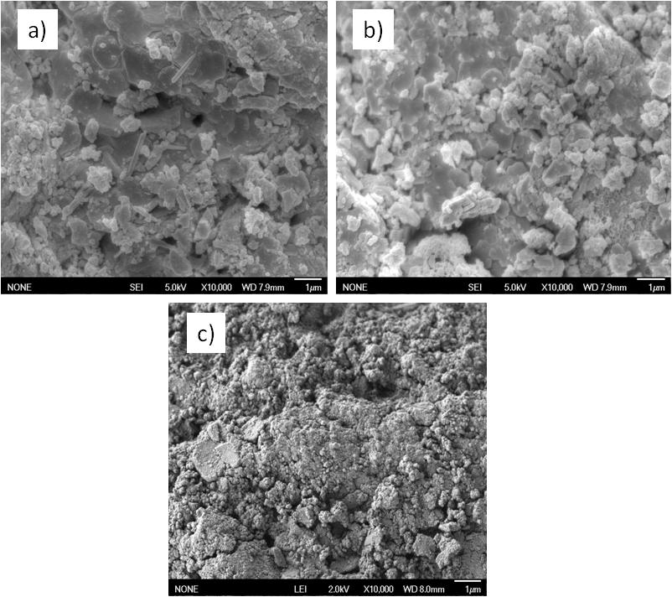

Figure 4. FESEM micrographs of Ca/MoO₃-PO₄ (15:85)/Al₂O₃ calcined at a) 400ºC b) 500ºC c) 600ºC. Magnification 10 k, scale bar 1µm

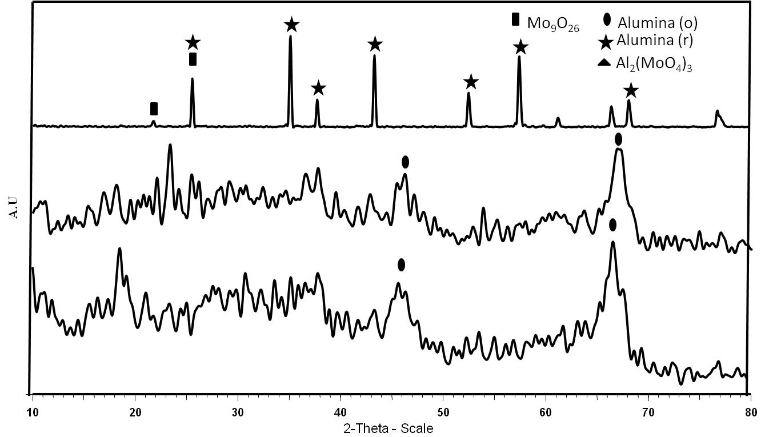
(b)
(a)
(c)

Figure 5. XRD diffractogram patterns of Ca/MoO₃-PO₄/Al₂O₃ calcined at (a) 500°C, (b) 700°C and (c) 900°C.

Increasing the calcination temperature at 900 °C led to the formation of crystalline Mo₉O₂₆ with new peaks obtained at 2θ value = 21.760° (I₁₀₀) and 25.85° (I₆₀) which attributed to base centered monoclinic phase. As shown in the diffractogram at 900 °C, the phase was dominated by alumina support which assigned as Al₂O₃ rhombohedral occurred at 2θ = 35.10° (I₁₀₀), 43.32° (I₉₄), 57.41° (I₇₉), 25.85º (I₇₄). It was claimed by Jones et al. [9] that catalysts calcined at temperatures above 500 °C showed high crystallinity. It was observed that the higher crystallinity and crystallize size of sample was observed at 900 °C than those treated at 500 °C and 700 °C suggesting that sample prepared at high temperature aggregate and agglomerate to form larger particle size with high crystallinity and also showed clear pattern of metal oxide. This results was agreement with our catalytic activity where the increased of calcinations temperature diminished the catalytic activity.

Mechanistic Study
The proposed peroxidic oxidation mechanism of DBT on Ca/MoO₃-PO₄/Al₂O₃ catalyst with TBHP is shown in Figure 6. The reaction pathway proceeded initially through the nucleophilic attack of TBHP on Ca/MoO₃₋PO₄/Al₂O₃ to form species (1). The oxidation process must proceed by nucleophilic attack of the sulfur in the DBT (2) on the positively charged peroxometallic complex (1) to form DBT sulfoxide (3) and regenerated polymolybdate species, respectively. Subsequently, the sulfoxide (3) undergoes further oxidation to form DBT sulfone (4) [2].

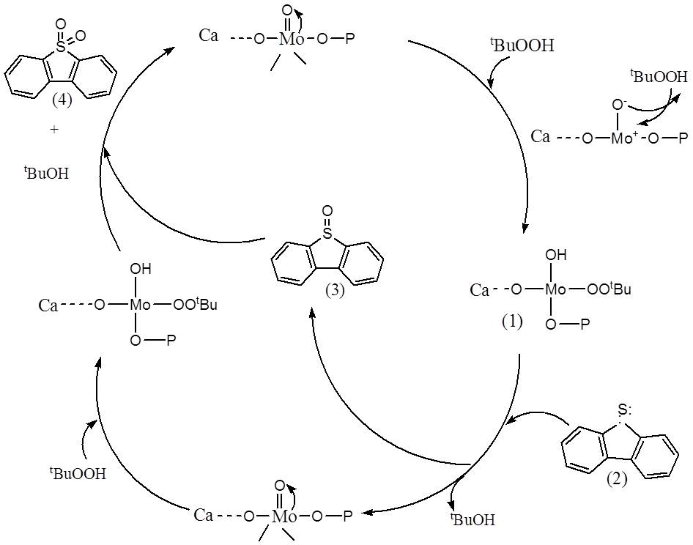

Figure 6. A proposed cyclic mechanism for the oxidation of dibenzothiophene by TBHP in the presence of

Ca/MoO₃-PO₄/Al₂O₃ catalyst

Conclusion

Sulfur level in the Malaysia commercial diesel can be reduced from about 440 ppmw to 92 ppmw of sulfur at 45 ºC under mild condition using polymolybdate based catalyst with alkaline earth metal as dopant. Further improvement on MoO₃-PO₄/Al₂O₃ catalyst using different dopants indicated that oxidative desulfurization (ODS) for commercial diesel has been achieved over the Ca/MoO₃-PO₄/Al₂O₃ (15:85) calcined at 500 ºC. The catalyst had good activity in the oxidative desulfurization with TBHP in diesel fuel. These results may indicate that alumina supported polymolybdate based catalyst has the potential to be used as catalyst in Cat-ODS to meet the future regulation of sulfur in diesel fuel.

Acknowledgement

The authors thank the Department of Chemistry, Faculty of Science, Universiti Teknologi Malaysia, Johor as well as to FRGS vot 4F195 for funding the project and Ministry of Higher Education (MOHE).

References

1. Chica, A., Corma, A. and Dómine M. E. (2006). Catalytic oxidative desulfurization (ODS) of diesel fuel on a continuous fixed-bed reactor. Journal of Catalysis, 242: 299 – 308.

2. Abdullah, W. N. W., Bakar, W. A. W. A. and Ali, R. (2014). Catalytic oxidative desulfurization of diesel fuel utilizing a polymolybdate alumina supported catalyst: Characterization, catalytic activity and mechanistic study. Reaction Kinetic Mechanism and Catalyst, 114:547 – 560.

3. Lifeng, W., Baode, S., Frances, H. Y. and Ralph, T. Y. (2012). Effects of aromatics on desulfurization of liquid fuel by p-complexation and carbon adsorbents. Chemical Engineering Society, 73:208 – 217.

4. Tam, P. S., Kittrell, J. R. and Eldridge J. W. (1990). Desulfurization of fuel oil by oxidation and extraction. 1. Enhancement of extraction oil yield. Industrial & Engineering Chemistry Research, 29(3): 321 – 324.

5. Wan Abu Bakar, W. A., Ali, R., Abdul Kadir, A. A. and Wan Mokhtar, W. A. (2012). Effect of transition metal oxides catalyst on oxidative desulfurization of model diesel. Fuel Processing Technology, 101: 78 – 84.

6. Malka, K. and Tatiboue, J. M. (1998). A two-step preparation of silica-supported calcium-molybdenum catalysts. Journal of Catalysis, 175: 204 – 212.
7. Chang, J., Wang, A., Liu, J., Li, X. and Hu, Y. (2010). Oxidation of dibenzothiophene with cumene hydroperoxide on MoO₃/SiO₂ modified with alkaline earth metals. Catalysis Today, 149: 122 – 126.
8. Wan Abdullah, W. N., Wan Abu Bakar W. A., Ali R. and Embong Z. (2015). Oxidative desulfurization of commercial diesel catalyzed by tert-butyl hydroperoxide polymolybdate on alumina: Optimization of Box-Behnken design. Clean Technologies and Environment Policy, 17: 433 – 441.
9. Jones, C., Cole, K. J., Taylor, S. H., Crudace, M. J. and Hutchings, G. J. (2009). Copper manganese oxide catalysts for ambient temperature carbon monoxide oxidation: Effect of calcination on activity. Journal of Molecular Catalysis A: Chemical, 305:121 – 124.

