

MALAYSIAN JOURNAL OF ANALYTICAL SCIENCES
ISSN 1394 - 2506

Published by The Malaysian Analytical Sciences Society

ELECTROCHEMICAL SYNTHESIS OF ORDERED TITANIA NANOTUBES IN MIXTURE OF ETHYLENE GLYCOL AND GLYCEROL ELECTROLYTE

(Sintesis Nanotiub Titania Bertertib Secara Elektrokimia dalam Campuran Elektrolit Etilena Glikol dan Gliserol)

Lim Ying Chin¹*, Zulkarnain Zainal^{2, 3}, Zuraida Khusaimi¹, Siti Sarah Ismail¹

¹School of Chemistry and Environment, Faculty of Applied Sciences,
Universiti Teknologi MARA, 40450 Shah Alam, Selangor, Malaysia
²Department of Chemistry, Faculty of Science
³Advanced Materials and Nanotechnology Laboratory, Institute of Advanced Technology (ITMA)
Universiti Putra Malaysia, 43400 UPM Serdang, Selangor, Malaysia

*Corresponding author: limyi613@salam.uitm.edu.my

Received: 24 February 2015; Accepted: 27 October 2015

Abstract
The electrolyte chemistry (nature and its composition) plays a critical role in determining the nanotube architecture and its growth process. In the present study, the formation of well-ordered titania nanotubes (TNT) is achieved by electrochemical anodization of titanium substrate in aqueous ethylene glycol-glycerol electrolyte (EG/Gly). The resulted samples were characterized using X-ray Diffraction (XRD) and the morphology changes were monitored by Field Emission Scanning Electron Microscopy (FESEM). Compositional changes of the titania nanotubes (TNT) were determined using Energy Dispersive X-ray Spectroscopy (EDX). The influence of anodization voltage, volume ratio of electrolyte and NH₄F content on the morphology and geometry of titania nanotubes have been investigated. The nature of electrolytes influenced the ordering and uniformity of nanotubes. In addition, nanotubes with various diameters ranging from 62 – 112 nm and lengths of 1.1 – 1.3 μm were obtained by controlling the anodization voltage and volume ratio of EG/Gly. Ultimately, anodization of Ti at 20 V in 1:1 volume ratio of EG/Gly containing 0.25 – 1.0 wt.% NH₄F appears to be an optimum condition for controlling the ordering of nanotubes.

Keywords: titania, nanotube, anodization, glycerol, ethylene glycol

Abstrak
Kimia elektrolit (sifat dan komposisinya) memainkan peranan kritikal dalam menentukan senibina nanotiub dan proses pertumbuhannya. Dalam kajian ini, pembentukan nanotiub titania (TNT) tertertib rapi boleh dicapai melalui penganodan subtrat titanium secara elektrokimia dalam larutan akueus etilena glikol-gliserol (EG/Gly). Pencirian sampel dilakukan menggunakan pembelauan sinar-X (XRD) dan perubahan morfologi pula diawasi menggunakan mikroskopi pengimbasan elektron pancaran medan (FESEM). Perubahan komposisi nanotiub titania ditentukan dengan penyerakan tenaga sinar-X (EDX). Kesan voltan penganodan, nisbah isipadu elektrolit dan kandungan NH₄F ke atas morfologi dan geometri nanotiub titania telah dikaji. Sifat elektrolit mempengaruhi penertiban dan keseragaman nanotiub. Tambahan pula, pelbagai diameter nanotiub berukuran dari 62 – 112 nm dan 1.1 – 1.3 μm panjang dapat dicapai melalui pengawalan voltan penganodan dan nisbah isipadu EG/Gly. Penganodan Ti pada 20V dalam nisbah isipadu 1:1 EG/Gly yang mengandungi 0.25 – 1.0 wt.% NH₄F merupakan keadaan optimum dalam pengawalan penertiban nanotiub.

Kata kunci: titania, nanotiub, penganodan gliserol, etilena glikol

Introduction
Water pollution problem had become a critical issue worldwide. Various methods had been used in order to remove the pollutants for instance; biodegradation, coagulation, adsorption, advanced oxidation process (AOP) and membrane process [1]. Many studies had found that semiconductor materials can photodegrade recalcitrant organic matter under the sunlight illumination using AOP [2,3]. One of them is titania (TiO₂), an inexpensive and photostable semiconductor, which had been studied extensively for the purification of water and air [4,5] due to its high oxidative power. There are three different crystalline structures of titania: anatase, rutile and brookite being anatase and rutile with tetragonal structure and brookite with orthorhombic structure. However, among these crystalline structures, anatase is metastable and is the most photoactive [6]. In this context, titania nanotubes (TNT) have received wide attention from the research community over the last decade because of its wide application in energy conversion and storage, photocatalysis, membrane and sensing. In order to fabricate and functionalize TNT, several methods such as sol-gel method, hydrothermal, and anodization have been used to modify the morphology and functions of TiO₂ [7]. Electrochemical anodization of Ti is one of the promising methods to produce self-organized nanotubes, which is more favorable for electron transport pathways in photoelectrode performance [8]. This method is a simple process that involves connecting the Ti substrate to an anode in electrolyte solution and then applying current/voltage. Other advantages include strong adhesion between oxide layers and the substrate and facile control of the surface morphology [9]. Generally, dilute fluoride anion containing electrolytes is used, with optimization anodization conditions and evaluates the parameters such as pH, water content, fluoride content, anodization voltage, and anodization time on the formation of tubes and resulting geometry [10]. Therefore, in the present work, an attempt is made to fabricate TNT by electrochemical anodization in ethylene glycol and glycerol electrolytes with different anodization parameters such as anodization voltage, volume ratio of ethylene glycol and glycerol and concentration of fluoride ions. The effects of these parameters are studied to observe the impact on the formation and morphology of the TNT.

Materials and Methods
Materials and instruments
Ti foils (0.127 mm, 99.7 % purity) was purchased from Sigma Aldrich and was used as substrate for producing ordered TiO₂ nanotubes film (TNT). Acetone and isopropanol (R&M Chemicals) were used in cleaning of Ti substrate. Ethylene glycol (Fisher, 99.8% p.a), glycerol (Fisher, 98.0% p.a) and ammonium fluoride (Fluka, 98.0%) were used as components for preparation of electrolytes used in anodization process. All reagents were used without further purification. Deionized water (Millipore Alpha Q System, 18.2 MΩ) was used throughout the experiments. Crystalline structure of the TNT films was determined by X-ray diffraction (XRD, Shimadzu D6000) using Cu K_{α} radiation (λ = 1.5406 Å). The surface morphological and cross sectional features of the films were studied using a field emission scanning electron microscope, FESEM (Zeiss, SUPRA 40 VP, Germany). Quantitative measurements of the geometrical features of TNT were done using image analysis software; Image J. FESEM micrographs were taken from at least three different locations on each sample to ensure the measurements of tube diameter were representatives and to calculate the samples variability (as indicated by the standard deviations). About 100 measurements of tube diameter were taken per sample. The tube length was measured directly from cross section images of mechanically bent samples. An energy dispersive X-ray (EDX) analyzer fitted to the Carl Zeiss FESEM chamber was used to analyze the composition of the as-anodized and calcined TNT films.

Preparation of titania nanotubes
The Ti foil was first cut into small rectangle of 1cm × 2cm. Then, it was cleaned by sonicating in acetone, 2-propanol and deionized water for 15 minutes each using an ultrasonicator (Analab Scientific Instruments). After that, the Ti foil was washed with deionized water and then dried at room temperature. The anodization process was conducted in a standard 2-electrode cell in which the Ti foil was served as the anode and the graphite electrode as the cathode. The distance between the two electrodes was fixed at 2 cm. Both electrodes were immersed in electrolyte containing ethylene glycol, glycerol, 50% deionized water and 0.5 wt% NH₄F. The voltage was provided by a DC power supply and the anodization process was carried out at room temperature under continuous stirring. Anodization was carried out at 20 V unless otherwise stated in 1:1 vol.% ethylene glycol and glycerol (herein denoted as EG/Gly) for 60 minutes except for the effect of electrolyte ratio. After anodization, the resulting films were immediately rinsed with deionized water and subsequently dried in air. The as-anodized films were amorphous initially. To induce crystallinity, the films were annealed at 500 ºC in a Thermolyne 21100 furnace for 2 hours with a heating rate of 2 ºC/min.

Results and Discussion
Effect of voltage
Electrochemical growth of TNT from Ti substrate is considered as a complex reaction, primarily involved three kinds of chemical effect, namely the electric field dissolution (shown as Eq. 1), electric field oxidation (shown as Eq. 2) and chemical dissolution (shown as Eq. 3).

Ti Ti⁴⁺ + 4e⁻ (1)
H₂O 2H⁺ + O²⁻ , Ti⁴⁺ + O²⁻ TiO₂ (2)
NH₄F NH₄⁺ + F⁻ , TiO₂ + 6F⁻ + 4H⁺ [TiF₆]²⁻ + 2H₂O (3)

At the beginning of anodization, TiO₂ layer is grown due to the electric field dissolution and oxidation. Due to accumulation of electric charge at the interface between TiO₂ and Ti, Ti⁴⁺ will disrupt the TiO₂ layer and formed nanapores. Consequently, the thickness of TiO₂ layer increases due to electric field dissolution and oxidation, but at the same time, TiO₂ nanopores layer becomes thinner due to chemical dissolution. Growth of nanotubes is believed to be the result of the TiO₂ layer moving forward to the Ti substrate by the effect of oxidation and dissolution continuously. The nanotubes are produced and elongated when the rate of electric field induced dissolution and oxidation of Ti is faster than the rate of chemical dissolution of TiO₂. If the electric field induced oxidation and chemical dissolution are equal, the TiO₂ nanotubes length would remain constant [11].

Figure 1 shows the current density profile of nanotubes formed at different voltage. Generally, current density drops intially followed by a sudden increase and continues to stabilize and reach an equilibrium. The current drop indicates the formation of TiO₂ layer on the Ti as shown in Eq. 2. After the formation of the oxide layer, the current density increases when the fluoride ions attack the TiO₂ layer which lead to the formation of nanotubes as shown in the Equation 3. When the voltage is increased, the electric current also increased until the titania layer is thick enough for electric resistance causing current to decrease. When the dissolution of titania and the formation of the nanotubes start, the current increases again. The electric current remains constant when equilibrium is achieved between the oxide formation and dissolution. From Figure 1, all samples show similar characteristics of the current density where current density increases with increasing voltage.

Figure 1. Current density profiles of titania nanotubes formed in 1:1 vol.% of EG/Gly at different voltage

Figure 2 shows the FESEM images of titania nanotubes anodized at different voltages range from 5V to 30V. It can be observed that Ti plate anodized at 5V demostrated porous structure as the voltage supplied was inadequate to form titania nanotubes. Similar observation was applied to the 10V Ti plate where the pore sizes are slightly bigger than that anodized at 5V. At 20 V, well-aligned and unifrom nanotubes can be seen clearly. The tops of the tubes are open and clean. The diameters of these nanotubes are about 86±11 nm with a wall thikcness of 17 ± 5 nm. However, when the applied voltage is too high (30 V), the nanotubes was destroyed or disintegrated, in which few nanotubes can be found among sponge-like structure. This is probably ascribed to electric field induced dissolution and oxidation occur too rapidly. The outer diameter of nanotubes fabricated at 30V is also bigger than that prepared at 20V, which is 122 ± 19 nm as higher voltage can strike out bigger pores leading to increase pore size with increasing voltage.

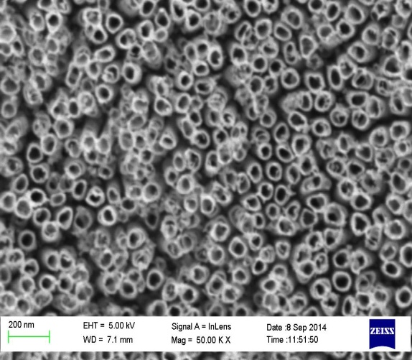
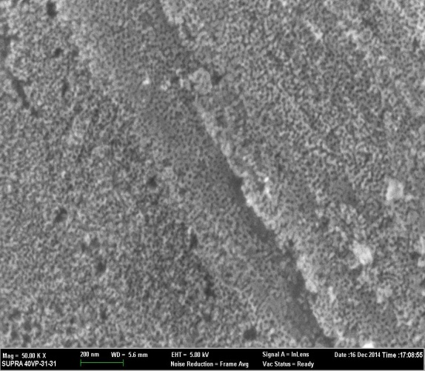
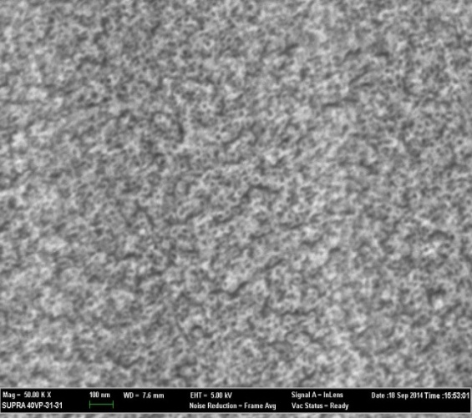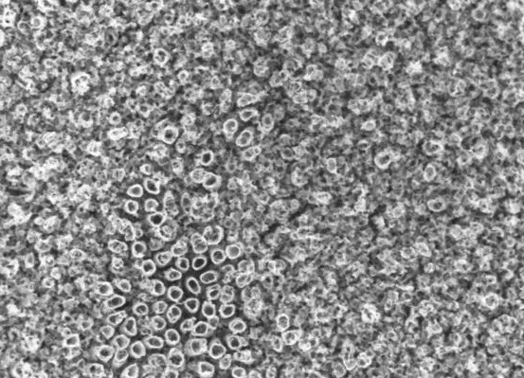
30 V
10 V
20 V
5V
20V

Figure 2. FESEM images showing the formation of titania nanotubes in 1:1 vol.% of ethylene glycol- glycerol for 60 minutes.

Effect of volume ratio of ethylene glycol-glycerol electrolyte
Ethylene glycol and glycerol are organic electrolytes with different viscosity, being the glycerol (945 cP) is more viscous than ethylene glycol (13.5 cP). The viscosity of the electrolyte affects the movement of ions during anodization process and thus resulting in formation of samples with different morphologies. To further compare the effects of electrolyte composition on the nanotubes growth process, mixture of different volume ratio of ethylene glycol and glycerol was explored. Figure 3 shows the FESEM images of titania nanotubes anodized at 20 V in different volume ratio of ethylene glycol and glycerol electrolyte. From Figure 3, it is obvious that equal ratio of both electrolytes gives uniform and clear nanotubes. However, nanotubes tend to clump together with increasing ethylene glycol ratio. In contrast to the observation obtained using different anodization voltage, there is no discernible change in nanotubes diameter as a function of volume ratio of ethylene glycol to glycerol. These nanotubes have a diameter of 85±10 nm with a wall thickness of 17 nm. When the ratio of glycerol is increased, nanotubes with larger diameter (102 ± 16 nm) were obtained. In addition, higher ratio of glycerol to ethylene yields more compact, uniform and well-aligned nanotubes, indicating the viscosity of the electrolyte has an effect on the uniformity and ordering of nanotubes.

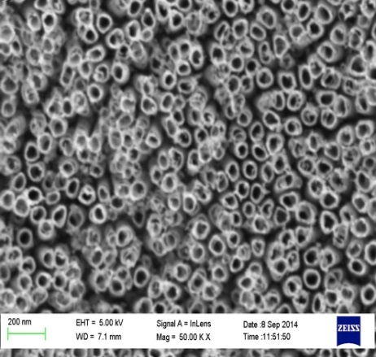
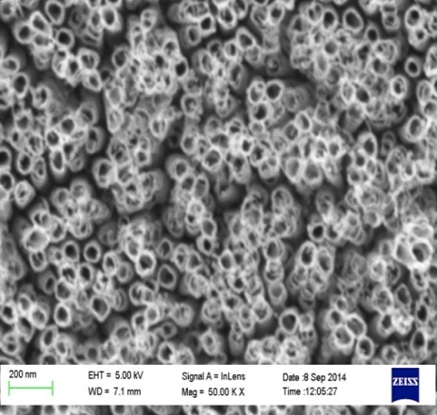
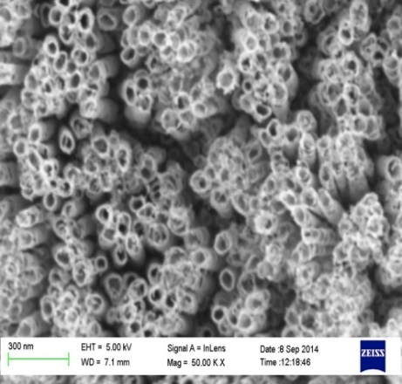
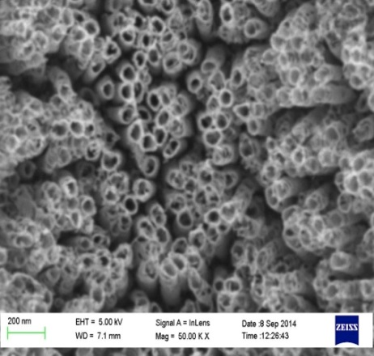
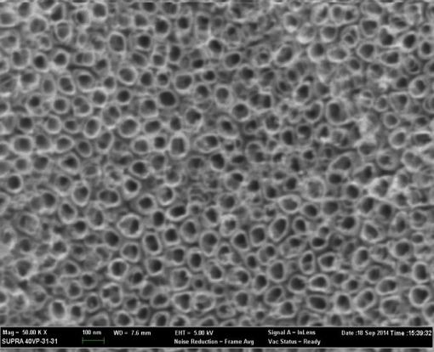
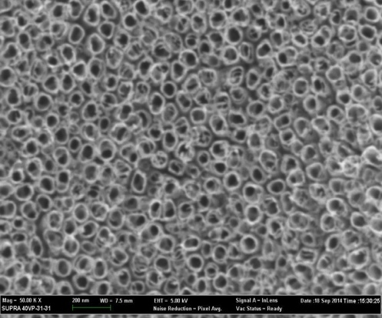
EG:Gly 1:3
EG:Gly 1:1
EG:Gly 2:1
EG:Gly 3:1
EG:Gly 4:1
EG:Gly 1:2

Figure 3. FESEM images of titania nanotubes anodized at 20 V in different ratio concentration of ethylene glycol/ glycerol electrolyte for 60 minutes

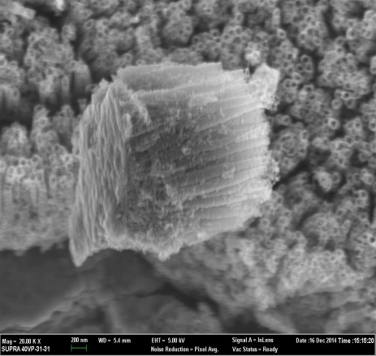
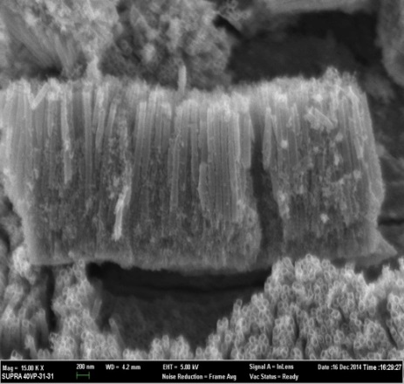
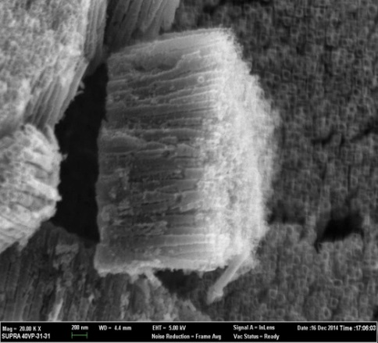
EG:Gly 1:1
EG:Gly 1:3
EG:Gly 4:1

Figure 4. Cross sectional FESEM images of titania nanotubes prepared in different volume ratio of ethylene glycol to glycerol electrolyte.

The lateral view of titania nanotubes with different ratio of EG/Gly in Figure 4 shows that the TiO₂ nanotubes are cylinder-shaped structure and the tubes are packed vertically side by side, and their average length is about 1.1-1.3 μm as shown in Table 1. It seems that the length of nanotubes was not much affected by the ratio composition in the present study where the highest nanotube length was obtained in 1:1 volume ratio of ethylene glycol to glycerol. With addition of water to the electrolyte (50 vol.% in this study), the viscosity of the electrolyte was reduced and thus relatively higher rate of chemical dissolution of TiO2 is expected. This caused the formation of ripples of the side wall of nanotubes as shown in Figure 4.

Table 1. Length measurements of titania nanotubes prepared in different volume ratio of
ethylene glycol to glycerol
Ratio concentration (EG:G) | Length (nm)
1:1 | 1320 ± 126
1:3 | 1112 ± 10
4:1 | 1275 ± 36

It is interesting to observe the difference of composition of TiO₂ anodized in different volume ratio of ethylene glycol to glycerol. Table 2 shows the EDX result of the as-anodized sample in EG:Gly 1:1 and calcined samples prepared in EG:Gly 4:1 and EG:Gly 1:3, respectively. Apart from the Ti and O, fluorine that originated from NH₄F and carbon from ethylene glycol or/and glycerol was found on the surface of the samples. The as-anodized sample contains higher amount of fluoride ions that act as the pore initiating agent than its calcined counterpart. This is because the fluoride ions were eventually lost during the calcination process. As for the calcined sample prepared in 1:3 EG:Gly, the sample still contain 1.5 wt.% fluorine and but in negligible amount. Same observation was obtained for calcined sample prepared in 1:1 and 4:1 EG:Gly where very little amount of carbon was found in the sample.

Table 2. Elemental composition of titania nanotubes prepared at 20 V in different volume ratio of
ethylene glycol to glycerol
Element | Weight %
Element | As-anodized EG:G  1:1 | Calcined EG:G  1:1 |  | Calcined EG:G  4:1 | Calcined EG:G  1:3
C | 0.91 |  | 0.79 | 1.17 | -
O | 41.29 |  | 35.43 | 41.65 | 41.80
F | 7.07 |  | 1.46 | - | 1.45
Ti | 56.46 |  | 56.59 | 57.18 | 56.75

The XRD patterns of the titania nanotubes formed in different volume ratio of ethylene glycol to glycerol upon calcination at 500 ºC are shown in Figure 5. Apparently, a mixture of anatase and rutile was observed for all samples, indicating the electrolyte nature has no effect on the crystal structure of TNT. The diffractions of Ti peaks can be observed at 2θ = 35.1º, 38.6º, 40.2º and 53.1º respectively. The anatase phase can be seen at 2θ = 25.4º, 38.0º, 48.2º, 54.0 and 55.2º corresponding to (101), (004), (200), (105) and (211) plane. Rutile phase was obtained at 2θ = 44.2º corresponding to (210) plane.

Figure 5. XRD patterns of TNT prepared at 20 V in different concentration ratio of EG:G. A, R and Ti represents anatase, rutile and titanium respectively

Effect of NH₄F concentration
Fluorides ions participate in the chemical dissolution reaction with negligible amount of them were deposited on the surface of TNT. However, most of them form [TiF₆]⁻ species in electrolyte as shown in Eq. 3 [12]. The presence of fluoride ions is a key factor to activate the pore drilling, which give rise to the formation of highly ordered nanotubes [13,14]. The influence of fluoride ions on the morphology of TNT is schematically presented in Figure 6.

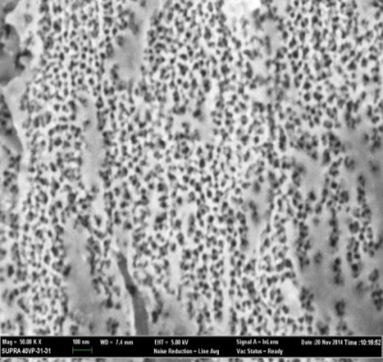
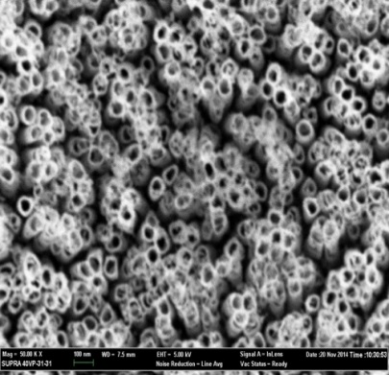
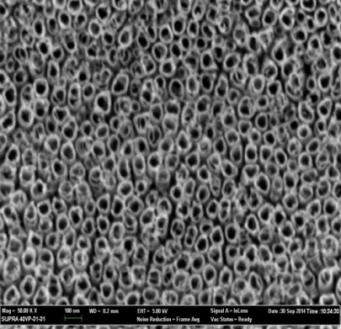
0.10 wt%
0.25 wt%
0.50 wt%

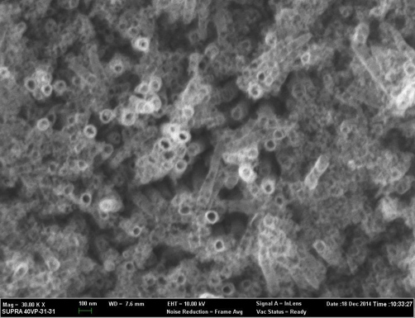
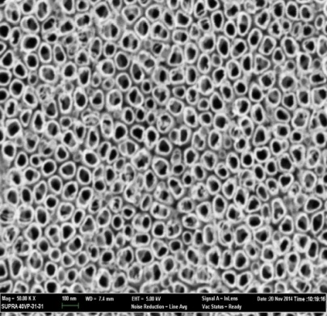
1.0 wt%
1.5 wt%

Figure 6. FESEM images of TNT prepared at 20 V in different NH₄F content in 1:1 EG: G for 30 minutes
Apparently, at a NH₄F content of 0.1 wt.%, only an ordered porous TiO₂ film is obtained. This result is attributed to the fact that chemical dissolution rate occurs too slowly to form nanotubes under low F⁻ content and thus only nanopores is obtained under such condition. Nevertheless, uniform, clean, and well-aligned nanotubes can be formed at NH₄F content of 0.25 wt. % to 1.0 wt.% NH₄F, indicating the amount of NH₄F is adequate for the formation of nanotubes. With increasing concentration of NH₄F to 1.5 wt.%, nanotubes tend to clump together and collapse eventually, ascribed to too rapid chemical etching rate. Table 3 shows the measurements of the nanotube diameter and wall thickness. Nanotubes formed in 1.0 wt. % resulted in bigger diameter and thicker wall, compared to those formed in 0.25 wt.% NH₄F.

Table 3. Measurements of TNT prepared at 20 V in different NH₄F content in 1:1 EG:G
for 30 minutes
Concentrations (wt.%) | Outer diameter (nm) | Inner diameter (nm) | Wall thickness  (nm)
0.10 | porous structure
0.25 | 96±14 | 62±11 | 17±4
0.50 | 92±11 | 57±9 | 18±5
1.00 | 112±10 | 75±4 | 17±3
1.50 | nanotubes collapse

Conclusion
In summary, TNT was successfully synthesized via electrochemical anodization of Ti in mixture of ethylene glycol and glycerol. Our results revealed that the electrolyte composition affects the morphological features and diameter of TNT. It was found that 20 V is the optimum voltage to form uniform and well aligned nanotubes with a diameter of 86 nm and 1.3 μm in length. A minimum of 0.25 wt.% NH₄F is required to yield an aligned nanotubes. Besides, volume ratio of EG/Gly has no effect on the crystal structure of the TNT formed but does affects the uniformity and ordering of nanotubes.

Acknowledgement
This material is based upon work supported by the Malaysia Toray Science Foundation through S&T research grant no.100-RMI/PRI 16/6/2 (7/2014) and the Ministry of Education through FRGS grant no. 600-RMI/FRGS 5/3 (1/2014). The authors would also like to acknowledge Faculty of Applied Sciences, Universiti Teknologi MARA (UiTM) for the facilities provided.

References
- Malengreaux, C. M., Léonard, G. M. L., Pirard, S. L., Cimieri, I., Lambert, S. D., Bartlett, J. R. and Heinrichs, B. (2014). How to modify the photocatalytic activity of TiO₂ thin films through their roughness by using additives. A relation between kinetics, morphology and synthesis. Chemical Engineering Journal, 243: 537 – 548.
- Hou, Y., Li, X., Zhao, Q., Quan, X. and Chen, G. (2010). Electrochemically assisted photocatalytic degradation of 4-chlorophenol by ZnFe₂O₄− modified TiO₂ nanotube array electrode under visible light irradiation. Environmental Science & Technology, 44 (13): 5098 – 5103.
- Li, Y., Ma, Q., Han, J., Ji, L., Wang, J., Chen, J. and Wang, Y. (2014). Controllable preparation, growth mechanism and the properties research of TiO₂ nanotube arrays. Applied Surface Science, 297: 103 – 108.
- Tekin, D. (2014). Photocatalytic degradation of textile dyestuffs using TiO₂ nanotubes prepared by sonoelectrochemical method. Applied Surface Science, 318: 132 – 136.
- Kumar, S. G. and Devi, L. G. (2011). Review on modified TiO₂ photocatalysis under UV/visible light: selected results and related mechanisms on interfacial charge carrier transfer dynamics. The Journal of Physical Chemistry A, 115 (46): 13211 – 13241.
- Erol, M., Dikici, T., Toparli, M. and Celik, E. (2014). The effect of anodization parameters on the formation of nanoporous TiO₂ layers and their photocatalytic activities. Journal of Alloys and Compounds, 604: 66 – 72.
- Zhang, Y., Yu, D., Gao, M., Li, D., Song, Y., Jin, R., Ma, W. and Zhu, X. (2015). Growth of anodic TiO₂ nanotubes in mixed electrolytes and novel method to extend nanotube diameter. Electrochimica Acta, 160: 33 – 42.
- Nishanthi, S. T., Subramanian, E., Sundarakannan, B. and Padiyan, D. P. (2015). An insight into the influence of morphology on the photoelectrochemical activity of TiO₂ nanotube arrays. Solar Energy Materials and Solar Cells, 132: 204 – 209.
- Komiya, S., Sakamoto, K. and Ohtsu, N. (2014). Structural changes of anodic layer on titanium in sulfate solution as a function of anodization duration in constant current mode. Applied Surface Science, 296: 163 –168.
- Sánchez-Tovar, R., Lee, K., García-Antón, J. and Schmuki, P. (2013). Formation of anodic TiO₂ nanotube or nanosponge morphology determined by the electrolyte hydrodynamic conditions. Electrochemistry Communications, 26: 1 – 4
- Yao, B. D., Chan, Y. F., Zhang, X. Y., Zhang, W. F., Yang, Z. Y. and Wang, N. (2003). Formation mechanism of TiO₂ nanotubes. Applied Physics Letters, 82 (2): 281 – 283.
- Xue, Y., Sun, Y., Wang, G., Yan, K. and Zhao, J. (2015). Effect of NH₄F concentration and controlled-charge consumption on the photocatalytic hydrogen generation of TiO₂ nanotube arrays. Electrochimica Acta, 155: 312 – 320.
- Liang, Y. Q., Cui, Z. D., Zhu, S. L. and Yang, X. J. (2011). Study on the formation micromechanism of TiO₂ nanotubes on pure titanium and the role of fluoride ions in electrolyte solutions. Thin Solid Films, 519 (15): 5150 – 5155.
- Ku, Y., Chen, Y. S., Hou, W. M. and Chou, Y. C. (2012). Effect of NH₄F concentration in electrolyte on the fabrication of TiO₂ nanotube arrays prepared by anodisation. Micro & Nano Letters, 7 (9): 939 –942.

