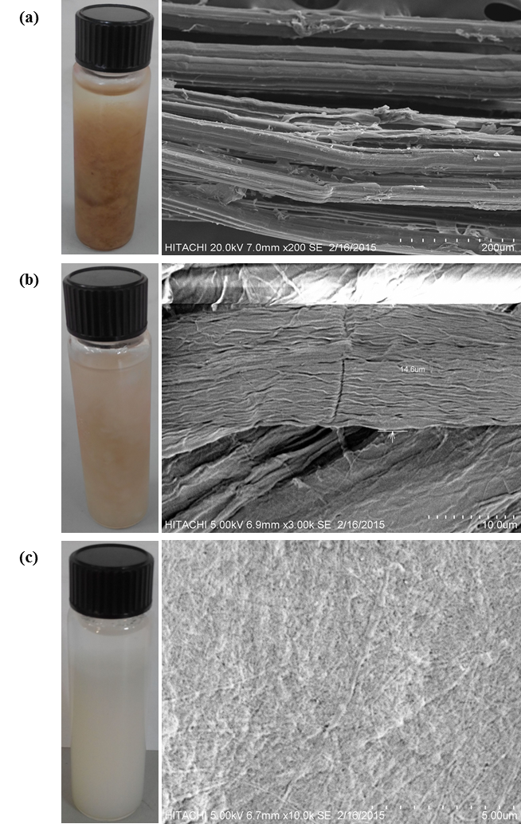

Figure 1

Figure 2

Figure 3

