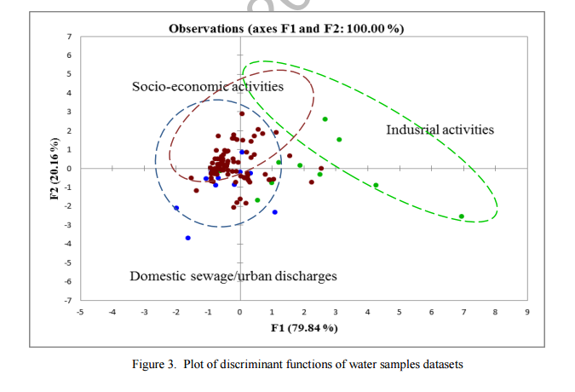
Please change the position of the three dot circle below (slightly down)

Figure 3. Plot of discriminant functions of water samples datasets

