

MALAYSIAN JOURNAL OF ANALYTICAL SCIENCES
ISSN 1394 - 2506

Published by The Malaysian Analytical Sciences Society

NEW METHYLTRIMETHOXYSILANE-(3-MERCAPTOPROPYL)-TRIMETHOXYSILANE COATED HOLLOW FIBER-SOLID PHASE MICROEXTRACTION FOR HEXANAL AND HEPTANAL ANALYSIS

(Pengekstrakan Mikro Fasa Pepejal-Gentian Berongga Tersalut Metiltrimetoksisilana-
(3-merkaptopropil)trimetoksisilana Baharu bagi Analisis Heksanal dan Heptanal)

Siti Munirah Abd Wahib¹, Wan Aini Wan Ibrahim^{1,2}*, Mohd Marsin Sanagi³

¹Separation Science and Technology Group (SepSTec), Department of Chemistry, Faculty of Science
²Frontier Materials Research Alliance
³Ibnu Sina Institute for Scientific and Industrial Research
Universiti Teknologi Malaysia, 81310 UTM Johor Bahru, Johor, Malaysia

*Corresponding author: wanaini@kimia.fs.utm.my; waini@utm.my

Received: 9 December 2014; Accepted: 16 October 2015

Abstract
Determination of volatile organic compounds (VOCs) in various matrices is often accomplished using solid phase microextraction (SPME) as a superior mode of extraction. Alternatively, another configuration of solid phase microextraction (SPME) namely hollow fiber-solid phase microextraction (HF-SPME) is a great approach to redress some limitations of the ordinary SPME fibers including fiber breakage, coating stripping and sample carry over. The HF-SPME technique highlights the use of hollow polypropylene (PP) membrane to hold and protect the adsorbent inside its lumen. Unlike the conventional SPME, the inexpensive HF device can be disposed after single use. Introducing extracting phase via sol-gel technology has gained great interest owing to its simple preparation method and promising way to obtain materials with good characteristics. In the present work, a new hybrid silica material based on methyltrimethoxysilane-(3-mercaptopropyl)trimethoxysilane (MTMOS-MPTMOS) was introduced as a new extractant of HF-SPME and the effectiveness of the proposed method was tested for analysis of hexanal and heptanal as the target VOC analytes. Preparation of the HF-SPME MTMOS-MPTMOS was simple in which the hybrid material was synthesized via sol-gel method and was self-polymerized in small segments of HF. Parameters affecting the efficiency of the HF-SPME MTMOS-MPTMOS in extracting both aldehydes were thoroughly investigated and analyzed by gas chromatography-flame ionization detection (GC-FID). It was found that the highest efficiency was achieved as the extraction was conducted in 30 min at a stirring rate of 1000 rpm in a 10 mL of sample solution whereby the back-extraction was performed via vortex for 3 min using 100 µL methanol as desorption solvent. Under the optimal conditions, linearity was observed over a range of 0.020-10.00 µg mL⁻¹ with detection limits of 0.015 µg mL⁻¹ and 0.010 µg mL⁻¹ for hexanal and heptanal, respectively. The applicability of the HF-SPME MTMOS-MPTMOS for analysis of hexanal and heptanal in human urine sample was proven from the quantitative recoveries (> 90%) achieved. The HF-SPME MTMOS-MPTMOS offers an attractive alternative for rapid and convenient extraction tool and showed good potential for analysis of hexanal and heptanal from aqueous samples.

Keywords: hollow fiber-solid phase microextraction, sol-gel hybrid, methyltrimethoxysilane, (3-mercaptopropyl)tri-methoxysilane, hexanal, heptanal

Abstrak
Penentuan sebatian organik meruap (VOC) dalam pelbagai matriks sering dicapai dengan pengekstrakan mikro fasa pepejal (SPME) sebagai mod unggul pengekstrakan. Sebagai alternatif, pengekstrakan mikro fasa pepejal-gentian berongga (HF-SPME) adalah pendekatan yang baik untuk mengatasi kekangan gentian SPME biasa termasuk kerapuhan gentian, salutan tertanggal dan baki sampel suntikan tertinggal. Teknik HF-SPME mengetengahkan penggunaan membran polipropilena (PP) berongga untuk memegang dan melindungi fasa pengekstrak dalam lumen HF. Tidak seperti konvensional SPME, alat HF yang murah boleh dibuang selepas sekali penggunaan. Menghasilkan fasa pengekstrak melalui teknologi sol-gel telah mendapat perhatian luas kerana kaedah penyediaan yang mudah dan cara yang memberangsangkan untuk menghasilkan bahan dengan ciri-ciri yang baik. Dalam kajian semasa, bahan silika hibrid baharu berdasarkan metiltrimetoksisilana-(3-merkaptopropil)trimetoksisilana (MTMOS-MPTMOS) telah diperkenalkan sebagai bahan penjerap baharu HF-SPME dan keberkesanan kaedah yang dicadangkan telah diuji terhadap analisis heksanal dan heptanal sebagai analit VOC sasaran. Penyediaan HF-SPME MTMOS-MPTMOS adalah mudah yang mana bahan hibrid ini telah disintesis menggunakan kaedah sol-gel dan telah diswapolimer di dalam segmen kecil HF. Parameter yang mempengaruhi kecekapan HF-SPME MTMOS-MPTMOS dalam mengekstrak kedua-dua aldehid telah dikaji dengan teliti dan dianalisis menggunakan kromatografi gas-pengesan pengionan nyala (GC-FID). Kecekapan tertinggi telah dicapai apabila pengekstrakan dijalankan selama 30 min pada kadar kacauan 1000 rpm di dalam 10 mL larutan sampel yang mana pengekstrakan-kembali dilakukan melalui vorteks selama 3 min menggunakan 100 µL metanol sebagai pelarut penyahjerapan. Pada keadaan optimum, julat linear ialah 0.020-10.00 µg mL⁻¹ dengan had pengesanan bagi heksanal dan heptanal masing-masing ialah 0.015 µg mL⁻¹ and 0.010 µg mL⁻¹. Kesesuaian HF-SPME MTMOS-MPTMOS untuk analisis heksanal dan heptanal dalam sampel air kencing manusia terbukti dengan perolehan kuantitatif yang dicapai (> 90%). HF-SPME MTMOS-MPTMOS menawarkan alternatif menarik sebagai alat pengekstrakan yang cepat dan mudah serta menunjukkan potensi yang baik untuk analisis heksanal dan heptanal daripada sampel akueus.

Kata kunci: pengekstrakan mikro fasa pepejal-gentian berongga, hibrid sol-gel, metiltrimetoksisilana, (3-merkaptopropil)-trimetoksisilana, heksanal, heptanal

Introduction
Aldehydes are common carbonyl compounds that take part in the pathology of certain diseases and their presence have been suggested as degradation products of lipid peroxidation [1, 2]. Besides, aldehydes were predominately VOCs biomarker found at elevated concentrations level in lung cancer subjects. In particular, hexanal and heptanal have been extensively studied as potential lung cancer biomarkers that can be measured in different biological samples [3 – 6]. The accurate determination of volatile compounds in biological samples is a major constraint due to the presence of overwhelming matrix effects and the analyte concentration might be too low to be analysed directly. Thus, searching for a reliable extraction technique is of vital importance. The prevalent extraction method employed to analyze aldehydes is solid phase microextraction (SPME) [2 – 6]. Specifically, carboxen/ polydimethylsiloxane (CAR/PDMS) [3] and polydimethylsiloxane/divinylbenzene (PDMS/DVB) [4 – 6] are two well-known SPME fibers that were used for the determination of aldehydes. SPME is a rapid and simple technique. Extraction, preconcentration and sampling can be carried out as a single step. However, SPME has certain limitations such as commercially available fibers are not chemically stable due to mere physical deposition or partial cross linking of the polymer coating. In addition, the ordinary SPME fibers suffer from low recommended operating temperature, fragile, limited lifetime and is expensive [7, 8]. Other than ordinary SPME fiber, several methods were developed for analysis of hexanal and heptanal in biofluids [9 – 11]. However, the proposed techniques involved complicated preparation material or extraction procedure. This is time consuming as it adds extra step in the sample preparation steps.

Sol-gel technology offers the simplest way to obtain adsorbent with good characteristic for extraction purpose. Various adsorbents were synthesized by sol-gel method including the combination of sol-gel precursors with other different coating materials to enhance the properties of extracting phase [12 – 16]. Some inherent advantages of sol-gel process that can redress the limitations of commercial SPME are; porous structure material with high surface areas for better analytes adsorption, coating is stable towards high temperature, good adhesion towards fiber as support owing to chemical bonding [17 – 19]. However, there are still several factors impeding the use of SPME fiber including troublesome in pre- and post-gelation treatment, long conditioning time needed before first use, and sample carryover during analysis. Emerging of different configurations of solid-based extraction is a promising solution and alternative to the above-mentioned problem.

Recently, Es’haghi et al. [20, 21] has come out with a new SPME approach namely hollow fiber-solid phase microextraction (HF-SPME). Instead of using a fiber, small segments of polypropylene HF were used for coating purpose. The possible memory effect can be avoided by discarding the HF tool after single use. Besides, the use of porous polypropylene enables to eliminate matrix interferences by prohibiting the larger molecules enter/adsorb onto the coated material, thus, promotes clean extraction. HF-SPME technique was successfully applied for the determination of different types of compounds including phenobarbital [21] organophosphorus pesticides [22, 23] selected aflatoxins [20], diclofenac and piroxicam [24], diethylstilbestrol [25], metronidazole [26] and heavy metals [27]. Introducing HF-SPME extracting phase via sol-gel method is a good approach since the HF can act as a medium to hold the sol-gel material and in the same time, simple preparation of sol-gel material can be accomplished by in-situ gelation process of sol solution in the lumen of HF. To the best of our knowledge, no development of sol-gel hybrid materials for use as adsorbent material has been reported for the determination of hexanal and heptanal, particularly for HF-SPME. Therefore, in the present work, the sol-gel material based on methyltrimethoxysilane-(3-mercaptopropyl)trimethoxysilane (MTMOS-MPTMOS) is proposed to be employed as the main extractant of HF-SPME for the determination of hexanal and heptanal in aqueous samples.

Materials and Methods
Standards and Chemicals

Methyltrimethoxysilane (MTMOS), (3-mercaptopropyl)trimethoxysilane (MPTMOS), trifluoroacetic acid (95%) and polymethylhydroxysiloxane (PMHS) were obtained from Aldrich (St. Louis, MO, USA). HPLC grade methanol was purchased from Fisher Scientific (Leicestershire, UK) and deionized water was produced from a Millipore water purification system (Molsheim, France). Accurel Q3/2 polypropylene tubular membranes from Membrana (Wuppertal, Germany) with a wall thickness of 200 μm, pore size of 0.2 μm, and an ID of 600 μm were used for the HF-SPME device. Hexanal and heptanal were purchased from Merck Schuchardt (Hohenbrunn, Germany). Individual stock solution (1000 µg/mL) of hexanal and heptanal was prepared by dissolving the calculated amounts in HPLC grade methanol and fresh working solutions were prepared in methanol daily by further dilution of the stock solution.

Instrumentation
A 7820A Agilent GC from Agilent Technologies (Waldbronn, Germany) equipped with a HP-5 (5% phenyl methyl siloxane) column (30 m × 0.32 mm ID and 0.23 µm film thickness), a split/splitless injector and flame ionization detector (FID) was used for analysis of extracted hexanal and heptanal. Helium was used as the carrier gas at a flow rate of 1 mL/min. The flow rate of air as oxidant was set at 400 mL/min while the flow rate of hydrogen was set at 30 mL/min. All gaseous sources were supplied from Linde Malaysia (Kuala Lumpur, Malaysia). The oven temperature program was as follows: initial temperature of 50 °C, ramp to 80 °C at a rate of 10 °C/min, then to 180 °C at a rate of 40 °C/min to obtain a run time of 5.5 min. The inlet temperature used was 250 °C and the FID temperature was set at 280 °C.

The sol-gel MTMOS-MPTMOS was characterized using a Perkin Elmer FT-IR Spectrometer (Shelton, USA) in the region 650-4000 cm⁻¹ via attenuated total reflectance (ATR) method. The images of the HF-SPME MTMOS-MPTMOS was captured with a Hitachi S3400N scanning electron microscopy (SEM) (Tokyo, Japan) using back-scattered electrons (BSE) mode at an accelerating voltage of 15 kV and low vacuum of 30 Pa.

HF membrane preparation
The polypropylene (PP) HF membrane was cut into ~ 2.5 cm segments and cleaned with acetone. It was then air dried before being injected with 6 µL of the prepared sol solution [22]. Both sides of the HF devices were heat-sealed before used. The sol solution was prepared by mixing appropriate volumes (µL) of precursors (MTMOS and MPTMOS), water, TFA (95%) as acid-catalyst, methanol (MeOH) as solvent and polymethylhydroxysiloxane (PMHS) in a 2 mL centrifuge tube to produce the desired mol ratios. The mixtures were vortexed for 2 min followed by centrifugation at 15 965 × g for 5 min. Then the homogenous solutions were directly injected into the lumen of the HF to allow for in-situ gelation. To ensure that the sol solidified in the HF, it was left at ambient temperature for overnight. The HF-SPME devices were then kept in an oven at 100ºC for further drying before use.

HF-SPME Procedure
Typical HF-SPME extraction was performed using direct immersion mode in a sample vial containing 10 mL of deionised water spiked with an appropriate volume of a working standard hexanal and heptanal solution to obtain a final concentration of 10.0 µg/mL. To achieve the highest extraction efficiency, systematic studies were performed in triplicate for the optimization of several parameters including extraction time (15 - 70 min), sample volume (3 - 20 mL), sample stirring rate (450 – 1000 rpm) and salt addition (0 – 2.0%, w/v). After extraction, the PP HF membrane tool was transferred into a 2 mL vial containing an appropriate volume of suitable organic solvent (methanol, MeOH) prior to desorption process. For back-extraction, vortex-assisted method was selected to desorb the extracted analytes for 3 min. Parameters affecting desorption process including desorption solvent volume (80 – 500 µL) and vortex speed (15.8 – 86.4 × g) were also studied.

Preparation of real samples
The urine samples were obtained from healthy volunteers and stored at -2°C. An aliquot of the human urine samples was spiked with an appropriate amount of hexanal and heptanal. The urine samples were then diluted two times with deionised water and filtration through a 0.20 µm membrane filter prior to extraction. The same extraction procedure was applied for the spiked human urine and blank human urine sample (without spiking), similar to above-mentioned HF-SPME procedure.

Method Validation

The analytical performance of HF-SPME MTMOS-MPTMOS was validated in terms of repeatability, linearity, limit of detection (LOD) and limit of quantification (LOQ) using the optimized extraction conditions. The within batch and inter-batch precision were evaluated based on relative standard deviation in which the repeatability of extraction was calculated using 4 replicates. Linearity was obtained from the construction of calibration curve from 0.020 - 10.0 µg mL⁻¹. The LOD was determined at signal-to-noise ratio (S/N = 3) whilst the LOQ was determined at signal-to-noise ratio (S/N = 10). Accuracy (recovery) of the proposed HF-SPME MTMOS-MPTMOS method was assessed by spiking 1.0 and 0.25 µg mL⁻¹ of hexanal and heptanal in human urine sample.

Results and Discussion
Preliminary Study
In order to assess the potential and effectiveness of the proposed sol-gel silica-based hybrid material in extracting hexanal and heptanal, effect of sol-gel process such as precursor, water, solvent and acid catalyst were optimized. Selection of optimal sol-gel synthesis was based on extraction efficiencies (measured by peak area response) obtained from GC-FID.

Effect of precursor
Precursors are the backbones of sol-gel polymer and synthesis of extracting phase using only precursors is much easier, faster, cheaper and more controllable as compared to addition of coating polymer [28]. In this study, the extracting phase was synthesized based on two precursors; MTMOS and MPTMOS. MTMOS is a good selection of precursor as the sol-gel network originating from an alkyl derivative of a tetraalkoxysilane precursor possesses a more open structure which can minimize cracking and shrinkage problems during drying step [29]. Meanwhile, the addition of MPTMOS that possess thiol (-SH) moiety can alter the polarity of the sol-gel hybrid formed thus enhance the possibility to extract the two mid-polar hexanal and heptanal more effectively.

Initially, the MTMOS amount was kept constant at 1 mmol whereas the addition of MPTMOS was evaluated at different mol ratios (1 – 7 mmol). Trifluoroacetic acid (TFA) as acid catalyst and methanol (MeOH) as solvent were fixed at a 2.5 and 6.0 mmol, respectively. PMHS as a deactivation agent (25 µL) was added to each sol solutions. As the mol ratios of MTMOS: MPTMOS was increased gradually from 1:1 to 1:4, better peak area response of hexanal and heptanal was obtained. However, further increase of MPTMOS from 5 mmol to 7 mmol resulted in a decrease of extraction performance for the two aldehydes. At higher mol of MPTMOS, the increase number of thiol moieties possibly led to covalent formation of disulphide (-S-S) [30]. This behavior decreased the number density of the bridging oxygen -Si-O-Si- as the network backbone thus alter the features of the sol-gel material in which the coated HF-SPME was easily ruptured. Therefore, the mol ratio 1:4 MTMOS: MPTMOS was selected as the optimum sol-gel composition and was used for further study.

Effect of water
Water is needed in sol-gel process to hydrolyze the precursors to form the reactive species for condensation reaction that leading to the formation of 3-D network [31]. In the present work, the sol-gel based on 1:4 mol ratio MTMOS: MPTMOS materials were prepared using different mol ratios of water from 3 mmol to 9 mmol, keeping the other amount constant (6 mmol MeOH, 2.5 mmol TFA). Addition of 3 mmol water in sol solution resulted in the lowest extraction efficiency of hexanal and heptanal. It is possible that in the presence of small amount of water content in sol system, both precursors (MTMOS and MPTMOS) compete with each other to be hydrolyzed and only partial of the precursors enable to form reactive species for further reaction process. As the water content was increased from 3 mmol to 6 mmol, increasing in peak areas response were observed for hexanal and heptanal. Based on stoichiometric calculation, both MTMOS and MPTMOS have three methoxy groups each that can be hydrolyzed. This is parallel with the results obtained as the addition of 6 mmol of water in the sol system gave the highest peak area response. Further increase of water content from 7 to 9 mmol resulted in a reduction of extraction performance of the sol-gel hybrid material. It seems that the addition of higher volume of water content may not be necessary as water is also eliminated during the condensation process to produce the 3-D networks. In short, 6 mmol was selected as the optimum amount of water and was used for further investigation on sol-gel synthesis optimization.

Effect of acid catalyst
Catalyst plays a role in hydrolysis part of sol-gel process in which under acidic condition, the sol solution will undergo polymerization to form long, linear and poorly cross-linking material which is suitable for coating purpose or thin film end-product [32]. TFA, commonly used as acid catalyst, was adopted in this study. TFA is favourable since the organic acid could disperse in the organic matrix more evenly as compared to inorganic acid and enable to minimize crack formation as reported by Chen and co-workers [33]. The different mol of TFA varied from 1 mmol to 3.5 mmol were mixed in the sol solution consisting of 1 mmol MTMOS, 4 mmol MPTMOS, 6 mmol water and 6 mmol MeOH. According to the peak areas obtained (data not shown), using 2.5 mmol TFA (95%) gave the highest extraction efficiency, hence, was selected as the optimum acid mol in sol-gel MTMOS-MPTMOS.

Effect of solvent
Solvent is added in sol system to facilitate mixing of sol-gel precursors, water and deactivating reagents into a homogenous system [34]. In the current work, MeOH was used as the sol-gel solvent system and the effect of the solvent was investigated from 4-9 mmol. Higher peak areas of hexanal and heptanal were observed as MeOH was increased from 4 mmol to 7 mmol in sol solution. The apparent increase in signals is due to the increase amount of solvent which will favor more precursors to be solvated, hence increase the reaction rates of polymerization. However, addition of higher volumes of solvent (8 mmol and 9 mmol) caused a reduction in peak area performance for both hexanal and heptanal. This behavior is probably due to the excess amount of solvent which will dilute the sol solution and thus reduce the precursor concentration [31]. Thus, 7 mmol MeOH was selected as the optimum solvent to be added in the sol solution.

In brief, the optimum sol-gel MTMOS-MPTMOS in extracting the two aldehydes was 1 mmol MTMOS, 4 mmol MPTMOS, 6 mmol H₂O, 7 mmol MeOH, 2.5 mmol TFA (95%) and PMHS was added at a constant volume (25 µL) in the sol solutions. The optimization of sol-gel synthesis become more convenient and faster as the preparation of sol solution involved merely one-pot reaction at mild condition including vortex and centrifugation procedure before directly injected into the lumen of HF (the whole process takes ~10 min). Likewise, sol-gel hybrid is simply self-polymerized after left overnight and no troublesome post-gelation procedure is needed. SEM image of HF-SPME MTMOS-MPTMOS device is shown in Figure 1. It can be seen a thin layer coating surrounded the inner wall of hollow fiber with estimated thickness of 30 µm. Meanwhile, the small insert image indicates the sol-gel coating possesses a porous surface in which the pores are evenly distributed with average pore size of ~0.7 µm.

FTIR Characterization
To prove the existence of inorganic-organic networks in the synthesized material, the material was characterized using FTIR. The absorption bands of sol-gel hybrid MTMOS-MPTMOS spectrum are nearly identical to both spectra of MTMOS and MPTMOS precursors (Figure 2). The broad absorption band at wave number 3397.14 cm⁻¹ corresponds to -OH stretching mode. This is possibly due to the presence of water or methanol in the sol-gel material. CH-stretching mode can be observed at wave number 2930.41 cm⁻¹ but at lower intensity as compared to precursor’s spectra. A very weak absorption band at 2556.02 cm⁻¹ is due to the existence of thiol (-SH) functional group in the sol-gel hybrid. Even though the intensity is very low, it is similar to the absorption of pure MPTMOS precursor. Two wave numbers at 1000.15 cm⁻¹ and 1091.13 cm⁻¹ correspond to Si-O-Si absorption. The presence of the two bands with broader absorption at 1000.15 cm⁻¹ and 1091.13 cm⁻¹ as compared to spectra of MTMOS and MPTMOS precursor indicates that siloxane chains become longer or branched, hence proved the successful polymerization of alkoxides to form Si-O-Si network.

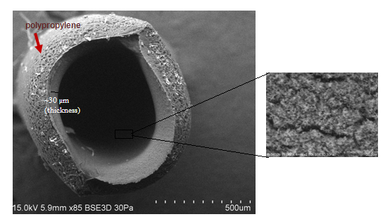
Figure 1. SEM images of sol-gel hybrid MTMOS-MPTMOS HF-SPME at × 85 magnification

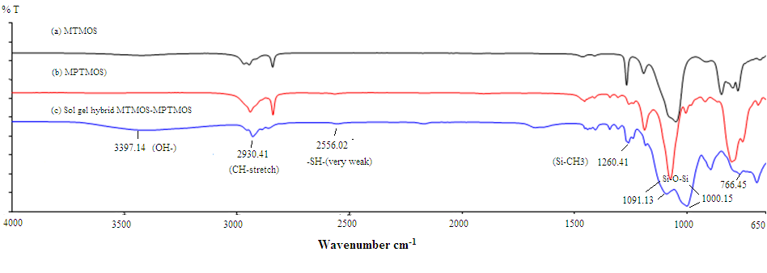

Figure 2. FTIR spectra of (a) MTMOS, (b) MPTMOS and (c) sol-gel hybrid of MTMOS-MPTMOS

Optimization of HF-SPME Performance
To obtain the highest extraction efficiency in extracting the two target aldehydes in aqueous samples, several parameters affecting the HF-SPME MTMOS-MPTMOS extraction performance were evaluated and optimized.

Selection of desorption method
Two desorption methods namely ultrasonication and vortex were used to back-extract the two analytes of interest. It was found that 20 min was the optimum desorption time using ultrasonication technique. In contrast, comparable peak efficiency for both aldehydes was obtained when desorption was performed via vortex for 3 min. As shorter analysis time is more practical, desorption via vortex for 3 min was selected for subsequent study.

Effect of extraction time
HF-SPME technique is based on an equilibrium process in which mass transfer is time-dependent. Thus, extraction time is a crucial factor to be optimized as the solute molecules need sufficient time to transfer from sample solution to HF interface and adsorbed onto the sol-gel material [21, 22]. In this work, different extraction times ranging from 15 min to 70 min were evaluated at ambient temperature and other extraction parameters were kept constant at a stirring rate of 600 rpm and sample volume of 10 mL while back-extraction was performed via vortex-assisted for 3 min using 100 µL MeOH (Figure 3). The selectivity of the fibre was found to be significantly higher for heptanal compared to hexanal. The extraction efficiency of hexanal and heptanal increased up to 30 min and no apparent signal differences was observed when extraction was increased from 40-70 min. Thus, 30 min was chosen as the optimum extraction time and was used for further study.

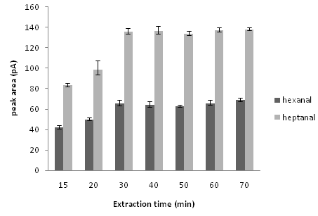

Figure 3. Effect of extraction time on the HF-SPME extraction efficiency (based on peak area). Extraction conditions: sample volume, 10 mL; stirring rate, 600 rpm. Desorption conditions: desorption solvent, MeOH; vortex assistance desorption for 3 min; vortex speed, 44.1 × g; desorption volume, 100 µL.

Effect of sample stirring rate and sample volume
Agitation of sample solution is favourable in extraction as it will shorten the required time needed for the analyte/s to reach equilibrium thus reduce the extraction time [21]. Effect of different stirring rate (450-1000 rpm) was tested for the HF-SPME MTMOS-MPTMOS extraction (Figure 4a). Higher stirring rate (beyond 1000 rpm) was avoided as it led to formation of excessive bubble during extraction and in the same time vigorous collision occurred between the HF and the vial wall. It was observed that higher stirring rate resulted in higher extraction efficiency as it can enhance the mass transfer of the analyte/s towards the extractant. Agitation at 1000 rpm showed the best extraction efficiency for hexanal and heptanal, thus, it was chosen as the optimum sample stirring rate.

During the HF-SPME process, the interaction between the analytes in the sample solution and the extractant is based on equilibrium, hence the ideal sample volume is also play a role to achieve the optimum extraction efficiency. Sample volume as a donor phase was varied from 3 – 20 mL (Figure 4b) for 30 min extraction time with an agitation rate of 1000 rpm while back-extraction was performed via vortex-assisted method for 3 min in 100 µL MeOH. Increasing the sample volume stepwise from 3 mL to 10 mL enhanced the peak areas of hexanal and heptanal. On the contrary, further volume increase to 15 mL and 20 mL gave poorer extraction efficiency for both aldehydes. This is probably due to poorer mass transfer kinetics in larger sample volume that resulted in the poor extraction efficiency observed. Therefore, 10 mL was chosen as the best sample volume for HF-SPME MTMOS-MPTMOS extraction.

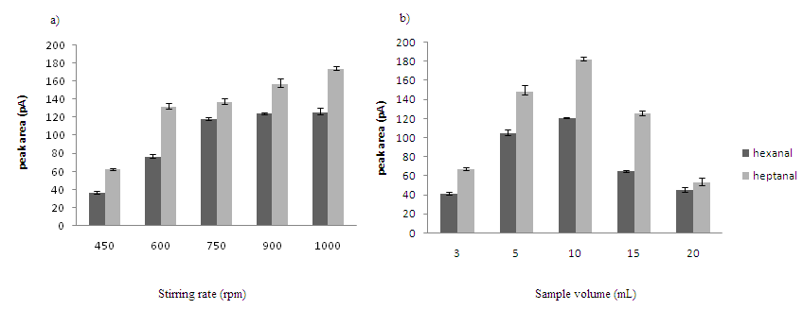

Figure 4. Effect of (a) sample stirring rate and (b) sample volume on the HF-SPME extraction efficiency (based on peak area). Other conditions are as in Figure 3.

Effect of salt addition
In most cases, salt is added to increase the ionic strength and to decrease the solubility of analyte/s in sample solution. In the present work, addition of sodium chloride was investigated at different concentrations from 0.5 - 2.0%, w/v (Figure 5) and the results were compared with the sample solution without the addition of sodium chloride. It was found that the higher the addition of salt concentration in sample solution, lower extraction efficiency of hexanal and heptanal was obtained. This is probably due to the presence of salt that can alter the properties of material coated in the tube of HF, change the diffusion rates hence, less analyte/s transfer to the extractant. Similar behavior was reported by Ebrahimi et al. [22]. Therefore, salt addition was not significant to be utilized for HF-SPME MTMOS-MPTMOS extraction of hexanal and heptanal.

Effect of desorption volume
Selection of appropriate volume of solvent is essential for the desorption capacity and to strip the analytes of interests from the sorbent phase. In this study, methanol was used as desorption solvent and the solvent volume was varied from 80 µL to 500 µL (Figure 6). Increase in extraction efficiency was observed for hexanal and heptanal when amount of the desorption volume was reduced. This is expected as the lower the desorption volume, the higher the preconcentration factor obtained. However, using a 80 µL desorption solvent resulted in peak decrease. The reason is, the volume level did not completely immerse the HF segments thus resulted in improper back-extraction of analyte/s. As the highest extraction efficiency was achieved using 100 µL of methanol, this volume was selected as the best desorption volume.

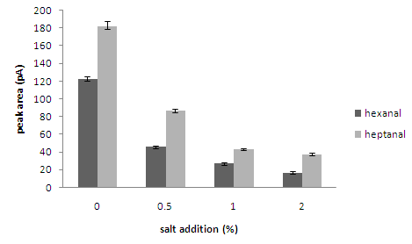

Figure 5. Effect of salt addition on the HF-SPME extraction efficiency (based on peak area). Other conditions are as in Figure 3.

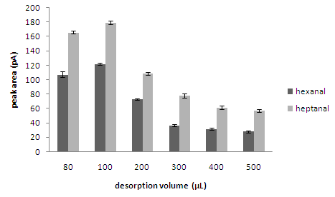

Figure 6. Effect of desorption volume on the HF-SPME extraction efficiency (based on peak area). Other conditions are as in Figure 3.

Effect of vortex speed
In this study, desorption was performed by vortex-assisted method. To select the ideal vortex speed, different vortex speed was explored within the range of 15.8 - 86.4 × g (Figure 7). As expected, increasing the speed of vortex provided higher extraction efficiency and the highest peak areas response of both aldehydes were obtained when the applied speed rate was 63.5 × g. Increasing the vortex speed to 86.4× g led to massive bubble formation and this is a fast speed to use to back-extract the analyte/s in 100 µL of desorption solvent, resulting in the reduction of extraction efficiency for both hexanal and heptanal. As vortex assistance desorption at 63.5 × g gave the highest extraction efficiency in determining hexanal and heptanal, it was chosen as the best vortex speed.

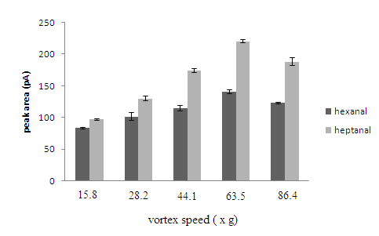

Figure 7. Effect of vortex speed on the HF-SPME extraction efficiency (based on peak area). Other conditions as in Figure 3.

Method Validation
Optimum extraction performance of hexanal and heptanal based on peak area response measured by GC-FID was achieved using 30 min extraction time, 1000 rpm agitation rate using 10 mL of aqueous sample, back-extraction of extracted analytes performed via vortex for 3 min at a speed of 63.5 × g using 100 µL methanol as the desorption solvent. Table 1 summarizes the calibration curve equation, limit of detection (LOD = 3 S/N), limit of quantification (LOQ = 10 S/N)) together with their coefficient of determination (R²) and precision (intra batch and inter-batch) of HF-SPME MTMOS MPTMOS under the optimum extraction conditions. Linearity order observed was 500 with good coefficient of determination (> 0.996).

Table 1. Calibration curve equation, coefficient of determination, LOD, LOQ and precision values (within batch and inter-batch) HF-SPME at optimum conditions
Compound | Calibration curve  Equation | Coefficient of determination  (R²) | LOD  (µg/mL) | LOQ  (µg/mL) | Within batch RSD  (%, n = 4) | Inter batch RSD  (%, n = 4)
Hexanal | y = 0.013x + 4.568 | 0.9985 | 0.015 | 0.040 | 3.82 | 7.86
Heptanal | y = 0.021x + 6.378 | 0.9969 | 0.010 | 0.030 | 3.25 | 9.36
Linear range: 0.020 –10.0 µg mL⁻¹

The applicability of the proposed HF-SPME MTMOS-MPTMOS method was tested on human urine from a healthy volunteer. Urine samples were spiked with hexanal and heptanal standard at certain concentrations after confirming the non-presence of the two aldehydes. Two levels of spiking were used in order to compare the recovery and precision values. Quantitative percentage recoveries were obtained for hexanal and heptanal (91.21 – 97.51 %, RSD < 5.5%, n = 3) (Table 2). Figure 8 shows the chromatograms of extract of blank and spiked urine samples (at 0.25 µg/mL of hexanal and heptanal) using HF-SPME MTMOS-MPTMOS. Based on the chromatograms, it is noticed that there was no significant interference from the sample matrix thus proved that HF-SPME method provided clean extraction.

Table 2. Average recovery of hexanal and heptanal in spiked urine sample
Analyte | Spiked concentration  (µg/mL) | Average recovery  (%) | RSD  (%, n = 3)
Hexanal | 1.0 | 97.51 | 3.28
 | 0.25 | 95.34 | 5.58
Heptanal | 1.0 | 93.16 | 4.00
 | 0.25 | 91.21 | 2.78
*All extractions were carried out at optimum conditions
*n = 3 (three different extractions)

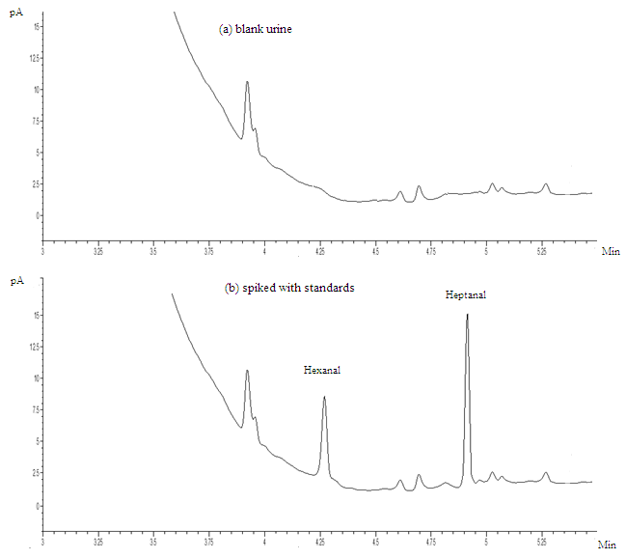

Figure 8. Chromatograms of a) blank urine sample b) extract of urine sample spiked with 0.25 µg/mL mixture of hexanal and heptanal using the proposed HF-SPME MTMOS-MPTMOS. Unknown peaks are most likely small molecular weight interferences from urine sample.

Conclusion

The sol-gel hybrid material, MTMOS-MPTMOS was successfully synthesized using mild conditions and used as a new adsorbent of HF-SPME for quantitative analysis of hexanal and heptanal from human urine samples with minimum sample preparation process. Several parameters affecting the extraction performance were successfully optimized and used in method validation. The proposed HF-SPME MTMOS-MPTMOS method is an easy and convenient microextraction technique that provides easy material preparation step and can be potentially applied for determination of hexanal and heptanal in human urine sample analysis.

Acknowledgement
The authors would like to thank Ministry of Higher Education Malaysia (MOHE) for the University Research Grant vote number 04H22 for the financial assistance. Ministry of Science, Technology and Innovation Malaysia (MOSTI) is also acknowledged for the MyBrain15 award to S. M. Abd Wahib.

References
- Fathy Bakr Ali, M., Kishikawa, N., Ohyama, K., Mohamed, H. A-M., Abdel-Wadood, H. M., Mohamed, A. M. and Kuroda, N. (2013). Chromatographic determination of aliphatic aldehydes in human serum after pre- column derivatization using 2,2’-furil, a novel fluorogenic reagent. Journal of Chromatography A, 1300: 199 –203.
- Li, N., Denga, C., Yao, N., Xizhong Shen, X. and Zhang, X. (2005). Determination of Acetone, Hexanal and Heptanal in Blood Samples by Derivatization with Pentafluorobenzyl Hydroxylamine Followed by Headspace Single-drop Microextraction and Gas Chromatography Mass Spectrometry. Analytica Chimica Acta, 540: 317 – 323.
- Deng, C, Zhang, X. and Li, N. (2004). Investigation of Volatile Biomarkers in Lung Cancer Blood using Solid-Phase Microextraction and Capillary Gas Chromatography-Mass Spectrometry Journal of Chromatography B, 808: 269 – 277.
- Deng, C., Li, N. and Zhang, X. (2004). Development of Headspace Solid-Phase Microextraction with On-Fiber Derivatization for Determination of Hexanal and Heptanal in Human Blood. Journal of Chromatography B, 813: 47 – 52.
- Poli D, Goldoni M, Corradi M. Acampa, O., Carbognani, P., Internullo, E., Casalini, A. and Mutti, A. (2010). Determination of Aldehydes in Exhaled Breath of Patients with Lung Cancer By Means of On-Fiber Derivatization SPME-GC/MS. Journal of Chromatography B, 878: 2643 – 2651.
- Guadagni, R., Miraglia, N., Simonelli, A., Silvestre, A., Lamberti, M., Feola, D., Acampora, A. and Sannolo, N. (2011). Solid-phase Microextraction-Gas Chromatography-Mass Spectrometry Method Validation for the Determination of Endogenous Substances: Urinary Hexanal and Heptanal as Lung Tumor Biomarkers. Analytica Chimica Acta, 701: 29 –36.
- Sarafraz-Yazdi, A. Dizavandi, Z. R. and Amiri, A. (2012). Determination of phenolic compounds in water and urine samples using solid-phase microextraction based on sol-gel technique prior to GC-FID. Analytical Methods, 4: 4316 – 4325.
- Sarafraz-Yazdi, A., Ghaemi, F., and Amiri, A. (2012). Comparative Study of the Sol-Gel Based Solid Phase Microextraction Fibers in Extraction of Naphthalene, Fluorene, Anthracene and Phenanthrene from Saffron Samples Extractants. Microchimica Acta, 176: 317 – 325.
- Xu, H., Wang, S., Zhang, G., Huang, S., Song, D., Zhou, Y. and Long, G. (2011). A Novel Solid-Phase Microextraction Method Based on Polymer Monolith Frit Combining with High-Performance Liquid Chromatography for Determination of Aldehydes in Biological Samples. Analytica Chimica Acta, 690: 86 – 93.
- Song, D., Gu, Y., Liang, L., Ai, Z., Zhang, L., and Xu, H. (2011). Magnetic Solid-Phase Extraction Followed by High Performance Liquid Chromatography for Determination of Hexanal and Heptanal in Human Urine. Analytical Methods, 3: 1418 –1423.
- Mieth, M., Kischkel, S., Schubert, J. K., Hein, D. and Miekisch, W. (2009). Multibed Needle Trap Devices for On Site Sampling and Preconcentration of Volatile Breath Biomarkers. Analytical Chemistry, 81: 5851 – 5857.
- Wan Ibrahim, W. A., Farhani, H., Sanagi, M. M., and Aboul-Enein, H. Y. (2010). Solid Phase Microextraction using New Sol-Gel Hybrid Polydimethylsiloxane-2 Hydroxymethyl-18-Crown-6-Coated Fiber for Determination of Organophosphorous Pesticides. Journal of Chromatography A, 1217: 4890 – 4897.
- Wan Ibrahim, W. A., Wan Ismail, W. N., Abdul Keyon, A. S. and Sanagi, M. M. (2011). Preparation and Characterization of a New Sol-Gel Hybrid Based Tetraethoxysilane Polydimethylsiloxane as a Stir Bar Extraction Sorbent Materials. Journal of Sol-Gel Science and Technology, 58: 602 – 611.
- Zheng, Y., Wang, D. and Tian, J. (2012). Preparation and Application of Multiwalled Carbon Nanotubes Microspheres/Poly(ethylene glycol) Coated Fiber for SPME. Advanced Materials Research, 512-513: 2084 - 2087.
- Wan Ibrahim W. A, Veloo, K. V. and Sanagi, M. M. (2012). Novel Sol-Gel Hybrid Methyltrimethoxysilane- Tetramethoxysilane as Solid Phase Extraction Sorbent of Organophosphorus Pesticides, Journal of Chromatography A, 1229: 55 – 62.

- Gao, Z., Deng, Y., Hu, X., Yang, S., Sun, C. and He, H. (2013). Determination of Organophosphate Esters in Water Samples Using An Ionic Liquid-Based Sol-Gel Fiber for Headspace Solid-Phase Microextraction Coupled to Gas Chromatography-Flame Photometric Detector. Journal of Chromatography A, 1300: 141 –150.
- Mu, Li., Hu, X., Weng, J. and Zhou, Q. (2013). Robust Aptamer Sol-Gel Solid Phase Microextraction of Very Polar Adenosine from Human Plasma. Journal of Chromatography A, 1279: 7 –12.
- Zhou, Z. P., Wang, Z. Y., Wu, C. Y., Zhan, W. and Xu, Y. (1999). Sol-Gel Method for the Preparation of Solid-Phase Microextraction Fibers. Analytical Letter, 32: 1675 –1681.
- Spietelun, A., Marcinkowski, Ł., de la Guardia, M. and Namieśnik, J. (2013). Recent Developments and Future Trends in Solid Phase Microextraction Techniques Towards Green Analytical Chemistry. Journal of Chromatography A, 1321:1 – 13.
- Es’haghi, Z., Orayaei, H., Samadi, F., Masrournia, M. and Bakherad, Z. (2011). Fabrication of A Novel Nanocomposite Based on Sol-Gel Process for Hollow Fiber-Solid Phase Microextraction of Aflatoxins: B1 and B2, in Cereals Combined with High Performance Liquid Chromatography-Diode Array Detection. Journal of Chromatography B, 879: 3034 – 3040.
- Es’haghi, Z., Rezaeifar, Z., Rounaghi, G-H., Nezhadi, Z. A., and Golsefidi, M. A. (2011). Synthesis and Application of A Novel Solid-Phase Microextraction Adsorbent: Hollow Fiber Supported Carbon Nanotube Reinforced Sol-Gel for Determination of Phenobarbital. Analytica Chimica Acta, 689: 122 –128.
- Ebrahimi, M., Es’haghi, Z., Samadi, F. and Hosseini, M-S. (2011). Ionic Liquid Mediated Sol-Gel Sorbents for Hollow Fiber Solid-Phase Microextraction of Pesticide Residues in Water and Hair Samples. Journal of Chromatography A, 1218: 8313 – 8321.
- Ebrahimi, M., Es’haghi, Z., Samadi, F. and Hosseini, M-S. (2012). Rational Design of Heteropolyacid-Based Nanosorbent for Hollow Fiber Solid Phase Microextraction of Organophosphorus Residues in Hair Samples. Journal of Chromatography A, 1225: 37 – 44.
- Song, X-Y, Shi, Y-P and Chen, J (2012). A Novel Extraction Technique Based on Carbon Nanotubes Reinforced Hollow Fiber Solid/Liquid Microextraction for the Measurement of Piroxicam and Diclofenac Combined with High Performance Liquid Chromatography. Talanta, 100: 153 – 161.
- Yang, Y., Chen, J. and Shi, Y-P. (2012). Determination of Diethylstilbestrol in Milk Using Carbon Nanotube- Reinforced Hollow Fiber Solid-Phase Microextraction Combined with High-Performance Liquid Chromatography. Talanta, 97: 222 – 228.
- Li, J., Wang, Y-B., Wu, L., Li, K-Y. and Feng, W. (2014). Fabrication of Multi-Walled Carbon Nanotubes/ Oxide Reinforced Hollow Fibers by Sol-Gel Technique for Rapid Determination of Metronidazole in Milk. Analytical Methods, 6: 1404 –1411.
- Su, S., Chen, B., He, M. and Hu, B. (2014). Graphene Oxide-Silica Composite Coating Hollow Fiber Solid Phase Microextraction Online Coupled with Inductively Coupled Plasma Mass Spectrometry for the Determination of Trace Heavy Metals in Environmental Water Samples. Talanta, 123: 1 – 9.
- Bagheri, H., Piri-Moghadam, H. and Ahdi, T. (2012). Role of Precursors and Coating Polymers in Sol-Gel Chemistry toward Enhanced Selectivity and Efficiency in Solid Phase Microextraction. Analytica Chimica Acta, 742: 45 – 53.
- Azenha, M., Malheiro, C. and Silva, A. F. (2005). Ultrathin Phenyl-Functionalized Solid Phase Microextraction Fiber Coating Developed by Sol-Gel Deposition. Journal of Chromatography A, 1069: 163 –172.
- Mandal, B and Basu, B. (2014). Recent advances in S–S bond formation. RSC Advances, 4: 13854 – 13881.
- Kabir, A., Furton, K.G. and Malik, A. (2013). Innovations in Sol-Gel Microextraction Phases for Solvent-Free Sample Preparation in Analytical Chemistry. Trends in Analytical Chemistry, 45: 197 –218.
- Kumar, A., Gaurav, Malik, A. K., Tewary, D. K. and Singh, B. (2008). A Review on Development of Solid Phase Microextraction Fibers by Sol-Gel Methods and Their Applications. Analytica Chimica Acta. 610: 1 –14.
- Chen, G., Li, W., Zhang, C., Zhou, C. and Feng, S. (2012). Preparation of a Novel Hyperbranched Carbosilane-Silica Hybrid Coating for Trace Amount Detection by Solid Phase Microextraction/Gas Chromatography. Journal of Chromatography A, 1256 : 213 – 221.
- McDonagh, C., Bowe, P., Mongey, K. and MacCraith, B.D. (2002). Characterisation of Porosity and Sensor Response Times of Sol-Gel-Derived Thin Films for Oxygen Sensor Applications. Journal of Non-Crystalline Solids, 306: 138 –148.

