

MALAYSIAN JOURNAL OF ANALYTICAL SCIENCES
ISSN 1394 - 2506

Published by The Malaysian Analytical Sciences Society

NUTRIENT REMOVAL OF GREY WATER FROM WET MARKET USING SEQUENCING BATCH REACTOR

(Penyingkiran Nutrien Air Basuhan dari Pasar Basah Mengguna Reaktor Kelompok Urutan)

Omar Danial¹, Mohd Razman Salim^{1,2}, Salmiati^{1,2}*

¹Department of Environmental Engineering, Faculty of Civil Engineering
² Center of Environmental Sustainabiliy and Water Security (IPASA), Research Institute for Sustainable Environment (RISE)
Universiti Teknologi Malaysia, 81310 UTM Johor Bahru, Johor, Malaysia

*Corresponding author: salmiati@utm.my

Received: 9 December 2014; Accepted: 16 October 2015

Abstract
Fresh water scarcity has become an important issue in this world today. Water reuse is known as one of the strategies to overcome this problem. Grey water is one of the sources of reused water. Several researches were carried out on water reuse, but limited attention was focused on reusing grey water from wet market, which contains high nutrient and organic matters. This study was carried out on nutrient removal from grey water using sequencing batch reactor (SBR). The grey water sample was taken from a wet market (Pasar Peladang, Skudai). About 1L of grey water was fed into the reactor with a total volume of 4L. Anoxic-aerobic phase were divided with a ratio of 30%-70% of total time respectively. Mixing was maintained at 30 rpm during the start of each cycle until settling phase to achieve uniform condition. Influent and effluent were set for 30 minutes. The SBR was operated with 3 cycles/day, temperature 30°C, cycle time 8 hours and hydraulic retention time (HRT) 1.2 days. Aeration at 35 L/min was induced for ammonia conversion and assisting nitrification.. The results show that the bacteria growing in alternating anoxic/aerobic systems could remove organic substrates and nutrient. The COD, Total Nitrogen and Total Phosphorus removal efficiencies were maximum at the levels of 94%, 88% and 70% respectively. Anaerobic-Aerobic-Anoxic phase was proposed to increase the removal percentage.

Keywords: SBR system, nutrient removal, grey water, hydraulic retention time, chemical oxygen demand

Abstrak
Kekurangan bekalan air bersih menjadi isu penting di dunia pada masa kini. Penggunaan semula air sisa yang telah diolah dikenali sebagai salah satu langkah strategik untuk mengatasi masalah ini. Penggunaan semula air basuhan telah menjadi salah satu sumber yang penting sebagai air sisa kitar semula. Beberapa kajian tentang perkara ini telah dijalankan, tetapi fokus yang berkaitan penggunaan semula air basuhan dari pasar basah, yang mengandungi nutrien dan permintaan oksigen kimia (COD) yang tinggi, agak terbatas. Kajian ini mengenai penyingkiran nutrien di dalam air basuhan dari pasar basah menggunakan reaktor kelompok urutan (SBR). Sampel air basuhan diambil dari pasar basah (Pasar Peladang, Skudai).Sebanyak 1L air basuhan telah dimasukkan ke dalam reaktor dengan jumlah isipadu total 4L. Nisbah tahap anoksik-aerobik ditentukan 30% -70% daripada jumlah masa total. 30 rpm pengaduk pencampuran dikekalkan pada awal setiap kitaran untuk mencapai tahap keadaan seragam. Influen dan efluen ditetapkan selama 30 minit. SBR telah dikendalikan dengan 3 kitaran / hari, suhu 30 ° C, masa kitaran 8 jam dan masa tahanan hidraulik (HRT) 1.2 hari. Pengudaraan pada 35 L/min telah dipasang untuk penukaran ammonia dan membantu nitrifikasi. Hasil kajian menunjukkan bahawa bakteria yang membiak dalam sistem anoksik / aerobik boleh menyingkir substrat organik dan nutrien. Tahap kecekapan maksimum penyingkiran COD, Nitrogen Jumlah dan Fosforus masing-masing adalah pada kadar 94%, 88% dan 70%. Fasa anaerobik-aerobik-Anoxic dicadangkan untuk meningkatkan peratusan penyingkiran.

Kata kunci: Sistem SBR, penyingkiran nutrien, air basuhan, masa tahanan hidraulik, permintaan oksigen kimia

Introduction
Scarcity of fresh water has become a global issues nowadays, which is already faced by almost one-fifth of the world’s population (1.2 billion) [1]. Malaysia is not exempted from this problem. Although Malaysia received heavy rains all year around, approximately 2600 mm a year, it still cannot accommodate the increasing demand of fresh water. Fresh water problem in Malaysia needs to be viewed from economical consideration. While water rates keep increasing, the burden suffered by consumers especially high load consumer will help them when reuse water will lower the total costs of operation [2]. The need of water reuse is acceptable to cover such big activities as agriculture. Among all potential new sources of reused water is grey water that contribute 60 –75 % to domestic wastewater [3]. According to Lamine et. al. [4], grey water is wastewater produced from bath, showers, hand basin, washing machines, dishwashers, kitchen sink. This type of wastewater can be generated from household, office building and schools. Grey water is differentiated from black water, where sewage is excluded from grey water.

Grey water reuse has been applied in many countries, especially in the Middle East countries such as Lebanon and Palestine [5, 6]. These countries face a shortage of clean water hence grey water reuse has come into special focus to meet their basic needs. On the other hand, western countries such as Germany also applied grey water reuse even though the scarcity of fresh water did not come as special focus [7]. Grey water reuse can be applied to many hygienic activities. It can be used for toilet flushing, lawn, athletic field, cemeteries, park and golf courses, domestic garden, washing vehicle activities, fire protection, boiler feed water and concrete production [8 – 12]. However, different reuse purposes require different quality standards and thus different type of treatment [13].

Wet markets are fresh food markets that possess advantages in terms of costs, freshness and food preparation, which make them more attractive to consumers. According to Gorton [14], it is an important location to acquire the daily needs especially raw food at reasonable prices. Places that are easily approachable, affordable prices and a broad choice of goods and items make it more attractive to consumers. As wastewater generated from wet market is separated from toilet trench, it can be considered as grey water.

The purpose of this study was to investigate the application of sequencing batch reactor (SBR) technology for treating grey water collected at wet market effluent chamber. This study aimed to establish an approach in removing nutrients from grey water in an SBR. Wet market in Pasar Peladang, Skudai area was chosen for investigation to determine the process treatment of each type of wastewater and its possible re-use.

Materials and Methods
Wastewater characteristic
The grey water was collected from wet market effluent chamber. The sample was characterized to determine the properties of the water as it varies from source to source.

System configuration
Sequencing batch reactor (SBR) system was used in this study. It was fabricated from a transparent glass cylinder with a total volume of 5L and a working volume of 4L as shown on Figure 1.

Air (35 L/min) was provided by set of air pumps, model Atman HP-4000, equipped with two peristaltic pumps in charge of influent feeding and effluent discharging, respectively. A mechanical agitation (30 rpm) was operated whereby the wastewater is stirred or agitated so that well mixed wastewater achieved. The operation program of the SBR system consisted of five steps: fill, react (aeration), settle (sedimentation/clarification), draw (decant) and idle [15].

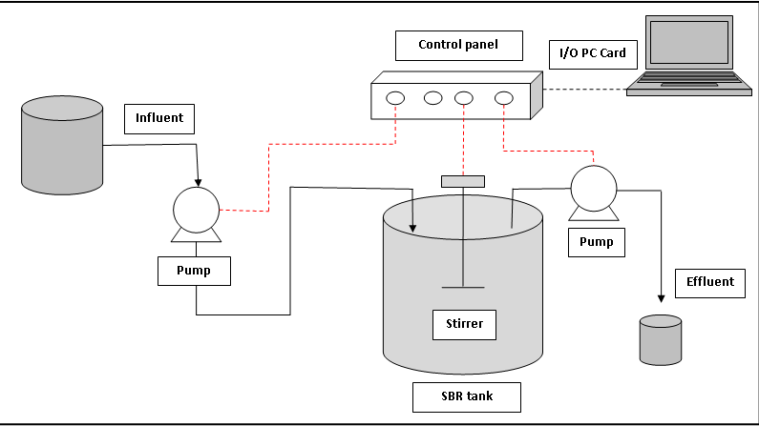

Figure 1. Schematic diagram of SBR system

Start-up of SBR
Bio-sludge to be used as inoculum during the start-up of the SBR was obtained from the sludge storage tank of a local municipal wastewater treatment plant (Taman Harmoni Wastewater Treatment Plant). The SBR was operated under alternating anoxic–aerobic conditions over 28 days. Activated sludge contained in the aeration basin in the activated sludge process (MLSS) was maintained at 3000 – 5000 mg/L. Within the process, pH was set at range 7.0 to 7.5 to ensure successful nitrification process. The reactor was operated at room temperature without control.

The process operates on batch basis. The SBR system worked at three cycles per day with 1.2 days hydraulic retention time (HRT). Each operating cycle consisted of four phases. They are FILL, REACT, SETTLE, and DRAW phases. During the filling process (0.5h), air pump was shut down to promote anoxic condition. The anoxic phase was then continued for 2 hours after feeding. Aeration phase was started for 4 hours when air pump was automatically switch on while mechanical agitation continuously operated. Aeration was then shut down for 1 hour. After 1 hour settling phase was occurred when aerobic phase finished. At the end of each cycle, supernatant of 1000 mL was removed from the SBR (0.5h).

Analytical procedure
Chemical oxygen demand (COD), Total Nitrogen (TN), Total Phosphorus (TP), Ammonia were analyzed using Spechtrophotometer DR5000. The pH value was measured using pH meter (HACH-Germany). Total suspended solids (TSS), MLSS and sludge volume index (SVI) concentrations were determined using standard method. [16].

Results and Discussion
The SBR performance was initially evaluated by measuring COD, TSS, TP, TN and Ammonia compounds in the effluent. The determined characteristics during the full operations are presented in Table 1.

The percentage COD removal in the grey water is shown in Figure 2. At the beginning of the run during start-up, the percentage COD removal was slow with the removal percentage of approximately 40 %. It was observed that the removal percentage gradually increased, where after a month an increased in the measurement of oxygen equivalent of the organic material in wastewater that can be oxidized chemically was achieved. During the total operational period, high COD removal was achieved in the reactor and the effluent COD was nearly 90 %. This indicates that carbon removing bacteria were able to utilize carbon at pH level 7.0 to 7.5. The performance of grey water treatment in the SBR stabilized with low sludge production. The low production of sludge with good settling properties were also reported by Hernandez et. al. [17] for grey water treatment using SBR at an HRT of 12 hours and 1 day.

Table 1. Characteristics of effluent grey water
Parameters | HRT = 1.2 days, Cycle time: 8 hours
 | Average Influent | Max Effluent | Average Removal
COD (mg/l) | 1708 | 97 | 94%
TSS (mg/l) | 140 | 40 | 71%
TN (mg/l) | 288 | 13 | 88%
TP (mg/l) | 66 | 22 | 67%
NH₄-N (mg/l) | 98 | 7 | 93%
NO₂-N (mg/l) | 0.040 | 0.058 | -
NO₃-N (mg/l) | 0.01 | 38 | -

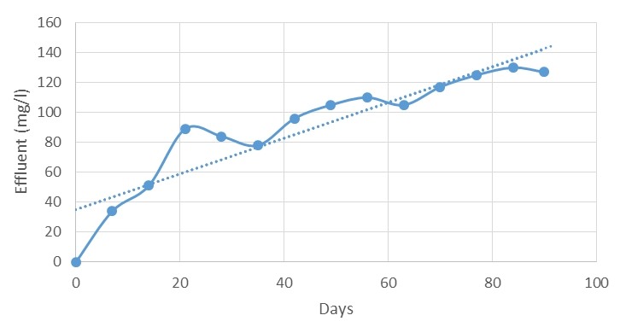

Figure 2. Percentage COD removal of grey water

Figure 2. Percentage COD removal of grey water

The 8 hours cycle time with 4 hours aeration period was found to be enough in converting organic materials to CO₂, ammonia and water as expressed in Equation 1.
(1)

The percentage removals of Total Nitrogen and Ammonia-Nitrogen are shown on Figure 3. This type of removal involved two step biological processes in which ammonia (NH₄-N) is oxidized to nitrite (NO₂-N) and nitrite is oxidized to nitrate (NO₃-N) during the nitrification process. Akunna and Shepherd [18] using SBR to treat a mixture of black and grey water achieved ammonia-nitrogen content from 20 – 59 mg/L NH₃-N to 5 – 25 mg/L NH₃-N. This was then continued with denitrifcation process, where nitrate was reduced to small amount of nitric oxide and nitrous oxide, and mostly in the form of nitrogen gas, which escapes into the atmosphere. From the observation made, the slowly and persistence growth of bacteria occurred within two month. It was assumed that biological uptake of nitrogen for the growth of biomass, Nitrosomonas and Nitrobacter (nitrification bacteria) and Nitrococcus, Nitrispira and Nitroeystis in wet market wastewater was achieved.

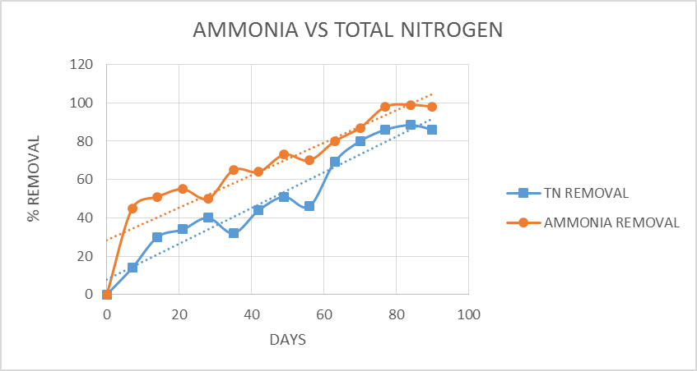

Figure 3. Percentage of Ammonia vs Total Nitrogen removal of grey water

The two lines of different removal (Ammonia-nitrogen and Total Nitrogen) showed that both parameters interlinked with each other. Successful total nitrogen removal must be started with great indicator of ammonification process which ammonia-nitrogen (NH₃-N) is converted to inorganic ammonium or ammonia with assistance of the catalysing by heterotrophic biomass concentration. Figure 4 illustrates the percentage removal of ammonia to nitrite and nitrate to nitrate in the grey water.

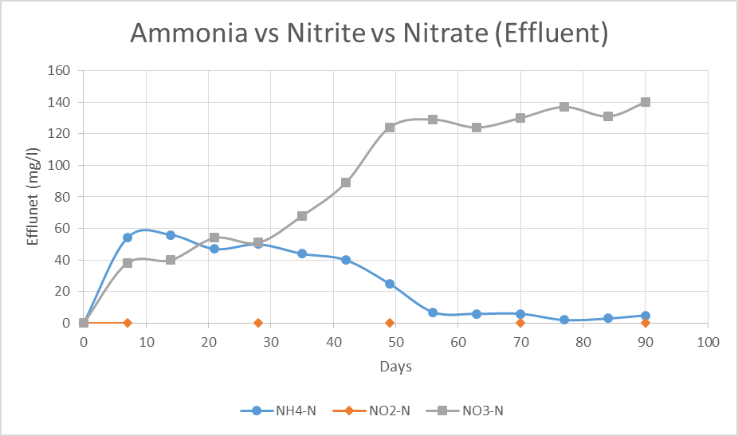

Figure 4. Percentage of Ammonia vs Nitrite vs Nitrate removal of grey water
The data was obtained by taking the effluent samples and tested for the removal performance. It was found that conversion of ammonia to nitrite and nitrate occurred successfully within four hours of aeration and two hours of anoxic stage. This indicated that the nitrification occurred during the first aerobic phase, where ammonia decreased to around 7 mg/L while nitrate increased until it peaked at 140 mg/L. This agrees with the result obtained by Puig et. al. [19], where the ammonia reduced from 9.6 to 0.7 mg/L with nitrate concentration peaking at 6.2 mg/L. The whole process of nitrification requires oxygen. Aerobic autotrophic bacteria are responsible for nitrification in activated sludge. In the first stage, ammonia (NH₄-N) is oxidized to nitrite (NO₂-N) by one group of autotrophic bacteria. In the second stage, nitrite (NO₂-N) is oxidized nitrate (NO₃-N) by another group of autotrophic bacteria.

It should be noted that at 0 – 20 days, the exchange of ammonia to nitrate is very low. This can be observed when the nitrate is in the range of 40 – 60 mg/L. This may cause the bacteria responsible for nitrification to grow much more slowly than heterotrophic bacteria. However, it is good to see uptrend movement despite of slow growth. On day 60 – 80 days, obvious conversion can be seen when the low ammonia and high nitrate effluent results were obtained. Nitrate is converted to nitrogen gas during the settling stage and the rest will be converted at anoxic stage in the next cycle. Also observed lower total nitrite stimulated seem invisible. This may be due to nitrite produced was directly converted to nitrate in the same cycle. If the number of high nitrite (NO₃-N) was seen in the effluent sample, this may be probably due by to the inadequate amount of oxygen or inappropriate pH level found in the system.

The total phosphorus removal average within 60 –70% as seen in Figure 5. The average result of removal may be caused by the initial phosphorus uptake becoming stunted by the long aeration time as observed by Hauschild et. al. [20] in their study. Phosphate accumulating organisms (PAOs), organisms that are capable of storing orthophosphate in excess of their biological growth requirements, are slow growing and normally surpassed by faster growing organisms (non-PAOs). It is suggested that an anaerobic zone is placed ahead of the aerobic zone [21]. This concurred with the finding by Puig et. al. [19], where the polyphosphate was found to be released during the anaerobic phase, while in the aerobic phase the PAOs in the reactor will quickly take up the phosphate.

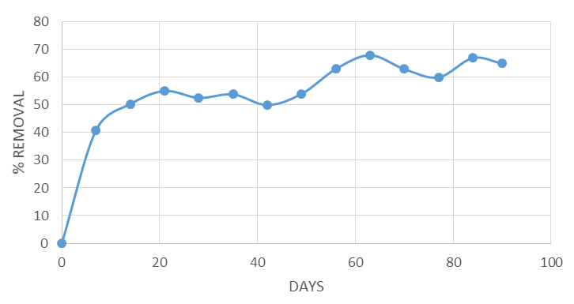

Figure 5. Percentage of Total Phosphorus removal of grey water

Conclusion
The SBR system can effectively remove nutrients and promote biodegradation of organic matter for wet market grey water when the reactor was operated with 1.2 day HRT (8 hours cycle time). The nitrification rate increased while the SBR reactor achieved above 90 % COD removal. The pH should be kept in the range 7.0 –
7.5 in order to prevent inhibition of the nitrifiers. Total phosphorus removal achieved was not above 80 %. It is suggested that aeration time should be increased to enhance poly P uptake.

Acknowledgement
The authors are pleased to acknowledge the Ministry of Higher Education, MOHE (Vot No.01H17) and Universiti Teknologi Malaysia (UTM) for funding this research.

References
- Watkins, K. (2006). Human Development Report 2006 - Beyond scarcity: Power, poverty and the global water crisis. UNDP Human Development Reports (2006).
- Eriksson, E., Auffarth, K., Henze, M. and Ledin, A. (2002). Characteristics of grey wastewater. Urban Water, 4(1): 85 – 104.
- Ghunmi, L. A., Zeeman, G., Fayyad, M. and van Lier, J. B. (2011). Grey water treatment systems: A review. Critical Reviews in Environmental Science and Technology, 41(7), 657 – 698.
- Lamine, M., Bousselmi, L. and Ghrabi, A. (2007). Biological treatment of grey water using sequencing batch reactor. Desalination, 215(1): 127 – 132.
- Keough, N., Smira, S. and Benjamin, S. (2010). Lessons from a participatory approach to household greywater use in Jordan. In: Greywater Use in the Middle East, McIlwaine and Redwood (eds). IDRC.
- Burnat, J. and Eshtayah, I. (2010). On-site grey water treatment in Qebi a Village, Palestine: Grey Water Use in the Middle East. 17.
- Allen, L., Christian-Smith, J. and Palaniappan, M. (2010). Overview of greywater reuse: The potential of greywater systems to aid sustainable water management. Pacific Insfitute, November 2010, www. pacinst. org.
- Karpiscak, M.M., Kennith, E. F. and Nancy, S. (1990) "Residential Water Conservation: Casa Del Aguai, 939 – 948.
- Surendran, S. and Wheatley, A. D. (1998). Grey‐water reclamation for non‐potable re‐use. Water and Environment Journal, 12(6): 406 – 413.
- Okun, D. A. (1997). Distributing reclaimed water through dual systems. Journal-American Water Works Association, 89(11): 52 – 64.
- Santala, E., Uotila, J., Zaitsev, G., Alasiurua, R., Tikka, R. and Tengvall, J. (1998). Microbiological greywater treatment and recycling in an apartment building. AWT98-Advanced Wastewater Treatment, Recycling and Reuse: Milan, 14 – 16.
- Otterpohl, R., Albold, A. and Oldenburg, M. (1999). Source control in urban sanitation and waste management: Ten systems with reuse of resources. Water Science and Technology, 39(5): 153 – 160.
- Gulyas, H. (2007). Greywater reuse–Concepts, benefits, risks and treatment technologies. In International Conference on Sustainable Sanitation–Food and Water Security for Latin America, Fortaleza, Ceará, Brazil.
- Gorton, M., Sauer, J. and Supatpongkul, P. (2011). Wet markets, supermarkets and the “big middle” for food retailing in developing countries: evidence from Thailand. World Development, 39(9): 1624 – 1637.
- Metcalf and Eddy. (1991). Wastewater Engineering: Treatment, Disposal, and Reuse. G. Tchobanoglous and F. L. Burton (Eds.). McGraw-Hill.
- U.S.EPA (1999). Wastewater, Technology Fact Sheet: Sequencing Batch Reactors, U.S Environmental Protection Agency, Office of Water, Washington, D.C., EPA 932-F-99-037.
- Hernandez, L., Zeeman, G., Temmink, H., and Buisman, C. (2007). Characterization and biological treatment of grey water. Water Science and Technology, 56: 193 – 200.
- Akunna, J. and Shepherd, W. (2001) Comparison of RBC and SBR systems for the treatment of sewage from small communities. Water and Environment Journal, 15: 147 – 151.
- Puig, S., Coraminas, Ll., Balaguer, M.D. and Colprim, J. (2007) Biological nutrient removal by applying SBR technology in small wastewater treatment plants: carbon source and C/N/P ratios effect. Water Science and Technology, 55(7), 135 – 141.
- Hauschild, K., Leverenz, H. L. and Darby, J. L (2010) Development of Design Criteria for Denitrifying Treatment Wetlands. Water Environment Research Foundation (WERF) 3 – 11.
- Nutrient Removal: WEF Manual of Practice (2005) No. 34. McGraw Hill Professional.

