

MALAYSIAN JOURNAL OF ANALYTICAL SCIENCES
ISSN 1394 - 2506

Published by The Malaysian Analytical Sciences Society

ENZYMATIC SACCHARIFICATION ON AMMONIA PRE-TREATED OIL PALM TRUNK BIOMASS FOR GLUCOSE PRODUCTION:
AN OPTIMIZATION USING RESPONSE SURFACE METHODOLOGY

(Sakarifikasi Enzim pada Prarawatan Ammonia Biomas Batang Kelapa Sawit bagi Penghasilan Glukosa: Pengoptimuman dengan Kaedah Gerak Balas Permukaan)

Long Wee Lai*, Siti Sarenah Mohd Yahya, Norakma Mohd Nor, Moohamad Ropaning Sulong

Faculty of Science and Biotechnology,
Universiti Selangor,
Jalan Timur Tambahan, 45600 Bestari Jaya, Selangor, Malaysia

*Corresponding author: zki@unisel.edu.my

Received: 14 August 2015; Accepted: 31 December 2015

Abstract
This paper reported the optimization of glucose production from ammonia pre-treated oil palm trunk biomass via enzymatic saccharification process using response surface methodology (RSM). A set of experiment was computed by face centered central composite design (FCCCD) using Design Expert software to statistically evaluate the findings. Three independent variables namely: temperature (35 – 55 °C), pH (4.5 – 6.5) and enzyme ratio (cellullase: β-glucosidase; 3:1 – 7:1) were investigated under the given conditions designed by RSM. The experimental result (4.964 ± 0.006 g.L⁻¹) was in good agreement with RSM model prediction (4.958 g.L⁻¹) with an error less than 0.2 %. The RSM design has been proven to successfully predict the glucose response in this study.

Keywords: oil palm trunk biomass, enzymatic saccharification, lignocellulosic substrate, ammonia pre-treament, response surface methodology

Abstrak
Kertas kerja ini melaporkan pengoptimuman hasilan glukosa daripada prarawatan ammonia biomas batang kelapa sawit melalui proses sakarifikasi enzim dengan menggunakan kaedah gerak balas permukaan (RSM). Satu set eksperimen telah dibentuk iaitu kaedah muka berpusat reka bentuk komposit dengan menggunakan perisian Design Expert bagi menilai penemuan kajian secara statistik. Tiga pembolehubah bebas iaitu: suhu (35 – 55 ° C), pH (4.5 – 6.5) dan nisbah enzim (selulase: β-glukosidase; 3:1 – 7:1) telah disiasat di bawah situasi yang direka oleh RSM. Hasil eksperimen (4.964 ± 0.006 g.L⁻¹) yang diperoleh berada dalam persetujuan yang baik dengan ramalan model RSM (4.958 g.L⁻¹) iaitu pada ralat kurang daripada 0.2 %. Reka bentuk RSM telah terbukti berjaya meramalkan respon glukosa dalam kajian ini.

Kata kunci: biomas batang kelapa sawit, sakarifikasi enzim, substrat lignoselulosa, pra-rawatan ammonia, kaedah gerak balas permukaan

Introduction
Oil palm (Elaeis guineensis) is broadly established in tropical countries such as Malaysia, Indonesia, and Thailand for its comestible oil [1]. In general, the oil palm starts bearing its oil in 2.5 years after being planted, and become lower in productivity after 20-25 years [2, 3]. Therefore, it is necessary to cut the old oil palm tree and to replant new seedlings for sustainable palm oil.

This practise would generate abundance of felled oil palm trunk (OPT). As reported in 2013, Malaysia possesses an oil palm plantation area up to 5.038 million hectares and the oil palm industries have generated 59 million ton of solid biomass annually [4]. These oil palm residues (dry weight, %) include oil palm empty fruit bunch (30 %); oil palm frond (44 %) and oil palm trunk (26 %) respectively. The oil palm trunk like others part oil palm, consists of lignocellulosic biomass which rich in cellulose, hemicellulose and lignin. Consequently, the felled oil palm trunks can be used as one of vital biomass resource to generate beneficial products such as animal feed, biofertilizer, biodiesel, bioplastic and etc. [5].

Generally, the conversion of lignocellulosic biomass into fermentable monosaccharide (sugars) is inevitably through two major steps i.e. pre-treatment of raw materials and enzymatic hydrolysis of pre-treated material [4]. The pre-treatment step is aimed to breaking up the complex structure of lignocellulosic matrix so as to disrupt the crystalline structure of cellulose and thus enhance the enzyme digestibility during the hydrolysis reaction [6]. Up to date, pre-treatment processes such as chemical, physiochemical and biological have been employed to pre-treat the raw lignocellulosic biomass. However, none of the pre-treatment protocol is universal and economically viable to pre-treat different cellulosic biomass. Hence, the proper pre-treatment is essential for the efficiency of biomass conversion [7]. The pre-treatment objective is to eliminate lignin, detached cellulose and hemicellulose, increase the surface area accessibility and subsequently improving the accessibility of hydrolytic enzymes for the maximum emanation of fermentable monosaccharide.

To take full advantage of plentiful OPT residues, the present study has used OPT as a substrate candidate for glucose emanation. This study has utilized the hot dilute aqueous ammonia (7 %) to pre-treat the OPT biomass. The ammonia treated OPT was then subjected to enzymatic hydrolysis for glucose production. The main objective of this investigation is to determine the best hydrolysis conditions for the maximum glucose production. Hence, the RSM based on face centered central composite design (FCCCD) was employed as to identify the optimal enzymatic saccharification conditions in present study.

The response surface methodology (RSM) was used in the present study to analyse the effects of different independent variables (temperature, pH and enzyme ratio) and to optimise the response (glucose production). Generally, the RSM could be used to simplify the optimization by study the multi-parameters simultaneously [8]. By setting up the three dimensional plots, the overall behaviour reaction of experimental data could be easily understood as well as the interaction effects. The software also provides the statistical ANOVA analysis to identify the significant or insignificant factor in the experiment.

Materials and Methods
Raw material
The oil palm trunk (OPT) biomass was used as a substrate in present study. It was collected from Concept Renewable Energy Sdn. Bhd., Macap, Johor. The fresh pulverized OPT was dried at 45 ºC for 3 consecutive days and then it was sieved to get the particle size with less than 1.0 mm [4].

Ammonia pre-treatment method
The 5.0 g of sieved OPT biomass was soaked in 7 % ammonia solution at 80 °C for 8 hours [7]. Once completed, the slurry was recovered by passed thru the filter cloth and then followed by washing with plenty of distilled water until the pH of wash liquid has reached at neutral value. The treated OPT was dried at 45 ºC to constant weight. The chemical compositions of treated OPT contained 38.7 %, 14.7 %, 9.1 % 6.4 %, 2.3 % 19.4 % and 5.4 % (w/w) of glucan, xylan, arabinan, mannan, galactan, acid-insoluble lignin and ash, respectively on a dry weight basis [7].

Enzymes
Two commercial enzymes were used in this study namely: cellulase (Celluclast 1.5) from Trichoderma reesei ATCC 26921 and β-glucosidase (Novozym 188) from Aspergillus niger. The activity of both enzymes was measured at 80.41 FPU.mL⁻¹ and 134.68 CBU.mL⁻¹, respectively [9, 10]. The 40 FPU.g⁻¹ and 100 CBU.g⁻¹ of substrate were used throughout the study.

Buffer preparation
The sodium citrate buffer was made by mixing of citric acid monohydrate and trisodium citrate dihydrate. The 0.1 M concentrations for both solutions were prepared by dissolving 21.01 g.L⁻¹ of citric acid and 29.41 g.L⁻¹ of trisodium citrate dehydrate, respectively. The desired pH value could be attained by mixing both solutions to a total of 100 ml [11]. The 0.1 M sodium citrate buffer was then further diluted to desire 50 mM concentration for the whole investigation.

Experimental design
The response surface methodology (RSM) was employed to design the experiment. Three independent variables, namely: temperature, pH and enzyme ratio (cellulase: β-glucosidase) were examined to determine the effect of each factor on glucose production response. The total of 20-run was computed using face centered central composite design (FCCCD) with six center points of replicates and the alpha value of 1.0. The ranges and the designed levels of process variables are given in Table 1.

Table 1. Actual values of independent variables
Factors | Low level, (–1) | Center level, (0) | High level, (+1)
A: Temperature, °C | 35 | 45 | 55
B: pH | 4.5 | 5.5 | 6.5
C: Enzyme ratio  (cellulase: β-glucosidase) | 3:1 | 5:1 | 7:1

The quadratic model equation for predicting the optimal point is expressed by Eq. (1) as followed:

Y = β₀ + Ʃ β_{i}X_{i} + Ʃ β_{ii}X_{i}² + Ʃ β_{ii}X_{i}X_{j} + Ɛ (1)

where Y is the predicted response (glucose amount, g.L⁻¹), β₀ is constant coefficient, β_{i}, β_{ii} and β_{ij} are coefficient for the linear, quadratic and interaction effects, X_{i} and X_{j} are factors (independent variables) while Ɛ is the error.

The Design Expert 6.0.4 software was used for regression and graphical analyses of the attained data. Generally, a full second-order model with linear, quadratic and interaction term was fitted in order to conclude the optimum combinations of factors level [2]. Meanwhile, the main and interaction effects of model term were also statistically analysed using analysis of variance (ANOVA).

Enzymatic hydrolysis of treated OPT
The treated OPT substrate, 1 % (w/v) was added into a glass jar which contained 100 ml of 0.05 M buffer solution (pH 4.5 – 6.5) and 100 µl 0.2 % (w/v) of sodium azide. The glass jar was then transferred into water bath and heat-up to 35 - 55 °C for 15 min according to RSM design. Lastly, both enzymes with certain ratio (3:1 to 7:1) were discharged into glass jar to initiate the enzymatic hydrolysis reaction. All enzymatic hydrolysis reaction was performed in triplicate and the errors were within ± 5 %.

Glucose analysis
The withdrawal hydrolysate was mixed with 3, 5-dinitrosalicylic (DNS) reagent in ratio of 1:1 and brought to heating at 100 °C for 15 min to cease the enzyme activity. The mixture was cool-down to room temperature prior to read spectrophotometrically at wavelength of 540 nm [12]. The reducing sugars formed during the enzymatic hydrolysis were represented with glucose equivalent [10]. All hydrolysis experiment was conducted in triplicate and the obtained glucose data was presented in an average value.

Validation of RSM prediction points
The optimization predicted points, i.e. temperature, 44.23 ºC; pH, 5.22 and cellulase: β-glucosidase 3:1 were recommended by the RSM software. These suggested parameters were tested in subsequent confirmation run in order to validate the RSM prediction points.

Results and Discussion
Optimization of glucose production
A total of 20-set run which divided into 3 blocks was computed based on face centered central composite design (FCCCD) protocol as shown in Table 2. The enzymatic hydrolysis reaction on ammonia pre-treated OPT biomass was conducted as per each set point as described. Table 2 also tabulates the glucose response for both experimental and predicted values.

The run-11 shows the highest glucose concentration up to 5.73 g.L⁻¹ when the experimental conditions were set to temperature, 45 °C; pH, 5.5 and enzyme ratio 5:1, respectively. It was noticed that when the experiment was conducted in conditions at temperature, 55 °C; pH, 6.5, and enzyme ratio 3:1, the lowest glucose concentration was attained i.e. 0.20 g.L⁻¹.

Table 2. RSM design of experiment: experimental and predicted value
Run | Block | Factor A: Temperature | Factor B: pH | Factor C: Enzyme ratio | Response, Glucose (g.L⁻¹)
 |  |  |  |  | Experimental | Predicted
1 | Block 1 | 45.00 | 5.50 | 5:1 | 4.28 | 4.65
2 | Block 1 | 55.00 | 4.50 | 7:1 | 1.24 | 1.27
3 | Block 1 | 35.00 | 4.50 | 3:1 | 2.11 | 2.10
4 | Block 1 | 55.00 | 6.50 | 3:1 | 0.20 | -0.28
5 | Block 1 | 45.00 | 5.50 | 5:1 | 3.96 | 4.65
6 | Block 1 | 35.00 | 6.50 | 7:1 | 0.56 | -0.06
7 | Block 2 | 55.00 | 4.50 | 3:1 | 0.72 | 1.22
8 | Block 2 | 35.00 | 4.50 | 7:1 | 2.04 | 2.40
9 | Block 2 | 55.00 | 6.50 | 7:1 | 0.22 | 0.11
10 | Block 2 | 35.00 | 6.50 | 3:1 | 0.42 | 0.27
11 | Block 2 | 45.00 | 5.50 | 5:1 | 5.73 | 4.89
12 | Block 2 | 45.00 | 5.50 | 5:1 | 4.66 | 4.89
13 | Block 3 | 45.00 | 5.50 | 5:1 | 4.50 | 4.05
14 | Block 3 | 45.00 | 5.50 | 3:1 | 4.22 | 4.35
15 | Block 3 | 45.00 | 4.50 | 5:1 | 4.31 | 3.42
16 | Block 3 | 45.00 | 5.50 | 7:1 | 4.11 | 4.45
17 | Block 3 | 45.00 | 5.50 | 5:1 | 4.99 | 4.05
18 | Block 3 | 55.00 | 5.50 | 5:1 | 0.95 | 1.01
19 | Block 3 | 35.00 | 5.50 | 5:1 | 1.21 | 1.61
20 | Block 3 | 45.00 | 6.50 | 5:1 | 0.34 | 1.69

A full quadratic regression model based on actual values was as shown in Eq. (2). The Eq. (2) has a high coefficient of determination, R² and adjusted coefficient of determination, R²_{Adj} at 0.9057 and 0.7997, respectively. This indicates the quadratic model could be well explained. There is merely 9.43 – 20.03 % of the variation occur might due to noise that cannot be explained by the model it self [14].

Glucose = – 82.94287 + 2.31023*Temp + 14.78740*pH -0.87010*Enzyme – 0.027414*Temp² – 1.49843*pH²+0.086392*Enzyme² + 0.020438*Temp*pH + 2.93125x10⁻³*Temp*Enzyme – 0.018187*pH*Enzyme (2)

The analysis of variance (ANOVA) for glucose content after enzyme hydrolysis was used to estimate the glucose response as a function of temperature, pH and enzyme ratio is shown in Table 3. Mathematically, when the Prob > F values greater than 0.05, those factors are considered statistically insignificant. Meanwhile when Prob > F values less than 0.05, it could be defined as a significant factor [14]. In present study, the quadratic model with 0.003 was significant. The “lack-of-fit” F-value of 4.52 implies that the “lack-of-fit” was insignificant relative to the pure error. There is a 12.2 % chance for the model that a “lack-of-fit” F-value of this large could occur due to noise. In general, the non-significant lack-of fit was good and implied that all data in this experiment were adequated as well as good predicatibility of the model [2].

Table 3. Analysis of Variance (ANOVA)
Source | Sum of  Square | DF | Mean Square | F value | Prob >F
Block | 4.06 | 2 | 2.03
Model | 61.40 | 9 | 6.83 | 8.54 | 0.0030 | Significant
A | 0.90 | 1 | 0.90 | 1.13 | 0.3196
B | 7.51 | 1 | 7.51 | 9.40 | 0.0155
C | 0.03 | 1 | 0.03 | 0.03 | 0.8602
A² | 20.2 | 1 | 20.2 | 25.2 | 0.0010
B² | 6.03 | 1 | 6.03 | 7.54 | 0.0252
C² | 0.32 | 1 | 0.32 | 0.40 | 0.5442
AB | 0.33 | 1 | 0.33 | 0.42 | 0.5360
AC | 0.03 | 1 | 0.03 | 0.03 | 0.8575
BC | 0.01 | 1 | 0.01 | 0.01 | 0.9112
Residual | 6.39 | 8 | 0.80
Lack of Fit | 5.64 | 5 | 1.13 | 4.52 | 0.1220 | Not Significant
Pure Error | 0.75 | 3 | 0.25
Cor Total | 71.88 | 19
Note: A: Temperature; B: pH; and C: Enzyme ratio; R² = 0.9057, R_{Ajd}² = 0.7977

In present study, only the main effect, pH was significant where the value of Prob>F equal to 0.015. Others significant terms were of square effect of temperature (Prob>F = 0.001) and square effect of pH (Prob>F = 0.025). On the other hand, those insignificant factors were the main effect: temperature (Prob>F = 0.320) and enzyme ratio (Prob>F = 0.860); square effect of enzyme ratio (Prob>F = 0.5442); and all three interactive effects: temp*pH (Prob>F = 0.53), temp*enzyme ratio (Prob>F = 0.856) and pH* enzyme ratio (Prob>F = 0.911), respectively. Based on the ANOVA analysis, those insignificant factors whether main, square or interaction effect can be eliminated and therefore the new reduced quadratic model could be expressed in Eq. (3) as followed:

Glucose = – 82.94287 + 14.78740*pH – 0.027414*Temp² – 1.49843*pH² + 0.020438*Temp*pH + 0.018187*pH*Enzyme (3)

Although interaction effects such as temp*pH and pH*enzyme were insignificant, but they were still maintained in new model (Eq. 3) to retain the model hierarchy [13].

Normality test and predicted versus actual analysis
A graphical technique uses to regulate the relevance of assumption on normality is by plotting the data points on a normal probability paper. If a straight line can be draw through the plotted points, the assumption of normality is reflected to be rational. Figure 1 showed the obtained data were fall on the straight line.

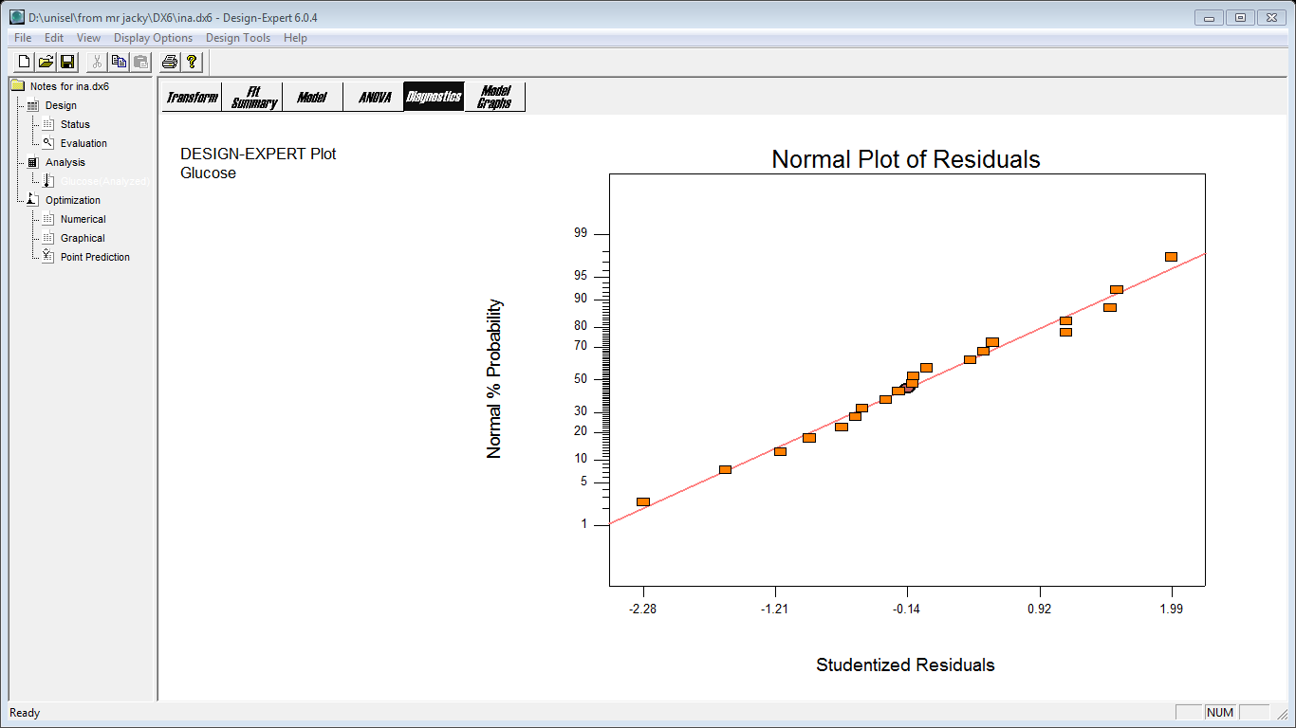

Figure 1. Normality plot of residuals

On the other hand, the data in Table 2 shows that the predicted values were in good agreement with the experimental values for glucose response. The results could be further corroborated as illustrated in Figure 2 which graphically depicts the correlation between the actual and predicted responses. All data point was closed to the straight line, demonstrating that no significant violations of the model were found. Moreover, the model should adequate to predict the glucose amount during enzymatic hydrolysis within the range in present study as it was highly significant, where the Prob > F value is 0.003. In fact, the coefficient of determination, R² = 0.9057, considered sufficient to identify the correlation between the actual and the predicted values [15].

Three-dimensional (3D) response surface plots
As shown in Table 3, the main factor: pH was statistically significant. Therefore, the interaction effects which involve Temp*pH and pH*Enzyme ratio should be remained. Further analysis on these interaction effects were carried out. The three-dimensional (3D) response surface plots of both interaction effects were illustrated in Figure 3 and Figure 4, respectively.

Interaction effects of temperature versus pH (temp*pH)
Figure 3 demonstrates the 3D response surface plot for the interaction effects of temperature versus pH. Both of the interaction effects were temperature and pH (varying from 35 – 55 ºC and 4.5 – 6.5, respectively) on the glucose production, while holding the enzyme ratio at its center point, viz. 5:1.

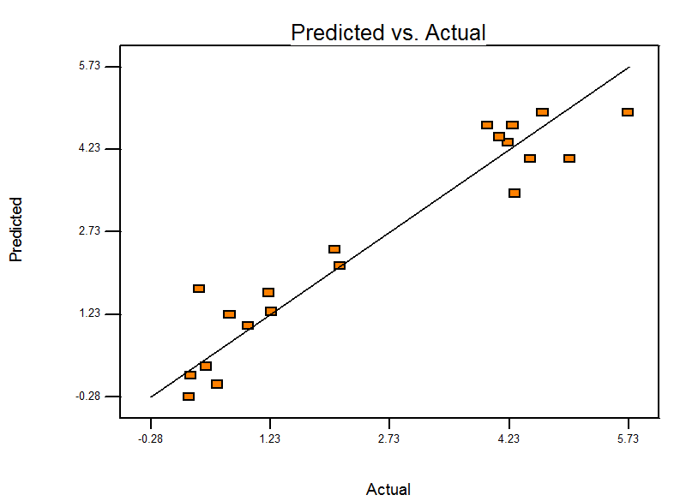

Figure 2. Actual and predicted plot of glucose response

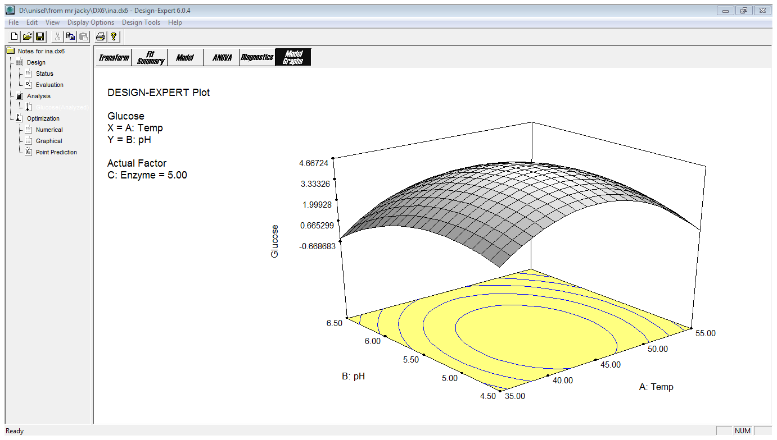

Figure 3. 3D response surface plot for interaction effects of temperature versus pH

It was noticed that the highest glucose concentration > 4.39 g.L⁻¹ could be attained when temperature at 45 ºC and pH in the range of 5.0 – 5.5, respectively. The pH range of 4.5 – 6.0 is favour the glucose production in all tested temperature ranging from 35 – 50 ºC. The glucose concentration was increased when the temperature was raised from 35 to 45 ºC. This could be explained as the enzyme-catalyzed reaction behaves like most chemical reaction, proceed at a faster velocity as the temperature is raised. An increase in temperatures, it would impart more kinetic energy to the reactant molecules resulting in more productive collision per unit time [16]. As a result, more glucose released when the temperature was raised from low to mid-point in present study. However, further increased of temperature (> 45 ºC), the glucose concentration was decreased. Figure 3 has obviously showed the raising of glucose amount from 35 – 45 ºC and sharply declined when the tested temperature was in range of 45 – 55 ºC. In general, an enzyme molecule is a very delicate and fragile structure. If the molecule absorbs too much energy, the tertiary structure will be disrupted and the enzyme will lose its catalytic activity and eventually denatured. This is the main reason why low glucose concentration was detected when at higher temperature. In short, both cellulase and β-glucosidase enzymes were performed well and reach their optimum temperature point at 45 °C.

Interaction effects of pH versus enzyme ratio (pH*enzyme ratio)
Figure 4 reveals the interaction between pH and enzyme ratio on glucose production. When temperature was fixed at 45 °C, enzyme ratio and pH were set to 5:1 and 4.8 – 5.6; 4.65 g.L⁻¹ of glucose concentration is obtainable. Meanwhile, when the pH value greater than 5.6 the glucose amount was decreased.

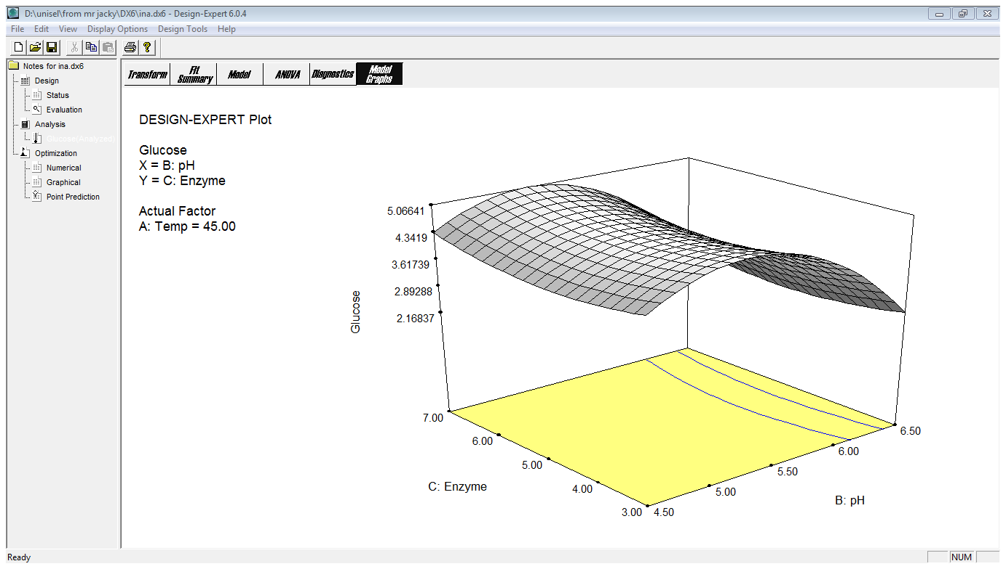

Figure 4. 3D response surface plot for interaction effects of pH versus enzyme ratio

Generally, enzymes have ionic groups on their active sites and must be in suitable environment either acid or base to function. A change of pH in the medium would lead to modification of enzyme in the ionic form of active site and its three-dimensional shape [17]. For these reasons, enzymes are only active over a certain pH range. Hence, the enzyme activity would be retarded once it is beyond the suitable pH range and thus impede the reaction rate. It was noticed that both cellulase and β-glucosidase was active at low acidic pH condition ranging from 4.5 – 5.5. The higher pH value (pH > 5.6) did not favour the enzyme hydrolysis in this study. This is a reason why the glucose content was lower at high pH condition compared to low pH circumstance. Figure 4 shows the 3D response surface plot where the glucose amount was increased from 4.5 to its optimum point 5.5 and declined with increment of pH values.

Prediction and verification of optimization conditions
Response optimizer function has provided a set of solutions that were used to predict the optimum conditions of glucose production from enzymatic saccharification of ammonia treated OPT substrate. The criteria of the variables were set accordingly as to maximize the response, i.e. glucose production. By following RSM prediction, ones could obtain the glucose at 4.958 g.L⁻¹ when the parameters were set to temperature, 44.23; pH 5.22 and enzyme ratio, 3:1, respectively. Moreover, the desirability value of this response is 1.00. It means when running the pre-set conditions, the experimental value should be the same as prediction. In order to ascertain the prediction, three replication runs were performed as to verify the RSM prediction. Table 4 tabulates both of the RSM prediction and experimental values for glucose production.

Table 4. Optimum conditions suggested by the RSM for glucose production
A  Temperature | B  pH | C  Enzyme ratio | Glucose production,  g.L⁻¹ |  | Error,  %
 |  |  | RSM prediction | Experimental
44.23 | 5.22 | 3:1 | 4.958 | 4.964 ± 0.006 | 0.12

In present study, the glucose concentration of 4.964 ± 0.006 g.L⁻¹ was obtained. Both predicted and experimental values were in closed agreement to each other with the error less than 0.2 %. Last but not least, the RSM model has successfully modelled the glucose production on ammonia pre-treated OPT substrate in present study.

Conclusion
This investigation studied three independent variables on glucose emanation from enzymatic saccharification of ammonia pre-treated OPT substrate using response surface methodology (RSM). Statistical optimization of enzyme hydrolysis for glucose production has been successfully carried out. The attained data could fit the second order equation well with an R² up to 90.57 %. The RSM optimization of glucose response, 4.958 g.L⁻¹ was achieved when the experiment was performed according to the software optimizing settings. The model suggested the best conditions when temperature, pH and enzyme ratio were set at 44.23 °C, 5.22 and 3:1, respectively.

Acknowledgement
The authors would like to thank the Faculty of Science and Biotechnology, Universiti Selangor for funding the project. Special thanks to Mr KV Lai, Concept Renewable Energy Resources Sdn. Bhd. who have provided the oil palm trunk sample for this investigation.

References
- Chooklin, S, Kaewsichan, L. and Kaewsrichan, J. (2013). Potential Use of Oil Palm Sap on Lactic Acid Production and Product Adsorption on Dowex™ 66 Resin as Adsorbent. Asia Pacific Journal Chemical Engineering, 8(1): 23 – 31.
- Amouzgar, P, Khalil, H. P. S. A, Salamatinia, B, Abdullah, A. Z. and Issam, A. M. (2010). Optimization of Bioresource Materials from Oil Palm Trunk Core Drying Using Microwave Radiation: A Response Surface Methodology Application. Bioresource Technology, 101: 8396 – 8401.
- Yuanisa, A, Kafidul Ulum, K. and Wardani, A. K. (2015). Pretreatment of Oil Palm Trunk Lignocellulose as First Step to Produce Second Generation of Bioethanol: A Review. Jurnal Pangan Agroindustri, 3(4): 1620 – 1626.
- Lai, L. W. and Idris, A. (2013). Disruption of Oil Palm Trunks and Fronds by Microwave-Alkali Pretreatment. Bioresources, 8(2): 2792 – 2804.
- Sukri, S. S. M., Rahman, R. A., Illias, R. M. D. and Yaakob, H. (2014). Optimization of Alkaline Pretreatment Conditions of Oil Palm Fronds in Improving the Lignocelluloses Contents for Reducing Sugars Production. Romanian Biotechnology Letter, 19(1): 9006 – 9018.
- Binod, P, Satyanagalakshmi, K, Sindhu , R, Janu, K. U, Sukumaran, R. K. and Pandey, A. (2012). Short Duration Microwave Assisted Pretreatment Enhances the Enzymatic Saccharification and Fermentable Sugar Yield from Sugarcane Bagasse. Renewable Energy, 37: 109 –116.
- Jung, Y. H, Lee, H. J, Seo, J. H, Kim, S, Seung, D, Choi, I. G, Yang, T. H, Park, Y. C. and Kim, K. H. (2012). Aqueous Ammonia Pretreatment, Saccharification, and Fermentation Evaluation of Oil Palm Fronds for Ethanol Production, Bioprocess and Biosystems Engineering, 35:1497 – 1503.
- Wong, Y. C, Tan, Y. P, Taufiq, Y. Y. H. and Ramli, I. (2015). An Optimization Study for Transesterification of Palm Oil Using Response Surface Methodology. Sains Malaysiana, 44(2): 281 – 290.
- Zhang, P. Y. H, Hong, J. and Ye, X. (2009). Cellulase Assay, In: Jonathan, R.M. (ed) Biofuels: Methods and Protocols, Methods in Molecular Biology. New York: Humana Press.
- Bommarius, A. S, Katona, A, Cheben, S. E, Patel, A. S, Ragauskas, A. J, Knudson, K. and Pu, Y. (2008). Cellulase Kinetics as A Function of Cellulose Pretreatment. Metabolic Engineering, 10: 370 – 381.
- Dawson, R. M. C, Elliot, D. C, Elliot, W. H. & Jones, K. M. (1986). Data for Biochemical Research (3rd ed.). U. K.: Oxford Science Publication.
- Ghose, T. K. (1987). Measurement of Cellulase Activities. Pure Applied Chemistry, 59: 257 – 268.
- Lai, L.W, Idris, A. and Yusof, N. M. (2014). Lignin extraction from oil palm trunk by Microwave-Alkali technique. Malaysian Journal Fundamental Applied Science, 10: 59 – 63.
- Wee, L. L, Annuar, M. S. M, Ibrahim, S. and Chisti, Y. (2011). Enzyme-Mediated Production of Sugars from Sago Starch: Statistical Process Optimization. Chemical Engineering Communications, 198(11): 1339 – 1353.
- Alshaibani, M, Yaakob, Alsobaai, Z. A. M. and Sahri, M. (2014). Optimization of Pd-B/ɣ-Al₂O₃ Catalyst Preparation for Palm Oil Hydrogenation by Response Surface Methodology (RSM). Brazilian Journal of Chemical Engineering, 31(1): 69 – 78.
- Segel, I. H. (1976). Biochemical Calculations: How to Solve Mathematic Problem in General Biochemistry. USA: John Wiley and Sons.
- Shuler, M. L. and Kargi, F. (1992). Bioprocess Engineering: Basic Concepts. New Jersey: Prentice Hall.

