

MALAYSIAN JOURNAL OF ANALYTICAL SCIENCES
ISSN 1394 - 2506

Published by The Malaysian Analytical Sciences Society

EFFECT OF SILVER NANOPARTICLE ADDITION ON THE STRUCTURE AND CHARACTERISTICS OF RADIO-PHOTOLUMINESCENCE GLASS DOSIMETER

(Kesan Penambahan Nanozarah Argentum Terhadap Struktur dan Sifat – Sifat Dosimeter Kaca Radio – Pendarcahaya)

Irman Abdul Rahman^{1,2}*, Muhammad Taqiyuddin Mawardi Ayob^{1,3}, Hur Munawar Kabir Mohd¹,
Ainee Fatimah Ahmad¹, Shamellia Sharin¹, Faizal Mohamed^{1,2}, Sidek Ab Aziz³, Shahidan Radiman^{1,2}

¹School of Applied Physics, Faculty of Science and Technology
²Nuclear Technology Research Center, Faculty of Science and Technology,
Universiti Kebangsaan Malaysia, 43600 UKM Bangi, Selangor Darul Ehsan, Malaysia
²Department of Physics, Faculty of Science,
Universiti Putra Malaysia, 43400 Serdang, Selangor Darul Ehsan, Malaysia

*Corresponding author: irman@ukm.edu.my

Received: 9 December 2014; Accepted: 16 October 2015

Abstract
A series of silver-activated phosphate glass was prepared by melt quenching method. The effect of silver nanoparticle addition on the phosphate glass microstructure, composition and chemical characteristics was investigated using x-ray diffraction, fourier transform infrared and photoluminescence spectroscopy. Other physical property such as density was also evaluated. The density increased when the amount of silver ions were increased, due to the enhanced formation of non-bridging oxygen. In this study, we discuss the emission mechanism of two radio-photoluminescence peaks at 460 nm and 620 nm, where the electrons and holes produced by γ-irradiation a re-trapped by Ag⁺ ions to produce Ag⁰ and Ag²⁺ ions respectively, when the Ag⁺-doped phosphate glass is exposed to γ-ray. We proposed that an emission mechanism of 460 and 620 nm radio-photoluminescence peaks with these Ag²⁺ and Ag⁰ ions. Furthermore, a correlation between the investigated properties and glass composition is discussed.

Keywords: silver nanoparticle, optical and physical properties, radio-photoluminescence glass dosimeter

Abstrak
Satu siri gelas argentum-aktif fosfat telah dihasilkan menerusi kaedah peleburan. Kesan penambahan nanobahan argentum ke dalam mikrostruktur gelas fosfat, komposisi dan sifat-sifat kimia dikaji dengan menggunakan pembelauan sinar-X, penjelmaan inframerah Fourier dan spektroskopi pendarcahaya. Sifat fizikal yang lain seperti ketumpatan kacaturut dikaji. Ketumpatan kaca bertambah apabila jumlah ion-ion argentum ditingkatkan, disebabkan oleh peningkatan pembentukan oksigen tanpa-hubung. Dalam kajian ini, kami membincangkan mekanisme pemancaran oleh dua puncak radio-pendarcahaya pada jalur 460 nm dan 620 nm, di mana elektron dan lohong yang terhasil daripada sinar-γ diperangkap oleh ion – ion Ag⁺ seterusnya menghasilkan ion – ion Ag⁰ dan Ag²⁺, apabila kaca Ag⁺-aktif fosfat didedahkan kepada sinar-γ. Kami turut membincangkan mekanisme pemancaran bagi setiap puncak radio-pendarcahaya pada jalur 460 dan 620 nm berdasarkan ion – ion Ag²⁺ dan Ag⁰ berkenaan. Tambahan lagi, hubung kait antara komposisi kaca dan sifat-sifat kaca yang terhasil turut dibincangkan.

Kata kunci: nanobahan argentum, sifat fizikal and optik, dosimeter kaca radio-pendarcahaya

Introduction
Recent technological applications have generated more interest in the study of glasses especially oxide glasses [1 – 6]. Among oxide glasses, phosphate based glasses are particularly attractive due to their ability to accommodate large concentrations of active ions without losing their useful properties of the material [1]. Phosphate glasses are relatively easy to prepare and offers a large range of compositional possibilities, which facilitates in tailoring the physical, chemical and optical properties of interest for specific technological applications [7]. In particular, embedding materials such as metal nanoparticles in glasses are expected to produce promising materials for functional optical devices due to a large third-order nonlinear susceptibility and an ultra-fast non-linear response [8]. The doping process plays an important role in the development of many optoelectronic devices especially dosimeters. Some dopants such as noble metal ions capture negatively charged electrons or positively charged holes, creating defects in the form of a change in their valence state through photo chemical reaction during exposure to successive gamma irradiation [6]. Radio-photoluminescence (RPL) in various glasses containing silver impurities has long been examined [9 – 11] for applications in personal solid-state dosimetry and radiation measurements. Yokota et al. [11] reported how to produce a glass element having low energy dependence, high sensitivity and good chemical stability. Moreover, the centers of luminescence will never disappear unless the glasses are annealed with high temperatures of about 400 °C. This produces some excellent features such as repeatable measurement and small dispersions among samples [12].

In this study, phosphate glass dosimeters were prepared from reagent powders of P₂O₅, Li₂CO₃, Al(OH)₃, NaNO₃, H₃BO₃and silver nanoparticles. The optical and physical properties were determined with different silver ion contents within the phosphate base glass. The photoluminescence properties of silver-phosphate glass were studied. In addition, the density of the phosphate glass system was determined. The excitation and emission properties of radio-photoluminescence glass dosimeter in the form of Ag⁺-doped phosphate glass and discussed the mechanism of RPL which is based on the excitation and emission properties also were evaluated.

Materials and Methods
Before synthesizing the Ag-doped phosphate glass, silver nanoparticles was firstly prepared. To obtain the Ag nanoparticles, 0.2 M of AgNO₃ (Aldrich; ≥ 99%) and 0.2 M of NaOH (Fluka; ≥ 97%) were dissolved in 100 ml of deionised water (resistivity = 18.2MΩ, TOC ≤ 5 ppb) under magnetic stirring at room temperature for 10 minutes. Triethanolamine (TEA) was poured into each solution at a molar ratio of 1:3 with excess TEA and continued stirring for 20 minutes. NaOH solution was added to the AgNO₃ solution during the ultrasound irradiation process (misonix-400, 60 Hz, 70 amplitude) for 60 minutes under nitrogen gas flow. The sample was then centrifuged and washed with excess deionised water to remove impurities and the excessive TEA used to cap the surface of the Agproducts, then dried overnight at 60 °C in the oven. The crystallinity and morphology of the products were later characterized by XRD (Bruker X-ray diffractometer) and TEM (Hitachi H-7100) instruments.

Secondly, phosphate glass for the solid state dosimetry was prepared from reagent grade powders of anhydrous P₂O₅, Li₂CO₃, Al(OH)₃, NaNO₃ and H₃BO₃. Silver nanoparticles were used as the main component for the radio-photoluminescence glass dosimeter. Silver-doped phosphate glasses were prepared by the melt-quenching method. The weight composition of the glass dosimeters were 9.26% Al(OH)₃, 7.34% Li₂CO₃, 2.0% NaNO₃, 2.72% H₃BO₃ and P₂O₅:Ag (73.58:5.1, 74.38:4.3& 75.18:3.5 respectively) in mol %, weighted using a digital weighing machine with an accuracy of ± 0.01 g, then mixed together using a mortar and pestle. Appropriate amount of each powder was melted in an alumina crucible which was placed in an electrical heated furnace in atmosphere. At a heating rate of about 10⁰C/min, the temperature was gradually increased up to 600 °C and kept at this temperature for 5 hours. Once the mixture was liquidised, the temperature was then increased again to 1250 °C and left for one hour to obtain the appropriate viscosity. After the stirring and refining process, the glass liquid was then poured into a preheated stainless steel plate. At this point it then takes 24 hours to complete the annealing process at 350 °C. The density of the glass samples were measured using the Archimedes principle, and distilled water was used as the immersion liquid. All samples were irradiated withγ-radiation, performed using a Co-60 source delivered at 1.8 kGy/h. In this work, the samples were irradiated such that the absorbed dose was 1 kGy. Excitation and emission measurements were performed at room temperature and RPL intensity was measured using FLS-920 spectrophotometer (excitation wavelength: 265 and 320 nm). The RPL emitted from the crystal was observed in a direction perpendicular to that of the excitation beam and analysed using suitable filters with central wavelengths of 460and 620nm, respectively. The structure of the silver-phosphate glass was investigated using X-ray diffraction (Bruker X-ray diffractometer) and Fourier transform infrared spectroscopy (Perkin Elmer/Lamda 950).

Results and Discussion
The glass density values are lightly shifted in the range 2.48 to 2.67 g/cm³, increasing with the silver content. With a high amount of Ag in the vitreous network the density increases up to 2.67 g/cm³, possessing higher density values.

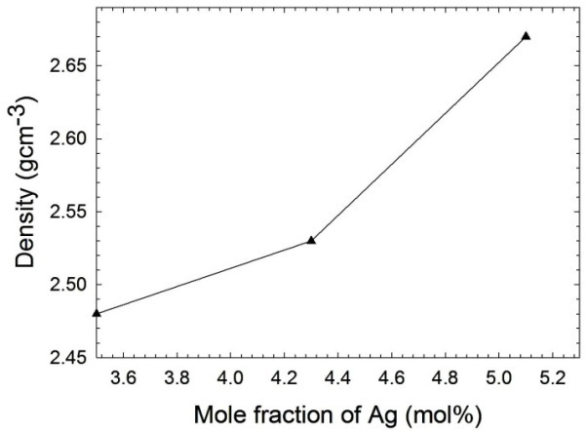

Figure 1. Density with different mole fraction (mol %) of silver-activated phosphate glass system

The micrograph of the Ag nanoparticles was obtained via TEM analysis is shown in Fig. 2(a). It shows structures consisting of irregular spherical metallic Ag with the average particle size estimated to be in range of 5 to 17 nm, determined by using the Sigma scan method as shown in Fig. 2(b).

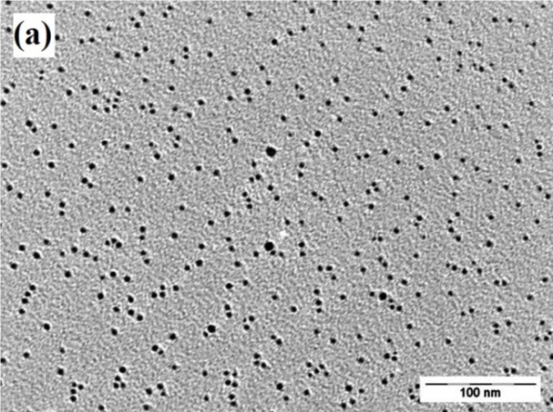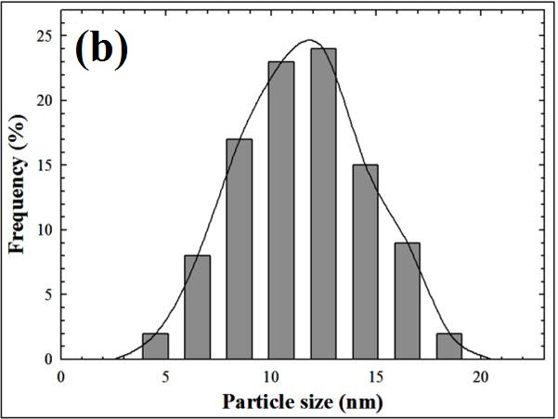

Figure 2. TEM micrograph of Ag nanoparticles prepared by sonication method

Aggregations occur due to large speciﬁc surface area and high surface energy, occurring during the process of sonication [13]. Due to the advantageous properties of silver nanoparticles, addition of these nanoparticles to phosphate glass increases the luminescence properties of the glass. Thus, it is interesting to study the effects of the addition of silver nanoparticles to phosphate glassesand the influence of its ions on the glass forming network.

The XRD pattern of Ag nanoparticles is shown in Fig. 3(a). The series of characteristic peaks have been indexed to metallic Ag indicating a face-centered cubic structure, according to JCPDS Card No. 1-87-717, with the lattice parameters; a = 4.0857 nm and space group fm-3m. No diffraction peaks of impurities have been observed, implying that all the AgNO₃was fully decomposed into Ag nanoparticles.

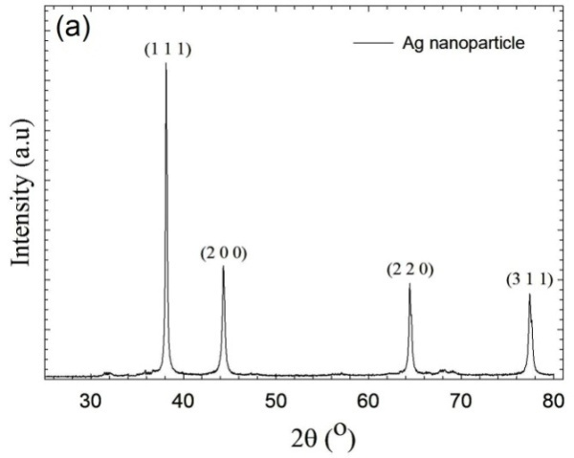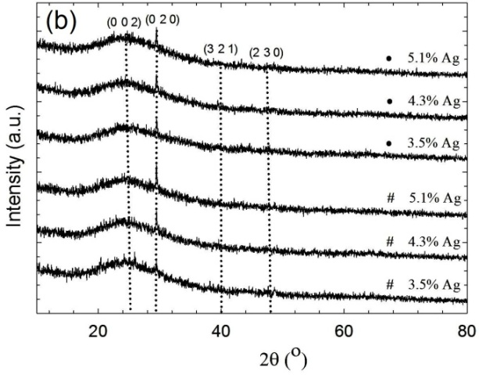

Figure 3. X-ray diffraction patterns of the (a) silver nanoparticles and (b) 3.5, 4.3 and 5.1mol % of Ag nanoparticles doped phosphate glasses before (#) and after (•) 1.0 kGy of γ-irradiation.

Figure 3(b) shows the pattern of the silver-activated phosphate glasses. The silver content was increase, no remarkablechange was exhibited in the XRD proﬁles of the six samples with differing silver contents (3.5, 4.3 and 5.1 mol %) before and after γ-irradiation. The overall features of these XRD curves conﬁrm the amorphous nature of the glasses doped with silver nanoparticles. The pattern displays no sharp peaks, indicating the absence of any crystalline nature observed broad humps in the glass samples, characteristic of the phase at diffraction angles (2θ) to be fully amorphous, indicates that these glass samples are composed of a glassy phase. The series of characteristic peaks were indexed to monoclinic structure of silver phosphate with the lattice parameters; a = 11.86 nm, b = 6.06 nm, c = 7.31 nm and space group P21/n. From the XRD patterns, two strong peaks are present in the region at 24.38º (0 02) and 29.51º (0 2 0), which indicates that the material was silver doped in phosphate glass related in JCPDS Card No. 1-72-122. Therefore silver diffraction peaks were not well identiﬁed, since they were only present in the after mentioned bands. A great deal of interest has been shown in glasseswith implanted metallic clusters. As expected, the signal intensity of silver increased in the 5.1% sample, due to a higher amount of Ag nanoparticle.

In order to obtain more information about the prepared glasses, FTIR measurements were performed. Figure 4 shows the FTIR spectrum of each sample before and after gamma irradiation (1 kGy) for the silver doped phosphate glasses. The positions of the bands for the Ag-doped phosphate glass system are summarized in Table 1. A comparison of spectra in Figure 4 shows that the samples before and after γ-irradiation shows nearly similar IR transmission (absorption) spectra, which may be due to similar composition of the glass matrix, except for a change in the intensities of some peaks in same region for different amount of Ag, which seems to be having less or negligible effect on IR absorption spectra. Main observation after 1 kGy γ-irradiation is the generation of some new peaks in the 800 – 1017 cm⁻¹ range dominated by P-O-P linkages. This clearly indicates the breaking of these P-O-P linkages, which produces more non-bridging oxygen. This is associated with an increase in the intensity of band due to P=O bond at 1187 cm⁻¹ (non-bridging oxygen), which confirms the idea of breaking P-O-P linkages in the glass. The bands in the region of 1400-500 cm⁻¹ show a number of strong characteristic bands of phosphate glass. There is no significant difference in the line shapes of the spectra, because all of the samples contain > 50 mol% P₂O₅, which is as expected. These spectra consist of two main sets of IR absorption bands in the low and high frequency regions due to phosphate group and O-H molecule (bending mode), respectively. The three bands located in the range of 2346 – 2926 cm⁻¹were relatively weak and can be assigned to the stretching vibrations of P-O-H group in different structural sites, which was consistent in all samples. The shoulder observed at 1425 cm⁻¹ is due to the characteristic stretching mode of the P=O bond.

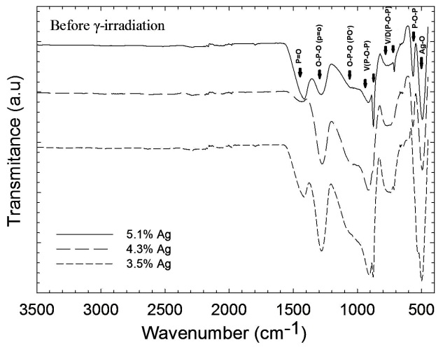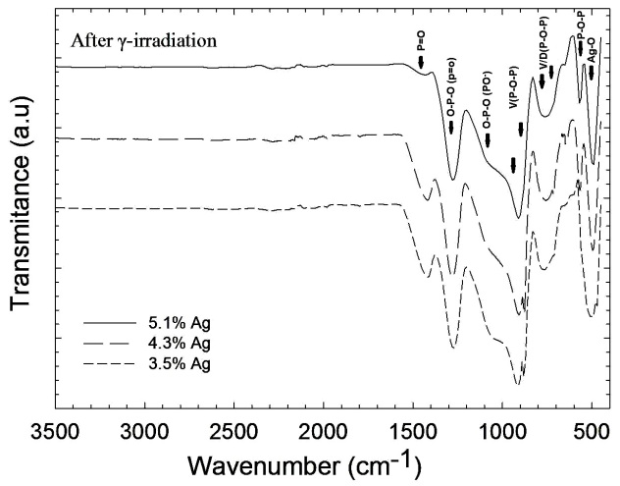

Figure 4. FTIR spectra for the phosphate glasses doped with 3.5, 4.3 and 5.1 mol % of silver nanoparticles.

Several authors have reported that the band corresponding to the stretching vibration of doubly bonded oxygen could be found in the frequency range of 1230 – 1390 cm⁻¹. The band at about 1281 cm⁻¹ is assigned to the asymmetrical stretching vibration of O-P-O and P=O groups, v_{as}(O-P-O)/ v_{as} (P=O), while the medium broad band at 1100 cm⁻¹ is related to the symmetric stretching vibration of that group, v_{s}(O-P-O). The 1100 cm⁻¹ band is the dominant feature of the spectra and has been assigned to P-O- groups. Moreover, increasing the quantity of the silver component, results in alteration of each band in the region of 1200 –1500 cm⁻¹, conﬁrming the modifying behaviour of silver. The phosphorous non-bridging oxygen portion of PO₄ tetrahedra in a chain structure has been referred to as a P-O⁻ unit. The asymmetric stretching vibration of the metaphosphate group, v_{as}(PO₃) was observed in the range of 1012 –1153 cm⁻¹. This indicates that the bands due to v_{as}(PO₃) can interfere with the band at 1100 cm⁻¹. The broadening observed in the region of 900 – 1105 may be due to the interference of v_{s}(PO₃) with the spectral range 1000 – 1060 cm⁻¹. The shoulder around 878 cm⁻¹ is assigned to the asymmetric stretching vibration of P-O-P linkages, v_{as}(P-O-P), while the relatively weak band around 764 cm⁻¹ is due to the symmetric stretching vibration of that linkage, v_{s}(P-O-P). The region below 600 cm⁻¹ is usually assigned to the vibration of metals [14]. The broad band at about 525 – 539 cm-1 may be assigned to the harmonics of P-O-P bending vibration as well as to the deformation mode of PO⁻ group. The wavenumbers of 480 and 510 cm⁻¹ corresponds to the stretching and Ag-O symmetrical vibrations in PO₄. Piao et. al [15] describes that production of electron hole pairs during irradiation provides another path for bond rearrangement, reducing the constraints on structural relaxation. The relaxation process releases some of the excess energy stored in the structure, resulting in change in the bond angle.

Table 1. Vibrational assignment of the FTIR spectra of Ag-doped phosphate glass samples
No. | Vibrational mode | Wavenumber (cm⁻¹)
1. | V_{s}(P-O-H) | 2346-2926
2. | Stretching mode of P=O | 1425
3. | Asymmetric stretching O-P-O  V_{as}(O-P-O)/(P=O) | 1281
7. | Symmetric stretching  V_{s}(O-P-O)/PO⁻ | 1100
8. | V_{as}(PO₃) | 1012-1153
9. | V_{s}(PO₃) | 1000-1060
10. | Asymmetric stretching P-O-P  V_{as}(P-O-P) | 878
11. | V_{s}(P-O-P) | 764
12. | Harmonics of P-O-P bending vibration/deformation mode of PO⁻ | 525-539
13. | V_{s}(Ag-O) | 480 & 510

Figure 5 shows the radio-photoluminescence spectra of the silver-activated phosphate glass excited at 265 and 320 nm after gamma irradiation with an absorbed dose of 1 kGy.

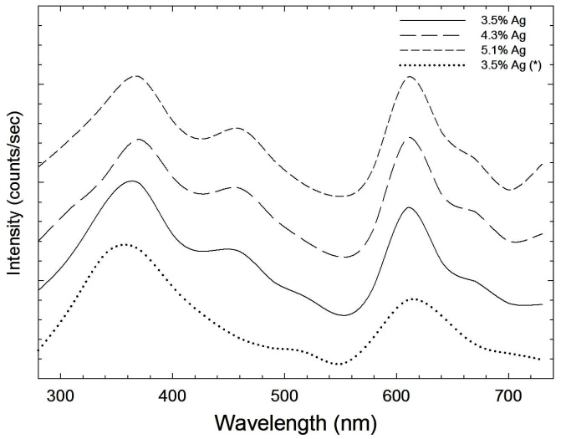

Figure 5. Radio-photoluminescence spectra of the silver-activated phosphate glass excited at 265 and 320 nm before (*) and after gamma irradiation with an absorbed dose of 1 kGy.

The PL spectra were measured to investigate the emission of silver ions corresponding to the dipolar electric transition 4d¹⁰4d⁹5s¹. The main feature is composed of an excitation band at 265 nm, which consequently released an emission at 380 nm. Another excitation band can be seen at around 320 nm leading to emission between 450 up to 700 nm, with a band located around 460 nm and second band around 620 nm. This last intrinsic fluorescence is due to Ag⁺–Ag⁺ pairs. One has to mention that for the lowest amount of Ag nanoparticles doped (3.5 %), the relative intensity of the band at 500 nm appears, to indicate that different nature of luminescent centers are most likely occurring. The existence of this emission band can be related to the formation of significant amount of Ag⁰ centers within the glass network. Even if the formation mechanisms of hole and electron traps are different, in all the irradiated cases, the 460 and 620 nm peak observed in the emission spectrum is believed to be due to aggregation of Ag⁰ and Ag⁺ ions which have possibly generated additional chemically stable clusters Ag_{m}^{x+} such as Ag₂⁺, Ag₃²⁺ [9]. All these observations are consistent with a decrease of the emission of isolated silver ions showing that silver is definitely acting as the electron trap [16]. There is no emission peak observed for 3.5% of Ag-doped phosphate glass sample before γ-irradiation at 460 nm, which means there is no mechanism of hole and electron traps occurs and no Ag⁰ centreswere producedwithin the glass network.

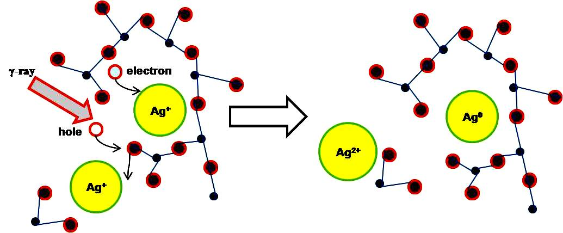

Figure 6. The colour centers formation mechanism of Ag-activated phosphate glass dosimeter

Radio-photoluminescence glass dosimeteris a mixture of inorganic amorphous solid and does not have lattice structure and lattice luminescence centers (molecular-level structures). Therefore, we can only establish the RPL model based on the energy of the excitation source and the energy of the released visible light. The networks of phosphate glass can be classified by the oxygen-to-phosphorus ratio, as set by the glass composition.The colour or luminescence centers are structured at the silver activated phosphate glass, as shown in Figure 6. The number of ionic silver is proportional to the numbers of electron traps. However, excessive numbers of ionic silver decreases the penetration efficiency of the pulse ultra-violet laser and increases energy dependence [17]. Therefore, a proper ratio of ionic silver is required for the best luminescence and excitation efficiency [18].

After γ-irradiation, the AgPO₄ in silver activated phosphate glass can be viewed as Ag⁺/PO₄⁻-related colour centres, produced inside the samples of Ag-doped phosphate glass (Equation 1). The glass changed colours from colourless to slightly yellow after γ-irradiation. When the tetrahedron of PO₄⁻ is exposed to radiation, it loses one electron and forms a positron hole, hPO₄ as shown in Equation 2. Equation 3 shows that the electron released from the PO₄⁻ will combine with Ag⁺ to form an Ag⁰. In gamma irradiated silver-doped phosphate glasses, all electrons are trapped by Ag⁺ ions immediately after irradiation because Ag⁺ has a strong ability to trap electron. Similarly, hPO₄ will combine with Ag⁺ to become an Ag²⁺as shown in Equation 4. The process where Ag⁺ ions trap holes is the main reason of the stabilization phenomenon of RPL centers. Both Ag⁰ and Ag²⁺ form the colour centers. The colour centers formation mechanisms are shown below.

AgPO₄ Ag⁺ + PO₄⁻ (1)
PO₄⁻ hPO₄ + e⁻ (2)
Ag⁺＋e⁻ Agº (electron trap) (3)
Ag⁺＋ hPO₄ PO₄＋Ag²⁺ (hole trap) (4)

When these colour centers were excited with ~335 nm pulse ultra-violet lamp, the electrons in Ag⁰ and Ag²⁺are excited to higher energy levels and emit 600 – 700 nm visible orange light, then return to the original colour centers. These electrons will not return to the valence band of the glass material directly because the energy gained by electrons from the pulse ultra-violet laser is not high enough to let electron escape from colour centers. For electrons to gain enough energy to return to the valence band, the glass needed to be annealed at ~400 ⁰C for one hour. The colour centers won’t disappear after readout; hence, this glass can be read repeatedly.

Conclusion
In summary, optical, physical and chemical measurements on radio-photoluminescent silver-activated phosphate glass to clarify the origin and characteristics of the γ-induced colour centres was performed in this sudy. It was established that the phosphate glasses suitable for dosimeter control possess density values ranging from 2.48 to 2.67 g/cm³. The glass density values are composition dependent, which the density increases with increasing Ag nanoparticles content in the vitreous network. FT-IR spectra of Ag-doped phosphate glasses have been studied before and after γ-irradiation. The FT-IR absorption spectra of Ag-doped phosphate glasses provide information about the main characteristics frequencies for phosphate bonds present in the glass network such as P=O, P-O-P, O-P-O and P-O-H. The presence of P-O-H bond indicates the hygroscopic nature of these phosphate glasses. The decrease in oxygen content of glass sample after γ-irradiation was indicating by bond breaking in the glass sample. This creates oxygen vacancy in the glass sample, which has been noticed as generation of defects in the optical observations. The optical properties such as RPL emission and excitation spectra of the Ag⁺-doped phosphate glass were also investigated in this study. RPL emission spectrum consists of two emission bands peaked at about 460 nm and 620 nm. Blue RPL at 460 nm was closely connected to the 265 nm bands of the excitation spectrum. These bands were attributed to the Ag₂⁺ and Ag⁰ centres, respectively. On the other hand, orange RPL at 620 nm was associated with the 320 nm band in the excitation spectrum and this optical activity was due to the Ag²⁺ centres. Finally, the effect of gamma irradiation was observed in the form of change in the structural units of phosphate glass due to breaking and rearrangement of bonds in the glass network. All these changes were found to be dependent on the composition of the glasses system.

Acknowledgement
The authors wish to acknowledge the support from centre for research and instrumentation management (CRIM) for sample analysis and funding for this study from Universiti Kebangsaan Malaysia from grant DLP-2013-037, GUP-2014-17, UKM-DIP-2014-22 and FRGS/1/2014/5G06/UKM/02/3.

References
- Andreeva, N. Z., Vil’chinskaya, N. N., Dmitryuk, A.V., Perminov, A. S., Petrovskii, G. T. and Savvina, O. C. (1985). Influence of activator concentration on the dosimetric properties of radio photoluminescent glasses. Atom. Énergiya. 58(2): 132 – 135.
- Beekenkamp, P. (1965). Colorcenters in borate, phosphate and borophosphate glasses. Thesis, Technical University, Eindhoven, Philips Res., Suppl. 4.
- Bishay, A. (1961). Gamma-ray induced coloring of some phosphate glasses. J. Am. Ceram. Soc. 44(11): 545-552.
- Bishay, A. (1970). Radiation induced colorcenters in multicomponent glasses. J. Non-Cryst. Solids. 3: 54 –114.
- Bocharova, T. V., Karapetan, G. O., Mironov, A. M., Khalilev, V. D. and Tagil’tseva, N. O. (2006). Gamma-induced absorption spectra as a new method for RE-ion environment study in a fluorophosphates glasses. Opt. Mater. 28: 1296 –1300.
- Dmitryuk, A. V., Paramzina, S. E., Savvina, O. C. and Yashchurzhinskaya, O. A. (1989). Nature of radiophotoluminescent centers in silver-activated phosphate glasses. Opt. Spectrosc. 66: 1070 – 1075.
- Hsu, S. M., Yang, H. W., Huang, D. Y. C., Hsu, W. L., Lu, C. C. and Chen, W. L. (2008). Development and physical characteristics of a novel compound radiophotoluminescent glass dosimeter. Radiat. Meas. 43: 538 –541.
- Takeda, Y., Plaksin, O. A. and Kishimoto, N. (2007). Dispersion of nonlinear dielectric function of Au nanoparticles in silica glass. Opt. Express. 15: 6010 – 6018.
- Dmitryuk, A. V., Paramzina, S. E., Solov’eva, N. D. and Timofeev, N.T. (1996). The influence of glass composition on the properties of silver-doped radiophotoluminescent phosphate glasses. J. Non-Cryst. Solids. 202: 173 – 177.
- Kurobori, T., Zheng, W., Miyamoto, Y., Nanto, H. and Yamamoto, T. (2010). The role of silver in the radio-photoluminescent properties in silver-activated phosphate glass and sodium chloride crystal. Opt. Mater. 32: 1231 –1236.
- Yokota, R. and Imagawa, H. (1965). ESR studies of radiophotoluminescent centers in silver-activated phosphate glass. J. Phys. Soc. Jpn. 20: 1537 –1538.
- Ahmed, I., Abou Neel, Valappil, S. P., Nazhat, S. N., Pickup, D. M., Carta, D., Carroll, D. L., Smith, M. E. and Knowles, J. C. (2007). The structure and properties of silver-doped phosphate-based glasses. J. Mater. Sci. Mater. Med. 42:9827 – 9835.
- Birkin, P. R., Offin, D. G., Joseph, P. F. and Leighton, T.G. (2005). Cavitation, shock waves and the invasive nature of sonoelectrochemistry. J. Phys. Chem. B.109: 16997 –17005.
- ElBatal, F. H., Ouis, M. A., Morsi, R. M. M. and Marzouk, S. Y. (2010).Interaction of gamma rays with some sodium phosphate glasses containing cobalt.J. Non.-Cryst. Solids. 356(1): 46-55.
- Piao, F., Oldham, W. G. and Haller, E. E. (2000). The mechanism of radiation-induced compaction in vitreous silica. J. Non-Cryst. Solids. 276: 61 –71.
- Maurel, C., Cardinal, T., Bellec, M., Canioni, L., Bousquet, B., Treguer, M., Videau, J. J. and Richardson, M. (2009). Luminescence properties of silver zinc phosphate glasses following different irradiations. J. Lumin. 129(12): 1514 –1518.
- Zhao, Quan, Z., Qiu, J. R., Jiang, X. W., Zhao, C. J. and Zhu, C. S. (2004). Controllable precipitation and dissolution of silver nanoparticles in ultrafast laser pulses irradiated Ag⁺-doped phosphate glass. Opt. Exp. 12(17): 4035 – 4040.
- Yokota R. and Muto Y. (1971). Silver-activated phosphate dosimeter glasses with low energy dependence and higher sensitivity. Health Phys. 20: 662 – 663.

