

MALAYSIAN JOURNAL OF ANALYTICAL SCIENCES
ISSN 1394 - 2506

Published by The Malaysian Analytical Sciences Society

ASSESSMENT ON BACTERIA IN THE HEAVY METAL BIOREMEDIATION

(Penilaian ke atas Bakteria dalam Bioremediasi Logam Berat)

Mohamad Romizan Osman^{1,2}, Azman Azid²*, Kamaruzzaman Yunus¹, Ahmad Dasuki Mustafa²,
Mohammad Azizi Amran², Fazureen Azaman², Zarizal Suhaili³, Yahya Abu Bakar¹,
Syahrir Farihan Mohamed Zainuddin¹

¹Kulliyyah of Science,
International Islamic University Malaysia, 25200 Kuantan, Pahang, Malaysia
²East Coast Environmental Research Institute (ESERI),
Universiti Sultan Zainal Abidin, Gong Badak Campus, 21300 Kuala Terengganu, Terengganu, Malaysia
³Faculty of Bioresources and Food Industry,
Universiti Sultan Zainal Abidin, Tembila Campus, 22200 Besut, Terengganu, Malaysia

*Corresponding author: azmanazid@unisza.edu.my

Received: 14 April 2015; Accepted: 9 July 2015

Abstract
The aim of this study was to identify and verify the potential bacteria as the bioremediation agent. It involved bacteria isolation, identification through Gram staining, analytical profile index (API) test and determine bioremediation activities by using inductively coupled plasma mass spectrometry (ICPMS). The soil and water sample were collected from downstream of Galing River, Kuantan Malaysia. Based on phenotypic identification and biochemical analysis, the bacteria present at the vicinity area are possibility of Myroides spp. and Micrococcus spp. These bacteria were proven as bioremediation agent based on the ICPMS result. The result 1 ppm of Zink (Zn), Lead (Pb), Arsenic (As), Selenium (Se), Cadmium (Cd), Manganese (Mn), and Indium (In) dwindled after the bacteria inoculated and incubated for seven days in mixture of base salt media (BSM) with the heavy metal elements. Therefore, this proves that the bacteria which are present at downstream of Galing River, Kuantan Malaysia are significant to help us in the bioremediation activity to decrease the heavy metal pollution in the environment.

Keywords: bioremediation, heavy metal, bacteria, analytical profile index, inductively coupled plasma mass spectrometry

Abstrak
Kajian ini bertujuan untuk mengenal pasti dan mengesahkan bakteria yang berpotensi sebagai agen bioremediasi. Ia melibatkan pengasingan dan pengenalan bakteria melalui ujian pewarnaan Gram, ujian indeks profil analisis (API) dan menentukan aktiviti bioremediasi dengan menggunakan spektometri jisim gadingan plasma teraruh (ICPMS). Sampel tanah dan air telah diambil dari hilir Sungai Galing, Kuantan Malaysia. Berdasarkan ujian pengasingan, pewarnaan dan API, bakteria yang hadir di kawasan sekitar adalah berkemungkinan Myroides spp. dan Micrococcus spp. Bakteria ini telah terbukti sebagai ejen bioremediasi berdasarkan keputusan ICPMS dimana 1 ppm Zink (Zn), Plumbum (Pb), Arsenik (As), Selenium (Se), Kadmium (Cd), Mangan (Mn), dan Indium (In) berkurangan selepas bakteria disuntik dan dieram selama tujuh hari dalam campuran media garam asas (MGA) dengan unsur-unsur logam berat. Oleh itu, ini membuktikan bahawa bakteria yang hadir di hilir Sungai Galing, Kuantan, Malaysia adalah penting untuk membantu kita dalam bioremediasi aktiviti untuk mengurangkan pencemaran logam berat di dalam alam sekitar.

Kata kunci: bioremediasi, logam berat, bakteria, indeks profil analisis, spektometri jisim gadingan plasma teraruh

Introduction
Bacteria are microorganisms with a very large group of single-celled and consist of wide range of metabolic types, geometric shapes and environmental habitats and niches of occurrence. Normally, bacteria are 0.2 micrometres in diameter and 2-8 micrometres (µm) in length with coccus shapes, bacillus or spiral [1]. They can live in all parts of the biosphere such as in the water, soil, hot springs, ocean floor and even within the Earth’s crust. Some of them are pathogenic that can be harmful and cause diseases, but there are some microorganisms that are needed for other living organisms to survive and useful in bioremediation activities [2].

Bioremediation is the use of living organisms to break down or transform hazardous materials to harmless compounds [3]. This treatment technique is more effective than other techniques [4]. The bioremediation process is cheaper than other technologies that are used to clean-up of hazardous waste [5]. It is also environment friendly that it does not destroy the ecosystem and very useful to remove pollutants [6]. Thus, there is no doubt that bioremediation has great potential for dealing with certain types of site contamination [7].

Many bacteria are useful to human being through their bioremediation activities. For instance, Pseudomona. alcaligenes, is able to degrade the recalcitrant polycyclic aromatic hydrocarbon, Pseudomonas mendocina and Pseudomonas putida have the ability to degrade toluene [8]. On the other hand, Pseudomonas resinovorans is capable to degrade carbazole and Pseudomonas veroniiis is able to degrade a variety of simple aromatic organic compounds. Furthermore, the Pseudomonas pseudoalcaligenes has been proven that they use cyanide as nitrogen source to survive [9] meanwhile Pseudomonas, alcaligenes, Sphingomonas, Rhodococcus, and Mycobacterium are able to degrade pesticides and hydrocarbons, both alkanes and polyaromatic compounds [10].

Soil and water are contained a variety of microorganisms including bacteria that can be found in any natural ecosystem. Particularly, they well adapted to environments contaminated with high levels of toxic metals, and that are would be useful for bioremediation applications [11]. The bacteria are crucial in nutritional chains and exerting important roles in biological balance. Adapting several abilities, bacteria have becomes an important influence on the ecological systems, making them necessary for superior organisms living in this planet. Ability of bacteria such as Bacillus, Micrococcus, Staphylococcus, Pseudomonas and Methylococcus to transform and degrade various types of pollutants in different matrixes such as soil, water, sediments and air has been widely recognized during the last decades [12].

According to Environmental Protection Agency (EPA), there are various types of metal contaminants such as arsenic, antimony, beryllium, cadmium, chromium, copper, lead, mercury, iron, manganese, magnesium, radium, nickel, selenium, silver, thallium and zinc are present in surface water, groundwater, soil, storage tanks, lagoons, industrial gaseous emissions and industrial waste are priority pollutant [13]. Bioremediation techniques may be applied to reduce or eliminate the pollutants that harmful to environment [14,15]. The attuned heavy metal bioremediation bacteria are inclusive of Escherichia coli, Salmonella typhi, Bacillus licheniformis and Pseudomona fluorescence [16], Pseudomonas aeruginosa, Alcaligenes eutrophus [17], Enterobacter cloaceae, Rhodobium marinum and Rhodobacter sphaeroide [18]. Thus, the objectives of this study was to identify the potential bacteria through phenotypic and biochemical API test as well as verification in the bioremediation application by using ICPMS.

Materials and Methods
Sample Collection
The plastic bottles sample and Erlenmeyer were washed with 1% of nitric acid and sterilized in the UV light chamber. Meanwhile, all media were sterilized by the autoclave. Surface water samples were collected from downstream of the Galing River, Kuantan Malaysia (N.3°.81118’’ and E. 103°. 34047”) and soil sample was obtained from the river bank. Respectively, they were stored into the plastic bottle sample with screw cap.

Bacteria Identification
One gram from each sample are weighed and inoculated into 99g of sterilized Bifidus Selective Medium (BSM) followed by incubation at 37ºC for 24h with shaker incubator (120 rpm). The overnight culture of each samples were subcultured onto nutrient agar (NA) followed by another incubation at 37ºC for 24h. The bacteria species were phenotypically identified and biochemically characterized by using Gram Staining and API 20E, respectively.

Bioremediation Activity Test
One part per million (ppm) solution of multi element (Zn, Pb, As, Se, Cd, Mn, In) with BSM was prepared with adding 10g of multi element 10 ppm into 90 g of BSM. The single colony from each type of bacteria was inoculated into 1 ppm of the solution and incubated in ambient temperature for 7 days. 1 g of dry soil sample was weighed and mixed in vessel with 9 mL of concentrated nitric acid, 2ml hydrochloric acids and 1 ml of the hydrogen peroxide. Subsequently, the vessel heated with 180 °C in the microwave digestion Multiwave 3000 for 5.5 minutes [19]. Hundred times dilution with deionized water 18 micro ohm (µΩ) was performed after the digestion [20]. In contrast, 50 ml of water sample was treated with 500 µL of Concentrated Nitric Acid [21]. All of treated samples filtered through 0.45µm of syringe filter and analyzed by the ICPMS Elan 9000 Perkin Elmer to check the respective heavy metal element in the water and soil before and after inoculated bacteria into the solution.

Results and Discussion
Media Test

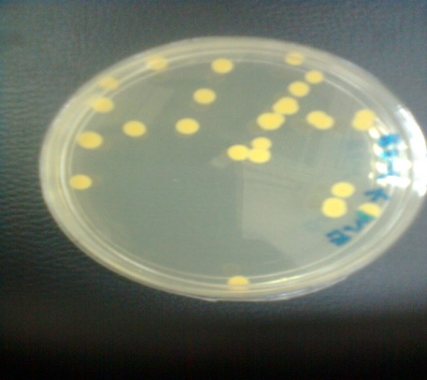 | 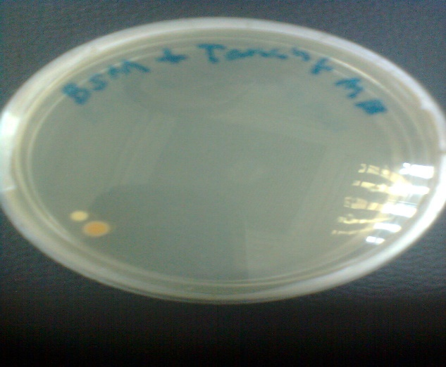
Figure 1. Colonies of bacteria isolated from the water  samples | Figure 2. Single colony of bacteria isolated from the  soil sample

Based on Figure 1, there was only one colour observed on the culture plate. It is shown that only one type of bacteria was found from the water sample. Meanwhile, Figure 2 portrays the water sample consists of two colours which are white and yellow. This indicates two types of bacteria found from the water samples.

Gram Staining Identification
The staining result as Figure 3 portrayed the bacteria in rod shapes and shown Gram negative reaction with pink coloured under microscope observation. Meanwhile, Figure 4 shows the staining result for the white-coloured bacteria whereby the bacteria in coccus shape and the crystal violet to be purpled-coloured when seen through a microscope. It indicated that the microbes are Gram- positive bacteria.

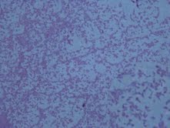 | 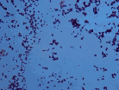
Figure 3. Yellow-coloured single colony bacteria  from the water samples show Gram  negative reaction | Figure 4. White-coloured single colony bacteria  from the soil sample

Analytical Profile Index Test
Resultant through the staining test, the gram-negative bacteria must be identified by using API 20E test system [22] meanwhile the gram-positive coccus bacteria is compatible to be identified through the API Staph test [23]. Thus, Figure 5, 6 and Table 1 and 2 illustrate the result of the bacteria identification isolated from the samples.

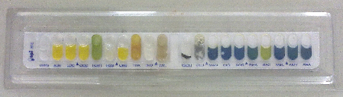

Figure 5. API 20 E test results for yellow-coloured bacteria isolated from the water sample.

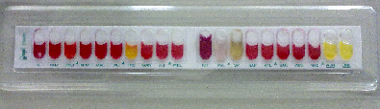

Figure 6. API Staph test results for white-coloured bacteria isolated from the soil sample.

Table 1. API 20 E test results for yellow-coloured bacteria isolated from the water sample.
Test | Active Ingredients | Reactions/ Enzymes | Color Changes | Results
ONPG | 2-nitropheny-BD-galactopyranoside | B-galactosidase (Ortho Nitrophenyl-BD-galactopyranoside) | Colorless | Negative
ADH | L-arginine | Arginine DIHyrolase | Yellow | Negative
LDC | L-lysine | Lysine Decarboxylase | Yellow | Negative
ODC | L-ornithine | Ornithine Decaboxylase | Yellow | Negative
CIT | Trisodium citrate | Citrate utilization | Pale green | Negative
H₂S | Sodium thiosulphate | H₂S production | Colorless | Negative
URE | Urea | Urease | Yellow | Negative
TDA | L-Tryplophane | Tryplophane Deaminase | Reddish | Positive
IND | L-Tryplophane | Indole production | Yellow | Negative
VP | Sodium pyruvate | Acetoln production  (Voges Proskauer) | Colorless | Negative
GEL | Gelatin  (bovine origin) | Gelatinase | Diffusion of black pigment | Positive
GLU | D-glucose | Fermentation/oxidation  ( Glucose )( 4 ) | Blue Green | Negative
MAN | D-mannitol | Fermentation/oxidation  ( Mannitol )( 4 ) | Blue | Negative
INO | Inositol | Fermentataion/oxidation (Inositol) (4) | Blue | Negative
SOR | D-sorbitol | Fermentataion/oxidation (Sorbitol) (4) | Blue | Negative
RHA | L-rhamnose | Fermentataion/oxidation (Rhamnose) (4) | Blue | Negative
SAC | D-sucrose | Fermentataion/oxidation (Sacharose) (4) | Yellow | Positive
MEL | D-melibiose | Frementation /Oxidation(Gmelibose) | Blue | Negative
AMY | Amygdalin | Fermentation/ oxidation (Amygdalin)(4) | Blue | Negative
ARA | L-arabinose | Fermentation/oxidation (Arabinose)(4) | Blue | Negative
OX | Oxidase | Cytochrome-Oxidase | Purple color formation | Negative
Nitrate Reduction  GLU tube | Potassium nitrate | NO₂ production | Yellow | Negative
Nitrate Reduction  GLU tube | Potassium nitrate | Reduction to N₂ gas | Orange-red | Negative
MOB | API M Medium or microscope | motility | Motile | Negative
mcC | MacConkey | growth | Presence of bacteria | Positive
OF-F | Glucose (API of Medium) | Fermentation: under  mineral oil | Green | Negative
OF-O | Glucose (API of Medium) | Oxidation: exposed to the air | Green | Negative

Table 2. API staph test results for white-coloured bacteria isolated from the soil sample.
 | Tests |  | Active  Ingredients | Reaction / Enzymes | Color  Changes | Results
 |  | O | No substrate | Negative Control | Red | Negative
 |  | GLU | D-glucose | (Positive Control)(D-Glucose) | Red | Negative
 |  | FRU | D-fructose | Acidification (D-Fructose) | Red | Negative
 |  | MNE | D-mannose | Acidification (D-Mannose) | Red | Negative
 |  | MAL | D-maltose | Acidification (D- Maltose) | Red | Negative
LAC |  |  | D-lactose (bovine origin) | Acidification (D-Lactose | Red | Negative
TRE |  |  | D-trehalose | Acidification (D-Trehalose) | Yellow | Positive
MAN |  |  | D-mannitol | Acidification (D-Mannitol) | Red | Negative
XLT |  |  | Xylitol | Acidification (D-Xylitol) | Red | Negative
MEL |  |  | D-melibiose | Acidification (D-Melibiose) | Red | Negative
 | NIT |  | Potassium Nitrate | Reduction of Nitrates to Nitrites | Colourless-light pink | Negative
 | PAL |  | ß-Naphthyl phosphate | Alkaline Phosphatase | Violet | Positive
 | VP |  | Sodium Pyruvate | Acetyl-Methyl-Carbinol production (Voges Proskauer) | Violet-Pink | Positive
 | RAF |  | D-raffinose | Acidification (Raffinose) | Red | Negative
 | XYL |  | D-xylose | Acidification (Xylose) | Red | Negative
 | SAC |  | D-saccharose (Sucrose) | Acidification (Saccharose) | Red | Negative
 | MDG |  | Methyl-ἀD-Glucopyranoside | Acidification (Methyl-ἀD-Glucopyranoside | Red | Negative
 | NAG |  | N-acetyl-glucosamine | Acidification (N-acetyl-glucosamine) | Red | Negative
 | ADH |  | L-arginine | Arginine DiHydrolase | Red | Negative
 | URE |  | Urea | Urease | Red | Negative

According to the API result (Table 2), the bacteria identification was determined by using API 20E Stand Alone Version 1.1 Software in order to identify the possibility of the bacteria species (spp). Thus, based on the software, the possibility of bacteria present at the area is 75% of Myroides spp. Furthermore, the API Staph result Table 2 analysed through the API Staph Stand Alone Version 1.1 Software in order to identify the bacteria species. Thus, the possibility of the bacteria present at the area is 97.2% of Micrococcus sp. Therefore, the analysis of water and soil has revealed that contaminated there is a possibility of the presence of indigenous Myroides spp. and Micrococcus spp at downstream of the river.

Organisms of Myroides spp. are aerobic, yellow-pigmented, gram-negative rod that grows at both room temperature and 37°C. They are habitat-specific organisms, like other members of the Flavobacteriaceae family, and are commonly found in wet environments. Particularly, Myroides spp is marine bacteria whereby can cause diseases such as cellulites, necrotizing fasciitis, urinary tract infection, surgical wound infection, ventriculitis and endocarditic that dangerous to human being [24]. However, the Myroides spp can degrade the residue of C5-C8 fatty acids including pentanoic acid, hexanoic acid, heptanoic acid, octanoic acid, and 2-methylbutanoic acid that can lead the further air and water pollution [25].

Meanwhile, Micrococcus spp. is a genus of bacteria in the Micrococcaceae family and exists in a wide range of environments, including water, dust, and soil. The bacteria can cause the diseases such as septic arthritis, endocarditis, pneumonia and septic shock. These bacteria are dangerous to human being if infected. Nevertheless, they are involved in detoxification or biodegradation of many other inevitable environmental pollutants such as hydrocarbon waste, wax, organic pollutant, plastic [18] and radioactive residue [26]. Micrococcus sp is beneficial microorganism to clean up the oil contaminated sites and prevent the soil from the detrimental substances [27].

ICPMS Analysis

Table 3. The concentration of solution without bacteria (control) and after inoculated
with the yellow-coloured bacteria (sample 1)
Element | Control (ppm) | Sample (ppm)
Zn | 1.000 | 0.513
Pb | 1.000 | 0.521
As | 1.000 | 0.791
Se | 1.000 | 0.533
Cd | 1.000 | 0.523
Mn | 1.000 | 0.857
In | 1.000 | 0.697

Table 4. The concentration of solution without bacteria (control) and after inoculated
with the white-coloured bacteria (sample 2)
Element | Control (ppm) | Sample (ppm)
Zn | 1.000 | 0.660
Pb | 1.000 | 0.405
As | 1.000 | 0.707
Se | 1.000 | 0.205
Cd | 1.000 | 0.493
Mn | 1.000 | 0.835
In | 1.000 | 0.651

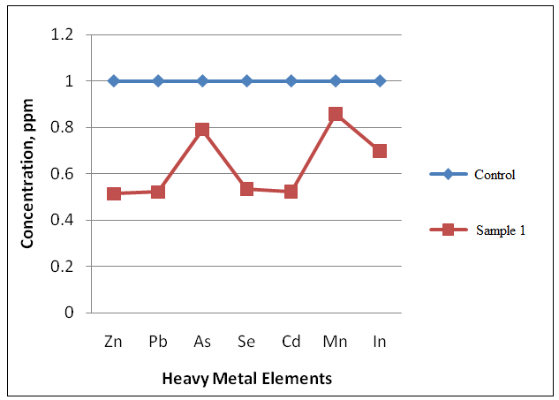

Figure 7. The comparison between concentration of control and sample 1

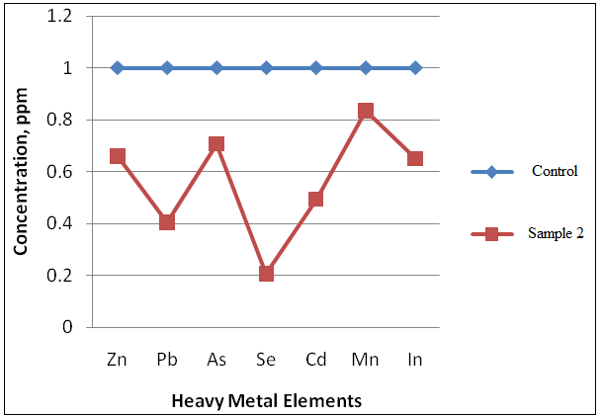

Figure 8. The comparison concentration of control and sample 2

Correspondingly, Table 3 and 4 show concentrations of the elements are dwindled after the bacteria inoculated into the 1 ppm of solution multi element with BSM and incubated in ambient temperature for 7 days. Additionally, Figure 7 and 8 illustrate trend of the heavy metal concentration in the solution without the presence of bacteria and inoculated with the bacteria. Therefore, it demonstrates that the bacteria are capable to degrade the heavy metal elements contaminated in the water and soil thereby established the bioremediation activities ensue at the area.

Heavy metal elements such as Zn, Pb, Cd and In are not contaminated in the water as well as Mn, In and Cd in the soil (Table 5). On the other hand, the elements concentration of As, Se, Mn in the water and Zn, Pb, As and Se in the soil are still low and comply with the acceptable value of raw water quality standard recommended by the Ministry of Health, Malaysia [28]. Respectively, the concentration elements of heavy metal contaminated in the soil and water samples are low thereby indicated the presence of the bacteria in the river and soil at downstream Galing River are playing the imperative role to assist people in decreasing the pollution of heavy metal contains in the environment which is very harmful to the ecology system. It is proved that the bioremediation activities by the bacteria are happening at the vicinity area.

Table 5. Concentration of heavy metal contaminated in the soil and water
at the downstream of Galing River
Element | Water (ppm) | Soil  (ppm) | Maximum acceptable  value (ppm)
Zn | 0 | 0.001 | 3
Pb | 0 | 0.004 | 0.05
As | 0.003 | 0.07 | 0.01
Se | 0.003 | 0.002 | 0.01
Cd | 0 | 0 | 0.003
Mn | 0.028 | 0 | 0.2
In | 0 | 0 | NA

Conclusion
In conclusion, this study demonstrates that the bacteria confer a positive result in bioremediation process. This also suggest the possibility of Myroides spp. and Micrococcus spp which exist indigenously in the downstream of Galing River, Kuantan have ability in the bioremediation. Therefore, these bacteria can be utilized as potential bioremediation agent to eliminate or decrease the heavy metal pollutant in future. However, more study on this matter should be executed in order to reconfirm the bioremediation activity by the bacteria, the presence of the bacteria, as well as bacteria identification genotypically and the concentration of heavy metal polluted in the river water and soil.

Acknowledgement
The authors acknowledge Kuliyyah of Science International Islamic University Malaysia (IIUM) and East Coast Environmental Research Institute Universiti Sultan Zainal Abidin (UNISZA) for giving us permission to utilize the research facilities, advice, guidance, and support for this study.

References
- Hogan, M.C. (2014). Bacteria. Available at: http://www.eoearth.org/view/article/150368/. Accessed November 2014.
- Ragini, G. and Pankaj, B. (2012). Cynobacteria: A comprehensive review. International Research Journal of Pharmacy 3(2): 1-5.
- Mandal, A. K., Sarma, P. M., Singh, B., Jeyaseelan, C. P. Channashettar, V. A. Lal, B. and Datta, J. (2012) Bioremediation: An Environment Friendly Sustainable Biotechnological Solution for Remediation of Petroleum Hydrocarbon Contaminated Waste. ARPN Journal of Science and Technology 2: 1-12.
- Alavijeh, P. K., Halimoon, N., Pauzi, Z., Johari, W. L. W., Karimi, B. (2014). Crude oil biodegradation using isolated bacteria from polluted soil: pp 127-129.
- Naik, M. M., Pandey, A. and Dubey, S. K (2012). Bioremediation of Metals Mediated by Marine Bacteria. Microorganisms in Environmental Management Microbes and Environment: pp 665-682.
- Sharma, S. (2012). Bioremediation: Features, Strategies and applications. Asian Journal of Pharmacy and Life Science 2 (2): 1-12.
- Hamza, U. D., Mohammed, I. A. and Sale, A. (2012). Potentials of bacterial isolates in bioremediation of petroleum refinery wastewater. Journal of Applied Phytotechnology in Environmental Sanitation 1(3):131-138.
- Poornima, K., Karthik, L., Swadhini, S. P., Mythili, S., and Sathiavelu, A. (2010). Degradation of Chromium by Using a Novel Strains of Pseudomonas Species. Journal of Microbial and Biochemical Technology, 2: 95-99.
- Igeno, I.M., Orovengua, E., Guijo, I.M., Merchán, F., Quesada and Blasco, R. (2007). Biodegradation of cyanide-containing wastes by Pseudomonas pseudoalcaligenes CECT5344. Available at: http://www.formatex.org/microbio/pdf/Pages100-107.pdf. Accessed March, 2015.
- Vidali, M. (2001). Bioremediation. An overview. Available at: http://www.eolss.net/sample-chapters/c17/e6-58-09-13.pdf. Accessed March 2015.
- Salem, I. B., Sghaier, H., Trifi1, H., Héni, S., Khwaldia, K., Saidi, M. and Landoulsi, A. (2012). Isolation and characterization of a novel Micrococcus strain for bioremediation of strontium in radioactive residues. African Journal of Microbiology Research 6(4), pp. 851-858.
- Bahig A. E., Aly E. A., Khaled A. A. and Amel K. A (2008). Isolation, Characterization and Application of Bacterial Population from Agricultural Soil at Sohag Province, Egypt. Malaysian Journal of Microbiology 4(2): 42- 50.
- Perriello. (2005). Remediation of Metal Contaminants with Hydrocarbon Utilizing Bacteria. United States Patents: 1-19.
- Wongsa, P., Tanaka, M., Ueno, A., Hasanuzzaman, M., Yumoto, I. and Okuyama, H. (2004). Isolation and Characterization of Novel Strains of Pseudomonas aeruginosa and Serratia marcescens Possessing High Efficiency to Degrade Gasoline, Kerosene, Diesel Oil, and Lubricating Oil. Journal of Current Microbiology 49: pp. 415–422
- Ahemed, M. and Malik, A. (2011). Bioaccumulation of Heavy Metal by zinc Resistant Bacteria Isolated from Agricultural Soils Irrigated with Wastewater. Bacteriology Journal 2: 12-21.
- Basha, S.A. and Rajaganesh, K. (2014). Microbial Bioremediation of Heavy Metals from Textile Industry Dye Effluents using Isolated Bacterial Strains. International Journal of Current Microbiology and Applied Science 3(5): 785-794.
- Garbisu, C. and Alkorta, I. (2003). Basic concepts on heavy metal soil bioremediation, The European Journal of Mineral Processing and Environmental Protection 3 (1): pp. 58-66.
- Dash, H.R., Mangwani, N., Chakraborty, J., Kumari, S. and Das, S. (2012). Marine bacteria: potential candidates for enhanced bioremediation. Applied Microbiology Biotechnology 97(2):561-71.
- Mangum, S.J. (2009). Field Application Report: Optical Emission Spectrometry and ICP-Mass Spectrometry.1-3. Available at:http://www.perkinelmer.com/content/applicationnotes/app_microwavedigestionmultiwave.pdf. Accessed March 2015.
- Kamaruzzaman, B.Y., Eina, Z., John, B.A., and Jalal, K.C.A. (2011). Heavy Metal Accumulation Comercially Important Fishes of South West Malaysian Coast. Research Journal of Environment 5(6): 595-602.
- Sarojam, P. (2010). Application Note: ICP-Optical Emission Spectroscopy.Available at: http://www.perkinelmer.com/cmsresources/images/4474318app_tracemetalsindrinkingwaterbyoptima7000.pdf. Accessed March, 2015.
- Popovic, N.T., Rakovac, R.C. and Perovic, I.S.(2007). Commercial phenotypic tests (API 20E) in diagnosis.of fish bacteria: A review 52 (2): 49–53.
- Benito, M. J. Aguez, M. M., Coardoba, M. G., Aranda, E., and Coardoba, J. J. (2000). Rapid differentiation of Staphylococcus aureus from staphylococcal species by arbitrarily primed-polymerase chain reaction. Letters in Applied Microbiology 31(5):368-373.
- Benedetti, P., Rassu, M., Pavan, G., Sefton, A. and Pellizzer, G. (2011). Septic shock, pneumonia, and soft tissue infection due to Myroides odoratimimus: report of a case and review of Myroides infections 39: pp 161-165.
- Xiao, Z., Zhu, X., Xi, L., Hou, X., Fang, L. and Lu, J.R. (2014). Biodegradation of C5-C 8 fatty acids and production of aroma volatiles by Myroides sp. ZB35 isolated from activated sludge. Journal of Microbiology 52(5):407-12.
- Francis, A. J. (2005).Microbial Transformations of Radionuclides and Environmental Restoration through Bioremediation. Available at: http://www.bnl.gov/isd/documents/32628.pdf. Accessed April 2015.
- Santhini, K., Myla, J., Sajani, S., and Usharani, G. (2009). Screening of Micrococcus Sp from Oil Contaminated Soil with Reference to Bioremediation. Botany Research International 2 (4): 248-252.
- Ministry of Health. (2010). National Guidelines for Raw Drinking Water Quality. Available at: http://kmam.moh.gov.my/public-user/drinking-water-quality-standard.html. Accessed January 2015.

