

MALAYSIAN JOURNAL OF ANALYTICAL SCIENCES
ISSN 1394 - 2506

Published by The Malaysian Analytical Sciences Society

TREND ANALYSIS OF PAHANG RIVER USING NON-PARAMETRIC ANALYSIS: MANN KENDALL’S TREND TEST

(Analisis Corak Sungai Pahang Menggunakan Kaedah Bukan Parametrik: Ujian Corak
Mann Kendall)

Nur Hishaam Sulaiman¹, Mohd Khairul Amri Kamarudin^{1,2}*, Ahmad Dasuki Mustafa¹,
Muhammad Azizi Amran¹, Fazureen Azaman¹, Ismail Zainal Abidin¹, Norsyuhada Hairoma¹

¹East Coast Environmental Research Institute (ESERI)

²Faculty of Design Arts and Engineering Technology

Universiti Sultan Zainal Abidin, 21300 Kuala Terengganu, Terengganu, Malaysia

*Corresponding author: mkhairulamri@unisza.edu.my

Received: 14 April 2015; Accepted: 9 July 2015

Abstract
Flood is common in Pahang especially during northeast monsoon season from November to February. Three river cross station: Lubuk Paku, Sg. Yap and Temerloh were selected as area of this study. The stream flow and water level data were gathered from DID record. Data set for this study were analysed by using non-parametric analysis, Mann-Kendall Trend Test. The results that obtained from stream flow and water level analysis indicate that there are positively significant trend for Lubuk Paku (0.001) and Sg. Yap (<0.0001) from 1972-2011 with the p-value < 0.05. Temerloh (0.178) data from 1963-2011 recorded no trend for stream flow parameter but negative trend for water level parameter. Hydrological pattern and trend are extremely affected by outside factors such as north east monsoon season that occurred in South China Sea and affected Pahang during November to March. There are other factors such as development and management of the areas which can be considered as factors affected the data and results. Hydrological Pattern is important to indicate the river trend such as stream flow and water level. It can be used as flood mitigation by local authorities.

Keywords: Mann Kendall, flood, trend analysis, hydrology, Pahang River

Abstrak
Banjir di Pahang pada musin monsun timur laut yang membadai pantai timur semenanjung Malaysia pada November hingga Febuari. Terdapat tiga buah stesen hidrologi yang ditempatkan di sepanjang Sungai Pahang telah dipilih untuk mewakili keseluruhan Sungai Pahang iaitu Lubuk Paku, Sg.Yap dan Temerloh. Dalam kajian ini juga, parameter yang digunakan ialah bersifat fizikal iaitu kelajuan arus dan paras air Sungai Pahang yang diperoleh daripada JPS. Kesemua data yang diperoleh dianalisa dengan menggunakan analisa bukan parametrik iaitu Ujian Corak Mann-Kendall. Keputusan yang diperoleh daripada hasil analisis data menunjukkan bahawa terdapat corak peningkatan positif pada data yang mewakili Lubuk Paku dan Sungai Yap dari tahun 1972-2011. Kesemua p-value yang dikira menunjukkan jelas terdapat corak dalam kedua-dua data pertama untuk Lubuk Paku (0.001) dan Sungai Yap (kurang daripada 0.0001) di mana jumlah p-value kurang daripada 0.05. Temerloh (0.178) mencatatkan tiada corak untuk kelajuan arus manakala untuk paras air ia mencatatkan corak negatif. Terdapat pelbagai faktor yang mempengaruhi corak hidrologi Sungai Pahang iaitu dari segi tiupan angin monsun dan pembangunan yang dijalankan di kawasan kajian yang memberi impak yang besar terhadap ketepatan data dan keputusan analisa. Pemantauan corak hidrologi amat penting untuk mengetahui corak sungai dan boleh digunakan sebagai maklumat persediaan banjir di Pahang.

Kata kunci: Mann Kendall, banjir, analisis corak, hidrologi, Sungai Pahang

Introduction
In recent years, the issues of river quality and availability of water resources are being questioned because of the degradation of environmental health and dramatically increased of pollution in Malaysia. Something has to be done before all this thing becomes worse and affected our water resources. According to Sulaiman et al. [1], there are possibilities that the land use and intensive development of a certain area will alter the river systems near to the development and also the alteration of the river itself such as flood control and power generation will increase the degradation of river systems in Malaysia. Due to exploitation of natural resources in Malaysia such as massive land reclamation, development of livestock production, energy development project and uncontrolled discharge of pollution, this disturbance may result in flood event, stream degradation and erosion [2].

The flood is the most common natural disaster that occurred in Malaysia. Approximately every year, flood event will occur in some places in Malaysia whether it is huge flood or only flash flood According to Sulaiman et al. [1], the flood event is becoming an often disaster in Malaysia. The land use cover due to deforestation and massive development of the areas has become a perception to the researcher that it is the main reason that contribute to the increased of results in flood frequency and severity. Stream flow of rivers is basically can be studied to be used as an indicator for the flood event [3]. Pahang basins are one of the areas that received highest total rainfall during north east monsoon period about 40 percent of the total rainfall annually [4,5]. According to Adnan and Atkinson [6], climate change and weather play an important role in various fields such as hydrology, epidemiology and environment sustainability. That is directly referring to the monsoon season that hit the east coast of Peninsular Malaysia about every year and the chances of being flooded are relatively high Therefore, trend analysis of Pahang River is important in order to evaluate the hydrological pattern for future flood assessment.

Statistical tools commonly used to detect the significant of trends in climate and hydrological field using non-parametric analysis such as Mann Kendall Trend test, spearman rank correlation, and the parametric analysis such as descriptive statistic and student’s t-test. In statistical tools, non- parametric test is considered better and it displays much insensitivity to outlier unlike parametric test [7]. The application of environ metric, a branch of environmental analytical chemistry and the use of multivariate statistical modelling and data treatment was reported to be the best method in analysing a large complex environmental monitoring data [8]. Trend analysis is verified as a very useful analytical tool for water resources planning and hydrological management since hydrological variables such as precipitation, water level, stream flow, direct runoff and discharge provides useful information on the possibility and changes tendency of the variables in the future [9,10].

The purpose of this study is to analyse the trend of the Pahang River using hydrological data and to come out with hydrological pattern of the river. In addition, there is further investigation being carried out in order to examine the effects of south-west monsoon season on November to March to the parameter that been studied in Pahang river.

Study Area
Pahang river also one of the largest river basins in peninsular Malaysia. Pahang river is located at longitude 101⁰ 30’E to 103⁰ 30’ E and latitude 3⁰ 00’ N to 4⁰ 45’ N. Pahang river is the major river system in Pahang state that started from the Titiwangsa mountain range to the south china sea. Stations that involve in this research are Lubuk Paku station, Sungai Yap station, and Temerloh station. All these stations are located alongside the Pahang River. The parameter that has been used in this analysis are stream flow and water level.

Materials and Methods
Data Set
In this research, the secondary data that's being used are coming from four different station that been set up by DID Malaysia to monitor the stream flow and water level of Pahang River. According to Gasim et al. [5], in hydrological procedure no. 4 in DID Malaysia had mentioned some of the data that obtained and recorded may have some not so quality secondary data may be due to the error of the gauge, inaccuracy in data collection and water level recorders. The records from prior to 1970 were operated by using a stick gauge that is manual gauge and after that it is being upgraded with automatic gauge is whether it is an underestimation or improper reading of the parameter.

Mann Kendall’s Trend Test
This study was used XLSTAT software for Mann Kendall trend test. This test was used to indicate whether there are trends in the data sets. Non-parametric Mann Kendall Trend Test was applied for the purpose to examine the temporal variation trend of stream flow and water level from 1983 to 2011 in the study area. Since there are chances of outliers to interfere as the extreme stream flow and water level event, non-parametric Mann Kendall Trend Test is useful because it is based on the significance of differences, not directly on the random values. Therefore the trend that's been determined are less affected by outliers [11]. The nonparametric Mann-Kendall trend test, also called Kendall’s tau test [14,15], has been applied in many studies to identify whether monotonic trends exist in hydro-meteorological data such as temperature, rainfall and stream flow. This test is often used because of its property that no assumptions are needed about the data that need to be tested. In the trend test, the null hypothesis Ho is that there is no trend in the population from which the dataset is drawn and the sample of data {xj, j equal to 1, 2… n} is independent and identically distributed. The alternative hypothesis H1 is that a trend exists in the dataset.

The Mann Kendall Trend Test, S is calculated by using a formula equation 1 below [14,15]:

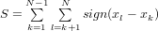 (1)

where x_{j} and x_{k} are the sequential data value and j greater than k, n is the length of the data set

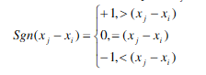 (2)
Variance of S is determined by:

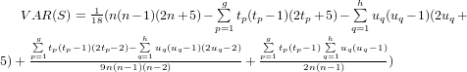 (3)

where t is the extent of any given time and the summation over all ties. For n greater than 10, the standard normal variate z is calculated by using equation 4 below:

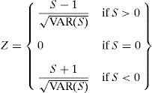 (4)
The positive z value indicates an increasing trend while a negative z value indicates a decreasing trend. When testing two sided trends at a selected level of significance a, the null hypothesis of no trend is rejected if the absolute value of z is greater than z_{a/2.}

Results and Discussion
The section below emphasizes on the overall trend of the data series on each station. Time series plot, Mann-Kendall Trend Test and descriptive statistical analysis were used in determining the trend associate stream flow and water level for each station. Results obtained show a significant trend at 95% confidence level for certain stations. Trend line also drawn to show the trend clearly. The p-values smaller than 0.05 must be fulfilled before the trend test was concluded to be significant. Figure 1 and 2 show the graph of stream flow trends and water level, respectively of Lubuk Paku, Sg. Yap, and Temerloh.

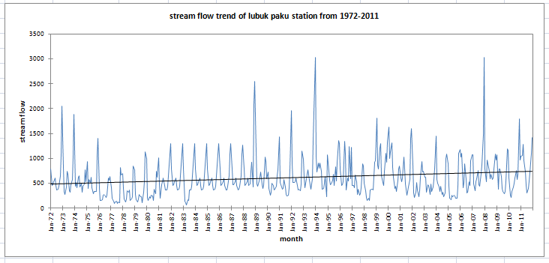
(i)

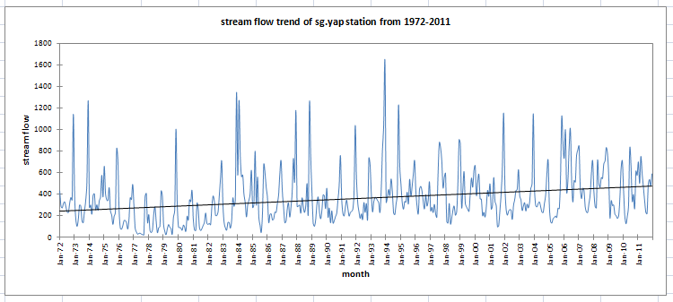
(ii)

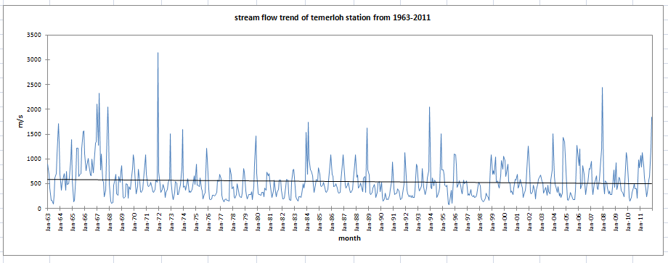
(iii)

Figure 1. Stream flow trend graph of (i) Lubuk Paku, (ii) Sg. Yap, and (iii) Temerloh
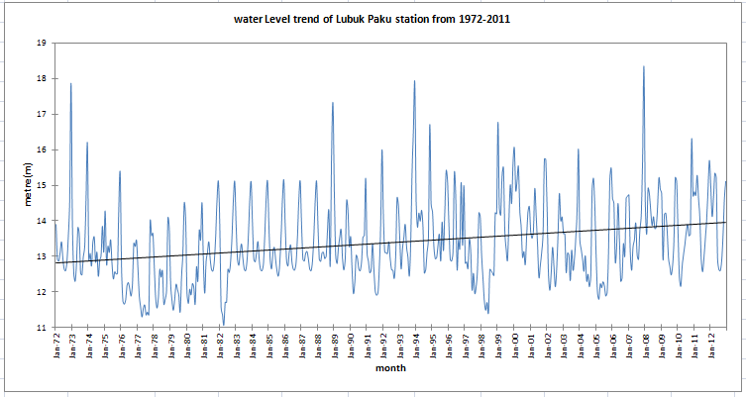
(i)

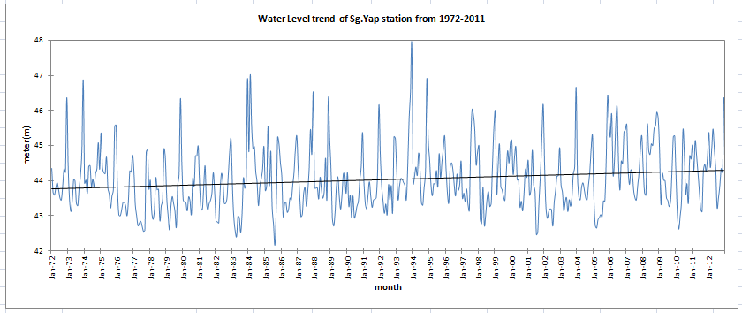
(ii)

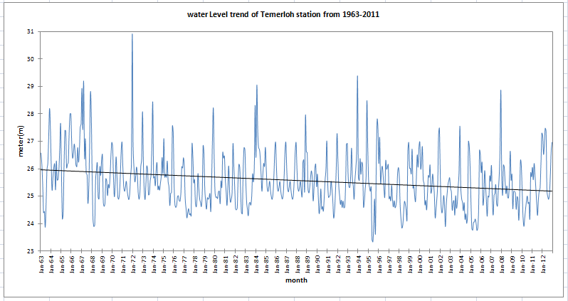
(iii)

Figure 2. Water level trend graph of (i) Lubuk Paku, (ii) Sg. Yap, and (iii) Temerloh

Mann Kendall’s Test
In Figure 1(i) and (ii), the analysis from Mann-Kendall Trend Test have resulted the trend of stream flow from 1972 to 2011 on two stations, Lubuk Paku station and Sg. Yap station. From Table 1, the Kendall’s tau values were 0.156 for Lubuk paku station and 0.230 for Sg. Yap station. It shows that the data sets are seasonal. For both stations, the p-value that computed are lower than significant level alpha equal to 0.05, which were 0.001 and less than 0.0001, respectively, indicated that there is a significant trend of stream flow velocity. Temerloh station trend graph portrayed in Figure 1(iii) have resulted 0.178 of p-value that was above the significant level α and also the Kendall’s tau value was -0.037, so the null hypothesis were accepted indicated that is no trend of stream flow from 1963-2012. There is enough evidence to conclude that the trend exist on both stations. Lubuk Paku and Sg. Yap station also shows that there are significant positive stream flow trend.

As in Figure 2(i) and (ii), the Mann-Kendall Trend Test have resulted the pattern of water level from 1972 to 2011 on two stations, Lubuk Paku station and Sg. Yap station. From Table 1, the kendall’s tau value were 0.204 for Lubuk Paku and 0.121 for Sg. Yap station. It shows that the data sets are seasonal. For both station, the p-value that computed are lower than significant level alpha equal to 0.05, which is less than 0.0001. There are enough evidence to conclude that trend exist on both station. Lubuk Paku and Sg. Yap station also show that there are significant positive stream flow trend. The analysis for Temerloh station (Figure 2(iii)) using Mann-Kendall Trend Test from data sets Temerloh station (1963-2011) shows that the p-value of this station was at less than 0.0001, but the trend line shows that it is negatively and decreasing from 1963 to 2011. Kendall‘s tau value was -0.152 for Temerloh station. There are significantly negative trend in Temerloh station.

Table 1. Statistical Analysis of stream flow and water level of selected station in Pahang River
Station | Parameter | p-value | Minimum | Maximum | Mean | Std deviation | CV | Kendall’s Tau
Lubuk Paku | Stream flow | 0.001 | 287.8 | 1392.5 | 623.11 | 347.17 | 0.56 | 0.156
Sg. Yap | Stream flow | <0.0001 | 158.15 | 850.66 | 362.04 | 208.16 | 0.57 | 0.23
Temerloh | Stream flow | 0.178 | 238 | 1241.5 | 543.32 | 301.88 | 0.56 | -0.037
Lubuk Paku | Water level | <0.0001 | 12.28 | 15.42 | 13.5 | 0.98 | 0.07 | 0.204
Sg. Yap | Water level | <0.0001 | 43.78 | 45.02 | 44.03 | 0.81 | 0.02 | 0.121
Temerloh | Water level | <0.0001 | 24.53 | 27.35 | 25.58 | 0.86 | 0.03 | -0.152

Slope and Confidence Interval
The confidence interval value (equal to zero) will be determined the slope value. As shown in Table 2, when the minimum interval value is greater than maximum interval value give resulting of negative slope and when the maximum interval value is greater than minimum interval value, it will give resulting positive value. The results of positive slope have found at the Lubuk Paku and Sg. Yap, while negative slope recorded at Temerloh for both stream flow and water level parameters.

The results obtained from the Mann-Kendall Trend Test also indicate the high peak in the stream flow of all three stations in Pahang River. Based on the information and data obtained from the Department of Drainage and Irrigation Malaysia and Malaysia Meteorological Department, the higher peak in the trend graphs of stream flow are matched with the major flood history that happen in Pahang state, which obviously affected by the increase in precipitation that can be visualised by referring the stream flow and water level parameter. According to the flood disaster archive [12] and [13], there were a major flood disaster event in Pahang on November 1994, December-January 1999 and December 2007, which was verified the data in 1994, 1999 and 2007 as shown in Figure 1(i) and 2(i) that portrayed high of stream flow velocity and water level. This data also parallel to the northeast monsoon season that beginning in November until February that contributed a high amount of precipitation every year during this season.

Table 2. Slope and confidence Interval of Mann Kendall's Trend Test
Station | Parameter | Slope | Confidence interval
Station | Parameter | Slope | Min | Max
Lubuk Paku | Stream Flow | 0.475 | -14.011 | 15.012
Sg. Yap | Stream Flow | 0.453 | -8.759 | 9.063
Temerloh | Stream Flow | -0.084 | -11.054 | 9.95
Lubuk Paku | Water Level | 0.002 | -0.044 | 0.046
Sg. Yap | Water Level | 0.001 | -0.036 | 0.037
Temerloh | Water Level | -0.001 | -0.033 | 0.03

Referring to Figure 1(iii), Temerloh station for stream flow shows no trend in the test. However, the data in 1994, 1999 and 2007 portray slightly changes in the high stream flow velocity but did not comply with the stream flow that shown high peak of increasing in water level. This issue due to the development and logging that widely conducted during the period of time.

Conclusion
In conclusion, the application of the Mann-Kendall Trend test have been applied and the outcome of the test has shown the significant trend of the Pahang River for each of the station involves in this study. However, the trend of stream flow and water level of Pahang River is sometimes affected indirectly or directly by northeast monsoon and southwest monsoon. The results that obtained from the analysis have suited the objective of this study that to examine the trend of the Pahang River uses stream flow and water level. This study also performed in order to help in flood assessment and forecasting of flood event in the future.

Acknowledgement
The authors acknowledge East Coast Environmental Research Institute Universiti Sultan Zainal Abidin (UNISZA) for giving us permission to utilize the research facilities, advice, guidance, and support for this study, and the Ministry of Education for the financial assistance under FRGS 2015 Flood Disaster Management Grant
FGRS/1/2015/STWN01/UNISZA/02/1.

References
- Sulaiman W. N. A, Heshmatpoor A. and Rosli M. H. (2010). Identification of flood source areas in Pahang River Basin Peninsular Malaysia, Environment Asia (special issue) 3: 73-78.
- Saher F. N, Ali N. M, Abdul Kadir T. A, Teruggi G. and Hossain M. A. (2012). Environmental degradation inMalaysia’s Pahang river basin and its relation with river pollution: strategic plan from assesement to mitigation using geo-informatics. International conference on energy, environment and sustainable development, EEM-25.
- Jusoh, J. (2005). Hydrological Forecasting of Pahang River basin using the Rainfall-Runoff Model HEC-HMS, Universiti Teknologi Mara.
- Jabatan Meteorologi Malaysia, JMM. ( 2010).
- Gasim M. B, Toriman M. E, Idris M, Lun P. I, Kamaruddin M. K. A, Nor Azlina A. A, Mokhtar M, and Sharifah Mastura, M. A. (2013). River flow condition and dynamic state analysis of Pahang river. American Journal of Applied Sciences 10 (1): 45-47.
- Adnan N. A. and Atkinson P.M. (2008). Hydrometeorological trend analysis in a monsoon catchment. 8th annual meeting of the EMS volume 5, EMS2008-A-00368.
- Jayawardene H. K. W. I, Sonnadara D. U. J. and Jayewardene D.R (2005). Trends of Rainfall in Sri Lanka over the Last Century. Sri Lankan Journal Physic 6: 7-17.
- Simeonov, V., Stefanov, S. and Tsakovski, S. (2000). Environmetrical Treatment of Water Quality Survey Data from Yantra River, Bulgaria. Microchimica Acta 134: 15–21.
- Hamilton J. P, Whitelaw G. S. and Fenech A. (2001). Mean annual temperature and annual precipitation trends at Canadian biosphere reserves. Environmental Monitoring and Assessment 67: 239–275.
- Yue S. and Wang C. (2004). The Mann-Kendall Test Modified by Effective Sample Size to Detect Trend in Serially Correlated Hydrological Series. Water Resources Management 18: 201-18.
- Jamaludin S. and Sayang M. D. (2010). Trend in Peninsular Malaysia Rainfall Data During The Southwest Monsoon and Northeast Monsoon Season: 1975-2004. Sains Malaysiana 39(4): 533-542.
- Flood Disaster Archive (2009), National Security Council of Malaysia.
- Department of Drainage and Irrigation (DID, JPS) Flood Archive (2010).
- Mann, H. B. (1945). Nonparametric tests against trend. Econometrica 13: 245-259.
- Kendall, M. G. (1975). Rank Correlation Methods. 4th edition. London: Charles Griffin.

