

MALAYSIAN JOURNAL OF ANALYTICAL SCIENCES
ISSN 1394 - 2506

Published by The Malaysian Analytical Sciences Society

THE INFLUENCE OF TIDAL ACTIVITIES ON HYDROLOGIC VARIABLES OF PAKA RIVER, TERENGGANU, MALAYSIA

(Pengaruh Aktiviti Pasang Surut Bagi Variabel Hidrologi di Sungai Paka,
Terengganu, Malaysia)

Mohd EkhwanToriman^{1,2}, Muhammad Barzani Gasim¹*, Haniff Muhamad¹

¹East Coast Environmental Research Institute (ESERI),
Universiti Sultan Zainal Abidin, Gong Badak Campus, 21300 Kuala Terengganu, Terengganu, Malaysia

²School of Social, Development and Environmental Studies, Faculty of Social Sciences and Humanities,

Universiti Kebangsaan Malaysia, 43600 UKM Bangi, Selangor, Malaysia

*Corresponding author: dr.barzani@gmail.com

Received: 14 April 2015; Accepted: 9 July 2015

Abstract
A hydrological study was conducted to determine their characteristics at Paka River, Terengganu. Seven sampling stations were identified in this study. Sampling was started from the estuary of Paka River, and ended about 14 km away from the estuary as each station was 2 km apart from each other. Sampling was carried out at two different water tides (low and high water tides) and two durational variations which represented by the wet and dry periods. Hydrological variables such as river velocity, river width and river depth were measured by using specific equipment. River width was measured by using a rangefinder (model Bushnell 20-0001), river depth was measured by using a depth meter (model Speedtech SM-5) and river velocity was measured by using a flow meter/current flow meter (model FP101). Station 1 that located at the downstream identified by highest readings for hydrological variables both water tides during the first and second samplings compared to stations 7 which located at the upstream. Higher readings of hydrological variables were also shown during dry season since low freshwater flow due to less rainfall intensity in the upstream area.

Keywords: Paka River, hydrological measurement, high and low tides, wet and dry periods

Abstrak
Satu kajian hidrologi telah dijalankan untuk menentukan ciri-cirinya di Sungai Paka, Terengganu. Tujuh stesen pensampelan telah dikenal pasti dalam kajian ini. Persampelan yang bermula dari muara Sungai Paka, dan berakhir kira-kira 14 km dari muara kerana setiap stesen pensampelan berjarak 2 km diantara satu dengan yang lain. Persampelan telah dijalankan berdasarkan perbezaan aras laut (air laut pasang dan air laut surut) dan dalam dua variasi musim yang diwakili oleh tempoh basah dan kering. Beberapa variabel hidrologi seperti halaju sungai, lebar sungai dan kedalaman sungai diukur dengan menggunakan peralatan khas. Lebar sungai diukur dengan menggunakan “rangefinder” (model Bushnell 20-0001), kedalaman sungai diukur dengan menggunakan “depth”meter (model Speedtech SM-5) dan halaju sungai diukur dengan menggunakan meter alir (model FP101). Stesen 1 yang terletak di hilir dikenal pasti mempunyai bacaan tertinggi bagi bagi kesemua variabel hidrologi di kedua-dua keadan pasang dan surut dan dalam pensampelan pertama dan kedua berbanding stesen 7 yang terletak di hulu. Bacaan variabel hidrologi yang tinggi juga telah ditunjukkan semasa musim kering ini adalah disebabkan aliran sungai yang rendah kerana keamatan hujan yang rendah di kawasan hulu.

Kata kunci: Sungai Paka, pengukuran hidrologi, air laut pasang surut, tempoh basah dan kering

Introduction
A semi-enclosed tropical continental shelf sea that situated between east and west of Malaysia is called the southern South China Sea. Sea surface temperature of South Sea China is affected by monsoons as stated by Nasir and Camerlengo [1]. Northeast monsoon during winter season enhances a low and high pressure system over Australia and Asia, respectively. On the other hand, southwest monsoon caused by a high pressure system over Australia and a low pressure system over Asia during northern summer. Besides, sea surface temperature also declines around 1ºC as reported by Camerlengo and Ines Demmle [2] and Daryabor et al. [3], as cloudy skies during this season reducing the penetration of solar radiation to the sea surface. This is because the intensity of solar heating rises during the summer that leads to blistering temperature over the Asian landmass. As hot air expands and rises upwards, a semi-permanent low-pressure area develops. In addition, there is a lack of clouds during this season which causes salinity field pattern and sea surface temperature is rising due to increasing the penetration of solar radiation into sea surface. However, increase exposure of solar radiation caused by global warming, becomes a critical issue as the sea surface temperature gradually increases. Besides, deformation occur due to differences in propagation velocities at low and high water, since wave cannot propagate at the same pattern as the water depth decreases from deep water to shallow water. The high tidal water becomes a sharply peaked event and low water become a long flat events are the result of wave deformation. Damping also one of the phenomena that can influences wave propagation.

A river flowing down a steep slope or gradient has higher velocity than one which flows down a gentler gradient, higher water velocity at the upstream during low tide may due to the greater volume freshwater drainage, as compared to the downstream [4, 5]. Tidal phenomenon in deep water can be totally explained by a series of astronomical constituents; meanwhile there are other contributors that affect the tidal propagation in shallow water near coasts and in estuaries, such as reflection, amplification, deformation and damping phenomena [6]. Damping occurs when the friction between flowing water and the bottom especially in the shallower parts of the estuary cause energy loss and as a result the wave height will be reduced. A study conducted by Mclean et al. [7] stated that coastal populations and ecosystems can be affected by sea level rise through coastal inundation, flooding and saline intrusion [8, 9]. While, Hull et al. [10] showed that sea level rise cause sodium concentration in excess of 50 mg/L to be present in aquifer recharge water of Delaware River, Philadelphia. A study conducted by Li et al. [11] showed that most of the tidal ranges are usually highest during spring tides, while low tides are typically higher and high tides are lower during neap tides. In the mixed tide, the diurnal and semidiurnal oscillations are both important factors and the tide is characterized by a large inequality in the high water heights, low water heights, or both. There are usually two high and two low waters each day, but occasionally the tide may become diurnal. Based on BERNAMA [12] and Siti Arunnisa[13] reports, there was erosion cases had been occurred at the area of Paka River estuary due to development and reducing vegetation at the river banks along the river and eventually increase the rate of erosion. The main objective in this study is to determine the hydrological variables conditions of the study area during water tides of dry and wet periods. The strength of this research lies on its specific focus on the sea level intrusion at Paka River, Terengganu, to know the tide fluctuation and the possible water rise along the study area.

Materials and Methods
Sampling Methods
Samplings were carried out two times during study period, involving the dry and rainy periods, the first sampling was done in the month of November 2012 which represented the Northeast monsoon (wet period), meanwhile the second sampling was done in the month of February 2013 which represented the Southeast monsoon (dry period). The study site was divided into seven stations which 2 km apart, starting at the estuary of river. Sampling station was ended where value of water salinity nearly or exactly reaches zero. Prior to in situ parameter measurements and water samples collecting, Global Positioning System (GPS) was used to locate the exact coordinate for each sampling station.

Measurement of In Situ Parameters
Hydrological variables such as river velocity, river width and river depth were measured by using specific equipment. River velocity was measured by using a flow meter/current flow meter (model FP101), river width was measured by using a rangefinder (model Bushnell 20-0001) and the depth of the river was measured by using a depth meter (model Speedtech SM-5). All of these equipment’s were calibrated before taking any measurements during field sampling.

Determination of Velocity
Velocity was measured on each section. For a shallow river into about 60 cm, the velocity is taken at the point of 0.6 times the depth of the river. If it exceeds 1m depth section, the velocity will be measured at two points, which is located on 0.2 and 0.8 of the depth to the surface (0.2d, 0.8 d). If the cross-sectional area (A) and mean velocity (v) is known. As the water depth and flow velocity is not uniform for the entire cross section. Proper discharge measurement is obtained by dividing the cross section into a series of sub-section. Each section is limited by surface water, the river bed and two imaginary vertical line, called Vertical. Each vertical dimension is common to two adjoining sections, water depth and current velocity is set when the observations were made. Observations made sufficient velocity to derive the average velocity in each vertical boundary.

Laboratory Analysis
Analysis of hydrological variables such as river width, river depth, and velocity were performed to determine the river discharge or Q.

Paka River
Paka River is situated in the Dungun district in the south of Kuala Terengganu, Malaysia. It has flowed about 87 km long before reaching the South China Sea and with a total catchment area of 830 km² (Figure 1). Geographical location of Paka River is located at latitudes of 4° 40' 40" North of the equator and 103° 25' 50" East of the prime meridian. Terengganu has a heavy rainfall in the monsoon seasons which is the main factor that leads to flooding problem. [14] stated that Terengganu shows the highest annual rainfall in Peninsular Malaysia nearly for a decade, with the range between 2500-4500 mm/year from 1984 until 1993. In addition, Paka River is a meandering river with varying depth of 1.6 to 4.9 m, and 161 m wide of the river mouth [15]. Paka River is flowing from two main sources which are Bukit Patang (629 m) and Gunung Ulu Bakar (1391 m). General land use activities along this river starting from the upstream are forests, agricultures, villages, fisheries, sand minings, swampy areas and mangroves. In Malaysia, the main source of sand is from in-stream mining. This is a common practice at mining locations are usually near the “market” or along transportation route which can reduce transportation costs [16].

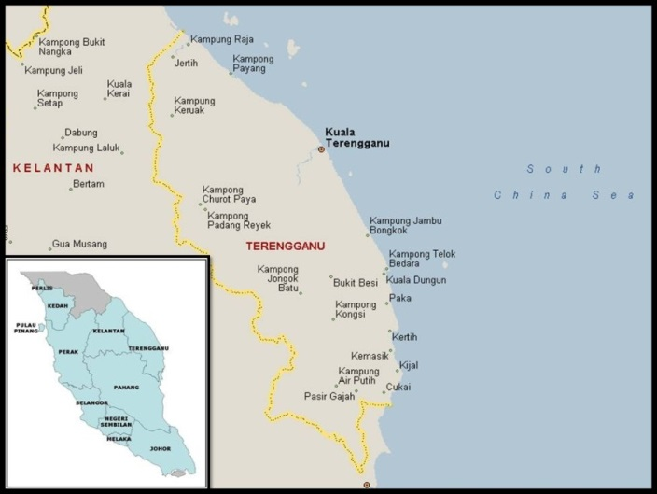

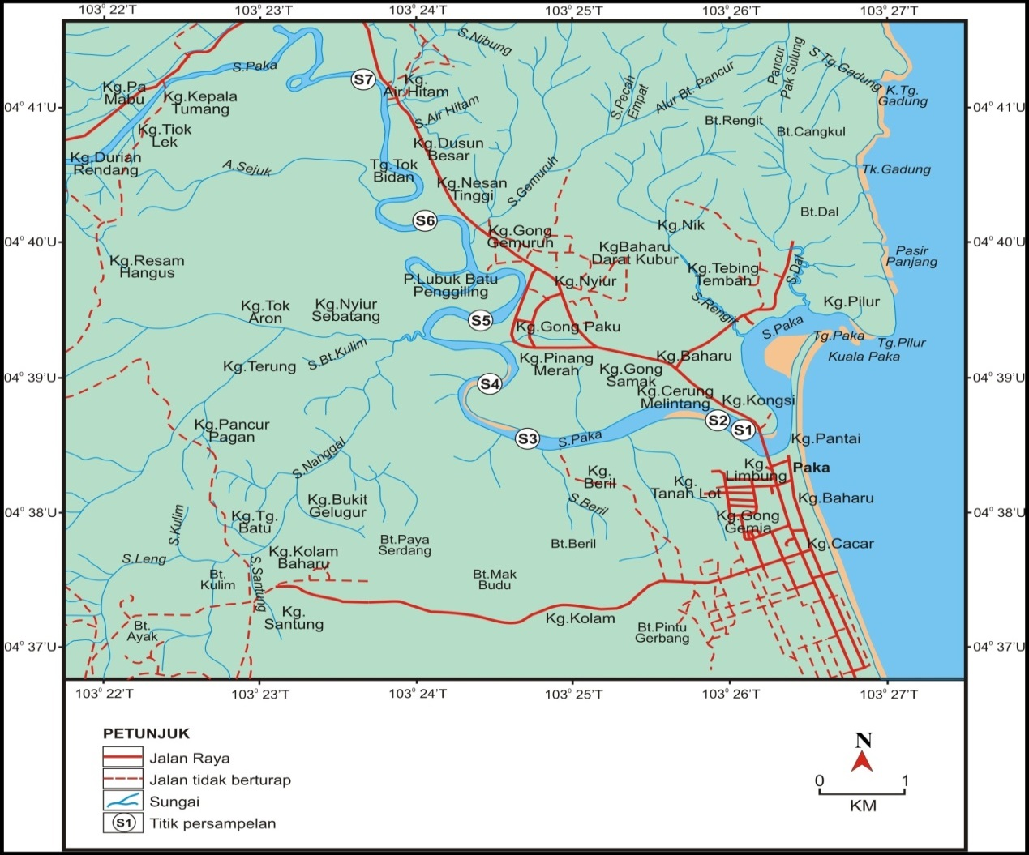

Figure 1. A map showing the location of Paka River and their tributaries

Results and Discussion
Hydrologic Measurement
Hydrological measurements which consist of three fundamental hydraulic variables known as river width, river depth, and velocity which is required in order to determine the river discharge, Q. Description of each parameter is as follow.

River Width
Most of the station showed a variation in width during both tides, at range between 66.00 m to 460.00 m. Station 1 showed the highest reading of river depth for both water tides, which is 334.00 m during low tide and 460.00 m during high tide, whereas station 7 showed the lowest reading of river depth for both water tides, which is 66.00 m during low tide and 76.00 m during high tide. River width was higher during high tides for all stations as compared to the river width during low tides, and the increment range was between 3 m to 126 m (Figure 2a). This is because the inflow of seawater during high tides towards the river, thus occupying more space at the river. Statistical analysis of one-way ANOVA revealed that there are significant differences (P < 0.05) in river width between stations during first sampling (df = 13, F = 22.202, P = 0.000).

Figure 2b, shows the river width of Paka River at seven stations during the second sampling for low and high water tides. The pattern for river width was similar in which the higher river with reading during low tide and high tides ranged from 77m to 308m and from 78m to 338m respectively. Station 1 showed the highest reading of river width for both water tides, which is 308.00 m during low tide and 338.00 m during high tide, station 7 showed the lowest reading of river depth for both water tides, which is 77 m during low tide and 78 m during high tide, showing progressively movement of seawater about 14 km toward the land.

River width was higher during high tides for all stations because the inflow of seawater during high tides towards the river, thus occupying more space at the river. Furthermore, station 1 located at the wide estuary of Paka River that had been heavily impacted by the rapid development of the area via expansion of housing area as well as increase in population. Erosion can adversely impact on hydrological properties of the river by widening the river. Statistical analysis of one-way ANOVA revealed that there are significant differences (P < 0.05) in river width between stations during the second sampling (df = 13, F = 231.851, P = 0.000).

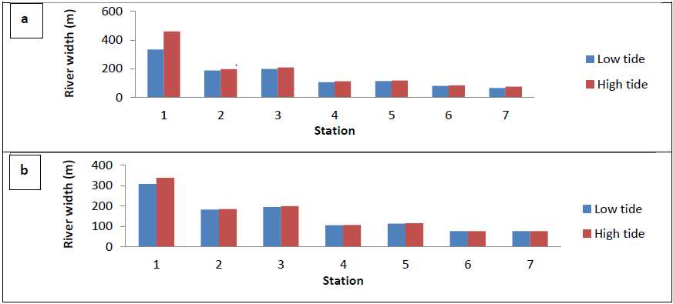

Figure 2. River width at seven sampling stations during (a) first and (b) second samplings

River Depth
Figure 3a shows the river depth of Paka River at seven stations during the first sampling for low and high water tides were varied between 1.17 to 5.17m and from 1.87 to 6.23m. Station 6 showed the highest reading of river depth for during low tide, while station 4 showed the highest reading of river depth during high tide. Meanwhile, station 1 showed the lowest depth values for both water tides. Higher river depth at station 2, 4 and 6 due to the sand mining activities which can disturb the actual hydrological parameters of the river, primarily for depth parameter. Statistical analysis of one-way ANOVA revealed that there are significant differences (P < 0.05) in river depth between stations during first sampling (df = 13, F = 11.599, P = 0.002).

The river depth pattern of Paka River at seven stations during the second sampling of high and low water tides were shown in Fig. 3b. River depth values fluctuated between 1.26 m to 6.47 m. Station 4 showed the highest reading of river depth for both water tides, which is 5.45 m during low tide and 6.47 m during high tide, meanwhile station 1 showed the lowest reading of river depth for both water tides, which is 1.26 m during low tide and 1.40 m during high tide. Shallow areas were shown at the locations at station 1, station 5 and station 7, which may be due to the absence of sand mining activities. Statistical analysis of one-way ANOVA revealed that there are significant differences (P < 0.05) in river depth between stations during the second sampling (df = 13, F = 27.483, P = 0.000).

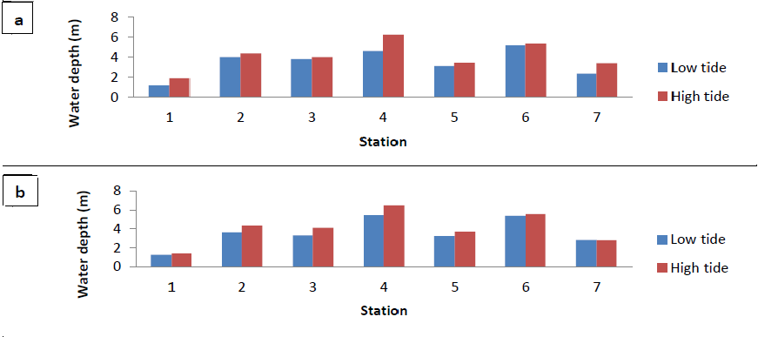

Figure 3. River depth at seven sampling stations during (a) first and (b) second samplings

River Velocity
River velocity is one of the main components that are required in order to calculate stream flow. Most of the stations showed a variation in velocity during both of water tides, with values between 0.19 m/s to 0.80 m/s. During first sampling, station 7 showed the highest reading of river velocity during low tide (0.39 m/s), while station 1 showed the highest reading of river velocity during high tide (0.80 m/s). Meanwhile, station 2 and station 4 showed the lowest reading during low tide (0.19 m/s), while station 4 showed the lowest velocity during high tide (0.21 m/s) (Figure 4a). Statistical analysis of one-way ANOVA revealed that there are no significant differences (P > 0.05) in river velocity between stations during first sampling.

Figure 4b shows the river velocity of Paka River at seven stations during the second sampling for high and low water tides. The mean velocity for all station for both water tides were ranged between 0.03 m/s to 0.44 m/s. Station 2 showed the highest reading of river velocity for during low tide (0.25 m/s), while station 1 showed the highest reading of river velocity during high tide (0.44 m/s). The lowest mean velocity during low tide was recorded at station 7 with a value of 0.04 m/s, and the lowest mean velocity during high tide was recorded at station 6 with a value of 0.03 m/s (Fig. 4b). Water velocity at downstream was higher during high tide due to the inflow of seawater that increase water volume. In addition, wider river at station 1 also can control the water velocity as a wider area can support larger water volume. Statistical analysis of one-way ANOVA revealed that there are no significant differences (P > 0.05) in river width between stations during second sampling.

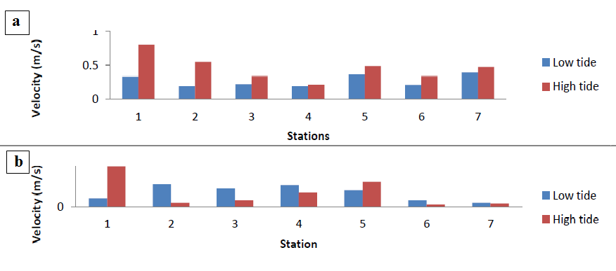

Figure 4. River velocity at seven sampling stations during (a) first and (b) second samplings

Water Discharge
The water discharge values of Paka River at seven stations during the first sampling for high and low water tides varied widely from 29.81 m³/s to 343.96 m³/s (Figure 5a). Station 3 showed the highest reading of stream flow during low tide (70.83 m³/s), while station 1 showed the highest reading (343.96 m³/s) during high tide. Meanwhile, station 7 showed the lowest water discharge for both water tides, with values of 29.81 m³/s during low tide and 53.45 m³/s during high tide (Figure 5a). Statistical analysis of one-way ANOVA revealed that there are no significant differences (P > 0.05) in water discharge between stations during first sampling.

The water discharge of Paka River at seven stations during the second sampling for high and low tides were ranging from 3.87 m³/s to 115.04m³/s (Fig. 5b). Station 2 showed the highest reading (79.44 m³/s) during low tide which is, while station 1 showed the highest reading (115.04 m³/s) during high tide. Station 7 showed the lowest water discharge for both water tides, with a value of 4.33 m³/s during low tide and 3.87 m³/s during high tide (Fig. 5b). Water discharges during second sampling were lowered as compared to first sampling, since second sampling was conducted during dry season with low rainfall intensity. Thus, the pattern of discharge variation was determined by fluctuation of precipitation. Statistical analysis of one-way ANOVA revealed that there are no significant differences (P > 0.05) in water discharge between stations during second sampling.

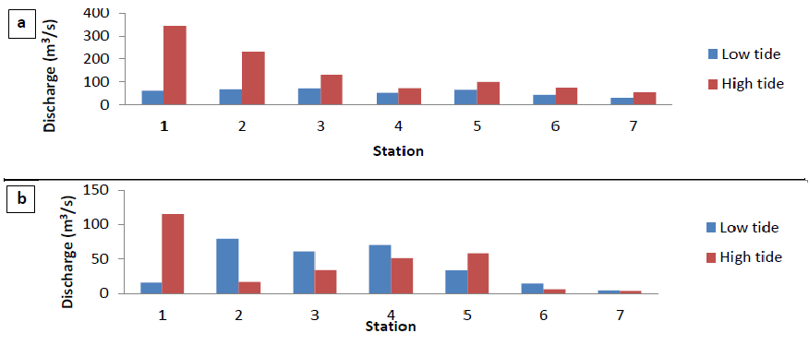

Figure 5. River discharge at seven sampling stations during (a) first and (b) second samplings

Conclusion
Most of the hydrological variables, especially in the estuary of study area were influenced by the tidal activities, higher during high tide and lower during low tide. The estuary of Paka River is identify by wide, shallow and usually identify by the accumulation of sand bars along the shore during low tide but disappear during high tide, this part is acting as barrier in the estuary area which as a result of encounter with South China Sea. Station 1 which is located at the downstream was recorded relatively low depth reading. Surrounding station 1 consist of highly developed compared to other stations, the development of fishing village, housings, jetty and other activities causes erosion and deposition along river bank, greater runoff, and mass movements of released sediments into the river. Presence of sand dunes and sand bars along the side of the river due to serious silting at station 1 also could explain the shallow of the area. Areas at the upstream especially station 7 had less disturbance by erosion, thus reducing friction of obstacles and increasing the water velocity during low tide.

Correspondingly, seawater movement was further 14 km towards the upstream during high tides due to the effect of tidal fluctuation during high tides. Seawater movement is also greater during dry season since less freshwater flow from the upstream due to minimal rainfall intensity during dry season. But during rainy season, higher of water discharge due to heavy rainfall intensity and also increase in height of water tides, this can explained why coastal areas are highly susceptible to flooding problems especially during wet season.

Acknowledgement
The authors would also like to thank to the FRGS grand ((FRGS/2/2014/STWN06/UNISZA/01/1) for funded us during this study carried out and express an appreciation to East Coast Environmental Research Institute (ESERI, UNISZA)for the use of their research facilities.

References
- Nasir, M.S. and Camerlengo, A. L. (1997). Response of the ocean mixed layer, off the east coast of Peninsular Malaysia, during the northeast and southwest monsoons. Geoacta 22: 134-143.
- Camerlengo, A. and Ines Demmle, M. (1997). Wind driver circulation of Peninsular Malaysia’s eastern Continental Shelf. Scientia Marina 61(2): 2003-211.
- Daryabor, F., Samah A. A. and Ooi, S. H. (2015). Dinamical structure of the sea off the east coast of Peninsular Malaysia. Ocean Dinamic 65: 93-106.
- Aberle, J. and Smart, G. M. (2003). The influence of roughness structure on flow resistance on steep slopes.Journal of Hydraulic Research 41(3): 259-269.
- Urish, D.W. and Qanbar, E. K. (1997). Hydraulic evaluation of ground water discharge, Nauset Marsh, Cape Cod National Seashore, Massachusetts. Technical Report NPS/NESO-RNR/NRT 97–07.
- Van Rijn, L. C. (2010).Tidal phenomena in the Scheldt Estuary. Deltares: Delft. I. pp 99.
- McLean, R. F., Tsyban, A., Burkett, V., Codignott, J. O., Forbes, D. L. Mimura, N., Beamish, R. J. and Ittekkot, V. (2001). Coastal Zones and Marine Ecosystems. In Climate Change 2001: Impacts, Adaptation, and Vulnerability. Contribution of Working Group II to the Third Assessment Report of the Intergovernmental Panel on Climate Change. Edited by James J. McCarthy Osvaldo F. Canziani, Neil A. Leary, David J. Dokken, and Kasey S. White, Cambridge University Press, Cambridge, UK, 343-379.
- Giménez, E. and Morell, I. (1997).Hydrogeochemical analysis of salinization processes in the coastal aquifer of Oropesa (Castellón, Spain). Environmental Geology 29: 118-131.
- O’Brien, T. (1995). Assessment of the impact of saline drainage on key fish species. In Banens, R.J. &Lehane, R (Eds).Riverine Environment Research Forum. Canberra: Murray-Darling Basin Commission. 43-46.
- Hull, C.H. J., Thatcher, M. L. and Tortoriello, R.C. (1986). Salinity in the Delaware Estuary. Hull, C.H.J. and Titus, J.G.Greenhouse Effect, Sea Level Rise, and Salinity in the Delaware Estuary. Eds. Washington: Delaware River Basin Commission and US Environmental Protection Agency. pp 8–18.
- Li, L., Barry, D. A., Stagnitti, F., Parlange, J. Y. and Jeng, D.S. (2000). Beach water table fluctuations due to spring–neap tides: moving boundary effects. Advances in Water Resources 23(8): 817-824.
- BERNAMA (2012).Consultant to Study Erosion of Sungai Paka Estuary. Bernama Media.26 February. http://my.news.yahoo.com/consultant-study-erosion-sungai-paka-estuary-115605004.html [5 April 2013].
- Siti Airunnisa, A. (2010). Consultant to Study Erosion of Sungai Paka Estuary. Utusan Online. 5May. http://www.utusan.com.my/utusan/info.asp?y=2010&dt=0505&pub=Utusan_Malaysia&sec=Timur&pg=wt_01.htm [5 April 2013].
- Shaaban, A. J., Chan, Y. M., Kavvas, M. L., Chen, Z.Q. and Ohara, N. (2010). Impact of climate change on Peninsular Malaysia Water Resources and Hydrogic Regime. NAHRIM: pp1-11.
- Muhamad Nasir. (1996). Coastal and estuarine land use management around some major river system in Peninsular Malaysia. Case study 1: Paka-Kertih, Terengganu. WWF Project Report.
- Ministry of Natural Resources and Environment & Department of Irrigation Drainage (2009). River Sand Mining Management Guideline. Kuala Lumpur: Department of Irrigation and Drainage (DID).

