

MALAYSIAN JOURNAL OF ANALYTICAL SCIENCES
ISSN 1394 - 2506

Published by The Malaysian Analytical Sciences Society

GEOGRAPHICAL INFORMATION SYSTEM (GIS) FOR RELATIONSHIP BETWEEN DENGUE DISEASE AND CLIMATIC FACTORS AT
CHERAS, MALAYSIA

(Perhubungan Antara Kes Denggi dan Faktor Iklim Menggunakan Sistem Maklumat Geografi di Cheras, Malaysia)

Ahmad Dasuki Mustafa¹, Azman Azid¹, Hafizan Juahir¹*, Kamaruzzaman Yunus², Ismail Zainal Abidin¹,
Nur Hishaam Sulaiman¹, Mohammad Azizi Amran¹, Mohamad Romizan Osman²,
Mohd Khairul Amri Kamarudin^{1,3}, Muhammad Barzani Gasim¹

¹East Coast Environmental Research Institute (ESERI),
Universiti Sultan Zainal Abidin, Gong Badak Campus, 21300 Kuala Terengganu, Terengganu, Malaysia
²Kulliyyah of Science,
International Islamic University Malaysia, 25200 Kuantan, Pahang, Malaysia

³Faculty of Design Arts and Engineering Technology,

Universiti Sultan Zainal Abidin, Gong Badak Campus, 21300 Kuala Terengganu, Terengganu, Malaysia

*Corresponding author: hafizanjuahir@unisza.edu.my

Received: 14 April 2015; Accepted: 9 July 2015

Abstract
The Geographical Information System (GIS) was utilized to generate dengue distribution cases and its correlation to the climatic factors in Cheras, Kuala Lumpur, Malaysia. The data were provided by Dewan Bandaraya Kuala Lumpur (DBKL). The data was integrated with Kuala Lumpur map to graphically present information about the areas which been hit by the dengue outbreak through a graphic display. The analysis using focused on overlay, buffer creating, and query builder. The statistical analysis such as linear regression is undertaken to show the correlation between dengue diseases with the climatic factors that is rainfall, temperature and relative humidity for the year 2008, 2009, 2010, and 2011. The study found that there is no correlation between disease incidence and total rainfall (R²=0.057). Thus, it can be concluded that the climatic factors were not contributed to the dengue cases. Through this research, highly expect that the dengue distribution map had been developed and can be used by the authorities to analyzing the dengue disease pattern by related with the climatic factors.

Keywords : dengue, Geographic Information System (GIS), climate, linear regression, Aedes aegypti

Abstrak
Sistem Maklumat Geografi (GIS) digunakan untuk menghasilkan peta taburan kes denggi dan perkaitan dengan faktor iklim di Cheras, Kuala Lumpur, Malaysia. Data diperoleh dari Dewan Bandaraya Kuala Lumpur (DBKL) dan diintegrasi dengan peta Kuala Lumpur untuk mempersembahkan secara grafik maklumat bagi kawasan tersebut yang telah dilanda wabak denggi. Analisis statistik seperti persamaan linear digunakan untuk mencari korelasi antara kes denggi dan faktor iklim iaitu taburan hujan, suhu, dan kelembapan untuk tahun 2008 hingga 2011. Hasil kajian ini, tiada hubungan yang signifikan antara faktor-faktor dan kes denggi tersebut (R²= 0.057). Melalui kajian ini, adalah menjadi tanggapan yang tinggi bahawa peta taburan ini dapat lebih dibangunkan dan digunakan oleh pihak berkuasa untuk menganalisis corak penyakit denggi dengan menghubungkait dengan faktor iklim.

Kata Kunci: denggi, Sistem Maklumat Geografi (GIS), iklim, persamaan linear, Aedes aegypti

Introduction
Dengue is a mosquito-borne infection that has become major threat health problems in Malaysia. Dengue is commonly found in tropical and sub-tropical climates regions around the world, dominantly in urban and sub-urban areas. Asian countries which has suitable tropical climate are always being affected by the outbreak of dengue fever (DF) and dengue haemorrhagic fever (DHF). The phenomenon commonly can cause devastating impact to human health such as serious illness and fatality to children. Currently, the disease cannot be cure from medical perspectives but the only mitigation to avoid the outbreak from occurs is by combat the virus carrier [1].For the last half century, the dengue incidence has increased rapidly and mark perceptions as most rapid spreading mosquito-borne viral disease in the world. The increasing dengue incidences expand to other part of the world by affecting either urban or rural area [2].

Dengue fever becomes major mosquito-borne disease at Malaysia. The dengue fever started in Penang 1902 while the dengue haemorrhagic fever firstly reported at 1962 in the same state [3]. There are 17,800 cases and 29 deaths dengue cases reported between January and October 2012 while for 2013, 28,200 cases and 60 deaths were recorded for the same period [4]. Based on the Figure 1, the dengue cases recorded is show increasing trend from 1988 to 2005. The trend is because of Aedes aegypti being introduced into Malaysia because rapid urbanization due to increasing economic activities and the species spread to developing urban areas [5]. The cases very low in the early years and in 2000 because there is a cyclical pattern observes in Malaysia that show some pattern which cases will increase dramatically after low cases recorded that can be known as total average lull period [5]

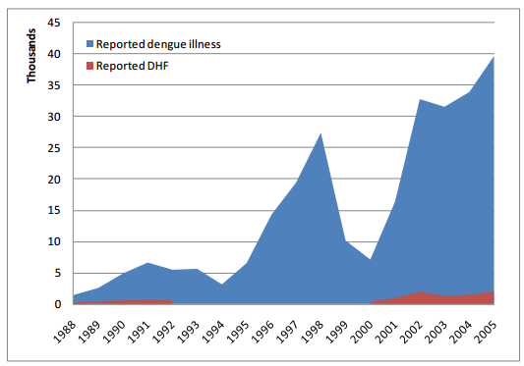

Figure 1. Reported cases of dengue in Malaysia, 1988-2005. Source: Ministry of Health Malaysia (2010) [4]

The dengue disease outbreak worsen in Kuala Lumpur with grow about 8.4 percent in 2013 and average 6 cases reported every day [6]. From the report by The Star on 2013, dengue cases at Kuala Lumpur increasing from 1330 cases to 1442 cases between January and August for 2012 and 2013 respectively. In 2013, six dengue-related deaths were reported in Kuala Lumpur. Local authorities found that many residents and businesses in Kuala Lumpur were ignoring the warning signs or failed to clear Aedes mosquito breeding grounds. Rubbish is still poorly managed and dumped indiscriminately, making them ideal for breeding grounds [6]. The dengue distribution map generate through this study will highlight the locality of the dengue cases within Cheras district for 2011. The map which consists of buffer map will be useful to the local authorities such as Kuala Lumpur City Council and Health Department to undergo monitoring and inspection to the affected area. Apart from that, this study will analyze the dengue cases incidence with the climatic factor to find the relationships between these two variables. Thus, the objectives of this study are to generate dengue distribution map for 2011 dengue cases at Cheras, Kuala Lumpur and to relate between climatic factors with the incidence of dengue cases occurred.

Materials and Methods
Study Area
Location is an important component of health and environment studies and thus a GIS-based information system is ideal. The Cheras area had been chosen as the study area because according to the report from Jabatan Kesihatan Dewan Bandaraya Kuala Lumpur, Cheras Zone (ZC) has the highest case among the other zones for year 2008 (DBKL, 2008). The geographic area under study is Cheras as can be seen on Figure 3 which is a suburb of Kuala Lumpur, the capital city of Malaysia. The township is located to the south-east of Kuala Lumpur. This overall city area of Kuala Lumpur is 243.65 km². Cheras, Kuala Lumpur is situated adjacent to Ampang to the north and Kajang to the south, both of which are major cities within the metropolitan area of Kuala Lumpur. Kuala Lumpur is easily the largest city in the nation, possessing a population of over one and a half million people drawn from all of Malaysia's many ethnic groups.

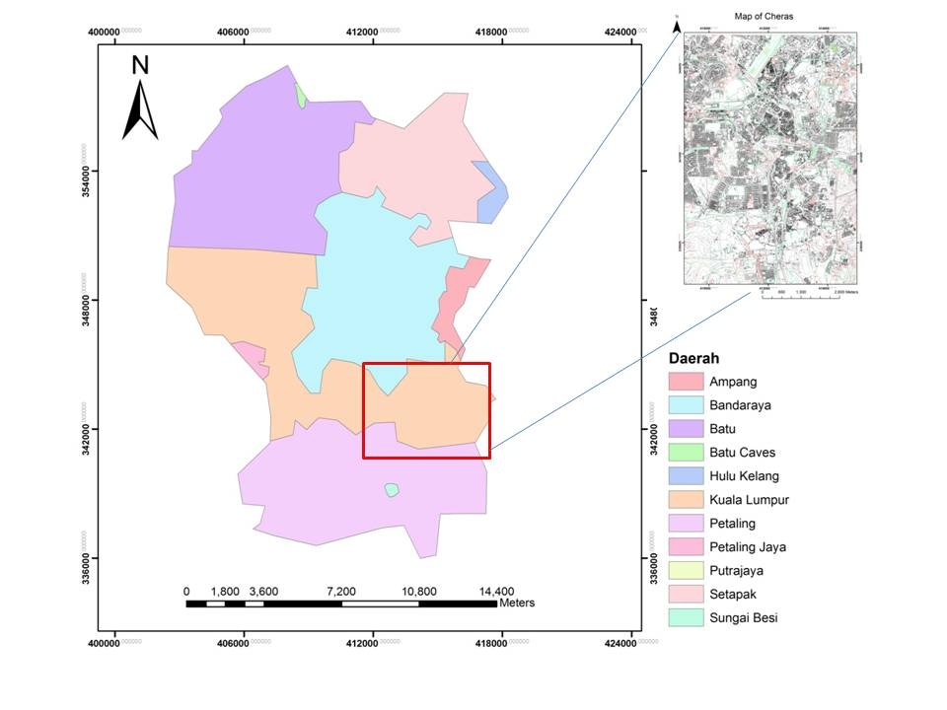

Figure 2. Location of Study Area

Data Collection
Data that are using in this study is the primary and secondary data. All the information of the data comes from dengue notification and prompted by Bahagian Kawalan Vektor, Jabatan Kesihatan, Dewan Bandaraya Kuala Lumpur (DBKL) as secondary data. Climatic data that are temperature, distribution and frequency of rainfall were obtained from the Malaysian Metrological Department under the Ministry of Science, Technology and Innovation considered as secondary data.

Data Analysis
Data analysis consisted of dengue cases recorded monthly being analysed and determination rates of change, temperature analysis based on time series and rainfall intensity, study of climatology of temperature and rainfall, variations in monthly temperatures and rainfall intensity with monthly dengue rates in Kuala Lumpur between 2008, 2009, 2010, and 2011, and analyzed statistical significance tests for observed correlations. The analyses on the dengue distribution in Cheras area are done by using ArcGis 9.3 software. The analysis is including buffer creation, map editing, and query developing where the SPSS software will be used to analyze data on dengue case, rainfall, mean temperature and mean relative humidity. For this study, the analysis using ArcMap is focus on overlay, buffer creating, and query builder. Map editing process is using the Editor Toolbar to produce a map of Cheras area from Kuala Lumpur and Petaling Jaya map that has been provided from Jabatan Ukur dan Pemetaan (JUPEM).

Results and Discussion
In order to develop the dengue distribution map, the spatial distribution in terms of geographic locations, gender, and also the ages of the victims has taken into account. Other than that, the discussion further on the buffer and overlay of dengue cases also in this part. As well as the detail about relationship between dengue cases with environmental factors that are mean temperature, mean relative humidity and rainfall intensity. The distribution of dengue cases consist of several locations that recorded high incidence. The distribution was divided into 37 small locations that represent all over Cheras. Bandar Cheras area recorded the highest case of dengue incidence for 2011 and the lowest case reported is in Kampung Malaysia Raya. The dengue cases were concentrated in the few locations that consist of high rise buildings residential area as example low cost flat which many of them located at Cheras area such as Flat Sri Johor, Flat Sri Sabah, and Flat Sri Melaka. The Dengue cases for 2011 have reported 261 of total incidence at Cheras.

There were few locations that recorded high distribution of dengue incidence such as Cheras area and Bandar Sri Permaisuri. The Cheras area noted the highest dengue incidence with total of 40 cases while Bandar Sri Permaisuri recorded 29 cases. This area consist of many high rise buildings that most dengue cases been recorded because of there were many breeding grounds available [7]. Based on the survey by Kuala Lumpur City Hall [7], the communities here do not concern about their health and were not co-operating by not allowing them to fog their homes. Based on that survey also find many mosquito-breeding grounds that can be place mosquitoes easily breed in these poor condition.

Buffer Result
In this study, in order to predict high risk area for dengue disease, buffer zone was being applied and categorized into two buffers which are 500 meter and 1000 meter buffer were applicable to predict the highest area that affected [8].The Figure 4 shows the buffer map with a buffer zone 500 meter and 1000 meter within Cheras for 2011. It shows that the high risk area for dengue cases was within 500 meter buffer and low risk area within 1000 meter buffer from the dengue cases. It is based on the two factors which area the life span of the Aedes Aegypti mosquito and the distance travelled per day [8]. From buffer creation, mitigation steps can be taken in order to encounter with a dengue cases. One of the mitigation steps is regular monitoring that can be done to affected area in order to combat with this dengue incidence. Other than that, many mitigation steps can be taken by the local public health authorities such as fogging and continuous inspection to the high risk area of dengue disease area [8].
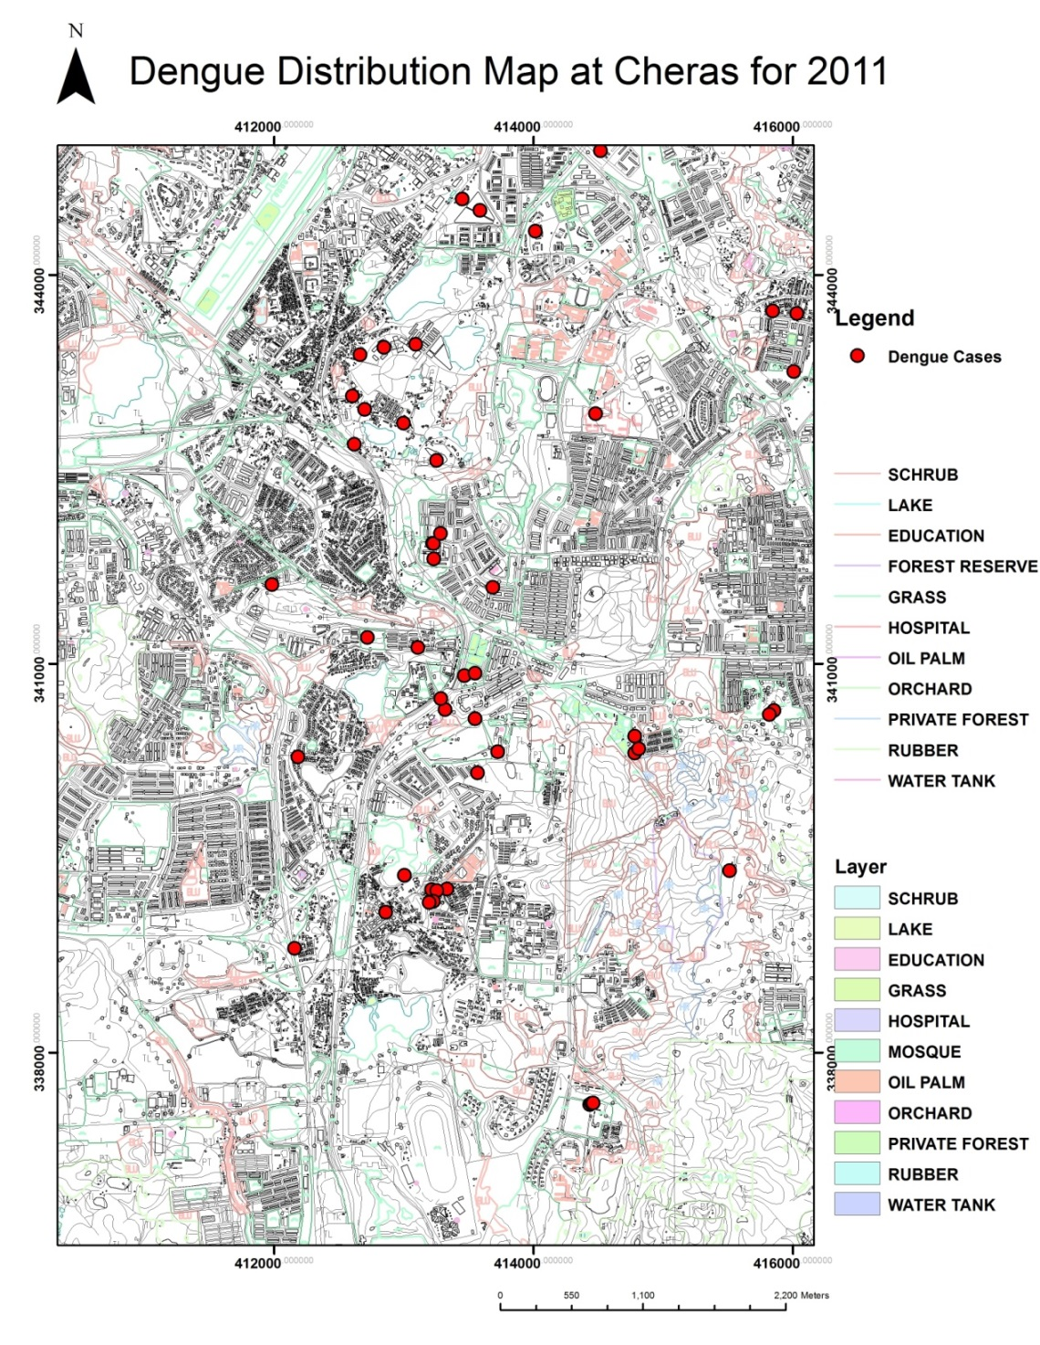
Figure 3. The Dengue Distribution Map at Cheras for 2011
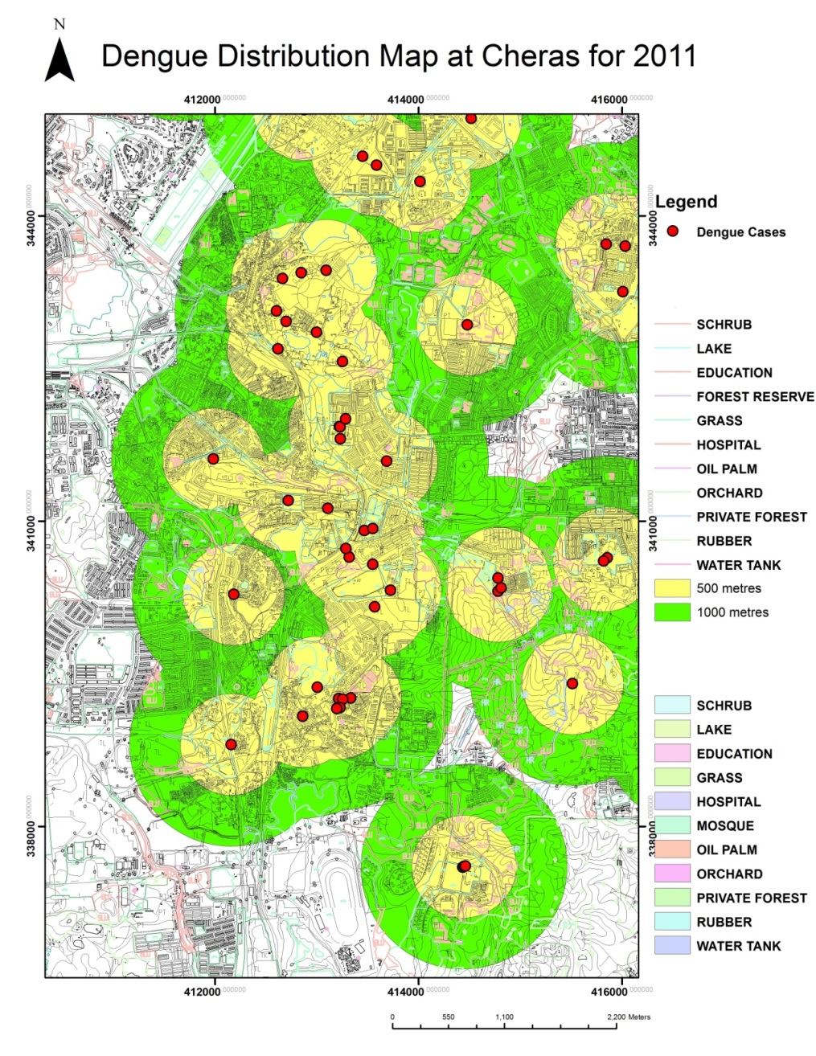
Figure 4. The buffer map of dengue cases incidence for 2011

Correlation between Dengue Disease and Rainfall, Temperature and Humidity
According to result, all the value of r is more closed to 0. In fact, for a linear regression analysis, the value of r should be in range 1 to -1. The closer the r value to 1 or -1, the strong correlation would be. Since the value of r for the three factors is near to 0, a conclusion can be made that these three factors are not contribute to dengue transmission in 4 years term for this study.

Dengue Infection 2008
In 2008, total case reported are 435 cases where the highest case occurs on August (57 cases). In November, the cases are lowest that only 21 cases were detected. When compared to rainfall data for 2008, in August there is 11.483mm (third highest in 2008) rain and 10.931 (fourth highest in 2008) in November. However, the correlation shows no relationship between the dengue case and the rainfall and it cannot be proven that rainfall can be a major factor for dengue disease at Cheras. A negative association between the number of dengue cases and rainfall was observed in Cheras for 2008. The previous study that find out similar relationship are [9] and [10] both in Malaysia. The study by Nazri on 2011, the rainfall indirectly influence the number of dengue incidence. Based on the study by [11] the population vector for dengue disease must be always associated with the rainfall in Asia including Malaysia. But there are previous study found out significant correlation between rainfall and dengue cases in Malaysia, as example [12]. This opposite results because the fluctuations of rainfall constantly that may affect the survivor rate of mosquitoes [13].

Dengue Infection 2009
For dengue infection on 2009, total case reported are 361 cases where November recorded the highest cases that are 46 cases. In August, the cases are lowest that only 13 cases were detected. Compared to rainfall data for 2009, in November there is 10.638mm (second highest in 2009) rain and 6.858mm (seventh highest in 2009) in August. So, same to 2008 the correlation was very weak and cannot prove the relationship between total dengue case and rainfall at Cheras. Based on the previous studies by [14], the increasing in rainfall intensity the higher disease occur, but very heavy rainfall intensity can inhibit the mosquitoes breeding site by destroy the stagnant water by flushing it out. Other than that, heavy rainfall with addition of strong wind can disturb flying distance covered by the mosquitoes [15]. Other than that, the study by [16] on 2010 is found that urbanization influence the increasing trend of heavy rainfall. The urbanization occur at Kuala Lumpur based on the report by Department of Statistics on 2010 contribute to the increasing frequency of heavy rainfall that can affect the transmission of the dengue disease. Thus, the urbanization may influence the insignificant correlation between rainfall and dengue incidence in this study.

Dengue Infection 2010
In 2010, total case reported are 433 cases where the highest case occurs in the April (72 cases). In October, the cases are lowest that only 19 cases were detected. When compared to rainfall data for 2010, in April there is 4.617mm (second lowest in 2010) rain and 17.71mm (highest in 2010) in October. But, the correlation was very low that is no correlation at all between the dengue case and rainfall at Cheras. The high incidence of dengue cases may have caused by the migration of people into the city and increasing population [17]. Other than that, rapid uncontrolled urbanization also influences the outbreak of dengue disease [18]. According to report by [19], the most densely populated state and 100 per cent level of urbanization was Kuala Lumpur, support the statement that these two factors contribute to dengue incidence in this study area.

Dengue Infection 2011
In the year 2011, dengue cases even more decrease to 260 cases throughout the year compare to other year. Different with other years, September record the highest cases for this year that is 32 cases and the lowest cases occur in July, only 12 cases. Comparing to rainfall data for 2011, in September there is 3.069mm (second lowest in 2011) rain and 1.983mm (lowest in 2011) in July. Same goes to this year where no correlation between dengue case and rainfall at the study area. The result of no significant correlation is similar to several previous studies such as at Thailand [20] and Singapore [21] which are same climate with Malaysia. But, there are also significant correlation found out by several previous studies such as [22]. This inconsistent result may be caused by the fluctuation of the monthly temperature related with geographic location [23].

Conclusion
The overall objective for this study like as mention in the first chapter is to develop a Dengue distribution map at Cheras for 2011 and correlate it with the climatic factors. This study also can show how the GIS can be used as a tool for analyze and also solving problems in the health sector. The climatic factors that correlated with the increasing number of dengue disease incidence cannot be identified as the weak correlation with total case found in this study. The type of buildings that contributed to the high incidence of dengue cases within Cheras for 2011 was high rise buildings such as apartments and flats. The highly populated area and poor conditions of sanitation that provide suitable breeding ground for Aedes Aegypti mosquitoes has influence to the high dengue cases.

The dengue distribution map for 2011 at Cheras has been generated included spatial distribution of the case. The spatial distribution has display the distribution of dengue incidence. From the distribution map, the source and type of building that has contribute to the dengue disease incidence and mitigation step can be taken to prevent it from worsen. The buffer creation analysis was done to identify the location belong to high risk for dengue disease incidence. From previous study about dengue fever, 500 meter from the dengue case incidence can be classified as high risk area while 1000 meter from the dengue cases point can be identified as low risk area.

By using statistical analysis, the relationship between dengue cases incidence and climatic factor can be determined through linear regression analysis. From this study, there are no climatic factors whether rainfall, mean temperature and humidity show significant correlation with the total case. But this thing can be improve by using more data that is more than 10 years to get accurate finding. As a conclusion, GIS provided a very powerful tool in the health or disease mapping. Other than that, effective surveillance and prediction of the dengue outbreak in order to reduce the number of dengue cases are the advantage by using GIS in public health sector.

Acknowledgement
The authors acknowledge East Coast Environmental Research Institute Universiti Sultan Zainal Abidin (UNISZA) for giving us permission to utilize the research facilities, advice, guidance, and support for this study.

References
- WHO – Regional Office for South-East Asia, SEARO (1999). Comprehensive Guidelines: Prevention and control of dengue and dengue haemorrhagic fever, WHO Regional Publication, SEARO No.29, 1999.
- Edelman R. Dengue vaccines approach the finish line. Clinical Infectious Diseases, (2007), 45(Suppl 1): S56 –S60.
- Rudnick, A., Tan, E. E., Lucas, J. K. and Omar, M. B. (1965). Mosquito-borne haemorrhagic fever in Malaya. British Medical Journal 1(5445): 1269-1272.
- Ministry of Health Malaysia Vector Borne Disease Control Section (2010). Retrieved from http://www.dph.gov.my/vektor/eng/kes_dd_tahunan.htm.
- Abu Bakar, S. and Shafee, N. (2002). Outlook of dengue in Malaysia: a century later. The Malaysian Journal of Pathology 24(1): 23-27
- Dengue deaths double in Malaysia, says Health Ministry. The Malaysian Insider. Published on 5th November 2013. Retrieved from http://www.themalaysianinsider.com/malaysia/article/dengue-casualties-double-in-malaysia
- Dewan Bandaraya Kuala Lumpur, Denggi: Cheras paling teruk, Harian Metro, Published on 25th March 2008
- Nakhapakorn, K. and Tripathi, N.K. (2005). An information value based analysis of physical and climatic factors affecting dengue fever and dengue hemorrhagic fever incidence. International Journal Health Geographics 4: 1- 13.
- Adnan. R. A., Osman M, Unyah N. Z., Abdullah W. O., Hamat R. A. and Majid R. A. (2009). Fogging impact on Aedes mosquitoes: A preliminary findings on continuous vector surveillance. Kuala Lumpur: 45 th Annual Scientific Seminar, Malaysian Society of Parasitology and Tropical Medicine.
- Nazri, C.D., Abu Hassan, A., Abd Latif, Z. and Rodziah Ismail. (2011). Impact of Climate and Landuse variability based on Dengue Epidemic Outbreak in Subang Jaya. IEEE Colloquium on Humanities, Science and Engineering Resesarch (CHUSER).
- Lo, E. K. C. and Narimah, A. (1984). Epidemiology of dengue disease in Malaysia, 1973-1982. Journal of Malaysian Society of Health 4(1): 27-35.
- Cheong, Y., Burkart, K.. and Leitao, P. (2013). Assessing weather effects on dengue disease in Malaysia. International Journal of Environmental Research and Public Health 10: 6319-6334
- Hopp M.J. and Foley, J.A. (2001). Global-scale relationships between climate and the dengue fever vector, Aedes aegypti. Climate Change 48:441–463.
- Foo, L. C., Tim, T. W., Lee, H. L. and Fang, R. (1985). Rainfall, abundance of Aedes aegypti and dengue infection in Selangor, Malaysia. Southeast Asian Journal of Tropical Medicine and Public Health 16(4): 560-568.
- Hornby, J. A., Moore, D. E. and Miller, T. W. Jr. (1994). Aedes albopictus distribution, abundance and colonization in Lee County, Florida, and its effect on Aedes aegypti. Journal of American Mosquito Control Association 10(3): 397-402.
- Kishtawal, C. and Niyogi, D. (2010). Urbanization signature in the observed heavy rainfall climatology over India. International Journal of Climatology 30(13): 1908–1916.
- Kyle, J. L. and Harris, E. (2008). Global spread and persistence of dengue. Annual Review of Microbiology 62: 72 – 92.
- Gubler, D. J. (2011). Dengue, urbanization, and globalization: The unholy trinity of the 21 st Century. Tropical Medicine and Health 39(4): 3 – 11.
- Department of Statistics Malaysia, Population and Basic Demographic Characteristics’ Report. (2010). Retrieved from http://www.statistics.gov.my/portal/index.php?option=com_content&view=article&id=1215%3 A population-distribution-and-basic-demographic-characteristic-report-population-and-housing-census-malay sia-2010-updated-2972011&catid=130%3Apopulation-distribution-and-basic-demographic-characteristic-report-population-and-housing-census- malaysia-2010&Itemid=154&lang=en
- Gould, D. J., Mount, G. A., Scanlon, J. E., Ford, H. R. and Sullivan, M. F. (1970). Ecological control of dengue vectors on an island in the Gulf of Thailand. Journal of Medical Entomology 4: 499 – 508.
- Goh, K. T., Ng, S. K, Chan, Y. C., Lim, S. J. and Chua, E. C. (1987). Epidemiological aspects of an outbreak of dengue fever/dengue haemorrhagic fever in Singapore. Southeast Asian Journal of Tropical Medicine and Public Health. 18: 295 –302.
- Sia Su and G. L. (2008). Correlation of climatic factors and dengue incidence in MetroManila, Philippines. Ambio. 37(4): 292 – 294.
- Picardal P. J. and Elnar, A.R.R. (2012). Rainfall, temperature and the incidence of dengue in Central Visayas, Philippinesare not correlated. CNU Journal of Higher Education Category B CHED-JAS, 6.

