ANALYSIS OF THERMOGRAVIMETRIC (TG) AND INFRA-RED (FTIR) ON Dy SUBSTITUTION IN Bi(Pb)-2223
SUPERCONDUCTOR

(Analisis Termogravimetri (TG) dan Infra-Merah (FTIR) ke atas pemasukan Dy dalam Superkonduktor Bi(Pb)-2223)

Siti Hawa Jamil¹, Azhan Hashim^{2*}, Syed Yusainee Syed Yahya¹, Azman Kasim², Nurul Hidayah Hasan¹,
Norazidah Abdul Wahab¹

¹Faculty of Applied Sciences,
Universiti Teknologi MARA, 40450 Shah Alam, Selangor, Malaysia
²Faculty of Applied Sciences,
Universiti Teknologi MARA Pahang, 26400 Jengka, Pahang, Malaysia

*Corresponding author: dazhan@pahang.uitm.edu.my

Abstract
In this paper, the results of the thermal and infra-red analysis of Dy substituted in Bi (Pb)-2223 superconductor have been studied by thermogravimetric (TG) and Fourier transform infrared (FTIR). The samples with nominal composition of Bi_{1.6}Pb_{0.4}Sr₂Ca_{2-x}Dy_{x}Cu₃O_{y} where x = 0.000, 0.025, 0.050, 0.100, and 0.200 were prepared by co-precipitation (COP) method using metal acetate as the starting salts. The mechanism of thermal analysis of the precursor powder for each stage (drying, precalcine, and calcine) were studied from 20 °C to 920 °C by 5 °C/min of heating rate. Interestingly, the thermal decomposition proceeds in the almost similar way regardless of the Dy substitution level with five major drops at the drying stage. Based on TG curves results, the temperature range from 840 °C to 850 °C can be suggested as an optimum calcination and sintering temperature. The majority of decomposition step which related to the loss of water from oxalate was in the range of 100 °C to 200 °C while the formation of precipitation into Bi₂O₃, PbO, SrCO₃, CaCO₃, CuO, and Dy₂O₃ were in the range of 210 °C to 360 °C. From the FTIR result, all the precursor powders qualitatively showed four main regions and the existence of –OH group can increase the diffusion rate between metals during the synthesis process.

Keywords: dy-substitution, BSCCO, Superconductor, FTIR, Thermogravimetric analysis

Abstrak
Dalam laporan ini, keputusan analisa terma dan infra-merah terhadap pemasukan Dy di dalam superkonduktor Bi (Pb)-2223 telah dikaji melalui termogravimetri dan transformasi fourier infra-merah (FTIR). Semua sampel dengan komposisi nominal Bi_{1.6}Pb_{0.4}Sr₂Ca_{2-x}Dy_{x}Cu₃O_{y} dimana x = 0.000, 0.025, 0.050, 0.100 dan 0.200 telah disediakan melalui kaedah ko-pemendakan (COP) dengan menggunakan logam asetat sebagai garam pemula. Mekanisma analis terma terhadap serbuk pelopor untuk setiap peringkat (pengeringan, pra-pengkalsinan dan pengkalsinan) telah dikaji dari suhu 20 °C hingga 920 °C dengan kadar pemanasan 5°C/min. Menariknya, penguraian terma berlaku agak sama tanpa menghiraukan aras pemasukan Dy iaitu dengan lima jatuhan pada peringkat pengeringan. Berdasarkan kepada keputusan keluk TG, dicadangkan bahawa julat suhu dari 840 °C hingga 850 °C merupakan suhu pengkalsinan dan suhu sinteran optimum. Majoriti langkah penguraian yang berhubungkait dengan kehilangan air dari oksalat, berlaku dalam julat 210 °C hingga 360 °C manakala pembentukan pemendakan dalam Bi₂O₃, PbO, SrCO₃, CaCO₃, CuO, dan Dy₂O₃ adalah dalam julat 210 °C hingga 360 °C. Dari keputusan FTIR, semua serbuk pelopor secara kualitatifnya menunjukkan empat daerah utama dan keujudan kumpulan –OH boleh meningkatkan kadar peresapan antara logam semasa proses sintesis.

Kata kunci: Pemasukan Dy, BSCCO, Superkonduktor, FTIR, Analisis termogravimetri

Introduction
Bi-2223 superconductor is one of the Bi-Sr-Ca-Cu-O systems that is reported to be difficult to synthesize as a single phase. Generally, solid-state reaction (SSR) method was used to prepare this superconductor material. However, several disadvantages are observed with this technique, such as high impurity content, inhomogeneity, large particle size and shape, and the requirement of a high temperature range with long calcination and sintering time. Therefore, several wet chemical methods including the co-precipitation (COP) method, have been developed to overcome these problems [1]. Powder that is produced by COP is better in chemical mixing since all cation species mixed in an atomic scale. Previously, the substitution of various elements in Bi-2223 is proven to be important to study due to the considerable change such as in superconducting, structural, mechanical, and transport properties. The thermal decomposition of COP samples gave valuable information of the precursors and also the optimum condition for SSR to obtain superconducting samples. Moreover, FTIR spectra could also be used to analyse the decomposition process of the precursor powder with different stages of the process. In this paper, we have reported the influence of Dy substitution on the TG and FTIR Analysis of Bi (Pb)-2223 superconductor prepared via co-precipitation method.

Materials and Methods
Sample of Bi_{1.6}Pb_{0.4}Sr₂Ca_{2-x}Dy_{x}Cu₃O_{y} (x = 0.000, 0.025, 0.050, 0.100, and 0.200) were prepared using co-precipitation (COP) method described in our previous paper [2]. The precipitated (drying at 60 °C), precalcine (750 °C for 12 hours) and calcine (845°C for 24 hours) powders were studied by TGA and FTIR instrument. In this study, TGA (Pyris 1) was used to analyze the mass change of the samples as a function of temperature. The powder was run by 5°C/min from 20 °C to 920 °C. The FTIR spectroscopy was used to investigate the mechanism of the COP transition. The IR absorption spectra of samples’ powder were measured in the range of 400 cm⁻¹ to 4000 cm⁻¹ with a resolution of 4 cm⁻¹ and recorded at room temperature using Spectrum 400 FT-1R/FT-NIR Spectrometer, Perkin Elmer.

Results and Discussion
The thermal analyses of the Bi_{1.6}Pb_{0.4}Sr₂Ca_{2-x}Dy_{x}Cu₃O_{y} precursor powder for each stage (drying, precalcine, and calcine) were studied from 20°C to 920°C by 5 °C/min of heating rate. Interestingly, the thermal decomposition proceeds in almost similar way regardless of the Dy substitution level. Figure 1 shows the TG curve for x = 0.025 Dy substituted sample.

The TG curves for x = 0.025 Dy substituted sample right after co-precipitation is displayed in Figure 1(a). According to the Figure 1(a), obviously there are five major drops. The weight loss occurred below 110 °C (5.964 %) was due to the evaporation of water and moisture loss from the powders. Similar behaviour has been reported for the evaporation of water and solvent molecules [3]. The second decomposition step in the range 120°C to 210°C (6.440 %) can be attributed to the loss of water molecule from Bi₂(C₂O₄)₃, Pb(C₂O₄), Sr(C₂O₄), Ca(C₂O₄), Cu(C₂O₄), and Dy(C₂O₄) in which dehydrated oxalate were formed. This behaviour is confirmed by previous works [4]. In the range of 210°C to 360°C (28.700 %), weight loss were apparent in the decomposition of Bi₂(C₂O₄)₃ to Bi₂O₃, Pb(C₂O₄) to PbO, Sr(C₂O₄) to SrCO₃, Ca(C₂O₄) to CaCO₃, Cu(C₂O₄) to CuO, and Dy(C₂O₄) to Dy₂O₃. Similar results shown by other researchers resulted in thermal decomposition of individual oxalates of Bi, Sr, Ca, and Cu [5]. Somehow, the decomposition of rare earth acetate took place at similar results which were around 200°C to 300°C [4, 5]. The next drop in the range of 540°C to 670°C (4.311 %) was the decomposition of CaCO₃ to CaO and in the range of 670°C to 760°C (2.564 %) was the decomposition of SrCO₃ to SrO. These results also had been proved by Popa et al. in which the decomposition of CaCO₃ to CaO took place in the range of 550 °C to 1000 °C and the decomposition of SrCO₃ to SrO took place in the range 600 °C to 1000 °C [5]. From the result, the weight of a stable metal oxide powder was obtained with 43.69 % of the sample weight.

The TG curves for the sample right after precalcine for 12 hours at 730°C and calcined for 24 hours at 845°C are shown in Figure 1(b) and (c) respectively. Based on Figure 1(b), the TG curves for x = 0.025 Dy substituted samples right after precalcine, obviously shows two major drops. As seen in the figure, the decomposition steps in the range 460°C to 770°C (3.452 %) and 850°C to 920°C (1.757 %) can be attributed to the decomposition of carbonate phase. This observation was in agreement with the results studied by previous works [6, 7]. These TGA result is in agreement with FTIR result and will be discussed later. From the Figure 1(c), the Dy substituted sample right after calcine for 24 hours at 845 °C, obviously shows one drop in the temperature above 820°C (3.044 %). Apparently, no indication of mass loss could be seen below 800°C for x = 0.025 Dy substituted in Bi_{1.6}Pb_{0.4}Sr₂Ca_{2-x}Dy_{x}Cu₃O_{y}. Therefore, it was revealed that the formation of the carbonate can be suppressed in the calcined stage. This result is slightly similar to other reports [7]. This observation will be supported by the result of FTIR later.

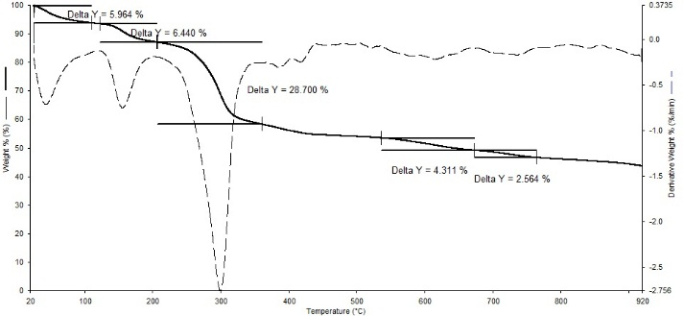
(a)

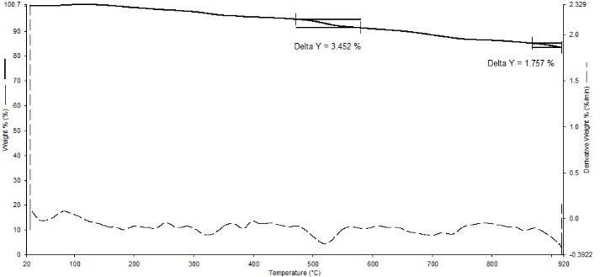
(b)

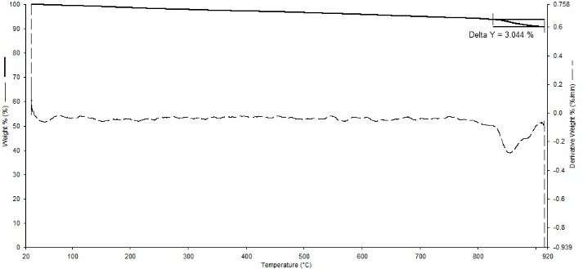
(c)

Figure 1. TGA of x = 0.025 Dy for (a) drying (b) precalcined (c) calcined stages

FTIR absorption spectra of a representative sample of Dy³⁺ substituted in Bi_{1.6}Pb_{0.4}Sr₂Ca_{2-x}Dy_{x}Cu₃O_{y} where x = 0.025 superconductors recorded in the range between 400 cm⁻¹ to 4000 cm⁻¹ at room temperature are shown in Figure 2 and Table 1.

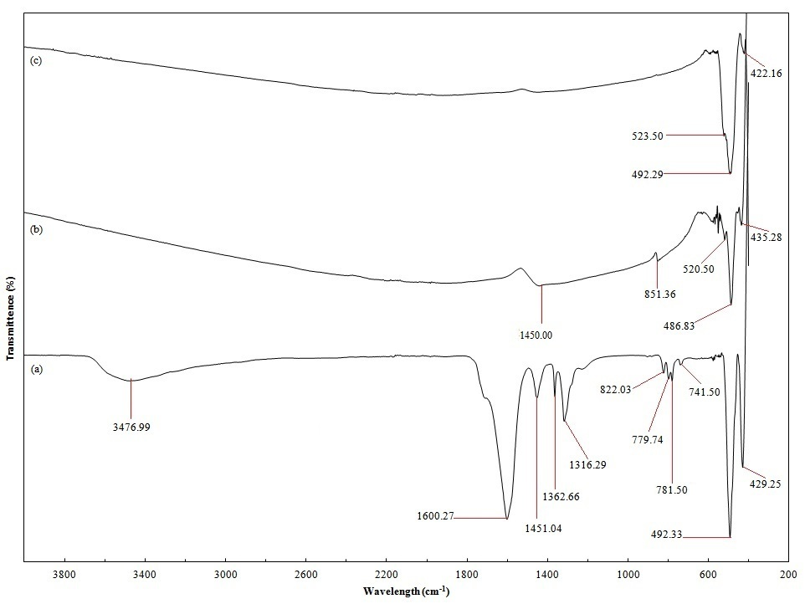
Figure 2. FTIR spectra of x = 0.025 Dy for (a) drying (b) precalcined (c) calcined stages

Table 1. The absorption bands in the FTIR Spectra right after co-precipitation, Precalcine, and Calcine for x = 0.025

Co-precipitation |  | Precalcine |  | Calcine
Wavelength  (cm⁻¹) | Assignment  (ions) | Wavelength  (cm⁻¹) | Assignment  (ions) | Wavelength  (cm⁻¹) | Assignment (ions)
3476.99 | O-H
1600.27 | -COO-
1451.04 | CO₃²⁻ | 1450.00 | CO₃²⁻
1362.66 | C-C / C-O
1316.29 | C-C / C-O
822.03 | SrCO₃ | 851.36 | SrCO₃
779.74 | M-O
781.50 | M-O
741.50 | M-O
 |  | 520.55 | M-O | 523.50 | M-O
492.33 | M-O | 486.83 | M-O | 492.29 | M-O
429.25 | M-O | 435.28 | M-O | 422.16 | M-O

Figure 2(a) shows the FTIR spectrum. The presence of broad absorption peaks in the range of 3700 cm⁻¹ to 2900 cm⁻¹ and a specific peak at about 3476.99 cm⁻¹ correspond to the stretching vibration of intermolecular hydrogen band (O-H). The assignment of fundamental stretching of the OH groups is in agreement with previous reports [7]. The characteristic of absorption band due to carboxylate ion [-COO-] is presented around 1600.27 cm⁻¹ which was confirmed as the complex formation in the BPSCCO system. The same observation of the presence of carboxylate ion was showed by other studies [8]. The presence of CO₃²⁻ is proven by the main peak absorption at approximately 1451.04 cm⁻¹, whereby this result is supported by Arshad et al. [7]. The characteristic bands of the oxalate group are evident at about 1362.66 cm⁻¹ and 1316.29 cm⁻¹ and are attributed to the stretching vibration of C-O and C-C. These observations are in agreement with earlier studies [8]. The peak at around 822.03 cm⁻¹ is the characteristic for SrCO₃. Similar absorption band of SrCO₃ was observed in previous studied [7]. In addition, in the 800 cm⁻¹ to 400 cm⁻¹ region of the FTIR spectrum may be attributed to the characteristic of metal oxide (M-O) vibration. Similar behaviour had been reported for the M-O vibration [5, 7].

FTIR spectra for sample right after precalcine for 12 hours is shown in Figure 2(b). According to the result presented by precalcine at 750°C, the remaining volatile was removed and thus, changed the oxalates co-precipitation to a mixture of crystallized oxides and carbonates. The peaks for the carboxylate ion [-COO-] had disappeared in precursor precalcined. The presence of CO₃²⁻ carbonate group still remained and was proven by the main peak absorption at about 1450 cm⁻¹. The characteristic bands for the oxalate group had disappeared because the oxalate group were decomposed completely during the heat treatment 750°C for 12 hours supported by TGA results discussed earlier. Similar result was observed [7]. The characteristic for SrCO₃ at around 851.36 cm⁻¹ still remained in this precalcine stage. The 800 cm⁻¹ to 400 cm⁻¹ region of the FTIR spectrum may be attributed to the characteristic of O-M vibration.

FTIR spectra for sample right after calcined for 24 hours at 845°C is shown in Figure 2(c). The presence of a CO₃²⁻ carbonate group and the peak for the characteristic of SrCO₃ had disappeared at calcine stage. This result is in agreement with previous studies [7]. This observation also had been supported by the TGA result discussed earlier, whereby it was revealed that the formation of the carbonate can be suppressed in the calcine stage. The observed specific peaks at around 523.50, 492.29, and 422.16 cm⁻¹ may be attributed to the characteristic of O-M vibration which is in agreement with the literature.

Conclusion
Bi_{1.6}Pb_{0.4}Sr₂Ca_{2-x}Dy_{x}Cu₃O_{y} superconducting samples prepared by COP method were investigated. From the TG curves of drying stages, the majority of the decomposition steps were the formation of precipitation into Bi₂O₃, PbO, SrCO₃, CaCO₃, CuO, and Dy₂O₃ in the range of 200°C to 365°C. On the other hand, the decomposition of SrCO₃ to SrO and CaCO₃ to CaO took place in the range of 540 °C to 670 °C and 670 °C to 760 °C. According to the TG curves for the Dy substituted samples right after precalcine obviously showed two drops occurred. Apparently, no indication of mass loss could be seen below 800°C in the calcined stage. Therefore, it was revealed that the formation of the carbonate can be suppressed in this stage. FTIR results for Dy substituted precursor showed that the apparent FTIR was in the 800 cm⁻¹ to 400 cm⁻¹ region of the FTIR spectrum. The observation may be attributed to the characteristics M-O vibration.

Acknowledgment
The authors wish to thank the Malaysian Ministry of Education (MOE) for the financial support provided via Fundamental Research Grant Scheme (FRGS) no. 600-RMI/FRGS 5/3 (6/2012).
References
- Hamadneh, I., Halim, S. A. and Lee, C. K. (2006). Characterization of Bi_{1.6}Pb_{0.4}Sr₂Ca₂Cu₃O_{y} ceramic superconductor prepared via coprecipitation method at different sintering time. Journal of Materials Science 41: 5526 – 5530.
- Hawa, J. S., Azhan, H., Yahya, S.Y., Azman, K., Hidayah, H. N. and Norazidah, A. W. (2012). Influence of Na, Mg and Yb Substitution for Ca in Bi (Pb)-2223 Superconductor. Advanced Materials Research. 501: 289 – 293.
- Bahmani, A., Sellami, M. and Betthahar, N. (2012). Synthesis of bismuth mixed oxide by thermal decomposition of a coprecipitate precursor. Journal of Thermal Analysis and Calorimetry 107: 955 – 962.
- Wahid, M. H., Zainal, Z., Hamadneh, I., Tan, K. B., Halim, S. A., Rosli, A. M., Alaghbari, E. S., Nazarudin, M. F. and Kadri, E. F. (2012). Phase formation of REBa₂Cu₃O_{7−δ} (RE: Y_{0.5}Gd_{0.5}, Y_{0.5}Nd_{0.5}, Nd_{0.5}Gd_{0.5}) superconductors from nanopowders synthesised via co-precipitation. Ceramic International 38: 1187 – 1193.
- Popa, M., Calderon-Moreno, J., Crisan, D. and Zaharescu, M. (2000). Study of Fe addition on the thermal decomposition of coprecipitated oxalates for the Bi-based superconductor synthesis. Journal of Thermal Analysis and Calorimetry 62: 633 – 645.
- Nenartaviciene, G., Tõnsuaadu, K., Jasaitis, D., Beganskiene, A. and Kareiva, A. (2007). Preparation and characterization of superconducting YBa₂(Cu_{1−x}Cr_{x})₄O₈ oxides by thermal analysis. Journal of Thermal Analysis and Calorimetry 90: 173 –178.
- Arshad, M., Qureshi, A. H., Masud, K. and Qazi, N. K. (2007). Production of BSCCO bulk high T_{C} superconductors by sol-gel method and their characterization by FTIR and XRD techniques. Journal of Thermal Analysis and Calorimetry 89: 595 – 600.
- Tran T. T., Hoste, S., Herman, G. G., De Buysser, K., Lommens, P., Feys, J. and Vandeput, D. (2009). Van Driessche, I. Sol–gel chemistry of an aqueous precursor solution for YBCO thin films. Journal of Sol-Gel Science and Technology 52: 124 – 133.

