

MALAYSIAN JOURNAL OF ANALYTICAL SCIENCES
ISSN 1394 - 2506

Published by The Malaysian Analytical Sciences Society

APPLICATION OF CARRIER ELEMENT-FREE CO-PRECIPITATION METHOD FOR Ni(II), Cu(II) AND Zn(II) IONS DETERMINATION IN WATER SAMPLES USING CHRYSIN

(Penggunaan Kaedah Ko-Pemendakan Bebas Elemen Pembawa Untuk Penentuan Ion Ni(II), Cu(II) Dan Zn(II) Dalam Sampel Air Menggunakan Krisin)

Layth Imad Abd Ali¹, Wan Aini Wan Ibrahim^{1,2}*, Azli Sulaiman¹, Mohd Marsin Sanagi³

¹Separation Science and Technology Group, Department of Chemistry, Faculty of Science
²Frontier Materials Research Alliance
³Ibnu Sina Institute for Scientific & Industrial Research
Universiti Teknologi Malaysia, 81310 UTM Johor Bahru, Johor, Malaysia

*Corresponding author: wanaini@kimia.fs.utm.my; waini@utm.my

Received: 9 December 2014; Accepted: 16 October 2015

Abstract

A co-precipitation method was developed to separate and pre-concentrate Ni(II), Cu(II) and Zn(II) ions using an organic co-precipitant, chrysin without adding any carrier element termed as carrier element-free co-precipitation (CEFC). Analytes were determined using flame atomic absorption spectrometry (FAAS). The influence of analytical conditions, such as pH of the solution, quantity of co-precipitant, standing time, centrifugation rate and time, sample volume, and interference of concomitant ions were investigated over the recovery yields of the trace metals. The limit of detection, the limit of quantification and linearity range obtained from the FAAS measurements were found to be in the range of 0.64 to 0.86 µg L^{–1}, 2.13 to 2.86 μg L^{–1} and 0.9972 to 0.9989 for Ni(II), Cu(III) and Zn(II) ions, respectively. The precision of the method, evaluated as the relative standard deviation (RSD) obtained after analyzing a series of 10 replicates, was between 2.6% to 3.9% for the trace metal ions. The proposed procedure was applied and validated by analyzing river water reference material for trace metals (SLRS-5) and spiking trace metal ions in some water samples. The recoveries of the analyte metal ions were between 94.7-101.2%.

Keywords: carrier element-free coprecipitation, preconcentration, chrysin, trace metal ions, FAAS

Abstrak

Suatu kaedah ko-pemendekan telah dibangunkan untuk pemisahan dan pra-pemekatan ion Ni(II), Cu(II) dan Zn(II) menggunakan ko-pemendak organik, krisin tanpa penambahan sebarang elemen pembawa, dikenali sebagai ko-pemendakan bebas elemen pembawa (CEFC). Analit ditententukan menggunakan spektrometri serapan atom nyala (FAAS). Pengaruh keadaan analisis, seperti pH larutan, kuantiti ko-pemendak, masa berdiri, kadar dan masa pengemparan, isipadu sampel, dan gangguan ion iringan telah dikaji ke atas hasil perolehan semula logam surih. Had pengesanan, had kuantitatif dan julat kelinearan yang diperoleh daripada pengukuran FAAS ialah antara 0.64 - 0.86 µg L^{–1}, 2.13 - 2.86 μg L^{–1} dan 0.9972 - 0.9989, masing-masing untuk ion Ni(II), Cu(III) and Zn(II). Kepresisan kaedah yang dibangunkan telah dinilai berdasarkan sisihan piawai relatif (RSD) yang diperoleh setelah menganalisis 10 replikat sampel (2.6-3.9%) untuk ion logam surih. Prosedur cadangan telah digunakan dan ditentusahkan dengan menganalisis bahan air sungai rujukan untuk logam surih (SLRS-5) dan menambahkan ion logam surih ke dalam beberapa sampel air. Perolehan semula analit ion logam ialah antara 94.7-101.2%.

Kata kunci: ko-pemendakan bebas elemen pembawa, pra-pemekatan, krisin, ion logam surih, FAAS

Introduction

Pollution from heavy metals, in environment is one of the main sources of contamination. Small quantities of these elements are common in our environment and actually necessary for good health, but large quantities of them may cause acute and chronic poisonousness. Heavy metal ions toxicity can result in damaged of central nervous function, low of energy levels, harm the blood composition, lung, liver and kidney [1, 2]. Due to these reasons analysis and determination of trace metal ion concentrations in environmental samples is one of the best significant areas of the analytical chemistry [3, 4].

Flame atomic absorption spectrometry (FAAS) is a significant technique for determination of trace heavy metal ions, because of its lower costs and easy instrument procedure [4, 5]. Two chief limitations in FAAS determinations of trace metal ions are lower levels of analytes than the limit of detection FAAS instrument and positive or negative effects of interferences ions on the signal of the analyte ions [6, 7]. To solve these two problems, many separation/preconcentration methods, including ion exchange [8], adsorption [9, 10], solvent extraction [11, 12], membrane filtration [13, 14], solid phase extraction (SPE) [15, 16], electro-analytical techniques [17, 18], co-precipitation [19, 20], etc. can be applied. Among these techniques, the co-precipitation process has many significant benefits which include effective, selective, simple and economical procedure. In addition high enrichment factors can be achieved and analytes can be separated from the matrix medium. A precipitate can be obtained by using a suitable inorganic and organic ligand in the separation and preconcentration method.

Several inorganic co-precipitants such as erbium hydroxides [21], zirconium [22], thulium [23] and organic ligands, commonly dithiocarbamates [24], 3-benzyl-4-p-nitrobenzylidenamino-4,5-dihydro-1,2,4-triazole-5-on (BPNBAT) [4], 3-ethyl-4-(p-chlorobenzylidenamino-4,5-dihydro-1H-1,2,4-triazol-5-one (EPHBAT) [5], triazole derivative (2-{4-[2-(1H-indol-3-yl)ethyl]-3-(4-chlorobenzyl)-5-oxo-4,5-dihydro-1H-1,2,4-triazol-1-yl}-N-aryl methylidene aceto-hydrazid) [7] have been widely applied. In recent years, the carrier element-free co-precipitation (CEFC) procedure has been established for separation and preconcentration of heavy metals. The CEFC procedure has various benefits for preconcentration of trace metal ions such that in this procedure the pollution and adsorption risks for the target analytes from a carrier element can be removed [4].

Flavonoids are widely distributed between higher plants as secondary metabolites. Flavonoids organize one of the most typical classes of compounds including hydroxyl groups linked to ring structures [25]. These molecules are owned by a large family of compounds with a shared diphenylpropane structure (C₆C₃C₆) with different degrees of hydroxylation, oxidation and substitution. Flavonoids have been described to be able to interfere with the activities of enzymes involved in reactive oxygen species generation, quenching free radicals, chelating transition metals and rendering them redox inactive [26, 27].

In this work, we carried out the CEFC procedure by using a flavonoid compound, chrysin (5,7-Dihydroxy-2-phenyl-4H-chromen-4-one) (Figure 1), as an organic co-precipitant without any carrier- element for pre-concentration and determination of Ni(II), Cu(II) and Zn(II) metal ions in tap, river and lake water samples. The effects of several analytical parameters such as pH of the aqueous solution, quantity of chrysin, sample volume, standing time, and centrifugation rate and time were examined on the recovery of the metal ions studied. The procedure was validated by analyzing river water reference material for trace metals (SLRS-5) and spiked water samples.

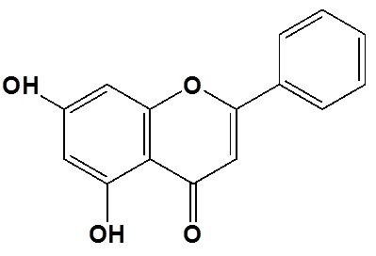
Figure 1. Chemical structure of chrysin

Materials and Methods
Chemicals and Reagents

All vessels were immersed in diluted nitric acid for more than 12 h before use. Deionized water (18.2 MΩ) was obtained from a Simplicity 185, Millipore Merck (Darmstadt, Germany) water filtration system and used for preparation of the standards and sample solutions. Stock solutions (1 g L⁻¹) of Ni(II), Cu(II) and Zn(II) and absolute ethanol (99.8%) was purchased from Merck (Darmstadt, Germany). 5,7-Dihydroxy-2-phenyl-4H-chromen-4-one (chrysin 97%), sodium hydroxide (NaOH ≥ 98%), nitric acid (HNO₃ 65%) were all purchased from Sigma–Aldrich (St. Louis, MO, USA). In this work, 0.2% (w/v) chrysin solution was used as a co-precipitating reagent. 0.2% (w/v) chrysin solution was prepared by dissolving it in ethanol. Hydrochloric acid (HCl 37%) was purchased from Fluka Chemika (Buchs, Switzerland). River water reference material for trace metals (SLRS-5) was purchased from National Research Council Canada (Ottawa, Canada).

Sample Preparation

River water samples were collected from Skudai River, Johor Bahru, Malaysia. River water samples were filtered through Advantec filter paper (0.45 µm) and acidified to pH 1 with concentrated HCl for storage prior to usage. Lake and tap water samples were taken from UTM Lake and Chemistry research laboratory (UTM, Johor Bahru, Malaysia), respectively. Lake and tap water samples were filtered off by using Millipore cellulose acetate membrane filter (pore diameter 0.45 µm) and acidified to pH 2 with 2 M HNO₃. The triplicate measurements were performed using FAAS analysis for all the water samples.

Instruments
A Perkin-Elmer AAnalyst 400 flame atomic absorption spectrometer (Waltham, MA USA), equipped with hollow cathode lamps for nickel, copper and zinc with a deuterium lamp for background correction was used for analysis. The hollow cathode lamps were operated at 8 mA and the wavelength was set at 232.0, 324.75 and 213.9 nm for Ni(II), Cu(II) and Zn(II), respectively. The flame composition was operated with an acetylene flow rate of 1.8 L min⁻¹ and air flow rate of 10 L min⁻¹. A Metrohm model 713 (Herisau, Switzerland) pH-meter with a combined glass electrode was used for pH measurements. A Sigma 3-16P centrifuge (Sigma laborzentrifugen GmbH, Germany) was employed to centrifuge the solutions.

Co-Precipitation Method

In this method, three trace metal ions were examined simultaneously. Firstly, a mixture of the metal ion solution consisting of 50 mg L^{–1} of Ni(II), 30 mg L^{–1} of Cu(II) and 20 mg L^{–1} of Zn(II) ions was prepared. Then 0.5 mL of this solution was added to 50 mL of an aqueous solution. In the present case, the working solution consists of 25 µg of Ni(II), 15 µg of Cu(II) and 10 µg of Zn(II) ions. The solution was placed in a centrifuge tube, and the pH of the solutions was adjusted to 6 by using dilute HCl and NaOH solutions. Then 2 mL of the co-precipitating reagent (chrysin) (0.2%, w/v) was added. After standing for 20 min, the solutions were centrifuged at 3000 rpm for 20 min. The supernatant was removed. The precipitate remained adhering to the tube was dissolved with 1 mL of conc. HNO₃. The final volume was adjusted to 3 mL with deionized water, and then the levels of analytes in the final solution were determined by using FAAS.

Analytical Performance of the CEFC Method

The analytical performance of the proposed separation and pre-concentration method based on CEFC was evaluated for limit of detection (LOD), limit of quantification (LOQ), and precision from the results obtained using FAAS measurements.

Method Validation and Applications to Real Samples

The recovery of the ions investigated from several water samples were performed to assess the accuracy of the proposed co-precipitation procedure using chrysin for the separation and preconcentration of Ni(II), Cu(II) and Zn(II) ions. For this purpose different amounts of Ni(II), Cu(II) and Zn(II) ions were spiked in 150 mL of water samples (tap, river and lake water) after confirming the non-presences of these ions. River water reference material for trace metals (SLRS-5), as a certified reference material, was also used for the method validation.

Results and Discussion
Effects of pH
The pH influence is one of the most significant analytical factors on the recovery of analytes on the co-precipitation of trace metal ions [28, 29]. The effects of pH on the recoveries of Ni(II) and Cu(II) and Zn(II) metal ions were examined in the solution pH range of 1–10 under optimum conditions. As it is seen from Figure 2, quantitative recovery values (> 93%) were obtained for coprecipitation of the analyte ions with chrysin as the co-precipitation reagent in the pH range of 6 to 10, thus further experiments were performed at pH 6. For subsequent work during this investigation involving general applications, pH 6 was selected as a working medium.

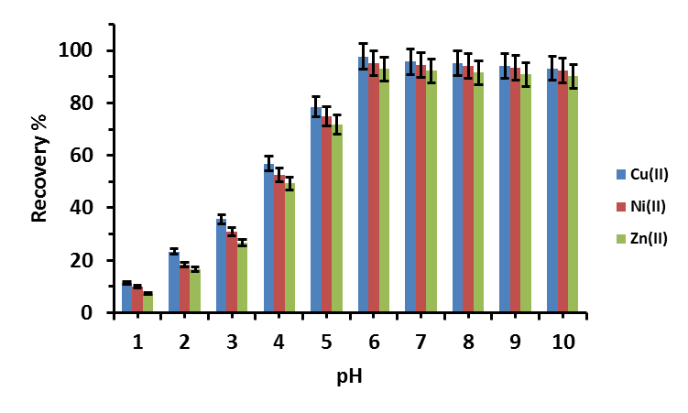

Figure 2. Effect of pH on the recoveries of analyte ions (N: 3, sample volume: 50 mL, amount of chrysin: 6 mg (3 mL 0.2% (w/v)), standing time: 20 min, centrifugation rate: 3000 rpm, centrifugation time: 20 min)

Effects of Amounts of Co-Precipitating Reagent
To obtain the effect of the quantity of chrysin on the coprecipitation of Ni(II), Cu(II) and Zn(II) metal ions, the tests were carried out using different chrysin amounts ranging from 0−10 mg (0–5 mL, 0.2% (w/v)) under optimum conditions. It was observed that the recovery of the Ni(II), Cu(II) and Zn(II) metal ions increased with an increase in the quantity of chrysin complexing reagent, up to a certain level and then levels off. The recovery for Ni(II), Cu(II) and Zn(II) metal ions was below 10%, when no chrysin was added to the solution. However, the recovery of the three metal ions increased rapidly with increasing quantity of chrysin, but after reached the optimal quantity of complexing reagent (6 mg, 3 mL, 0.2% (w/v) of chrysin); there was no change in the recovery yields (Figure 3). On this basis, 6 mg of chrysin as complexing reagent was added to the solutions for all subsequent works.

Effect of Sample Volume
In order to achieve high preconcentration factor, sample volume is one of the significant factors [30, 31]. For example, the concentrations of Ni(II), Cu(II) and Zn(II) metal ions in real samples are very low, thus the optimization of sample volume is required to obtain high preconcentration factors for the analysis of a real sample using presented coprecipitation procedure. Based on this, the influence of sample volume on the quantitative recoveries of the analyte ions was examined in the sample volume range of 25–200 mL under optimum conditions. As can be seen from Figure 4, the recovery values decreased significantly after 150 mL sample volume. Thus, the sample volume was optimized as 150 mL in the application of the method for tap, river and lake waters. The enrichment factor (EF) was determined to be 50 (150 mL sample volume which was finally reduced to a final volume 3 mL).

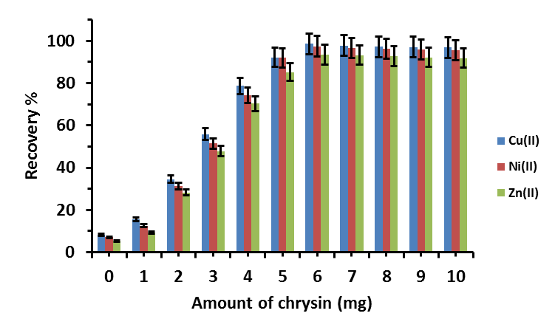

Figure 3. Effect of quantity of chrysin on the recoveries of analyte ions (n: 3, sample volume: 50 mL, pH: 6, standing time: 20 min, centrifugation rate: 3000 rpm, centrifugation time: 20 min)

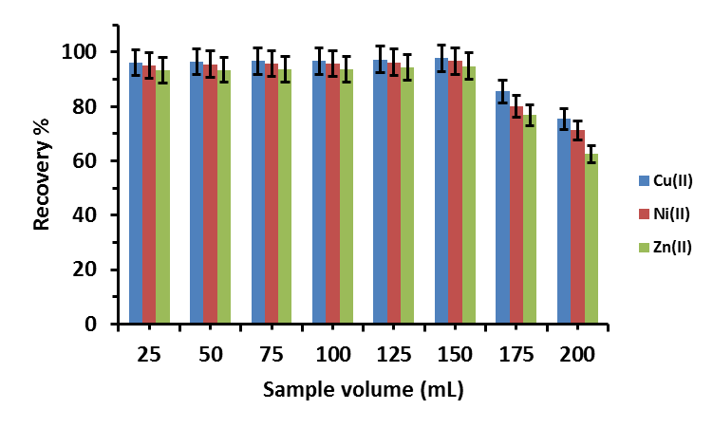

Figure 4. Effect of sample volume on the recoveries of analyte ions (n: 3, amount of chrysin: 6 mg, pH: 6, standing time: 20 min, centrifugation rate: 3000 rpm, centrifugation time: 20 min)

Effect of Standing Time, Centrifugation Rate and Time
The effect of standing time, centrifugation time and centrifugation rate on the recoveries of analyte ions were also examined under the optimum experimental conditions. For this purpose the effect of standing time on the recovery of the metal ions was examined in the range of 5–60 min (Figure 5). The quantitative recoveries of target analytes were achieved after a standing period of about 20 min for Ni(II), Cu(II) and Zn(II) metal ions were co-precipitated with chrysin as the co-precipitation reagent. Thus 20 min standing time was used for subsequent studies.

The precipitates were centrifuged in the range of 1000–3500 rpm in order to determine the optimum centrifugation rate. The quantitative recoveries of analytes were achieved after 3000 rpm of centrifugation rates. Therefore, for further tests centrifugation rate of 3000 rpm was applied. The results are given in Figure 6 for Ni(II), Cu(II) and Zn(II) metal ions were coprecipitated with chrysin as coprecipitation reagents.

The effect of centrifugation time on the recoveries of metal ions was investigated in the range of 1–30 min at 3000 rpm (Figure 7). Quantitative recoveries of Ni(II),Cu(II) and Zn(II) metal ions were obtained after 20 min. For remaining studies, 20 min centrifugation time and 3000 rpm was applied.

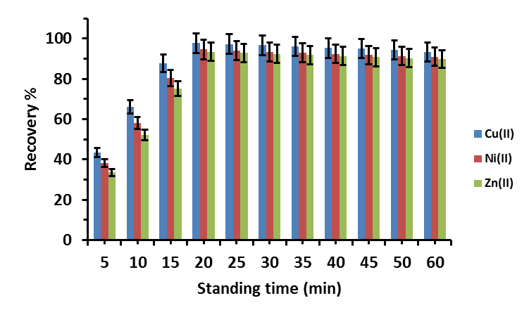

Figure 5. Effect of standing time on the recoveries of analyte ions (n: 3, amount of chrysin: 6 mg, pH: 6, sample volume: 50 mL, centrifugation rate: 3000 rpm, centrifugation time: 20 min)

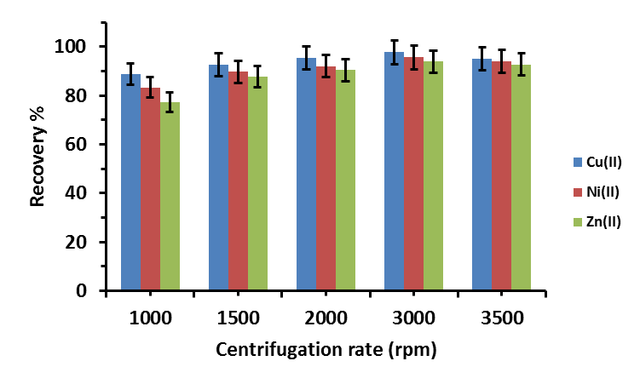

Figure 6. Effect of centrifugation rate on the recoveries of analyte ions (n: 3, amount of chrysin: 6 mg, pH: 6, sample volume: 50 mL, standing time: 20 min, centrifugation time: 20 min)

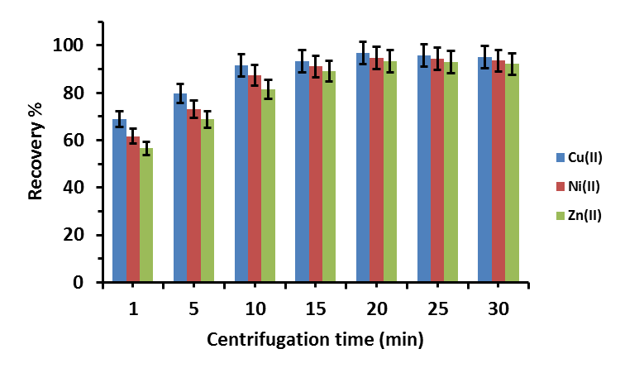

Figure 7. Effect of centrifugation time on the recoveries of analyte ions (n: 3, amount of chrysin: 6 mg, pH: 6, sample volume: 50 mL, standing time: 20 min, centrifugation rate: 3000 rpm)

Effects of foreign ions
The impact of foreign ions is a notable factor for quantitative recoveries of metal ions from real samples [30, 32]. Analytes exist in real samples together with different matrix ions. The effects of some cations and anions on the recoveries of Ni(II), Cu(III) and Zn(II) metal ions were studied at pH 6. High concentrations of some cations and anions and some transition metals have not interfere in the FAAS determination of Ni(II), Cu(II) and Zn(II) metal ions coprecipitation with chrysin as the co-precipitation reagent (Figure 8). Therefore, the CEFC procedure could be used to the real samples involving high content of foreign ions at tolerable concentration levels.

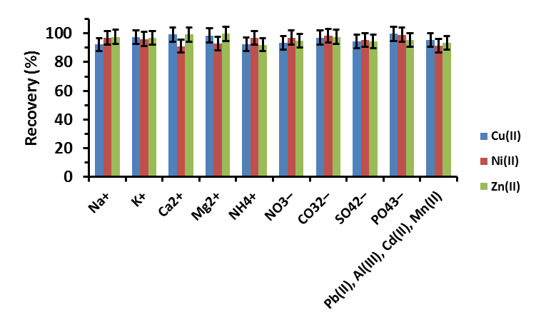

Figure 8. Influences of some foreign ions on the recoveries of analyte ions under optimum conditions (n: 3, amount of chrysin: 6 mg, pH: 6, sample volume: 50 mL, standing time: 20 min, centrifugation rate: 3000 rpm)

Analytical Performance of the CEFC Method
Relative standard deviations (RSD) reflect the precision of the method and it was found to be 3.9% for Ni(III), 2.6% for Cu(II) and 3.4% for Zn(II) ions. Ten replicates were used using model solutions containing 25 μg of Ni(II), 15 μg of Cu(II) and 10 μg of Zn(II) ions. The limit of detections (LOD), defined as the concentration that gives a signal equivalent to three times the standard deviation of 10 replicate measurements of the blank samples, were found to be 0.86, 0.64 and 0.72 µg L^{–1}, for Ni(II), Cu(II) and Zn(II) ions, respectively. The LOQ was defined as ten times the standard deviation of 10 replicate measurements of the blank samples [33], were obtained to be 2.86, 2.13 and 2.40 µg L^{–1}, for Ni(II), Cu(II) and Zn(II) ions, respectively.

Method Validation and Applications to Real Samples
The proposed CEFC method using chrysin to determine the Ni(II), Cu(II) and Zn(II) metal ions in water samples including tap, river and lake water were applied. In order to determine the metal ions, different amounts of examined ions were spiked to these samples. As can be seen Table 1, a good agreement was obtained between the spiked and found analyte ion amounts, so the proposed procedure could be successfully practical for separation and pre-concentration of trace amounts of Ni(II), Cu(II) and Zn(II) metal ions in water samples, with recovery of 94.66 - 101.2% using chrysin as co-precipitation reagent. Satisfactory precision (RSD < 7%) was obtained for the proposed procedure using FAAS for determination.

The accuracy of the proposed method was verified by analyzing certified reference materials, River water reference material for trace metals (SLRS-5). The results from the presented method (Table 2) revealed good agreement with the certified values for the investigated analyte ions.

Equally, the Student’s t-test was useful to results of the suggested method and certified values (Table 3). At the 95% confidence level t_{critical} is 4.30, and t_{calculated} values are lower than t_{critical} for all practical result of three metal ions. Hence there was no significant difference between the founded values and certified values for 95% confidence level.

Table 1. Spiked recoveries of analyte ions from water samples (n: 3, pH: 6, sample volume: 150 mL, amount of chrysin: 6 mg, final volume: 3 mL)
Element |  | Tap water |  | River water |  | Lake water
Element | Added (μg) | ªFound (μg) | Recovery (%) | Found (μg) | Recovery (%) | Found (μg) | Recovery (%)
Ni(II) | 0 | 0 | – | 0 | – | 0 | –
 | 10 | 9.91 ± 0.6 | 99.1 | 9.94 ± 0.9 | 99.4 | 9.92 ± 0.8 | 99.2
 | 15 | 14.2 ± 3.13 | 94.6 | 14.5 ± 5.4 | 96.6 | 14.30 ± 3.4 | 95.33
Cu(II) | 0.0 | 0 | – | 0 | – | 0 | –
 | 6 | 5.82 ± 1.2 | 97 | 6.07 ± 1.48 | 101.2 | 5.95 ± 1.34 | 99.16
 | 12 | 11.8 ± 3.55 | 98.3 | 11.95 ± 6.5 | 99.6 | 11.86 ± 4.4 | 98.83
Zn(II) | 0 | 0 | – | 0 | – | 0 | –
 | 3 | 2.87 ± 2.09 | 95.7 | 2.95 ± 1.69 | 98.3 | 2.91 ± 1.37 | 97
 | 6 | 5.76 ± 2.25 | 96 | 5.68 ± 5.8 | 94.7 | 5.72 ± 5.06 | 95.33
ªmean± RSD%

Table 2. Application of the CEFC method to the standard reference material (n: 3, volume of CRM-SLRS-5
River water: 50 mL, quantity of chrysin: 6 mg, final volume: 3 mL)
Metals | Certified value  (µg kg^{–1}) | ªFound value  (µg kg^{–1}) | Recovery  (%)
Ni | 0.476 ± 0.064 | < LOD | -
Cu | 17.4 ± 1.3 | 17.28 ± 1.5 | 99.31
Zn | 0.845 ± 0.095 | 0.824 ± 0.6 | 97.51
ªmean ± standard deviation

Table 3. Statistical evaluation of the results obtained in the accuracy study (Table 2)
using student's t-test
Metals | ªµ | ^{b}M | |µ–M| | ^{c}S | ^{d}t_{calculated}
Ni | 0.476 | - | - | - | -
Cu | 17.4 | 17.28 | 0.12 | 1.5 | 0.138
Zn | 0.845 | 0.824 | 0.021 | 0.6 | 0.060
ª: Certified value; ^{b}: Mean based on three replicate determinations (n: 3); ^{c}: standard deviation;
^{d}:$t=(|μ-M| \sqrt{N})/S$.

Comparison of the Developed CEFC Method with Other Methods
A comparison of the recommend developed CEFC procedure with other coprecipitation procedures is summarized in Table 4 in terms of some optimization parameters. The parameters achieved were comparable to those presented by other procedures in the literature. The recommended co-precipitation method developed by using the new organic coprecipitating reagent chrysin without any carrier element has relatively high pre-concentration factors and low LOD when compared to other reported literature methods (Table 4).

Table 4. Comparison of the developed CEFC method with other co-precipitation method using FAAS
Co-precipitating reagent | Studied elements | EF | LOD (µg L⁻¹) | Ref.
Chrysin | Cu(II), Ni(II), Zn(II) | 50 | 0.64, 0.86, 0.72 | This work
ICOTMA | Cu(II) | 50 | 0.56 | [7]
Zirconium(IV) hydroxide | Cu(II), Ni(II) | 25 | 1.55, 2.50 | [22]
BTEB | Ni(II) | 50 | 0.46 | [29]
CTAB | Cu(II) | 10 | 1.36 | [30]
MEFMAT | Cu(II) | 50 | 1.49 | [31]
IMOTFAH | Ni(II) | 50 | 1.21 | [32]
LOD: Detection Limit; EF: enrichment factor; Chrysin: 5,7-Dihydroxy-2-phenyl-4H-chromen-4-one; ICOTMA: (2-{4-[2-(1H-indol-3-yl)ethyl]-3-(4-chlorobenzyl)-5-oxo-4,5-dihydro-1H-1,2,4-triazol-1-yl}-N-rylmethylidene acetohydrazid); BTEB: 1,2-bis-(2-tosylethoxy) benzene; CTAB: (N-cetyl N,N,N trimethyl ammonium bromide; MEFMAT:2-{[4-(4-fluorophenyl)-5-sulphanyl-4H-1,2,4-triazol-3-yl]methyl}-4-{[(4-fluorophenyl)methylene] amino}-5-(4-methylphenyl)-2,4-dihydro-3H-1,2,4-triazol-3-one; IMOTFAH: 2-{4-[2-(1HIndol-3-yl)ethyl]-3-(4-methylbenzyl)-5-oxo-4,5-dihydro-1H-1,2,4-triazol-1-yl}-N0-(3-fluoro-phenylmethyliden) acetohydrazide

Conclusion
In order to determine the levels of nickel, copper and zinc in aquatic samples, a simple, fast, and low cost separation and preconcentration procedure based on CEFC was established. In accordance with this purpose for the occurrence of the precipitate only organic ligand, chrysin was used without needing a carrier element. Hence, the contamination risk for the analytes ion from a carrier element was eliminated. After being optimized the investigational factors and validated the method, it was successfully applied to determine nickel, copper and zinc in tap, river and lake water samples.

Acknowledgement
The authors would like to express their appreciation to the Ministry of Education Malaysia (MOE) for the Fundamental Research Grant Scheme (FRGS) (Project No 4F307) for the financial support and partial support from the Research University Grant (RUG) vote number 04H22 is also acknowledged. L. I. Abd Ali would also like to acknowledge UTM for the IDF sponsorship.

References
- Ge, F., Li, M.M., Ye, H. and Zhao, B.X. (2012). Effective removal of heavy metal ions Cd²⁺, Zn²⁺, Pb²⁺, Cu²⁺ from aqueous solution by polymer-modified magnetic nanoparticles. J. Hazard. Mater. 211–212: 366-372.
- Kumar, R., Barakat, M. A., Daza, Y. A., Woodcock, H. L. and Kuhn, J. N. (2013). EDTA functionalized silica for removal of Cu(II), Zn(II) and Ni(II) from aqueous solution. J. Colloid Interface Sci. 408: 200-205.
- Saracoglu, S., Saygi, K. O., Uluozlu, O. D., Tuzen, M. and Soylak, M. (2007). Determination of trace element contents of baby foods from Turkey. Food Chem. 105 (1): 280-285.
- Bulut, V. N., Duran, C., Gundogdu, A., Soylak, M., Yildirim, N. and Elci, L. (2008). A new approach to separation and pre-concentration of some trace metals with co-precipitation method using a triazole. Talanta, 76 (2): 469-474.
- Uluozlu, O. D., Tuzen, M., Mendil, D., Kahveci, B. and Soylak, M. (2009). l-4-(p-chlorobenzyli denamino-4,5-dihydro-1H-1,2,4-triazol-5-one (EPHBAT) as precipitant for carrier element free coprecipitation and speciation of chromium(III) and chromium(VI). J. Hazard. Mater. 172 (1): 395-399.
- Duran, C., Gundogdu, A., Bulut, V. N., Soylak, M., Elci, L., Sentürk, H. B. and Tüfekci, M. (2007). Solid-phase extraction of Mn(II), Co(II), Ni(II), Cu(II), Cd(II) and Pb(II) ions from environmental samples by flame atomic absorption spectrometry (FAAS). J. Hazard. Mater. 146 (1–2): 347-355.
- Bahadır, Z., Bulut, V. N., Ozdes, D., Duran, C., Bektas, H. and Soylak, M. (2014). Separation and preconcentration of lead, chromium and copper by using with the combination coprecipitation-flame atomic absorption spectrometric determination. J. Ind. Eng. Chem. 20 (3): 1030-1034.
- Liu, Y., Ingle, J. D. (1989). Automated on-line ion-exchange trace enrichment system with flame atomic absorption detection. Anal. Chem. 61 (6): 520-524.
- Ali, L. I. A., Wan Ibrahim, W. A., Sulaiman, A. and Sanagi, M. M. (2014). Adsorption Studies of Nickel (II) Metal Ions Uptake Using Fe₃O₄ Magnetic Nanoadsorbent. J. Teknol. 71 (5): 99-10.
- Klapiszewski, Ł., Bartczak, P., Wysokowski, M., Jankowska, M., Kabat, K. and Jesionowski, T. (2015). Silica conjugated with kraft lignin and its use as a novel ‘green’ sorbent for hazardous metal ions removal. Chem. Eng. J. 260: 684-693.
- Raju, B., Kumar, J. R., Lee, J.Y., Kwonc, H.S., Kantam, M. L. and Reddy, B. R. (2012). Separation of platinum and rhodium from chloride solutions containing aluminum, magnesium and iron using solvent extraction and precipitation methods. J. Hazard. Mater. 227–228: 142-147.
- Chu, H., He, L., Jiang, Q., Fang, Y., Jia, Y., Yuan, X., Zou, S., Li, X., Feng, W., Yang, Y., Liu, N., Luo, S., Yang, Y., Yang, L. and Yuan, L. (2014). CMPO-calix[4]arenes with spacer containing intramolecular hydrogen bonding: Effect of local rigidification on solvent extraction toward f-block elements. J. Hazard. Mater. 264: 211-218.
- Divrikli, U., Kartal, A. A., Soylak, M. and Elci, L. (2007). Preconcentration of Pb(II), Cr(III), Cu(II), Ni(II) and Cd(II) ions in environmental samples by membrane filtration prior to their flame atomic absorption spectrometric determinations. J. Hazard. Mater. 145 (3): 459-464.
- Urgun-Demirtas, M., Benda, P. L., Gillenwater, P. S., Negri, M. C., Xiong, H. and Snyder, S. W. (2012). Achieving very low mercury levels in refinery wastewater by membrane filtration. J. Hazard. Mater. 215–216: 98-107.
- Krawczyk, M., Jeszka-Skowron, M. and Matusiewicz, H. (2014). Sequential multi-element determination of iron and zinc in water samples by high-resolution continuum source graphite furnace atomic absorption spectrometry after column solid-phase extraction onto multiwalled carbon nanotubes. Microchem. J. 117: 138-143.
- Wan Ibrahim, W. A., Abd Ali, L. I., Sulaiman, A., Sanagi, M. M. and Aboul-Enein, H. Y. (2014). Application of Solid-phase Extraction for Trace Elements in Environmental and Biological Samples: A Review. Crit. Rev. Anal. Chem. 44 (3): 233-254.
- Es'haghi, Z., Heidari, T. and Mazloomi, E. (2014). In situ pre-concentration and voltammetric determination of trace lead and cadmium by a novel ionic liquid mediated hollow fiber-graphite electrode and design of experiments via Taguchi method. Electrochim. Acta. 147: 279-287.
- Kamal, A., Kumar, K., Kumar, V. and Mahajan, R. K. (2014). Electrochemical and Chromogenic Sensors Based on Ferrocene Appended Chalcone for Selective Quantification of Copper (II). Electrochim. Acta. 145: 307-313.
- Feist, B., Mikula, B., Pytlakowska, K., Puzio, B. and Buhl, F. (2008). Determination of heavy metals by ICP-OES and F-AAS after preconcentration with 2,2′-bipyridyl and erythrosine. J. Hazard. Mater. 152 (3): 1122-1129.
- Feist, B., Mikula, B. (2014). Preconcentration of some metal ions with lanthanum-8-hydroxyquinoline co-precipitation system. Food Chem. 147: 225-229.
- Soylak, M., Saracoglu, S., Divrikli, U. and Elci, L. (2005). Coprecipitation of heavy metals with erbium hydroxide for their flame atomic absorption spectrometric determinations in environmental samples. Talanta, 66 (5): 1098-1102.
- Citak, D., Tuzen, M. and Soylak, M. (2009). Simultaneous coprecipitation of lead, cobalt, copper, cadmium, iron and nickel in food samples with zirconium(IV) hydroxide prior to their flame atomic absorption spectrometric determination. Food Chem. Toxicol. 47 (9): 2302-2307.
- Soylak, M., Aydin, A. (2011). Determination of some heavy metals in food and environmental samples by flame atomic absorption spectrometry after coprecipitation. Food Chem. Toxicol. 49 (6): 1242-1248.
- Elçi, L., Soylak, M. and Özcan, B. (2003). Coprecipitation of Cu(II), Ni(II), Fe(III), Cd(II), Pb(II), and Co(II) in Wastewater, Sediment, and Metallic Zinc Samples with HMDTC–HMA for Flame Atomic Absorption Spectrometric Determination. Anal. Lett. 36 (5): 987-999.
- Mulazmoglu, I. E., Solak, A. O. (2011). A novel apigenin modified glassy carbon sensor electrode for the determination of copper ions in soil samples. Anal. Methods. 3 (11): 2534-2539.
- Wong, S. P., Leong, L. P. and William Koh, J. H. (2006). Antioxidant activities of aqueous extracts of selected plants. Food Chem. 99 (4): 775-783.
- Quideau, S., Deffieux, D., Douat-Casassus, C. and Pouységu, L. (2011). Plant Polyphenols: Chemical Properties, Biological Activities, and Synthesis. Angew. Chem. Int. Ed. 50 (3): 586-621.
- Tufekci, M., Bulut, V., Elvan, H., Ozdes, D., Soylak, M. and Duran, C. (2013). Determination of Pb(II), Zn(II), Cd(II), and Co(II) ions by flame atomic absorption spectrometry in food and water samples after preconcentration by coprecipitation with Mo(VI)-diethyldithiocarbamate. Environ. Monit. Assess. 185 (2): 1107-1115.
- Duran, C., Ozdes, D., Akcay, H. T., Serencam, H. and Tufekci, M. (2015). Simultaneous separation and preconcentration of Cd(II), Co(II), and Ni(II) ions in environmental samples by carrier element-free wcoprecipitation method prior to their flame atomic absorption spectrometric determination. Desalin. Water Treat. 53 (2): 390-397.
- Saracoglu, S., Soylak, M. (2010). Carrier element-free coprecipitation (CEFC) method for separation and pre-concentration of some metal ions in natural water and soil samples. Food Chem. Toxicol. 48 (5): 1328-1333.
- Duran, C., Ozdes, D., Sahin, D., Bulut, V. N., Gundogdu, A. and Soylak, M. (2011). Preconcentration of Cd(II) and Cu(II) ions by coprecipitation without any carrier element in some food and water samples. Microchem. J. 98 (2): 317-322.
- Bahadir, Z., Ozdes, D., Bulut, V. N., Duran, C., Elvan, H., Bektas, H. and Soylak, M. (2013). Cadmium and nickel determinations in some food and water samples by the combination of carrier element-free coprecipitation and flame atomic absorption spectrometry. Toxicol. Environ. Chem. 95 (5): 737-746.
- Cantle, J. E. (1982). Chapter 3 Practical techniques. In Techniques and Instrumentation in Analytical Chemistry, John Edward, C., Ed. Elsevier:, 5: 37-66.

