

MALAYSIAN JOURNAL OF ANALYTICAL SCIENCES
ISSN 1394 - 2506

Published by The Malaysian Analytical Sciences Society

DEVELOPMENT AND VALIDATION OF UV SPECTROPHOTOMETRIC

METHOD FOR ESTIMATION OF DOLUTEGRAVIR SODIUM IN TABLET DOSAGE FORM

(Pembangunan dan Pengesahsahihan Kaedah Spektrofotometri UV bagi Anggaran Dolutegravir sodium dalam Bentuk Dos Tablet)

Bhavar Girija Balasaheb¹*, Aher Kiran Balasaheb², Thorat Ravindra Subhash², Kakadsachin Jijabapu²,

Pekamwar Sanjay Sudhakar³

¹Department of Pharmaceutical Chemistry

²Department of Quality Assurance Techniques

Amrutvahini College of Pharmacy, Sangamner, Maharashtra, India 422608.

³School of Pharmacy,

Swami Ramanand Teerth Marathwada University, Nanded Maharashtra, India 431606

*Corresponding author: girijabhavar@gmail.com

Received: 12 July 2015; Accepted: 8 October 2015

Abstract

A simple, rapid, precise and accurate spectrophotometric method has been developed for quantitative analysis of Dolutegravir sodium in tablet formulations. The initial stock solution of Dolutegravir sodium was prepared in methanol solvent and subsequent dilution was done in water. The standard solution of Dolutegravir sodium in water showed maximum absorption at wavelength 259.80 nm. The drug obeyed Beer–Lambert’s law in the concentration range of 5–40 μg/mL with coefficient of correlation (R²) was 0.9992. The method was validated as per the ICH guidelines. The developed method can be adopted in routine analysis of Dolutegravir sodium in bulk or tablet dosage form and it involves relatively low cost solvents and no complex extraction techniques.

Keywords: dolutegravir sodium, UV spectrophotometry, validation, tablets

Abstrak

Satu kaedah spektrofotometri mudah, cepat, tepat dan jitu telah dibangunkan untuk analisis kuantitatif kandungan Dolutegravir sodium di dalam formulasi tablet. Larutan stok Dolutegravir sodium disediakan dalam pelarut methanol dan pencairan berikutnya dilakukan di dalam pelarut air. Larutan piawai Dolutegravir sodium di dalam air menunjukkan penyerapan maksimum pada jarak gelombang 259.80 nm. Ia mematuhi hukum Beer - Lambert dalam julat kepekatan di antara 5 - 40 μg/mL dengan nilai pekali korelasi (R²) adalah 0.9992. Kaedah ini telah ditentusahkan mengikut garis panduan ICH. Kaedah ini boleh digunapakai dalam analisis rutin Dolutegravir sodium secara bentuk pukal atau juga dos tablet dan ia melibatkan pelarut kos yang rendah dan tidak memerlukan teknik pengekstrakan yang kompleks.

Kata kunci: dolutegravir sodium, spektrofotometri UV, pengesahsahihan, tablet

Introduction

Dolutegravir sodium or formula name known as (4R,12aS)-9-{[(2,4-difluorophenyl)methyl]carbamoyl} -4-methyl-6,8-dioxo-3,4,6,8,12,12a- Hexahydro-2H-pyrido [1',2':4,5]pyrazino[2,1-b] [1,3]oxazin-7-olate, is a novel integrase stand transfer inhibitor active against Human Immunodeficiency Virus. Dolutegravir (DTG) is active against HIV type 1 (HIV-1) and also has some in vitro activity against HIV type 2 (HIV-2) [1-3]. DTG is a prescription medicine approved by the U.S. Food and Drug Administration (FDA) for the treatment of HIV infection in adults and children 12 years of age and older and weighing at least 40 kilograms. DTG is always used in combination with other HIV medicines [4]. It is a discovery of the second-generation integrase stand transfer inhibitor as a result of the collaborative efforts of scientists working for Shionogi (Japan) and GlaxoSmithKline (UK) [5].

Dolutegravir sodium is a white to light yellow powder and is slightly soluble in water. DTG is rapidly absorbed after oral administration. Its low apparent clearance and oral terminal half-life of approximately 13–15 h in healthy volunteers [3] and 11–12 h in HIV-positive adults [6] supports once-daily dosing without the need for a boosting agent. In total, 34% of the DTG dose is absorbed and excreted with the feces and urine; another 33 – 48% is involved in enterohepatic recirculation; and a further portion is secreted in bile [7, 8].

The literature review revealed a liquid chromatography–tandem mass spectrometry method [9] and a sensitive HPLC–MS/MS method [10] for estimation of DTG in human blood plasma has been carried out. There is no UV spectrophotometric method is available for quantitative determination of Dolutegravir in tablet formulation. Further, no official or draft monograph of Dolutegravir sodium was published in any of the pharmacopoeia for compendia applications.

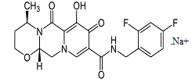

Figure 1. Chemical Structure of DTG

The present work deals with the development of UV spectrophotometric method and its validation as per International Conference on Harmonisation (ICH) guidelines [11-13]. The developed method can be adopted in routine analysis of Dolutegravir sodium in bulk and tablet dosage form and it involves relatively low cost solvents and no complex extraction techniques.

Materials and Methods
Materials and Reagents
Dolutegravir sodium bulk drug was obtained from Mylan Labs Ltd, (Hyderabad, India), the commercially tablets of Dolutegravir sodium were not available in Indian market; hence we have manufactured immediate release tablet containing Dolutegravir sodium equivalent to 50 mg DTG as per cGMP guidelines. The tablets contained lactose monohydrate, microcrystalline cellulose, starch and magnesium stearate with average weight of 250 mg. Water was obtained from a Milli-Q UF-Plus apparatus (Millipore) and was used to prepare all solutions for the method. Other chemicals used were analytical grade and glassware used was Class A grade.

Instrument
Shimadzu UV - 1700 UV/VISIBLE spectrophotometer with UV probe 2.10 software and 1 cm matched quartz cells were used for absorbance measurements. Analytical balance used for weighing standard and sample was Make-Mettler Toledo, Model- XP 105.

Selection of Solvent
The solubility of Dolutegravir sodium was checked in water, acetonitrile and methanol. It was found to be freely soluble in methanol, slightly soluble in water but insoluble in acetonitrile. Methanol was selected as the solvent for dissolving the drug.

Preparation of Standard Stock Solution
Accurately weighed of Dolutegravir sodium working standard equivalent to 10 mg of DTG was transferred into a 100 mL volumetric flask. It was dissolved in 20 mL methanol by sonication for 10 minutes. Final volume was made up to 100 mL with methanol to give the solution containing 100 μg/mL of DTG.

Selection of Maximum Wavelength for Analysis
The standard stock solution was further diluted with water to obtain concentration level of DTG at 10 μg/mL. The solution was scanned between 200 and 400 nm using water as blank.

Preparation of the Calibration Curve
An aliquot of standard stock solution were further diluted with water to get the solutions of concentration within range 5 – 40 μg/mL. The absorbance was measured at 259.80 nm against water as blank. All measurements were repeated three times for each concentration.

Assay of DTG in Tablet
Twenty tablets were weighed; their average weight was determined and finely powdered. Powder equivalent to 50 mg DTG of was accurately weighed and dissolved in small amount of methanol in 50 mL volumetric flask and then the volume was adjusted with methanol to obtain the final concentration is 1000 µg/mL. Hence, 10 mL solution was taken and then diluted up to 100 mL with the same solvent in a volumetric flask to obtain the solution of concentration 100 µg/mL. From this solution, aliquot of 1 mL was diluted to 10 mL using water. The absorbance of sample solution was measured at wavelength 259.80 nm. This procedure was repeated for six times.

Method Validation
The developed method was validated as per ICH guidelines for following parameters [7 – 9].

Linearity
Aliquots of standard stock solution were further diluted with water to get the solutions of concentration within range from 5 – 40 μg/mL. The absorbance was measured at wavelength 259.80 nm. Linear calibration graph was obtained by plotting the absorbance value versus concentration of DTG.

Specificity
Specificity is the ability to assess unequivocally the analyte in the presence of components which may be expected to be present. The specificity of the method for determination of DTG in tablet dosage form was determined by comparing the spectrum of tablet solution with that of standard solution. The sample spectrum was checked for any interference from the excipients.

Recovery
To ensure accuracy of the method, recovery studies were performed by standard addition method at 80%, 100%, and 120% level to pre-analyzed samples (10µg/mL) and subsequent solutions were reanalyzed. At each level, three determinations were performed. Accuracy is reported as % recovery which was calculated from the expression as equation 1 below

% Recovery= Observed value x 100 / True value (1)

Precision
The precision of an analytical procedure expresses the closeness of agreement (degree of scatter) between a series of measurements obtained from multiple sampling of the same homogeneous sample under the prescribed conditions. Precision of the method was determined in terms of repeatability and intraday and interday precisions.

Repeatability
Repeatability of the method was determined by analyzing six samples of same concentrations of drug (10 µg/mL). Spectra were recorded, and the area of each spectrum was measured.

Intraday and Interday Precision (Intermediate Precision)
Intraday precision was determined by analyzing the drugs at three different concentrations (10, 20 and 30 µg/mL) and each concentration for three times, on the same day. Interday precision was determined similarly, but the analysis being carried out daily, for three consecutive days.

Robustness
The robustness of developed method is its capacity to remain unaffected by small changes in conditions. To determine the robustness of the method, the experimental conditions were deliberately altered and assay was evaluated. The effect of detection wavelength was studied at ±2 nm.

Solution Stability
The stability of the solution was studied by analyzing the standard solution at 1, 6and 24 hour intervals.

Results and Discussion
Selection of Wavelength for Analysis
The UV spectrum of DTG has shown maximum absorbance at the wavelength 259.80 nm. It was selected for the analysis of DTG in bulk and tablet formulation (Figure 2).

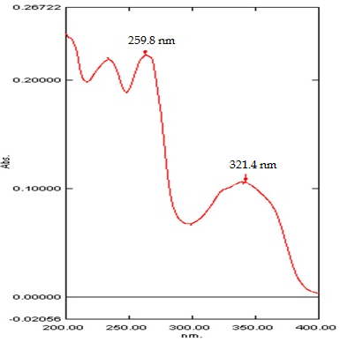

Figure 2. UV spectrum of standard DTG

Preparation of the Calibration Curve
The calibration curve was constructed by plotting absorbance against corresponding concentration. The calibration curve for DTG is shown in Figure 3. The drug was obeyed Beer–Lambert’s law in the concentration range of 5–40 μg/mL with coefficient of correlation (R²) was 0.9992.

Figure 3. Calibration Plot for DTG

Assay of DTG in Tablet
The amount of DTG present in formulation was calculated by comparing the absorbance of sample with standard absorbance. Content of DTG in tablet formulation determined by developed method was in good agreement with the label claim. The results obtained are shown in Table 1.

Table 1. Assay of Tablet Formulation
Labeled claim (mg) | 50
Amount found* ± SD (mg) | 50.18 ± 0.14
% Labeled claim | 100.37
% RSD | 0.28
*Mean of six determinations

Method Validation
DTG showed linear response in the concentration range of 5-40 µg/mL with the correlation coefficient of 0.9992. The spectra obtained from tablet solutions were identical with that obtained from standard solution containing an equivalent concentration of DTG (Figure 4). This showed that there was no any interference from excipients. Therefore, it could be said that developed method is highly specific.

The percentage recovery of standard drug, determined by developed method at 80, 100 and 120 % of sample concentration was ranged from 98.22 to 99.71%. The values of % recovery and % RSD shown in Table 2 indicate that the method is accurate. The % RSD values for repeatability and intermediate precision were found to be less than 2%.The low % RSD value indicate the precision of the method. The results are summarized in Table 3 and Table 4 respectively.

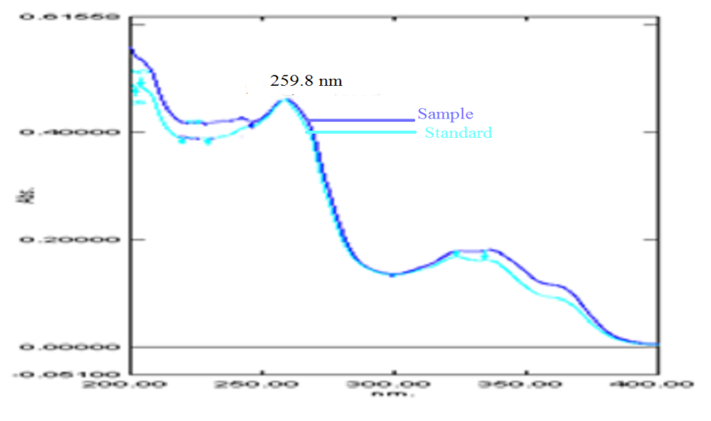

Figure 4. Overlain Spectra of Standard and Sample DTG

Table 2. Results of recovery studies
Level of addition (%) | Amount of std drug added (µg/mL) | Amount recovered *± SD (µg/mL) | % Recovery | % RSD
80 | 8 | 7.85 ± 0.13 | 98.22 | 1.71
100 | 10 | 9.97 ± 0.13 | 99.71 | 1.29
120 | 12 | 11.89 ± 0.10 | 99.09 | 0.85
*Mean of three determinations, SD- Standard Deviation

Table 3. Results of repeatability studies
Concentration applied (µg/mL) | 10
Concentration found* ± SD (µg/mL) | 9.98 ±0.05
% RSD | 0.54
*Mean of six determinations

Table 4. Results of Intermediate Precision Studies
Concentration (μg/mL) | Intra-day precision |  | Inter-day precision
Concentration (μg/mL) | Concentration found* ± SD (µg/mL) | % RSD | Concentration found* ± SD (µg/mL) | % RSD
10 | 9.98± 0.02 | 0.18 | 10.05 ±0.03 | 0.27
20 | 19.32± 0.15 | 0.76 | 19.44 ± 0.16 | 0.81
30 | 28.90± 0.06 | 0.20 | 28.93 ± 0.06 | 0.19
*Mean of three determinations
Assay of DTG for all deliberate changes of conditions was within 98.0–102.0 % as shown in Table 5, which indicates robustness of the method. Meanwhile, results of stability studies indicate that the solution was stable for 24 hours at ambient temperature. The % RSD of assay was 0.65 % after 24 hours. The results are shown in Table 6.

Table 5. Result of Robustness Studies
Wavelength | % Assay* ± SD | %RSD
261.40 nm | 98.16 ± 0.77 | 0.77
257.40 nm | 99.44 ± 0.80 | 0.80
*Mean of three determinations

Table 6. Results of Solution Stability Studies
Time (hour) | % Assay* ± SD | %RSD
1 | 99.02 ± 0.46 | 0.47
6 | 100.31 ± 0.28 | 0.28
24 | 99.88 ± 1.33 | 1.32
*Mean of three determinations

Conclusion
A simple and reliable UV Spectrophotometric method has been developed and successfully validated for estimation of DTG in tablet dosage form. The results of the validation tests indicated that the developed method was accurate, precise, robust and reproducible. This assay system provides an accurate, precise, and sensitive method for DTG quantitation and was successfully applied to pharmaceutical dosage form. Hence, the developed UV method is suitable for routine determination of DTG in pharmaceutical formulation in quality control laboratories, where economy and time are essential.

Acknowledgement
Authors are thankful to Mylan laboratories limited, Hyderabad, India, for providing pure drug samples for this study and the Amrutvahini Sheti and ShikshanVikas Sanstha, Sangamner, India for providing us the research facility.

References
- ViiV Healthcare, Tivicay® (dolutegravir) prescribing information. (2014), Research Triangle Park, NC.
- Castellino, S., Moss, L., Wagner, D. & et. al., (2013). Metabolism, excretion, and mass balance of the HIV-1 integrase inhibitor dolutegravir in humans. Antimicrobial Agents and Chemotherapy, 57: 3536 - 3546.
- Min, S., Song, I., Borland, J. Song I, Chen, S., Lou, Y., Min, S. S., Goljer, I., Culp, A., Piscitelli, S. C., Savina, P. M. (2010), Pharmacokinetics and safety of S/GSK1349572, a next-generation HIV integrase inhibitor, in healthy volunteers. Antimicrobial Agents and Chemotherapy, 54: 254 – 258.
- United State Food and Drug Administration, FDA (2013). Approves new drug to treat HIV infection http://www.fda.gov/NewsEvents/Newsroom/PressAnnouncements/ucm364744.htm [Access Online Aug. 12 2013].
- Kobayashi, M., Yoshinaga, T., Seki, T. Wakasa-Morimoto, C., Brown, K. W., Ferris, R., Foster, S. A., Hazen, R. J., Miki, S., Suyama-Kagitani, A., Kawauchi-Miki, S., Taishi, T., Kawasuji, T., Johns, B. A., Underwood, M. R., Garvey, E. P., Sato, A. and Fujiwara, T. (2011). In vitro antiretroviral properties of S/GSK1349572, a next-generation HIV integrase inhibitor. Antimicrobial Agents and Chemotherapy, 55: 813 – 821.

- Min, S., Sloan, L., De Jesus, E., Hawkins, T., McCurdy, L., Song, I., Stroder, R., Chen, S., Underwood, M., Fujiwara, T., Piscitelli, S. and Lalezari J. (2011). Antiviral activity, safety, and pharmacokinetics/pharmacodynamics of dolutegravir as 10-day monotherapy in HIV-1-infected adults. AIDS, 25(14): 1737 – 1745.
- Reese, M. J., Savina, P. M., Generaux, G. T. and Tracey, H., Humphreys, J. E., Kanaoka, E., Webster, L. O., Harmon, K. A., Clarke, J. D. and Polli, J. W. (2013). In vitro investigations into the roles of drug transporters and metabolizing enzymes in the disposition and drug interactions of dolutegravir, a HIV integrase inhibitor. Drug Metabolism and Disposition, 41: 353 – 361.
- Castellino, S., Moss, L., Wagner, D., Borland, J. Song, I., Chen, S., Lou, Y., Min, S. S., Goljer, I., Culp, A., Piscitelli, S. C. and Savina, P. M. (2013). Metabolism, excretion, and mass balance of the HIV-1 integrase inhibitor, dolutegravir, in humans. Antimicrobial Agents and Chemotherapy, 57(8): 3536 – 3546.
- Bennetto-Hood, C., Tabolt, G., Savina, P. and Acosta, E. P. (2014). A sensitive HPLC-MS/MS method for the determination of dolutegravir in human plasma. Journal of Chromatography B- Analytical Technologies in the Biomedical and Life Sciences, 945 – 946: 225 - 232.
- Grégoirea, M., Deslandesa, G., Renauda, C., Bouquiéa, R., Allaenac, C., Raffic, F., Jollieta, P. and Dailly E. (2014), A liquid chromatography–tandem mass spectrometry assay for quantification of rilpivirine and dolutegravir in human plasma. Journal of Chromatography B- Analytical Technologies in the Biomedical and Life Sciences, 971: 1 – 9.
- International Conference on Harmonisation. ICH. (2005). ICH – Q2 (R1): Guideline on Validation of Analytical Procedure: Text and Methodology.
- International Conference on Harmonization, ICH. (2003). Q1A( R2): Stability testing of new drug substances and products.
- International Conference on Harmonization, ICH (2003). Q2 (R1): Validation of analytical procedures: test and methodology.

