

MALAYSIAN JOURNAL OF ANALYTICAL SCIENCES
ISSN 1394 - 2506

Published by The Malaysian Analytical Sciences Society

THERMAL PERFORMANCE ANALYSIS OF STAGING EFFECT OF SOLAR THERMAL ABSORBER WITH CROSS DESIGN

(Analisis Prestasi Haba kepada Kesan Berperingkat Penyerap Haba Suria
dengan Reka Bentuk Bersilang)

Amir Abdul Razak¹*, Zafri Azran Abdul Majid², Mohd Hafidz Ruslan¹, Kamaruzzaman Sopian¹

¹Solar Energy Research Institute (SERI),
Universiti Kebangsaan Malaysia, 43600 UKM Bangi, Selangor, Malaysia
²Kulliyyah of Allied Health Sciences,
International Islamic University Malaysia, 25200 Bandar Indera Mahkota, Kuantan, Pahang, Malaysia

*Corresponding author: amirrazak@outlook.com

Received: 9 March 2015; Accepted: 29 September 2015

Abstract
The type and shape of solar thermal absorber materials will impact on the operating temperature and thermal energy storage effect of a solar air thermal collector. For a standard flat-plate design, energy gain can be increased by expanding the thermal absorber area along the collector plane, subject to area limitation. This paper focuses on the staging effect of a metal hollow square rod absorber of aluminium, stainless steel, and a combination of the two with a cross design, for the heat gain and temperature characteristics of a solar air collector. Experiments were carried out with three cross design set-ups, with 30 minutes of heating and cooling, phase, respectively, under 485 W/m² solar irradiance value, and at a constant air speed at 0.38 m/s. One-set aluminium set-up delivered the highest output temperature of 41.8 ºC, followed by two-sets aluminium and one aluminium set + one stainless steel set at 39.3 ºC and 38.2 ºC, respectively. The lowest peak temperature is recorded on three sets of the aluminium absorber at 35 ºC. The bi-metallic set-up performed better than the two aluminium set-up where each set-up obtained a temperature drop against heat gain gradient value of -0.4186 ºC/W and -0.4917 ºC/W, respectively. Results concluded that by increasing the number of sets, the volume and surface areas of the absorber material are also increased, and lead to a decrease in peak temperature output for each increase of sets.

Keywords: solar air heater, solar thermal absorber, cross design absorber

Abstrak
Jenis dan bentuk solar bahan penyerap haba akan memberi kesan kepada suhu operasi dan haba kesan penyimpanan tenaga udara pengumpul haba suria. Untuk standard reka bentuk plat rata, penghasilan tenaga boleh ditingkatkan dengan memperluaskan kawasan penyerap haba di sepanjang satah pengumpul tetapi tertakluk kepada had kawasan. Makalah ini memberi tumpuan kepada kesan bertingkat logam berongga penyerap rod persegi aluminium, keluli tahan karat dan gabungan kedua-duanya dengan reka bentuk silang kepada peningkatan haba dan ciri-ciri suhu pemanas udara suria. Eksperimen dilakukan dengan tiga jenis reka bentuk silang dengan 30 minit pemanasan dan penyejukan fasa masing-masing pada 485 W/m² nilai sinaran suria dan pada kadar halaju udara berterusan 0.38 m/s. One-set aluminium set-up delivered the highest output temperature of 41.8 ºC, followed by two-sets aluminium and one aluminium set + one stainless steel set at 39.3 ºC and 38.2 ºC, respectively. The lowest peak temperature is recorded on three sets of the aluminium absorber at 35 ºC. Satu set aluminium mencapai suhu output tertinggi pada 41.8 ºC, diikuti dengan dua set aluminium dan satu set aluminium + satu keluli tahan karat dengan masing-masing mencapai suhu 39.3 ºC dan 38.2 ºC. Suhu puncak terendah direkodkan pada tiga set penyerap aluminium pada 35 ºC. Set dwi-logam menunjukkan prestasi yang lebih baik daripada dua set persediaan aluminium di mana setiap set mencapai penurunan suhu terhadap nilai peningkatan haba dengan petunjuk aras kecerunan masing-masing pada -0.4186 ºC/W dan -0.4917 ºC/W. Melalui hasil kajian, kesimpulan dibuat bahawa dengan meningkatkan bilangan set, jumlah dan permukaan bidang bahan penyerap juga meningkat dan menyebabkan pengurangan suhu output dan suhu puncak bagi setiap peningkatan set.

Kata kunci: pemanas udara suria, penyerap haba suria, penyerap reka bentuk silang

Introduction
A solar thermal absorber is an integral component of a solar air thermal collector [1]. Its function is to convert solar radiation into thermal energy and then transferred it to the working fluid, air. The type and shape of material will have a direct impact on the operating temperature and thermal energy storage effect of a solar air thermal collector. To increase the energy gain of the absorbers, the area of absorbers to solar irradiance has to be increased [2]. For a standard flat-plate design, the absorber surface can be increased by expanding the collectors horizontally, which poses an issue for limited area availability.

Multilayer cross absorber design concepts are applied in [2–5]. A multilayer cross absorber consists of a number of sets of hollow square metal absorbers. One set of cross absorbers comprises two metal layers that are arranged at 90º and crossed perpendicularly with each other. The cross absorber design increases its surface area by expanding vertically upwards, at 90º to the collector plane. The most basic set-up for a cross absorber is a one-set cross absorber. By implementing a concept of a multilayer cross absorber design, vertical expansion for increasing the absorber surface is possible against horizontal expansion.

This paper focused on the staging effect of 0.02 m (¾ inch) aluminium hollow square rod (6063) and stainless steel (304) for the heat gain and temperature characteristics of a collector. Experimentation with aluminium and stainless steel thermal absorbers are both without coating. Aluminium arrangement and aluminium-stainless steel bi-metallic combination were tested, and the results compared. Aluminium and stainless steel exhibited good characteristics for the solar radiation absorption heat capacity and thermal diffusivity, with the advantage of relatively low cost [3, 6]. The material’s thermophysical characteristics for the solar thermal absorber are influenced significantly by the behavior of the solar thermal collector’s performance [7]. Common materials used in a non-concentrating flat absorber are mainly mild steel, stainless steel, aluminium and copper [8–12]. Although copper is widely used because of its high thermal conductivity value, it is not economical compared with other cheaper materials, with a slight trade-off of performance. Shariah et al. [6] concluded that a solar collector’s characteristic factors show an approximately 3% increase using an aluminium absorber application against a copper absorber. Aluminium is preferable owing to its cheaper price, with a slight reduction in thermal conductivity compared to copper, but is more feasible in terms of techno-economic and performance [3].

A correlation between the number of sets and temperature of output air and collector heat gain are determined. Heat retention for each arrangement set-up (one, two and three sets) is compared by means of the gradient of slope from a linear equation. The multilayer cross absorber is tested in a variable height solar air collector, with dimension of 125.5 cm length, 62 cm width and depth of 14.5 cm. A 120 cm and 60 cm aluminium and stainless steel square hollow rod with cross arrangement was used as a thermal absorber. A cross solar thermal absorber design was initially proposed by [2], but no detail consideration was made on the material arrangement and effect of sets on the collector’s thermal performance. By employing a cross absorber design and coupling square hollow rod aluminium with stainless steel, it is expected to result in a solar thermal absorber with dual functions of thermal absorber and temporary thermal storage, also defined as a thermal buffer owing to its short-term thermal storage property. The bi-metallic material combination set-up is expected to have longer duration of thermal energy storage before reaching thermal equilibrium with ambient air. Such a design could possibly improve the heat transfer rate between thermal absorbers and flowing air caused by increasing the surface contact heat transfer area, as well as turbulence induction inside the collector. Investigation of staging effect of cross design thermal absorbers to thermal performance of solar air collector is done in this work. Comparisons on thermal performance, especially heat gain and temperature gradient between different absorber set-ups, were made.

Materials and Methods
In this paper, the effect of staging cross design square hollow aluminium (6063) and stainless steel (304) without coating in solar thermal absorber applications was investigated. A solar thermal absorber testing system with variable depth (see Figure 1) was fixed at dimensions 125.5 cm length, 62 cm width, 4.5 cm height, and each hollow square metal with dimensions of 120 cm & 60 cm length x 19.1 mm diameter x 1 mm wall thickness was employed. Artificial solar radiation with 498 W/m² from variable angle solar simulator was used to provide energy input for the solar air collector. Aluminium and stainless steel both have thermal diffusivity of 64 x 10⁶ m²/s and 4.2 x 10⁶ m²/s, respectively.

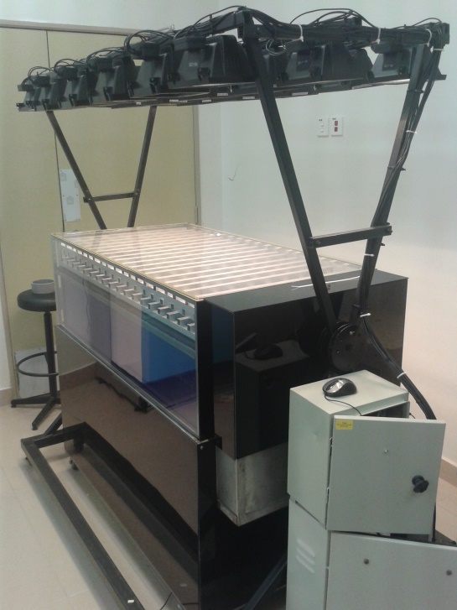
Data acquisition system
Solar simulator
Solar collector test stand
Solar thermal absorber

Figure 1. Solar thermal absorber test system with variable base depth

Aluminium 6063 and stainless steel 304 thermophysical properties are referred to in [13] and [14]. A summary of selected thermophysical properties of each material is given in Table 1.

Table 1. Thermophysical properties of solar thermal absorber material [13, 14]
Material | Density, kg/m³ | Thermal conductivity, W/mK | Specific heat capacity, J/kg K | Thermal diffusivity, ×10⁶, m²/s
Aluminium (6063-T5) | 2700.0 | 200.0 | 900.0 | 64.0
Stainless steel (304) | 8000.0 | 16.2 | 500.0 | 4.2

Density, thermal conductivity, specific heat and thermal diffusivity are important characteristics that determine how the absorber performs in absorption and heat retention. Previous solar collector and absorber research mostly take into account the properties of the thermal conductivity of materials for absorber material selection. However, for multilayer cross absorbers especially for bi-metallic cross absorbers, thermal diffusivity is an important property. Thermal diffusivity, α, represents how fast heat diffuses and propagates through a material where it is defined by heat conducted and divided by heat stored [15], where it is represented by the following equation 1:

 | $$α=\frac{k}{ρc_{pf}}$$ | (1)

Experiment set-up for non-coated and coated hollow rod material test was conducted. Four experiment set-ups are selected in the experiments which can be seen in Table 2. For each set-up, data on input air temperature, output air temperature, air speed and solar irradiance were collected. A data-logger system with 31 channels ADAMView was used to automate the data recording process. A solar pyranometer (Apogee Logan UT) and K-type thermocouple were utilized to measure solar irradiance and air temperature, respectively.

Table 2. Experiment material and properties
Set-up | Material | No. of sets | Solar irradiation, W/m² | Air speed, m/s
1 | Aluminium | 1 | 485 | 380.
2 | Aluminium | 2 | 485 | 380.
3 | Aluminium | 3 | 485 | 380.
4 | Aluminium + Stainless steel | 1 + 1 | 485 | 380.

Each set-up has underwent short wavelength solar radiation exposure under a solar simulator, with 485 W/m² for 30 minutes of heating period, and continued for 30 minutes with no solar radiation for the cooling period. Forced convection mode take place between flowing air into the solar air collector test stand and cross staging thermal absorbers, with an average wind speed of 0.38 m/s. Readings for each parameter were recorded in a 30-second sequence.

Experiment procedures were divided into two stages: heating and cooling the absorber. This was done in order to determine the radiation absorption rate of each solar thermal absorber material at heating stage, as well as the heat buffer effect shown during the cooling down period. Each set-up (see Figure 2) with a respective number of sets, was tested using the same procedure as explained above.

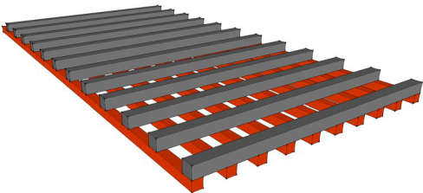  (a) | 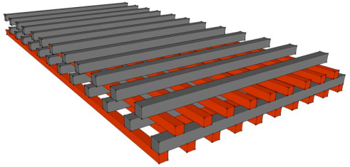  (b) | 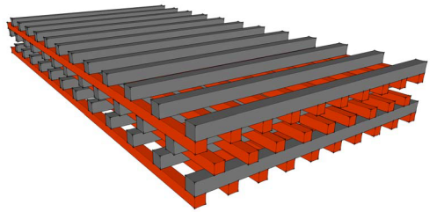  (c)

Figure 2. Cross thermal absorber one-set (a), two-set (b) and three-set (c)

Results and Discussion
The efficiency of the solar air collector is given by the energy extracted from the thermal absorber by flowing air to useful energy divided by total energy supplied to the collector by solar irradiation. Useful energy gain by collector, Q_{u}, is expressed by Hottel-Whillier-Bliss equation 2 [1] :

 | $$Q_{u}=A_{c}\left[S-U_{L}{(T}_{pm}-T_{a})\right]=\dot{m}C_{p}\left(T_{o}-T_{i}\right)$$ | (2)

Energy extracted by the flowing air from the thermal absorber is calculated using an energy gain equation, which is equivalent to energy balance terms of extracted by air flow at the collector. In practice, solar radiation energy, which is converted into thermal energy by the absorber, will suffer losses before being delivered to the output air.

In reference to Figure 3, under 485 W/m² of solar radiation, 0.38 m/s of air speed, during 30 minutes of heating, one-set aluminium absorbers has a highest peak temperature of 41.8 ºC, followed by two-set and one aluminium set and one stainless steel set at 39.3 ºC and 38.2 ºC, respectively. The lowest peak temperature is recorded on three-set of the aluminium absorber at 35 ºC. Average input air temperature is 26 ºC. A sharp increase detected on one set of the aluminium absorber set-up was due to less energy required to increase the absorber temperature which has a lower mass compared to the other set-ups.

Cooling
Heating

Figure 3. Temperature profile of heating and cooling of output air

Aluminium with a relatively high thermal diffusivity than stainless steel, causes a quick temperature increase of material owing to good absorptivity, but it is also easily disperses heat, causing sharp temperature reductions when no or less radiation energy source is supplied. Air flowing through the absorber removed the heat from the absorber via forced convection and it was drawn to the output side by fans. But when entering the cooling period, a weak thermal buffer characteristic is identified from the low steepness of the graph. One aluminium set + one stainless steel set shows a considerable balance profile of heat absorption and thermal buffer effect compared with the other arrangement, where heat transfer mechanism of conduction and forced convection take places to distribute heat to all parts of thermal absorber. This is because by combining the aluminium and stainless steel, the advantages of each material will overcome the weakness of the other material. With appropriate matching of thermal diffusivities of different materials, a combination of good absorptivity and thermal buffer cross absorbers can be achieved.

One-set arrangement with full aluminium absorbers (Figure 4) has a gradient of 0.1692 ºC/W, and two-set (Figure 5) aluminium cross absorbers obtained lower inclination than the former at 0.1471ºC/W. This behaviour is due to a lower number of sets having a lower thermal mass, lower total specific heat, thus leading to a faster increase in the temperature of the absorbers, exhibited by a sharp incline in the graph gradient. With the increase in sets, higher thermal mass is obtained, which means more thermal energy is needed to increase the temperature of the absorber. This behaviour is translated by a trend line through the decrease of the gradient value when compared with a one-set set-up. Figure 5-7 shows the change in temperature difference between output air temperature and input air temperature in relation to heat gained under constant exposure to solar irradiance, for different types of cross absorber arrangement. Linear regression lines are defined in the graph to determine trend of graphs.

Figure 4. One-set aluminium (heating)

Figure 5. Two-set aluminium (heating)

Figure 6. Three-set aluminium (heating)

By increasing the sets to three, the steepness changed to 0.1305 ºC/W, which is less than that for one and two sets. This signifies the reduction of rate of temperature increase of absorbers owing to a higher volume of material to be heated by solar radiation.

Figure 7. One-set aluminium + one-set stainless steel (heating)
With one-set aluminium + one-set stainless steel, it performs better than two sets of aluminium with gradient 0.1508 ºC/W, where two-set aluminium acquired 0.1471 ºC/W. A combination of both materials produced a better absorption rate of solar radiation than the same aluminium set-up. A comparison of results for air temperature difference is summarized in Table 3.

Table 3. Relation of quantity of sets with gradient of slope ∆T against heat gain
Set-up | Gradient slope (∆T vs Heat gain)  ºC/W
1 set aluminium | 0.1692
2 sets aluminium | 0.1471
3 sets aluminium | 0.1305
1 set aluminium + 1 set stainless steel | 0.1508

Temperature difference is proportionally linear with useful heat gain. The increase of value of slopes indicates that a higher temperature difference is required to maintain the same energy gain by different set-up.

Figure 8. Output air temperature at cooling period

During the cooling period, the solar radiation source is turned off to simulate a no-sun condition. By using linear regression analysis, the gradient of slope is determined for each set-up (Figure 8). With a lower slope, the temperature reduction rate is lower, which means thermal energy depletion is lower, and there is a slower output air temperature drop. In contrast with the higher slope, a faster temperature drop signifies low heat capacity of thermal absorbers and leads to a steep drop in output air temperature. Slope values during the cooling phase are referred to in Table 4. A three-set aluminium thermal absorber set-up has lowest slope at -0.3675, while the highest slope obtained by a one-set aluminium thermal absorber was -0.5074. By comparing the slope of output air temperature, the rate of heat removal can be determined. A three-set set-up has the lowest output air temperature drop owing to it has high mass of absorber material, resulting in a higher heat storage capacity and leading to a slower temperature drop. The gradient slope reflects the time output temperature to reach equilibrium, with ambient temperature at a different rate.

Table 4. Relation of quantity of sets with gradient of slope ∆T against heat gain
Set-up | Gradient slope (∆T vs Heat gain)  ºC/W
1 set aluminium | -0.5074
2 sets aluminium | -0.4917
3 sets aluminium | -0.3675
1 set aluminium + 1 set stainless steel | -0.4186

Conclusion
Output air temperature cross solar thermal absorbers are strongly influenced by the material type and number of absorber sets. Aluminium has material properties which are good in converting solar radiation energy into thermal energy, as shown by fast increase in temperature during the heating period, but has a low thermal energy storage capacity, as thermal energy is dispersed relatively quickly when referring to the cooling period. A bi-metallic combination of absorber material is promising, as shown by the cross absorber combination of stainless steel and aluminium experiment results. The highest peak output temperature is achieved by a one-set aluminium absorber of 41.8 ºC while the lowest peak output temperature is achieved by a three-set aluminium absorber at 34.9 ºC. The thermal buffer effect is defined where the short-term energy storage effects of each set-up are determined by using the gradient of the slope, whereas lower slope steepness means higher energy storage capabilities of the absorber set-up. The bi-metallic set-up of one-set aluminium + one-set stainless steel performed better than the two-set aluminium set-up, where each set-up obtained a gradient value of -0.4186 and -0.4917, respectively. Correlation of input and output temperature drop and heat gain was established through linear regression line.

Acknowledgement
The authors would like to thank you International Islamic University of Malaysia (IIUM) and Solar Energy Research Institute (SERI), Universiti Kebangsaan Malaysia for providing research facilities, Ministry of Education for financial assistance under project grant RAGS 12-011-0011 and SERI Colloquium 2014.

References
- Duffie, J. A. and Beckman, W. A. (1980). Solar Engineering of Thermal Processes-Second Edition. John Wiley & Sons, Inc.
- Majid, Z. A. A. (2011). Kajian prestasi sistem pengering pam haba terbantu suria dengan pengumpul suria multifungsi. Universiti Kebangsaan Malaysia, Bangi.
- Majid, Z. A. A., Razak, A. A., Ruslan, M. H. and Sopian, K. (2014). Characteristics of solar thermal absorber materials in cross absorber with combined material for solar air thermal collector. International Conference on Automotive Innovation and Green Energy Vehicle 2014 1–10.
- Azmi, M. S. M., Othman, M. Y. H., Ruslan, M. H. H. and Majid, Z. A. A. (2013). Thermal performance of solar collector with multi direction properties using cross absorber. In 2012 National Physics Conference AIP Conf. Proc. 1528( 117): 113–117
- Majid, Z. A. A., Othman, M. Y., Ruslan, M. H., Mat, S., Ali, B., Zaharim, A., and Sopian, K. (2008). Multifunctional Solar Thermal Collector for Heat Pump Application. In Proceedings of the 3rd WSEAS Int. Conf. on Renewable Energy Sources. 342–346.
- Shariah, A. M., Rousan, A., Rousan, K. K. and Ahmad, A. A. (1999). Effect of thermal conductivity of absorber plate on the performance of a solar water heater. Applied Thermal Engineering 19: 733–741
- Kalogirou, S. A. (2013). Solar Energy Engineering (Second Edition), Processes and Systems. Elsevier, Academic Press.
- Akpinar, E. K. and Koçyiğit, F. (2010). Experimental investigation of thermal performance of solar air heater having different obstacles on absorber plates. International Communications in Heat and Mass Transfer 37(4): 416–421.
- Alvarez, G., Arce, J., Lira, L. and Heras, M. R. (2004). Thermal performance of an air solar collector with an absorber plate made of recyclable aluminium cans. Solar Energy 77(1): 107–113.
- Benli, H. (2013). Experimentally derived efficiency and exergy analysis of a new solar air heater having different surface shapes. Renewable Energy 50: 58–67.
- Bouadila, S., Kooli, S., Lazaar, M., Skouri, S. and Farhat, A. (2013). Performance of a new solar air heater with packed-bed latent storage energy for nocturnal use. Applied Energy 110: 267–275.
- Chiou, J. P., El-Wakil, M. M. and Duffie, J. (1965). A slit-and-expanded aluminium foil matrix solar collector. Solar Energy, 9(2): 73–80.
- Bagdade, S. D. (2002). ASM Ready Reference: Thermal Properties of Metals (Materials Data Series). ASM International.
- Salazar, A. (2003). On Thermal Diffusivity. European Journal of Physics, 24 (4): 351 - 358.
- Çengel, Y. A., Turner, R. H. and Cimbala, J. (2011). Fundamental of Thermal-fluid Sciences (4th ed.). McGraw-Hill.

