

MALAYSIAN JOURNAL OF ANALYTICAL SCIENCES
ISSN 1394 - 2506

Published by The Malaysian Analytical Sciences Society

THE EFFECT OF SOLAR RADIATION ON RADIO SIGNAL FOR RADIO ASTRONOMY PURPOSES

(Kesan Radiasi Solar Terhadap Isyarat Radio untuk Kajian Astronomi Radio)

Nor Hazmin Sabri¹*, Atiq Wahidah Azlan², Roslan Umar^{3,4}, Shahirah Syafa Sulan², Zainol Abidin Ibrahim⁵,
Wan Zul Adli Wan Mokhtar⁶

¹School of Fundamental Science
²Physics, Electronic and Instrumentation Programme, School of Ocean Engineering
Universiti Malaysia Terengganu, 21030 Kuala Terengganu, Terengganu, Malaysia
³East Coast Environmental Research Institute (ESERI)
⁴Faculty of Contemporary Islamic Studies
Universiti Sultan Zainal Abidin, Gong Badak Campus, 21300 Gong Badak, Kuala Terengganu, Terengganu, Malaysia
⁵Physics Department, Faculty of Science,
Universiti of Malaya, 50603 Kuala Lumpur, Malaysia
⁶Department of Physics, Faculty of Science and Mathematics,
Universiti Pendidikan Sultan Idris, 35900 Tanjung Malim, Perak, Malaysia

*Corresponding author: norhazmin@umt.edu.my

Received: 14 April 2015; Accepted: 9 July 2015

Abstract
Radio astronomy is a subfield of astronomy which is discovers the celestial objects at radio frequencies. Observation in radio astronomy is conducted using single antenna or array of antennas, known as radio telescope. Other than that, radio astronomy also holds an advantage over other alternatives to optical astronomy due to its capability of observing from the ground level. In this study, the effect of solar radiation that contributes the Radio Frequency Interferences (RFI) is reviewed. The low RFI level is required to set up the radio telescope for radio astronomy observation. The effect of solar radiation on radio signal was investigated by determining the RFI pattern using spectrum analyzer. The solar radiation data was obtained from weather station located at KUSZA Observatory, East Coast Environmental Research Institute (ESERI), UniSZA. We can conclude that the solar radiation factor give the minimum significant effect to radio signal

Keywords: solar radiation, radio signal, radio astronomy, radio frequency interference

Abstrak
Astronomi radio adalah salah satu cabang bidang astronomi yang mengkaji objek samawi dalam julat frekuensi radio. Cerapan astronomi radio dilakukan dengan menggunakan antenna tunggal atau jujukan antena yang dipanggil sebagai teleskop radio. Selain itu, astronomi radio mempunyai kelebihan berbanding alternatif lain bagi astronomi optic disebabkan kebolehannya mencerap dari paras tanah. Dalam kajian ini, kesan radiasi solar yang menyumbang kepada interferen frekuensi radio (RFI) dibincangkan. Aras RFI yang rendah diperlukan untuk menempatkan teleskop radio untuk cerapan astronomi radio. Kesan radiasi solar keatas isyarat radio dikaji dengan menentukan pola RFI dengan menggunakan penganalisa spectrum. Data radiasi solar diperolehi dari stesen kajicuaca yang terletak di Balai Cerap KUSZA, Institut Penyelidikan Alam Sekitar Pantai Timur (ESERI), UniSZA. Konklusifnya, radiasi matahari memberi kesan minimum kepada isyarat radio.

Kata kunci: radiasi solar, isyarat radio, astronomi radio, interferen frekuensi radio

Introduction
Radio wave propagation is influenced by the properties of the earth and the atmosphere. The curvature of the earth and the condition of the atmosphere can refract electromagnetic waves either up, away from, or down toward the earth’s surface [1]. In Malaysia, the sources of man-made RFI, such as telecommunication and navigation signals, are primarily listed by Malaysian Communications and Multimedia Commission (MCMC) [2]. The ionosphere reflects transmitted VLF radio waves back to Earth. The strength of these radio waves depends on how much or how little the ionosphere is ionized. Solar radiation contributes to ionization of the atmosphere, which can alter the strength of the transmitted VLF radio waves [3]. Radio frequency bands defined by International Telecommunications Union (ITU) together with their mode of propagation and primary uses are shown in Table 1. Solar radiations and other solar activities affect the total electron content of the ionosphere and also affect various radio frequencies used in telecommunications [4].

Table 1. Radio Frequencies Together with their Primary Propagation Characteristics and their Uses.
S/N | Name | Frequency Range | Primary Mode of Propagation | Primary Uses
1. | Extremely Low Frequency (ELF) | 3 KHz | Earth and the ionosphere. Wave guide penetrates sea water. | Land to sub-marine communications.
2. | Very Low Frequency (VLF) | 3 – 30 KHz | Between ground and lower ionosphere. It is a ground wave and uses wave guide also. | Navigation, communication, standard frequency, and time
3. | Low Frequency (LF) | 30 – 300 KHz W | Wave guide, ground wave. | Maritime and broadcasting.
4. | Medium Frequency | 300 – 3000KHz | E region of the ionosphere reflection (might). Ground wave. | Maritime, aeronautical, international distress, and maritime/land mobile.
5. | High Frequency (HF) | 3 – 30 MHz | Reflection from E and F region of the ionosphere. | Maritime and aeronautical fixed services and broadcasting.
6. | Very High Frequency (VHF) | 30 – 300 MHz | Line of sight, scatter from ionosphere. Reflection by active satellites | Television, frequency modulated broadcasting , public safety, and aeronautical
7. | Ultra High Frequency (UHF) | 300 – 3000 MHz | Line of sight (affected by ionosphere irregularities). Active satellites. | Space communications, TV, radar, broadcasting, and navigation (fixed mobile)
8. | Super High Frequency (SHF) | 3000 – 30000 MHz | Line of sight (troposphere affected by ionosphere irregularities) | Space communication, TV, radar, broadcasting, and navigation (fixed mobile)
Source: MCMC manual of ‘Spectrum Plan [5]

Abidin et al. in 2012 have conducted an RFI investigation for setting up a VLBI station below 2.8 GHz in Malaysia [2]. The frequency window below 2.8 GHz which has been chosen are 322-328MHz, 608-614MHz, 1660-1660.5MHz and 1660.5-1668.4MHz. They found that two band below 2.8 GHz are permitted for the purpose of radio astronomy in Malaysia. They are 608-614MHz and 1660-1660.5MHz. The RFI level in these permissible bands at the best site which is Langkawi were also measured and concluded to be relatively low. They also reviewed several current VLBI observations in these two bands [6]. RFI factors are include location of radio and TV transmitters and electrics power generators. A study of the spectrum management of the country has also been made [7]. It is crucial to select areas with the least expected RFI to carry out radio astronomy observation.

Materials and Methods
The main equipment involves in the data collection process (observation) is hand-held spectrum analyzer (SPECTRAN HF-6080 V4) to obtain the level of RFI. In this study, the frequencies and RFI trends of below 8GHz are investigated. Rest frequency of spectral lines below 8 GHz are listed in Table 2. This range covers at least 5 radio astronomical frequency window including the Hydrogen Line (1420MHz), Deuterium Line (328MHz), and Hydroxyl line (1660MHz). The observation was done for at least 1 hour in a row. The solar radiation data was obtained using weather station (Davis Vantage Pro2). The instrument setup for RFI observation is illustrated in Figure 1. The spectrum analyser was attached to the antenna and the computer would record and save the data collected. Concurrently, the weather station was started recording the solar radiation data.

Table 2. Rest frequency of spectral lines [8].
Atom/ Molecule | Line name | Rest Frequency (GHz)
DI | Deuterium | 0.327384
HI | Neutral hydrogen | 1.420405752
OH | Hydroxyl radical | 1.6122310
OH | Hydroxyl radical | 1.6654018
OH | Hydroxyl radical | 1.6673590
OH | Hydroxyl radical | 1.7205300

Analysis will include producing RFI pattern. We also made use of the spectrogram technique in order to find consistent and non-consistent RFI. Then the relationship between RFI pattern and solar radiation pattern was determined.

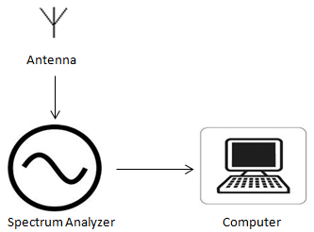
Figure 1. Instrument Setup for RFI observation
Results and Discussion
The results from the spectrum analyzer for frequencies up to 8GHz can be seen in Figure 2. The one-hour observation has been done 5 times at different date and time. From the figure below the radio signals detected at KUSZA Observatory were 100MHz, 200MHz, 300MHz, 500MHz, 1225MHz and 5825MHz.
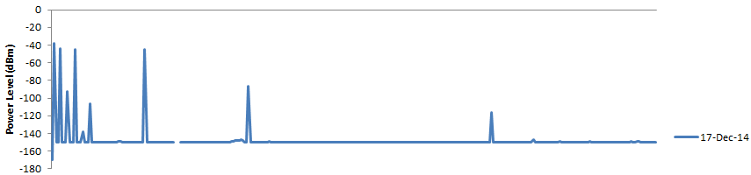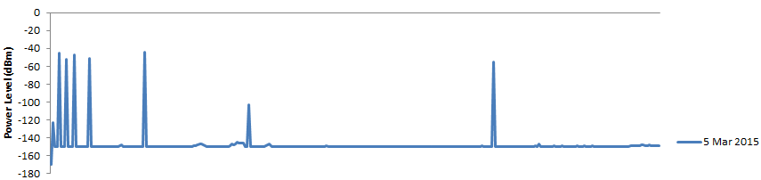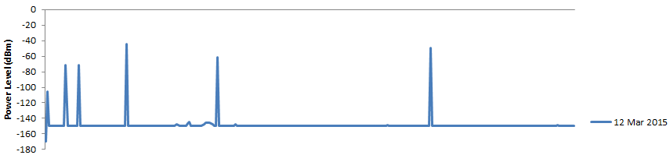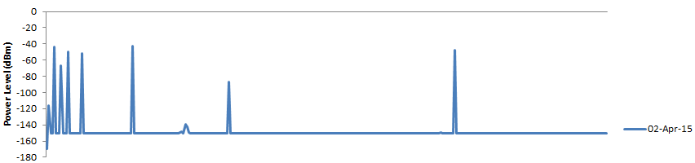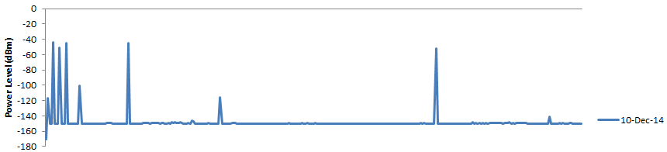
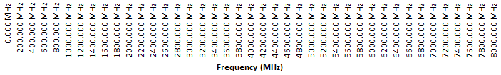

Figure 2. Power Level against Frequency
The RFI pattern change compared to solar radiation for selected frequencies are shown in Figure 3 until Figure 8. The RFI level change over the variation of solar radiation was observed against time.

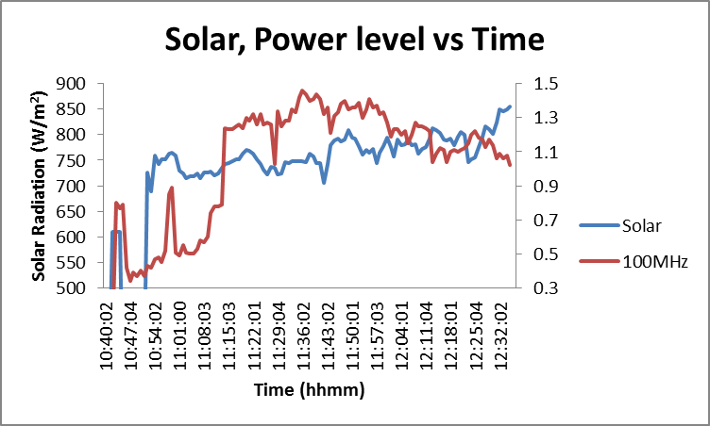
Figure 3. Solar and Power Level against Time at 100 MHz

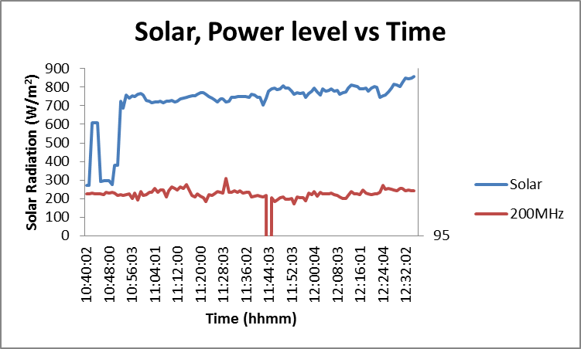
Figure 4. Solar and Power Level against Time at 200MHz

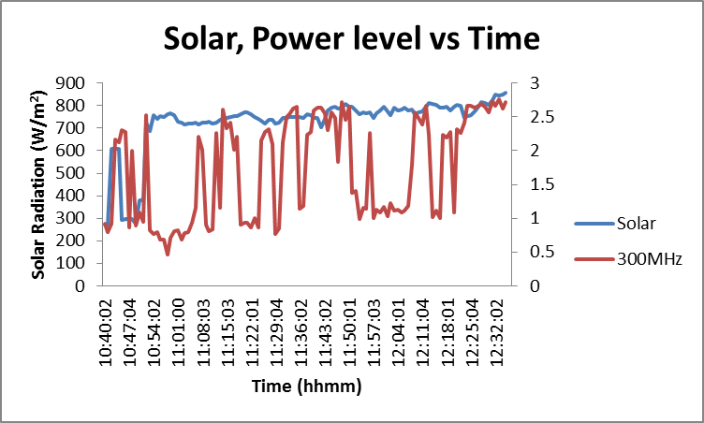
Figure 5. Solar and Power Level against Time at 300MHz

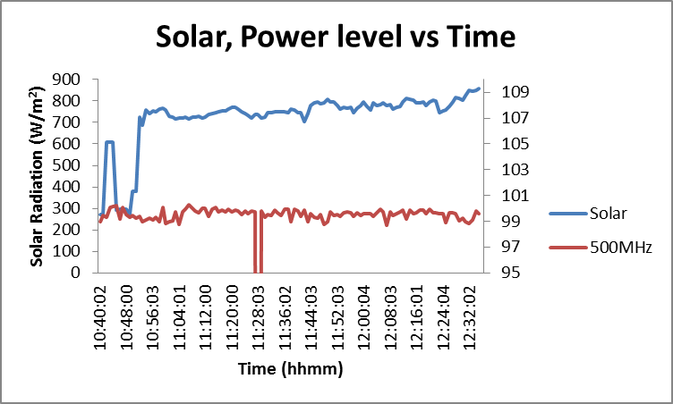
Figure 6. Solar and Power Level against Time at 500MHz

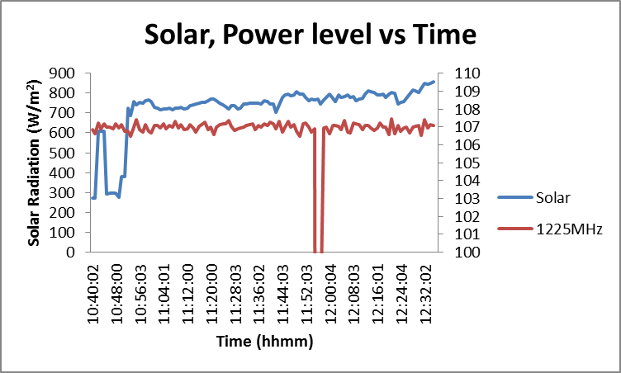
Figure 7. Solar and Power Level against Time at 1225MHz

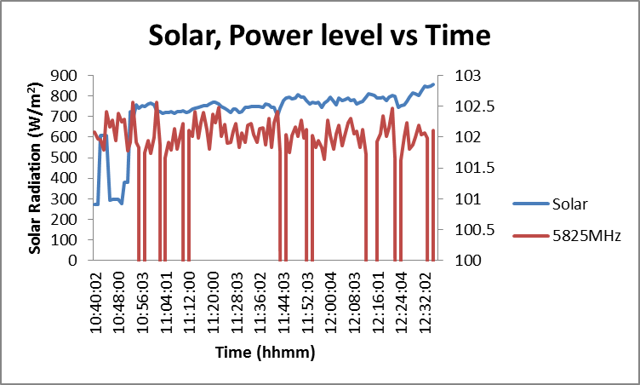
Figure 8. Solar and Power Level against Time at 5825MHz

From Fig. 3 until 8, the effect of solar radiation has been determined. The RFI level seems not affected by the solar radiation. There are no obvious connection between solar radiation amount of energy received and the RFI pattern. This may be contributed by several factors; the observation time duration and the absence of Low Noise Amplifier (LNA). For better observation, the time duration for data collection should be conducted for 24hours to make sure the radiation from the sun along the day are taken into account. The LNA should be connected to the antenna to remove all of possible background noise for better reading.

In research done by Ezekoye and Obodo (2007) about the effects of solar radiation on telecommunications, they investigate the effects of electron densities of the ionosphere and how they affect telecommunications [4]. They refer to the case study in year 2000, which was have maximum solar and was used to show the variations of electron density of ionosphere. In this research, they state that solar can make the telecommunication suffer of disturbances. For the conclusion, the telecommunication is adversely affected by solar activities. Electromagnetic storms from the sun may wipe out the telephone line, television signal and others.

For future works, the threshold level for solar radiation effect on radio signal should be determined. This will contribute to the production of RFI map of Malaysia for solar radiation factor. Hence, the most suitable area with low interference could be determined for radio observation site.

Conclusion
In conclusion, we can say that the solar radiation factor give the minimum significant effect to radio signal. This may be due the limited observation period of 1 hour and the absence of LNA. We suggest that the observation should run in 24 hours and the antenna should connect to the LNA for future observation.

Acknowledgement
This study is made possible by the usage of the grant RACE/F1/ST1/UNISZA/15. The authors gratefully acknowledge University Malaysia Terengganu, Universiti Sultan Zainal Abidin and Universiti Pendidikan Sultan Idris for the financial and experimental support of this work. Special thanks are also dedicated to other researchers Electromagnetic Research Group (EMRG) for their assistance in this work.

References
- Adediji, A. T., Mandeep, J. S. and Ismail, M. (2014). Meteorological Characterization of Effective Earth Radius Factor (k-Factor) Wireless Radio Link Over Akure, Nigeria. Metrology Society of India 29 (2): 131-141
- Abidin, Z. Z., Adnan, S. B. R. S. and Ibrahim, Z.A. (2009). RFI profiles of prime candidate sites for the first radio astronomical telescope in Malaysia. New Astronomy 15(3): 307–312.
- Merola, L. (2006). A Study of the Effects of Sunrise and Sunset on the Ionosphere as Observed by VLF Wave Behavior (online). http://solar-center.stanford.edu/SID/StudentWork/LeandraMerola.pdf (21 April 2015)
- Ezekoye, B. A. and Obodo, R. M. (2007). The Effects of Solar Radiations on Telecommunications. The Pacific Journal of Science and Technology 8 (1): 109-117
- MCMC manual of ‘Spectrum Plan (2006). MCMC manual of ‘Spectrum Plan, Malaysian Communication and Multimedia Commission’ (2006). Resources Assignment Management Department Available: http://www.mcmc.gov.my/what_we_do/spectrum/plan.asp.
- Abidin, Z. Z., Ibrahim, Z. A., Rosli, Z., Malim, S. F. F., Anim, N. M. and Noorazlan, N. (2012). An RFI Investigation for Setting up a VLBI Station below 2.8 GHz in Malaysia. New Astronomy 17 : 61-64
- Abidin, Z.Z., Umar, R., Ibrahim, Z. A., Rosli, Z., Asanok, K. and Gasiprong, N. (2013). Investigation on the Frequency Allocation for Radio Astronomy at the L Band. Publications of the Astronomical Society of Australia (PASA) 30: 47-57.
- Umar, R., Abidin, Z. Z., Ibrahim, Z. A., Rosli, Z. and Noorazlan, N. (2014). Selection of Radio Astronomical Observation Sites and Its Dependence on Human Generated RFI. Research in Astronomy and Astrophysics 14 (2) : 241-248.

