

MALAYSIAN JOURNAL OF ANALYTICAL SCIENCES
ISSN 1394 - 2506

Published by The Malaysian Analytical Sciences Society

SPATIAL AND TEMPORAL ASSESSMENT ON DRUG ADDICTION USING MULTIVARIATE ANALYSIS AND GIS

(Penilaian Ruang dan Masa Terhadap Penagihan Dadah Menggunakan
Analisis Multivariat dan GIS)

Mohd Ekhwan Toriman^{1,2}, Siti Nor Fazillah Abdullah¹*, Izwan Arif Azizan¹,
Mohd Khairul Amri Kamarudin¹, Roslan Umar¹, Nasir Mohamad³

¹East Coast Environmental Research Institute,
Universiti Sultan Zainal Abidin, Gong Badak Campus, 21300 Kuala Terengganu, Terengganu, Malaysia
² School of Social Development and Environmental Studies, Faculty of Social Science and Humanities,
Universiti Kebangsaan Malaysia,43600UKM Bangi, Selangor, Malaysia
³Medical Centre,
Universiti Sultan Zainal Abidin, Kampus Gong Badak, 21300 Kuala Terengganu, Terengganu, Malaysia

*Corresponding author: fazillah1988@gmail.com

Received: 14 April 2015; Accepted: 9 July 2015

Abstract
There is a need for managing and displaying drug addiction phenomena and trend at both spatial and temporal scales. Spatial and temporal assessment on drug addiction in Terengganu was undertaken to understand the geographical area of district in the same cluster, in addition, identify the hot spot area of this problem and analysis the trend of drug addiction. Data used were topography map of Terengganu and number of drug addicted person in Terengganu by district within 10 years (2004-2013). Number of drug addicted person by district were mapped using Geographic Information system and analysed using a combination of multivariate analysis which is cluster analysis were applied to the database in order to validate the correlation between data in the same cluster. Result showed a cluster analysis for number of drug addiction by district generated three clusters which are Besut and Kuala Terengganu in cluster 1 named moderate drug addicted person (MDA), Dungun, Marang, Setiu and Hulu Terengganu in cluster 2 named lower drug addicted person (LDA) and Kemaman in cluster 3 named high drug addicted person(HDA). This analysis indicates that cluster 3 which is Kemaman is a hot spot area. These results were beneficial for stakeholder to monitor and manage this problem especially in the hot spot area which needs to be emphasized.

Keywords: drug addiction, GIS, multivariate analysis, cluster analysis

Abstrak
Terdapat keperluan untuk menguruskan dan memaparkan fenomena dan tren penagihan dadah dalam skala ruang dan masa. Penilaian ruang dan masa bagi masalah penagihan dadah di Terengganu telah dijalankan untuk memahami kawasan geografi daerah-daerah yang berada dalam ketegori yang sama, di samping untuk mengenal pasti kawasan panas dan juga menganalisis trend penagihan dadah. Data yang digunakan ialah peta topografi negeri Terengganu dan bilangan penagih dadah mengikut daerah dalam tempoh sepuluh tahun (2004-2013). Bilangan penagih dadah bagi setiap daerah telah dipetakan menggunakan sistem Maaklumat Georgafi (GIS) dan dianalisis menggunakan gabungan analisis multivariat iaitu kluster analisis yang diaplikasikan ke dalam pengkalan data untuk mengesahkan hubungan di antara data yang berada dalam kategori yang sama. Keputusan kajian menunjukkan, hasil analisis kluster bagi bilangan penagih dadah mengikut daerah dibahagikan kepada tiga kategori iaitu Besut dan Kuala Terengganu dalam kluster satu yang dinamakan sederhana penagih dadah, Dungun, Marang, Setiu dan Hulu Terengganu dalam kluster dua, dinamakan kurang penagih dadah dan Kemaman dalam kluster tiga dinamakan tinggi penagih dadah. Analisis ini menunjukkan bahawa kluster ke tiga iaitu Kemaman merupakan kawasan panas penagih dadah. Hasil kajian ini sangat berguna kepada pihak berkepentingan untuk memantau dan menguruskan masalah ini terutamanya bagi kawasan panas yang memerlukan pengkhususan.

Kata kunci: penagihan dadah, GIS, analisis multivariat, analisis kluster

Introduction
Drug addiction is a chronic and recurrent disease recognized by [1]. The drug defendants (Treatment and Rehabilitation) Act 1983 defines a drug addicted personas a person that has gone through the use of any dangerous drugs [2]. Importantly, drug addiction one of the primary problems not only in Malaysia, unfortunately it is a worldwide problem, affecting almost every country in the world with different characteristics [3]. Global estimation depicts that the illicit drug users in developed countries with various psychoactive substance usage is higher than in developing countries [4]. Worldwide estimation reported the count of injecting drug users are nearly to 13.2 million and surprisingly that over 10 million (78%) of them living in developing and transitional countries [5]. Moreover, the illicit drug usage contributing contagious effects on not only health lives of individuals, but it also considered such of significant social illnesses, public health and safety threat in Malaysia [6]. Under drug Dependence (treatment and rehabilitation) Act 1983, drug addiction or so-called substances use disorder is an offence Drug addiction is an offense as the outcomes from drug addiction to be violent towards other people. Drug abuse among those adolescence and elderly in this country had have become crucial issue and alarming since 1970s, prompting the government to officially declared the drug is number one nation enemy in 1983 [5,7]. Despite various ways has been made by the government to solve drug –associated problems in order striving for a visionary of drug-free society in 2015 [4], this drug related problem has remained constant. This issue had alleviate government worries upon increases in the percentage of drug addicts despite the implementation of various prevention and treatment and rehabilitation programs.

Despite the government imposing draconian punishment, the total number of drug addicted person in Malaysia including new and relapse substantially increasing as the main factor attributing to geographically Malaysia location proximate to the Golden triangle (border regions between Myanmar, Laos, Thailand is known as opium grown for trade), rapid progress and urbanization [5]. Relapse was defined as participants who failed urine toxicology test for illicit drugs or were arrested by police and subject to compulsory isolation treatment during the follow-up period [8]. Likewise, Sainders and Allops [9] defined relapse as a return to the pre-treatment state of drug abuse. Selected Social Statistics 2010 [10] reported the number of relapse in Malaysia relatively increased dramatically more than 50% in 2008. As Terengganu state bound with South China Sea on the east, obviously either Terengganu has also affected to illicit substance abuse drug trafficking through Kelantan state waterways (South China Sea), in which have led the study of the drug addiction was conducted. The statistic of drug addicted person in each Terengganu province is shown in Figure 1.

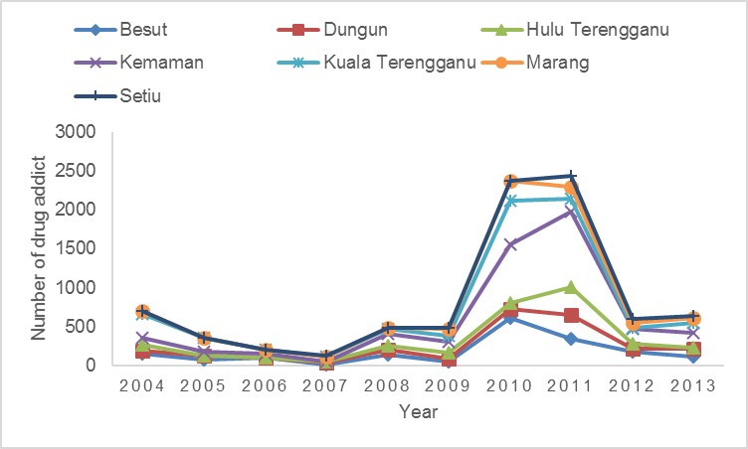

Figure 1. Number of drug addiction in Terengganu by district and year

Therefore, the causes of drug addiction should be determined in order to tackle the problem. There are some important local factors which influenced the disease such as socioeconomic, socio cultural and behavior patterns of the community which play a major role in disease transmission [11]. Certain area adjacent or distant location show the distribution of drug addicted person pretty similar which considered same factors related to the area. Thus, study of spatial distribution in this field is significantly important to determine the hot spot area, then identify the spatial and temporal cluster which have similar factors lead to the increasing of drug addicted person in that area. The ability to track drug addicted person distribution using GIS tools can help public health professionals and researchers detect drug addicted person clustering and analyzing the problem in communities.

Multivariate analysis bid a valuable tool for the evaluation of spatio temporal variation and interpretation of drug addiction in Terengganu. This analysis refers to statistically models that have two or more dependent or outcome variables [12]. Previous study by D’Ovidio and colleagues [13] using multivariate analysis (Segmentation and Cluster Analysis) to explore the characteristics of the customers and their quality perception. In this study, multivariate analysis, namely hierarchical cluster analysis and combination with GIS has been emphasized for reliable classification of drug addicted person by district and year. Geographic information system (GIS) technology allows geographic patterns, which would not be apparent using conventional statistical methods, to emerge from data and be displayed in the easily understood format a map [14]. Most studies were focusing on the presentation of data on maps, hence geospatial visualization. By using the GIS tools, maps not only can represent the pattern in the phenomena but also can present many data in easily understood map [15]. In public health research, it has proven that spatial epidemiology useful for understanding the geographical distribution of many diseases [11,16,17].

The increasing availability and sophistication of GIS in recent years has had an impact on the approaches available in the study of health geography and helping them to monitor and respond to health challenges because GIS tools aiding pinpoint cases, identify spatial trend and disease cluster, correlate different set of spatial and test statistical hypothesis and mapping the data [18,19]. The health care industry is just now beginning to realize the tremendous potential of GIS. In recent years also, tools for performing spatial analysis in a GIS have become more available to social science [20]. Nowadays, both public and private sectors are developing innovative ways to harness the data integration and spatial visualization power of GIS, where, GIS can be used to map where people diagnosed with a particular disease live [21]. The previous research by Rasidi et al. [22] shows that GIS used to map the spatial and temporal distribution of dengue cases in Seremban. Besides, the ability of GIS tools to track disease distribution has help public health researchers to detect disease clustering then identify the hot spot area of disease [19]. Studied by Brownstein et al. [23] as well using GIS to identify hot spots area for potential opioid medication abuse, they used risk mapping and applied spatial detection clustering to identify clusters of medication used.

In this study, by using ArcMap program, which is the main component of Esri’s ArcGIS suite of geospatial processing program, in addition to quick and correct access to the data required. The spatial and attribute data of studied these could be visualized and represented in the form of maps based on existing dataset. Combination statistical analysis such as box plot and clustering will identify the features with similar attribute and determine the range of number of drug addicted person by district. Cluster analysis is useful in determining whether geographical accessibility may vary across an area then identifying whether and where groups of features with similar attributes are found [24]. Cluster analysis classifies subject into the same classes which are have similar characteristic but different between with the other classes [25].

This study aimed to determine factors which may be related to variation in the spatial pattern, identified hot spot area of drug addiction and derive useful information for planning. Monitoring the trends is an important aspect in the context of lowering the level of drug addicts in the state of Terengganu. The trend serves as benchmark indicators for relevant authorities or organizations to promptly conducting campaign or program over drug abuse awareness.

Materials and Methods
Description of Study Area
The study area is in Terengganu, one of the states located in East Coast of Peninsular Malaysia. It is situated within latitude 04⁰00’N-05⁰50’N and longitude 102⁰25’E-103⁰50’E, covering an area of approximately 1,295,638.3 hectares and consist of seven districts viz Besut, Dungun, Hulu Terengganu, Kuala Terengganu, Kemaman, Setiu and Marang where is Hulu Terengganu is the largest district [26] (Figure 2).
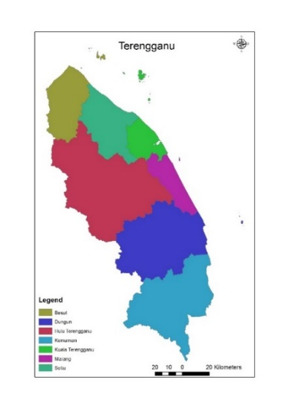
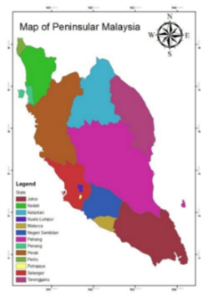

Figure 2. Map of study area classes by district

According to Population and Housing Census Report (2010), total population in Terengganu state is 1,035,977 where is Kuala Terengganu district is the highest population density compatible with its function as a state capital of Terengganu [27]. The population of all districts in Terengganu as of the study periods are shown in Table 1. The Official Portal Terengganu State government that has been updated on 2nd February 2015 stated that the main economic activity in Terengganu state is fishery [26].

Table 1. Population in Terengganu by district
District | Population
Besut | 136,563
Dungun | 149,851
Kemaman | 166,750
Kuala Terengganu | 337,553
Marang | 95,283
Hulu Terengganu | 70,800
Setiu | 54,563

Source: Population and Housing Census Report 2010 [27]

Data Acquisition
This is a retrospective cohort study of which using record of drug addiction cohort in Terengganu for a data of ten years period (2004 until 2013) provided by Agensi Antidadah Kebangsaan (AADK). The topographic map of Terengganu stated obtained from Jabatan Ukur Dan Pemetaan Malaysia (JUPEM) and subsequently digitized according to seven provinces in Terengganu using ArcGis 10.2 software. The early on mapping state, it involves with procuring base layers of Terengganu. The inputs to the GIS include digitize database of districts in Terengganu and information of drug addiction.

Database Design
The developed GIS database design consist of two different types of information involving the identification of information required for the GIS analysis viz, spatial database design and attribute database design. The spatial database includes vector type where the spatial data is administrative district boundary of Terengganu and stored as polygon. Attribute database includes number of drug addicted person by district in Terengganu (2004 until 2013). The attribute dataset stored in the unified data format (.dbf). Both of the databases are intercorrelated. The space characteristics and the corresponding attribute data are usually connected by user identity code. In this study, the field name of administrative district is used as the keyword for connecting the attribute database and the spatial database. The topographic map of Terengganu was georeferenced and the root mean square error (RMSE) was found. The RMSE is a measure of precision and used to determine accuracy of the transformation from one system to another system of coordinates. The formula of RMSE as shown in equation 1:

RMSE 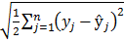 (1)

where, the large sigma character represents summation, j represents the current predictor, and n represents the number of predictors [28].

Data Analysis
In this study, cluster analysis used for combining observations into groups or cluster that is observations in each group are similar to each other, but should be different of other groups. Where, the first analysis is to make the cluster distribution of drug addicted person by districts in Terengganu intend to identify whether geographical accessibility of drug addiction may vary across Terengganu. The second one is to perceive the clustering of drug addiction by year. Hierarchical agglomerative cluster analysis was performed on the normalized datasets by means of the wards method, using single Euclidean distances as a measure similarity, then classification of the object can be illustrated in a dendogram [29]. The Euclidean distance is reported as D_{link/} D_{max}. Which represent the quotient between the linkages distances divided by the maximal distance.

Multivariate analysis was done using Microsoft excel (XLSTAT), using data of drug addiction by district in Terengganu within 10 years. Two types of multivariate analysis were applied in this study were boxplot and cluster analysis. Boxplot analysis was required in this study to determine the range area and the number of drug addicts by spatial and temporal. The observation upon the differences among the groups was achievable.

Results and Discussion
The Spatial Distribution of Drug Addict
The visual representation of spatial data for drug addiction cohort distribution is illustrated in the Terengganu state map appended below. Drug addiction distribution in this study demonstrates result of the analysis to visualize differences across the region and identifying hot spot areas of drug addiction cohort distribution of Terengganu. Spatial distribution of every district in Terengganu by year is described by a series of features in Figure 3.

Based on the spatial analysis as shown in the map (Figure 3), trend of drug addiction in every district present a various number of drug addicted person in a given year. Referring to the map, the hot spot areas were identified and analysed. A hot spot area refers to the area with relatively highest number of drug addict. The darkest area indicate the highest number of drug addict, meanwhile, the light colour represent the diminishing number of drug addict. The number of drug addicted person in Kemaman keep increasing every year and was identified as a hot spot area for the period six years consecutively (2008-2013). The reason of this district became a hot spot area for many years may be the economic factor because according to Sulong and colleagues (2002) [30], the Kemaman district considered as underdeveloped district except the coastline and port area, where the steel and petrochemical were produced. Many oil and gas company providing employment opportunities to local and foreign resident which lead to the condensed this area. Peer influence, whether in the workplace or residence is the major factor contributing to drug abuse which will cause drug addiction [31] Figure 3 (a)-(d) indicated that on the North Terengganu (Besut, Setiu and Kuala Terengganu), drug addicted person distribution was high compare to the other district. The location of these district were adjacent to the state boundary and golden triangle which cause source of drug easy to derive. Previous literature has shown that what happens in a specific area depends on what happen in the close neighborhood [32].
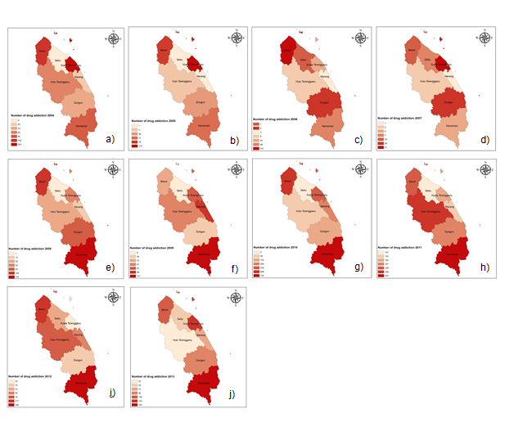

Figure 3. Number of drug addiction according to year, a) 2004,b) 2005, c) 2006, d) 2007, e) 2008, f) 2009, g) 2010, h) 2011, i) 2012, j) 2013
i)

The summary and interpretation the number of drug addicted person according to districts was presented by boxplot in Figure 4. The boxplot displays the significant difference distributions of drug addicted person among the districts. The result proved Kemaman was the highest ranking of substance abuse followed by Kuala Terengganu and Besut. Both districts are considered the most populous in Terengganu state due to Kemaman is known as industrial area, while Kuala Terengganu is the capital state of Terengganu and Besut considered as one of the Terengganu’s district that has a huge population [27]. The standard deviation of Kemaman was very high (Table 2) due to the maximum value significantly different with others.

Table 2. Table of Descriptive Analysis by Spatial
Statistic | Besut | Dungun | HT | Kemaman | KT | Marang | Setiu
No of Observations | 10 | 10 | 10 | 10 | 10 | 10 | 10
Minimum | 16 | 2 | 2 | 4 | 22 | 1 | 0
Maximum | 608 | 307 | 358 | 974 | 559 | 264 | 147
1st Quartile | 83.750 | 34.500 | 10.000 | 62.000 | 64.250 | 5.500 | 1.000
Median | 132.000 | 44.500 | 58.500 | 147.000 | 104.500 | 48.000 | 6.500
3rd Quartile | 171.250 | 83.750 | 69.250 | 186.750 | 171.500 | 84.250 | 21.500
Mean | 178.900 | 77.300 | 72.800 | 257.900 | 160.900 | 69.400 | 25.000
Variance(n-1) | 30376.322 | 7662.233 | 10950.400 | 106996.544 | 26285.433 | 7060.711 | 2110.667
SD (n-1) | 174.288 | 87.534 | 104.644 | 327.103 | 162.128 | 84.028 | 45.942
SD: Standard Deviation, HT: Hulu Terengganu, KT: Kuala Terengganu

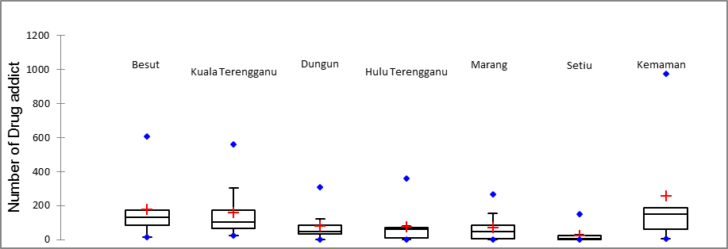
Cluster 2
Figure 4. Boxplot of Number of drug addiction by district
Cluster
2
Cluster
1
Cluster
3

Figure 5 presents the characterization of dendogram obtained when clustering number of drug addicts based on districts were performed. Three cluster composed of districts in Terengganu viz. Besut and Kuala Terengganu (first cluster), Dungun, Hulu Terengganu, Marang and Setiu (second cluster), Kemaman (third cluster). The observation of the dendogram, there are three main clusters that show the pattern number of drug addicts (Kemaman), followed by the moderate (Besut and Kuala Terengganu) and the lowest number of drug addicts (Dungun, Hulu Terengganu, Marang and Setiu). Population and Housing Report Census, (2010) reported that the total population are most crowded in Kemaman and Besut, Terengganu districts's area. Thus it likely has potential to get more people higher involvement in drugs. These three districts are characterized with different criteria, where the Kuala Terengganu is the hub of administrative thus, providing better job opportunities in the government sector, while Kemaman is the place of employment in the industrial sectors and Besut a famous with fisheries resources, tourism industry and geographically accessible as Terengganu just only 162 km away to Kelantan state.

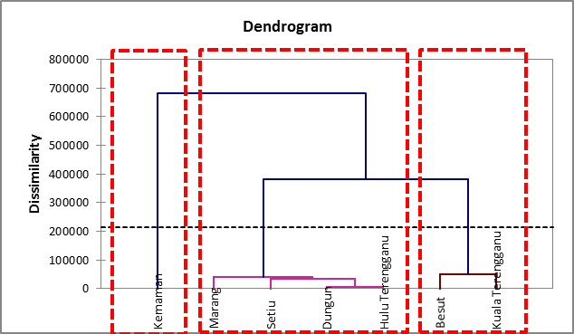

Cluster 1
Cluster 2:
LDA
Cluster 3:
MDA
Cluster 3:
HDA

Figure 5. Hierarchical dendrogram for number of drug addicted person based on district

The Temporal Distribution of Drug Addict
The trend of distribution of drug addicted person in every district as shown in Figure 6. (a – g). The graphs were indicating significantly increase and decrease from 2004 until 2009, but suddenly dramatically increase in 2010 and 2011 for every district. The number of drug addicts in every districts were different for each year. But, the pattern of the distribution of drug addicted person quite similar for every year, where are in 2004 until 2009, the number of drug addicted person increase and decreased until 2009, then suddenly increasing drastically in 2010 and 2011 but dropped back in 2012 and 2013.

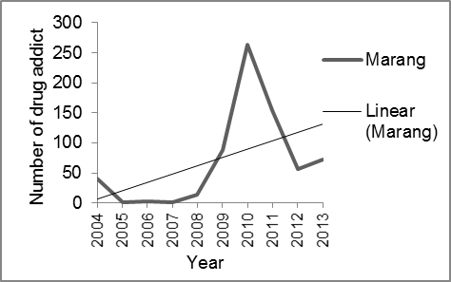
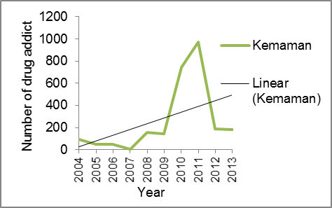
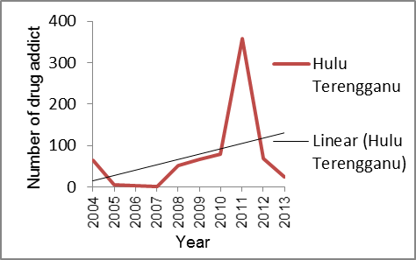
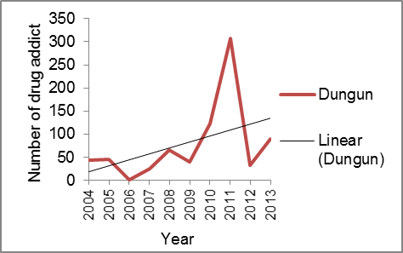
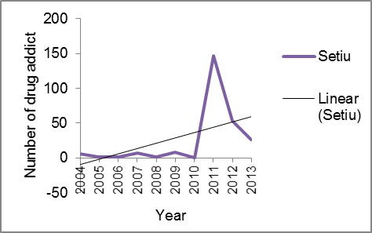
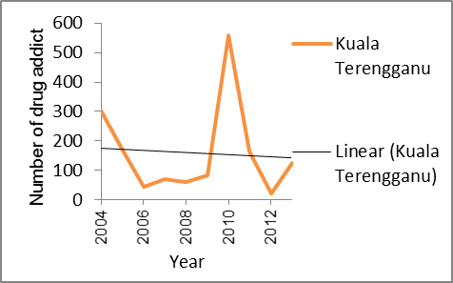
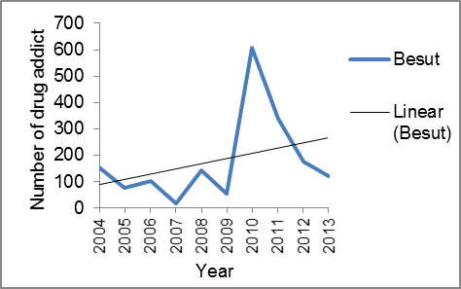
(c)
(d)
(g)
(f)
(e)
(b)
(a)

(b)
Figure 6. Temporal distribution of drug addicted person by district a) Besut, b) Kuala Terengganu, c) Kemaman, d) Setiu, e) Hulu Terengganu, f) Marang, g) Dungun.

The maximum value in 2010 and 2011 explained that number of drug addicted person increased dramatically (Table 3). Box plot in Figure 7 indicates that the highest number of drug addicted person was in 2010, as length of the box plot is the longest compared to others that means of large spatial variations. Within 10 years, the highest number of drug addicted person was on 2010. It is seen from the figure that length of box in case in 2010 is largest in comparison to that for others, which indicate large spatial variations. The important observation revealed from boxplot of drug addicts by year indicate that the highest number of drug addicts in two years (2010 and 2011). According to NADA Drug report (2013), a significant increase of the number of drug addiction on 2010 and 2011 as attributed from many relapse were detected on that years [7].

Table 3. Table of Descriptive Analysis by Temporal
Statistic | 2004 | 2005 | 2006 | 2007 | 2008 | 2009 | 2010 | 2011 | 2012 | 2013
No. of observation | 7 | 7 | 7 | 7 | 7 | 7 | 7 | 7 | 7 | 7
Minimum | 6 | 1 | 1 | 1 | 1 | 8 | 0 | 147 | 22 | 25
Maximum | 303 | 174 | 101 | 71 | 153 | 141 | 744 | 974 | 188 | 183
1st Quartile | 41.50 | 3 | 2.50 | 3 | 32.50 | 46 | 101 | 159.50 | 43 | 49.50
Median | 65 | 46 | 4 | 7 | 62 | 67 | 264 | 307 | 56 | 90
3rd Quartile | 124.50 | 64.50 | 45.50 | 21 | 104.5 | 86.50 | 583.50 | 348 | 123.50 | 122
Mean | 100.85 | 50.85 | 28.85 | 18.14 | 70.00 | 68.71 | 339.57 | 349 | 85.57 | 91.57
Variance  (n-1) | 10175.81 | 3833.14 | 1423.81 | 623.14 | 3464.66 | 1780.23 | 86583.28 | 84209.33 | 4638.95 | 3216.28
SD(n-1) | 100.87 | 61.91 | 37.73 | 24.96 | 58.86 | 42.193 | 294.25 | 290.18 | 68.11 | 56.71
SD: Standard Deviation

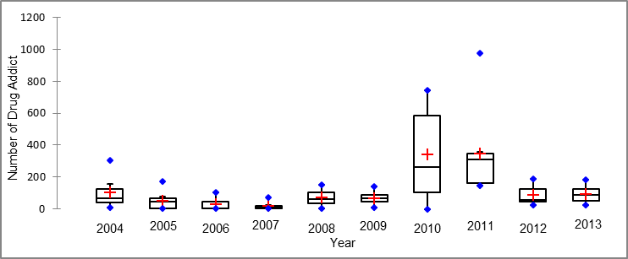

Figure 7. Boxplot of Number of drug addiction by year

From the analysis, the dendogram has generated three clusters viz. Cluster 1 (2004, 2005, 2006, 2007, 2008, 2009, 2012 and 2013), named Low drug addicted person (LDA). Cluster 2 (2010), named Moderate drug addicted person (MDA) and Cluster 3 (2011), named High drug addicted person (HDA). The increasing number of drug addicted person on 2010 drastically caused by the growing number of new drug addicted person compare to the previous year [33] It is noticeable after 2011, there was a significant reduction in number of drug addicted person in Terengganu due to partly to the implementation of many drug prevention programs. Besides, the policeman of Kemaman districts are actively conducting drug operation towards drug abuse [7].

Cluster 1: LDA
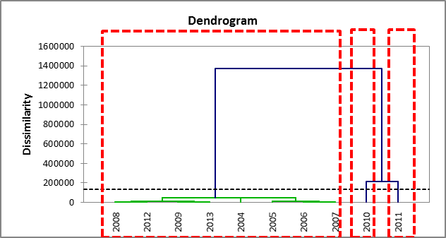

Cluster 2:
MDA
Cluster 3:
HDA

Figure 8. Hierarchical dendogram for number of drug addicted person based on year

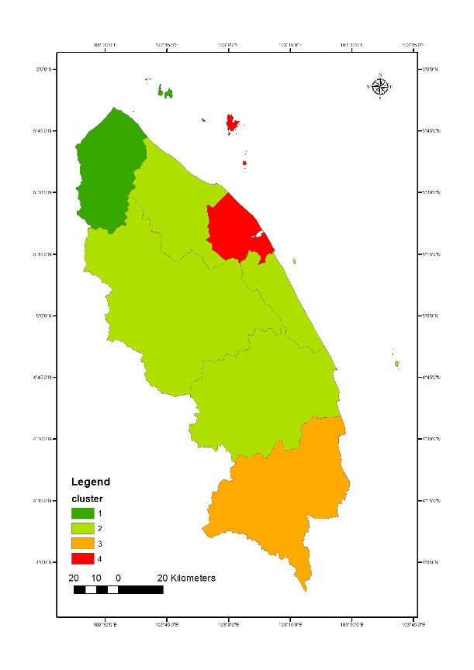

Figure 9. Clustering of District
GIS modelling was used to represent a clear picture of the area with the same cluster (Figure 9).Figure 9 represent the cluster of district drug addicted person in Terengganu. According to the map above, the location of cluster significantly show the distribution of drug addicted person by regions. Location of cluster 1, 3 and 4 are independent on each other. Otherwise from other clusters, Cluster 2 point out that location of districts in the same cluster was adjacent. Setiu, Hulu Terengganu, Marang and Dungun has a lower number of drug addicted person compare to other clusters. Location of this district is in the middle of Terengganu state.

Conclusion
The goal of the study was to determine the spatial distribution of the drug addiction in every district in Terengganu within 10 years. The maps generated clearly show where the cases coming from. The distribution of drug addiction in every districts causes by their geographical area which influence their economic factors. The positions of districts near to the coastal area enabling the supply of drugs derive and industrial area which offer job opportunity lead to high risk area distribution of drug addict. This study showed clustering of spatial and temporal helping to identify area of drug problem which have similar characteristic. This research beneficial to stakeholder to identify the most critical area and eradication program should be focus in these risk areas. Cluster analysis shows a clear variation in drug addicted person distribution both spatial and temporal.

Acknowledgement
We would like to acknowledge the special research was funded by the Niche Research Grant Scheme (NRGS-KPM) UnisZA/NRGS/2013/RR057. A special thank goes to the Ministry of Higher Education Malaysia, Prison Department of Malaysia (Marang) and UnisSZA for providing general assistants to this project. Finally yet importantly, great thankful to East Coast Environmental Research Institute (ESERI) upon kind assistance in data analysis techniques and peer support in completing this paper. The office can be contacted at 6(09)-6627034 (attnt= Miss Nurul Syazwani binti Rani).

References
- Neuroscience of psychoactive substance use and dependence. http:// www.who.int /substance _abuse / publications/en/Neuroscience. Accessed on 18 Disember 2014.
- Sayed Mohamed S. M. A. A., Mohamad, Z. Ismail, B. and Yusof, R. A. R. M. (2013). Therapeutic Experience of drug rehabilitation clients through expressive arts therapy. International Journal of Humanities and Social Science 3 (17):210-223.
- Kulsudjarit, K. (2004). Drug problem in Southeast and South West Asia. New York Academy of Science 1025:446-457.
- Huong, A. G. W., Guan, N. C., Nordin, A. S. A., Adlan, A. S. A. and Habil, H. (2009). Quality of life assessment of opioid substance abusers on methadone maintainance therapy (MMT) in University Malaya medical centre. Journal of Psychiatry 10 (1): 1-11.
- Devi, J. P., Azriani, A. B., Mohd, Z. W., Ariff, M. N. M. and Hashimah, A. N. (2012). The effectiveness of methadone maintainance therapy among opiate depandents registered with Hospital Raja Perempuan Zainab II Kota Bharu Kelantan. Malay Journal Medical Sciences 19 (4): 17-22.
- Yusoff, F., Shril, N., Rasidi, N. M., Zaki, N. A. M., Muhamad, N. and Ahmad, N. (2014). Illicit Drug Use Among Svhool-Going Adolescents in Malaysia. Asia-Pacific Journal of Public Health 26(55): 100S-107S.
- National Antidrug Agency, (2013). Laporan dadah bulan disember 2013. National Antidrug Agency.
- Hao, S-H., Zhao, M., Zhang, R-W., Zhang, J-C., Zhang, J. and Feng, X-S. (2013). The effectiveness comparison of Jitai tablets versus methadone in community-based drug treatment: A 1-year follow up study. Addictive Behaviours 38: 2596-2600.
- Sainders, B. and Allops, S. (1987). Relapse a psychological perspective. British Journal of Addiction 82: 417-429.
- Selected Social Statistics. Series 12/2010. (2010). National Antidrug Agency.
- Daash, A., Srivastava, A., Nagpal, B.N., Saxena, R. and Gupta, S.K. (2009). Geographical information system (GIS) in decisión support to control malaria- a case study of Koraput district in Orissa. India Journal Vector Borne Diseases 46 (1):72-74.
- Hidalgo, B., & Goodman, M. (2013). Multivariate or multivariable regression? American Journal of Public Health 103(1): 39–40.
- D’Ovidio, F. D., Leogrande, D., Mancarella, R., Schinzano, A. and Viola, D. (2014). A multivariate analysis of the quality of public transport services. Procedia Economics and Finance 17: 238-247
- Petronis, K.R., Johnson, C.C. and Wish, E.D. (1995). Location of drug-using arrested and treatment centres in Washington D.C.: A geocoding demonstration Project.University of Maryland at College Park. Washington, D.C.
- Johnson, C.P. and Johnson, J. (2001). GIS: A tool for monitoring and management of epidemics. Map India Conference. New Delhi.
- Blanton, J.D, Manangan, A.,Manangan, J., Hanlon, C.A., State, D. and Rupprect, C.E. (2006). Development of a GIS-based, real-time Internet mapping tolos for rabies surveillance. International Journal of Health Geographics 5:47-55.
- Srivastava, A., Nagpal, B. N., Srivastava, A., Gupta, S. K. and Dash, A.P. (2009). Identification of malaria hot spots for focused intervention in tribal state of India: a GIS based appoach. International Journal Health Geographics, 8:30-38.
- Sanders, L. J., Aguilar G. D. and Bacon C. J. (2013). A spatial analysis of the geographic distribution of musculoskeletal and general practice healthcare clinics in Auckland, New Zealand. Applied Geography 44: 60-78.
- Carroll, L. N., Au, A. P., Detwiler, L.T., Fu, T-C, Painter, I. S. and Albernethy, N. F. (2014). Visualization and analytics tolos for infectious disease epidemiology: A systematic review. Journal of Biomedical Informatics. 51:287-298.
- Kwan, M-P. (2000). Analysis of human spatial behavior in a GIS environment: Recent developments and future prospects. Journal of Geographical Systems 2: 85-90.
- Elebead, F.M., Hamid, A., Hilmi, H. S. M. and Galal, H. (2012). Mapping cáncer disease using geographical information system (GIS) in Gezira state-sudan. Journal Community Health 37: 830-839.
- Rasidi, M. N. M., Sahani, M., Othman, H., Hod, R., Idrus, S., Ali, M. Z., Choy E. A. and Rosli. M. H. (2013). Aplikasi sistem maklumat geografi untuk pemetaan reruang masa suatu kajian kes denggi di daerah Seremban, Negeri Sembilan, Malaysia. Sains Malaysiana 42 (8):1073-1080.
- Brownstein, J. S., Green T. C., Cassidy T. A. and Buttler, S. F. (2010). Geographic Information Systems and Pharmacoepidemiology, usng spatial cluster detection to monitor local patterns of prescription opioid abuse. Pharmacoepidemiol Drug Safety 19:627-637.
- Mitchell, A. (2005). The ESRI guide to GIS analysis: Spatial measurements & statistics. V 2. Redlands, California: ESRI Press.
- Kannel, P.R., Lee, S., Kanel, S.R. and Khan, S.P. (2007). Chemometric application in classification and assessment of monitoring locations of urban river system. Analytica. Chim Acta 582: 390-399.
- Official Portal Terengganu State.(2015). Terengganu http: //jheatweb. terengganu. gov. my/ maxc2020 /agensi/article2.php?sectionid=1&cid=1&aid=6997. Accessed on 21 December 2014.
- Population and Housing Census Report, Population and Housing Census of Malaysia (2014) Oficial Website.https://www.statistics.gov.my/mycensus2010/index.php?option=com_content&view=frontpage&Itemid=1&lang=en. Accessed on 21 Dicember 2014.
- Imam, E. (2011). Use of geospatial technology in evaluating landscape cover type changes in Chandoli National Park, India. Computational Ecology and Software 1 (2): 95-111.
- Shrestha, S. and Kazama, F. (2007). Assessment of Surface wáter quality Using Multivariated Statistical Techniques: a case study of the Fuji River Basin, Japan. Environment Modelling Software 22 (4): 464-475.
- Sulong, I. and Ismail, A. (2002). Mangrove mapping using landsat imagery and aerial photographs : kemaman district . Environment, Development and Sustainability 4: 135–152.
- Yusoff, F., Sahril, N., Rasidi, N. M., Zaki, N. A. M., Muhamad, N., and Ahmad, N. (2014). Illicit Drug Use among School-Going Adolescents in Malaysia. Asia-Pacific Journal of Public Health 26(5 Suppl): 100S–107S.
- Colasante, E., Molinaro, S. and Mariani, F. (2008). Italian of public health spatial analysis of drug-related hospital admissions : an auto-Gaussian model to estimate the hospitalization rates in Italy. Italian Journal of Public Health 5(4): 253–260.
- National Antidrug Agency, (2010). Laporan Dadah Bulan Disember 2010. National Antidrug Agency

