GLYCEROL AS A CHEAPER CARBON SOURCE IN BACTERIAL CELLULOSE (BC) PRODUCTION BY GLUCONACETOBACTER XYLINUS DSM46604 IN BATCH FERMENTATION SYSTEM
(Gliserol Sebagai Sumber Karbon Kos Rendah Dalam Penghasilan Bakteria Selulosa (BC) Oleh Gluconacetobacter Xylinus DSM46604 Dalam Sistem Penapaian Berkelompok)
Azila Adnan¹, Giridhar R. Nair², Mark C. Lay³, Janis E. Swan³, Roslan Umar^{4,5}

¹School of Fundamental Sciences, Universiti Malaysia Terengganu,
21030, Kuala Terengganu, Terengganu, Malaysia
²Department of Biotechnology and Biochemical Engineering, Sree Buddha College of Engineering,
Pattoor P.O., Alappuzha – 690529, India
³School of Engineering, Faculty of Science & Engineering, University of Waikato,
Private Bag 3105, Hamilton, New Zealand
⁴East Coast Environmental Research Institute (ESERI), Universiti Sultan Zainal Abidin, Gong Badak Campus,
21300, Gong Badak, Kuala Terengganu, Terengganu, Malaysia
⁵Faculty of Contemporary Islamic Studies, Universiti Sultan Zainal Abidin, Gong Badak Campus,
21300, Gong Badak, Kuala Terengganu, Terengganu, Malaysia

*Corresponding author: azila.adnan@umt.edu.my

Abstract
Bacterial cellulose (BC) is a polymer of glucose monomers, which has unique properties including high crystallinity and high strength. It has potential to be used in biomedical applications such as making artificial blood vessel, wound dressings, and in the paper making industry. Extensive study on BC aimed to improve BC production such as by using glycerol as a cheaper carbon source. BC was produced in shake flask culture using five different concentrations of glycerol (10, 20, 30, 40 and 50 g/L). Using concentration of glycerol above 20 g/L inhibited culture growth and BC production. Further experiments were performed in batch culture (3-L bioreactor) using 20 g/L glycerol. It produced yield and productivity of 0.15 g/g and 0.29 g/L/day BC, respectively. This is compared with the control medium, 50 g/L glucose, which only gave yield and productivity of 0.05 g/g and 0.23 g/L/day, respectively. Twenty g/L of glycerol enhanced BC production by Gluconacetobacter xylinus DSM46604 in batch fermentation system.

Keywords: Bacterial cellulose, glycerol, fermentation, carbon source

Abstrak
Bakteria selulosa (BC) adalah polimer daripada monomer glukosa, yang mempunyai ciri-ciri unik termasuk penghabluran yang tinggi dan kekuatan yang tinggi. Ia mempunyai potensi untuk digunakan dalam aplikasi bioperubatan seperti membuat saluran darah tiruan, pembalut luka, dan dalam industri pembuatan kertas itu. Kajian yang menyeluruh pada BC bertujuan untuk meningkatkan pengeluaran BC seperti dengan menggunakan gliserol sebagai sumber karbon kos rendah. Bakteria selulosa telah dihasilkan dalam kelalang penggoncang menggunakan lima kepekatan gliserol yang berbeza (10, 20, 30 , 40 dan 50 g/L). Penggunaan kepekatan gliserol melebihi 20 g /L telah merencat pertumbuhan kultur dan penghasilan BC. Ujikaji lanjutan telah dilakukan di dalam sistem penapaian berkelompok (3- L bioreaktor) menggunakan 20 g/L gliserol. Ia masing-masing telah menghasilkan hasil dan produktiviti sebanyak 0.15 g/g dan 0.29 g/L/hari BC. Ini dibandingkan dengan medium kawalan, 50 g/L glukosa, masing-masing hanya memberikan hasil dan produktiviti sebanyak 0.05 g/g dan 0.23 g/ L/hari BC. Dua puluh g/L gliserol telah mempertingkatkan penghasilan BC oleh Gluconacetobacter xylinus DSM46604 dalam sistem penapaian berkelompok.

Kata kunci: Bakteria selulosa, gliserol, penapaian, sumber karbon

Introduction
The extracellular bacterial cellulose (BC) is produced by cellulose-producing bacteria, which fermented in a culture medium containing various carbon sources and nitrogen sources [1]. This biopolymer, which is often produced as discrete particles, has high crystallinity, high mechanical strength and higher purity than plant based cellulose. BC does not contain components such as lignin and hemicellulose present in plant-based cellulose [2]. As Gluconacetobacter xylinus is the most efficient BC producer [3], this bacterium has been utilized in numerous BC research.

Several strategies have been attempted by many researchers such as the optimal medium, the culture conditions and their interaction effects [4] to improve BC production. The main problems associated with the bioprocess technology are productivity, ease of industrial application, and production cost [5]. In spite of all applications, the BC production costs, which involve costly fermentation media, have encouraged researchers to achieve high yields capable of meeting the worldwide demand for cellulose [6].One of alternative in reducing BC production cost is by using low-cost substrate, which can be utilized as carbon source in fermenting BC.
Glycerol is yet another low-cost substrate for fermentation. Large quantities of crude glycerol will be generated by the emerging biodiesel industry. Approximately, 10% (w/w) of glycerol is produced from biodiesel industry [7], and it is estimated that the production of glycerol will reach 5.8 billion pounds (2.6 million tonnes) in 2020 [8]. Also, the glycerol generated from biodiesel production contains several pollutants that make its disposal expensive and sophisticated [7]. Hence, the price of glycerol is forecasted to fall in the coming years, making it an ideal raw substrate for industrial processes.
Thus, this study investigated the potential of glycerol utilization by employing Gluconacetobacter xylinus DSM46604 in batch fermentation system. The BC productions were compared with BC produced on commercial glucose media.
Materials and Methods

Materials
The bacterium Gluconacetobacter xylinus DSM 46604, from German Collection of Microorganisms and Cell Cultures, was used in this study. Stock cultures of the bacterium were grew at 30ºC on nutrient media agar slants containing the following media: 50 g/L D-glucose (UNIVAR), 5 g/L yeast extract (OXOID), 5 g/L ammonium sulphate (UNIVAR), 3 g/L disodium hydrogen phosphate (SIGMA), 0.05 g/L magnesium sulphate (M&B Laboratory Chemicals) and 20 g/L agar (Becton Dickinson). The growth media and seed media did not contain agar.

Seed Culture
To prepare the seed for trials, a loop full of bacteria was gently scraped from the surface of solid agar and transferred into sterilized 65 mL glycerol growth media in a 200-mL conical flask. The flask was plugged with cotton wool and incubated on a shaking incubator (150 rpm) at 30ºC for 5 days until white pellicles appeared.

Effect of Glycerol Concentrations in Shake Flask Fermentation
Five different glycerol concentrations (10, 20, 30, 40 and 50 g/L) were used. The seed culture (as mentioned in Section 2.2) was aseptically transferred into 65 mL medium in 200-mL shake flasks containing other media components (g/L): yeast extract, 5, ammonium sulphate, 5; potassium hydrogen orthophosphate, 3; magnesium sulphate, 0.05. The pH of the medium was adjusted to 6.8 with 6M NaOH. The cultures were incubated at 30ºC and 150 rpm for 5 days. The results between glucose and glycerol were compared and further trials were done under large-scale fermentation of batch, fed-batch and continuous operation modes.

Batch Fermentation Conditions
Agitated and aerated cultures were grown on glucose/glycerol standard media in the 3-L bench-top bioreactor (BioFlow Celligen 115, United Stated of America). Fermentations were done for 5 days, 30ºC, an aeration rate of 0.3 vvm with a working volume of 2 L. The pH was controlled at 6.8 using 6 M NaOH. The reactor was inoculated with 150 mL of seed culture. Biomass, glucose/glycerol and BC concentrations of samples taken every 24 hours were determined.

Analytical Methods: Bacterial Cellulose Concentration
The washed pellet from one sample was treated with 1M NaOH at 90ºC for 30 minutes to dissolve cells. The BC obtained was centrifuged at 4000 rpm for 20 minutes, washed with distilled water, dried at 80ºC for 24 hours, and weighed.

Biomass Concentration
The pellet from the second sample was suspended in 10 mL of cellulase (SIGMA) and 90 mL citrate buffer (pH 5.0), mixed for 5 minutes, then centrifuged at 4000 rpm for 20 minutes to remove suspended solids. The supernatant was kept at 50ºC for 30 minutes to hydrolyse the BC. The sample was then washed, centrifuged at 4000 rpm for 20 minutes and dried at 80ºC for 24 hours, and weighed until constant weight was achieved. The biomass concentration was expressed as gram dry cell weight per litre media (g DCW L⁻¹).

Glucose Analysis
Miller’s method [9] was used for determining glucose concentration in the culture broth.

Glycerol Analysis
Glycerol concentration was determined by refractive index, which measures the change in angle of light. This was converted to glycerol concentration using the standard curve with regression [10].

Results and Discussion
Five glycerol concentrations between 10 and 50 g/L) were used. The BC concentration varied from 0.65 g/L when grown on 10 g/L glycerol to 1.43 g/L on 20 g/L glycerol (Figure 1). It then fell gradually to 1.39 g/L as glycerol was increased to 30, 40 or 50 g/L. The final pH of the media was similar, being between pH 5.43 and 5.68 from the initial pH 6.8. This differs from Jung et al. [11], who reported maximum BC concentration on 30 g/L glycerol and a drop in concentration above this glycerol concentration. Research by Kim et al., 2006; Hungund and Gupta 2010 [12,13] also obtained BC concentrations of 4.5 g/L and 2.47 g/L respectively on 15-20 g/L glycerol.

Figure 1. Effect of glycerol concentration on BC production by G. xylinus DSM46604
Trials were done to investigate using glycerol as a carbon source to produce BC by G. xylinus. Shake flask trials showed that the highest BC concentration was produced on 20 g/L glycerol. The trials were scaled to growth in a 3-L bioreactor using 2.5 L media containing 20 g/L glycerol. The control was 50 g/L glucose. Substrate consumption, biomass and BC production in the two media were measured and compared (Figures 2 and 3).
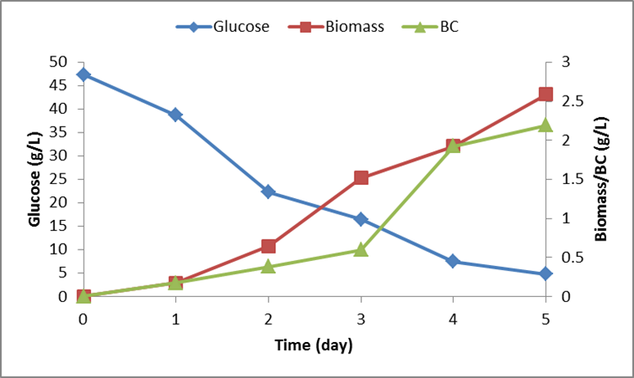
Figure 2. Glucose, biomass and BC profiles when growing G. xylinus DSM46604 on 50 g/L glucose media in a 3-L bioreactor.
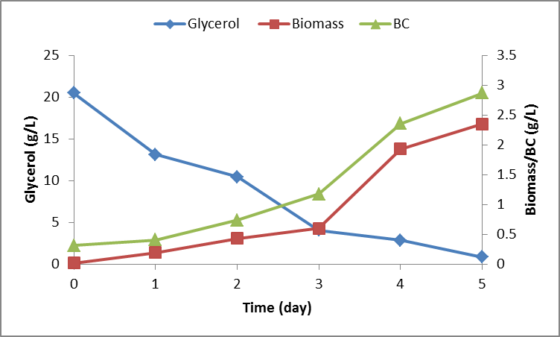
Figure 3. Glycerol, biomass and BC profiles when growing G. xylinus DSM46604 on 20 g/L glycerol in a 3-L bioreactor.
The BC concentration on 20 g/L glycerol after five days growth was 2.87 g/L, which was higher (2.19 g/L) than on 50 g/L glucose. The BC yield of 0.15 g/g glycerol obtained in this study (Table 1) is comparable to yields reported in other investigations. Previous studies by Keshk and Sameshima [14], Kim et al. [12] and Hungund and Gupta [13] obtained 0.12 -0.13 g BC/g glycerol in agitated cultures of G. xylinususing 20 g/L glycerol.
Table 1. Biomass and BC production by G. xylinus DSM 46604 growing on glucose or glycerol in a 3-L bioreactor.
Parameter | Carbon sources
Parameter | 50 g/L glucose | 20 g/L glycerol
BC (g/L) | 2.19 | 2.87
Carbon source consumed (g/L) | 42.52 | 19.66
Biomass (g/L) | 2.59 | 2.35
BC yield (g/g) | 0.05 | 0.15
Biomass yield (g/g) | 0.06 | 0.12
BC productivity (g/L/day) | 0.23 | 0.29
Biomass productivity (g/L/day) | 0.26 | 0.24

Comparison of BC concentrations produced from 50 g/L glucose and 20 g/L glycerol were shown in Figure 4.
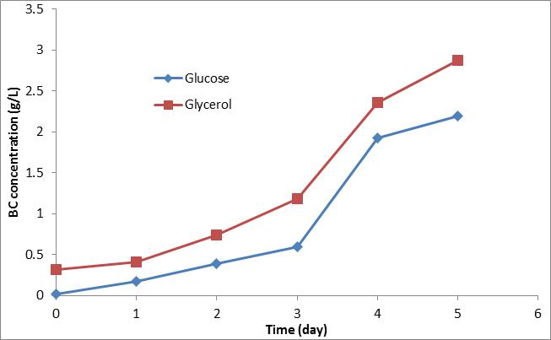
Figure 4. Profile for BC production when growing G. xylinus DSM46604 on 50 g/L glucose or 20 g/L glycerol in a 3-L bioreactor
When the carbon source is glycerol, BC biosynthesis occurs by first generating glucose via the gluconeogenesis metabolic pathway. This may become the rate limiting under the given physiological conditions [15]. Glucose supported rapid initial synthesis of BC and it is assumed that the slower BC formation in initial stages growth on glycerol could be due to insufficient glucose being available. The second reason is that the media contained 50 g/L glucose but only 20 g/L glycerol, so the BC concentrations achieved on glucose should be higher than formed on glycerol. Lastly, glycerol can be channelled to form dihydroxyacetone (DHA) and small amounts of acetic acid via the TCA cycle [16].

Conclusion
Replacing glucose with 20 g/L of glycerol increased BC yield to 0.15 g/g carbon source, which is three times higher than on glucose (0.05 g/g). Studying the carbon source effects on BC production allowed optimization of fermentation media, allowing fermentation cost and time to be more effective. Investigating the effect of carbon sources concentration gave a picture of how BC production is affected by these factors.

Acknowledgements
Azila Adnan acknowledges the scholarships from Ministry of Higher Education Malaysia and Universiti Malaysia Terengganu (UMT) for carrying out this research at The University of Waikato. Special thanks to Dr. Mohd Khairul Amri Kamarudin from Universiti Sultan Zainal Abidin (UNISZA) for technical support.

References
- Keshk, S. M. (2014). Vitamin C enhances bacterial cellulose production in Gluconacetobacter xylinus. Carbohydrate Polymer 99: 98-100.
- Mohite, B. V. and Patil, S. V. (2014). A novel biomaterial: bacterial cellulose and its new era applications. Biotechnology and Applied Biochemistry 61(2):101 – 110.
- El-Saied, H., Basta, A. H. and Gobran, R. H. (2004). Research Progress in Friendly Environmental Technology for the Production of Cellulose Products (Bacterial Cellulose and Its Application). Polymer-Plastics Technology and Engineering 43(3): 797-820.
- Mohammadkazemi, F., Azin, M. and Ashori, A. (2015). Production of bacterial cellulose using different carbon sources and culture media. Carbohydrate Polymers 117: 518-523.
- Koutinas, A. A., Sypsas, V., Kandylis, P., Michelis, A., Bekatorou, A., Kourkoutas, Y. and Yianoulis, P. (2012). Nano-Tubular Cellulose for Bioprocess Technology Development. PLoS ONE 7(4): 1-9.
- Donini, Í. A., De Salvi, D. T., Fukumoto, F. K., Lustri, W. R., Barud, H. S., Marchetto, R. and Ribeiro, S. J. (2010). Biosynthesis and recent advances in production of bacterial cellulose. Eclética Química 35(4): 165-178.
- Johnson, D. T. and Taconi, K. A. (2007). The glycerin glut: Options for the value-added conversion of crude glycerol resulting from biodiesel production. Environmental Progress 26(4): 338-348.
- Ayoub, M. and Abdullah, A. Z. (2012). Critical review on the current scenario and significance of crude glycerol resulting from biodiesel industry towards more sustainable renewable energy industry. Renewable and Sustainable Energy Reviews 16(5), 2671-2686.
- Miller, G. L. (1959). Use of dinitrosalicylic acid reagent for determination of reducing sugar. Analytical Chemistry 31(3): 426–428.
- Stasiak-Rozanska, L., Blazejak, S. and Miklaszewska, A. (2011). Application of immobilized cell preparation obtained from biomass of Gluconacetobacter xylinus bacteria in biotransformation of glycerol to dihydroxyacetone. Acta Scientiarum Polonorum. Technologia Alimentaria, 10(1):35-49.
- Jung, H. I., Jeong, J. H., Lee, O. M., Park, G.T., Kim, K. K., Park, H. C., and Son, H. J. (2010). Influence of glycerol on production and structural–physical properties of cellulose from Acetobacter sp. V6 cultured in shake flasks. Bioresource Technology 101(10): 3602-3608.
- Kim, S. Y., Kim, J. N., Wee, Y. J., Park, D. H., and Ryu, H. W. (2006). Production of bacterial cellulose by Gluconacetobacter sp. RKY5 isolated from persimmon vinegar. Applied Biochemistry and Biotechnology 131(1-3), 705-715.
- Hungund, B. S. and Gupta, S. G. (2010). Improved production of bacterial cellulose from Gluconacetobacter persimmonis GH-2. Journal of Microbial and Biochemical Technology 2(5): 127-133.
- Keshk, S. and Sameshima., K. (2005). Evaluation of different carbon sources for bacterial cellulose production. African Journal of Biotechnology 4(6): 478-482.
- Ross, P., Mayer, P. and Benziman, M. (1991). Cellulose biosynthesis and function bacteria. Microbiology Review 55: 35-58.
- Schramm, M., Gromet, Z. and Hestrin, S. (1957). Synthesis of cellulose by Acetobacter xylinum. 3. Substrates and inhibitors. Journal of Biochemistry 67(4): 669-679.

