WATER QUALITY DEGRADATION OF CEMPAKA LAKE, BANGI, SELANGOR, MALAYSIA AS AN IMPACT OF EXCESSIVE E. COLI AND NUTRIENT CONCENTRATIONS

(Degradasi Kualiti Air di Tasik Cempaka, Bangi, Selangor, Malaysia Disebabkan oleh E.Coli dan Kepekatan Nutrisi yang Berlebihan)

Muhammad Barzani Gasim¹, Mohd Ekhwan Toriman^{1,2}, Hafizan Juahir¹, Mohd Khairul Amri Kamarudin^{1,3}, Azman Azid¹, Soaad Muftah¹, Amal Barggig¹, Nor Azlina Abd Aziz¹, Fazureen Azaman¹,

Norsyuhada Hairoma¹, Haniff Muhamad¹

¹East Coast Environmental Research Institute (ESERI), Universiti Sultan Zainal Abidin,

Gong Badak Campus, 21300 Kuala Terengganu, Terengganu, Malaysia

² School of Social, Development and Environmental Studies, Faculty of Social Sciences and Humanities,

National University of Malaysia, 43600, Bangi Selangor, Malaysia

³ Faculty of Design Arts and Engineering Technology, Universiti Sultan Zainal Abidin,

Gong Badak Campus, 21300 Kuala Terengganu, Malaysia

*Corresponding author: drbarzani@gmail.com

Abstract

This study was carried out to determine the status of the water quality condition in Cempaka Lake, Bandar Baru Bangi, Selangor, Malaysia. Seven sampling stations were selected to represent the water quality condition of the lake. The sampling was carried out in two different times; the first sampling was in June 2010 and the second sampling in August 2010. A total of fifteen water quality parameters was selected, analyzed in-situ and ex-situ, and classified based on WQI and NWQS Classifications. Results for in-situ water quality parameters are: pH content ranged from 6.13 to 6.92; DO from 1.63 to 4.94 mg/L; temperature from 26.02 to 28.37 ºC and conductivity from 94 to 213μS/cm. For ex-situ water quality parameters are: BOD from 0.38 to 2.4 mg/L, Escherichia coli from 120x102 CFU/100mL to 403x102CFU /100mL; nitrite from 0.06 to 0.99 mg/L, nitrate from 1.0 to 1.8 mg/L; ammoniacal nitrogen from 2.00 to 2.84 mg/L; phosphate from 0.21 to 0.56 mg/L; sulphate from 21 to 35 mg/L; COD from 9.3 to 69 mg/L and TSS from 1.8 to 33.3 mg/L; oil & grease from 5.7 to 11.8 mg/L; hardness from 13.89 to 35.57 mg/L. Overall, Cempaka Lake was classified moderately polluted due to urban activities.

Keyword: Cempaka Lake, water quality parameter, WQI and NWQS classifications, moderately polluted

Abstrak

Kajian ini telah dijalankan untuk menentukan status kualiti air di Tasik Cempaka, Bandar Baru Bangi, Selangor, Malaysia. Tujuh stesen pensampelan telah dipilih untuk mengenalpasti kualiti air tasik. Pensampelan telah dijalankan dalam dua masa yang berlainan; pensampelan pertama ialah pada bulan Jun 2010 dan persampelan kedua pada bulan Ogos 2010. 15 parameter kualiti air telah dipilih, dianalisis in-situ dan ex-situ, dan berdasarkan pengkelasan IKA dan PKAK. Keputusan untuk in-situ parameter kualiti air adalah: Kandungan pH adalah antara 6.13-6.92; DO 1.63-4.94 mg/L; suhu 26.02 – 28.37 ºC dan kekonduksian daripada 94 sehingga 213μS/cm. Bagi ex-situ parameter kualiti air adalah: BOD 0.38-2.4 mg/L, Escherichia coli dari 120x102CFU/100ml sehingga 403x102 CFU/100ml; nitrit 0.06-0.99 mg/L, nitrat 1.0-1.8 mg/L; nitrogen ammoniacal 2.00-2.84 mg/L; fosfat 0.21-0.56 mg/L; sulfat 21-35 mg/L; COD 9.3-69 mg/L dan TSS dari 1.8 sehingga 33.3 mg/L; minyak & gris 5.7-11.8 mg/L; keliatan air 13.89-35.57 mg/L. Secara keseluruhan, Tasik Cempaka dikelaskan sebagai sederhana tercemar akibat kesan aktiviti bandar.

Kata kunci: Tasik Cempaka, parameter kualiti air, pengkelasan IKA dan PKAK, sederhana tercemar

Introduction

Water is vital to the human existence. Early human civilizations were centered on spring and streams. Many civilizations that flourished after developing a reliable water supply collapsed when the supply was exhausted or its quality deteriorated [1]. The fast growth of urban areas has affected the water quality of the surface water due to over exploitation of resources and improper waste disposal practices. The catchment area is important for water resource conservation, both in terms of quality and quantity. The study of water quality aspects of the water distribution system is of great significance as it plays an important role in assuring a good quality of water to the consumer [2].

Water quality is important in drinking water supply, irrigation, fish production, recreation and other purposes to which the water must have been impounded. Water quality is determined by the physical and chemical limnology and includes all physical, chemical and biological factors of water that influence the beneficial use of the water [3]. The destruction of catchment area will lead to the deterioration in quality and quantity of the water resource further downstream [4].

In general, the status of water quality can provide useful information on land activities within the catchment area, for example, the deterioration of water quality at Tasik Chini have been raised due to their correlated with agriculture and mining activities [5]. About one third of the drinking water requirements of the world is obtained from surface sources like rivers, canals and lakes unfortunately; these sources seem to be used as the best place for waste discharge for agriculture, domestics and industries [6].

In general, the status of water quality at each of the sampling sites could provide useful information on land activities within the lake’s catchment area. It is believed that at the catchment studied, higher concentrations of the DO, for example, was triggered by intensive agriculture activities which resulted in changes to land use and land cover [7]. The water quality index is one of the most effective tools to communicate information on the quality of water to the concerned citizens and policy makers. It becomes a significant parameter for the assessment and management of surface water [1]. WQI is defined as a rating that reflects the complex influence of different water quality parameters. WQI is calculated from the point of vision of the suitability of surface water for human consumption [8].

Water quality classification in all seasons where the quality slightly differs in summer and winter compared to the post monsoon season are reasons to introduce water quality change and measures to be taken in terms of the groundwater quality management [9]. Discharge of toxic chemicals, over pumping of aquifer and contamination of water bodies with substance that promote algae growth are some of today’s major cause for the degradation of water quality. Direct contamination of surface water with metals in discharges of mining, smelting and industrial manufacturing, is a long-standing phenomenon. Today there are traces of contamination not only of surface water but also of groundwater bodies, which are susceptible to leach from waste dumps, mine tailings and industrial production sites [10].

The physical and chemical properties of water resources are driven by numerous environmental variables such as climate, wastewater effluent, and tidal effect at the estuary [11]. The main purpose of analyzing the physical, chemical and microbiological characteristics of water is to determine its nutrient status. Since the water contains both dissolved and suspended materials in various proportions, its physical and chemical characteristics differ along with its biological characteristics [12].

Cempaka Lake, Bangi is a man-made lake, located between the commercial centre and Kompleks Perbadanan Kemajuan Negeri Selangor (PKNS) Jabatan Kemajuan Bangi (Figure 1). The lake originated from a small river called Sg. Ayer Hitam. It was then up-graded into a lake which covered about 15.7 acre of land; the length of the lake from the inlet to outlet is about 700 m with maximum depth 3 meter in the middle. The lake is connected with Sungai Langat through Sg. Ramal, a shallow river that runs through Kajang and Bangi areas. Flood always occurs when there are heavy rains. Thus, Cempaka reacts as a retention pond by slowing down the water flow into Sungai Langat. Later on, the area is made into a recreational park. Today, the Cempaka Lake serves the local people recreation or as an infrastructure for social activities such as jogging, fishing, fitness training and a playground area for children.

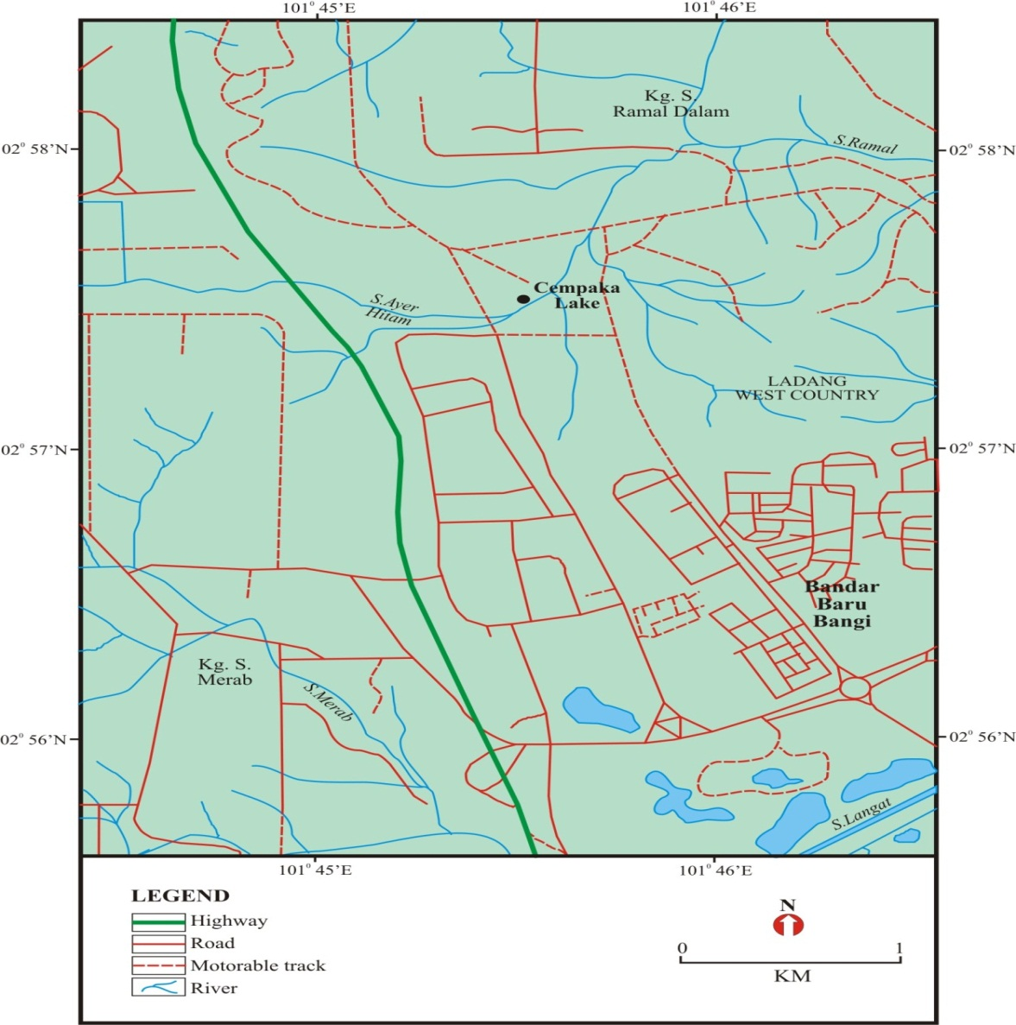

Figure1. Location map of the study area

Materials and Methods

Seven sampling stations were chosen from the surrounding the lake (station 1 to station 7) as shown in Figure 2. Station 1 was located at the inlet area of the lake, four sampling stations(station 2 to station 5) in the surroundings of the lake and Station 6 was in the centre, and the last station, Station 7 was located in the outlet of the lake. The samples were taken using polyethylene bottles, which had been soaked and cleaned before the sampling. After the collection, the samples were immediately placed into ice boxes and processed for analysis in the laboratory. The water samples were collected on a range of time, from 8:30 to 10 am. Three replications of samples were taken randomly at each station.

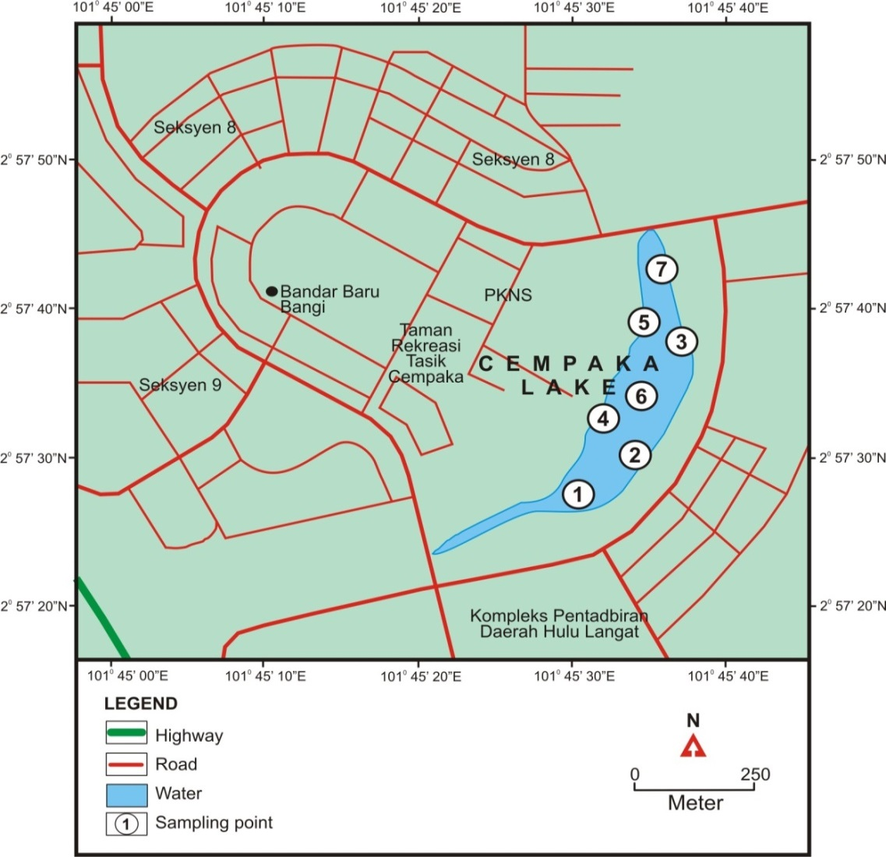

Figure 2. Location of seven water sampling stations in the Cempake Lake

The water quality analysis is divided into two measurements: In-situ measurement and in the lab measurement. Four water quality parameters (temperature, pH, dissolved oxygen and electrical conductivity) were measured in-situ using HYDROLAB meter DataSonde. Eleven other parameters are physico-chemical parameters such as the chemical oxygen demand (COD), biochemical oxygen demand (BOD), total suspended solids (TSS), hardness, sulphate (SO₄), ammoniacal nitrogen (NH₃⁻N), phosphate (PO₄), Escherichia coli (E.coli), nitrite (NO₂), nitrate (NO₃), and oil & grease (O&G) were analyzed in the laboratory. All the analyses were performed in accordance with the Standard Methods [13] and HACH procedure.

Results and Discussion

In-Situ Analysis

Four water quality parameters; temperature, pH, DO and conductivity were measured in-situ (during sampling) to get the best fit result in this study.

Temperature

The range of temperature values during first sampling was from 26.02 to 27.82°C, with an average of 26.98°C, the highest (27.82°C), was recorded at St. 7 and the lowest (26.02°C) was recorded at St. 1. The range of value of the temperature during the second sampling was from 27.62°C to 28.37°C, with an average of 28.04 °C, the highest (28.37°C), was recorded at St. 3 and St.7 and the lowest (27.62°C) was recorded at St. 1 (Fig.3a).

At both sampling times showed that the highest temperature is at stations 7. This reading may result from the high level of exposure of the sun at this point of time and the location of station 7 as river bank is basically an exposed land, whereas the lowest temperature was at station 1 for both sampling time which is surrounded by vegetation. Temperature is a measure of the degree of hotness or coldness of a substance, rate of biochemical and chemical reactions in the water body, reduction in the solubility of gases and amplifications of tastes and odors of water [14]. Several factors which are affected by weather variations and may influence the water temperature; sampling time and location were taken considerably. The statistical analysis showed that there were significant differences of mean temperature between stations and between sampling times (ANOVA, p < 0.05, p < 0.05). The temperature values were recorded at the Cempaka Lake, Bangi and were classified as normal based on the NWQS and classified as class I.

pH

The range of pH value during the first sampling was from 6.13 to 6.88, with an average of 6.59, the highest (6.88), was recorded at St. 6 and the lowest (6.13) was recorded at St. 1. The range of values of the pH during the second sampling was from 6.40 to 6.92, with an average of 6.66, the highest (6.92), was recorded at St. 6 and the lowest (6.40) was recorded at St. 1 (Fig. 3b).

The mean pH value of the Cempaka Lake is indicated as slightly acidic, especially at stations 1 and 2. The low acidity of the Cempaka Lake may also be due to the free carbon dioxide as well as the various acids and alkalis which can penetrate the water bodies that came along with the industrial wastewater. Low pH was probably due to the rainfall and runoffs from the nearby roads and surrounding areas and attributed to the presence of high organic matter resulting from the discharge of organic matter into the lake from the food processing industries [15]. The pH value was ideal when compared to the NWQS and classified as class I. The statistical analysis showed that there were no significant differences of the mean pH levels between stations and between sampling times (ANOVA, p > 0.05, p > 0.05). The pH values of the lake in this study are not different compared to the values that have been by [16] in the study of Varsity Lake, University of Malaya, which was from 5.8 to 6.9. This could be contributed by the water from the engineering faculty that recorded as the lowest pH.

Dissolved Oxygen (DO)

The range of dissolved oxygen value during the first sampling was from 3.76 to 4.94 mg/L, with an average of 4.34 mg/L, the highest (4.94 mg/L) was recorded at St. 1 and the lowest (3.76 mg/L) was recorded at St. 7. The range of dissolved oxygen during the second sampling was from 1.63 to 2.73 mg/L, with an average of 2.14 mg/L, the highest (2.73 mg/L) was recorded at St. 4 and the lowest (1.63 mg/L) was recorded at St. 1 (Fig, 3c).

The DO value was higher during the first sampling compared to the second sampling and there was raining during the first sampling. [11] reported lower values of dissolved oxygen in summer months due to a higher rate of decomposition of organic matter and limited flow of water in the low oxygen holding environment due to the high temperature. The DO values of the lake in this study are higher compared to the DO values at Tasik Chini, Pahang [5] which was from 0.6 to 6.4 mg/L. According to NWQS, Cempaka Lake falls under class III. The statistical analysis of this study showed that there were no significant differences of the mean DO levels within sampling stations, but there were significantly differences between sampling times (ANOVA, p > 0.05, p < 0.05).

Conductivity (EC)

The range of conductivity value during the first sampling was from 94 to 212 μS/cm, with an average of 168.42 μS/cm, the highest (212 μS/cm), was recorded at St. 6 and the lowest (94 μS/cm) was recorded at St. 1. The range of Conductivity during the second sampling was from 142.6 to 186 μS/cm, with an average of 153.9 μS/cm, the highest (186 μS/cm) was recorded at St. 1 and the lowest (142.6 μS/cm) was recorded at St. 7 (Fig. 3d).

The average of two samplings of conductivity in the study area was (161 μS/cm ± 38.56). The conductivity values at the first sampling were higher than second sampling and this showed the effect of raining, which decreases the concentration of all minerals, salts, etc which can increase the conductivity. Based on the NWQS, the level of conductivity in the study area is classified as class I. The results showed that the lake has a higher concentration of conductivity compared to the lake Putrajaya by [17], which was from 40.7 to 152.6 μS/cm. The statistical analysis showed that there were no significant differences of conductivity levels within sampling stations and between sampling times (ANOVA, p > 0.05,p > 0.05).

a
b

c

d

Figure 3. Distribution of in-situ water quality parameters between two samplings temperature (a), pH (b), DO (c) and conductivity (d)

Laboratory Analysis

Physico-Chemical: Chemical Oxygen Demand (COD)

The range of Chemical Oxygen Demand during the first sampling was from 2.7 to 69 mg/L, with an average of 30.08 mg/L, The highest (69 mg/L),was recorded at station 7 and the lowest (2.7 mg/L) was recorded at station 1. The range of Chemical Oxygen Demand during the second sampling was from 9.3 to 22.6 mg/L, with an average of 14.25 mg/L, the highest (22.6 mg/L), was recorded at station 5 and the lowest (9.3 mg/L) was recorded at station 2 (Fig. 4a).

The Chemical Oxygen Demand is useful as an indicator of organic pollution for surface water. In this study the value of COD in all sampling stations was high, especially at station 7 during first sampling, the station was located at the end of the lake. Increases of the COD level in the waters are due to the increase of organic matter and inorganic chemicals [18] runoff from the restaurant food waste and waste water from areas around the lake. Based on the NWQS, the level of COD measured at all the stations in the lake was classified as class II. The COD values in this lake are not different compared to the COD values at Lake Engineering in Universiti Kebangsaan Malaysia [19] which was from 51.09 to 64.37 mg/L.

Biochemical Oxygen Demand (BOD)

The range Value of the biochemical oxygen demand during the first sampling was from 0.91 to 2.4mg/L, with an average of 1.43 mg/L, The highest (2.4 mg/L), was recorded at station 1and the lowest (0.91 mg/L) was recorded at station 5. The range of value of biochemical oxygen demand during the second sampling was from 0.38 mg/L to 0.60 mg/L, with an average of 0.50mg/L, the highest was (0.60 mg/L) was recorded at station 2 and the lowest (0.38 mg/L) was recorded at station 1 as shown in (Fig. 4.b).

The amount of BOD depends on the type and amount of organic chemicals present, temperature, pH, presence of nutrients and trace elements that are necessary for growth. It is an empirical test to measure the amount of oxygen used by the microorganisms in the aerobic oxidation, or breakdown of organic matter in the lake, the higher BOD, the more organic matters in the water. Based on the NWQS, the BOD value of the Cempaka Lake was classified as class I. The statistical analysis in this study showed that there were no significant differences of BOD concentration levels within sampling stations, but significantly differences between sampling times (ANOVA, p > 0.05, p < 0.05). However, when comparing with a study which was done by [20] at Engineering Lake the value of BOD 0.49 to 3.48 mg/ L and classified as class II.

Total Suspended Solids (TSS)

The range of total suspended solids during the first sampling was from 1.8 to 33.3 mg/L, with an average of 8.52 mg/L, the highest (33.3 mg/L), was recorded at station 2 and the lowest (1.8 mg/L) was recorded at station 3. The range of total suspended solids during the second sampling was from 3.7 to 7.6 mg/L, with an average of 4.98 mg/L, the highest (7.6 mg/L), was recorded at station 7 and the lowest (3.7 mg/L) was recorded at station 3 (Fig.4c).

Based on average of two samplings, the total suspended solids in the study area was (6.75 mg/L ± 2.50). The result of TSS values is high at stations 1 and 2 during the first sampling, because there was raining, and generated a strong rate of soil erosion and contributing more suspended solids in the area of flat land. The statistical analysis showed that there were no significant differences of mean TSS concentration within sampling stations nor between sampling times (ANOVA, p > 0.05, p > 0.05). Based on the NWQS, level of TSS in the study area is classified as class I. However, the result was slightly lower compared to the TSS values at Tasik Chini, Pahang [5],which was from 1.2 to 34.0 mg/L.

Hardness (CaCO₃)

Hardness of water depends mainly upon the amounts of calcium or magnesium salts or both (Olajire et al 2001). The range of hardness during the first sampling was from 15.07 to 35.57 mg/L, with an average of 30.94 mg/L, the highest (35.57mg/L), was recorded at station 5 and the lowest (15.07 mg/L) was recorded at station 7. The range of hardness during the second sampling was from 13.89 to 17.01 mg/L, with an average of 16.30 mg/L, the highest (17.01 mg/L), was recorded at station 6 and the lowest (13.89 mg/L) was recorded at station 3 (Fig. 4d).

The average of two samplings of hardness in the study area was 24.63 mg/L ± 11.22). It is recorded a higher value of hardness values during first sampling, especially at station 3 to 6. The statistical analysis showed that there were no significant differences of mean hardness levels within sampling stations, but significantly differences between sampling times (ANOVA, p > 0.05, p < 0.05). Compared to the NWQS, the level of hardness was very low and it is classified as class I, which represents the natural level of supporting aquatic lives. The results showed that the lake has a higher concentration of hardness compared to the study by [11] in the Gundolav Lake at Kishangarh, which was from 180.6 to 327.2 mg/L. Higher values indicate maximum disturbance due to the human activities.

Oil and Grease (O&G)

The range of oil & grease during the first sampling was from 5.7 to 11.8 mg/L, with an average of 8.17 mg/L, the highest (11.8 mg/L), was recorded at station 6 and the lowest (5.7 mg/L) was recorded at station 7. The range of oil & grease during the second sampling was from 6.6 to 11.4 mg/L, with an average of 8.12 mg/L, the highest (11.4 mg/L), was recorded at station 6 and the lowest (6.6 mg/L) was recorded at station 4 and 7 (Fig.4e).

The average of two samplings of oil & grease in the study area was 8.14 mg/L ± 0.03. Statistical analysis showed that there were significant differences of mean oil &grease value within sampling stations, but no significant differences between sampling times (ANOVA, p < 0.05, p > 0.05). A number of potential sources for this contaminant, especially the vehicle service stations, workshops, hotels and restaurants that are located close to the lake. Compared to the NWQS, the level of oil & grease was very low and classified as class I which represents the natural level of supporting aquatic lives. The result of oil & grease in this study was lower when compared to the value which obtained by [16] in the study of Varsity Lake, University of Malaya, which ranged from 232 to 291 mg/L.

a
b

c

d
e

Figure 4. Distribution of COD (a), BOD (b), TSS (c), hardness (d) and O&G (e) between two samplings

Escherichia Coli (E. coli)

The Escherichia coli concentration for the first sampling ranged from 135x10² to 403x10² CFU/100mL, the average value was 201 x10²CFU/100mL. The highest was (403 x10² CFU/100mL) at St.4, and the lowest (135x10² CFU/100mL) at St.7. E .coli concentration for the second sampling from 120 x10² CFU/100mL to 306 x10² CFU/100mL, or at the average of 1663 x10² CFU/100mL, the highest was (306x10² CFU/100mL) at station 4 and the lowest (120 x10²CFU/100mL) at station 3 (Figure 5).

The value of E .coli was ranged from 1319.5 to 3551.0CFU/100mL or at an average of 1841.1+314.1CFU/100mL. The highest distribution was recorded at the station 4 (near the restaurant), the pollutants are expected come from human activities. The statistical analysis of E .coli show that there were significantly differences of mean levels of E .coli within the sampling stations, but no significantly differences between sampling times (ANOVA, p < 0.05, p > 0.05). Based on the NWQS, the E .coli content of the Cempaka Lake, was within the normal range and classified as Class III. Total Coliforms (TC) and Faecal Coliforms (FC) are normally used as indicators of pathogens related to the faecal contamination of water major bacterial strain in TC and FC is E.coli.

Figure 5. Distribution of E. coli values from the seven sampling stations

Ammoniacal Nitrogen (NH₃-N)

The range of ammoniacal-nitrogen during the first sampling was from 2.56 to 2.84 mg/L, with an average of 2.69 mg/L. The highest (2.84 mg/L), was recorded at station 3 and the lowest (2.56 mg/L) at station 2. The range of ammoniacal-nitrogen during the second sampling was from 2.00 mg/L to 2.46 mg/L, with an average of 2.23 mg/L., the highest (2.46 mg/L) at station 1 and the lowest (2.00 mg/L) at station 5 (Fig.6a).

The average two samplings of NH₃N in the study area were 2.46 mg/L±0.32. The statistical analysis in this study showed that there were no significantly differences of mean NH₃N levels within sampling stations, but significantly differences between sampling times (ANOVA, p > 0.05, p < 0.05). The NWQS recommended a threshold level of ammoniacal-nitrogen for the Malaysian surface water is 0.90 mg/L for the support of aquatic life and supply water for potable, industrial and agriculture uses. Based on the NWQS, the NH₃N in Cempaka Lake is classified as class IV. However, NH₃N values in this study were high when comparing with NH₃N value of nine sampling stations in Chini Lake [21], its only ranged from 0.003 to 0.57 mg/L or at an average of 0.17 mg /L.

Phosphate (PO₄)

The range of phosphate during the first sampling was from 0.24 to 0.56 mg/L, with an average of 0.36 mg/L, the highest (0.56 mg/L) at station 1 and the lowest ( 0.24 mg/L) at station 5. The range of phosphate during the second sampling was from 0.21 to 0.44 mg/L, with an average of 0.31 mg/L. The highest (0.44 mg/L) at station 2 and the lowest (0.21 mg/L) at station 5 (Fig. 6b).

The average of PO₄ in the study area was 0.30 mg/L ± 0.03. Higher PO₄ concentration was identified at stations 1 and 2 during both samplings, presumably due to the human activities such as restaurants, clinics and settlements. In this study, the statistical analysis showed that there were significantly differences of mean PO₄ levels within sampling stations, but no significant differences between sampling times (ANOVA, p < 0.05, p > 0.05). The level of PO₄ concentration was low during the second sampling. Based on the NWQS, the level of phosphate measured at the study area is classified as class I. The PO₄ values in this study were convergent compared to the value obtained by [16] in the study of Varsity Lake, University of Malaya, which ranged from 0.2 to 33 mg/L. The high concentration of PO₄ in the water comes from the biomedical and chemical engineering departments.

Sulphate (SO₄)

The range of sulphate during the first sampling was from 21 to 35 mg/L, with an average of 18.05 mg/L, the highest (35 mg/L) at station 2 and the lowest value (21 mg/L) at stations 4 and 7. The range of sulphate during the second sampling was from 18 to 22.6 mg/L, with an average of 19.62 mg/L, the highest (22.6 mg/L), at station 1 and the lowest value (18 mg/L) at station 6 (Fig. 6c).

The average of SO₄ in two samplings was 18.58 mg/L ± 0.46. The statistical analysis showed that there were no significantly differences of mean SO₄ levels within sampling stations, but significantly differences between sampling times (ANOVA, p > 0.05, p < 0.05). The main source of SO₄ was from the domestic, waste discharge [7] such as detergent from the nearby areas. Based on the NWQS the concentration of SO₄ was within the average of natural level and the lake would be classified at class I. The sulphate values of the lake in this study are higher compared to the value obtained by Muhd. Barzani et al. (2008), in Tasik Chini, Pahang, which was from 0.00 to 2.00 mg/L.

Nitrite (NO₂)

The range of nitrite for the first sampling ranged from 0.10 mg/L to 0.2 mg/L, or an average of 0.17, the highest (0.21mg/L) at stations 5 and 6 while the lowest (0.10 mg/L) at station 1. The NO₂ concentration for the second sampling was from 0.06 mg/L to 0.99 mg/L; or an average of 0.22 mg/L, the highest (0.99 mg/L) at station 7; while the lowest (0.06mg/L) at station 1 as shown in Fig. 6d.

The average level of NO₂ in the lake was 0.19 +0.12. The statistical analysis in this study showed that there were no significantly differences of mean NO₂ levels within sampling stations and between sampling times (ANOVA, p > 0.05, p > 0.05). The main source of NO₂ was due to runoff from the restaurant food waste and waste water from areas around the lake. Station 7 was the highest of NO₂ (0.99 mg/L) located at the end of the lake and received water, which comes from the entire lake. Based on the NWQS showed NO₂ of the Cempaka Lake, and classified as class I.

Nitrate (NO₃)

The range of nitrate during the first sampling ranged from 1.0mg/L to 1.8 mg/L, with an average of 1.24 mg/L, the highest and lowest values were recorded respectively (1.8 mg/L) St.2, and (1.0mg/L) St.4. The NO₃concentration for the second sampling ranged from 1.0 mg/L to 1.2 mg/L, or at the average of 1.1 mg/L, the highest (1.2mg/L) at stations 1and 3, while the lowest (1.0 mg/L) at station 4 (Fig. 6e).

The average level of NO₃ in the lake was 1.17+ 0.10. The statistical analysis in this study showed that there were no significantly differences of mean NO₃ levels within the sampling stations, but no significantly differences between sampling times (ANOVA, p > 0.05, p > 0.05). highest NO₃ value (1.8mg/L) was measured at station 2, received discharge from human activities such as sewages and sanitary wastes and restaurants. Based on the NWQS, the NO₃ of the Cempaka Lake was within the normal range and classified as class I. But, when comparing with data from Muhd. Barzani et al., (2007) at Chini Lake, it is considered low.

To give a clear picture, Table 1 shows a summary of the relationship between fifteen water quality parameters with their classification. NH₃N showed the highest classification, followed by E. coli and DO, COD, the rest had normal values.
a
b

d
c

e

Figure 6. Distribution of ammoniacal nitrogen (a), phosphate (b) and sulphate (c) nitrite (d) and nitrate (e) between two samplings

Table 1. Relationship between fifteen water quality parameters with their classification

Water Quality Parameter | Class
DO | III
pH | I
EC | I
Temp | I
Hardness | I
O & G | I
TSS | I
BOD | I
COD | II
NO₂ | I
NO₃ | I
NH₃-N | IV
PO₄ | I
SO₄ | I
E. Coli | III

Conclusions

The results of the study indicated that the mean concentrations of some parameters such as the pH, conductivity, TSS, BOD, sulphate, phosphate, hardness, oil & grease for two different samplings were within the normal range and are classified under Class I. The mean temperature and COD are classified under Class II, but the DO is classified under Class III, and ammoniacal-nitrogen under Class IV.

The calculated WQI values confirm that the lake can be classified under Class II and III for all sampling stations. The results clearly shown that the majority of the water quality parameter is more polluted during the first sampling compared to the second sampling. Water body in the study area was contaminated may probably originate from the urban activities, such as from residential areas, petrol station, especially vehicle service stations, waste discharge, domestic sewage, hotels and restaurants that are closely located to the lake. These activities were generated both organic and inorganic waste and these wastes are ultimately contaminating the water bodies.

Acknowledgment

The authors would also like to express their appreciation to the East Coast Environmental Research Institute (ESERI) for the use of their research facilities.

References

- Yisa, J. and Jimoh, T. (2010). Analytical Studies on Water Quality Index of River Landzu. American Journal of Applied Sciences 7 (4): 453-458.
- Munavalli, G. R. and Mohan Kumar, M. S. (2005). Water quality parameter estimation in a distribution system under dynamic state. Water Research 39: 4287-4298.
- Mustapha, M. K. (2008). Assessment of the Water Quality of Oyun Reservoir, Offa, Nigeria, Using Selected Physico-Chemical Parameters. Turkish Journal of Fisheries and Aquatic Sciences 8: 309-319.
- Lee, Y. H., Shahril, M. H., Md Fauzan, H.Y., Lim, C. Y. and Lim, A. G. (2002). The water quality of streams at the watershed of the Putrajaya wetlands. Proceedings of the Regional Symposium on Environment and Natural Resources 1: 553-565.
- Gasim, M. B., Toriman, M. E., Abas, A., Islam, M. and Tan, C. (2008). Water quality of several feeder rivers between two seasons in Tasik Chini, Pahang. Sains Malaysiana, 37(4): 313-321.
- Gasim, M. B. Toriman, M. E., Abd rahim, S., Islam, M. S., Chek, T. C. and Juahir, H. (2006). Hydrology and Water Quality and Land-use Assessment of Tasik Chini’s Feeder Rivers, Pahang Malays. Geografia 3 (3): 1-16.
- Gasim., M. B., Shuhaimi, O. M. and Chek, T. C. (2005). Total flows contribution of the Tasik Chini feeder river and its significant water level, Pahang, Malaysia. Proceeding of the 6th ITB-UKM Joint Seminar on Chemistry: 543-547.
- Ramakrishnaiah, C. R., Sadashivaiah, C. and Ranganna, G. (2009). Assessment of Water Quality Index for the Groundwater in Tumkur Taluk, Karnataka State, India. E-Journal of Chemistry 6(2): 523-530.
- Rajankar, P. N., Gulhane, S. R., Tambekar, D. H., Ramteke, D. S. and Wate, S. R. (2009). Water Quality Assessment of Groundwater Resources in Nagpur Region (India) Based on WQI. E-Journal of Chemistry 6(3): 905-908.
- Mahananda, M. R., Mohanty, B. P. and Behera, N. R. (2010). Physico-Chemical Analysis of Surface and Group Water of Bargarh District, Orissa, India IJRRAS 2 (3): 284-295.
- Sharma, A., Ranga, M. M. and Sharma, P. C. (2010). Water Quality Status of Historical Gundolav Lake at Kishangarh as Primary Data for Sustainable Management. South Asian Journal of Tourism and Heritage 3 (2): 549-558.
- Agarwal, A. K. and Rajwar, G. S. (2010). Physico-Chemical and Microbiological Study of Tehri Dam Reservoir, Garhwal Himalaya, India. Journal of American Science 6 (6): 65 – 71.
- APHA. (1998). Standard methods for study of examination of water and waste water analysis, 20th Ed., Washington DC: American Public Health Association.
- Olajire, A. A. and Imeokparia, F.E. (2001). Water quality assessment of Osun River: Studies on inorganic nutrients. Environmental Monitoring and Assessment 69: 17–28.
- Sukiman Sarmani. (1989). The determination of heavy metals in water, suspended materials and sediments from Langat River, Malaysia. Hydrobiologia 176 (177): 233-238.
- Ashraf, M. A., Maah, M. J. and Yusoff, I. (2010). Water Quality Characterization of Varsity Lake, University of Malaya, Kuala Lumpur, Malaysia. E-Journal of Chemistry 7(S1): S245 - S254.
- Lee, Y. H., Shahril, M. H., Md Fauzan, H.Y., Lim, C. Y. & Lim, A. G. (2002). The water quality of streams at the watershed of the Putrajaya wetlands. Proceedings of the Regional Symposium on Environment and Natural Resources 1: 553-565.
- Wandan, E. N. & Zabik, M. J. (1996). Assessment of Surface Water Quality in Cote d’ Ivoire. Bulletin Environmental Contaminant Toxicolology 56: 73-79.
- Mushrifah, I. Shuhaimi-Othman, M., Ahmad, A.,. & Lim, E. C. (2008). Seasonal Influence on Water Quality and Heavy Metals Concentration in Tasik Chini, Peninsular Malaysia. The 12th World Lake Conference: 300-303
- Othman K., Ngo, L. P. I., Mokhtar, M. and Zaharim, A.(2006). Kajian Kualiti Air Tasik Kejuruteraan UKM ke arah mewujudkan Kampus Lestari dan Mesra Alam. Jurnal Kejuruteraan 18: 57-64
- Gasim, M. B., Ismail, B.S., Rahim, S. A. Islam, S. and Tan, C.C. (2007). Hydrology and water quality assessment of the Tasik Chini’s feeder rivers, Pahang, Malaysia. American-Eurasian Journal Agricultre and Environmental Sciences 2(1): 39-47.

