THE INFLUENCE OF TIDAL ACTIVITIES ON HYDROLOGIC VARIABLES OF MARANG RIVER, TERENGGANU, MALAYSIA

(Pengaruh Aktiviti Pasang Surut bagi Pembolehubah Hidrologi di Sungai Marang,
Terengganu, Malaysia)

Muhammad Barzani Gasim¹*, Mohd Ekhwan Toriman^{1,2}, Hafizan Juahir¹, Mohd Khairul Amri Kamarudin^{1,3}, Azman Azid¹, Nur Hidayah Ariffin¹, Haniff Muhamad¹, Norsyuhada Hairoma¹

¹East Coast Environmental Research Institute (ESERI), Universiti Sultan Zainal Abidin, Gong Badak Campus,
21300 Kuala Terengganu, Terengganu, Malaysia

²School of Social, Development and Environmental Studies, Faculty of Social Sciences and Humanities,

National University of Malaysia, 43600, Bangi Selangor, Malaysia

³Faculty of Design Arts and Engineering Technology, Universiti Sultan Zainal Abidin, Gong Badak Campus,

21030 Kuala Terengganu, Terengganu, Malaysia

*Corresponding author: drbarzani@gmail.com

Abstract
A study was conducted at Marang River, Terengganu on determination of hydrological variation of Marang River at seven sampling stations. Sampling stations were selected along Marang River started from downstream to upstream. Each station was located 2km apart from each other. Sampling was done twice; the first sampling was in 13 November 2012 (rainy season) and was repeated for second sampling on 24 February 2013 (dry season). Hydrological measurements of river such as velocity, river width and river depth were measured by using specific equipment. River velocity was measured by using flow meter (model FP101), river width was measured by using a rangefinder (model Bushnell 20-0001) and river depth was measured by using depth meter. Primary data of hydrological measurements of Marang River were measured and analyzed for each sampling station. Overall, station 1 shows the highest readings for most hydrological variables at both water tides during the first and second samplings. Station 1 that was located at the Marang River estuary identified by higher hydrological variables due to seawater movement during high tide as compared to stations 7 which located at the upstream. During dry season hydrological variables were slightly decrease since low freshwater flow from the upstream due to less rainfall intensity.

Keywords: Marang River, hydrological variables, primary data, rainy and dry seasons

Abstrak
Satu kajian telah dijalankan di Sungai Marang, Terengganu dalam penentuan pembolehubah hidrologi Sungai Marang di tujuh stesen pensampelan. Stesen pensampelan telah dipilih di sepanjang Sungai Marang bermula dari kawasan hilir ke hulu. Setiap stesen terletak 2km di antara satu dengan yang lain. Persampelan telah dilakukan sebanyak dua kali; pensampelan pertama adalah pada 13 November 2012 (musim hujan) dan diikuti persampelan kedua pada 24 Februari 2013 (musim kering). Pengukuran hidrologi sungai seperti halaju, lebar sungai dan kedalaman sungai diukur dengan menggunakan peralatan khas. Halaju sungai diukur dengan menggunakan meter alir (model FP101), lebar sungai diukur dengan menggunakan “rangefinder” (model Bushnell 20-0001) dan kedalaman sungai diukur dengan menggunakan rod meter. Data primer hasil daripada pengukuran hidrologi Sungai Marang diukur dan dianalisis untuk setiap stesen pensampelan. Hasilnya, stesen 1 menunjukkan bacaan tertinggi bagi kebanyakan pembolehubah hidrologi di kedua-dua keadaan pasang surut dan semasa pensampelan pertama dan kedua. Stesen 1 yang terletak di muara Sungai Marang telah dikenal pasti mempunyai pembolehubah hidrologi yang tertinggi akibat pengaruh pergerakan air pasang surut berbanding stesen 7 yang terletak di bahagian hulu. Semasa musim kering pembolehubah hidrologi sedikit berkurangan sebagai kesan aliran sungai dari hulu kerana kurangnya keamatan hujan.

Kata kunci: Sungai Marang, pembolehubah hidrologi, data primer, musim hujan dan kering

Introduction
Peninsular Malaysia is situated in the tropics between 1° and 7° north of the equator and at eastern longitude from 100° to 103 °E. The climate of peninsular Malaysia is very much influenced by the monsoons. The southwest monsoon occurs from May to August while the northeast monsoon occurs from November to February yearly. The period of the southeast monsoon is a drier period for the whole country. While during the northwest monsoon, the eastern areas of Peninsular Malaysia receive heavier rains than the other parts of the country.

Heavy rainfalls are also expected during the two inter monsoons; first between March to April and second between September to October [1]. There are more than 150 river systems in Malaysia, 100 are found in Peninsular Malaysia while the remaining 50 river systems are found in Sabah and Sarawak. These river systems are estimated to contribute about 97 % of the raw water supply, in addition, river is important for irrigation, recreation and fisheries development. Precipitation patterns will include a greater proportion of extreme events, leading from dry season flows tomore frequent flooding in the rivers [2 – 5].

More intense rainfall will lead to increased erosion and higher sedimentation rates in reservoirs and canals [6]. The threats of global warming nowadays cannot be lightly taken by the community [7]. Global warming is not a new phenomenon and not a new issue and it is already been felt by people all around the world. The phenomenon of global warming not only affects the people, but also our seas. There are a lot of factors that contributed to global warming on the sea such as rise of sea level, changes in wave’s action, water current and wind velocity [8, 9]. Coastal sea level is an important environmental parameter in global warming phenomenon. Its variation affects the coastal ecosystems, the inhabitants and the infrastructure of coastal areas.

Besides, coastal sea level can be used diagnostically as an indicator of processes related to climate change [10,11]. Even within the context of global climate change when impacts come to be determined, it is the local sea level variability also important. Practically; sea level must be considered locally [12]. Since 1993, sea level is accurately monitored by satellite and these observations have shown that sea level does not rise uniformly. In some regions it rises faster than the global average while in others, the rise is slower [13]. From combination of tide/altimetry data for the period 1950 to 2000, the global rate of sea level change is 1.8 ± 0.3 mm/yr, for the 20th century of 1.7 ± 0.3 mm/yr found in and almost identical to the 1.8 ± 0.1 mm/yr found in, based on the straightforward approach for the period 1880 to 1980 [14]. They added that corrections for Global Isostatic Adjustment (GIA) are then applied to obtain absolute rates of sea level change, which produce a consistent rising rate at around 1.8 mm/yr for the 20th century. Current estimates of sea level rise over the 21 st century shows average rates of 1.8 to 5.9 mm yr−1, based ondeglaciations higher rates of 16 mm yr−1 have occurred [15].

According to the study, many Sydney suburbs are facing significant danger of inundation, significant parts of Newcastle and the central coast are also potentially in harm's way. Moreover, the problem associated with rising sea levels is claimed to be not limited to coastal areas but also to be affecting the rivers. Coastal areas of Australia are considered a priority for adaptation action because of the claimed vulnerability of many communities to sea inundation [16]. Nowadays, sea level change has been an extremely active research area in recent years due to the availability of several new observations both on sea level variations and their causes. From 1993 to 2004 a value significantly larger than during the previous decades (1.8 ± 0.3 mm/year), however new estimates of glaciers and ice sheet melting for the 1990s suggest an additional contribution to recent sea level change reaching about 1 mm/year [17].

This hydrological study (Fig. 1) was carried along Marang River (5°14’ N and 103°8’ E) that situated in Marang, Terengganu, Malaysia. Marang district is an area of 66,654.3 hectares and 20 km from Kuala Terengganu. The area is always flooded during November and December every year. The occurrence of flood is due to heavy rain during Northeast Monsoon winds coming from South China Sea. Views can be seen along the Marang River are mangrove tress, nipah and freshwater fish cages operated by local residents. The main objective in this study is to determine the hydrological variables conditions of the study area during high and low tides between first sampling (wet season) and second sampling (dry seasons).The strength of this research lies on its specific focus on the sea level intrusion at Marang River, Terengganu, to know the tide fluctuation and the possible water rise along the study area.

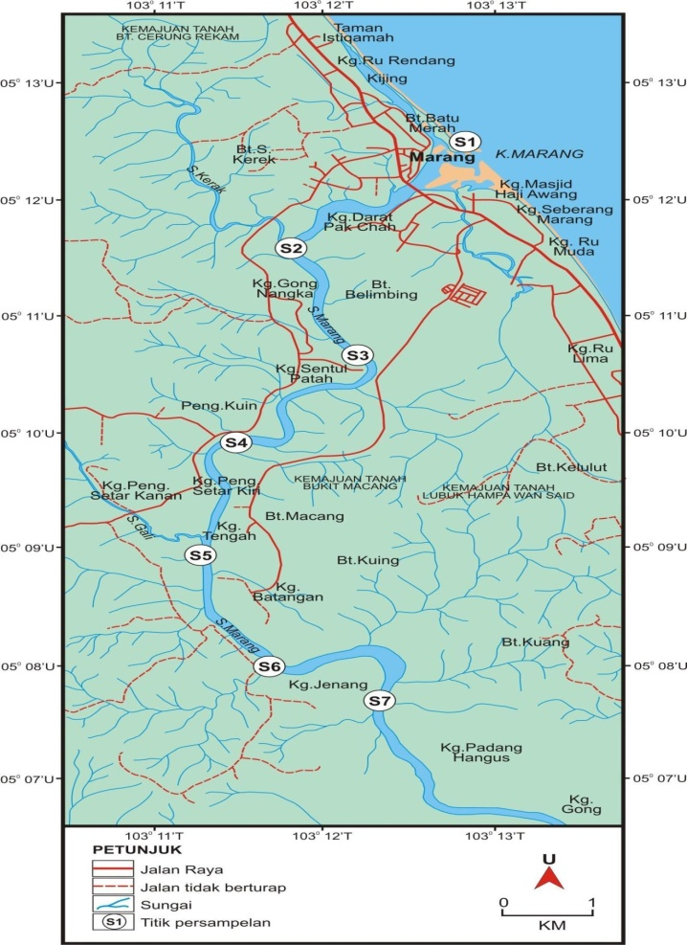

Figure 1. A map showing the seven sampling stations along Marang River

Materials and Methods
Sampling Methods
Seven sampling stations were selected along Marang River from downstream to upstream. The stations were 2km apart from each other. Sampling was done twice; the first sampling was in 13 November 2012 (rainy season) and was repeated in 24 February 2013 (dry season). At each station, in situ measurements were taken. The exact sampling location was determined using Global Positioning System (GPS). The second sampling process was done on the same locations according to recorded coordinates from the previous sampling. The recorded coordinate for sampling stations were illustrated in Table 1.

Table 1. Coordinate position at each sampling station

 | Station | Latitude | Longitude
 | 1 | N 05° 12' 34.9" | E 103° 12' 49.8"
 | 2 | N 05° 11' 36.41" | E 103° 11' 43.87"
 | 3 | N 05° 10' 38.51" | E 103° 12' 03.65"
 | 4 | N 05° 09' 53.16" | E 103° 11' 32.8"
 | 5 | N 05° 08' 59.55" | E 103° 11' 11.58"
 | 6 | N 05° 08' 00.29" | E 103° 11' 34.13"
 | 7 | N 05° 07' 41.04" | E 103° 12' 14.06"

Measurement of In Situ Parameters
The hydrological measurement such as river velocity, river width and river depth used specific equipments. River velocity was measured by using flow meter (model FP101), river width was measure by using a rangefinder (model Bushnell 20-0001) and river depth was measured by using a Speedtech SM-5 Depth Meter. All the equipments were calibrated before taking any measurement.

Determination of velocity
Velocity was measured on each section. For a shallow river into about 60 cm, the velocity is taken at the point of 0.6 times the depth of the river. If it exceeds 1m depth section, the velocity will be measured at two points, which is located on 0.2 and 0.8 of the depth to the surface (0.2d, 0.8 d). If the cross-sectional area (A) and mean velocity (v) is known. As the water depth and flow velocity is not uniform for the entire cross section. Proper discharge measurement is obtained by dividing the cross section into a series of sub-section. Each section is limited by surface water, the river bed and two imaginary vertical line, called Vertical (Fig. 2). Each vertical dimension is common to two adjoining sections, water depth and current velocity is set when the observations were made. Observations made sufficient velocity to derive the average velocity in each vertical boundary (Fig. 2). Then the average velocity of the section is:

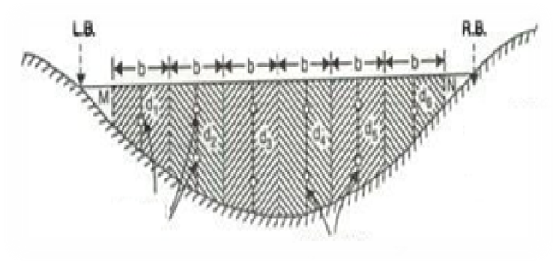
Location of flow Meter Alir
Vertical measurementfor velocity and depth

Figure 2. Measurement of velocity and water depth along the river segments

Laboratory Analysis

V = (v_{0.2d} x v_{0.8d})/2or v_{0.6d}
Q = (bd)(v_{0.2d} x v_{0.8d})/2 or = (bd)( v_{0.6d})

The results of the average velocity and the area of ​​each section will give a discharge. While the discharge from all sections will provide the total discharge as equation 1.

Q = (Q0,1) + (Q1,2) + (Q2,3) …….+ (Qn,n + 1) (1)

Data Analysis
One way ANOVA (Analysis of Variance) and SPSS (Statistical Package for the Social Sciences) software were used to analyze the collected data.

Results and Discussion
Hydrological measurements which consist of three fundamental hydraulic variables known as river width, river depth, and velocity which is required in order to determine the river discharge, Q. Description of each parameter is follow:

River Depth
For the first sampling (Fig. 3a), the river depth of Marang River at seven sampling stations were ranging from 3m to 5.7m for low tide and from 3.03m to 5.77m for high tide. Station 7 shows the highest depth during low and high tides at 5.7 m and 5.77 m respectively. During low tide, station 1 and station 3 were the shallowest (3m). During high tide, station 7 was the deepest (5.77m).Statistical analysis of one-way ANOVA revealed that there are significant differences (P < 0.05) in river depth between stations during first sampling. For the second sampling (Fig. 3b), the river depth were ranging from 3.7m to 6.47m for low tide and from 3.83m to 6.17m for high tide. Station 7 shows the highest depth value during low and high tides at 6.47 m and 6.17 m respectively. Station 1 show the lowest depth value during low and high tide at 3.7 m and 4 m respectively. Statistical analysis of one-way ANOVA revealed that there are significant differences (P < 0.05) in river depth between stations during second sampling.

Overall, almost all sampling stations show high reading of river depth during high tide compared to the reading recorded during low tide for both first and second sampling. This is because the seawater progress toward the land during high tide, and the mixing zone of freshwater and seawater move further inland, causing the water depth to become a little bit higher compared to record reading during low tide.

a

b

Figure 3. River depth at seven sampling stations during first (a) and second (b) samplings

River Width
For the first sampling the river width of Marang River at seven stations were ranging from 99m to 432m for low tide and from105m to 510m during high tide. Station 1 show the highest width value during low (432m) and high tides (510m). Station 7 shows the lowest width value during low 99m and high tides at105m (Fig. 4a).Statistical analysis of one-way ANOVA revealed that there are significant differences (P < 0.05) in river width between stations during first sampling. For the second sampling the river width of Marang River were ranging from 98m to 182m during low tide and from 101m to 210m for high tide. Station 1 shows the highest width value during low and high tides at 182m and 210m respectively. Station 7 shows the lowest value of width during low tide (98m) and station 5 and station 7 shows the lowest value of width (101m) during high tide (Fig. 4b).Statistical analysis of one-way ANOVA revealed that there are significant differences (P < 0.05) in river width between stations during second sampling.

River width was higher during high tides for almost at all over stations because the inflow of seawater during high tides towards the river, thus occupying more space at the river. Station 1 recorded higher value for high and low tides for both first and second sampling compared to other stations because it is situated at estuary of the Marang River.

a
b
Figure 4. Riverwidth at seven sampling stations during first (a) and second (b) samplings

River Velocity
For the first sampling the river velocity of Marang River at seven sampling stations were ranging from 0.28m to 0.74m during low tide and from 0.34m to 0.92m during high tide (Fig. 5a). Station 3 shows the highest velocity value during low tide (0.74 m/s) and station 1 show the highest velocity value during high tide (0.92 m/s). Station 7 shows the lowest value during low and high tides at 0.28 m/s and 0.34 m/s respectively. Statistical analysis of one-way ANOVA revealed that there are no significant differences (P > 0.05) in river velocity between stations during first sampling.

During second sampling, the river velocity of Marang River at seven stations were ranging from 0.19m to 0.39m for low tide and from 0.28m to 0.45m for high tide (Fig. 5b). Station 4 shows the highest velocity value during low tide (0.39 m/s). Station 3 and station 5 shows the highest value of velocity during high tide at 0.45 m/s. Station 7 shows the lowest value during low and high tides at 0.19 m/s and 0.28 m/s respectively. Statistical analysis of one-way ANOVA revealed that there are no significant differences (P > 0.05) in river velocity between stations during second sampling.

a

b

Figure 5. River velocity at seven sampling stations during first (a) and second (b) samplings

Water Discharge
For the first sampling the water discharge of Marang River at seven sampling stations were ranging from 79m³/s to 395.28m³/s for low tide and from 97.11m³/s to 602.12m³/s for high tide (Fig. 6a). Station 1 shows the highest water discharge value during low tides and high tides at 395.28m³/s and 602.12m³/s respectively. Station 7 shows the lowest value of water discharge during low and high tides at 79m³/s and 97.11m³/s respectively. Statistical analysis of one-way ANOVA revealed that there are significant differences (P < 0.05) for stream flow (discharge) between stations during first sampling.For the second sampling, the water discharge of Marang River at seven stations were ranging from 62.08m³/s to 138.41m³/s for low tide and from 87.24 m³/s to 167.94m³/s for high tide (Fig. 6b).

Station 4 shows the highest water discharge value during low tide at 138.41m³/s and station 3 shows the highest value of water discharge during high tide at 167.94m³/s. Station 7 shows the lowest value of water discharge during low and high tides at 62.08m³/s and 87.24m³/s respectively. Statistical analysis of one-way ANOVA revealed that there are no significant differences (P > 0.05) for stream flow (discharge) between stations during second sampling.

a

b

Figure 6. River discharge at seven sampling stations during first (a) and second (b) samplings

Conclusions
The hydrological variables in this study were controlled by the tidal activity which is high during high tide and low during low tide. Station 1 is located at the Marang River estuary and is identify as wide, shallow and sand bars along the shore during low tide but disappear during high tide, this part is acting as barrier in the estuary area which as a result of encounter with South China Sea. Areas around station 1 are the most highly developed among other stations, the development of fishing village, housings, jetty and other activities causes erosion and deposition along river bank, greater runoff, and mass movements of released sediments into the river. As a consequence, water depth around station 1 became shallower.

Correspondingly, seawater movement was further towards the upstream during high tides due to the effect of tidal fluctuation during high tides. Seawater movement is also greater during dry season since less freshwater flow from the upstream due to minimal rainfall intensity during Southeast Monsoon. But during rainy season, higher of water discharge due to heavy rainfall intensity and also increase in height of water tides, this can explained why coastal areas are highly susceptible to flooding problems especially during Northeast Monsoon.

Acknowledgments
The authors would also like to thank to East Coast Environmental Research Institute (ESERI, UniSZA) for the use of their research facilities.

References
- Jamaludin, S., Jemain, A. A., Hamdan, M. F. and Zin, W. Z. W. (2011). Comparing rainfall patterns between regions in Peninsular Malaysia via afunctional data analysis technique. Journal of Hydrology 411: 197-206.
- Mannina, G. and Viviani, G. (2010). Water quality modelling for ephemeral rivers: model development and parameter assessment. Journal of Hydrology 393: 186-196.
- Ravenscroft, N. O. M. and Beardall, C. H. (2003). The importance of freshwater flows over estuarine mudflats for wintering waders and wildfowl. Journal of Biological Conservation 113(1): 89-97.
- Li, Y. P., Huang, G. H. and Nie, S. L. (2009). A robust interval-based minimax-regret analysis approach for the identification of optimal water-resources-allocation strategies under uncertainty. Journal of Resources, Conservation and Recycling 54(2): 86-96.
- Li, Y. P., Huang, G. H. and Nie, S. L. (2010). Planning water resources management systems using a fuzzy-boundary interval-stochastic programming method. Journal of Advances in Water Resources 33(9): 1105-1117.
- Davies, E. G. R. and Simnovic, S. P. (2011). Global water resources modeling with an integrated model of the social economic-environmental system. Journal of Advances in Water Resources 34(6): 684-700.
- Kumar, P. K. D., Kumar, S. P., Roshin, R. P., Narvekar, J. and Vivekanandan, E. (2009). Response of the Arabian Sea to global warming and associated regional climateshift. Journal of Marine Environment 68: 217-222.
- Shaffril, H. A. M., Samah, B. A., D’Silva, J. L. and Uli. J.(2011). Global warming at the east coast zone of Peninsular Malaysia. Journal of Agricultural and Biological Sciences 6(3): 377-383.
- Wilby, R. L., Orr, H., Watts, G., Battarbee, R.W., Berry, P.M., Chadd, R., Dugdale, S.J., Elliott, J. A., Extence,C., Hannah, D. M., Holmes, N., Johnson, A. C., Knights, B.,Milner, N. J., Ormerod, S. J., Solomon, D., Timlett, R., Whitehead, P. J. and Wood, P. J. (2010). Evidence needed to manage freshwater ecosystems in a changing climate: Turning adaptation principles into practice. Journal of Science of the Total Environment 408(19): 4150-4164.
- Chang, S. W., Clement, T. P., Simpson, M. J. and Lee, K. K. (2011). Does sea-level rise have an impact on saltwater intrusion?. Journal of Advances in Water Resources 34(10): 1283-1291.
- Werner, A. D., Bakker, M., Post, V. E. A., Vandenbohede, A., Lu, C., Ashtiani, B. A., Simmons, C. T. and Barry, D. A. (2012). Seawater intrusion processes, investigation and management: recent advances and future challenges. Advances in Water Resources 51: 3-26.
- Tsimplis, M., Spada, G., Marcos, M. and Flemming, N. (2011). Multi-decadal sea level trends and land movements in the Mediterranean Sea with estimates of factors pertubing tide gauge data and cumulative uncertainties. Journal of Global and Planetary Change 76: 63-76.
- Meyssignac, B., Calafat, F. M., Somot, S., Rupolo, V., Stocchi, P., Llovel, W. and Cazenave, A. (2011). Two-dimensional reconstruction of the Mediterranean Sea level over 1970-2006 from tide gage data and regional ocean circulation model outputs. Journal of Global and Planetary Change 77(1-2): 49-61.
- Trisirisatayawong, I., Naieje, M., Simons, W. and Marc, L. F. (2011). Sea level change in the Gulf of Thailand from GPS-corrected tide gauge data and multi-satellite altimetry. Journal of Global and Planetary Change 76(3-4): 137-151.
- Pickering, M. D., Wells, N. C., Horsburgh, K. J. and Green, J. A. M. (2012). The impact of future sea level rise on the European Shelf tides. Journal of Continental Shelf 35: 1-15.
- Boretti, A. (2012). Is there any support in the long term tide gauge data to the claims that parts of Sydney will be swamped by rising sea level?. Journal of Coastal Engineering 64: 161-167.
- Lombart, A., Cazenave, A., DoMinh, K., Cabanes, C. and Nerem, S. (2005). Thermosteric sea level rise for the past 50 years; comparison with tide gauges and inference on water mass contribution. Journal of Global and Planetary Change 48(4): 303-312.

