

MALAYSIAN JOURNAL OF ANALYTICAL SCIENCES
ISSN 1394 - 2506

Published by The Malaysian Analytical Sciences Society

MEASUREMENT TECHNIQUE IN RADIO FREQUENCY INTERFERENCE (RFI) STUDY FOR RADIO ASTRONOMY PURPOSES

(Teknik Pengukuran dalam Kajian Gangguan Interferen Radio (RFI) bagi Tujuan
Astronomi Radio)

Roslan Umar^{1,2}*, Nor Hazmin Sabri³, Zainol Abidin Ibrahim⁴, Zamri Zainal Abidin⁴, Asyaari Muhamad^{1,5}

¹East Coast Environmental Research Institute (ESERI)
²Faculty of Islamic Contemporary Studies
Universiti Sultan Zainal Abidin, Gong Badak Campus, 21300 Kuala Terengganu, Terengganu, Malaysia
³School of Fundamental Science,
Universiti Malaysia Terengganu, 21030 Kuala Terengganu, Terengganu, Malaysia
⁴Department of Physics, Faculty of Science,
Universiti of Malaya, 50603 Kuala Lumpur, Malaysia
⁵Institute of The Malay World and Civilisation (ATMA),
Universiti Kebangsaan Malaysia, 43600 UKM Bangi, Selangor, Malaysia

*Corresponding author: roslan@unisza.edu.my

Received: 14 April 2015; Accepted: 9 July 2015

Abstract
In this paper, we will review our method in making measurements of radio frequency interference (RFI) in order to investigate the sereneness of interference in selected radio interference in Malaysia and Thailand. The selected site are University of Malaya (UM), Universiti Pendidikan Sultan Idris (UPSI), Ubon (UB) and Chiang Mai (CM). The major RFI affecting radio astronomical windows below 1 GHz are electronic equipment system specifically radio navigation between 73.1 MHz and 75.2 MHz, radio broadcasting (151 MHz, 151.8 MHz and 152 MHz), aeronautical navigation (245.5 MHz, 248.7 MHz and 249 MHz and also fixed mobile at 605 MHz, 608.3 MHz, 612.2 MHz, 613.3 MHz. It is obviously showed that all sites within this region are free from interference between 320MHz and 330 MHz and is the best specific region to be considered for solar burst monitoring. We also investigate the effect of RFI on discovery of solar burst.

Keywords: Radio Frequency Interferences, Radio Astronomical Windows, solar burst

Abstrak
Dalam kajian ini, kajian semula kaedah kami dalam membuat pengukuran gangguan frekuensi radio (RFI) untuk mengkaji kesan gangguan dalam gangguan radio terpilih di Malaysia dan Thailand. Tapak dipilih antaranya adalah Universiti Malaya (UM), Universiti Pendidikan Sultan Idris (UPSI), Ubon (UB) dan Chiang Mai (CM). Faktor utama yang memberi kesan kepada RFI tingkap astronomi radio di bawah 1 GHz antaranya adalah sistem elektronik peralatan khusus seperti navigasi radio antara 73.1 MHz dan 75.2 MHz, penyiaran radio (151 MHz, 151,8 MHz dan 152 MHz), navigasi aeronautik (245,5 MHz, 248,7 MHz dan 249 MHz dan juga telekomunikasi mudah alih tetap pada 605 MHz, 608,3 MHz, 612,2 MHz, 613,3 MHz. Ia jelas menunjukkan bahawa semua tapak di rantau ini bebas daripada frekuensi antara 320MHz dan 330 MHz dan kawasan yang terbaik khusus boleh dipertimbangkan untuk pemantauan kajian solar. Kami juga akan mengkaji kesan RFI pada penemuan letupan solar.

Kata kunci: Gangguan Frekuensi Radio, Tingkap Astronomi Radio, letupan solar

Introduction
Multi-wavelength astronomy has become a very significant scientific tool in observing the outer space, especially since the discovery of radio astronomy in the 1950s. Radio astronomy holds an advantage over other alternatives to optical astronomy due to its capability of observing from the earth. Radio astronomy research is complementary to optical astronomy [1]. Early studies of radio frequency interference are important to create good atmosphere in the radio astronomy observatory condition. Radio astronomy in Malaysia is still young, especially in the study of astronomy application. Abidin et al. [2]was investigated the radio frequency interference (RFI) affecting CALLISTO at several stations, they found that the RFI severely affecting CALLISTO within radio astronomical windows below 870 MHz are in the ranges of 80–110 MHz and 460–500 MHz. Radio astronomy normally focuses on higher frequency since low windows monopoly by industrial and commercial activity. As a result, the study of the level of interference in the spectrum or band allocated helps us to identify the best site with a quiet and peaceful environment to observe the astronomical objects [3].

The advancement of the interferometer technology has also enhanced the capability of higher sensitivity radio imaging. The use of the interferometer technique can also make radio astronomical telescopes comparable to the Hubble Space Telescope in sensitivity. There are several important frequencies in the radio band that covers many scientific research of the radio sky, especially the deuterium spectral line window (322 MHz to 328 MHz) to study structure of radio galaxy. We also focus our attention to the frequency windows of below 1000MHz [1]. Others purposes and important radio astronomical windows are; 13.36 MHz - 13.41 MHz and 37.5MHz – 38.25 MHz for decametric radiation from Jupiter and sun and 73 MHz – 74 MHz for monitoring interplanetary weather structure in solar wind [4]. These frequencies are listed by the International Astronomical Union (IAU) as important astrophysical windows in the radio frequency [1].

Materials and Methods
To observe the RFI, Ambrosini reported that the discone antenna can be used for Square Kilometer Array (SKA) project to identify the low or high RFI [5]. The discone has a pattern which is uniform in azimuth, with a maximum gain slightly below the horizon and nulls toward the zenith and nadir. These antennas are primarily vertically polarized with uniform azimuthal directivity. The Discone antenna was used as a one solution in order to identify surrounding RFI near the observation site. Material for discone may be made from solid metal (normally we used copper) [1]. Discone antenna very suitable for small indoor Very High Frequency (VHF) antenna such as WIFI. To study RFI below 1000MHz, the specified value in making discone as shown in Figure 1.

The RFI measurement system utilised here comprises of a spectrum analyser (Protek 3290N) that covers frequencies up to 2.8 GHz with a 180-kHz resolution bandwidth. 1.4-GHz LNA with 28 dB gain/0.34 dB NF was used with a discone antenna optimised at L-band. For instrument procedure in this research as shown in flow chart in Figure 1.

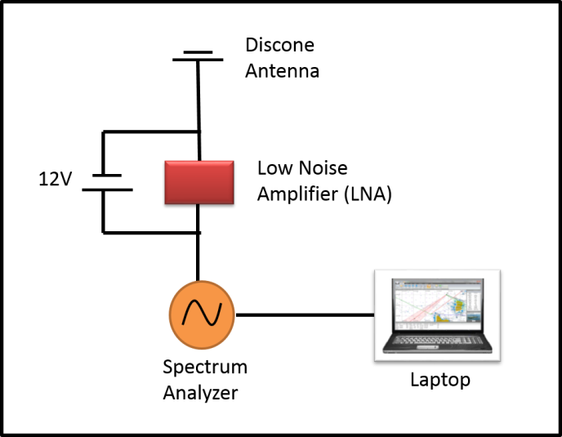

Figure 1. Instrument setup for observation work [1]

Therefore, it is important to have a several sites so that we can select a better data. There are four sites seleted in this study namely University of Malaya (UM), Universiti Pendidikan Sultan Idris (UPSI), Ubon (UB) and Chiang Mai (CM). Detail average power in dBm can be seen in Table 1.

Table 1. Average RFI and standard deviation for selected sites
Standard Error | Sites
Standard Error | UM | UPSI | UB | CM
Power level in dBm | 98.7 | 98.3 | 96.7 | 92.7
Standard deviation | 4.4 | 5.9 | 5.4 | 6.8

Results and Discussion
We also investigate the effect of RFI on detection of solar burst. So far, we have considered solar burst type III. It should be note that as the degree of X-ray radiation produced by a solar flare increased, the greater was the intensity of radio interference from the Sun. Radio noise burst are often associated with flares and are observed in the 4 to 400 MHz frequency range [6].

The 153.438 MHz band is important and reserve for solar radio observation. However, observations at these frequencies are complicated by pulsed interference from local interference. As a result, the performance at certain sites will be dominant with RFI.

It must be highlighted that there are different types of interference unpredictable, well-known interference, permanently and non-permanently RFI. From the present data one may derive several predictions. Based on the spectral monitoring, a lot of military satellites were identified between 190MHz and 270MHz. The signals are thought to be due to a local oscillator at 296MHz. Several windows of spectral ranges are almost free from interferences [6,7].

The RFI spectra observed in the selected sites (UM, UPSI, UB and CM) are listed and analysed in Figures 2 - 5. For the frequency band below 1000 MHz. We can obviously observe that in the range from 300 MHz - 400 MHz, this part of the windows is very unpolluted and undisturbed (see Figure 5). In addition, we can also use this window which is from 250 - 270 MHz even though there is a moderate interference. All reserved frequencies are still free from interference. However, most of the tough and vary interferences are homemade create from nearby electronic devices and local oscillators and clearly been seen from 85 MHz - 150 MHz. To eliminate the interferences is not easy as we think. From to the results, there are several frequency ranges was identified for useful astronomical observations; between 45 MHz and 80 MHz, between 240 MHz and 380 MHz and between 780 MHz and 850 MHz.
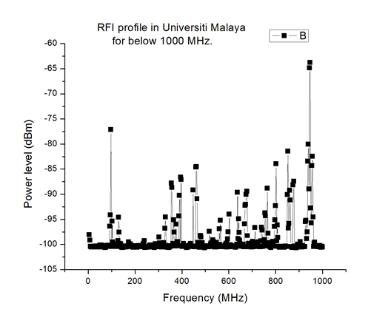
Figure 2. RFI profile in University of Malaya with average/standard deviation (98.7/4.4)

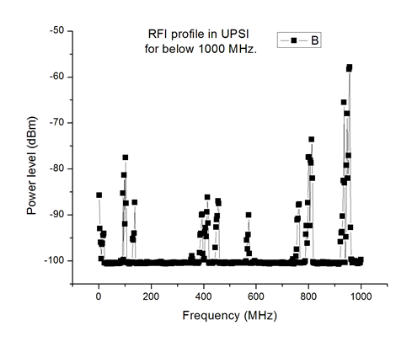
Figure 3. RFI profile in UPSI with average/standard deviation (98.3/5.9)

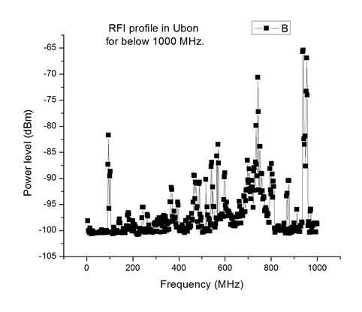
Figure 4. RFI profile in Ubon with average/standard deviation (96.7/5.4)

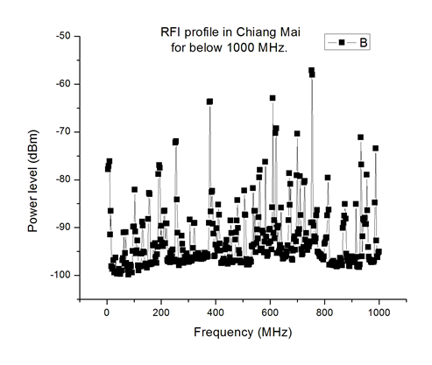
Figure 5. RFI profile in Chiang Mai with average/standard deviation (92.7/6.8)

Conclusion
RFI monitoring at low frequencies region (45-870) MHz has been discussed. Radio Frequency Interference (RFI) gives a great impact in in radio astronomical especially in solar field. The radio frequency interference region could be recognized by setting up a RF interference survey at the chosen location. We can conclude that UPSI in Tanjung Malim, Malaysia is the best site to observe solar monitoring. Nevertheless, other sites also could be possible to detect the best time of solar events. For the future we need to developed e-CALLISTO network to growing with potential solar burst candidate data [2,8].

Acknowledgement
This paper is made possible by the usage of the Universiti sultan Zainal Abidin grants RACE/F1/ST1/UNISZA/15. The author would also like to thank Universiti of Malaya and UPSI for their equipment and facility.

References
- Abidin, Z. Z., Umar, R., Ibrahim, Z. A., Rosli, Z., Asanok, K. and Gasiprong, N. (2013). Investigation on the Frequency Allocation for Radio Astronomy at the L Band. Publications of the Astronomical Society of Australia, 30, e047.
- Abidin, Z. Z. Anim, N. M. Hamidi, Z. S. Monstein, C. Ibrahim, Z. A. Umar, R. Shariff, N. N. M. Ramli, N. Aziz, N. A. I. and Sukma, I. (2015). Radio frequency interference in solar monitoring using CALLISTO. New Astronomy Reviews 67: 18 – 33.
- Umar, R., Abidin, Z. Z., Ibrahim, Z. A., Rosli, Z. and Noorazlan, N. (2014). Selection of Radio Astronomical Observation Sites and Its Dependence on Human Generated RFI. Research in Astronomy and Astrophysics 14: 241-248.
- Cohen, J. T. S., Ambrosini, R. and Van Drie, W. (2005), CRAF Handbook for Radio Astronomy (United Kingdom: European Science Foundation)
- Ambrosini, R., Bolli, P., Bortolotti, C., Gaudiomonte, F., Messina, F. and Roma, M. (2010), ExA, 27, 121
- MCMC, Spectrum Plan (2011). Malaysian Communications and Multimedia Commission.
- NBTC, Thailand Table of Frequency Allocations (2011). National Broadcasting and Telecommunication Commission (NBTC) of Thailand.
- Hamidi, Z. S., Shariff, N. N. M., and Monstein, C. (2014). Comparison of the Radio Frequency Interference (RFI) in the Region of Solar Burst Type III Data at Selected CALLISTO Network. International Letters of Chemistry, Physics and Astronomy 10: 38-45.

