

MALAYSIAN JOURNAL OF ANALYTICAL SCIENCES
ISSN 1394 - 2506

Published by The Malaysian Analytical Sciences Society

RADIO FREQUENCY INTERFERENCE: THE STUDY OF RAIN EFFECT ON RADIO SIGNAL ATTENUATION

(Interferens Frekuensi Radio: Kajian Kesan Hujan Pada Pengecilan Isyarat Radio)

Roslan Umar^{1,2}, Shahirah Syafa Sulan³, Atiq Wahidah Azlan³, Zainol Abidin Ibrahim⁴,
Wan Zul Adli Wan Mokhtar⁵, Nor Hazmin Sabri⁶*

¹East Coast Environmental Research Institute (ESERI)
²Faculty of Contemporary Islamic Studies
Universiti Sultan Zainal Abidin, Gong Badak Campus, 21300 Kuala Terengganu, Terengganu, Malaysia
³School of Ocean Engineering,
Universiti Malaysia Terengganu, 21030 Kuala Terengganu, Terengganu, Malaysia
⁴Physics Department, Faculty of Science,
Universiti of Malaya, 50603 Kuala Lumpur, Malaysia
⁵Department of Physics, Faculty of Science and Mathematics,
Universiti Pendidikan Sultan Idris, 35900 Tanjung Malim, Perak, Malaysia
⁶School of Fundamental Science,
Universiti Malaysia Terengganu, 21030 Kuala Terengganu, Terengganu, Malaysia
*Corresponding author: norhazmin@umt.edu.my

Received: 14 April 2015; Accepted: 9 July 2015

Abstract
The intensity of radio waves received by radio telescopes is always not subject to human control. In the millimetre band, the propagation of the electromagnetic waves is severely affected by rain rate, dust particle size and drop size in the terms of attenuation, noise and depolarization. At the frequency above 10 GHz, the absorption and scattering by rain cause a reduction in the transmitted signal amplitude which will lead to the reducing of the availability, reliability and performance on the communications link. In this study, the rain effect on radio signal has been investigated. Spectrum analyzer and weather stations were used to obtain the RFI level and rain rate data respectively. The radio frequency interference (RFI) pattern due to rain factor was determined. This will benefit radio astronomer in managing sites for radio observation for radio astronomy purposes.

Keywords: Radio Frequency Interference (RFI), rain effect, radio signal attenuation, radio astronomy

Abstrak
Keamatan gelombang radio yang dikesan oleh teleskop radio sentiasa tidak tertakluk kepada kawalan manusia. Dalam jalur panjang gelombang milimeter, perambatan gelombang elektromagnet terjejas teruk dengan kadar hujan, saiz zarah debu dan saiz titisan dalam terma pengecilan, hingar dan penyahkutuban. Pada frekuensi gelombang radio melebihi 10 GHz, penyerapan dan penyerakan oleh hujan menyebabkan pengurangan amplitud isyarat yang dihantar yang akan mengakibatkan gangguan isyarat dan prestasi hubungan telekomunikasi. Dalam kajian ini, kesan hujan pada isyarat gelombang radio telah dikaji. Penganalisa spektrum dan stesen kajicuaca digunakan untuk mendapatkan nilai RFI dan kadar hujan. Corak interferens frekuensi radio (RFI) yang disebabkan faktor hujan ditentukan. Ini akan memberi manfaat kepada ahli astronomi radio dalam menentukan lokasi untuk cerapan radio untuk tujuan kajian astronomi.

Kata kunci: Interferens Frekuensi Radio (RFI), kesan hujan, penurunan isyarat radio, astronomi radio

Introduction
Radio Astronomy is being a passive service which concerned only with the reception of radio waves that occur naturally. The humans cannot control the intensity of the radio waves as the frequencies are fixed by laws of nature. [1]. The radio communication systems’ performance depends on the propagating medium, called the atmosphere which occurs between the transmitter and the receiver. The physical characteristics of the atmosphere like temperature and pressure are depended by the radio channels which cause the radio channels to be very random. Plus, the propagating wave itself depends on the wavelength and its polarization while travelling through the atmosphere. The effect of the atmosphere will increase when the frequency of the signal increases [2]. In 2009, radio astronomy research was done in University of Malaya, where several suitable sites are suggested to locate a telescope with low in RFI [3-5].

The scattering and absorption of the electromagnetic waves by drops of water will cause rain attenuation. The scattering will diffuse the signal, while the resonance of the waves with individual molecules of water is involved in the absorption. With a few temperature increases, the molecular energy is increased by the absorption which led to the loss of signal energy.

Rain attenuation can be affected by factors such as rain rate, polarization, physical size of drops and operating frequency. During a heavy rainfall, the raindrops fall with a significant canting angle due to the strong winds basically occurs together with such events. Therefore, rain attenuation is related to the rain rate and the scattering with absorption mechanism of raindrops at the operating frequency [6,7]. According to Umar in 2014, human generated RFI also to be a factor that attenuate radio signal. They also discussed several factor that limited signal observed from outer space [8].

The goal of this research is to find the threshold levels for the rain rate. We determined the values of rain rate with the worst Radio Frequency Interference (RFI). Based on the rain rate distribution in Malaysia, we will be able to determine places with their RFI values in order to produce an RFI Map or RFI Profile, at the end of this research. Based on this map, we will be able to determine the best place in order to put the radio telescope. As Malaysia is one of the countries with the tropical climate, this map is going to be used to get the most suitable place to put the radio telescope according to the climate. The characteristics of the electromagnetic waves differ with the different frequency bands. So, it is necessary to completely understand the propagating characteristics and develop a channel model for the wireless communication system proposal before the site-specific planning and deployment can be started [2].

Materials and Methods
The main equipment used in this project are spectrum analyzer (SPECTRAN HF-6080 V4) and weather station (Davis Vantage Pro2) located at KUSZA Observatory, Institut Penyelidikan Alam Sekitar Pantai Timur (ESERI), UniSZA in Merang, Setiu, Terengganu. Same technique has been used in this study to measure and analysis RFI level as discuss in Abidin et al. [3,4,5]. The frequency below 8GHz was focused which at least 5 radio astronomical frequency windows were covered including Deuterium line (328MHz) and Hydrogen line (1420MHz) [5]. The flow of instruments set up and setting is shown in Figure 1.

An omni antenna was attached to spectrum analyzer to capture the radio waves in surrounding while the weather station read the rain rate data. All of the data obtain were then analyzed to investigate the relationship between frequency attenuation and rain rate factor.

Antenna
Spectrum Analyzer
Computer

Figure 1. Flow of instruments set up and setting

Results and Discussion
These observations were made within 1 hour at KUSZA Observatory on 17 December 2014. Figure 2 shows the average RFI level for all frequencies up to 8GHz.

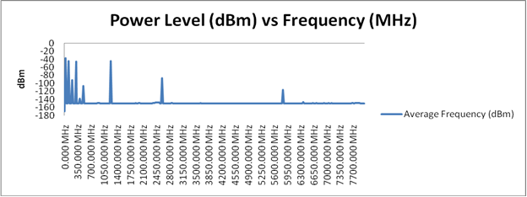
Figure 2. Graph of Power Level (dBm) vs Frequency (MHz) on 17 December 2014

Based on Figure 2, there were nine peaks overall relied on different frequencies which cover from 25MHz, 200MHz, 300MHz, 375MHz, 500MHz, 1000MHz, 1225MHz, 2600MHz and 5825MHz. The graph of RFI level difference and rain rate over time have been plotted to see the relationship between these two variable. How the RFI level difference responds to the change of rain rate were determined.

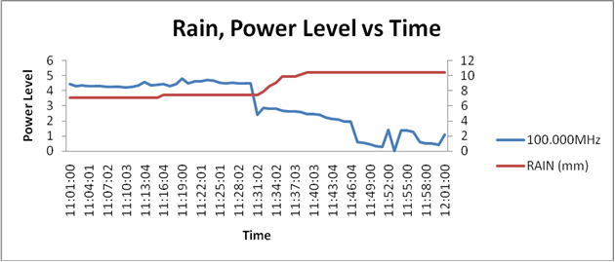
Rain rate
Figure 3. Graph of Rain, Power Level Difference vs Time – 100.000MHz

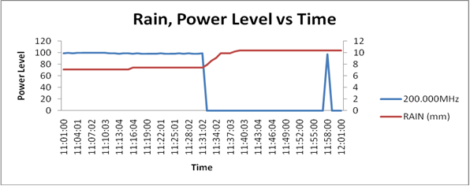
Rain rate
Figure 4. Graph of Rain, Power Level vs Time – 200.000MHz

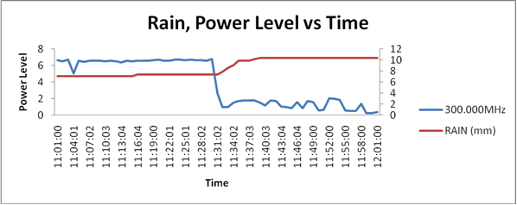
Rain rate
Figure 5. Graph of Rain, Power Level Difference vs Time – 300.000MHz
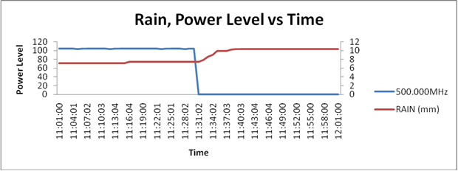
Rain rate
Figure 6. Graph of Rain, Power Level Difference vs Time – 500.000MHz

Based on the plots in Figure 3 until Figure 6, it can obviously seen from the graph that the RFI level difference responds to the rain rate. At 1131hours the rain rate drop rapidly. The RFI difference increase as the rain rate decrease. Thus, we can say that the radio signal is affected by the rain. The effect of rain on radio astronomical sources should be investigate so we can determine the effect on radio astronomy signals from outer space.

Therefore, the identified candidate for radio objects are galaxies NGC1566 and NGC289, galaxy clusters A262, A85 and A569 besides galaxy pairs NGC 3226 and NGC 2237 [5]. Among the science goals, the study of the evolution of these objects and their dark matter content will be included in the future [10].

Conclusion
In conclusion, we can say that the rain factor give a significant effect to radio signal. However, we suggest that the observation should run in 24 hours and the antenna should connect to the LNA for future observation. The instrument and antenna calibration also needed before observation set up.

Acknowledgement
This study is made possible by the usage of the grant RACE/F1/ST1/UNISZA/15. The authors gratefully acknowledge Universiti Malaysia Terengganu, Universiti Sultan Zainal Abidin and Universiti Pendidikan Sultan Idris for the financial and experimental support of this work. Special thanks are also dedicated to other researchers Electromagnetic Research Group (EMRG) for their assistance in this work.

References
- Cohen, J., Spoelstra, T., Ambrosini, R. and Driel, W. V. (2005). CRAF Handbook for Radio Astronomy. European Science Foundation.
- Omotosho, T. and Oluwafemi, C. (2009). Impairment of radio wave signal by rainfall on fixed satellite service on earth-space path at 37 stations in Nigeria. Journal of Atmospheric and Solar-Terrestrial Physics 71: 1-12.
- Abidin, Z. Z., Syed Adnan, S. S. B. R. and Ibrahim, Z. A. (2010). RFI profiles of prime candidate sites for the first radio astronomical telescope in Malaysia. New Astronomy 15(3): 307-312.
- Abidin, Z. Z., Ibrahim, Z. A., Adnan, S. B. R. S. and Anuar, N. K. (2009). Investigation of radio astronomical windows between 1 MHz and 2060 MHz in Universiti Malaya, Malaysia. New Astronomy 14(6): 579-583.
- Abidin, Z., Umar, R. Ibrahim, Z. Rosli, Z. Asanok, K. and Gasiprong, N. (2013). Investigation on the Frequency Allocation for Radio Astronomy at the L Band Publications of the Astronomical Society of Australia, Cambridge Univ Press, 30: pp 047.
- Agber, J. U. and Akura, J. M. (2013). A High Performance Model for Rainfall Effect on Radio Signals. Journal of Information Engineering and Applications: 1-12.
- Calla, O. and Purohit, J. (n.d.). Study of Effect of Rain and Dust on Propagation of Radio Waves at Millimeter Wavelength. 1-4.
- Umar, R. Abidin, Z. Z., Ibrahim, Z. A. Rosli, Z. and Noorazlan, N. (2014). Selection of radio astronomical observation sites and its dependence on human generated RFI Research in Astronomy and Astrophysics, IOP Publishing 14 (2): 241 - 248.
- MCMC manual of ‘Spectrum Plan (2006). MCMC manual of ‘Spectrum Plan, Malysian Communication and Multimedia Commission’. (2006). Resources Assignment Management Department Available Access: http://www.mcmc.gov.my/what_we_do/spectrum/plan.asp.
- Hashim, N. Abidin, Z. Ibrahim, U. Hassan, M. Hamidi, Z., Umar, R. and Ibrahim, Z. (2015). The Nonlinear Least Square Fitting for Rotation Curve of Orion Dwarf Spiral Sains Malaysiana, Universiti Kebangsaan Malaysia, 44, 457-462.

