

MALAYSIAN JOURNAL OF ANALYTICAL SCIENCES
ISSN 1394 - 2506

Published by The Malaysian Analytical Sciences Society

THE WATER QUALITY STUDY AND SOURCES OF POLLUTION IN ALUR ILMU, UKM

(Kajian Kualiti Air dan Punca-Punca Pencemaran di Alur Ilmu, UKM)

Nurul Afina Abd Mutalib¹, Othman A. Karim¹*, Ahmad Dasuki Mustafa²

¹Department of Civil & Structural Engineering,
Universiti Kebangsaan Malaysia, 43600 UKM Bangi, Selangor, Malaysia

²East Coast Environmental Research Institute (ESERI),

Universiti Sultan Zainal Abidin, 21300 Kuala Terengganu, Terengganu, Malaysia

*Corresponding author: othman.karim@ukm.edu.my

Received: 14 April 2015; Accepted: 9 July 2015

Abstract
The Alur Ilmu UKM is a large storm water channel that serves to store water and flows into Langat River. The primary objective of this study are to identify the water quality and pollution levels, the sources of which may cause pollution and to measures the control pollution that occurs in the area. Water sampling was carried out in order to determine the quality of water. The sampling water was taken during no-rain and after rainfall. The area includes UKM Forest Reserve (Hutan Pendidikan Alam – HPA), Student Cafeteria (Teres Eko Niaga), Restaurant of Fakulti Sains dan Teknologi (FST), Student Centre (Pusanika), Fakulti Pendidikan Islam (FPI) and UKM Mosque. Eight water quality parameters i.e consisting of Biochemical Oxygen Demand (BOD), Chemical Oxygen Demand (COD), pH, Turbidity, Total Suspended Solids (TSS), Total Kjeldahl Nitrogen (TKN), Temperature, Oil and Grease (O&G) were measured. The results shows that the water quality are in a class III and IV according to Water quality Index (WQI) and the water meet the standard B that set out in the Regulations of the Environmental Quality (Sewage and Effluent).

Keywords: Alur Ilmu, water quality index, point of sources pollution, water quality parameters, pollution

Abstrak
Alur Ilmu UKM merupakan sebuah saluran air ribut besar yang berfungsi untuk menakung air dan mengalir ke Sungai Langat. Kajian tentang Kualiti air dan punca-punca pencemaran di Alur Ilmu UKM telah dijalankan. Objektif utama kajian ini adalah untuk menentukan kualiti air disepanjang Alur Ilmu, membina pangkalan data punca-punca pencemaran di pencemaran titik dan pencemaran bukan titik serta mencadangkan langkah-langkah yang boleh diambil untuk mengawal pencemaran dan rehabilitasi. Untuk menentukan kualiti air, beberapa kawasan persampelan air dilakukan. Kawasan tersebut adalah di Hutan Pendidikan Alam (HPA), Restoran Fakulti Sains dan Teknologi (FST), Teras Eko Niaga, Pusanika, Fakuliti Pengajian Islam (FPI) dan masjid UKM. Pengukuran dilakukan ke atas lapan parameter kualiti air yang terdiri daripada Permintaan Oksigen Biokimia (BOD), Permintaan Oksigen Kimia (COD), pH, Kekeruhan, Jumlah Pepejal Terampai (TSS), Jumlah Nitrogen Kjeldahl (TKN), Suhu, Minyak dan Gris. Secara keseluruhannya, kualiti air berada dalam kelas III dan IV mengikut Indeks Kualiti Air (IKA) dan memenuhi piawaian B yang dinyatakan dalam Peraturan-Peraturan Kualiti Alam Sekeliling (Kumbahan dan Efluen).

Kata kunci: Alur Ilmu, indeks kualiti air, titik sumber tercemar, parameter kualiti air, pencemaran

Introduction
Nowadays, the demand for clean water is rising from day to day. This is due to the proliferation of high population and the reality of the world that is fast growing and developing. Furthermore, the economic growth causes the level of household income rising and boost a higher demand for additional water [1]. The increasing in population on urban areas indicates that there is an increase of environmental pressure on the river, especially in urban rivers. The increasing demand of the water resources will increase the pressure on water supply [2]. Growing population can exert pressure on natural water and also damaging water quality and disrupt the hydrological processes. This is because human activities can increase pollutants in the water whether it is intentionally or accidentally. Therefore, the water quality is an environmental factor of river that is often affected by urbanization [3].

The water pollution can be determined by point source and non-point sources. Point source pollution is pollution that can be related with a particular physical location and easily identifiable. The location of point sources includes sewage treatment plants, industrial plants, facilities and others. Normally these pollutants are out from the piping system. The non-sources point is pollution that cannot be identified with unassisted vision. Generally this non-source point caused by rainfall that seeping to the ground. As the runoff moves, it picks up and carries away natural and human-made pollutants that finally depositing them into river. The river flow can carry a large amount of material consisting of organic, inorganic and dissolved substances that cause the water is unsuitable for direct use [4].
The weather can also affect the water quality in the river. Typically, pollution in water body will be lower during hot season compared to wet season (rainfall). This is because when heavy downpours occurs it can increase the amount of runoff into rivers by washing out the sediment, nutrients, pollutants, trash, animal waste, and other materials into water supplies. Thus, making them unusable, unsafe, or needed of water treatment. These effects can reduce the quality of water. The direct correlation with the frequency and intensity of rainfall runoff with river discharge volume affects the load of pollutants affecting the water quality of the river [5].

Materials and Methods
Study Area
These studies have been conducted in an open channel that passes through UKM, also known as Alur Ilmu (N2˚ 56’ 24’’ – E 101˚ 47’ 24’’) UKM. This river at Hutan Pendidikan Alam UKM (upstream) running through the (downstream) border of UKM to Sungai Langat, Selangor. Six water samples were taken, namely UKM Forest Reserve (Hutan Pendidikan Alam – HPA); Student Cafeteria (Teras Eko Niaga); Restaurant at FST; Student Centre (Pusanika); Faculty of Islamic Studies and UKM Mosque (refer Figure 1).

Laboratory Analysis
Water quality experiment is divided into two conditions that is after the rainfall and when it is not raining. Analysis of the water sampling was conducted in the laboratory according to the parameters that have been classified. These includes the biochemical oxygen demand (BOD), chemical oxygen demand (COD), total suspended solids (TSS), total kjeldahl nitrogen (TKN), turbidity, pH, temperature, oil and grease (O&G).

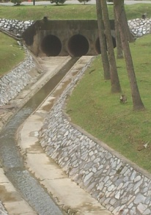
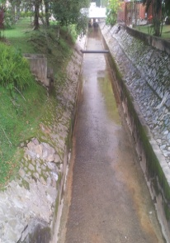
Faculty of Islamic Studies (FPI)
UKM Mosque
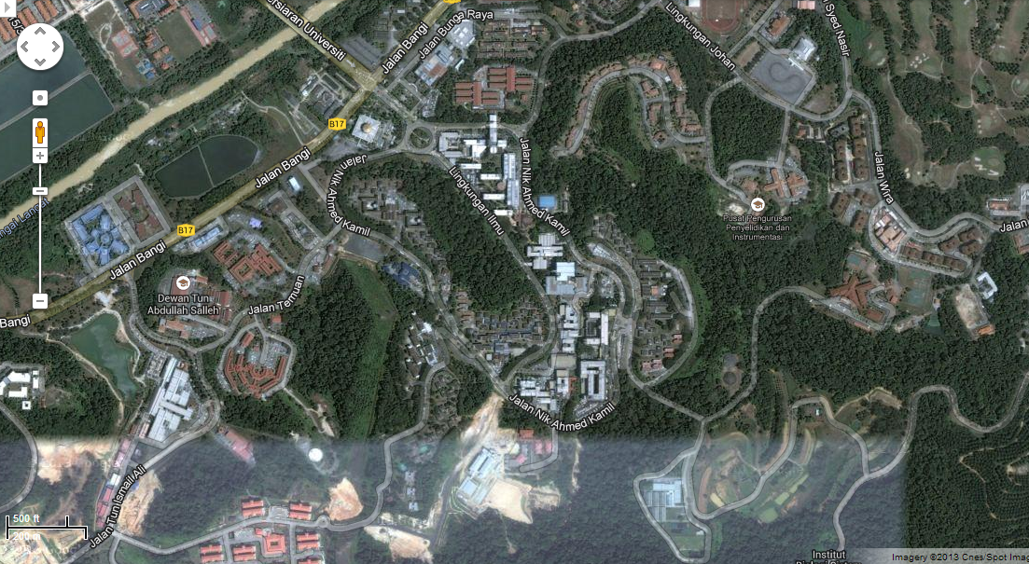
Teres Eko Niaga
Pusanika
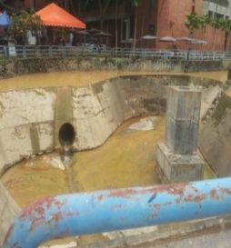
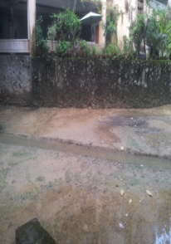
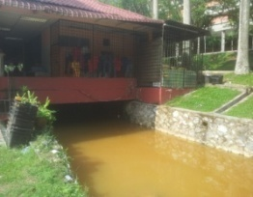
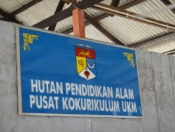

Hutan Pendidikan Alam (HPA)
Restaurant@FST

Figure 1. Location of water sampling along Alur Ilmu river

Results and Discussion
Biochemical Oxygen Demand (BOD)
BOD is a measurement of the quantity of oxygen used by microorganisms to decompose waste. High BOD indicates poor water quality. If there are large quantities of organic waste in the water, then many bacteria will be present to decompose the waste and oxygen demand will be higher. Thus BOD levels will also be higher. The value of BOD in the Alur Ilmu is between the ranged of 7.7 + 15.1 mg/L during no-rain (Figure 2(a)). The highest value of BOD is in FPI which is 15.5 mg/L. Factors that contribute to the highest value of BOD such as regularly cleaning activities of the river, drains that are not well managed and sewage from cafeteria nearby. Dry weather conditions also slow the velocity of the water flow to transport the waste into downstream. This shows that there are a lot of organic materials in the sample experiments that may not be decomposed by the organism that causes the organism to be at depressed levels and will eventually die. After rainfall the value of BOD are in range of 6.6 + 9.5 mg/L (Figure 2(a)). The highest value of BOD is 9.5 mg/L at Teres Eko Niaga. Factors that cause increase value of BOD in this area is the contribution of sewage and toxic waste came from laboratory and cafeteria nearby. During rainfall event the flow velocity will increases and the flow lead the contamination coming from upstream thereby making the BOD levels in this area builds up.Thus the average value of BOD is 10.8 mg/L during no-rain and 7.6 mg/L after the rainfall. This shows that the oxygen demand by the microorganism is less after the rainfall event.

Chemical Oxygen Demand (COD)
COD is a measurement of the presence of organic material in water bodies. Normally COD levels are higher than BOD levels. The surface water and domestic sewage for COD levels is between 20 and 50 mg/L and normally for industry wastewater are highly contaminated that is more than 100,000 mg/L [6]. COD it is one of the most important measurement parameter for monitoring water [7] that showed a decrease in the level of contamination of water with pollutants.

The value of COD during no-rain is in range of 46 + 87 mg/L (Figure 2 (b)). The highest value of COD is 87 mg/L in the Teres eko niaga area. This is because there is a high level of organic matter in this water body’s area that comes from cafeteria, laboratory nearby and also from the flora and fauna decay which settle in river from the upstream. In addition, in dry weather will also reduce the velocity of river that need to carry the organic material from upstream to downstream areas. After the rainfall, the value of COD is between the ranged of 55 + 150 mg/L (Figure 2(b)). The highest value COD after the rainfall is 150 mg/L at the UKM Mosque. The intensity of heavy rainfall causing high river flow velocity and brought organic material accumulated in the downstream area.

Thus the overall average value of COD is 58.2 mg/L during no-rain and 96.3 mg/L after rainfall event. The COD content is higher after rain than when it is not raining. Supposedly, the higher the rainfall intensity, the higher the velocity of flow and causes the lower the COD load of pollutants in the air and vice versa. Hence, although the content of high rainfall intensity, the pollutants are high, this condition occurs due to the factors other pollutant load resulting from the frequency of cleaning activities during dry weather.

Total Suspended Solid (TSS)
TSS is consists of solid materials, including organic and inorganic suspended in the water bodies. The amount of suspended solid causes physical changes that include reduction of light penetration, temperature changes and filling channels [8]. The value of TSS during no-rain is in range of 1.3 + 38 mg/L (Figure 2(c)). The highest value of TSS is in Teres Eko Niaga. Among the causes of the concentration of suspended solids is the frequency of cleaning activities of the channel. In addition, during dry weather, the movement of the water flow will be slower to bring these contaminants to downstream and cause the suspended solids are deposited at the bottom of the river area. The value of TSS after rainfall is in range of 4.7 + 41.3 mg/L (Figure 2(c)) and the Teres Eko Niaga are the highest value of TSS. The increase is due to suspended solids coming from upstream area that is insoluble and it is accumulated in Teres Eko Niaga. Normally, suspended solids do not dissolve in water immediately and it will settle with the rate specified periods. Moreover, during rainfall, the surface water runoff will bring all the particles of eroded land and donate the increase in suspended solids.

Thus the overall average value of TSS during no-rain is 12.3 mg/L and after rainfall is 18 mg/L. Therefore, the TSS levels after rainfall are higher than no-rain. TSS increased on rainy days because surface runoff has strong erosive forces to bring sand, silt, clay, and organic from the ground to the surface of the water. Despite that, the high current flow rate can carry more sediment particles and larger in size. Changes in speed or direction of increasing the flow of water can cause particles were deposited on the riverbed back floating on the water surface.

Total Kjeldahl Nitrogen (TKN)
TKN is a measurement of the amount of organic nitrogen and ammonia in water that is measured in milligrams per liter (mg/L). Nitrogen is one of the most important nutrients for the organism. Nitrogen emissions lead to significant impacts on the quality of water that causes the growth of phytoplankton, which is too fast and cause eutrophication in water [10]. Normally, value of TKN is due to sewage and fertilizer emissions to water. TKN has become a reference method for the determination of total organic nitrogen in various types of samples; medicine, agriculture, food products, sediment and biological wastewater [11].

The value of TKN is based on standard water quality for Ammonia Nitrogen (AN). The value TKN during no-rain is in range of 3.56 + 12 mg/L and the average is 7.01 mg/L (Figure 3(a)). TKN after rainfall is in range of 3.8 + 32.3 mg/L and the average is 14.7 mg/L (Figure 3(a)). The value of TKN after rain is higher than the value of TKN no-rain. This is because during rainfall events the surface runoff transports the excess fertilizers and pesticides into rivers. These materials can also seep into the soil and contaminate the surrounding river and result in increase value of TKN.

Turbidity
Turbidity is the cloudiness of water carried by different particles such as suspended solids [9]. Suspended solid particles including sand, silt and clay, bacteria and chemical precipitates cause turbidity in the river occurs. Higher turbidity due to suspended solids in water temperature will absorb more heat and reduce the concentration of dissolved oxygen (DO) in the water.

The value of turbidity after rainfall is in range of 4.2 + 70 NTU and during no-rain is in range of 1.3 + 68 NTU (Figure 3(b)). The highest value of turbidity is in Teres Eko Niaga during no-rain is 68 NTU and after rain is 70 NTU. High turbidity is normally caused by the sediments and suspended solids. Expansion of the campus including the new blocks for Faculty Science and Technology have resulted increased soil erosion and bare areas without vegetation cover. The surface of the bare land on the slopes without vegetation reduces the grip between soils and become unstable and collapse easily. This situation is aggravated by the presence of heavy rainfall. The higher the velocity of the water, the higher the rate of erosion and the more sediment will be heavy. Furthermore, sediment traps at Teres Eko Niaga is no longer functioning, thus sediment brought from upstream areas accumulated behind the weir. The water flow will reduce and the river becomes shallower at the upstream.

The overall average value of turbidity for no-rain is 17.2 NTU and after rainfall is 25.4 NTU. Therefore, the turbidity at no-rain is lower than turbidity after rainfall. Due to low flow velocity, the rivers are usually higher in turbidity during rainy season,

pH
The pH or the concentration of hydrogen is the measure of acidity and alkalinity, and is an important measure in determining the chemistry of the water for most of the processes involved in water treatment depends on this parameter. pH is usually measured on a scale of 0-14 where the seven is neutral. The pH value less than 7 shows high acidity, which can be caused by acid deposition formed when rain. pH values more than 7 indicates alkalinity. Overall, the pH of the river is considered not polluted [12] with an average pH during no-rain is 6.5 and after rainfall is 7.32 (Figure 3(c)).

Temperature
The value of temperature when it is no-rain is in range of 24.3 + 24.9˚C (Figure 3(d)). The highest value of temperature is 24.9˚C i.e. UKM Mosque. The increasing temperature at the downstream because of the pollutants from upstream has brought along the river and more accumulated in the downstream. Higher temperatures can stimulate the use of oxygen by the decomposition process and aesthetic values of the river will be affected. Furthermore, with dry weather conditions, the temperature in the surrounding area will increase. After the rainfall events the value of temperature is in range 22.4 + 23.1˚C (Figure 3(d)). The value of temperature after rainfall is slightly lower than dry weather. The quantity of rain water and high flow bring down the temperature of the water bodies.

Oil and Grease (O&G)
O&G is a measure of a variety of substances including fuels, motor oil, lubricating oil, hydraulic oil, cooking oil, and animal-derived fats. The concentration of these substances is typically measured within a body of water. Lakes, river, stormwater runoff, and wastewater are all monitored for O&G.

The value of O&G during no-rain is in range 131.1 + 167.8 mg/L (Figure 3(e)). The highest value of O&G is 178.9 mg/L which is in Teres Eko Niaga. The increasing in O&G was due to the high pollution carried from upstream along to this area. Moreover, contamination from the laboratory and cafeteria nearby contribute in high concentrations of O&G in surface water. The release of O&G with high temperature into the river can cause the O&G freeze in water bodies when water temperature drop.

The value O&G after rainfall is in range 148.6 + 209.5 mg/L (Figure 3(e)). The highest value of O&G is 209.5 mg/L at Pusanika. Among the causes of the increase in the value of O&G is because of the contribution of pollution attributed from upstream (the same reason during dry weather). Furthermore, the increasing of O&G also cause by the rainfall. When it rains, combination of rainwater and runoff will bring all contaminants in impermeable surface directly into the river.

Thus, the overall average of O&G during no-rain is 154.4 mg/L and after rainfall is 174.6 mg/L. In general, the value of O&G after rainfall is higher than value of O&G during no-rain. Long period heavy rains will increase the quantity of runoff in large quantities thus diffusion rate will decrease. Although the upper reaches of the area (forest) undisturbed, the O&G has increased considerably. This is because soil contains manganese and ion content. During rainy days, the grease will come out of the pores and will contribute to the increase of the water pollution.

BOD (mg/L)
COD (mg/L)
BOD (mg/L)
TSS (mg/L)
COD (mg/L)
Figure 2. Result of overall water sampling of (a) BOD (b) COD and (c) TSS during no-rain and after rainfall
events
Temperature (˚C)
pH
Turbidity (NTU)
TKN (mg/L)
O&G (mg/L)
Figure 3. Result of overall water sampling of (a) TKN (b) Turbidity (c) pH (d) Temperature and (e) O&G during no-rain and after rainfall events

Comparison between Overall Average Experimental Results with Water Quality Standard, National Water Quality Standard and Standard A and B are outlined in the Regulation on Environmental Quality (Sewage and Industrial Effluents), 1979
The average value of BOD is 10.8 mg/L during no-rain and the average value BOD after rainfall is 7.6 mg/L and both is in class IV according to WQI standard. According to NWQS in class IIB, the value of BOD are exceeding over its value. But according to A and B standards that set out in the Regulations of the Environmental Quality (Sewage and Effluent), the value of BOD is allowed. Higher BOD in water samples contains a lot of organic and inorganic substances (Table 1).

The average value of COD during no-rain is 58.2 mg/L and after rainfall is 96.3 mg/L and both is in class IV according to WQI standard. In Class IIB NWQS, the value of COD is already exceeding its standard. However, these values of COD are acceptable in standard B (Sewage and Effluent) (Table 1).

The average value of TSS during no-rain is 12.3 mg/L and after rainfall is 18 mg/L and both is in class I according to WQI standard. According to Standard A and B (Sewage and Effluent) and NWQS, the above TSS reading is still within the permissible limits (Table 1). During rainfall, TSS value will always be higher because rain water carries soil runoff into the river.

The average value of turbidity for no-rain is 17.2 NTU and after rainfall is 25.4 NTU. According to class IIB in NWQS, these values meet the standard (Table 1). Heavy rainfall causes a higher turbidity because rain water will carried sedimentation and siltation nearby the exposed area. Moreover, settlements of sediment are main problems for watersheds area [13]. The high turbidity caused rivers to rise in body temperature due to suspended solids that will absorb more heat, thereby reducing the concentration of dissolved oxygen (DO) in the water.

The value of the Total Kjeldahl Nitrogen is based on standard water quality for Ammonia Nitrogen (AN). This is because there is a small and almost no contamination of nitrogen organic in water sample. The average value during no-rain is 7.01 mg/L and after rainfall is 14.7 mg/L and both is in class V. In class IIB NWQS, the value of Ammonia Nitrogen is exceeding from its limit. The standard B (Sewage and Effluent) are acceptable for the value AN in this river (Table 1). The increasing ammonia in (Sewage and Effluent) are acceptable for the value of AN in this river (Table 1). The increasing ammonia in water body came from sewage and agricultural wastes. Nitrate may be derived from fertilizer plants in the garden area near the Alur Ilmu [14].

The average value of pH for no-rain is 6.5 and after rainfall is 7.32. The pH value was within the limit of class IIB NWQS and Standards A and B (Sewage and Effluent). Normally, aquatic life can survive in the pH range between 6.5 to 8.5 (Table 1). The average value of temperature is 24.6 ˚C during dry period. After rainfall the value of temperature is 22.7 ˚C. According to the standard A and B, the value of temperature was at acceptable levels (Table 1). Lastly, the value of O&G after rainfall is higher than no rain. The average during no-rain is 154.4 mg/L and after rainfall is 174.6 mg/L. The O&G values are exceeding the class IIB NWQS and Standard B limitation (Table 1). In the upstream, contaminants such as soil and garbage disposal have been found. This would lead to O&G pollution. The high level of O&G in water bodies may lead to polluted rivers loss it aesthetic value. Oil and grease will also produce unpleasant sight and smell. As comparisons with water quality standards, it was found that the flow of river water is contaminated with the quality of the water is at the level of Class IV. Some of the parameters that meet water quality requirements for Class I, but the assessment is based on the overall experimental parameters of water samples.

Table 1. Comparison of the result with the National Water Quality Standards and Standards A and B are outlined in Environmental Quality (Sewage and Industrial Effluents) Regulations, 1979
Parameter | Average Value |  | National Water Quality Standard | Standard A | Standard B
Parameter | No-Rain | After Rainfall | National Water Quality Standard | Standard A | Standard B
Biochemical Oxygen Demand (mg/L) | 10.8 | 7.6 | 3.0 | 20 | 50
Chemical Oxygen Demand (mg/L) | 58.2 | 96.3 | 25 | 50 | 100
Total Suspended Solid (mg/L) | 12.3 | 18.0 | 50 | 50 | 100
Ammoniacal Nitrogen (mg/L) | 7.01 | 14.7 | 0.3 | 10 | 20
Turbidity (NTU) | 17.2 | 25.4 | 50 | - | -
Ph | 6.5 | 7.32 | 6.0-9.0 | 6.0-9.0 | 5.5-9.0
Temperature (˚C) | 24.6 | 22.7 | Normal 2˚C | 40 | 40
Oil and Grease (mg/L) | 154.4 | 174.6 | 7.0 | Not detected | 10

Conclusion
The results showed that the parameters of BOD, COD, TKN, Oil and Grease had exceeded the class IIB limitation (Table 1). Only O&G parameter does not meet the standard B that been set out in the regulations of the Environmental Quality (Sewage and Effluent). Teres Eko Niaga is the major contributors to the point sources of pollution. Therefore, improvements are needed to restore the Alur Ilmu ecosystem such as installation the grease trap at every cafeteria and practice the constructed wetland system.

Acknowledgement
The researches and authors would like to thank all the individuals and department of Civil and Structural UKM, UKM via Grant Arus Perdana AP-2014-008 and East Coast Environmental Research Institute (ESERI) for their cooperation and information in the success of these studies.

References
- Schleich, J. and Hillenbrand, T. (2009). Determinants of residential water demand in Germany. Ecological Economics 68: 1756–1769.
- Liu, K. K., Li, C. H., Yang, X. L. Hu, J. and Xia, X. H. (2012). Water Resources Supply-Consumption (Demand) Balance Analysesin the Yellow River Basin in 2009. Environmental Sciences 13(1): 1956 – 1965.
- Paredes, J., Andreu, J. and Solera, A. (2010). A decision support system for water quality issues in the Manzanares River (Madrid, Spain). The Science of the total environment 408(12): 2576–89.
- Ntengwe, F. W. (2006). Pollutant loads and water quality in streams of heavily populated and industrialised towns. Physics and Chemistry of the Earth, Parts A/B/C 31(15-16): 832–839.
- Din, H. M., Toriman, M. E., and Mokhtar, M. (2012). Loading Concentrations of Pollutant in Alur Ilmu at UKM Bangi Campus: Event Mean Concentration (EMC) Approach. Malaysian Journal of Analytical Sciences 16(3): 353–365.
- Canals, A. and Cuesta, A. (2002). New ultrasound assisted chemical oxygen demand determination. Ultrasonics Sonochemistry 9(3): 142–149.
- Yao, H., Wu, B., Qu, H. and Cheng, Y. (2009). A high throughput chemiluminescence method for determination of chemical oxygen demand in waters. Analytical Chimica Acta 633(1): 76–80.
- Bilotta, G. S. and Brazier, R. E. (2008). Understanding the influence of suspended solids on water quality and aquatic biota. Water Research 42(12): 2849–2861.
- Yahyapour, S., Golshan, A. and Halim, A. (2013). Removal of total suspended solids and turbidity within experimental vegetated channel : optimization through response surface methodology. Journal of Hydro-Environment Research 4(3): 1–10.
- Xia, X., Yang, Z., Huang, G., Zhang, X., Yu, H. and Rong, X. (2004). Nitrification in natural waters with high suspended-solid content––A study for the Yellow River. Chemosphere 57(8): 1017–1029.
- Domini, C., Vidal, L., Cravotto, G. and Canals, A. (2009). A simultaneous, direct microwave/ultrasound-assisted digestion procedure for the determination of total Kjeldahl nitrogen. Ultrasonics Sonochemistry 16(4): 564–569.
- Jonnalagadda, S. and Mhere, G. (2001). Water quality of the Odzi River in the eastern highlands of Zimbabwe. Water Research 35(10): 2371–2376.
- Rossi, L., Chevre, N., Fankhauser, R. and Margot, J. (2012). Sediment contamination assessment in urban areas based on total suspended solids. Water Research 47(1): 339–350.
- Mokhtar, M., Hoe, C. F., Leng, C. W., Yong, O. Y. and Heong, T. B. (2005). Studies of water quality ‘Alur Ilmu’ Campus UKM, Bangi: Towards an integrated approach to water resources management. Malaysian Journal of Analytical Sciences, 9(3): 388–395.

