

MALAYSIAN JOURNAL OF ANALYTICAL SCIENCES
ISSN 1394 - 2506

Published by The Malaysian Analytical Sciences Society

SYNTHESIS, STRUCTURAL, AND CHEMICAL PROPERTIES OF Nd(III) ISATIN 2-METHYL-3-THIOSEMICARBAZONE

(Sintesis, Pengstrukturan dan Sifat Kimia Nd(III) Isatin 2-Metil-3-Tiosemikarbazon)

Nur Nadia Dzulkifli, Yang Farina*, Bohari M Yamin

School of Chemical Sciences and Food Technology,

Faculty of Science and Technology,

Universiti Kebangsaan Malaysia, 43600 UKM Bangi, Selangor, Malaysia

*Corresponding author: farina@ukm.edu.my

Received: 30 April 2015; Accepted: 28 August 2015

Abstract
Rare earth complexes can exhibit higher coordination numbers. The rare earth metal has the ability to form a multitude of geometries and stereochemistries. Studies on rare earth complexes with organic ligands have received considerable attention. Nd(Is2MeTSC)₃ [Is2MeTSC= isatin 2-methyl-3-thiosemicarbazone] was synthesized by condensation method. The compounds were structurally characterized by elemental analysis CHNS, FT-IR, NMR and thermo-gravimetric analyses. The elemental analyses for the compounds were in good agreement with the theoretical values. The melting point of the complex was higher than the ligand, as expected. The X-ray crystallographic structures for Is2MTSC showed that in the solid state, the compound existed in the thione form where the C=S bond length was shorter than a single bond C-S, which was 1.82 Å. Is2MTSC adopted an orthorhombic system, a = 14.3434(9), b = 8.4242(5), c = 17.8518(11) Å and Z = 8. The FT-IR spectral data impled a bidentate bonding of Is2MeTSC to Nd(III) ion through carbonyl oxygen and azomethine nitrogen. Thermal analyses (TGA) of the complex was carried out to confirm the final molecular structure of the complex and to study its thermal stability. This study proves that the complex was formed by the coordination of ligand to metal ion and that there was no coordinated water.

Keywords: Nd(II), thiosemicarbazone, isatin, thermogravimetric analysis

Abstrak
Sebatian kompleks nadir bumi boleh mempunyai nombor koordinatan yang lebih tinggi. Logam nadir bumi berkeupayaan untuk membentuk pelbagai geometri, stereokimia. Kajian terhadap sebatian kompleks nadir bumi dengan ligan organik telah mendapat perhatian. Nd(Is2MeTSC)₃ [Is2MeTSC= isatin 2-metil-3-tiosemiarbazon] telah disintesis dengan kaedah kondensasi. Kesemua sebatian telah dicirikan dengan analisis unsur CHNS, FT-IT, NMR dan analisis termogravimetrik. Data analisis unsur bagi sebatian adalah hampir sama dengan nilai teori. Takat lebur sebatian kompleks adalah lebih tinggi daripada ligan seperti yang dijangkakan. Struktur kristalografi sinar-X bagi Is2MTSC menunjukkan bahawa dalam keadaan pepejal ligan wujud dalam bentuk tion di mana panjang ikatan C=S adalah lebih pendek daripada ikatan tunggal C-S iaitu 1.82 Å. Is2MTSC menghablur dalam sistem ortorombik, a = 14.3434(9), b = 8.4242(5), c = 17.8518(11) Å dan Z = 8. Data inframerah menunjukkan Is2MTSC bertindak sebagai ikatan bidentat dengan ion Nd(III) melalui oksigen karbonil dan nitrogen azometin. Analisis terma (TGA) bagi kompleks telah dilakukan untuk mengesahkan struktur akhir kompleks dan mengkaji kestabilan haba. Kajian membuktikan bahawa terdapatnya pengkoordinatan sebatian ligan dengan ion logam dan mengesahkan bahawa tiada air yang terkoordinat.

Kata kunci: Nd(III), tiosemikarbazon, isatin, termogravimetrik analisis

Introduction
Isatin, also known as 1H-indole-2,3-dione, is a versatile moiety which is able to form a large number of heterocyclic molecules [1] and is biologically active [2]. The ligand has an indole ring structure, as shown in Figure 1, which has been reported to show anticancer activity. Recently, lanthanide complexes have drawn attention because of their properties and great potential in various applications such as in catalysis, magnetism, optoelectronic devices, medicine, separation and ions recognition [3]. Lanthanide complexes have great interesting bioinorganic and coordination chemistry [4]. Lanthanide complexes have been used in optical field because the lanthanide metals have the configuration of 4f electrons, which show sharp f-f transitions and luminescence properties. The lanthanide complexes have unique photophysical properties such as narrow emission bands, large strokes shift and long decay time [5]. Besides that, lanthanide ions have high potential to coordinate with hard bases such as oxygen or nitrogen atoms [6]. The lanthanide ions have higher coordination numbers, which give various coordination modes of complexes [7]. Suitable ligands can be used as light- harvesting antennas for luminescence applications [8]. Besides that, lanthanide ions have high magnetic moment and huge anisotropy [9].

Figure 1. Structure of isatin and indole ring

Materials and Methods

Material and Measurements
All reagents and reactants were of analytical grade and used without further purification. The melting points of the synthesized compound were determined using the Electrothermal IA 9100. The elemental analysis was performed on the CHNS/O Model Fision EA 1180 and Thermo Finnigan Flash EA 1112 Series. The infrared spectra of the ligands were recorded as KBr discs on FTIR Perkin Elmer model GX spectrophotometer in the 4000-400cm⁻¹ range. Thermogravimetric analysis (TGA) of the complex was recorded on Mettler Toledo model TGA.SDTA 851e. The electronic absorption spectra were recorded on a Shimadzu UV-1650 PC and were measured in the range 200-800 nm in DMF.

General Procedure for Obtaining The Ligand and The Complex
Synthesis of isatin 2-methyl-3-thiosemicarbazone [Is2MTSC]: An ethanolic solution (10 mL) of 2-methyl-3-thiosemicarbazide (0.105 g, 10 mmol) was added to an ethanolic solution (10 mL) of isatin (0.147 g, 10 mmol) followed by the addition of five drops of acetic acid (M). The mixture was heated under reflux for 2 hours. The mixture was filtered to remove unreacted solid material and the filtrate was left standing at room temperature to afford single orange crystals. Yield: 90%. Melting point: 208.4-210.4 ºC. Analysis: Calcd (%): C 51.28, H 4.30, N 23.93, S 13.66. Found (%): C 51.57, H 6.34, N 25.97, S 11.70. IR (cm⁻¹): 1601 ν(C=N), 1726 ν(C=O), 1097 ν(C=S), 1182 ν(C-N).

Synthesis of Nd(III) 2-methyl-3-thiosemicarbazone [Nd(Is2MTSC)₃]. An ethanolic solution (10 mL) of Nd(III) nitrate hexahydrate was added to an ethanolic solution (30 mL) of isatin 2-methyl-3-thiosemicarbazone (0.0717 g, 0.1 mmol) followed by the addition of excess NaOH solution. The precipitate was filtered and rinsed with hot ethanol. Yield: 72 %. Melting point: > 350ºC. Analysis: Calcd (%): C 42.70, H 3.23, N 19.92, S 11.38. Found (%): C 41.72, H 2.83, N 19.38, S 11.93. IR (cm⁻¹): 1604 ν(C=N), 1636 ν(C-O), 1097 ν(C=S), 1155 ν(C-N), 2774.52, 417 ν(Nd-O), 451 ν(Nd-N).

X-ray Crystallography
Crystals structures determination were carried out on a Bruker Smart APEX CCD area detector diffractometer equipped with graphite mono-chromatised Mo-K_{α} (λ=0.71073Å) [10]. All data collection were carried out at 296K. Data collection: SMART [11]; cell refinement: SAINT [12]; data reduction: SAINT; program(s) used to solve structure: SHELXTL [13]; program(s) used to refine structure: SHELXTL [13], molecular graphics: SHELXTL [13]; software used to prepare material for publication: SHELXTL and PLATON [13].

Results and Discussion

Electronic Spectra
The UV-visible absorption spectra of Is2MTSC and its complex were measured in DMF solution (c = 1 x 10⁻⁴ M) are shown in Figure 2. Is2MTSC spectrum displayed absorption at the shortest wavelength, 277 nm, which was attributed to the π→π* absorption of the aromatic ring [14]. The absorption at 366 nm was attributed to n→π* absorption of the lone pairs existing on oxygen and nitrogen in the ligand. Both absorptions underwent a bathochromic shift resulting from the coordination of the ligand [15]. In the complex spectrum, the number of absorptions were very weak, which are characteristics of the Laporte forbidden f-f transitions of Nd(III) ion observed in the visible region [16]. Cotton et al. 2006 suggested that the absorption bands appearing in the visible region for Nd(III) ion are due to the transition from the ground levels ³H₄, ⁴I_{9/2} and ⁶H_{5/2} respectively to the excited J level of the 4f configuration [17].

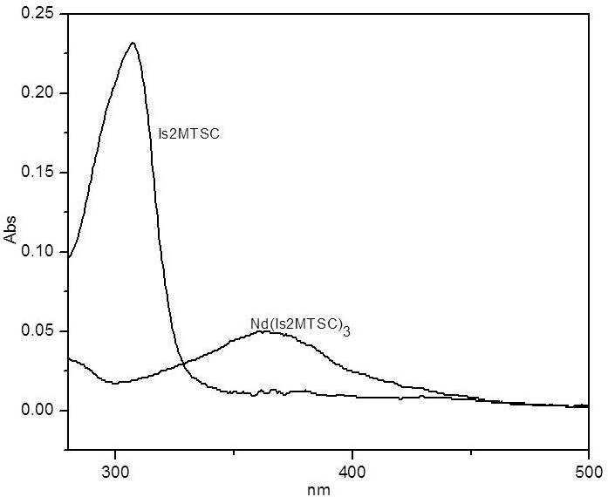
Figure 2. Electronic spectra of the compound

Infrared Spectra
A comparison was made between vibrational bands of specific functional groups in the spectra of the ligand and the complexes as shown in Figure 3. The IR spectrum of Is2MTSC showed a sharp stretching band at 1726 cm⁻¹ due to the stretching frequency of C=O group. The stretching frequency was absent in the spectra of complexes showing that the oxygen from carbonyl group was coordinated to the Nd(III) ion after deprotonation [18]. The absorption of nitrate ion was not exhibited in the Nd(Is2MTSC)₃ spectrum, indicating that the nitrate ion was not coordinated with Nd(III) ion. The strong intensity band at 1601 cm⁻¹ in the ligand spectrum was ascribed to ν(C=N) absorption of the azomethine moiety, which underwent a hypsochromic shift in the complexes spectra, proposing an interaction between the imino nitrogen and metal ion [19]. No changes value of the ν(C=S) stretching band between the ligand and the complex at 1097 cm⁻¹ indicating that the ligand remained as the thione tautomer. The band at 451 cm⁻¹ in the complexes was attributed to ν(Nd-N). While, the band at 417 cm⁻¹ was attributed to ν(Nd-O) [20].

Thermogravimetric Analysis (TGA)
The TGA curves of Nd(III) complex was carried out within a temperature up to 800ºC is shown in Figure 4. The complex showed no decomposition peak below 300ºC in the thermogravimetric plot indicating that the complex had been formed by the coordination between Is2MTSC with Nd(III) ion [21]. The thermogravimetric plot distinctly showed that the decomposition of the complex proceeded only in one step. The metal oxides of Nd(III) complex was formed at above 350ºC. The decomposition peak appeared at 350ºC with a percentage weight loss of 40.48 and 59.88% are ascribed complete decomposition giving Nd₂O₃ residue. The percentage residue of Nd₂O₃ was 39.86%, as expected. The expected structure of the complex due to elemental analysis, thermogravimetric analyses and UV-Vis are shown in Figure 5.

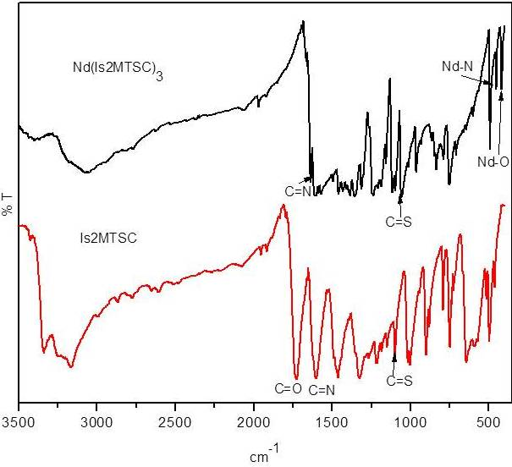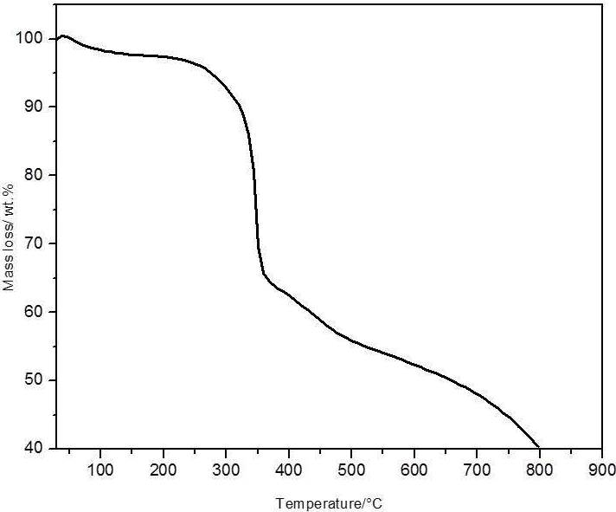
Figure 3. Comparison of the IR spectra between Figure 4. TGA graph with thermal degradation the the ligand and complex

Figure 5. Structure of Nd(Is2MTSC)₃

Crystal Structure Analysis
The single crystal data and structure refinement for the ligand is presented in Table 1. While the molecular structure of the ligand along with the atomic numbering scheme is shown in Figure 5. The non-hydrogen atoms of the ligand were planar. The indole ring N4/C2/C3/C4/C5/C6/C7/C8/C9[Is2MTSC] fragment was planar with maximum deviations of 0.048(2) for C(3) atom from the least square plane, respectively. In the crystal structure of Is2MTSC, the molecules were linked by intermolecular hydrogen bonds, N1—H1A..S1, N1—H1B..O1, N4—H4..S1, C10—H01B..O1 and C6—H6..S1 (symmetry codes as shown in Table 2).

Table 1. Crystal data and structure refinement for the ligand
 | Is2MTSC
Formula | C₁₀H₁₀N₄OS
Formula weight | 234.28
Wavelength, Mo Kα (Å) | 0.71073
Crystal system | Orthorhombic
Space group | Pbca
a (Å) | 14.3434(9)
b (Å) | 8.4242(5)
c (Å) | 17.8518(11)
α (°) | 90
β (°) | 90
γ (°) | 90
Volume (V) (Å³) | 2157.1(2)
Z | 8
Crystal size (mm) | 0.35x0.60x0.33
F(000) | 976
Goodness-of-fit on F²  R_{int}  Theta min | 1.185  0.0415  2.84
Theta max | 28.37

Table 2. H-bonding parameters of the ligand
No | D---H...A | Type | D – H (Å) | H...A (Å) | D...A (Å) | D – H...A (°)
1 | Is2MTSC  N1—H1A..N3 | Intra | 0.86 | 2.25 | 2.612(2) | 105
2 | N1—H1A..S1 | Inter | 0.86 | 2.69 | 3.5115(19) | 160
3 | N1—H1B..O1 | Inter | 0.86 | 2.13 | 2.973(2) | 167
4 | N4—H4..S1 | Inter | 0.86 | 2.56 | 3.3979(17) | 166
5 | C10—H01A..S1 | Intra | 0.96 | 2.67 | 3.030(3) | 103
6 | C10—H01B..O1 | Inter | 0.96 | 2.52 | 3.260(3) | 134
7 | C6—H6..S1 | Inter | 0.93 | 2.80 | 3.552(3) | 138
Symmetry codes: No 2: 1-x, -½+y, ½-z, No 3 : 1-x, ½+y, ½-z, No 4 : x, ½-y, ½+z, No 6 : ½-x, ½+y, z,
No 7 : x, 3/2-y, ½+z

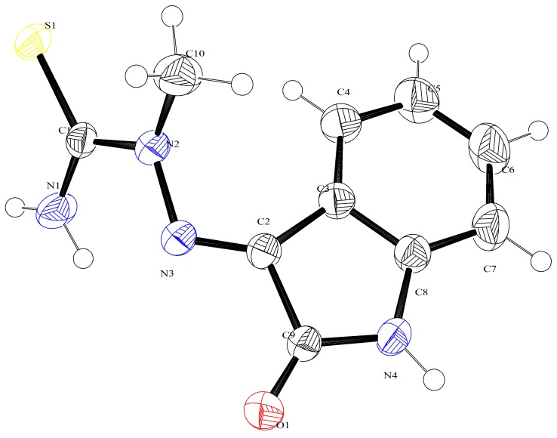
Figure 6. The molecular structure of (Is2MTSC) with the atom labeling scheme. Displacement ellipsods are drawn at the 50% probability level

Conclusion
Nd(Is2MTSC)₃ complex with isatin 2-methyl-3-thiosemicarbazone is synthesized and characterized by elemental analyses, infrared, electronic spectra, TGA and Nuclear Magnetic Resonance. The single crystal X-ray diffraction studies supported the spectral characterization, which proved that the ligands exist as the thione tautomer. From the elemental, infrared and thermogravimetric analyses of the complex, it was found that the ligand acted as a bidentate ligand to coordinate with the metal ion.

Acknowledgement

The authors would like to thank the Faculty of Science and Technology, Universiti Kebangsaan Malaysia and the Centre of Research and Instrumentation (CRIM) for the research facilities, the provision of laboratory facilities and technical assistance. The authors also gratefully acknowledge the research grant from GUP-2012-022, FRGS/2/2013/ST01/UKM/01/2 and a scholarship from the MyBrain15.

References
- Pakravan, P., Kashanian, S. and Khodaei, M. M. (2013). Biochemical and Pharmacological Characterization of Isatin and Its Derivatives: From Structure to Activity. Pharmacological Reports 65:313-335.
- Bhrigu, B., Pathak, D., Siddiqui, N., Alam, M. S. and Ahsan, W. (2010). Search for Biological Active Isatins: A Short Review. International Journal of Pharmaceutical Sciences and Drug Research 2(4): 229-235.
- Lama, P., Aijaz, A., Neogi, S., Barbour, L. J. and Bharadwaj, P. K. (2010). Microporous La(III) Metal-Organic Framework Using a Semi-rigid Tricarboxylic Ligand: Synthesis, Single-Crystal to Single-Crystal Sorption Properties and Gas Adsorption Studies. Crystal Growth Design 10(8): 3410-3417.
- Shiju, C., Arish, D. and Kumaresan, S. (2013). Homodinuclear Lanthanide Complexes: Synthesis, Characterization, Cytotoxicity, DNA Cleavage, and Antimicrobial Activity. Spectrochimica Acta Part A: Molecular and Biomolecular Spectroscopy 105:532–538.
- LMarques, L. F., Junior, A. A. B. C., Correa, C. C., Lahoud, M. G., Silva, R. R. D., Ribeiro, S. J. L. and Machado, F. C. (2013). First Crystal Structures of Lanthanide-Hydrocinnamate Complexes: Hydrothermal Synthesis and Photophysical Studies. Journal of Photochemistry and Photobiology A: Chemistry 252:69– 76.
- X. Hongzhen, X. and Guanzhong, L. U. (2013). Crystal Structures and Fluorescence Properties of Lanthanide Complexes Prepared with 2,2′-biphenyldicarboxylic acid and 2,2′:6′,2″-terpyridine. Journal of Rare Earths 31(6):639-644.
- Tang, K., Zhang, J. J., Zhang, D. H., Ren, N., Yan, L. Z and Li, Y. (2013). Crystal Structures and Thermodynamic Properties of Lanthanide Complexes with 2-chloro-4,5-difluorobenzoate and 1,10-phenanthroline. Journal of Chemical. Thermodynamics 56:38–48.
- Eliseeva, S. V. and Bünzli, J. G. (2010). Lanthanide Luminescence for Functional Materials and Bio-sciences. Chemical Society Reviews 39:189-227.
- Bag, P., Maji, S. K., Biswas, P., Flörke, U. and Nag, K. (2013). Macrocyclic Lanthanide (III) Complexes of Iminophenol Schiff Bases and Carboxylate Anions: Syntheses, Structures and Luminescence Properties. Polyhedron 52: 976–985.
- Bruker (2009). SMART, SAINT and SADABS. Bruker AXS Inc., Madison, Wisconsin,USA.
- Bruker (2008). APEX2, SAINT and SADABS. Bruker AXS Inc., Madison, WI
- Sheldrick, G. M. (2008). Acta Cryst A 64:112.
- Spek. A. L. (2009). Acta Cryst. D 65:148-155.
- Sreekanth, A. and Kurup, M. R. P. (2004). Synthesis, EPR and Mossbauer Spectral Studies of New Iron(III) Complexes with 2-benzoylpyridine-N(4), N(4)-(butane-1,4-diyl) thiosemicarbazone (HBpypTsc): X-ray Structure of [Fe(BpypTsc)₂]FeCl₄.2H₂O and The Free Ligand. Polyhedron 23:969-978.
- Siddiqi, Z. A., Shahid, A. M., Khalid, M., Sharma, P. K. and Siddique, A. (2013). Spectroscopic, Luminescence, Electrochemical and Antimicrobial Studies of Lanthanide Complexes of Bis-benzimidazole Derived Ligands. Journal of Molecular Structure. 1037: 402–411.
- Pitchaimani, P., Lo, K. M. and Elango, K. P. (2013). Synthesis, Spectral Characterization, Crystal Structures and Catalytic Activity of A Series of Lanthanide(III) Azepane Dithiocarbamate Complexes. Polyhedron 54:60–66.
- S. Cotton. (2006). Lanthanide and Actinide Chemistry, John Wiley & Sons Ltd.
- Dubey, R. K., Mariya, A. and Mishra, S. K. (2011). Synthesis and Spectral (IR, NMR, FAB-MS and XRD) Characterization of Lanthanide Complexes Containing Bidentate Schiff Base Derived from Sulphadiazine and O-Vanillin. International Journal of Basic and Applied Chemical Sciences 1(1):70-78.
- Meyers, R. A. (2000) Interpretation of Infrared Spectra, A Practical Approach John Coates In Encyclopedia of Analytical Chemistry R.A. Meyers (Ed.); John Wiley & Sons Ltd, Chichester.
- Tamboura, F. B., Diouf, O., Barry, A. H., Gaye, M. and Sall, A. S. (2012). Dinuclear Lanthanide(III) Complexes with Large-Bite Schiff Bases Derived from 2,6-diformyl-4-Chlorophenol and Hydrazides: Synthesis, Structural Characterization and Spectroscopic Studies. Polyhedron 43:97-103.
- Akinchan, N. T., Drozdzewski, P. M. and Holzer, W. (2002). Syntheses and Spectroscopic Studies on Zinc(II) and Mercury(II) Complexes of Isatin-3-thiosemicarbazone. Journal of Molecular Structure 641:17–22.

