

MALAYSIAN JOURNAL OF ANALYTICAL SCIENCES
ISSN 1394 - 2506

Published by The Malaysian Analytical Sciences Society

RADIO FREQUENCY INTERFERENCE: THE EFFECT OF AMBIENT CARBON DIOXIDE (CO₂) CONCENTRATION ON RADIO SIGNAL FOR RADIO ASTRONOMY PURPOSES

(Interferens Frekuensi Radio: Kesan Kepekatan Karbon Dioksida (CO₂) Ambien ke atas Isyarat Radio Dalam Kajian Astronomi Radio)

Nor Hazmin Sabri¹*, Sharifah Nurul Aisyah Syed Zafar², Roslan Umar^{3,4}, Wan Zul Adli Wan Mokhtar⁵

¹School of Fundamental Science
²Physic, Electronic and Instrumentation Programme, School of Ocean Engineering
Universiti Malaysia Terengganu, 21030 Kuala Terengganu, Terengganu, Malaysia
³East Coast Environmental Research Institute (ESERI)
⁴Faculty of Islamic Contemporary Studies
Universiti Sultan Zainal Abidin, Gong Badak Campus, 21300 Kuala Terengganu, Terengganu, Malaysia
⁵Department of Physics, Faculty of Science and Mathematics,
Universiti Pendidikan Sultan Idris, 35900 Tanjung Malim, Perak, Malaysia
*Corresponding author: norhazmin@umt.edu.my

Received: 14 April 2015; Accepted: 9 July 2015

Abstract
Radio astronomy is a complementary to optical astronomy. Radio astronomy observation is conducted using large radio antennas referred to as radio telescopes, that are either used singularly, or with multiple linked telescopes utilizing the techniques of radio interferometry and aperture synthesis. In this study, weather factor that affected the Radio Frequency Interference (RFI) is investigated. An ambient carbon dioxide (CO₂) concentration in the environment is determined to study the effect on radio signal up to 8GHz for radio astronomy purposes. The RFI pattern change against CO₂ concentration is determined for one-hour observation time. The observations were conducted at KUSZA Observatory, East Coast Environmental Research Institute (ESERI) and UniSZA situated in Merang, Terengganu using spectrum analyser for RFI measurement and gas meter for CO₂ concentration. The study findings found that for up to 600 ppm of CO₂ concentration, there are no significant effect detected on radio signals. Thus, the radio astronomy observations may not affected. This study is very important for researchers in the radio astronomy field for determining the best location for radio telescope sitting for future research in radio astronomy.

Keywords: ambient carbon dioxide, radio signal, radio astronomy, radio frequency interference

Abstrak
Astronomi radio adalah pelengkap kepada astronomi optik. Cerapan astronomi radio dijalankan dengan menggunakan teleskop radio dengan piring yang besar yang dipanggil teleskop radio, yang mana ianya boleh digunakan secara sendirian atau secara gabungan beberapa teleskop radio dengan menggunakan teknik interferometry dan sintesis bukaan. Dalam kajian ini, faktor cuaca yang memberi kesan terhadap interferens frekuensi radio (RFI) diselidik. Kepekatan karbon dioksida (CO₂) ambien dalam persekitaran ditentukan bagi mengkaji kesannya terhadap isyarat radio dalam julat sehingga 9GHz untuk tujuan kajian astronomi radio. Perubahan pola RFI terhadap perubahan kepekatan CO₂ dikenalpasti bagi tempoh satu jam cerapan dibuat. Cerapan dibuat Balai Cerap KUSZA, Institut Penyelidikan Alam Sekitar Pantai Timur (ESERI) dan UniSZA yang terletak di Merang, Terengganu dengan menggunakan penganalisa spectrum untuk pengukuran RFI dan pengukur gas untuk kepekatan gas CO₂. Hasil kajian mendapati, bagi kepekatan CO₂ ambien sehingga 600 ppm, tiada kesan yang ketara dilihat terhadap isyarat radio. Oleh itu, cerapan astronomi radio tidak akan terganggu. Kajian ini sangat penting untuk pengkaji dari bidang astronomi radio bagi penentuan lokasi yang paling sesuai untuk meletakkan teleskop radio untuk kegunaan kajian akan dating dalam bidang astronomi radio.

Kata kunci: karbon dioksida, isyarat radio, astronomi radio, interferens frekuensi radio

Introduction
Radio waves are a type of electromagnetic radiation with wavelengths from 1mm to 100km with corresponding frequencies from 300 GHz to as low as 3 KHz [1]. They are classified as non-ionizing radiations and the photons carries low energy. Different frequencies of radio waves have different propagation characteristics in the Earth's atmosphere [2]. Abidin et al. [3] have conducted an RFI investigation for setting up a Very-long-baseline Interferometry (VLBI) station below 2.8 GHz in Malaysia. They found that two band below 2.8 GHz are permitted for the purpose of radio astronomy in Malaysia which is 608-614 MHz and 1660-1660.5 MHz. They had determined the RFI levels in these permissible bands at the best site (Langkawi) and concluded to be relatively low. In other work focusing on spectrum management extended by the team, they reviewed the frequency allocation reserved for radio astronomy in the L band set by the International Telecommunication Union (ITU), which is between 1400 and 1427 MHz [4]. In this study, the nearby spectrum activities were detected gave an effect and interference to the allocated band for radio astronomy observation. Thus, they suggested that the determination of the minimal possible interference location is required to set up the base station for radio telescope sitting.

According to Umar et al. [5], from their research on the selection of radio astronomical observation sites, they discover that the radio signal is affected by population density. They found there is certain trend in population density where the RFI graph increase rapidly at lower values and slow down to almost flat at higher values. They also listed 13 individual potential sources contribute as a noise and mostly are telecommunication and radio navigation. For determining the potential radio astronomical sources of interest to study, we may refer to the work done by Hamidi et al. [6] on profiling the RFI and determining the potential astronomical radio sources [6]. They have investigated and qualified the potential of radio astronomical sources that can be detected and observed in Malaysia.
In our study, we focussed on natural source of RFI. We investigated the effect of ambient CO₂ concentration on radio signal. CO₂ is odourless, colourless gas, which is faintly acidic and non-flammable. CO₂ is in the form of water-soluble, when pressure is maintained. In 2013, CO₂ accounted for about 82% of all U.S. greenhouse gas emissions from human activities [7]. The main human activity that emits CO₂ is the combustion of fossil fuels (coal, natural gas, and oil) for energy and transportation, although certain industrial processes and land-use changes also emit CO₂ [8].

Materials and Methods
The main equipment used in the observation are spectrum analyser (SPECTRAN HF-6080 V4) and gas meter (3M). The frequencies up to 8000 MHz were observed which cover at least five radio astronomical sources including Hydrogen Line (HI) at 1420MHz, Deuterium (DI) at 327.384MHz, Methyladyne (CH) at 3263.794MHz and many more [8].

Omni antenna attached to the spectrum analyser is used to listen the radio signal and then the power level is plotted and displayed in spectrum analyser against time. The spectrum analyser is connected to the computer for clearer visualization and data storage. The gas meter is run simultaneously to detect the concentration of ambient CO₂ along the one-hour spectrum observation. Next, the RFI data and CO₂ concentration were analysed to determine the relationship between them. The arrangement of instrument setup is as shown in Figure 1. The observation was conducted in KUSZA Observatory, East Coast Environmental Research Institute (ESERI), UniSZA situated in Merang, Terengganu. Averaged spectra will be produced as the result of the analysis. The spectrogram technique also will used to find the consistent and non-consistent RFI. These identified sources will be recognized by referring to the Malaysian Communications and Multimedia Commission (MCMC) list of allowed radio signal transmitters and producers.

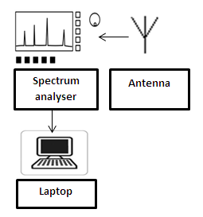
Figure 1. Instruments setup

Results and Discussion
Figure 2 shows the average RFI level versus all frequencies (MHz) up to 8000MHz at different observation site which are UMT hostel, Balai Cerap KUSZA and ESERI.

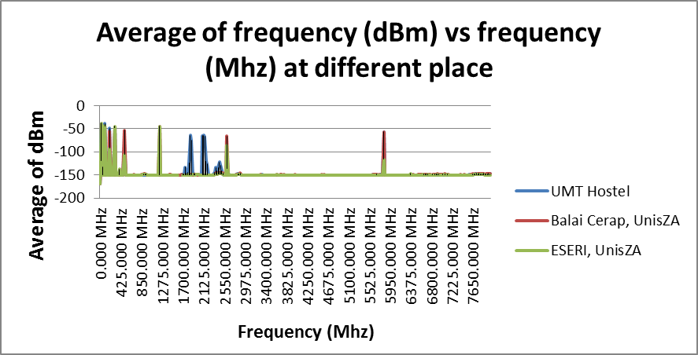

Figure 2. The average of RFI (dBm) vs frequency (MHz) at different places

Based on the results, the frequencies detected at the sites are 200MHz, 500MHz, 2600MHz and 5825MHz. According to MCMC manual [9], the frequencies detected are identified mostly come from telecommunication service provider and AM/FM radio. At the same observation time, the ambient concentration of CO₂ have been recorded. The minimum and maximum value detected are 450 ppm and 600 ppm respectively.

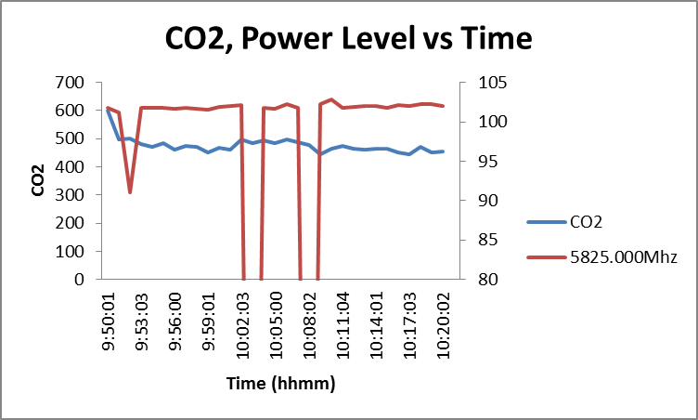

Figure 3. CO₂, Power level (dBm) against time for 5825MHz

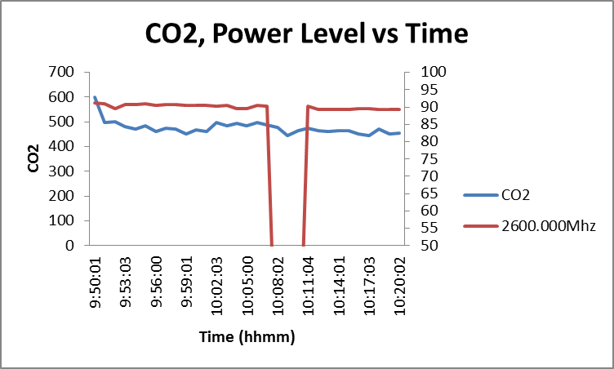

Figure 4. CO₂, Power level (dBm) against time for 2600MHz

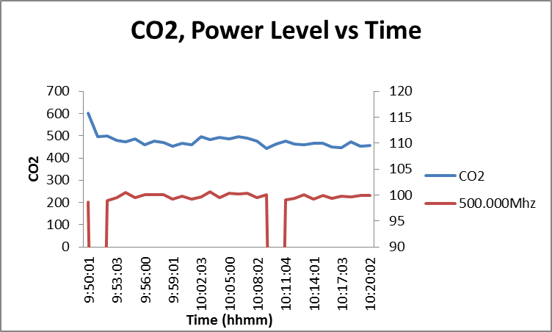

Figure 5. CO₂, Power level (dBm) against time for 500MHz

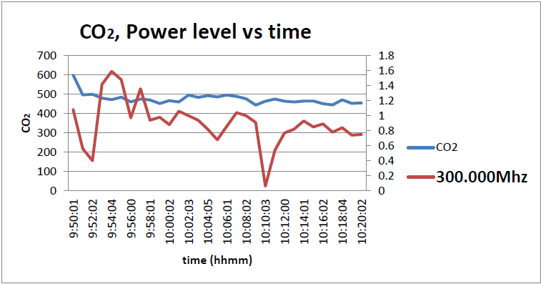

Figure 6. CO₂, Power level (dBm) against time for 300MHz

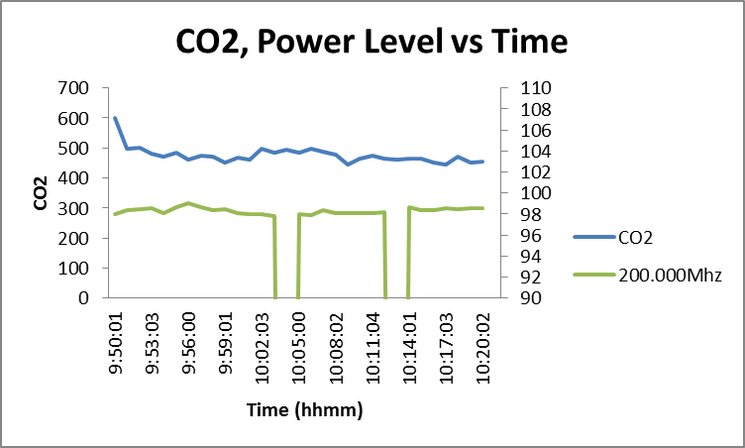

Figure 7. CO₂, Power level (dBm) against time for 200Mhz

The plots of the change in RFI level and CO₂ variation against time for different frequencies are as shown in Figure 3 until Figure 7. The ambient concentration of CO₂ for up to 600ppm can be concluded as no significant effect on the radio signal. The radio signal fluctuated randomly and did not have the same trends as CO₂ concentration fluctuations. This might be because of the value of CO₂ is very low so it did not affect the radio signal. According Okhimamhe et al. [10] on their research in 2013 about assessment of carbon dioxide emission at road junction in Suleja, Mina and Bida located in Nigeria, they found the highest level were 3005.38 and 2698ppm recorded in Suleja due to high vehicular movement compared to the in Mina and Bida. The same RFI pattern recorded where the RFI increases in Suleja if compared with Mina and Bida. We can conclude that, the radio signal is significantly affected by the high concentration of CO₂.

Conclusion
The ambient concentration of CO₂ and RFI level have been plotted against time to see how the radio signal change by the fluctuations of the CO₂ concentration. We can see the radio signal is not affected by the CO₂ concentration of below 600ppm. This may be due to the observation duration and the choice of observation sites. Future work is suggested to be conducted in urban area which is predicted to have higher value of ambient CO₂ concentration. The observation should be done in 24 hours for better findings. These findings may help the radio astronomer to decide the location for sitting the radio telescope for future studies.

Acknowledgement
This study is made possible by the usage of the grant RACE/F1/ST1/UNISZA/15. The authors gratefully acknowledge Universiti Malaysia Terengganu, Universiti Sultan Zainal Abidin and Universiti Pendidikan Sultan Idris for the financial and experimental support of this work. Special thanks are also dedicated to other researchers Electromagnetic Research Group (EMRG) for their assistance in this work.

References
- Cohen J, Spoelstra, T., Ambrosini, R. and van Driel, W. (2005). CRAF handbook for radio astronomy. European Science Foundation.
- John, A. (2013). Pyhsic Boundless Textbook: Chapter 23 Electromagnetic wave (online). https://www.boundless.com/physics/textbooks/boundless-physics-textbook/electromagnetic-waves-23 [15 March 2014].
- Abidin, Z. Z., Ibrahim, Z. A., Rosli, Z., Malim, S. F. F., Anim, N. M. and Noorazlan, N. (2012). An RFI Investigation for Setting Up a VLBI Station below 2.8 GHz in Malaysia. New Astronomy. 17: 61-64.
- Abidin, Z. Z., Umar, R., Ibrahim, Z. A., Rosli, Z., Asanok, K. and Gasiprong, N. (2013). Investigation on Frequency Allocation for Radio Astronomy at the L Band. Publications of the Astronomical Society of Australia (PASA) 30 : 47-57.
- Umar, R. Abidin, Z. Z, Ibrahim, Z. A, Rosli, Z. and Noorazlan, Z. (2014). Selection of radio astronomical observation sites and its dependence on human generated RFI., Research in Astronomy and Astrophysics 14: 241-248.
- Hamidi, Z. S, N. N. and Shariff, N. N. M. (2014). Investigation of Radio Frequency Interference (RFI) Profile, and Determination of Potential Astronomical Radio Sources. International Letter of Chemistry, Physic and Astronomy 24: 43-49.
- United States Environmental Protection Agency (2015). Overview of Greenhouse Gases. Access Online http://www.epa.gov/climatechange/ghgemissions/gases/co2.html
- National Research Council, NRC (2010). Advancing the Science of Climate Change. National Research Council. The National Academies Press, Washington, DC, USA.
- MCMC manual of ‘Spectrum Plan, 2006 MCMC manual of ‘Spectrum Plan, Malysian Communication and Multimedia Commission’ 2006. Resources Assignment Management Department, Access Online: http://www.mcmc.gov.my/what_we_do/spectrum/plan.asp.
- Okhimamhe, A. A. and Okelola, O.F. (2013). Assesment of Carbon dioxide Emission at Road Junction in the Southes of Niger State, Nigeria, Alam Cipta, International Journal of Sustainable Tropical Design Research and Practice 6 (2): 59 – 71.

