

MALAYSIAN JOURNAL OF ANALYTICAL SCIENCES
ISSN 1394 - 2506

Published by The Malaysian Analytical Sciences Society

sedimentary fatty alcoholS IN KAPAS ISLAND, TERENGGANU

(Alkohol Lemak Sedimen Di Pulau Kapas, Terengganu)

Noor Farahin Amiruddin¹, Mohamad Iznul Mua’zim Mohamad Zabidi¹, Nurul Fathihah Mt. Nanyan¹,
Masni Mohd Ali^{1,2}*

¹School of Environmental and Natural Resource Sciences, Faculty of Science and Technology,
Universiti Kebangsaan Malaysia, 43600 UKM Bangi, Selangor, Malaysia
²Associate Researcher, Institute of Oceanography and Environment,
Universiti Malaysia Terengganu, 21030 Kuala Terengganu, Terengganu, Malaysia

*Corresponding author: masni@ukm.edu.my

Received: 27 May 2015; Accepted: 12 August 2015

Abstract
A geochemical study was carried out to identify the composition and sources of fatty alcohols in Kapas Island, Terengganu, Malaysia. Fatty alcohols in surface sediments were extracted and analyzed using Gas Chromatography – Mass Spectrometry (GC-MS). A total of 23 fatty alcohol compounds were identified in the Kapas Island sediment. Total concentrations of fatty alcohols ranged from 0.53 to 21.31 ng/g dry weight and the highest total concentration was found at S2, which is probably due to its location profile that is located north of Kapas Island which is close to several small islands. The short chain/long chain fatty alcohol ratio and alcohol source index (ASI) were used together to identify the dominant input in Kapas Island. Kapas Island sediments contained a mixture of organic sources, of which terrestrial sources were indicated to be the most abundant sources in these marine sediments.

Keywords: fatty alcohols, surface sediments, Kapas Island

Abstrak
Sebuah kajian geokimia telah dijalankan untuk mengenal pasti komposisi dan sumber alkohol lemak di Pulau Kapas, Terengganu, Malaysia. Alkohol lemak di dalam sedimen permukaan diekstrak dan dianalisis menggunakan Kromatografi Gas – Spektrometri Jisim (GC-MS). Sebanyak 23 sebatian alkohol lemak telah dikenal pasti di dalam sedimen Pulau Kapas. Jumlah kepekatan alkohol lemak di antara 0.53 hingga 21.31 ng/g berat kering dan jumlah kepekatan tertinggi adalah di S2, yang berkemungkinan disebabkan oleh profil kedudukannya iaitu terletak di bahagian utara Pulau Kapas yang berdekatan dengan beberapa buah pulau kecil. Nisbah rantai pendek/rantai panjang alkohol lemak dan indeks sumber alkohol (ASI) telah digunakan bersama untuk mengenal pasti input dominan di Pulau Kapas. Sedimen Pulau Kapas mengandungi kepelbagaian sumber organik, yang menunjukkan sumber terestrial merupakan sumber yang paling banyak terdapat di dalam sedimen marin ini.

Kata kunci: alkohol lemak, sedimen permukaan, Pulau Kapas

Introduction
Sedimentary fatty alcohol is a lipid compound or more commonly known as bio-lipid has been studied in marine geochemistry field as an indicator to distinguish the contribution of organic matter as a result of a variety of sources. Distributions of fatty alcohols are widespread as well including lipid contained in organisms, surface sediment and each layer of core sediment, which is input directly from organism or degradation compound product containing fatty alcohol component [1]. It enters the marine environment through natural resources such as products from marine organisms and plants, and also human actions including the dilution of detergents and cosmetics [2]. Briefly, fatty alcohols could be categorized into three compound groups; known as short-chain alcohols, long-chain alcohols and branched-chain alcohols. Short-chain alcohols represent sources from marine organisms [3], while long-chain alcohols signify sources from terrestrial plants, and branched-chain alcohols refer to side products from bacterial processes [4]. The importance of this study is to distinguish and elucidate the organic matter sources present in the sediment pool of the study area.

The decomposition rate of short-chain compounds is higher than the long-chain compounds [5]. Additionally, the concentration of short-chain compounds in surface sediments is higher than long-chain compounds. However, with depth, the concentration of long-chain compounds will dominate the short-chain concentration. This shows two different processes of in situ decomposition of organic matter sources and changes in the marine environment [6].

The medium used in this study was marine sediment because it acted as a sink for many organic materials which could be beneficial or harmful to the environment. In addition, by using fatty alcohols to determine the main source of organic matter in aquatic environments, assessment using carbon can also be applied for similar purpose. According to Burone et al. [7], carbon is one of the main components of organic matter in aquatic environments. Generally, organic carbon components occur naturally in the aquatic environment of primary production through phytoplankton and input from terrestrial plants and also input from anthropogenic sources [8-10].

In identifying the sources of fatty alcohols, the short chain/long chain fatty alcohol ratio and alcohol source index (ASI) were used together with the data set in this study. The use of ratios and indices of fatty alcohols was necessary to reaffirm the main source of compounds in the aquatic environment. The ratio of short-chain/long chain fatty alcohol was used to determine the most abundant input in the sediment, either terrestrial or marine [11-14]. The ratio of fatty alcohol (short chain)/(long chain) in this study was calculated using the formula equation 1 below:

Short-chain/Long-chain Fatty Alcohol Ratio = $\frac{[∑(C12-C20) ]}{[ ∑(C21-C30) ]}$ (1)

Alcohol Source Index (ASI) is a method of determining the input of terrestrial organic matter in marine sediments. In applying ASI to determine the input of organic matter, marine resources are usually represented by C14 and C16, while terrestrial input is represented by C22 and C24 which form the ratio C22/ C14, C22/ C16, C24/ C14 and C24/ C16 [12].

This study was conducted at Kapas Island, Terengganu (Figure 1 and Table 1) which has a suitable environment to examine the presence of fatty alcohols that might be synthesized from varying sources. This island is also popular as a tourism destination with the entry of organic matter from various sources as a result of human activities along the coast. This research is part of an interdisciplinary study of sedimentary fatty alcohols which was carried out in order to distinguish and elucidate the sources present in the sediment pool of Kapas Island.

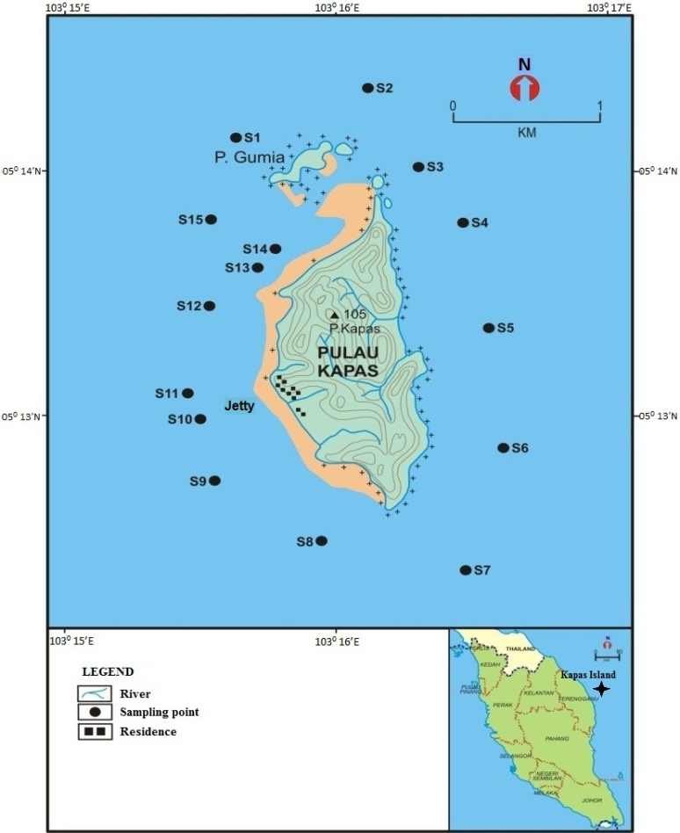
Figure 1. Sampling site in Kapas Island and its surrounding area

Table 1. Description of the sampling stations in Kapas Island
Station | Latitude (N) | Longitude (E) | Water Depth (m) | Description
S1 | 05° 14.162’ | 103° 15.679’ | 17.0 | Resort area
S2 | 05° 14.323’ | 103° 16.144’' | 25.2 | Rocky Beach with terrestrial trees
S3 | 05° 14.031’ | 103° 16.296’ | 25.0 | Rocky Beach with terrestrial trees
S4 | 05° 13.816’ | 103° 16.435’ | 24.7 | Rocky Beach with terrestrial trees
S5 | 05° 13.356’ | 103° 16.547’ | 23.4 | Rocky Beach with terrestrial trees
S6 | 05° 12.866’ | 103° 16.642’ | 22.8 | Rocky Beach with terrestrial trees
S7 | 05° 12.356’ | 103° 16.470’ | 20.2 | Rocky Beach with terrestrial trees
S8 | 05° 12.491’ | 103° 15.902’ | 11.0 | Resort area with terrestrial trees
S9 | 05° 12.710’ | 103° 15.681’ | 9.5 | Resort area
S10 | 05° 12.954’ | 103° 15.560’ | 11.3 | Jetty and resort area
S11 | 05° 13.195’ | 103° 15.519’ | 10.5 | Jetty and resort area
S12 | 05° 13.409’ | 103° 15.564’ | 10.8 | Resort area
S13 | 05° 13.648’ | 103° 15.715’ | 5.9 | Sandy bay
S14 | 05° 13.790’ | 103° 15.861’ | 3.5 | Sandy bay
S15 | 05° 13.840’ | 103° 15.543’ | 11.5 | Sandy near resort area

\

Materials and Methods
Fatty alcohol, total organic carbon (TOC) and grain size analysis
Surface sediment samples were randomly collected from 15 stations around Kapas Island, Terengganu on July 2012. The samples were collected at each site as shown in Figure 1 and Table 1 using a PONAR grab sampler. The methods used for the fatty alcohol analysis were adapted from the extraction procedures used by Mudge et al. [15] and Ali et al. [16]. The extraction involved three main phases: reflux, liquid-liquid separation and derivatives.

A total of surface sediment samples were dried in oven at at 60 ^{O}C. The dried samples are weighed until the weight remains constant. These wet weight and dry weight will be used to calculate the actual dry weight of each extracted samples. This is because the fatty alcohol concentration data that obtained from GC-MS analysis will be calculated in dry weight of sediment.

Briefly, sediments were hydrolyzed with 6% potassium hydroxide in methanol for 4 h and centrifuged at 4000 r.p.m for 3 mins. Non-polar lipids were extracted from the supernatant with hexane and double distilled water by liquid-liquid separation. The non-polar fractions were evaporated at 40 °C in a rotary-evaporator, redissolved in hexane and an amount of anhydrous sodium sulphate was added to remove any water and polar compounds that were left in the samples. The remaining solutions were dried and derivatized at 60 °C for 1h with N,O-Bis (trimethysily)-trifluoroacetamide (BSTFA).

The extracts were analyzed using a computerized GC-MS from Agilent Technologies (6890N-Network GC System and 5975C inert MSD with Triple-Axis Detecto) with HP-5 column (60 m length × 0.32 mm internal diameter × 0.25 µm film thickness). Blanks and calibration standards were used throughout the GC injections. A set of known concentration standards of octadecanol in eter-TMS form was used and quantified peaks were obtained from the analysis.

The total organic carbon (TOC) contents in the sediments were analyzed based on analytical procedures used by Nelson and Sommers [17]. The standard used for this analysis was sulphanilamide methionine. The grain size of sediments was identified using a hydrometer and sieve analysis (ASTM D 422- Standard test method for particle-size analysis of soils). Hydrometer was used to determine the size of the silt and clay-sized samples of < 63 μm, and for samples > 63 μm, it was determined by the sieve analysis.

Results and Discussion
The TOC were recorded for all samples of S1-S15 (Table 2), the TOC values ranged from 0.46% to 10.21%. Based on the result, the TOC content was high at stations along the west of Kapas Island, namely S8, S9, S10, S11, S12, S13, S14 and S15. These stations are located opposite the mouth of Marang River with a distance of 4.5 km and are near to the Kapas Island jetty. These were most probably attributable by the terrestrial input, since these stations are nearest to terrestrial land. Predominantly, the higher TOC level is directly proportionate to the higher nutrients as a result of the close distance to the location of sewage discharge, residence area and industries [18]. In addition, the biological productivity, the natural condition of sediments, the sedimentation rate, surrounding environment and diagenesis process could also be included as the factors that affect the organic carbon content [19].

Table 2. Fatty alcohol concentrations in dry weight sediments in Kapas Island
 | Stations
 | S1 |  | S2 |  | S3 |  | S4 |  | S5 |  | S6 |  | S7 |  | S8 |  | S9 |  | S10 |  | S11 |  | S12 |  | S13 |  | S14 |  | S15
TOC (%) | 2.34 |  | 0.46 |  | 1.26 |  | 0.91 |  | 0.62 |  | 0.52 |  | 2.11 |  | 6.44 |  | 7.49 |  | 4.00 |  | 6.99 |  | 9.11 |  | 8.77 |  | 10.21 |  | 9.48
Fatty alcohols (ng/g )
C12 | 0.05 | 5.12 |  | 0.14 |  | n.d. |  | n.d. |  | 0.13 |  | 0.07 |  | 0.07 |  | 0.07 |  | 0.13 |  | 0.08 |  | 0.08 |  | 0.08 |  | 0.08 |  | 0.09
C13 | n.d. | 1.01 |  | 0.19 |  | n.d. |  | n.d. |  | n.d. |  | n.d. |  | n.d. |  | 0.07 |  | 0.11 |  | n.d. |  | n.d. |  | 0.08 |  | n.d. |  | n.d.
C14 | 0.05 | 1.58 |  | n.d. |  | n.d. |  | n.d. |  | 0.13 |  | n.d. |  | 0.17 |  | 0.07 |  | 0.22 |  | 0.08 |  | 0.08 |  | n.d. |  | 0.08 |  | 0.09
iso-C15 | 0.06 | 0.54 |  | 0.12 |  | n.d. |  | n.d. |  | 0.13 |  | n.d. |  | 0.10 |  | 0.08 |  | 0.11 |  | n.d. |  | 0.08 |  | 0.08 |  | n.d. |  | n.d.
ante-C15 | 0.06 | 2.76 |  | 0.13 |  | n.d. |  | n.d. |  | 0.13 |  | n.d. |  | n.d. |  | 0.07 |  | 0.11 |  | n.d. |  | n.d. |  | n.d. |  | n.d. |  | n.d.
C15 | n.d. | 0.43 |  | 0.20 |  | n.d. |  | n.d. |  | 0.13 |  | n.d. |  | 0.09 |  | 0.08 |  | 0.11 |  | n.d. |  | 0.08 |  | n.d. |  | 0.08 |  | n.d.
C16 | 0.06 | 0.77 |  | 0.10 |  | 0.06 |  | 0.06 |  | 0.13 |  | 0.07 |  | 0.09 |  | 0.08 |  | 0.18 |  | 0.08 |  | 0.08 |  | 0.08 |  | 0.08 |  | 0.09
iso-C17 | 0.06 | 0.79 |  | 0.30 |  | n.d. |  | 0.06 |  | 0.13 |  | 0.07 |  | n.d. |  | 0.08 |  | 0.11 |  | n.d. |  | 0.08 |  | 0.08 |  | n.d. |  | 0.09
ante-C17 | n.d. | 1.62 |  | 0.29 |  | n.d. |  | n.d. |  | 0.13 |  | 0.07 |  | 0.08 |  | 0.08 |  | 0.11 |  | n.d. |  | 0.08 |  | 0.08 |  | n.d. |  | n.d.
C17 | n.d. | 0.50 |  | 0.13 |  | 0.06 |  | n.d. |  | 0.13 |  | n.d. |  | 0.08 |  | 0.08 |  | 0.11 |  | n.d. |  | n.d. |  | 0.08 |  | n.d. |  | n.d.
C18 | n.d. | 0.91 |  | n.d. |  | n.d. |  | n.d. |  | 0.13 |  | n.d. |  | n.d. |  | 0.08 |  | 0.11 |  | n.d. |  | n.d. |  | n.d. |  | n.d. |  | n.d.
C19 | 0.06 | 0.71 |  | 0.26 |  | n.d. |  | 0.06 |  | n.d. |  | n.d. |  | 0.10 |  | n.d. |  | 0.11 |  | n.d. |  | n.d. |  | 0.08 |  | n.d. |  | n.d.
C20 | 0.06 | 0.35 |  | 0.69 |  | n.d. |  | 0.06 |  | n.d. |  | n.d. |  | 0.08 |  | 0.08 |  | 0.23 |  | n.d. |  | n.d. |  | 0.08 |  | n.d. |  | 0.09
C21 | 0.08 | 1.15 |  | 0.31 |  | n.d. |  | 0.07 |  | 0.13 |  | n.d. |  | 0.20 |  | 0.08 |  | 0.11 |  | 0.08 |  | 0.08 |  | 0.08 |  | 0.08 |  | 0.10
C22 | n.d. | 1.17 |  | n.d. |  | 0.06 |  | n.d. |  | 0.13 |  | 0.07 |  | n.d. |  | 0.10 |  | 0.12 |  | 0.08 |  | 0.08 |  | 0.09 |  | 0.08 |  | 0.09
C23 | 0.14 | 0.23 |  | 0.32 |  | 0.06 |  | 0.09 |  | 0.16 |  | 0.07 |  | 0.36 |  | 0.12 |  | 0.11 |  | 0.09 |  | 0.09 |  | 0.10 |  | 0.14 |  | 0.10
C24 | 0.12 | 0.40 |  | 0.45 |  | 0.07 |  | 0.07 |  | 0.14 |  | 0.07 |  | 0.10 |  | 0.11 |  | 0.11 |  | 0.08 |  | 0.08 |  | 0.10 |  | 0.12 |  | 0.10
C25 | 0.12 | 0.21 |  | 0.34 |  | 0.06 |  | 0.07 |  | 0.16 |  | 0.07 |  | 0.10 |  | 0.12 |  | 0.10 |  | 0.09 |  | 0.09 |  | 0.10 |  | 0.11 |  | 0.10
C26 | n.d. | 0.35 |  | 0.36 |  | n.d. |  | n.d. |  | 0.17 |  | n.d. |  | 0.37 |  | 0.11 |  | 0.11 |  | n.d. |  | n.d. |  | 0.09 |  | 0.09 |  | n.d.
C27 | n.d. | 0.37 |  | 0.27 |  | 0.06 |  | n.d. |  | 0.17 |  | 0.07 |  | 0.19 |  | 0.10 |  | 0.19 |  | 0.08 |  | n.d. |  | 0.14 |  | 0.10 |  | n.d.
C28 | n.d. | 0.20 |  | 0.58 |  | 0.16 |  | n.d. |  | 0.17 |  | n.d. |  | 0.12 |  | 0.11 |  | 0.10 |  | n.d. |  | n.d. |  | 0.10 |  | 0.09 |  | n.d.
C29 | n.d. | n.d. |  | 0.20 |  | 0.07 |  | n.d. |  | 0.15 |  | 0.07 |  | 0.08 |  | 0.07 |  | 0.15 |  | n.d. |  | 0.08 |  | 0.18 |  | 0.09 |  | n.d.
C30 | n.d. | 0.14 |  | 0.15 |  | n.d. |  | n.d. |  | n.d. |  | 0.07 |  | 0.08 |  | n.d. |  | 0.10 |  | n.d. |  | n.d. |  | n.d. |  | 0.11 |  | n.d.
Total (ng/g) | 0.90 | 21.31 |  | 5.55 |  | 0.67 |  | 0.53 |  | 2.67 |  | 0.74 |  | 2.49 |  | 1.84 |  | 2.95 |  | 0.75 |  | 1.08 |  | 1.69 |  | 1.33 |  | 0.96
*n.d. not detected (< 0.05 ng/g dry weight)

A total of 23 fatty alcohol compounds were identified in the sediments of Kapas Island. The fatty alcohol concentrations were found to be relatively ranging from 0.05 ng/g to 5.12 ng/g (Table 2). These might be due to the grain size and type of sediment in the study area which is dominated by sandy sediments, which are coarse with sizes between 2mm to 1/16 mm. Organic matter is more easily trapped in fine-sized sediment compared to the coarse-sized sediment [20].

There are three main categories in the distribution of fatty alcohols of short-chain fatty alcohols (C12-C20), long-chain fatty alcohols (> C20) and branched-chain fatty alcohols (-iso and -anteiso) [12]. Based on the result, total concentrations of fatty alcohols ranged from 0.53 to 21.31 ng/g dry weight and the concentration of fatty alcohols was high at S2, which is located north of Kapas Island. This station was found with high concentrations of short-chain fatty alcohols and long-chain fatty alcohols. This station is close to several small islands with terrestrial plants covering almost the entire island. Terrestrial plants synthesize long-chain fatty alcohols from C20 to C32 [21]. Volkman et al. [22] also stated that aquatic organisms such as microalgae also produce long-chain fatty alcohols, but in little proportions. While for short- chain fatty alcohols, according to Rieley et al. [3] most are from marine organisms such as zooplankton which contains carbon (C12-C20).

In addition, based on the data set, it was noticed that the short-chain fatty alcohol compounds, C16, were present in all the sampling stations. The presence of C16 compounds shows that phytoplankton and zooplankton also contributed to the sedimentary fatty alcohol pool [23-24]. Besides, C16 was also produced by algae and bacteria [20].

In identifying the sources of fatty alcohols in these sediment samples, the ratio of short-chain per long-chain fatty alcohols and indices (ASI) were applied in this study. Based on Figure 2, most of the ratios of short-chain / long-chain fatty alcohols in this study were < 1 except for S1, S2, S9, S10 and S12.

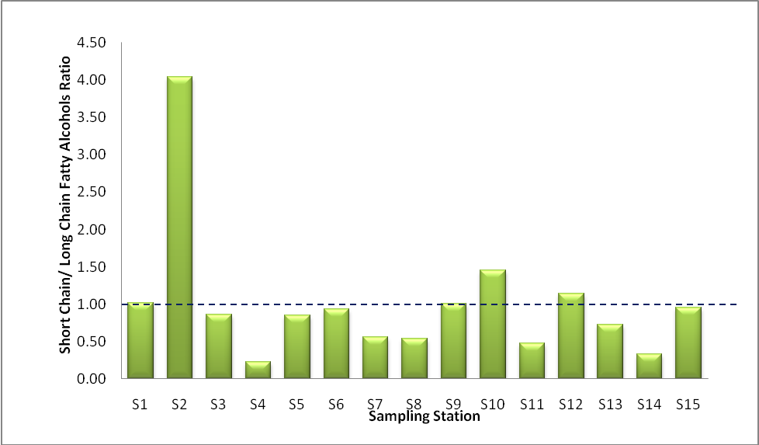

Figure 2. Short-chain / long-chain ratio for sampling stations at Kapas Island

Seguel et al. [24] noted that the ratio of short-chain per long-chain can potentially be used as markers for terrestrial input if the value is < 1.0, while the ratio of > 1 indicates high marine content sources. Sedimentary fatty alcohols of S1, S2, S9, S10 and S12 were dominant with the short-chain fatty alcohols, which were from marine sources. Therefore, it can be surmised that the abundance of marine organisms in these areas is higher than the other sampling stations.

The sources of organic matter can also be determined by using the ASI (Figure 3 & Figure 4). Ratios used in the ASI were C24/C12, C24/C16, C22/C12 and C22/C16. Compounds of C22 and C24 fatty alcohols represent terrestrial sources, while C16 and C12 represent short-chain fatty alcohol compounds. Therefore, the ASI helps in identifying the distribution of organic matter in sediments.

Figure 3. Alcohol Source Index (ASI) for C22/C12 & C22/C16 at Kapas Island

Figure 4. Alcohol Source Index (ASI) for C24/C12 & C24/C16 at Kapas Island

The ASI values for C22/C12 and C22/C16 (Figure 3) in the study area indicated values of > 1.0 except for some stations, while S4 and S5 stations did not show the presence of C12 compounds. ASI value above 1.0 indicated that most of the sampling stations were dominated by long-chain fatty alcohols (C22 and C24). Low ASI values at stations S1, S3, S8 and S10 were induced by the high concentrations of C16 and C12. C24 is the main terrestrial marker, while C16 and C12 are the primary markers of marine sources.

Almost all stations showed the ratio of C24/C12 and C24/C16 (Figure 4) > 1.0 except for stations S2 and S10. This shows that terrestrial sources dominate the study area when the concentration of C24 exceeded the concentration of C12 and C16 compounds. The ASI ratio for stations S2 and S10 showed the value of < 1.0. Stations S2 and S10 are likely to have an abundance of phytoplankton and zooplankton which caused the high input of marine sources in the area.

The position of Kapas Island which is opposite of the Marang River estuary causes the marine sediments in Kapas Island to be influenced by terrestrial sources. This can be proven when the concentration of C12 and C16 is lower than that of C22 and C24. The presence of long–chain fatty alcohols in the aquatic environment, especially in the river estuary and marine results from the movement of the water that brings the compounds together before they are deposited in the sedimentary layers [12].

Conclusion
The concentration of fatty alcohols in the sediment samples from Kapas Island, Terengganu were shown to be slightly low. For short-chain fatty alcohol compounds, compounds C16 dominated all the sampling locations. However, C24 assigned as long-chain alcohols, were also present in all the study locations. In identifying and elucidating the sources of fatty alcohols in Kapas Island, the use of short-chain per long-chain ratio and Alcohol Source Analysis (ASI) has resulted in better understanding of fatty alcohol sources in the study area. To conclude, Kapas Island was found to be dominated by terrestrial sources, followed by marine sources.

Acknowledgement
The authors gratefully acknowledge the support provided by Universiti Kebangsaan Malaysia (UKM). The authors would also like to extend their appreciation to all the research fellows and individuals in this research who helped out during the sampling and laboratory work, especially to Mr. Haris Hafidzal for the technical support provided. This research is funded by the grants of Ministry of Science, Technology and Innovation (MOSTI) through the Science Fund grant No. 04-01-02-SF0698.

References
- Mudge, S. M., Belanger, S. E. and Nielsen, A. M. (2008). Fatty Alcohol: Anthropogenic and Natural Occurrence in the Environment. Cambridge: The Royal Society of Chemistry.
- Mudge, S. M. (2010). What Contribution do Detergent Alcohol Makes to Sewage Discharge and the Marine Environment? School of Ocean Sciences, University of Wales- Bangor. For ERASM and SDA. Alcohol Sourcing Project- Phase II.
- Rieley, G., Collier, R. J., Jones, D. M. and Eglinton, G. (1991). The biogeochemistry of Ellwsmere Lake, UK-1: source correlation of leaf wax input to the sedimentary lipid record. Organic Geochemistry 17: 901-912.
- Parkes, R. J. (1987). Analysis of microbial communities within sediment using biomarkers In: Fletcher, M., Gray, T.R.G., Jones, J.G. (Eds.), Ecology of Microbial Communities. London: Cambridge University Press.
- Haddad, R.I., Martens, C.S. and Farrington, J.W. (1992). Quantifying early diagenesis of fatty acids in a rapidly accumulating marine sediment. Organic Chemistry 19: 205-216.
- Mudge, S. M. (2005). Fatty Alcohols - a Review of Their Natural Synthesis and Environmental Distribution. School of Ocean Sciences, University of Wales-Bangor. For SDA and ERASM. The Soap and Detergent Association.
- Burone, L., Muniz, P., Pires-Vanin, A. M. S. and Rodrigues, M. (2003). Spatial distribution of organic matter in the surface sediments of Ubatuba Bay (Southeastern-Brazil). Annals of the Brazilian Academy of Sciences 75(1): 77-90.
- Méjanelle, L. and Laureillard, J. (2008). Lipid biomarker record in surface sediments at three sites of contrasting productivity in the tropical North Eastern Atlantic. Marine Chemistry 108: 59-76.
- Ni, H.-G., Lu, F.-H., Luo, X.-L., Tian, H.-Y. and Zeng, E.-Y. (2008). Riverine inputs of total organic carbon and suspended particulate matter from the Pearl River Delta to the coastal ocean off South China. Marine Pollution Bulletin 56: 1150-1157.
- Pagani, M., Freeman, K.H. and Arthur, M.A. (1999). Isotope analyses of molecular and total organic carbon from Miocene sediments. Geochimica et Cosmochimica Acta 64: 37-49.
- Mudge, S. M. and Duce, C. E. (2005). Identifying the source, transport path and sinks of sewage derived organic matter. Environmental Pollution 136: 209-220.
- Mudge, S. M. and Norris, C. E. (1997). Lipid biomarkers in the Conwy Estuary (North Wales, U.K.): a comparison between fatty alcohols and sterols. Marine Chemistry 57: 61-84.
- Mudge, S. M. and Seguel, C. G. (1999). Organic contamination of San Vicente Bay Chile. Marine Pollution Bulletin 38: 1011-1021.
- Treignier, C., Derenne, S. and Saliot, A. (2006). Terrestrial and marine n-alcohol inputs and degradation processes relating to a sudden turbidity current in the Zaire Canyon. Organic Geochemistry 37: 1170-1184.
- Mudge, S. M., Bebianno, M. J. A. F., East, J. A. and Barreira, L. A. (1999). Sterols in the Ria Formosa Lagoon, Portugal. Water Research 4: 1038-1048.
- Ali, M.M. and Mudge, S. M. (2006). Cluster analysis in lipid biomarker studies: A case of Clyde Sea. Sains Malaysiana 35(2): 41-47.
- Nelson, D. W. and Sommers, L. E. (1996). Total carbon, organic carbon and organic matters. In: Sparks, D.L. (Ed.), Methods of Soils Analysis, Part 3, Chemical Methods. Soil Science Society of America, Madison.
- Adnan, N. H., Zakaria, M. P., Juahir, H. and Ali, M. M. (2012). Tracing sewage markers in the Langat River Malaysia: Integration of biomarker and multivariate statistical approaches. Journal of Environmental Sciences 24 (9): 1600-1608.
- Duan, Y. and Ma, L. (2001). Lipid geochemistry in a sediment core from Ruoergai Marsh deposit (Eastern Qinghai-Tibet plateau, China). Organic Geochemistry 32: 1429-1442.
- Guo, Z. G., Yang, Z. S., Qu, Y. H., Li, Y. Y. and Cui, Q. (1999). Distribution pattern of carbon storage in the surficial sediment in the middle continental shelf mud area and its adjoining East China Sea areas. Oceanologia et Limnologia sinica 30: 421-426.
- Server, J. and Parker, P. L. (1969). Fatty alcohol (normal and isoprenoid) in sediment. Science 164: 1052-1054.
- Volkman, J. K., Barrett, S. M. and Blackburn, S. I. (1999). Eustigmatophyte microalgae are potential sources of C₂₉ sterol, C₂₂-C₂₈ n-alcohols and C₂₈-C₃₂ n-alkyl diols in freshwater environments. Organic Geochemistry 30: 307-318.
- Ogura, K., Machihara, T. and Takada, H. (1990). Diagenesis of biomarkers in Biwa Lake sediments over 1 million years. Organic Geochemistry 16: 805-813.
- Seguel, C. G., Mudge, S. M, Salgado, C. and Toledo, M. (2001). Tracing sewage in the marine environment: altered signatures in Concepcion Bay, Chile. Water Research 35(17): 4166-4174.

