

MALAYSIAN JOURNAL OF ANALYTICAL SCIENCES
ISSN 1394 - 2506

Published by The Malaysian Analytical Sciences Society

NUTRITIONAL TRANSITION PERIOD IN EARLY LARVAE CLARIAS GARIEPINUS

(Tempoh Peralihan Nutrisi di Peringkat Awal Larva Clarias gariepinus)

Nguang Siew Ing* and Ha Hou Chew

Faculty of Bioresources and Food Industry
Universiti Sultan Zainal Abidin,
Tembila Campus, 22200 Besut, Terengganu, Malaysia

*Corresponding author: nguangsiewing@unisza.edu.my

Received: 14 April 2015; Accepted: 9 July 2015

Abstract
The nutritional transition period of Clarias gariepinus were described based on the early development from hatching to 120 hours after hatching (hAH) reared at 27.5-28.6ºC. Newly hatched larvae had a large greenish yolk sac volume (0.99+0.31 mm³) located below a straight undeveloped digestive tract, mouth not opened, eyes unpigmented and the larvae lie on the bottom of rearing tank. During endogenous feeding period, the larval feeding system has developed rapidly with development oesophagus. Yolk sac were not completely depleted at the onset of exogenous feeding (36 hAH, 0.19±0.11 mm³), and a period of mixed nutrition was observed up to 68 hAH when yolk was completely exhausted. Yolk sac volume was significantly different by time at hatching, 6, 12 and 18 to 36 hAH (ANOVA, P<0.05). At 36 hAH, the larvae commenced feeding once morphologically developed with opened anus, functional jaw and intestine, and demonstrated horizontally swimming. The rudimentary chemoreceptors like olfactory organs and taste buds that were found on the barbels and oral cavity assisted in food detection and commenced feeding without vision. Due to the cannibalistic behaviour at early stage, feed are suggested to be provided during 36 hAH and avoided delay feeding in the larval rearing.

Keywords: behaviour, Clarias gariepinus, early larval development, morphogenesis, nutritional transition period, sensory organs

Abstrak
Tempoh transisi pemakanan Clarias gariepinus diterangkan berdasarkan perkembangan awal iaitu daripada peringkat penetasan sehingga 120 jam selepas penetasan (jST) di bawah ternakan pada suhu 27.5-28.6ᵒC. Larva-larva ikan yang baru menetas ini mempunyai yolk-sec besar (0.99+0.31 mm³) yang kehijauan dan terletak di bawah saluran pencernaan lurus yang belum berkembang, mulutnya tidak terbuka, matanya tidak berpigmen serta terbaring sahaja di bahagian bawah tangki ikan. Sepanjang tempoh pakan endogen, sistem pemakanan larva-larva ikan tersebut berkembang pesat dengan esofagusnya. Yolk-sec didapati tidak diserap sepenuhnya pada permulaan pakan eksogen (36 jST, 0.19 ± 0.11 mm³), dan tempoh pemakanan campuran ini diperhatikan berlansung sehingga 68 jST. Isipadu yolk-sec didapati berbeza secara ketara sebagaimana umur meningkat, iaitu pada peringkat penetasan, 6, 12 dan 18 hingga 36 jST (ANOVA, P <0.05). Pada 36 jST, larva-larva ikan diperhatikan bermula makan sebaik sahaja morfologinya berkembang di mana anus terbuka, rahang dan usus berfungsi, dan berenang secara horizontal. Reseptor kimia asas seperti organ olfaktori dan tunas rasa didapati pada sesungut dan rongga mulut larva-larva ikan membantunya mengesan makanan dalam air serta makan tanpa menggunakan penglihatan. Disebabkan oleh tingkahlaku karnibalistik pada peringkat awal, makanan larva-larva ikan ini dicadangkan agar diberi semasa 36 jST dan mengelakkan daripada kelewatan memberi makanan sepanjang penternakan ikan.

Kata kunci: tingkahlaku, Clarias gariepinus, perkembangan awal larva, morfogenesis, tempoh transisi pemakanan, organ deria

Introduction
Clarias gariepinus (Burchell 1822) is a species of freshwater air breathing catfish native to Africa. Their unique characteristic as an omnivorous feeder, able to stand in harsh condition including low dissolved oxygen, change of temperature and high level of water pollution, high resistance of diseases, and delicious taste make them a popular aquaculture species [1,2]. This fish have been introduced to Southeast Asia in the early eighties and its culture spread rapidly because of their higher growth rate compared with the local catfish species [3,4,5]. They are commonly known as North African Catfish in English, keli Africa in Malaysia and Indonesia [6]. Despite the popularity of this fish, the seed production is still inconsistent due to low larval survival particularly during the early larval stage [2,4]. This obstacle still exists even though the protocol for controlled spawning and larval rearing of C. gariepinus has been established [2,4,6,7].

Larval development of C. gariepinus has been studied on the topic of by a number of people focusing on digestive system [8], cost of growth in relation to food intake and oxygen consumption [9], survival, growth, metabolism and behaviour of early larval stages under different light conditions [5], embryo-larval toxicity tests [10], feeding practices, growth and nutritional physiology [11] and others larval development study under different condition. However, the basic knowledge of the nutritional transition period with morphogenesis of the larvae is insufficient. Nutritional transition period in early larval stage means dietary conversion from endogenous to exogenous nutrition. This particular mixed feeding period counted when the yolk sac larvae begin to inject food as they have minimal morphogenesis and sensory organs prepared for feeding until the yolk sac completely exhausted. The knowledge of larval biology in this critical short period is a key element for effective larviculture that directly affects the seed quality and later of adult [12]. Larval behaviour is closely related to the morphogenesis and sensory organs development [13,14,15]. Fish larvae directly affected with a fluctuating and harsh environment. The larvae demonstrated several types of responses and behaviour that undertaking to their survival when they perceive stimuli from the environment. This study cultured the C. gariepinus larvae and traces the morphogenesis development and behavioural changes using light microscopy and histological assessment. This information will improve our understanding of the structural changes and nutritional period, which is useful in the improvement of rearing technique.

Materials and Methods
Egg Collection and Larval Rearing
The larval development studies and rearing of C. gariepinus larvae were carried out for five times at the Fish Hatchery, Borneo Marine Research Institute, Universiti Malaysia Sabah. The larvae were obtained from artificially fertilized eggs [16]. The eggs hatched during 20 to 22 hours after fertilization (hAF) at 27.5-28.6ºC. The fish age was shown in hours based on the hatching time. Ten thousands of newly hatched larvae were reared in a 1-tonne fibre reinforced plastic tank (1.5 m in diameter, 0.6 m in depth). Green algae Chlorella sp. was added to the rearing water at a density of 500,000 cells/ml. The rearing water was aerated with 500 ml/min. Tank bottom was cleaned daily by siphoning and new rearing water was added to refill the amount of water siphoned out earlier.

The larvae were fed with rotifer Brachionus spp. (150±0.05 μm in body length, n=20, 20-30 individuals per ml) and artificial powdered feeds (250-600 μm in diameter) (Otohime S1 & S2, Nissin Co., & Ltd.) after opened mouth were observed from the larvae, which will be described in the result later. The powdered feeds were given after 48 hours after hatching (hAH). Feeds were given when the larvae were observed with empty stomach day and night approximately six hours intervals. The rearing tank was placed in the natural light condition in the hatchery and the maximum illuminance was 1500 lux on the water surface during daytime. During the rearing period, water temperature, dissolved oxygen (DO), and pH of the rearing water were measured at 27.5-28.6ºC, 4.0-7.6 mg/l and 5.8-8.0, respectively.

Larval Development Observation and Measurement
The observation was done at six hours intervals from hatching to 72 hAH, and subsequently, at 96 and 120 hAH. Approximately 10 specimens were anaesthetized using α-methylquinoline (Nika, 10-50 ppm) before measurement and morphological observation under a dissection photomicroscope (Nikon Eclipse E600, Japan). Photographs were taken with a digital camera (Canon IXY 600F). The feeding and swimming behaviour of the larvae were observed in the rearing tank and in a 7 L rectangular transparent aquarium. Larval reactions to water current and light from a torch were observed in a 500 ml glass beaker under dark condition. The measurements were done under a profile projector (Mitutoyo PJ-3000, Japan). The yolk volume of a hatched larva was elliptical and the volume (V_{ys}) was calculated from the formula for a prolate spheroid: π/6 LH², where L represents the length (horizontal measurement; mm) and H the height (vertical measurement; mm) of the yolk sac. The total lengths of the larvae were measured from the tip of the snout to the end of the caudal fin fold. R ratio was used to evaluate the mixed feeding period of the larvae with the formula: R = t_{y}/ t_{f}, where t_{y} is the time from first feeding to end of yolk absorption and t_{f} is the time from hatching to first feeding [17]. First feeding rate was measured for each larva by counting the number of rotifer in the gut after one and six hours feeding session. Rotifer ingested was observed and counted under a dissection photomicroscope. In order to determine growth rates, growth of larvae was related to the mean of total length with development time. Data on yolk sac volume were statistically analysed using one-way analysis of variance (ANOVA) followed by Tukey’s post hoc test at the significance level below 5 % (P<0.05). The results were expressed as the means ± S.D. of the data.

Histological Assessment
Ten larvae were sampled randomly at interval six hours from 0 to 72 hAH, and thereafter, at 96 and 120 hAH. The sampled larvae were preserved in 10% buffered formalin and Bouin’s solution, and processed for morphogenetic study of the larvae. Standard histological techniques were employed in order to prepare C. gariepinus larvae histological sections. The larvae were dehydrated in ethanol, cleared in xilol and embedded in paraffin wax, and 6-μm thick horizontal, sagittal, and cross sections were made and stained with haematoxylin and eosin counterstain. All stained slides were mounted permanently in neutral balsam and observed under a light microscope. Photographs were taken with a digital camera.

Results and Discussion
Larval Morphogenesis and Behaviour
The notable features of larval development of C. gariepinus obtained in this study are presented in Figure 1. The correlation between morphogenesis and behaviour changes of C. gariepinus larvae are shown in Table 1. Newly hatched larvae were 4.24±0.15 mm in TL and had a greenish yolk sac at 0.99+0.31 mm³ in volume. They lied down on the bottom of tank and slowly moved their tails (Figure 2a). The larvae did not respond to a glass pipette inserted into the water and were easily caught. At this time, eyes were not pigmented and mouth was not opened. The incipient intestine appeared as a straight tube place dorsally to the yolk sac. Circulation of blood and body fluid were observed around the notochord and yolk sac. At 6 h AH, the rudiment of barbels and the mouth were formed. A pair of olfactory pits was observed above the larval mouth. At 12 h AH, the first opened mouth was noticed and the dark spots were observed on the eye vesicles. The larvae commenced vertical swimming and showed the thigmotactic behaviour in which larvae aggregated at the edge of the plankton net (Figure 2b). The larvae avoided the approaching pipette and positively rheotactic in which they swam against the water current. At 18 h AH, buccal cavity and intestine were clearly observed, and lower jaw began to move. At 24 h AH, the larvae showed horizontal swimming as pre-flexion appeared at the caudal fin. Taste buds were observed on the lip, barbels and fins. Anus was opened at 30 h AH.

Table 1. Correlation among the morphogenesis, sensory organs development and behavioural changes from hatching to 120 hours after hatching (hAH) in Clarias gariepinus.
Morphogenesis | Age  (Total Length) | Sensory organs development and behavioural changes
Hatched with a greenish yolk sac and sticky substance stick on it, mouth not open, anus not formed, no pectoral fin and incipient intestine appeared as a straight tube. | 0 hAH  (4.24±0.15 mm) | Lied on the bottom of tank, negatively rheotactic, eyes not pigmented, olfactory pits not opened, octic vesicle with two otoliths and no taste buds.
Mouth formed and rudiment of barbels developed. | 6 hAH  (2.73±0.05 mm)
Mouth opened and pectoral fins formed. | 12 hAH  (5.04±0.18 mm) | Demonstrated vertical swimming, positive rheotactic and eyes slightly pigmented.
Lower jaw moveable | 18 hAH  (5.65±0.14mm)
Pre-flexion at caudal fin formed | 24 hAH  (5.65±0.14 mm) | Showed horizontal swimming, taste buds found on lip, barbels and fins, free neuromast observed on the head and trunk.
Anus opened. | 30 hAH  (6.03±0.11 mm)
Intestine peristaltic | 36 hAH  (6.64±0.32 mm) | First feeding occurs, eyes not fully pigmented.
Sharp teeth observed in the mouth. | 48 hAH  (7.31±0.28 mm)
 | 54 hAH  (7.31±0.28 mm) | Eyes deeply pigmented and positively phototactic
Yolk sac completely absorbed. | 72 hAH  (7.84±0.17 mm) | Larvae aggregated near the surface water and negatively phototactic.
 | 96 hAH  (8.26±0.74 mm) | Larvae appeared various size and cannibalism behavior observed.
Caudal fin shaped | 120 hAH (10.03±0.45 mm) | Larvae congregated in middle water column.

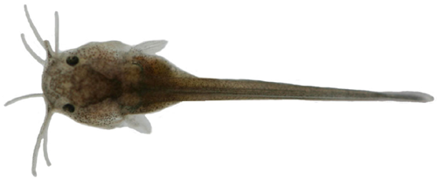
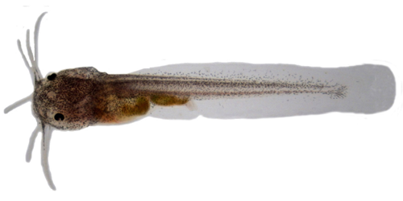
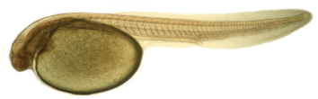
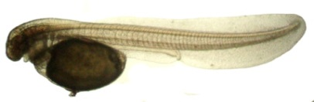
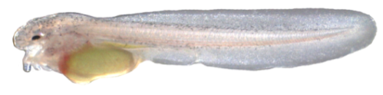
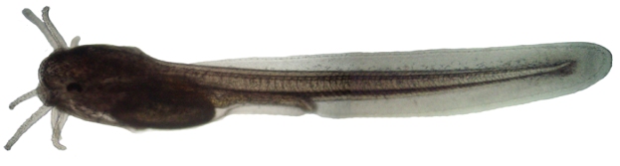
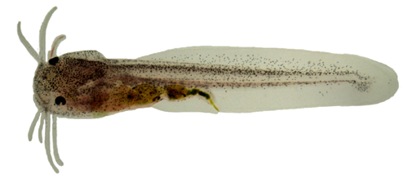
(g)
(f)
(a)
(b)
(c)
(d)
(e)
Ys
Ys
Ie
Ys
Bb
J
*
A
Ey
Ys
feed
Pi
Pf
hatching
6 hAH
18 hAH
36 hAH
48 hAH
72 hAH
120 hAH

Figure 1. Photomicrographs showed the typical pattern of early larval stage of Clarias gariepinus from hatching to 120 hours after hatching (hAH). Scale bar, 1 mm. (A = Anus, Bb = Barbels, Ey = Eye, Ie = Inner ear, Pi = Peristaltic intestine, J = Jaw, Pf = Pectoral fins, Ys = Yolk sac).

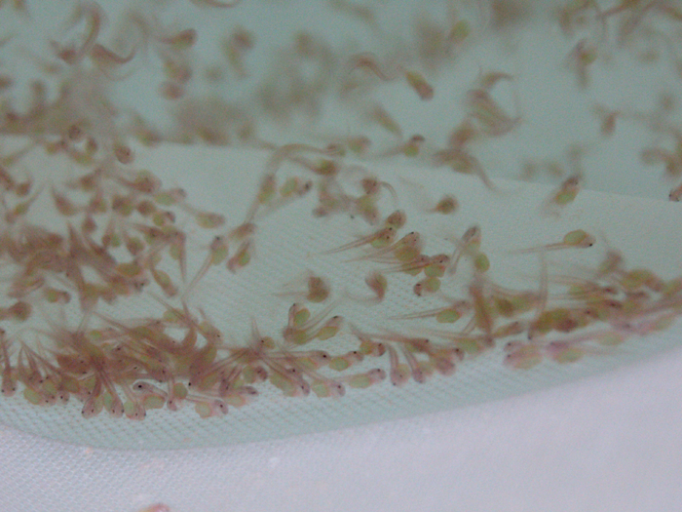
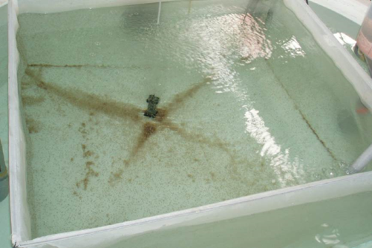
a
b

Figure 2. Thigmotactic behaviour of Clarias gariepinus larvae during early larval stage. (a) Newly hatched larvae lied on the bottom of tank. (b) Larvae swam and aggregated at the edge of plankton net (thigmotactic behaviour). Scale bar, 5 mm.

The first feeding was observed at 36 hAH. At this time, the larval eyes were not fully pigmented. The larval gut has developed into oesophagus primordia and intestine. The gut epithelium was made up of columnar cells and developed in a single layer (Figure 3). They were fed on rotifer Brachionus spp. and artificial powdered feed. The sharp teeth were observed at 48 hAH. At 54 hAH, as the eyes became deeply pigmented, the larvae become positively phototactic and attracted to torchlight. The yolk sac was completely absorbed at 68 h AH and teeth were developed in the mouth thereafter. At 72 hAH, the larvae showed more active swimming and aggregated near the surface water. The larvae appeared to be in various sizes at 96 hAH. They (8.26±0.74 mm in TL) were found attacking among themselves resulted in cannibalism (Figure 4). At 120 hAH, the caudal fin shaped, and the larvae congregated in the middle of thewater column. They fed well on live and artificial powdered feed both during the day and night (Figure 5).

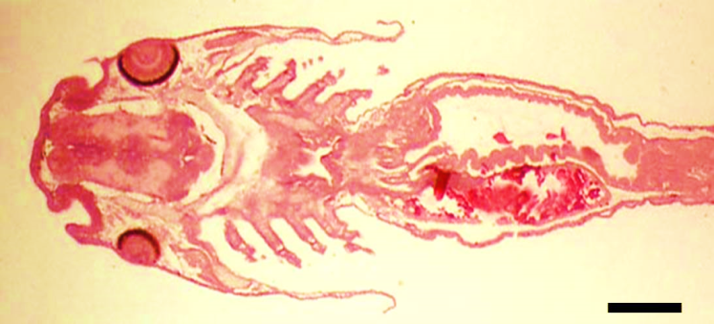
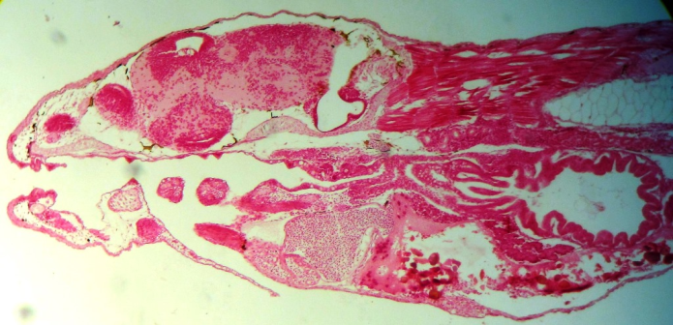
Mf
G
Oe
Ey
Ys
Int
(a)
Tb
Ie
Mf
G
Ys
(b)

Figure 3. Photomicrographs showed histology section of Clarias gariepinus larvae at 48 hours after hatching (hAH). (a) Cross section showed that the larvae have well developed olfactory epithelium, pigmented eyes, mucosa fold at the intestine that allowed the breakdown of food and nutrient absorption. (b) Longitudinal section showed the developed inner ear and taste buds in the oral cavity of larvae. Scale bar, 1 mm.(Ey = Eye, G = Gut, Ie = Inner ear, Int = Intestine, Oe = Olfactory epithelium, Mf = mucosa fold, Tb = Taste buds, Ys = Yolk sac)

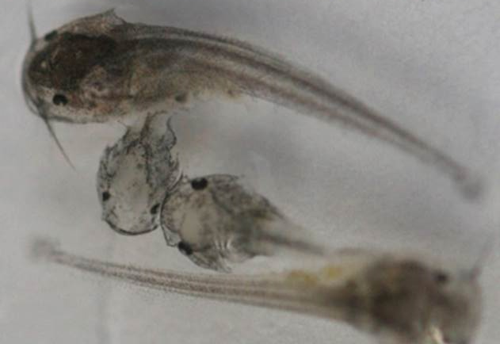
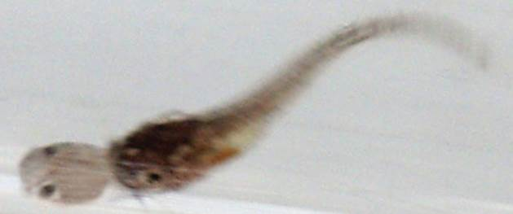

Figure 4. Intra-cohort cannibalism was observed in larvae at 96 hours after hatching (hAH). The larvae were observed caught tail-first, consume and discarded the head of victim. Scale bar, 2 mm

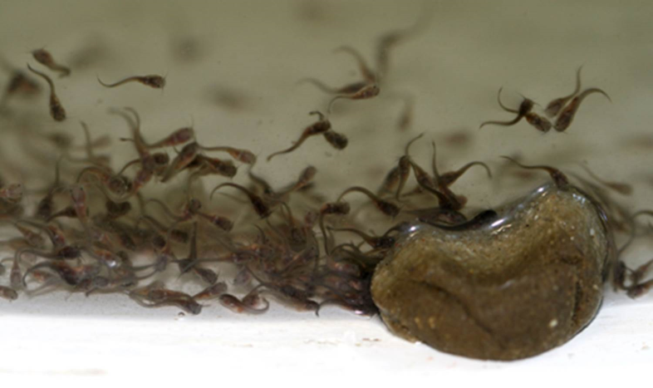

Figure 5. The larvae of 120 hours after hatching (hAH) were congregated in the middle water column and fed well both on live feed and formulated moist feed during day and night. Scale bar, 5 mm.

Yolks Sac Volume and Larval Growth
Yolk sac absorption in terms of yolk sac volume were significantly different as the age increased (ANOVA, Tukey’s HSD test, P<0.05). The data fitted the polynomial equation yolk sac volume to larval age (hours after hatching), y = 0.002x² + 0.2979x + 4.1676 (R² = 0.942). The largest amount of yolk sac absorption was observed at 6 hAH (remained volume 0.99±0.31 mm³-0.69±0.11 mm³), significant different with the absorption at 12 hAH (0.51±0.12 mm³), 18-36 hAH (0.33±0.08 mm³-0.19±0.11 mm³), 30-60 hAH (0.22±0.06 mm³-0.05±0.02 mm³), 36-66 hAH (0.19±0.11 mm³-0.03±0.14 mm³) and 42-72 hAH (0.14±0.07 mm³-0.00±0.00 mm³). The growth of C. gariepinus larvae as length by hours after hatching (mean±SD) was fitted to an exponential equation (y = 4.3812e^{0.0503x}, R² = 0.9495). The larvae grew exponentially at each important point from hatching, first feeding, yolk sac completely absorbed, until 120 hAH. Larval growth was slow after first feeding at 36 hAH while length increment was observed at 48 and 120 hAH.

The nutritional transition period, which starts from endogenous nutrient supply from yolk to exogenous feeding on prey, is a very important stage in early larval development. By observing the morphogenesis and behavioural changes of larvae, appropriate time for first feeding could be predicted. Most of the larvae begin exogenous feeding when the yolk sac absorption nearly complete and the mouth developed as also observed in perch fishes [18], river catfish Hemibagrus nemurus [19], Atlantic halibut Hippoglossus hippoglossus [20], Malaysian river catfish Mystus nemurus [21]. Once yolk sac is completely absorbed, larvae will enter the exogenous stage, and requisite begin the transition of exogenous nutrition, or they will gradually suffer from starvation [19,22,23]. During this critical period, first feeding timing, food availability and larval ability to consume food are decisive factors for larval survival [24 – 27]. At the onset of exogenous feeding, the morphogenesis and behavioural characteristics of C. gariepinus larvae to detect and catch food were observed similar to other teleost species such as largemouth bass Micropterus salmoides [14] and marble goby Oxyeleotris marmoratus [28], characid Salminus brasiliensis [29] and piracanjuba Brycon orbignyanus [30]. These fishes commenced feeding when they are morphologically developed with pigmented eyes, opened anus, functional jaw and intestine, and these larvae demonstrated horizontally swimming. These characteristics can be used to signify the timing of the first intensive feeding to ensure early larval survival. In this study, exogenous feeding of C. gariepinus was observed started at 36 hAH when yolk sac was 81.3% absorbed (remained 0.19±0.11 mm³). Yolk sac volume were significantly different by time at hatching, 6, 12 and 18 to 36 hAH which utilized for larval metabolism and growth (ANOVA, P<0.05) [9, 31]. At this time, C. gariepinus larvae have developed their feeding apparatus, except the eyes. However, the larvae have developed chemoreceptors including olfactory organs and taste buds found on the barbels and oral cavity. The morphogenesis and development of sensory organs assist the C. gariepinus larvae to detect food and commenced feeding without vision at night. Therefore, in this study, first feeding should be given to C. gariepinus larvae at 36 hAH both during day and night when the larvae have developed the most rudimentary morphology for foraging.

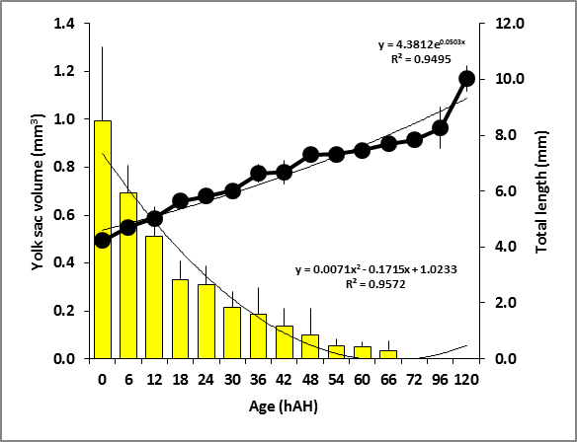
Nutritional transition period
a
b
c
d
d
de
def
ef
ef
ef
ef
f

Figure 6. Growth in total length (closed circles) and yolk sac volume depletion (yellow bar) by different time intervals in hours after hatching (hAH) of C. gariepinus larvae. The larvae grow exponentially, and their growth can be described by the equation, y = 4.3812e^{0.0503x} (R² = 0.9495). The yolk sac absorption in terms of yolk sac volume can be expressed as a second order polynomial equation, y = 0.0071x² - 0.1715x + 1.0233 (R² = 0.9572). Data are expressed as means±S.D. (n=10). Different letters above each bar indicate significant differences for yolk sac volume to time (ANOVA, Tukey’s HSD test, P<0.05).

The duration of nutritional transition period is important for larvae to experience learning feeding process and switching from endogenous to exogenous nutrition feeding in the early larval survival. By examining the morphogenesis and behavioural changes in this nutritional transition period, the duration for establishing larval first feeding and end of yolk sac absorption could be estimated [32 – 35]. Duration of the nutritional transition period differs in species and influenced by temperature and yolk absorption rate [36,37,38]. Previous studies on natural thermal at 26, 28 and 30ᵒC showed that yolk sac absorption in Pacific red snapper Lutjanus peru had prolonged 12 hours in lower temperature. The larvae have not completely absorbed the yolk reserve, allowing a longer endogenous feeding period and produce larger larvae with a higher probability of feeding success at the beginning of exogenous feeding [38]. Similar studies showed that lower water temperature decreased yolk sac absorption in catfish larvae [36]. In this study, nutritional transition period of C. gariepinus larvae was observed approximately 32 hours at 27.5 – 28.6ºC. Thus, lower temperature could be manipulated to regulate the duration of nutritional transition period and assist larvae in learning the feeding process for higher early larval survival.

In order to reduce the differences that affected by temperature and yolk sac absorption, R ratio has been employed to assess the nutritional transition period [17,39]. Previous studies showed that miiuy croaker Miichthys miiuy larvae (R = 1:3) [39] and flounder Platichthys flesus (R = 1:6) [40] had a short nutritional transition period. These larvae showed low feeding ability at first feeding and they might endure starvation during this critical period. In this study, R ratio for C. gariepinus larvae is shorter than former species (R = 1:1). However, at first feeding stage (36 hAH), C. gariepinus larvae showed high feeding ability and approximately 95% of the larvae observed fed on live feed after six hours. Besides, the C. gariepinus larvae have coeval sibling cannibalism behaviour that occurs among similar-aged individuals of post hatching stages and consume the conspecific [41,42]. In this study, cannibalistic behaviour of C. gariepinus larvae was first observed at 96 hAH even enough feed was provided. This aggressive behaviour to kill and consume among themselves have resulted in higher mortality and low production of C. gariepinus [43,44]. Therefore, food should be provided once the C. gariepinus larvae developed their rudimentary feeding system and delay feeding should be avoided in C. gariepinus larvae culture.

Conclusion
The present study provided important information in successful early larval rearing of C. gariepinus. These larvae immediately begin the first feeding (at 36 hAH) once developed the most rudimentary morphology including opened anus, functional jaw and intestine, showed the horizontally swimming, and chemoreceptors that for foraging even without vision. The shorter nutritional transition period (32 hours) and aggressive behaviour were observed to present few difficulties like starving in a short duration and cannibalism among the larvae caused the low larval survival. Thus, significant improvements need to be done in rearing conditions and feeding techniques including control the temperature of early larval rearing tank, provide first feeding before the larvae were morphologically to be feed and strictly avoided from delay feeding for the higher larval survival in captivity.

Acknowledgement
The authors wish to acknowledge the incentive and technical assistance from Prof. Dr. Senoo Shigeharu, Mr. Norazmi Osman, Mr. Raju Sulaiman and the staffs of the fish hatchery of Borneo Marine Research Institute, Universiti Malaysia Sabah. The authors also convey deep gratitude to Prof. Dr. Ridzwan Abdul Rahman, previous director of Centre for Research and Innovation of Universiti Malaysia Sabah for his encouragement and support. These contributions are gratefully acknowledged.

References
- Hogendoorn, H., Jansen, J. A. J., Koops, W. J., Machiels, M. A. M., van Ewijk, P. H. and van Hees, J. P. (1983). Growth and Production of the African Catfish, Clarias lazera (C&V). II. Effects of Body Weight, Temperature and Feeding Level in Intensive Tank Culture. Aquaculture 34: 265 - 285.
- Hecht, D. T. and Appelbaum, S. (1988). Observations on Intraspecific Aggression and Coeval Sibling Cannibalism by Larval and Juvenile Clarias gariepinus (Clariidae: Pisces) under Controlled Conditions. Journal of Zoology 214 (1): 21 – 44.
- Welcomme, R. L. (1988). International Introductions of Inland Aquatic Species. FAO Technical Paper No. 294. Fishery Resources and Environment Division FAO Fisheries Department, Rome. ISBN 92-5-102664-5: pp318.
- Graaf, G. and Janssen, H. (1996). Artificial Reproduction and Pond Rearing of the African Catfish Clarias gariepinus in Sub-Saharan Africa – A Handbook. FAO Fisheries Technical Paper. Rome, FAO. ISBN 9251039186: pp73.
- Appelbauma, S. and Kamler, E. (2000). Survival, Growth, Metabolism and Behaviour of Clarias gariepinus (Burchell 1822) Early Stages under Different Light Conditions. Aquacultural Engineering 22(4): 269 - 287.
- Sudarto, H. (2007). Systematic Revision and Phylogenetic Relationships among Populations of Clariid Species in Southeast Asia. PhD Thesis, University of Indonesia. pp 371.
- Hecht, T., Oellermann, L. and Verheust, L. (1996). Perspectives on Clariid Culture in Africa. Aquatic Living Resources, 9: 197 - 206.
- Verreth, J. A. J, Torreele, E., Spazier, E., der Sluiszen, A. V., Rombout, J. H. W. M., Booms, R. and Segner, H. (1992). The Development of A Functional Digestive System in the African Catfish Clarias gariepinus (Burchell). Journal of the World Aquaculture Society 23(4): 286 - 298.
- Conceição, L. E. C., Dersjant-Li, Y. and Verreth, J. A. J. (1998a). A first attempt to estimate protein turnover using a simulation model for amino acid metabolism in yolk-sac larvae of Clarias gariepinus (Burchell) and Hippoglossus hippoglossus (L.). ICES Marine Sciences Symposium 201: 80-86.
- Nguyen, L. T. H. and Janssen, C. R. (2002). Embryo-larval Toxicity Tests with the African Catfish (Clarias gariepinus): Comparative Sensitivity of Endpoints. Archives of Environmental Contamination and Toxicology 42(2): 256 - 262.
- Verreth, J. A. J., Eding, E. H., Rao, G. R. M., Huskens, F. and Segner, H. (2007). A Review of Feeding Practices, Growth and Nutritional Physiology in Larvae of the Catfishes Clarias gariepinus and Clarias batrachus. Journal of the World Aquaculture Society 24(2): 135 - 144.
- Øyvind, J. H., Puvanendran, V., Jrˇstensen, J. P. and Ous, C. (2011). Effects of Dietary Levels and Ratio of Phosphatidylcholine and Phosphatidylinositol on the Growth, Survival and Deformity Levels of Atlantic Cod Larvae and Early Juveniles. Aquaculture Research 42: 1026 – 1033.
- Blaxter, J. H. S. (1986). Development of Sense Organs and Behaviour of Teleost Larvae with Special Reference to Feeding and Predator Avoidance. Transactions of the American Fisheries Society 115(1): 98 - 114.
- Kawamura, G., Mori, H. and Kuwahara, A. (1989). Comparison of Sensory Organ Development in Wild and Reared Flounder Paralichthys olivaceus Larvae. Nippon Suisan Gakkaishi 55(12): 2079 - 2083.
- Mukai, Y., Tuzan, A. D., Lim, L. S., Siti Raehanah, M. S., Wahid, N. and Senoo, S. (2008). Development of Sensory Organ in Larvae of African Catfish Clarias gariepinus. Journal of Fish Biology 73(7): 1648 - 1661.
- Graaf, G. J., Galemoni, F. and Banzoussi, B. (1995). The Artificial Reproduction and Fingerling Production of the African Catfish Clarias gariepinus (Burchell 1822) in Protected and Unprotected Ponds. Aquaculture Research 26: 233 - 242.
- Kamler, E. (1992). Early Life History of Fish: An Energetics Approach. Chapman and Hall, London. ISBN 978-94-010-5026-5. 267 pp.
- Craig, J. F. (2008). Percid Fishes: Systematics, Ecology and Exploitation. John Wiley & Sons. ISBN 0-632-05616-9. 368 pp.
- Adebiyi, F. A., Siraj, S. S., Harmin, S. A. and Christianus, A. (2013). Embryonic and Larval Development of River Catfish, Hemubagrus nemurus (Valenciennes, 1840). Asian Journal of Animal and Veterinary Advances 8(2): 237 - 246.
- Cloutier, R., Souza, Browman, J. L. and Skiftesvik, H. I. (2011). Early Ontogeny of the Atlantic Halibut Hippoglossus hippoglossus Head. Journal of Fish Biology 78(4): 1035 - 1053.
- Hag, G. A. E., Kamarudin, M. S., Saad, C. R. and Daud, S. K. (2012). Mouth Development of Malaysian River Catfish, Mystus nemurus (C&V) Larvae. Journal of American Science 8(1): 271 – 276.
- Blaxter, J. H. S. and Ehrlich, K. F. (1974). Changes in Behaviour during Starvation of Herring and Plaice Larvae. p. 575-588. In: The Early Life History of Fish. H. S. John Blaxter (eds.). Springer-Verlag, Berlin. pp768.
- Yufera, M. and Darias, M. J. (2007). The Onset of Exogenous Feeding in Marine Fish Larvae. Aquaculture 268: 53 - 63.
- Iguchi, K. and Mizuno, N. (1999). Early Starvation Limits Survival in Amphidromous Fishes. Journal of Fish Biology 54: 705 - 712.
- Sanderson, S. L. and Kupferberg, S. J. (1999). Development and Evolution of Aquatic Larval Feeding Mechanisms. p. 301-377. In The Origin and Evolution of Larval Forms. B. K. Hall and M. H. Wake (eds). San Diego: Academic Press..
- Robert, D., Murphy, H. M., Jenkins, G. P. and Fortier, L. (2013). Poor Taxonomical Knowledge of Larval Fish Prey Preference is Impeding Our Ability to Assess the Existence of A “Critical Period” Driving Year-Class Strength. ICES Journal of Marine Science: 1-11.
- China, V. and Holzman, R. (2014). Hydrodynamic Starvation In First-Feeding Larval Fishes. Proceedings of the National Academy of Science of the United States of America 111(22): 8083 - 8088.
- Senoo, S., Ang, K. J. and Kawamura, G. (1994). Development of Sense Organ and Mouth and Feeding of Reared Marble Goby Oxyeleotris marmoratus Larvae. Fisheries Science 60(4): 361 - 368.
- Santos, J. E. and Godinho, H. P. (2002). Ontogenic Events and Swimming Behavior of Larvae of the Characid Fish Salminus Brasiliensis (Cuvier) (Characiformes, Characidae) under Laboratory Conditions. Rev. Bras. Zool. 19 (1): 163 - 171.
- Maciel, C. M. R. R., Lanna, E. A. T., Junior, A. M., Donzele, J. L., Neves, C. A. and Menin, E. (2010). Morphological and Behavioral Development of the Piracanjuba Larvae. Revista Brasileira de Zootecnia 39(5): 961 - 970.
- Pavlidis, M. and Mylonas, C. (2011). Sparidae: Biology and Aquaculture of Gilthead Sea Bream and Other Species. John Wiley & Sons. pp416.
- Yufera, M., Pascual, E. and Fernandez-Diaz, C. (1993). A Highly Efficient Microencapsulated Food for Rearing Early Larvae of Marine Fish. Aquaculture 177: 249 - 256.
- Mookerji, N. and Rao, T. R. (1999). Rates of Yolk Utilization and Effects of Delayed Initial Feeding in the Larvae of the Freshwater Fishes Rohu and Singhi. Aquaculture International 7: 45 - 56.
- Dou, S. Z., Masuada, R., Tanaka, M. & Tsukamoto, K. (2002). Feeding Resumption, Morphological Changes and Mortality during Starvation in Japanese Flounder Larvae. Journal Fish Biology 60: 1363 - 1380.
- Gisbert, E., Piedrahitac, R. H. and Conklinb, D. E. (2004). Ontogenetic Development of the Digestive System in California Halibut (Paralichthys californicus) with Notes on Feeding Practices. Aquaculture 232: 455 - 470.
- Conceição, L. E. C., Ozório, R. O. A., Suurd, E. A. and Verreth, J. A. J. (1998b). Amino Acid Profiles and Amino Acid Utilization in Larval African Catfish (Clarias gariepinus): Effects of Ontogeny and Temperature. Fish Physiology and Biochemistry 19(1): 43 - 58.
- Wellborn, T. L. (1988). Channel Catfish Life History and Biology. 87-CRSR-2-3218. Publication No. 180. Southern Regional Aquaculture Center. Texas Agricultural Extension Service, University of Florida. 4 pp.
- Peña, R., Dumas, S., Zavala-Leal, I. and Contreras-Olguı´n, M. (2014). Effect of Incubation Temperature on the Embryonic Development and Yolk-sac Larvae of the Pacific Red Snapper Lutjanus peru. Aquaculture Research 45: 519 - 527.
- Shan, X. J., Quan, H. F. and Dou, S. Z. (2009). Effects of Delayed First Feeding on Growth and Survival of Rock Bream Oplegnathus fasciatus Larvae. Aquaculture 277: 14 - 23.
- Yin, M. C. and Blaxter, J. H. S. (1987). Escape Speeds of Marine Fish Larvae during Early Development and Starvation. Marine Biology 96: 459 - 468.
- Smith, C. and Reay, P. (1991). Cannibalism in Teleost Fish. Reviews in Fish Biology and Fisheries, 1: 41 - 64.
- Mukai, Y., Sanudin, N., Firdaus R. F. and Saad, S. (2011). Reduced Cannibalistic Behavior of African Catfish, Clarias gariepinus, Larvae under Dark and Dim Conditions. Zoology Science 30(6): 421 - 424.
- Abdelhamid, A. M., Radwan, I. A., Mehrim, A. I. and Abdelhamid, A. F. B. (2010). Improving the Survival Rate of African Catfish, Clarias gariepinus. Journal Animal and Poultry Production 1(9): 409 - 414.
- Mukai, Y. & Lim, L. S. (2011). Larval Rearing and Feeding Behaviour of Africa Catfish, Clarias gariepinus under Dark Conditions. Journal of Fisheries and Aquatic Science 6(3): 272 - 278.

