

MALAYSIAN JOURNAL OF ANALYTICAL SCIENCES
ISSN 1394 - 2506

Published by The Malaysian Analytical Sciences Society

ASSESSMENT OF WATER SALINITY MODEL USING HYDRODYNAMIC NUMERICAL MODELLING IN ESTUARY OF SELANGOR RIVER, MALAYSIA

(Penilaian Kemasinan Air Menggunakan Pemodelan Model Berangka Hidronamik

di Muara Sungai Selangor, Malaysia)

Mohd Ekhwan Toriman^{1,2}*, Norbaya Hashim³, Mohd Khairul Amri Kamarudin^{1,4}, Abdul Jalil Hassan³,

Muhammad Barzani Gasim¹, Asyaari Muhamad^{1,5}, Nor Azlina Abd Aziz¹

¹East Coast Environmental Research Institute (ESERI),

Universiti Sultan Zainal Abidin, 21300 Kuala Terengganu, Terengganu. Malaysia

²School of Social, Development and Environmental Studies, Faculty of Social Sciences and Humanities,

Universiti Kebangsaan Malaysia, 43600 UKM Bangi, Selangor, Malaysia

³Hydraulic Engineering Division,

National Hydraulic Research Institute of Malaysia (NAHRIM), 43300 Seri Kembangan, Selangor, Malaysia

⁴Faculty of Design Arts and Engineering Technology,

Universiti Sultan Zainal Abidin, 21300 Kuala Terenganu, Terengganu. Malaysia
⁵Institute of The Malay World and Civilisation (ATMA),

Universiti Kebangsaan Malaysia, 43600 UKM Bangi, Selangor, Malaysia

*Corresponding author: ekhwantoriman@gmail.com

Received: 14 April 2015; Accepted: 9 July 2015

Abstract
Issues such as water pollution and extraction of water from Sungai Selangor system has been said to be the cause of ‘fading fireflies’. Salinity intrusion into estuary of the Sungai Selangor has been carried out on a hydrodynamic numerical modeling to access the parameter that governed the amount of salt in the river. The berembang trees on the river bank that become the fireflies’ habitat need some amount of salt for proper growth. Living at the lower reaches of Sungai Selangor, the fireflies are affected not only by the activities in their vicinity, but by activities in the entire river basin. Rapid economic development in the basin and the strong demand for the water resources puts pressure on the ecosystem. This research has been carried out to investigate the effect of water extraction along Sungai Selangor towards altering the amount of salt content in the river. The hydrodynamic modeling with regards to the salt content is expected to support long term assessment that may affect the berembang trees as a result of changes in the flow from upstream because of the water abstraction activity for domestic water supply.

Keywords: hydrodynamic modeling, numerical modeling, water extraction, estuary, water salinity model

Abstrak

Isu-isu seperti pencemaran air dan pengeluaran air dari sistem Sungai Selangor telah dikatakan punca 'kelip-kelip pudar. Pencerobohan kemasinan ke muara Sungai Selangor telah dijalankan ke atas model berangka yang hidrodinamik untuk mengakses parameter yang dikawal jumlah garam dalam sungai. Pokok-pokok berembang di tebing sungai yang menjadi habitat kelip-kelip 'memerlukan jumlah garam untuk pertumbuhan. Hidup di muara Sungai Selangor, kelip-kelip terjejas bukan sahaja oleh aktiviti-aktiviti di sekitar mereka, tetapi oleh aktiviti di lembangan sungai keseluruhan. Pembangunan ekonomi yang pesat di lembangan dan permintaan yang kukuh untuk sumber air meletakkan tekanan ke atas ekosistem. Kajian ini telah dijalankan untuk mengkaji kesan pengambilan air di sepanjang Sungai Selangor ke arah mengubah jumlah kandungan garam di dalam sungai. Pemodelan hidrodinamik yang berkaitan dengan kandungan garam yang dijangka menyokong penilaian jangka panjang yang boleh memberi kesan kepada pokok berembang akibat daripada perubahan dalam aliran dari hulu kerana aktiviti abstraksi air untuk bekalan air domestik.

Kata kunci: model hidrodinamik, permodelan berangka, pengambilan air, muara, model kemasinan air

Introduction

Kuala Selangor has been synonymous with firefly (Pteroptyx tener) watching. Just outside Kuala Selangor town is the quiet hamlet of Kampung Kuantan, site of one of the largest firefly colonies in the world. Kampung Kuantan is located 25 km from the river mouth. Tourists from near and far flock to Kampung Kuantan to take a boat trip along the Selangor River to have a closer look at what is considered to be the ‘eighth’ natural wonder of the world. What is special about these small insects is that they display their flashes of light synchronously while congregating in large numbers on certain trees. They particularly favour ‘berembang’ trees (Sonneratia caseolaris), the branches of which overhang the riverbank. At a glance, it would seem as if we are looking at a row of Christmas trees lighting up the night, and we cannot help but wonder how on earth such a small creature can produce such amazing light.

The firefly has a close relationship with the river ecosystem at Kampung Kuantan. The ecosystem comprises the Selangor River and the different types of vegetation especially berembang trees that glow on its bank. Living at the lower reaches of Sungai Selangor, the fireflies are affected not only by activities in their vicinity, but by activities in the entire river basin. The berembang trees only thrive in weakly saline water and a continuous freshwater outflow is necessary to prevent the water at the firefly habitat from becoming too saline. However rapid economic development in the basin and the strong demand for the water resources puts pressure on the ecosystem [1,2,3]. Changes in the river water quality as a result of pollution or the building of the dam and barrage further upstream may eventually have an impact on the survival of the snail and the riverside vegetation on which the fireflies depend [4,5,6]. To ensure future sustainability of Sungai Selangor as a reliable source of water, protection of water source alone is not sufficient. An effective planning and control of the whole river basin is essential [6,7,8,]. In the long term, the survival of this ‘eight’ natural wonder of the world will be dependent on our ability to understand the ecology and habitat requirements of the firefly, and our determination to manage the river system. The visual inspection indicates that the growth of the berembang trees started at about 6 km and ended at about 34 km from the river mouth. Therefore salinity sampling was carried out covering this stretch of the river.

Integrated river basin management is an important new strategy and vital ingredient in achieving successful water resource management planning in the country [9]. The objectives of this study are: a) to develop a 1-Dimensional flow and salinity model for Sungai Selangor basin using unsteady flow, b) to carry out hydrodynamic numerical modeling to access the parameter that governed the amount of salt in the river and c) to investigate the effect of water extraction along Sungai Selangor towards altering the amount of salt content in the river.

Materials and Methods

A hydrodynamic model is set up and developed in this study on the behaviour of the saline intrusion and movement in the river system. The model is calibrated by using a 1-Dimensional hydrodynamic InfoWorks RS. It deployed full St. Venant equation for shallow water which is also suitable for water quality and sediment transport modeling [9 – 12].

The modeling involves two phases which are developing a flow model and secondly a salinity model [13,14,15]. The model covers from river mouth up to Rantau Panjang hydrological station. After the calibration process, various analyses can be carried out to look at the salinity behaviour with the change of flow from upstream of the river. Figure 1 shows the location of the study area.

Modeling

The hydrodynamic model is carried out to cover Sg. Selangor river system from its river mouth up to Rantau Panjang which is free from tidal effect. Total distance of the model is 57 km. The main input to the model is the flow measured at the Rantau Panjang station, tide and salinity concentration at the river mouth.

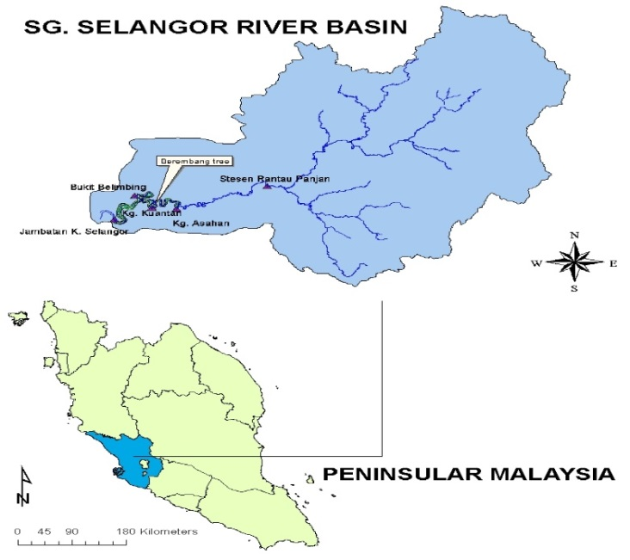

Figure 1. Location of the Study Area

Calibration

Flow and water level calibration was carried using data taken in November 2005 and comparison was carried out with measured water level at Kg. Asahan. The flow from upstream cover both high and low flows. The most suitable Manning’s coefficient ‘n’ value use in the calibration is 0.020. Figure 2 below shows the input data for the calibration process. Meanwhile Figure 3 shows the tide level at Kuala Selangor and Figure 4 shows the comparison between observed and simulated water level.

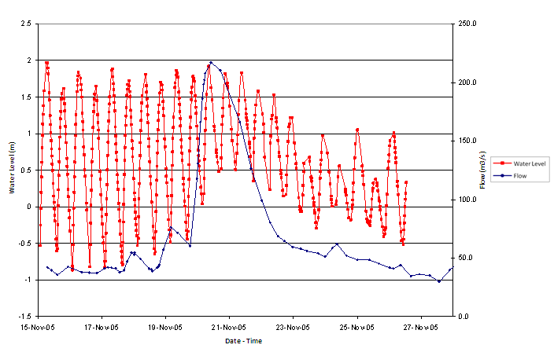

Figure 2. Inflow at Rantau Panjang Station and water level at Kg. Asahan

Figure 3. Tide level at Kuala Selangor

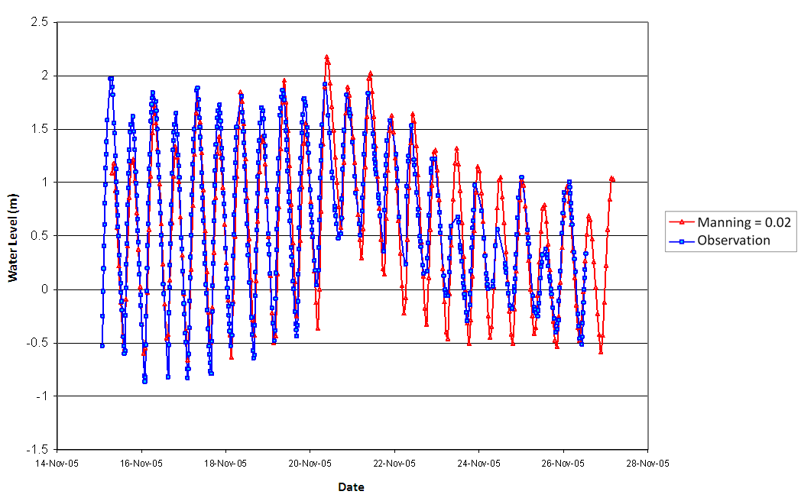
Figure 4. Comparison between observed and simulated water level

Salinity Calibration

Before the model can be used to analyse the behaviour of the salinity movement, a calibration need carried out [16-18]. Two salinity sampling were carried out in August 2005 and February 2006. There are three water intakes operating at Bistari Jaya, the SSP1, SSP2 and SSP3 which extract 950MLD, 950MLD and 800 MLD respectively. The total amount of water extracted from the river is equivalent to 30 cumecs.

The salinity calibration was carried out for the month of August 2005. This can be considered a dry month with average flow from upstream at Rantau Panjang set to 20 cumecs. Final flow after passing through the water intake is assumed at 10 cumecs. The simulated salinity results are shown in Figure 5 and 6 and the comparison of results between observed and simulated salinity at Kg. Bukit Belimbing and Kg. Kuantan is shown in Table 1. Table 2 shows the salinity comparison between observed and simulated at various locations in February 2006.
Figure 5. Salinity at Kg. Bukit Belimbing

Table 1 . Salinity comparison between observed and simulated in August 2005
Location | Time  (hours) | Salinity Observed  (ppt) | Salinity Simulated  (ppt)
Kg. Bukit Belimbing | 9: 48 am | 10 | 9.4
Kg. Kuantan | 10:15 am | 2.1 | 1.4

Figure 6. Salinity at Kg. Kuantan

Table 2 . Salinity comparison between observed and simulated in February 2006
 |  | Salinity (ppt)
Description | Time | Observation | Simulated
Kuala Selangor Bridge | 4.20 pm | 0.2 | 0
Bukit Belimbing | 4.34 pm | 0 | 0
Kg. Kuantan | 4.45 pm | 0.1 | 0
km 30 | 4.59 pm | 0 | 0
km 33 | 5.09 pm | 0 | 0
Kg. Asahan | 5.15 pm | 0 | 0
km 30 | 5.30 pm | 0 | 0
Kg. Kuantan | 5.39 pm | 0 | 0
Bukit Belimbing | 5.49 pm | 0 | 0
km 14 (Kg Sepakat) | 5.55 pm | 0.2 | 0.5
km 10 | 6.05 pm | 4.7 | 7
km 8 | 6.10 pm | 11.2 | 18
Kuala Selangor Bridge | 6.30 pm | 25.3 | 27

Results and Discussion

Preliminary simulation was carried out for year 2000 flow. The result is shown in Figure 7 below at Kg. Bukit Belimbing and Kg Kuantan.

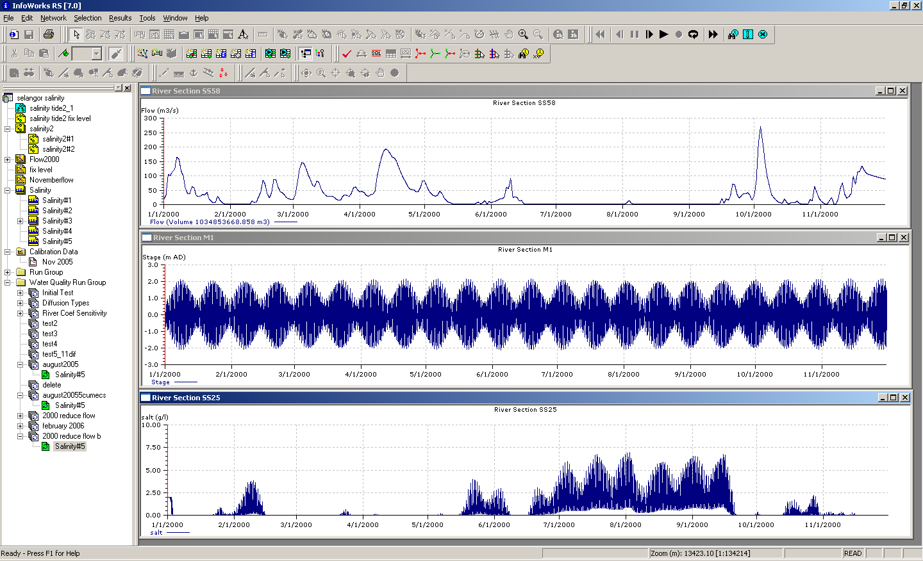

Figure 7. Top – Flow at Rantau Panjang; Middle – Tide level at river mouth; Bottom – salinity at Kg. Kuantan

The analysis shows that, salinity at Kg. Kuantan increase during low flow of the year. The salinity pattern also followed as tide reach spring tide. One simple analysis was carried out to see the effect of water intake [19]. The flow from upstream was reduced to 5 cumecs and comparisons at various places were done. For the purpose of this article, two scenarios were compared. From the result, it can be seen clearly that the salinity along the river increases once the flow is reduce (Figures 8 to 11). The model was able to predict the values and extent of the salinity intrusion. It is also interesting to note that saline water does travel further upstream which was estimate to about 5km.

Figure 8. Comparison of salinity for diff flow at kg Bkt Belimbing

Figure 9. Comparison of salinity for different flow at Kg Kuantan

Figure 9. Comparison of salinity for different flow at Kg Kuantan

Figure 10. Comparison of salinity for different flow at Kg. Asahan

Figure 11. Comparison of salinity for different flow at km 39 from river mouth

Conclusion

The hydrodynamic modeling was found out to be a useful tool in predicting the salinity changes and values in the river which can affect the growth of berembang trees. Then, expert in berembang trees should be able to analyse the effect of salinity changes to the berembang trees.

Although the model can be considered as straight forward in simulating the salt water intrusion in Sg. Selangor, this research reveals that more data are required to enhance the modeling process. However it can be indicate that the output from the modeling will be of a great help and support to in monitoring the effect on salinity changes due to the water extraction in Sg. Selangor. The model shall also be used to predict for the long term effect on salinity to the river system.

Acknowledgement

Special thanks are also directed to East Coast Environmental Research Institute (ESERI), Universiti Sultan Zainal Abidin, Terengganu, Malaysia and Hydraulic Engineering Division, National Hydraulic Research Institute of Malaysia in their contributions.

References
- Antonellini, M., P. Mollema, B. Giambastiani, K. Bishop, L. Caruso, A. Minchio, L., Pellegrini, M. Sabia, E. Ulazzi, and G. Gabbianelli, (2008). Saltwater intrusion in the coastal aquifer of the southern Po Plain, Italy. Hydrogeology Journal 16: 1541-1556.
- Arnell, N. W., (2004). Climate change and global water recourses: SRES emissions and socio-economic scenarios. Global Environmental Change 14: 31-52.
- Arnell, N.W., (1999). Climate change and global water resources, Global Environmental Change 9: 31–49.
- Smedt, F. D. (1989). Introduction to River Water Quality Modeling, VUB Press, Brussels. pp: 232.
- Ali, A., (1999). Climate change impact and adaptation assessment in Bangladesh, Climate Research 12: 109-116.
- Cartwright, N., L. Li., and P. Nielsen, (2004). Response of the salt-freshwater interface in a coastal aquifer to a wave-induced groundwater pulse: field observations and modelling, Advances in Water Resources 27: 297-303.
- Barlow, P. M. and Reichard, E. G., (2010). Saltwater intrusion in coastal regions of North America, Hydrogeology Journal 18: 247-260.
- Bobba, A. G., (2002). Numerical modeling of saltwater intrusion due to human activities and sea-level change in the Godavari Delta, India. Hydrogeological Sciences Journal 47: 67-80.
- Abd. Jalil H. (2005). Permodelan Hidrodinamik Sungai-Pendekatan Awal Menggunakan Infoworks RS, Institut Penyelidikan Hidraulik Kebangsaan Malaysia. pp:153.
- Toriman, M. E, Hashim, N., Hassan, A. J., Mokhtar, M., Juahir, H., Gasim, M. B. and Abdullah, M. P. (2011). Study on the Impact of Tidal Effects on Water Quality Modelling of Juru River, Malaysia. Asian Journal of Scientific Research 4: 129-138.
- Jaafar, O., Toriman, M. E., Mastura, S. A. S., Gazim, M. B. Lan, P. I., Abdullah, P., Kamarudin, M. K. A. and Aziz, N. A. (2010). Modeling the Impacts of Ringlet Reservoir on Downstream Hydraulic Capacity of Bertam River Using XPSWMM in Cameron Highlands, Malaysia. Research Journal of Applied Sciences 5(2): 47-53.
- Jaafar, O., Toriman, M. E., Mushrifah Idris, S.A. Sharifah Mastura, Juahir, H. Aziz, N. A. A., Kamarudin, M. K. A. and Jamil, N. R. (2010). Study of Water Level-Discharge Relationship Using Artificial Neural Network (ANN) in Sungai Gumum, Tasik Chini, Pahang, Malaysia. Research Journal of Applied Sciences 5(1): 20-26
- Church, J. A., White, N. J., Aarup, T., Wilson, W. S., Woodworth, P. L., Domingues, C. M. Hunter, J. R. and Lambeck, K. (2008). Understanding global sea levels: past, present and future. Sustainability Science 3: 9-22.
- Dausman, A. M. and Langevin, C. D. (2005). Movement of the saltwater interface in the Surficial Aquifer System in response to hydrologic stresses and water- management practices, Broward County, Florida: USGS Scientific Investigation Report : 2004-5256.
- Pilkey, O. H., and Cooper, J. A. G. (2004). Society and sea level rise. Science 303: 1781-1782.
- Chen, X., Zong, Y., Zhang, E., Xu, J and Li, S. (2001). Human impacts on the Changjiang (Yangtze) River basin, China with special reference to the impacts of the dry season water discharges into the sea, Geomorphology 41: 111-123.

- Giambastiani B. M. S., Antonellini, M., Oude Essink, H. P. and Stuurman, R. J. (2007). Saltwater intrusion in the unconfined coastal aquifer of Ravenna (Italy): A numerical model, Journal of Hydrology 340: 91– 104.
- Post, V. and Abarca, E. (2010). Preface: saltwater and freshwater interactions in coastal aquifers, Hydrogeology Journal 18: 1-4.
- Werner, A. D. (2010). A review of seawater intrusion and its management in Australia, Hydrogeology Journal 18: 281-285.

