

MALAYSIAN JOURNAL OF ANALYTICAL SCIENCES
ISSN 1394 - 2506

Published by The Malaysian Analytical Sciences Society

CHEMICAL CONSTITUENTS OF THE LICHENS Cladonia multiformis
AND Cryptothecia sp.

(Sebatian kimia liken Cladonia multiformis dan Cryptothecia sp.)

Hasliza Yusof¹, Husna Azahar¹, Laily B. Din¹*, Nazlina Ibrahim²

¹School of Chemical Sciences and Food Technology
²School of Biosciences and Biotechnology
Faculty of Science and Technology,
Universiti Kebangsaan Malaysia, 43600 UKM Bangi, Selangor, Malaysia

*Corresponding author: lbdin@ukm.edu.my

Received: 6 May 2015; Accepted: 18 August 2015

Abstract
Two depsides (atranorin 1 and evernic acid 4), an aromatic compound (methyl β-orcinolcarboxylate 2) and one cleavage product of depside (everninic acid 3) were isolated from two lichens, Cladonia multiformis (1 and 2) and Cryptothecia sp. (3 and 4). The identification of the four compounds was carried out by comparison of the recorded NMR data with that of the reported. Compounds 1 and 4 showed antibacterial activity against Bacillus subtilis and Enterobacter aerogenes.

Keywords: lichen, Cladonia, Cryptothecia, antibacterial activity

Abstrak
Dua depsida (atranorin 1 dan asid evernik 4), satu sebatian aromatik (metil β-orcinolkarboksilat 2) dan satu hasil pemutusan depsida 4 (asid everninik 3) telah dipencilkan daripada dua liken, Cladonia multiformis (1 dan 2) dan Cryptothecia sp. (3 dan 4). Pengecaman keempat empat sebatian dilakukan secara membandingkan data RMN yang direkodkan dengan data yang dilaporkan. Sebatian 1 dan 4 telah menunjukkan aktiviti antibakteria terhadap Bacillus subtilis dan Enterobacter aerogenes.

Kata kunci: liken, Cladonia, Cryptothecia, aktiviti antibakteria

Introduction
Lichen is a composite organism consisting of symbiotic association of fungus and photosynthetic partner, usually a green algae or crynobacterium [1, 2]. The lichen produces many unusual secondary products which are not found in other plants such as depsides, depsidones, diphenyl ethers, dibenzofurans and pulvinic acid derivatives [1, 2, 3]. They are found growing in almost everywhere from the poles to the tropics, from the intertidal zones to the peaks of mountains and on every kind of surfaces from soil, rocks and tree bark to the backs of living insects [3, 4].

Cladonia multiformis Merr. (Fig. 1). Primary squamules persistent or disappearing; middle-sized, 1-4 mm long, up to 0.5 mm broad; digitately lobed; ascending; flat to involute; the upper side glaucescent to olive-green or brownish; the underside white, darkening toward the base; esorediate. Podetia from the upper side of the primary squamules; up to 45 mm tall and about 1-2 mm in diameter; cup-bearing. Apothecia on the apices of the branches or proliferations, dark brown. Habitat on thin, mineral soil in sun to partial shade [4, 5]. However, no chemical study on this lichen has been reported. Previous studies on the taxa of this genus led to the isolation of usnic acid [6], α-D-glucan [7] and fatty acids [8].

Crustose’s Cryptothecia (Fig. 2) with thick, almost zoned thalli with a conspicuous prothallus developing at the periphery. Clearly defined fruiting bodies are not formed. Asci simply arise (sometimes in groups) within the thallus; spores colorless to pale brown, very large, muriform, 1-2 per ascus. Habitat on bark in subtropical woodlands [4]. But, no chemical study on this lichen has been reported.

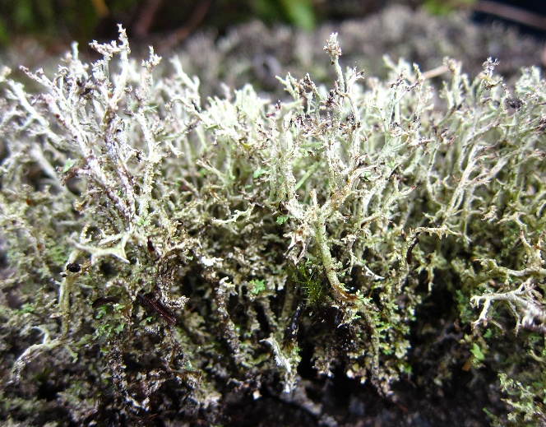
Figure 1. Cladonia multiformis

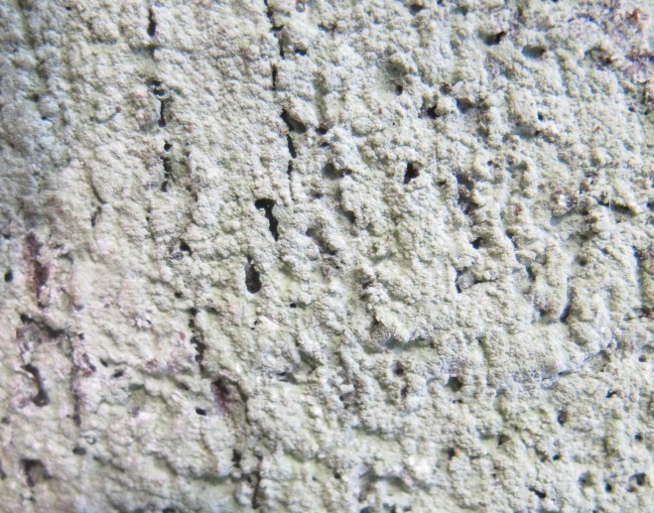
Figure 2. Cryptothecia sp.

Materials and Methods
Plant Material
Cladonia multiformis (GHR2) and Cryptothecia sp. (LDS1) were collected in February 2012 from Genting Highlands, Pahang and in April 2013 from Lembah Danum, Sabah, respectively. Both voucher specimen are deposited at the School of Chemical Sciences and Food Technology, Faculty of Science and Technology, Universiti Kebangsaan Malaysia. All samples were cleared of clinging debris such as soil, mosses and leaves using small paintbrush and forceps.

Extraction and Isolation
Cladonia multiformis (52.4 g) was extracted with acetone by using Soxhlet (3 x 8 hours) to give 1.10 g (2.1 %) of acetone extract. The extract was subjected to column chromatography (CC) eluted with CHCl₃-MeOH in the order of increasing polarity, to give ten fractions (A-J). Purification of fractions B (28.9 mg) and G (5.3 mg) by using Sephadex LH-20 column eluted with methanol gave compound 1 (4.1 mg) and 2 (1.9 mg), respectively.

Cryptothecia sp. (7.4 g) was extracted with acetone at room temperature (3 x 3 days) to yield 0.28 g (3.8 %) of acetone extract. The extracts was subjected to CC eluted with CHCl₃-MeOH in the order of increasing polarity, to give four fractions (A-D). Fraction B (17.1 mg) was purified by preparative thin layer chromatography (PTLC) (7H:3EA) to yield compound 3 (2.0 mg). Purification of fraction D (86.4 mg) by using Sephadex LH-20 column eluted by methanol gave compound 4 (6.3 mg).

Atranorin 1 (4.1 mg): pale orange fine needles. R_{f} = 0.76 (standard solvent C; toluene:acetic acid; 170:30). C₁₉H₁₈O₈. ¹H NMR (CDCl₃, 600 MHz) δ_{H}: 12.56 (1H, s, 4-OH), 12.52 (1H, s, 2-OH), 11.96 (1H, s, 2′-OH), 10.36 (1H, s, 8′-CHO), 6.52 (1H, s, H-5′), 6.41 (1H, s, H-5), 3.99 (3H, s, 7′-COOCH₃), 2.69 (3H, s, 9′-CH₃), 2.55 (3H, s, 9-CH₃), 2.10 (3H, s, 8′-CH₃). ¹³C-APT NMR (CDCl₃, 125 MHz) δ_{C}: 102.8 (C-1), 169.1 (C-2), 108.5 (C-3), 167.5 (C-4), 112.9 (C-5), 152.5 (C-6), 169.7 (C-7), 193.9 (C-8), 25.6 (C-9), 116.8 (C-1′), 162.9 (C-2′), 110.2 (C-3′), 152.0 (C-4′), 116.0 (C-5′), 139.9 (C-6′), 172.2 (C-7′), 24.1 (C-8′), 9.4 (C-9′), 52.4 (COOCH₃) [2].

Methyl β-orcinolcarboxylate 2 (1.9 mg): pale orange amorphous. R_{f} = 0.53 (standard solvent C). C₁₀H₁₂O₄. ¹H NMR (CDCl₃, 600 MHz) δ_{H}: 12.02 (1H, s, 2-OH), 6.21 (1H, s, H-5), 5.41 (1H, s, 4-OH), 3.93 (3H, s, COOCH₃), 2.46 (3H, s, 6-CH₃), 2.11 (3H, s, 3-CH₃). ¹³C-APT NMR (CDCl₃, 150 MHz) δ_{C}: 105.2 (C-1), 158.1 (C-2), 108.6 (C-3), 163.1 (C-4), 110.6 (C-5), 140.1 (C-6), 51.8 (COOCH₃), 24.1 (6-CH₃), 7.6 (3-CH₃), 172.6 (COOCH₃) [2].

Everninic acid 3 (2.0 mg): colourless fine needles. R_{f} = 0.47 (standard solvent C). C₉H₁₀O₄. ¹H NMR (CDCl₃, 600 MHz) δ_{H}: 11.76 (1H, s, 2-OH), 6.29 (1H, s, H-5), 6.24 (1H, s, H-3), 3.99 (3H, s, 4-OCH₃), 2.49 (3H, s, 6-CH₃). ¹³C-APT NMR (CDCl₃, 150 MHz) δ_{C}: 105.5 (C-1), 160.5 (C-2), 101.3 (C-3), 165.3 (C-4), 111.4 (C-5), 144.0 (C-6), 51.9 (4-OCH₃), 24.3 (CH₃), 172.2 (COOH) [2].

Evernic acid 4 (6.3 mg): pale orange amorphous. R_{f} = 0.24 (standard solvent C). C₁₇H₁₆O₇. ¹H NMR (acetone-d₆, 600 MHz) δ_{H}: 11.24 (1H, br s, COOH), 7.05 (1H, d, J = 1.2 Hz, H-5′), 6.89 (1H, d, J = 1.2 Hz, H-3′), 6.71 (1H, br s, 2-OH/2′-OH), 6.67 (1H, br s, 2-OH/2′-OH), 6.40 (1H, d, J = 1.8 Hz, H-3), 6.31 (1H, d, J = 1.8 Hz, H-5), 3.96 (3H, s, 4-OCH₃), 2.63 (3H, s, 8′-CH₃), 2.46 (3H, s, 8-CH₃). ¹³C-APT NMR (acetone-d₆, 125 MHz) δ_{C}: 103.8 (C-1), 163.4 (C-2), 100.9 (C-3), 165.0 (C-4), 112.0 (C-5), 144.0 (C-6), 166.0 (C-7), 23.6 (C-8), 120.7 (C-1′), 158.0 (C-2′), 103.9 (C-3′), 152.2 (C-4′), 115.8 (C-5′), 137.8 (C-6′), 169.9 (C-7′), 18.5 (C-8′) [2, 9].

Bioassay
The pure compounds 1 and 4 were assayed for antibacterial activity against Bacillus subtilis (ATCC 11774), Staphylococcus aureus (ATCC 11632), S. epidermidis (ATCC 12228), Enterobacter aerogenes (ATCC 13048) and Escherichia coli (ATCC 10536). Pure compounds were freshly prepared at 1 mg/mL in DMSO. 10 µL of these solutions were applied on MHA plates. Antibiotic sample (chloramphenicol) and the solvent used were also tested as positive and negative controls, respectively. The plates were incubated at 37ºC for 24 h [10].

Results and Discussion
Atranorin 1 (Fig. 3) is a depside and was isolated as white fine needles. The ¹H NMR spectrum showed the presence of three intramolecular hydrogen-bonded six-membered ring hydroxyl groups (δ_{H} 11.96, 12.52 and 12.56), three methyl groups (δ_{H} 2.10, 2.55 and 2.69), one methoxyl group (δ_{H} 3.99), two aromatic protons (δ_{H} 6.41 and 6.52) and one aldehyde proton (δ_{H} 10.36). The ¹³C-APT NMR spectrum displayed 19 signals consistent with 19 carbons. The presence of two carbonyl ester groups were shown at δ_{C} 169.1 and 169.7. It also showed a carbon of aldehyde group at δ_{C} 193.9.

Methyl β-orcinolcarboxylate 2 (Fig. 3) is an aromatic compound and was obtained as a pale orange amorphous. The ¹H NMR spectrum showed a simple skeleton, which has only one benzene ring. Six proton signals appeared to represent two hydroxyl groups (δ_{H} 5.41 and 12.01) with the latter is in the form of six-membered ring due to intramolecular hydrogen bonding, an aromatic proton (δ_{H} 6.21), a methoxyl group (δ_{H} 3.93) and two methyl groups (δ_{H} 2.11 and 2.46). The ¹³C-APT NMR spectrum showed a total of ten carbon signals assigned to six quaternary carbons (δ_{C} 105.2, 108.6, 140.1, 158.1, 163.1 and 172.6), an aromatic carbon (δ_{C} 110.6), a methoxyl group (δ_{C} 51.8) and two methyl groups (δ_{C} 7.6 and 24.1).

Everninic acid 3 (Fig. 3) is a cleavage product of the depside 4 appeared as a colourless fine needles. The ¹H NMR spectrum showed only five signals dedicated to a hydroxyl group (δ_{H} 11.76), two aromatic protons (δ_{H} 6.24 and 6.29), a methoxyl group (δ_{H} 3.93) and a methyl group (δ_{H} 2.49). The ¹³C-APT NMR spectrum showed nine carbon signals consisting of five quaternary carbons (δ_{C} 105.5, 143.9, 160.5, 165.3 and 172.2), two aromatic carbons (δ_{C} 101.3 and 111.4), one methyl carbon (δ_{C} 24.3) and one methoxyl carbon (δ_{C} 51.9).

Evernic acid 4 (Fig. 3) is a depside and was isolated as a pale orange amorphous. The ¹H NMR spectrum indicated the presence of two hydroxyl group signals appeared at δ_{H} 6.67 and 6.71. The aromatic protons H-3, H-5, H-3′ and H-5′ appeared as a doublet at δ_{H} 6.40, 6.31, 6.89 and 7.05, respectively. A signal at δ_{H} 11.24 (br s) is dedicated to carboxylic acid. The ¹³C-APT NMR spectrum showed 17 signals correspond to 17 carbons. The signal at δ_{C} 166.0 and 169.9 assigned to carbonyl ester (C-7) and COOH (C-7′), respectively.

Figure 3. Structure of compounds 1, 2, 3 and 4

Compounds 1 and 4 were evaluated for their antibacterial activity. Both compounds showed inhibitory against Bacillus subtilis and Enterobacter aerogenes which is comparable with the activity of Chloramphenicol. The inhibitory values are shown in Table 1.

Table 1. Antibacterial activity of compounds 1 and 4
Compound |  |  | Inhibitory zone (mm)
Compound | B. subtilis | S. aureus |  | S. epidermidis | E. aerogenes | E. coli
1 | 8±0.5 | - |  | - | 10.0±0.0 | -
4 | 10±0.0 | - |  | - | 12±0.0 | -
Chloramphenicol | 23±0.0 | 20.5±0.2 |  | 19.0±0.5 | 26±0.7 | 26±0.3

Conclusion
Chromatographic separation of acetone extract of Cladonia multiformis yielded two compounds which are identified as atranorin and methyl β-orcinolcarboxylate. This is the first reported phytochemical studies of this lichen. Everninic and evernic acids, on the other hand, were successfully isolated from acetone extract of Cryptothecia sp. and this is also the first reported chemical investigation of this lichen.

Acknowledgement
We would like to thank the Ministry of Education Malaysia and Universiti Kebangsaan Malaysia for financial support under UKM-DLP-2012-033 grants and postgraduates scholarship under MyBrain15. Special thanks to School of Chemical Sciences and Food Technology and School of Biosciences and Biotechnology, Faculty of Science and Technology, UKM and to Centre for Research and Innovation Management (CRIM) UKM for the technical support on NMR instrumentation.

References
- Mohd Wahid Samsudin. (2010). Liken tumbuhan primitif yang masih relevan. Syarahan perdana. Bangi: UKM
- Huneck, S. & Yoshimura, I. (1996). Identification of lichen substances. Berlin: Springer-Verlag
- Culberson, C. F. (1979). Chemical and botanical guide to lichen products. Koenigstein: Otto Koeltz Science Publishers
- Brodo, I. M., Sharnoff, S. D. & Sharnoff, S. (2001). Lichen of North America. New Haven: Yale University Press
- Thomson, J. W. (1967). The lichen genus Cladonia in North America. University of Toronto Press
- Ingólfsdóttir, K. (2002). Usnic acid. Phytochemistry, 61: 729-736
- Woranovicz, S. M., Gorin, P. A. J., Sassaki, G. L., Tischer, C. A., Ahti, T. & Iacomini, M. (1999). Chemotyping glucans from lichens of the genus Cladonia. Phytochemistry, 52: 1069-1074
- Dembitsky, V. M., Rezanka, T., Bychek, I. A. & Shustov, M. V. (1991). Identification of fatty acids from Cladonia lichens. Phytochemistry, 30: 4015-4018
- Narui, T., Sawada, K., Takatsuki, S., Okuyama, T., Culberson, C. F., Culberson, W. L. & Shibata, S. (1998). NMR assigments of depsides and tridepsides of the lichen family umbilicariaceae. Phytochemistry, 48: 815-822
- Pauletti, P. M., Araujo, A. R., Young, M. C. M., Giesbrecht, A. M. & Bolzani, V. S. (2000). nor-lignans from the leaves of Styrax ferrugineus (Styracaceae) with antibacterial and antifungal activity. Phytochemistry, 55: 597-601.

