

MALAYSIAN JOURNAL OF ANALYTICAL SCIENCES
ISSN 1394 - 2506

Published by The Malaysian Analytical Sciences Society

FABRICATION AND PROPERTIES OF CHITOSAN WITH STARCH FOR PACKAGING APPLICATION

(Pembuatan dan Sifat Chitosan (Cs) dengan Kanji untuk Kegunaan Pembungkusan)

Mohd Zaid Arqam Zainal Abidin¹, Nurhidayatullaili Muhd Julkapli², Hafizan Juahir¹*, Fazureen Azaman¹,
Nur Hishaam Sulaiman¹, Ismail Zainal Abidin¹

¹East Coast Environmental Research Institute (ESERI),
Universiti Sultan Zainal Abidin, Gong Badak Campus, 21300 Kuala Terengganu, Terengganu, Malaysia
²Malaysian Institute of Chemical & Bioengineering Technology,
University Kuala Lumpur, 1988 Vendor City, 78000 Alor Gajah, Melaka, Malaysia

*Corresponding author: hafizanjuahir@unisza.edu.my

Received: 14 April 2015; Accepted: 9 July 2015

Abstract
This paper described the fabrication of Chitosan (Cs) with starch for packaging application. The current plastic packaging is not environmental friendly. Thus, this experiment helps to overcome this problem by performing the production of Cs with starch for packaging application. This experiment had been conducted in order to fabricate the film by using casting technique and determine the analysis through Differential Scanning (DSC), Brookfield viscometer (RVT), Fourier Transform Infrared Spectrometry (FTIR) and degradation. The optimum ratio for Cs-film fabrication is 1:50 due to the color, thickness and the appearance of the produced film. The result from the analysis shows that Cs with starch + Glycerol had been proving that it more degrade than Cs with starch + Ethylene Glycol. As a conclusion the Cs with starch has been successful fabricate for packaging application and the degradation process has completely occurred in all types of samples.

Keywords: fabrication, chitosan, packaging application, degradation

Abstrak
Kajian ini adalah pembuatan dan sifat Chitosan (Cs) dengan kanji untuk kegunaan pembungkusan. Pembungkusan plastik semasa tidak mesra alam. Oleh itu, eksperimen ini dijalankan untuk mengatasi masalah ini dengan menunjukkan prestasi pengeluaran Cs dengan kanji dalam aplikasi pembungkusan. Eksperimen ini telah dijalankan dalam usaha untuk membentuk filem dengan menggunakan teknik casting dan menentukan analisis melalui Pengimbasan Perbezaan (DSC), Brookfield meter kelikatan (RVT), spektrometri inframerah transformasi Fourier (FTIR) dan analisis pelupusan. Nisbah 1:50 adalah hasil yang terbaik untuk membuat Cs-filem kerana ketebalan, warna dan rupa. Hasil daripada analisa menunjukkan bahawa Cs dengan kanji + Gliserol telah membuktikan bahawa ia lebih mudah merosot daripada Cs dengan kanji + Etilena Glikol. Sebagai kesimpulan proses pemerosotan telah berlaku dan objektif projek ini adalah tercapai.

Kata kunci: pembuatan, kitosan, kegunaan pembungkusan, penyusutan

Introduction
Chitosan (Cs) is natural polysaccharides that exist in considerable amount of the exoskeleton of arthropods and fungi. The Cs backbone consists of two primary units; 2-acetemido-2-deoxy-ß-D-glucose and 2-amino-2-deoxy-ß-D-glucose [1]. As a point of different from other abundant bio-polymers, Cs contains nitrogen in addition to carbon, hydrogen and oxygen elements [2]. Cs is a virtually a non-toxic polymer with a wide safety margin. Therefore, it shows many interesting many biotechnology applications; waste water treatments, tissue engineering matrices, dietary supplements, drug delivery and others [1].

For the last twenty years, research interest in the use of natural biopolymers for manufacturing edible or biodegradable material for packaging and preservation, has greatly increased. Proteins, lipids and polysaccharides have been used as film-forming agents [3]. Proteins are thermoplastic heteropolymers of both polar and non-polar amino acids that are able to form numerous intermolecular linkages and undergo various interactions, allowing a wide range of potential functional properties. Moreover, plant proteins are an inexpensive, renewable, and abundant raw material.

Edible film and coatings afford numerous advantages over conventional (non-edible) polymeric packaging. For example protein base films have been used to protect pharmaceutical and to improve the shelf life of food products. For example commercialization of protein films has been realized in pharmaceutical capsules [4]. In fact, wheat gluten is a major functional food ingredient, especially in baked goods [5], and an excellent film-forming agent.

Therefore, as consider to the social, production, environments and health aspects, it is of interest here to use other bio-polymer such as Cs. Cs is a bio-compatible [6], bio-active [7], bio-degradation [8] and non-toxic [9] compound obtained mainly from the shells of crustaceans such as crabs, prawns, lobsters and shrimps [10]. This made Cs inherent biocide properties against a wide range of microorganisms such as filamentous fungi, yeast and bacteria [11]. As for the soft capsule applications, it presents interesting properties by excellent film forming capacity [12] and gas/aroma barrier properties at dry conditions. Additionally, the reactive functional groups present in Cs can be readily subjected to form a good compatibility, improving the flexibility and the extensibility of the film.

However, there are some deficiencies in used of Cs as a substitute for packaging. On the mechanical properties itself, Cs is weak compared to the common plasticizers. The concentration of acidic medium on Cs must be reduced to avoid negative impact. Although anecdotal evidence suggests Cs is safe, there is some indication where it can trigger allergic reactions and has at least the possibility of undesired side effects in some users and to the environment. Thus, the objectives of this study are to develop Cs by using of starch through four difference type systems and also to determine the optimum parameters on the production of Cs with starch for packaging application.

Materials and Methods
Chemicals
Chitosan powder, acetic acid at purity of 99.98% was diluted with distilled water to get desired 0.1 M acetic acid, 0.1M sodium hydroxide (NaOH) used as received with a purity of 99.99% in pellet form, distilled water, starch, glycerol, ethylene glycol was used in this experiment.

Preparation of Film
The Cs powder was dissolved in the three different types of organic acid, which were acetic acid, glycerol, ethylene glycol and starch. The ratio of Cs powder with the solution being used is 1:50, means that 1 gram of Cs powder was dissolved in 50 ml of the acid solution. The solutions were stirred by using a magnetic stirrer at a constant rate and time. The preparation of processes film occurs at temperature of 25ºC.

Analysis of Sample: Determination of Viscosity of Sample
The viscosities of the native Cs with natural plasticizers solution were measured by using Brookfield viscometer, Model RVT. Measurement was made by using a spindle 1 at 10 rpm, 12 rpm and 20 rpm at room temperature, which is 25°C. 500 ml of solution was prepared with the same ratio, same acid concentration and Cs. The results were reported in the unit of MPas.

Determination of Thermal Properties of Sample
The thermal properties of sample have been determined by differential scanning calorimetry (DSC). DSC was performed using a DSC822e. The samples were scanned under a nitrogen atmosphere at a constant rate of 10ºCmin⁻¹. Accurately weighted 10mg samples were placed into aluminum cups and sealed. A small hole was done at the top of the cup in order to allow the release of water. An empty cup was used as reference. The experiment consisted of four runs. The first run from 35 to 100°C, the second one from 100 to 35°C, after cooling to 35°C, holding for 10 minutes, then heating to 200°C, and the fourth run was from 200ºC to 35°C.

Determination The Degradation of Cs Film
The degradation of the Cs solution was tested in rain water. The weight loss of the film showed how the Cs films degrade in the water. The samples were cut into the size 2 cm x 2 cm and weighed before immersing in the rain water. The degradation of the film was observed every week for 2 months by determining their weight after degrade.

Determination The Compound of Cs Solution
By using Fourier-Transform Infrared (FTIR), the Cs solution tested to find and confirm the amount of compound in the Cs solution. FTIR preferred method of infrared spectroscopy. Infrared spectroscopy, IR radiation is passed through a sample. Some of the infrared radiation is absorbed by the sample and some of it is passed through and transmitted. The resulting spectrum represents the molecular absorption and transmission, creating a molecular fingerprint of the sample. Like a fingerprint, no two unique molecular structures produce the same infrared spectrum. This makes infrared spectroscopy useful for this type of analysis. FTIR can identify unknown material, determine the quality and consistency of a sample and also can determine the amount of components in a mixture.

Results and Discussion
Fabrication of Cs Film
Fabrication of Cs film consists of combination of starch, glycerol, ethylene glycol and Cs itself. By performing the best method and parameter, the sample of Cs film successfully done as shown in Figure 1.

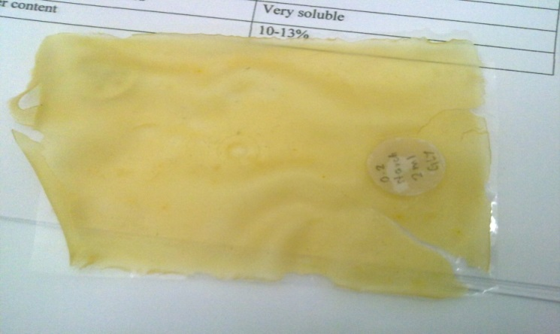

Figure 1. Sample of Cs Film

Based on the result, the ratio 1:50 was the best ratio to fabricate the Cs film. It is because the color and the appearance look nice and the important thing is the thickness of the film reliable and suitable to do the analysis for this project. Regardless of starch type, the tensile strength and elasticity of the Cs film first increase and then decrease with the starch addition. Furthermore, to maintain the strength and the elasticity only 0.2 g starch was added to the 40 ml of sample solution. Ethylene glycol has been widely used to be blended with Cs because of its biocompability and minimal toxicity and desirable properties in water or other common solvents. Once the Cs was with ethylene glycol, it can swell extensively due to the positive charges on the network and in response to changes in the pH of the clinical environment. Besides that, with addition 2ml of ethylene glycol, the mechanical properties of Cs film also increased.

The thickness of the solution with different ratio was also analyzed. The optimum thickness is needed for the film to analyze and degrade in nature environment. Table 1 shows the thickness of the Cs film with different ratios of the Cs and solution.

Table 1. The thickness of the Cs with various ratios.
Ratio | Thickness (cm)
1:20 | 0.3
1:30 | 0.2
1:50 | 0.1
1:60 | 0.07

The thickness of film was chosen and measured to the nearest 0.1 cm with a handheld micrometer five thickness measurements were taken along the length of each specimen. The mean was used in calculating the film for the various analyses such as DSC and degradation. There have been considerable researches in blending Cs with plasticizer in order to improve their mechanical, conductivity, thermal and water permeability and extended use as biomaterials. By adding 2 ml of glycerol as plasticizer, it is increasing the film flexibility and process ability. Plasticizers are low molecular weight agents, which can be combined with the film-forming biopolymers to modify physical properties. Glycerol as the plasticized Cs film had the highest thermal stability with lowest weight loss. This outcome was due to the formation of more inter-hydrogen bonds within the Cs polymer with the flexible and long chain glycerol. From the experiment analysis, Cs with 2 ml glycerol had the highest percentage of elongation, being 4.5 times higher than native Cs film.

Cs is widely distributed in nature and an abundant bio-polymer. A great deal of research has been performed regarding the utilization of Cs as a biomaterial, including production of Cs-based composite components. The approach gives rise to a new material having better balance of properties than those obtained in a single Cs.

Analysis of Sample: Determination the Viscosity of Sample
In order to understand the interaction between Cs and the different plasticizers, a viscometer model was used to measure the viscosity of each solution at temperature room with the spindle rotating at 10 rpm, 12 rpm, and 20 rpm. Table 2 shows the result of the viscosity of native Cs solution, Cs + Starch solution with Ethylene Glycol, and Viscosity of Cs + Starch solution with Glycerol.

Table 2. Viscosity of native Cs solution, Cs + Starch solution with Ethylene Glycol
and Cs + Starch solution with Glycerol
Samples | rpm | Viscosity (mPas)
native Cs solution | 10 | 59
 | 12 | 64
 | 20 | 64
Cs + Starch solution with Ethylene Glycol | 10 | 517
 | 12 | 460
 | 20 | 365
Cs + Starch solution with Glycerol | 10 | 590
 | 12 | 496
 | 20 | 343

The viscosity of the solution is determined mainly by the molecular weight and hydrogen bonds formed between molecules and water. First, it can be shown from the table above, the viscosity of Cs + Starch solution with Glycerol had a relatively higher viscosity at all-time points than Cs + Starch solution with Ethylene Glycol and native Cs. This is due to the glycerol that has the most hydrophilic hydroxyl group. The hydrophilic hydroxyl can form strong hydrogen bonds with water and Cs molecules. This in turn makes the molecules less mobile and causes the solutions to be more viscous [13]. The viscosity of Cs solution is dependent on the molecular weight (MW). The higher the MW of solution, the more viscous the polymer solution. As it has higher MW, it has a bigger hydrodynamic volume, which is the volume of a polymer coil when it is in solution. The solvent molecules will be bound more strongly to the polymer with increasing hydrodynamic volume, leading to an increase in the motion of the polymer in the solvent. Hence, the viscosity of the Cs solution plus glycerol is proportional to the MW of the polymer. Therefore, by measuring the viscosity of the Cs solution, the MW of the solution can be conveniently determined.

Second, the viscosities of all solutions obviously decreased over time. This phenomenon is associated with the degradation of Cs molecules in an acidic solution [14]. With the degradation of Cs, the size of the molecules in the solution becomes smaller, causing the viscosity of the solution decrease. Mucha [15] also reported an increment in the shear stress and viscosity of Cs solutions with increasing Cs concentration also due to the increase in entanglement among the macromolecular chains. The rheology of two aqueous systems of unmodified Cs and hydrophobically-modified Cs was studied by Nystrom et al. [16]. The results revealed that the linear and nonlinear viscoelasticity are affected by several factors such as pH, temperature, the amount of surfactant and polymer concentration. Besides, the storage time also affected the viscosity of the Cs solution due to the polymer degradation.

The results show that the Cs concentration of the film forming solutions that influenced the solutions viscosity, which is has a higher concentration of the present with higher polymer or plasticizer concentration. The films mechanical properties were also affected by the viscosity of the film forming solution. Furthermore, it was observed that Cs + Starch solution with Glycerol concentration led to films higher water content.

Determination of Thermal Properties of Sample
Differential Scanning Calorimetry (DSC) is unsurpassed for understanding the stability of biological systems. DSC directly measures heat changes that occur in biomolecules during controlled increase or decrease in temperature, making it possible to study materials in their native state. DSC measures the enthalpy (∆H) of unfolding due to heat denaturation. A biomolecule in solution is in equilibrium between the native (folded) conformation and its denatured (unfolded) state. DSC is also used to determine the change in heat capacity (ΔCp) of denaturation. Differential Scanning Calorimetry (DSC) is a powerful analytical tool, which directly measures the stability and unfolding of a protein, lipid, or nucleic acid. In DSC, the biomolecule is heated at a constant rate and there is a detectable heat change associated with thermal denaturation.

Differential Scanning Calorimetry (DSC) measures the temperatures and heat flows associated with transitions in materials as a function of time and temperature in a controlled atmosphere. These measurements provide quantitative and qualitative information about physical and chemical changes that involve endothermic or exothermic processes, or changes in heat capacity.

Based on the result (Figure 2), the process of DSC contains three phases, which are thermal history phase, cristality phase and degradation phase. In this analysis, three samples were tested to determine their thermal properties. At the first stage, the samples were heated from 40°C to 100°C. This process involved endothermic, where the transition absorbed energy. After that, the samples cooling down from 100°C to origin temperature 40°C where involved the process of exothermic that releases energy. At this stage, it is also known as the thermal history.

For the second stage, where the main purpose of the analysis of thermal properties. The process started at 40°C until to 200°C. From the result, the line of native-Cs peak was at 101.94°C, Cs + Ethylene Glycol at 112.64°C and Cs + Glycerol peak at 114.64°C. Each peak corresponds to a heat effect associated with a specific process, such as crystallization or melting. These temperature peaks mean the sample start to form crystallization or melting point. Based on the native Cs, which addition of the plasticizer Ethylene Glycol and Glycerol, the temperature of crystallization or melting were increased to 112.64°C and 114.64°C. The increase of these temperatures means that the sample improve their stability and concentration. However, the increasing in crystallization or melting point causes the thermal degradation of the sample. Based on the result, the trend of the peak curve increasing due to different plasticizer, which were the peak of the Cs + Glycerol higher than the Cs + Ethylene Glycol and native Cs. Meanwhile, the width of the peak also contributed to the smaller of the peak size. To relate the thermal degradation, the size of the peak shows the thermal degradation process of Cs + Ethylene Glycol rather than Cs + Glycerol as a consequence of the tendency on degradation.

The last stage of the analysis was done within the temperature decreased from 200°C to 40°C. The maximum degradation temperature was recorded at 200°C. Therefore, there were no heating event was present in this stage.

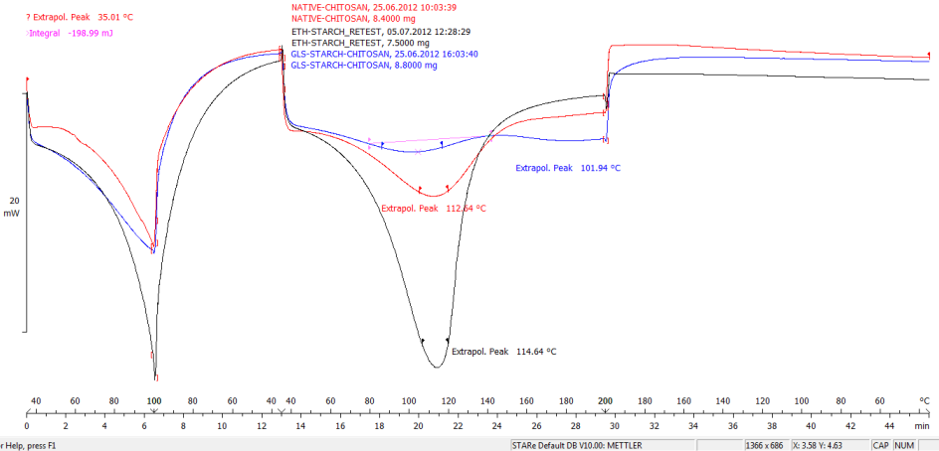

Figure 2. The result of the Differential Scanning Calorimetry (DSC) on the various samples

Degradation of Cs Sample
For degradation of the Cs sample, rain water was used as the medium to degrade the formation of the Cs sample. Figure 3, Figure 4, and Figure 5 shown the percentage of weight loss of Cs samples in different solutions, which were starch, ethylene glycol and glycerol.

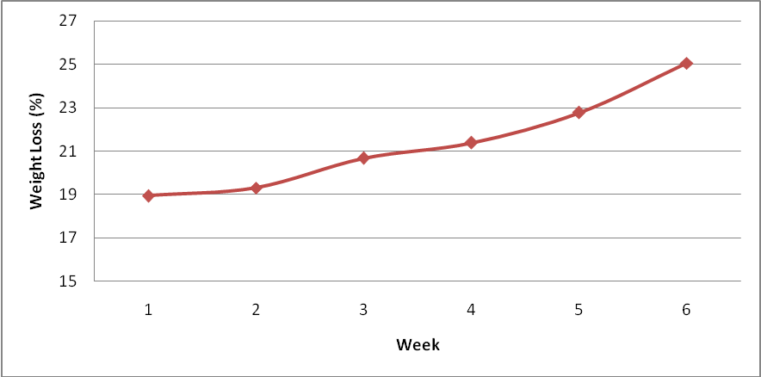
Figure 3. The degradation profile of native Cs with addition of starch in rain water

Figure 3 shows the graph of weight loss of Cs + Starch within 6 weeks. The line of the graph shows the increasing of the percentage of weight loss week by week. For the first week, the percentage of loss was 19%. The second week, the weight loss was insignificantly increased to (19.3%). However, the rapidly increasing of the weight loss occurred from the third week (20.67%), fourth week (21.38%), fifth week (22.78%) and 25.05% for a sixth week. From the graph, it was proven that Cs + Starch sample was degraded by submerge it in the rain water.

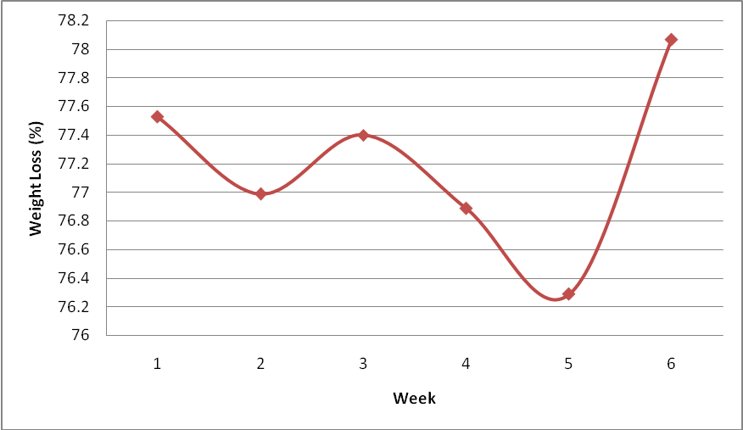
Figure 4. The degradation profile of Cs + Ethylene Glycol with addition of starch in rain water

From the Figure 4 above, the graph shown the weight loss of Cs + Ethylene Glycol in sixth weeks. For the first week, the weight loss was 77.53% of the original weight. But it was reduced to 76.99% in the second week. During the third week, the percentage slightly increased to 77.4% and dramatically decreased in the fourth week (76.89%) and fifth week (76.29%). For the final week of degradation analysis, the weight loss increased to 78.07%. Even though, the scatters of the graph shown the inconsistence weight loss due to the respective time. While, the process of degradation still occurs and successfully complete as the degradation medium.

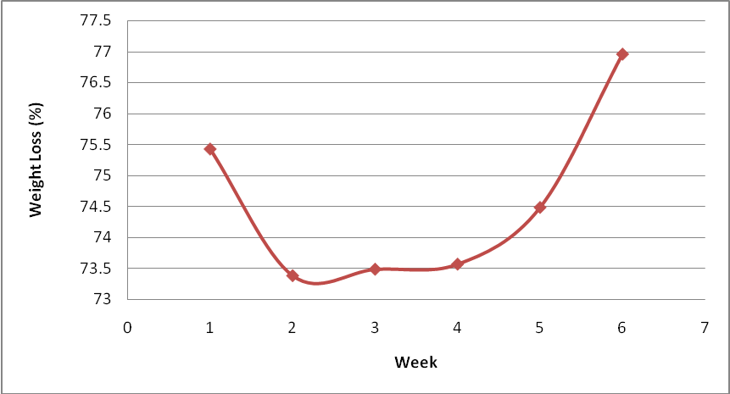

Figure 5. The degradation profile of Cs + Glycerol Glycol with the addition of starch in rain water

Figure 5 shows the graph of the weight loss of Cs + Glycerol. The graph pattern was identically similar with the ones obtained from the graph of Cs + Ethylene Glycol. From the 6 weeks of the degradation time, the first week and the final week showed the high of weight loss, which were 75.43% and 76.96%, respectively. The second week only 73.38% increased to 73.49% in the third week and 73.57% in the fourth week and 74.48% in the fifth week.

Based on the result, all of the samples were tended to degrade in the rain water, but the time of degradation was different due to the concentration in the type of plasticizers. The mechanism of the degradation of this analysis was occurring as the film samples absorb the rain water due to idle in water. The physical structure would expand because the rain water enters into the structure of the film sample. Then, as more water absorb to the film, the process of degradation will increase. Consequently, as conclusions more expand to the film sample mean the more degradation process will occur. Figure 6 shows the process of degradation Cs samples, where the samples immersed in the rain water before weighed.

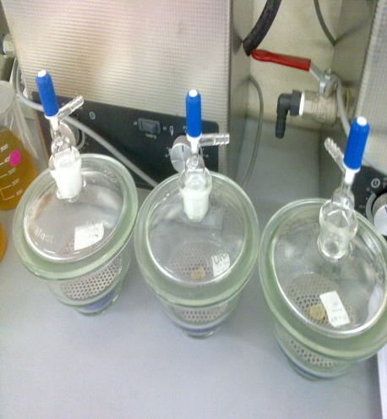
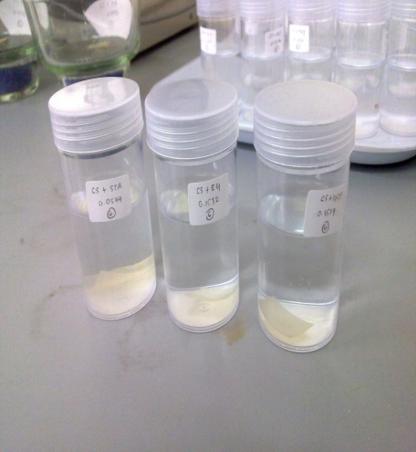
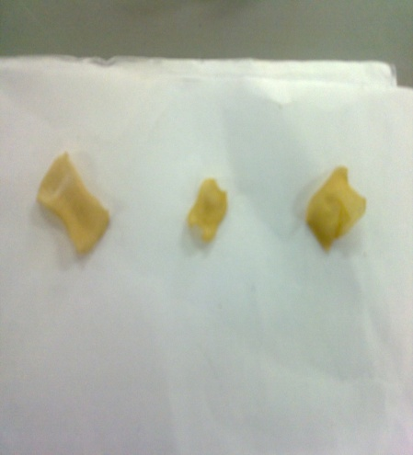

- (b) (c)

- (b) (c)

Figure 6. (a) Cs films immersed in the fisher bottle of rain water, (b) Cs films in the glass incubator before weighing and (c) Cs films after weighted.

Analysis Using Fourier Transform Infrared Spectroscopy (FTIR)
The characteristic infrared absorption for samples Native-Cs, Cs + Glycerol and Cs + Ethylene Glycol were determined by referring Characteristic Infrared Absorption Frequencies and Functional Groups. Table 3 shows the results of compound type present in all samples.

Table 3. Detection of compounds in Native-Cs, Cs + Glycerol and Cs + Ethylene Glycol
Samples | Wavenumber | Assignment | Transmitted (%)
Native-Cs | 2930 | Methylene asymmetric C-H stretching | 2600
 | 2870 | Methyl asymmetric C-H stretching | 1200
 | 2000-1700 | Overtone and combination band | 5208.2
 | 1275-1000 | In-plane C-H bending | 1100
Cs + Glycerol | 2930 | Methylene asymmetric C-H stretching | 2400
 | 2870 | Methyl asymmetric C-H stretching | 1200
 | 2000-1700 | Overtone and combination band | 5208.2
 | 1275-1000 | In-plane C-H bending | 1100
Cs + Ethylene Glycol | 2930 | Methylene asymmetric C-H stretching | 2400
 | 2870 | Methyl asymmetric C-H stretching | 1200
 | 2000-1700 | Overtone and combination band | 5208.2
 | 1275-1000 | In-plane C-H bending | 1100

This study was carried out in order to observe the chemical compounds as well as understanding the principle of operation of Fourier Transform Infrared Spectroscopy (FTIR). While running the process, the FTIR method would display the peak of chemical compounds in the standard and sample. This was done to compare the differences of spectra between native-Cs and the samples.

The analysis of samples by using FTIR was found, which are the same functional groups and the chemical compounds present. Table 3, native-Cs shows the compound type consisted at alkanes and alkynes. Alkanes contain only C-H and C-C bonds, but there was plenty of information to be obtained from the infrared spectra of these molecules. The most useful were those arising from C-H stretching and C-H bending. C-H stretching bands in aliphatic hydrocarbons appear in the 3000 cm⁻¹ to 2800 cm⁻¹ range and the C – H stretching bands of methyl groups and methylene groups is readily differentiated. Alkynes contained the C ≡ C group and three characteristic bands can be present such as ≡ C-H stretching, ≡C-H bending and C ≡ C stretching. Same in Table 4.5 and Table 4.6, it shows the same compound type, which consisted of alkanes and alkynes.

The functional groups responsible for absorption at each frequency of the sample spectrum were as follows; the stretching vibration of alkanes causes a shoulder at wavenumber of approximately 2930 cm⁻¹. Either asymmetrical or symmetrical stretching, vibration of methyl bands was observed at approximately 2870 cm⁻¹. The bands at 2000 cm⁻¹ and 1700 cm⁻¹ attributed to the structure of aromatic compounds may also be confirmed from the pattern of the weak overtone and combination tone bands. The bands at 1275 cm⁻¹ and 1000 cm⁻¹ were attributed to the In-plane C-H bending.

By comparing all the types of sample in this study, the result notices that the spectra of the samples had been identify and give the same compound type and functional group. Therefore, this proven that the samples contain same functional groups and modes of vibration in the sample observed. From the observation in Figure 7, it is shown the infrared spectrum are same. This analysis confirmed the presence of functional groups and modes of vibration in the all the Cs-samples studied.

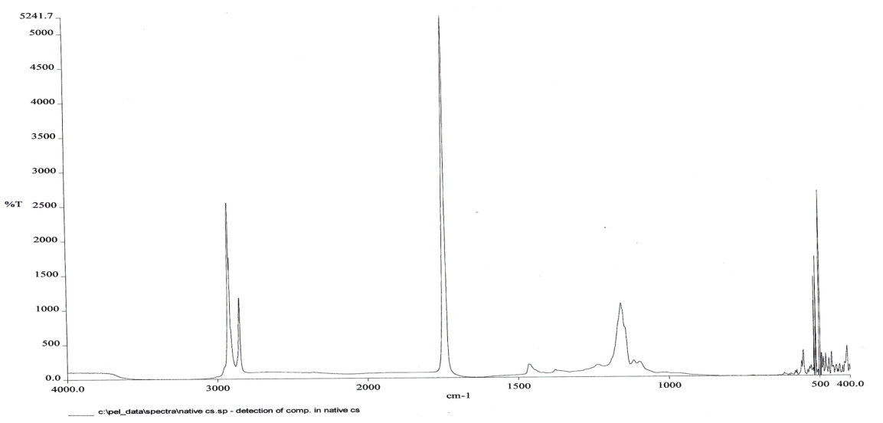
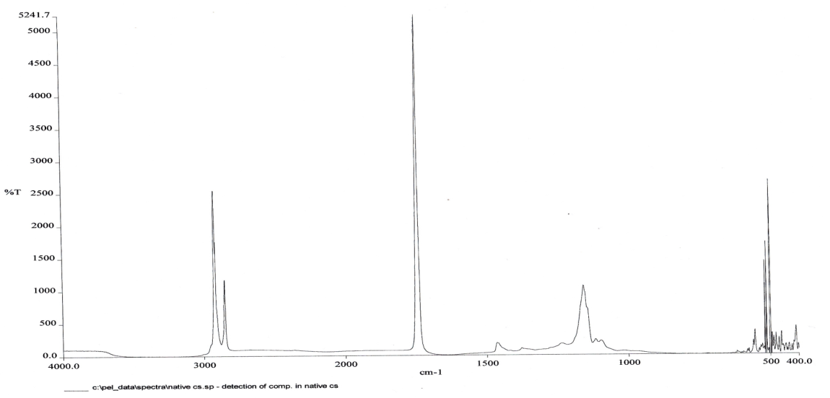
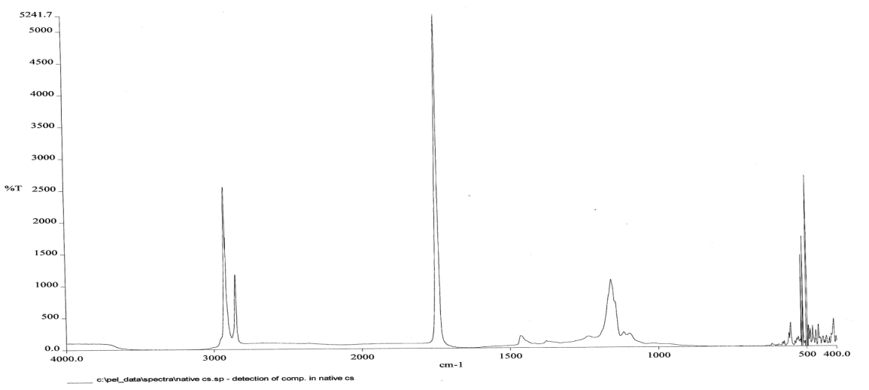
(a)

(b)

(c)

Figure 7. The result of the samples by using the Fourier Transform Infrared Spectroscopy (FTIR). (a) The result of the native Cs. (b) The result of the Cs + Ethylene Glycol. (c) The result of the Cs + Glycerol.

Conclusion
Based on the objective of this project, all objectives of this project were achieved. First of all is to prepare the fabrication of Cs film by variable parameters, which are the rate of mixing, time of mixing, acid concentration and the ratio of; 1) Cs powder, 2) starch powder, 3) ethylene glycol, 4) glycerol. After all parameters done, the ratio of 1:50 was the best result due to the color, thickness and the appearance. After that, all the samples were determined by various analyses, which are differential scanning (DSC), Brookfield Viscometer (RVT), Fourier Transform Infrared Spectrometry (FTIR), and degradation. In this project, a few parameters were changed as to see the best result of the production of Cs film and all the results of analysis achieve the objectives. In degradation analysis, the sample with addition of Glycerol more degrade than addition with Ethylene Glycol.

Acknowledgement
The authors acknowledge to the Malaysian Institute of Chemical & Bioengineering Technology, University Kuala Lumpur and East Coast Environmental Research Institute (ESERI), Universiti Sultan Zainal Abidin (UniSZA) the research facilities and support for this study.

References
- Julkapli M. N, Akil M. H and Ahmad Z. (2011). Preparation, Properties and Applications of Chitosan Based Biocomposites/ Blend Materials: A Review. Composite Interfaces 18: 449-507.
- Julkapli, N. M., Ahmad, Z. and Akil. H.M. (2008). Preparation and properties of kenaf filled chitosan bio-composites, Computer Interface 15: 851-866.
- Guilbert, S. (1986). Food packaging and preservation. Theory and practice. New York: Elsevier, 371.
- Rose, P.L. (1987). Encyclopedia of polymer science and engineering. Wiley, 488-513.
- Kasarda, D.D., Bernardin, J. E., Nimma, C. C. (1976). Advances in cereal and technology. American Association of Cereal Chemist, 158.
- Julkapli, N. M., Ahmad, Z. and Akil, H. M. (2009). X-ray diffraction studies of cross linked chitosan with different cross linking agents for waste water treatment applications. AIP Conference Proceeding 1202: 106-111.
- Julkapli, N. M., Ahmad, Z. and Akil, H. M. (2011). Mechanical properties of 1,2,4,5-benzenetetra carboxylic chitosan-filled chitosan bio-composites. Journal Application Polymer Science 121: 111-126.
- Julkapli N. M., Ahmad, Z. and Akil, H. M. (2011). Preparation, properties and application of chitosan-based bio-composites/blend materials: A Review. Computer Interface 18: 449-507.
- Julkapli, N. M. and Akil. H. M. (2008). Degradability of kenaf dust filled chitosan bio-composites. Materials Science Engineering C 28:1100-1111.
- Julkapli, N. M. and Akil, H. M. (2010). Influence of a plasticizer on the mechanical properties of kenaf filled chitosan bio-composites. Polymer Plastic Technology Engineering 49: 944-951.
- Coma, V., Deschamps, A. and Martial-Gros, A. (2006). Bioactive packaging material from edible chitosan polymer-antimicrobial activity assessment on dairy- related contaminants. Journal Food Science 68: 9-12.
- Julkapli, N. M., Ahmad, Z.and Akil, H. M. (2011) Thermal properties of 4,4’-oxydiphthalic anhydride chitosan filled chitosan bio-composites, Thermal Analysis Calculation 107: 356-376.
- Rinaudo, M. Pavlov1, G. and Desbrie J. (1999). Influence of acetic acid concentration on solubilizzation of chitosan. Polymer 40: 7029-7032.
- Tsaih, M. L. and Chen R. H. (1999). Effect of temperature on the intrinsic viscosity and conformation of chitosan molecule in solution, Journal Application Polymer Science 73: 2041-2050.
- Mucha, M. (1997). Rheological characteristics of semi-dilute chitosan solutions. Macromolecular Chemical Physical 198: 471-484.
- Nystrom B., Kjoniksen A. and Iversen C. (1999). Characterization of association phenomena in aqueos system of chitosan of different hydrophobicity. Advantage Colloid Interface Science 79: 81-103.

