ENVIRONMENTAL HEALTH IN RELATION TO URBAN PLANNING AND HUMAN PHYSICAL ACTIVITY

(Perkaitan antara Kesihatan Persekitaran dengan Perancangan Bandar

dan Aktiviti Fizikal Manusia)

Oliver Ling Hoon Leh*, Siti Nur Afiqah Mohamed Musthafa and Dasimah Omar

Faculty of Architecture, Planning and Surveying,
Universiti Teknologi MARA (UiTM), Shah Alam, Selangor, Malaysia.

*Corresponding author: oliverling.my@gmail.com

Abstract

The world is changing everyday in a fast pace that makes majority of the urbanized areas becoming more congested and polluted by the development. The planning of the urban world has brought about a great impact towards the environment and health. With the large number of human population, urban areas will have various kinds of activities that contributed to the higher rate of pollutants compared to areas with less development. In a car oriented urban development pattern, majority of the population will choose automobiles as their transportation modes rather than walking or cycling. Due to that, the air emission in urban areas will increase rapidly, and reduce the physical activity. Air pollutants contribute to various health problems, especially respiratory infection. Besides, lacking of physical activities also increase the health risk. However, there is limited study on the relationship between urban land use setting and health in developing country. Thus, a study had been carried out to establish the relationship between urban setting and human health. It involved air quality data collection, observation on land use setting, and questionnaire survey on human health and the lifestyle. Findings from the relationship analysis had been discussed with suitable recommendation and conclusion.

Keyword: air quality, health, neighborhood design, physical activity, urban areas

Abstrak

Perubahan pembangunan dunia yang kian pesat kearah kemajuan masa hadapan telah menyebabkan permasalahan kesesakan dan pencemaran. Pembangunan bandar memberi kesan yang besar keatas persekitaran dan kesihatan. Penambahan populasi manusia di kawasan bandar menyebabkan kadar pencemaran meningkat lebih tinggi berbanding dengan kawasan kurang membangun. Dalam era pembangunan bandar yang berorientasikan kenderaan ini, penduduk cenderung memilih kenderaan sebagai mod pengangkutan mereka berbanding berjalan kaki mahupun berbasikal. Dari segi kesannya, pencemaran udara kian menjadi-jadi berlakunya dan manusia semakin kurang dalam melakukan aktiviti fizikal. Pencemaran udara menyebabkan pelbagai masalah kesihatan seperti jangkitan pernafasan. Kekurangan aktiviti fizikal juga meningkatkan risiko kesihatan. Walau bagaimanapun, kajian adalah terhad dalam bidang perkaitan di antara guna tanah dan kesihatan terutamanya dalam negara sedang membangun. Oleh yang demikian, kajian ini dijalankan adalah untuk mengenalpasti perkaitan di antara pembangunan bandar dan kesihatan manusia. Kajian ini meliputi data kualiti udara, pemerhatian guna tanah dan soal selidik terhadap tahap kesihatan dan gaya hidup penduduk. Hasil kajian telah dibincang berserta dengan cadangan dan rumusan.

Kata kunci: kualiti udara, kesihatan, rekabentuk kejiranan, activiti fizikal, kawasan bandar

Introduction
Cities in developing countries are facing greater environmental problems due to the overwhelming scale and speed of urbanization. This has brought about huge effects on health and well being, besides constraining the development and growth of the cities themselves [1]. Air pollution is the major issue that has been affecting human health, agricultural crops, forest species and ecosystems [2]. Furthermore, in a report written by Siti Nurazlina [3] mentioned that people who live in the urban area are now facing the air pollution due to the excessive gases that produces by the vehicles in the urban area. This will turn the livable safe city into a “toxic city”. Health research has established that air pollution aggravates cardiovascular and respiratory illness, adds stress to the cardiovascular system, forcing the heart and lungs to work harder in order to provide oxygen, speed up the natural aging process of the lungs, accelerating the loss of lung capacity, damages cells in the airways of the respiratory system, damages the lungs even after symptoms of minor irritation disappear, and contributes to the development of disease including bronchitis, emphysema, and possibly cancer [4].

According to a study done by Richardson et al. [5] in New Zealand residents of the greenest urban neighborhoods had significantly lower risks of having poor mental health than those in the least green areas, and the results suggested a dose-response relationship. For cardiovascular disease (CVD) the results suggested that above a certain threshold the amount of green space was less important; individuals residing in neighborhoods with more than 15% green space coverage had similarly reduced CVD risks.

Actually, health research has established that air pollution aggravates respiratory illness and also cardiovascular [4]. In theory, urban development with polluted activities (land use) is potentially produce more pollution, and directly raise negative health impact on human being. However, most of the previous studies were focusing on the health data from hospital. The actual health scenario of the general public (the community) and the relationship with the air pollution level and urban land use coverage are not really been studied, especially for Malaysia. Furthermore, there were a very limited number of such studies in Malaysia. Besides, there is lacking of study on the Malaysian urban regional context. For instance, Rafia et al. [2] and Norela et al. [6] examined the possible health effects (acute respiratory infection, ARI, asthma and conjunctivitis) of forest fires (haze) by using public hospital data but not the health data direct from the local community. Thus, this paper is prepared with two main objectives which are to examine the relationship between health (direct data from the local community), land uses and air quality, and relationship between health, human physical activity and land use.

Materials and Methods

Study Area
This study has been conducted at three different continuous air monitoring stations in the Klang Valley, namely Shah Alam, Petaling Jaya, and Klang, which are located at three different backgrounds. These study areas are chosen to achieve the first objective as mentioned earlier.

Figure 1-3 show the study areas with the location of air monitoring stations, and the surrounding land use. The ambient air quality data, land uses and traffic volumes had been collected from various public authorities and documents. Air quality monitoring stations by the Department of Environment (DOE) [7] were the main sources for the ambient air quality data. Analysis of air quality has been presented in term of the number of good days and unhealthy days based on the API. Meanwhile, the traffic volume which was provided by the Highway Planning Unit (2006) was based on the counts for both directions at the selected roads. The traffic data was recorded hourly manually by the Highway Planning Unit (ministry of Works Malaysia) for 16 hours (0600-2200) during sampling days. The land use data was collected from Petaling Jaya City Council, Shah Alam City Council, and Klang Municipal Council.

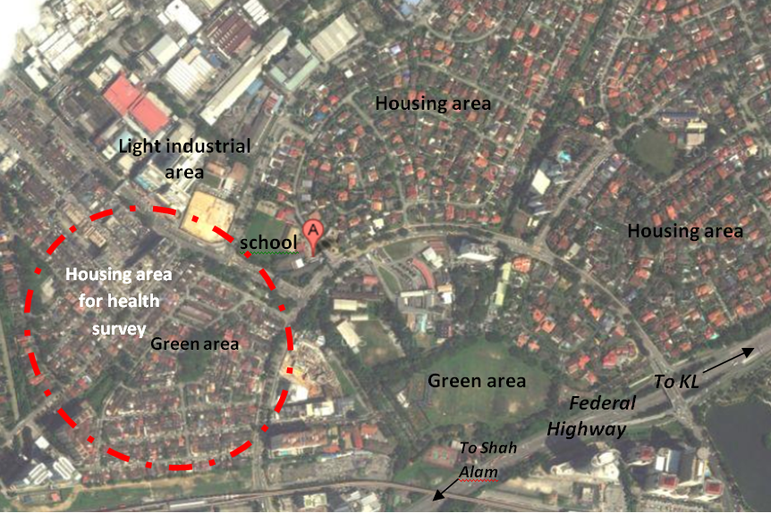

Figure 1. Location of study area and Sri Petaling Air Monitoring Station (marked with “A”), Petaling Jaya. (Source: Adapted from Google [8])

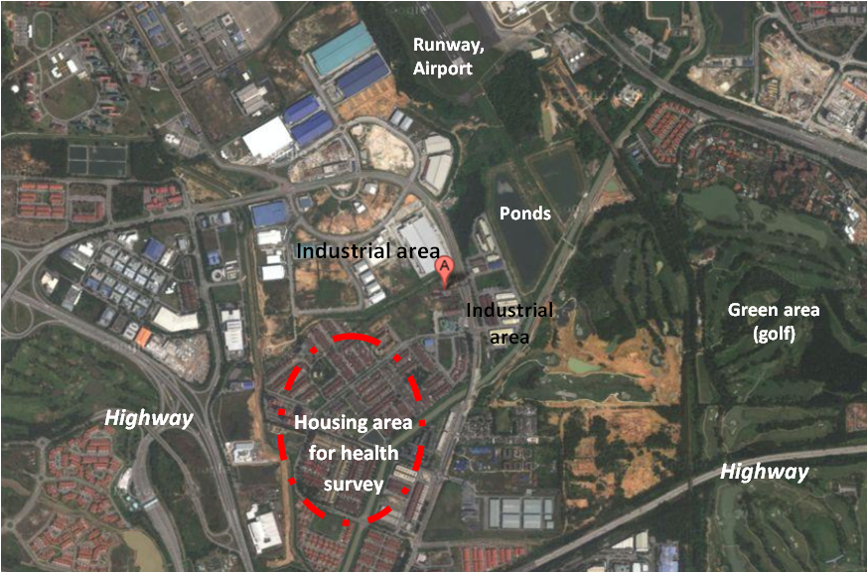

Figure 2. Location of study area and TTDI Jaya Air Monitoring Station (marked with “A”), Shah Alam. (Source: Adapted from Google [8]).

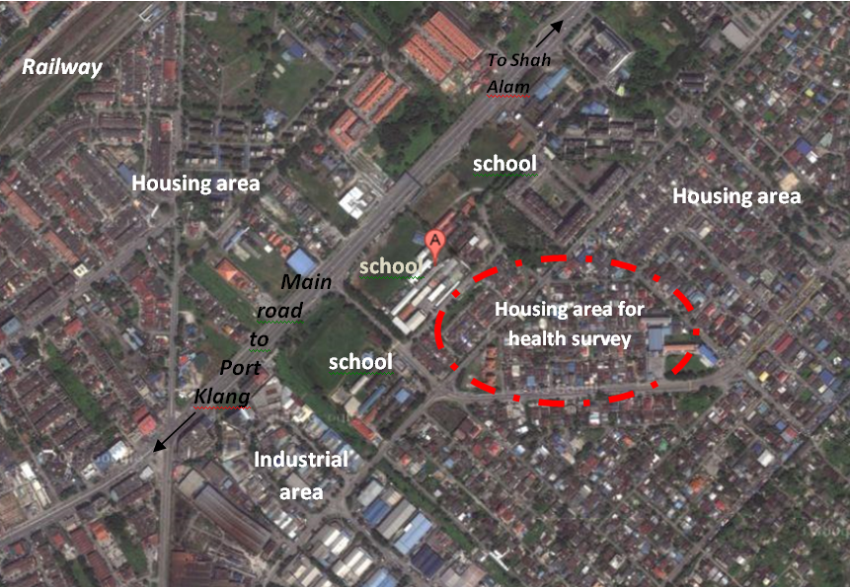

Figure 3. Location of study area and Raja Zarina Girls School Air Monitoring Station (marked with “A”), Klang. (Source: Adapted from Google [8])

Due to the limitations of time and costs, the health questionnaire survey (via the random sampling) did not cover all housing estates in the areas. Thus, only one housing area that is located nearest to the air monitoring station was selected for the health questionnaire sampling survey for early study areas (3 areas in total). For the purpose of this paper, data of two (2) air-related health indicators were analysed and discussed. Cases of ARI incidence were measured based on reported ARI symptoms by respondents, including cough, nasal discharge, nasal block, sore throat, loss of voice and throat irritation, with a duration of less than 14 days per case (less than 14 days is considered as acute infection). ARI outpatient cases were measured based on self-reported (by respondents) number of cases of getting medical advice or treatment without hospitalization due to ARI. The calculating formula for the two (2) air-related health indicators as equation 1 and 2 below:

ARI incidence rate (cases/10000) = (ARI incidence cases ÷ total respondents in each area) x 10000 (1)

ARI outpatient rate (cases/10000) = (ARI outpatient cases ÷ total respondents in each area) x 10000 (2)

As for the second objective, it is still in the literature stage which will be more focus on the scope of human physical activity, urban planning and health.

Result and Discussion

Human Health
Referring to Table 1, during the dry season which was from June- September 2012, all the three zones had their highest ARI incidence rate. The lowest rate of ARI incidence happened in wet season from November- March 2012. According to Ling et al. [9], it is due to the precipitation effects during the wet season that makes the air quality to be better and less in the negative health impact. The wet season with more rainfall could reduce the concentration of air pollutants in the air through the washout and rainout effects.

Table 1. ARI incidences in Petaling Jaya, Shah Alam and Klang
Zones | Nov. 2011 - Mar. 2012  (wet season) | Apr. - May 2012 (transitional period) | June - Sept. 2012  (dry season) | October 2012  (transitional period) | Total
Petaling Jaya  No. of cases Total respondents Rate (/10,000) | 21  133  1,578 | 28  133  2,105 | 36  133  2,706 | 21  133  1,578 | 106  133  7,970
Shah Alam  No. of cases Total respondents Rate (/10,000) | 0  126  0 | 24  126  1,904 | 31  126  2,460 | 17  126  1,349 | 72  126  5,714
Klang  No. of cases Total respondents Rate (/10,000) | 4  144  277 | 24  144  1,666 | 36  144  2,500 | 26  144  1,805 | 90  144  6,250

Note: Rate is calculated at number of cases per 10,000 people.

Table 2. ARI outpatient rates in Petaling Jaya, Shah Alam and Klang

Zones | Nov. 2011 – Mar. 2012 (wet season) | Apr. – May 2012 (transitional period) | June – Sept. 2012  (dry season) | October  2012 (transitional period) | Total
Petaling Jaya  No. of cases  Rate (/10,000) | 1  75 | 1  75 | 0  0 | 2  150 | 4  301
Shah Alam  No. of cases  Rate (/10,000) | 15  1,190 | 17  1,349 | 24  1,905 | 14  1,111 | 70  5,556
Klang  No. of cases  Rate (/10,000) | 15  1,042 | 23  1,597 | 28  1,944 | 24  1,667 | 90  6,250
Note: Rate is calculated at number of cases per 10,000 people.

Table 2 shows the result for the ARI outpatient rates, as in Shah Alam and Klang, the highest rates were in June-September 2012 (dry season) with the rate 1,905 and 1,944 respectively. This was related to the number of API unhealthy days in Shah Alam and Klang. Both the areas had the highest number of unhealthy days in that period of time. However, in Petaling Jaya, the highest ARI outpatient rate was in October 2012 (transitional period) with the rate of 150 (per 10,000), and the lowest rate is identified during the dry season. The scenario in Petaling Jaya was different than another two study areas.

Relationship between Health, Air Quality and Land Use
The relationship between health, air quality and land use can be showed in different pattern according to the areas (Table 3). As in Petaling Jaya, the health data which is on ARI outpatient rate (Table 3) shows a clear relationship with the air quality and city wide land use data. ARI outpatient rate in Petaling Jaya show lower rate, which may be due to the most healthy air quality as compared to the other 2 stations in Shah Alam and Klang. Furthermore, the percentage of land uses which is potentially improve the air quality in Petaling Jaya is 35.59% compared to the percentage of land uses which will potentially increase the air pollution (25.88%). However, in Petaling Jaya the health data on the ARI incidences rate does not shows any significant relationship with the other two variables (air quality and land use).

In Shah Alam, the health data for the ARI outpatient rate was the higher with the moderate level of air quality and higher percentage of land use which potentially to increase the air pollution (34.11%) compared to 15.15% land use potentially to improve the air quality. The ARI outpatient rate in Klang shows a clear relationship with the air quality since that the ARI outpatient rate is higher with the most polluted air quality in that zone. But, it does not related to the land use data. The percentage of land use which potentially improves the air quality in that zone is way higher compared to the other 2 zones with 73.59%. Thus, this may relate to the lower rate of the ARI incidences in Klang even though it does not shows a relationship with the air quality.

Table 3. Respiratory infection, air quality and city-wide land use in Petaling Jaya, Shah Alam and Klang.

Study area | Health (respiratory infection) | Air quality | City-wide land use of Petaling Jaya city, Shah Alam city & Klang town
Petaling Jaya | Higher in ARI incidences (Table 1), Lower in ARI outpatient rate (Table 2). | Most healthy.  Reported to have the highest number of good days in API (197 days, 54.12%) and the lowest number of unhealthy days in API (2 days, 0.55%) as compared to the other 2 stations, Nov. 2011- Oct. 2012 [7, 10]. | Higher % of land uses which potential to increase air pollution (25.88%):  - Industrial- 3.58%  - Transportation- 16.94  - Infrastructure & utilities- 5.36%  - Residential- 19.40%  - Commercial & service- 3.45%  - Institution- 13.64%  - Water body- 2.02%  Land uses which potential improve air quality (35.59%):  - Open space & recreation- 9.83  - Empty land- 19.60%  - Green lung- 6.16%
Shah Alam | Lower in ARI incidences (Table 1), Higher in ARI outpatient rate (Table 2). | The air quality as moderate as compared to another 2 stations, Nov. 2011- Oct. 2012.  But, it is the unhealthiest area in 2010 and 2011 with 32 and 22 unhealthy days respectively [7, 10]. | Higher % of land uses which potential to increase air pollution (34.11%):  - Industrial-12.79%  - Transportation- 16.33%  - Infrastructure & utilities- 4.99%  - Residential- 34.34%  - Commercial & service- 3.92%  - Mix development- 1.16%  - Institution- 8.80%  - Water body- 2.69%  Land uses which potential improve air quality (15.15%):  - Open space and recreation- 7.62%  - Agriculture-0.32%  - Green lung- 7.19%
Klang | Lower in ARI incidences (Table 1), Higher in ARI outpatient rate (Table 2). | Most polluted.  The good days (API) were reported as the lowest (117 days, 31.97%) and the unhealthy days (API) were the highest (11 days, 3%) as compared with other 2 stations, Nov. 2011- Oct. 2012 [7, 10]. | Low % of land uses which potential to increase air pollution (5.25%):  - Industrial- 4.73%  - Infrastructure & utility- 0.52%  - Residential- 8.32%  - Commercial- 0.85%  - Institution- 1.12%  - Special use- 0.84%  - Others- 20.01%  High % of land uses which potential improve air quality (73.59%):  - Open space & recreation- 0.71%  - Natural ecology- 34.33%  - Agriculture- 38.55%
Source: Adapted from Petaling Jaya City Council [11, 12], Shah Alam City Council [13, 14] & Klang Municipal Council [15].

Health, Physical Activity and Urban Planning
In this stage, the relationship between health and physical activity and urban land use has been identified through literature review. Conceptually, more physical activity will increase the human health level. Thus, good urban planning or design which is able to increase the level of physical activity can indirectly improve the human health. Actually, design elements in the built environment, such as street layout, land use, the transport system and the location of recreation facilities, parks and public buildings, are all components of a community that can either encourage or discourage active living [16]. Living in a greener neighborhood was associated with increased likelihood of the respondent meeting recommended levels of physical activity, and physical activity levels reduced the risks of poor mental health and CVD. Physical activity has been defined as “any body of movement provided by skeletal muscles that results in a substantial increase over the resting energy expenditure” (Brouchard and Shepard 1994) as stated by Loukaitou-Sideris [17]. Physical activity can occur in various forms and contexts and can be categorized in different ways based on the rate of energy expenditure (objective measurement), the level of perceived effort (subjective measurement), the type of activity (e.g., walking, cycling, swimming, aerobic exercise, etc.), as well as the primary purpose of the activity (e.g., recreational, utilitarian, etc.).

Physical activity levels had a small attenuating effect on the previously noted relationships of green space with both health outcomes, but the relationships remained significant (or near significance at the 5% confidence level). While greener environments may therefore encourage greater levels of physical activity in New Zealand, this is likely to be only part of the reason why cardiovascular and mental health is better in greener neighborhoods. Other causative mechanisms are likely to be pertinent [5]. It is likely that with the suitable housing environment, people will be encourage to live in an active lifestyle which indirectly will help in boosting up the health condition of the people despite of the pollution occurred.

Conclusion
In conclude, the air quality and urban land uses are potentially affecting the human health (respiratory infection), and by engaging in physical activity which is a healthy lifestyle may reduce the effect of pollution. However, from the study in the context of urban growth corridor (consist of three cities/towns), the relationship is not being constructed concretely. This is the first intent of such study in the regional context in Malaysia. More study on the regional context should be carried out in the future to re-examine the relationship between respiratory health, urban factors and healthy lifestyle (physical activity).

Acknowledgement
The authors would like to thank Ministry of Education Malaysia for funding the study by given the FRGS grant with the project code FRGS/1/2014/SS06/UITM/02/3. The authors also would like to thank all the departments, organizations and individual who contributed to this study.

References

- Farhad Atash. (2007). The Deterioration of Urban Environments in Developing Countries: Mitigating The Air Pollution Crisis in Tehran, Iran. Cities 2007; 399-409.
- Rafia, A., Mohd Nasir, H. and Noor Akma, I. (2003). Review of air pollution and health impacts in Malaysia. Environmental Research 92 (2): 71-77.
- Siti Nurazlina (2011). Bandar Beracun Ancam Penduduk. Utusan Online; 12 December 2011
- Boyce, A. (1997). Introduction to Environmental Technology, America: Van Nostrand Reinhold.
- Richardson, E.A., Pearce, J., Mitchell, R., Kingham, S. (2013). The role of physical activity in the relationship between urban green space and health. Public Health 127 (4): 318–324.
- Norela, S., Sadah, M.S. & Mohd Talib, L. (2008). Effects of haze on human health in Malaysia: case study in 2005. In Scientific report on the haze event in Peninsular Malaysia in August 2005. Part II: physical and social aspects, edited by Mahmud, M. & Abdullah, M. Malaysia: Department of Environment.
- Department of Environment. (2012). Malaysia Environmental Quality Report 2011. Malaysia. 2012.
- Google (2013). Google maps.
- Ling, O.H.L., Shaharuddin A., Kadaruddin A., Yaakob M.J. and Ting, K.H. (2012). Urban air environmental health indicators for Kuala Lumpur city. Sains Malaysiana 41 (2): 179-191.
- Ling, O.H.L., Siti Nur Afiqah M. M. and Noralizawati M. (2014). Air Quality and Land Use in Urban Region of Petaling Jaya, Shah Alam and Klang, Malaysia. EnvironmentAsia 7 (1): 134-144.
- Majlis Perbandaran Petaling Jaya. (2005). Rancangan Tempatan. Selangor: Department of Planning.
- Majlis Perbandaran Petaling Jaya. (2005). Maklumat Asas Petaling Jaya. Selangor: Department of Planning.
- Majlis Bandaraya Shah Alam. (2012). Rancangan Tempatan. Selangor: Department of Planning.
- Majlis Bandaraya Shah Alam. (2012). Maklumat Perancangan & Pembangunan Shah Alam. Selangor: Department of Planning.
- Majlis Perbandaran Klang. (2002). Rancangan Tempatan, Selangor: Department of Planning.
- World Health Organization, WHO (2006). Promoting physical activity and active living in urban environments. The role of local government.
- Loukaitou-Sideris. A. (no date). Transportation, Land Use, and Physical Activity Safety and Security Considerations. http://onlinepubs.trb.org/onlinepubs/archive (online access)

