

SURFACE MORPHOLOGY AND CHEMICAL COMPOSITION OF NAPIER GRASS FIBERS

(Morfologi Permukaan dan Komposisi Kimia Gentian Rumput Napier)

Shahida Hanum Kamarullah¹*, Marlina Mohd Mydin¹, Wan Siti Atikah Wan Omar¹, Siti Suhaila Harith¹,
Badrul Hisham Mohd Noor¹, Nurul Zaimatul Akma Alias¹, Shahirah Manap², Rosfarizan Mohamad³

¹Faculty of Applied Sciences,
Universiti Teknologi MARA Pahang, 26400 Bandar Tun Razak Jengka, Pahang, Malaysia
²Institute of Tropical Forestry and Forest Products,
Universiti Putra Malaysia, 43400 UPM Serdang, Selangor, Malaysia
³Department of Bioprocess Technology, Faculty of Biotechnology and Biomolecular Sciences,
Universiti Putra Malaysia, 43400 UPM Serdang, Selangor, Malaysia

*Corresponding author: shanum18@gmail.com

Received: 23 November 2014; Accepted: 27 June 2015

Abstract
A cellulosic component of Napier grass has high potential for the ethanol production. The presence of hemicelluloses, lignin and cellulose in Napier grass fiber can affect the ethanol production. The aim of this study is analyzed the effect of different pretreatment condition (2% of acetic acid and 2% of sodium hydroxide) on the chemical composition and observe the fiber surface morphology of the Napier grass fibers. The fiber surface morphology was observed using Scanning Electrone Microscope (SEM). The result of different pretreatment condition showed that 2% of acetic acid treatment have the highest percentage of cellulose followed by 2% of sodium hydroxide treatment and untreated sample. The hemicellulose content is reduced when treated with acid and alkali. Based on the fiber morphology characterization, acid and alkali pretreatment condition showed that the surface impurities on the fiber were removed. This study suggested that the acid and alkali treatment of Napier grass fibers has a potential to enhance the ethanol production because it can reduce the hemicellulose content.

Keywords: Cellulose, Napier grass fiber composition, Pretreatment

Abstrak
Komponen selulosa dalam rumput Napier mempunyai potensi yang tinggi untuk menghasilkan etanol. Kehadiran hemiselulosa, lignin dan selulosa dalam gentian rumput Napier boleh memberi kesan kepada penghasilan etanol. Objektif kajian ini adalah untuk menganalisa komposisi kimia rumput Napier dalam keadaan pra-rawatan yang berbeza (2% asid asetik dan 2% natrium hidroksida) dan untuk melihat pencirian gentian serat rumput Napier berdasarkan pra- rawatan yang berbeza. Morfologi permukaan gentian dilihat menggunakan Mikroskop Elektron Pengimbas. Keputusan analisa menunjukkan bahawa peratusan selulosa berdasarkan 2% rawatan asid asetik adalah paling tinggi, diikuti gentian yang dirawat dengan 2% natrium hidroksida dan sampel gentian yang tidak dirawat. Kandungan hemiselulosa berkurangan apabila dirawat dengan asid dan alkali. Berdasarkan pencirian morfologi, gentian rumput Napier yang dirawat dengan asid dan alkali mempunyai morfologi permukaan yang lebih licin dan mempunyai banyak ruang di antara gentian. Kajian ini mencadangkan bahawa rawatan asid dan alkali mempunyai potensi untuk menambahkan penghasilan etanol disebabkan berlakunya pengurangan kandungan hemiselulosa.

Kata kunci: Sellulosa, Komposisi gentian rumput Napier, Pra-rawatan

Introduction
Renewable energy is extensively running as the major alternative to replace depleting fossil fuel. Biomass from crops and woody plants as resources of energy is one of potential supplier. Cellulosic feedstock by the Pennisetum purpureum (local name as Napier grass or Elephant grass) is a good choice as it is classified in second generation source of renewable energy. Recent findings of Napier as promising C4 plant serving as asset in converting biomass to bioethanol were discussed previously [1, 2]. Biomass contains varying amounts of cellulose, hemicelluloses, lignin and traces of extractive. Cellulose make up the largest proportion of biomass about 40-50% by weight, followed by hemicelluloses which is about 20-40% [3].

The lignocellulosic biomass require pretreatment to remove hemicellulose, reduced the crystallinity and surface area of cellulose. The pretreatment methods can be divided into physical (milling, grinding, extrusion), chemical (acid or alkali), biological (microorganism), steam explosion methods. Among all the pretreatment methods, the chemical pretreatment such as sodium hydroxide pretreatment has been widely used because it can improve the enzymatic digestibility and enhancing ethanol production from enzymatic hydrolysis and fermentation steps. The advantage of dilute acid pretreatment is low cost treatment, easy to perform and highly active [4].

According to Yasuda et al. [5] finding, production of bio-ethanol from Napier grass which observed through an enzymatic saccharification and fermentation with yeast (Saccharomyces cerevisiae) showed low ethanol production because of the high content of hemicelluloses composed by pentose into bio-fuels is an unavoidable process in the lignocellulosic biomass conversion. The main objective of this study was to analyze the effect of different pretreatment condition on the chemical composition and observed the fiber surface morphology of the Napier grass.

Materials and Methods
Plant Materials
Taiwan Pennisetum Purpureum Schumach was obtained at Jengka 11, Pahang, Malaysia. The fresh green grass was collected during its flowering stage. The leaves and stems of each species were cut into small pieces and were oven-dried at 85ºC for two days. The dried sample was grinded using Wiley’s Mill. The leaves and stems were grinded separately and the powder was stored prior to alkaline pretreatment.

Alkaline and Acid Pretreatment
Pretreatment were conducted by soaking the dried samples in 2% sodium hydroxide (NaOH) solutions and 2% acetic acid (CH₃COOH) for 4 hrs. Then, the treated samples were washed with distilled water and soaked in distilled water for 24 hours, and followed by washing. The treated samples were dried in the oven at 70ºC for two days or until constant weight were achieved.

Preparation of Extractive-Free Sawdust
About 4 g of air dry sawdust were placed in the cellulose thimble. Then, it was placed in the Soxhlet apparatus. 200 mL of alcohol-toluene solution was transferred into rounded flask for extraction. The heating mantle was turned on and left for 4-5 h until the extractive was extracted from the air dry sawdust. The extractive free sawdust was dried in an oven for 24 h at 105ºC.

Determination of Lignin Content
About 1 g of oven-dried extractive free sawdust samples were placed in a 50 mL beaker. Then, 10 mL of 72% sulfuric acid (H₂SO₄) was added into a beaker and stirred with a glass rod for 2 hrs. After that, the mixture was transferred to a 500 mL conical flask, diluted with distilled water until the final volume reached 300 mL. The mixture was refluxed for 3 hrs of boiling water in water bath. After the refluxing was completed, the insoluble lignin was filtered by using filtering crucible. The lignin was washed with 250 mL of hot distilled water, and was placed in the oven for drying at 105ºC for 24 h. The mass of lignin was measured prior to use.

Determination of Hemicellulose
About 2 g of oven-dry extractive free sawdust sample was transferred into 250 mL conical flask. Then, 1.5 g of sodium chlorite (NaClO₂) and 5 mL of 10% acetic acid were added. The mixture was placed in the water bath at 70ºC. Another 5 mL of acetic acid was added and followed by 1.5 g NaClO₂ after 30 min. The process was continued with alternate addition of acetic acid and NaClO₂ was totally added. At the same time, the heating was keep continued for another 30 min until the residue was turned to creamy white. The mixture was filtered and washed with cold distilled water followed by acetone. The residue was left to dry for 4 days and the mass of hemicellulose was measured.

Determination of Alpha Cellulose
The residue of hemicellulose was used in this analysis. About 2 g of hemicellulose were put into the 250 mL beaker. Then, the beaker was placed in the water bath. After that, 15 ml of 17.5% of NaOH solvent was added and stirred gently for 1 min followed by 10 mL of NaOH and stirred for 45 sec. Another 10 mL of NaOH was added and stirred with 15 sec. The mixture was stirred again for 2 min. The step was repeated with addition of another 10 ml NaOH and stirred for 2 and half minute. The process was continued for 15 min with 5 times of NaOH addition. Then, 100 mL of distilled water was added and stirred and the beaker was left in the water bath for 30 min. The beaker was covered by watch glass.

The mixture was filtered with coarse filtering crucible and the beaker was rinsed with 8.5 % of NaOH solvent. The cellulose was washed with 650 mL distilled water and soaked with 25 mL of 2M acetic acid for 5 min. The cellulose was washed until it was free of acid as indicated by litmus paper. The cellulose was dried in the oven at 105ºC for 24 h and the mass of cellulose was measured.

Fiber surface morphology
Napier grass fibers were treated with 2% of sodium hydroxide (NaOH) and 2% of acetic acid (CH₃COOH) solutions at room temperature for 30 min to remove the hemicelluloses and other greasy materials. Then, the treated fibers were washed thoroughly in distilled water and sun dried for several days to ensure maximum moisture removal. The fibers were platinum coated before examined by using scanning electron microscope (SEM) [6].

Functional Group Analysis
The Fourier Transform Infra Red (FTIR) analysis of all samples were carried out using FTIR spectrophotometer by using of KBR pallets.

Results and Discussion
Chemical composition of Napier grass
There are three main chemical compositions were determined such as hemicellulose, cellulose, and lignin. Table 1 shows the percentage of each chemical composition observed from Napier grass. Untreated fiber contained 34.14% hemicellulose, 46.58% cellulose and 22.25% lignin. The cellulose percentage of acetic acid and NaOH treated fiber strands were found to be higher than untreated fibre. The main chemical composition that can enhance the production of ethanol is cellulose. Thus, acetic acid and NaOH treated fiber strands have a potential for higher ethanol production due to its higher content of cellulose.

Table 1. Percentage of chemical composition of Napier grass
Samples | Hemicellulose (%) | Cellulose (%) | Lignin (%)
Untreated | 34.14 | 46.58 | 22.25
2% NaOH | 25.24 | 55.28 | 21.75
2% Acetic Acid | 20.55 | 56.46 | 20.93

The highest percentage of hemicellulose and lignin were obtained from untreated fiber strand. The untreated fiber contain higher hemicellulose because its natural structure fiber was unchanged. The fiber of untreated Napier grass were retained its crystalline components to enhance the strength of the fiber. The natural fiber was treated with an alkali such as sodium hydroxide (NaOH) to eliminate the weak amorphous components [7]. The acetic acid and NaOH treatment reduced the content of hemicellulose in fiber strands. The content of hemicellulose was reduced about 39.80% and 26.07% in Napier grass fibers treated with acetic acid and NaOH respectively. The ethanol production will be reduced due to the hemicelluloses content which was composed by pentose. Pentose is a five carbon sugar which is not easily to be fermented and limits the ethanol production from cellulosic biomass. The pretreatment with either acid or alkali can reduce the crystallinity of cellulose and reduce the hemicellulose content that composed of pentose and affect the ethanol production [5]. The lignin percentage was reduced in acetic acid and NaOH treated fiber strands than untreated fiber. It is important to reduce the lignin content because higher lignin can produce inhibitory compound, therefore it can hinder the ethanol fermentation [8].

Functional group analysis
Figure 1 shows the FTIR spectra of 2% acetic acid treatment, 2% NaOH treatment and untreated samples. The peaks were observed at 3392, 3396, 3408 cm⁻¹ in untreated, 2% acetic acid, and 2% NaOH treated Napier grass fibers respectively, which indicated the presence of intermolecular hydrogen bonding. Acetic acid treated fiber shifted to higher absorption frequency values than untreated fiber [9]. The intermolecular hydrogen bonding was identified in the lignin, cellulose, and hemicelluloses structure.

The FTIR peaks were also observed at 2917, 2878, and 2894 cm⁻¹ in untreated, 2% acetic acid, and 2% NaOH respectively. At these range, the C-H stretching from alkanes group was identified and sp³ C-H absorption was occurred. The FTIR bands at 2894-2917 cm⁻¹ was corresponded to lignin composition. Previous research found that the hemicellulose content was identified at 1727 and 1260 cm⁻¹ peaks [7]. However, this band was absent in this research due to its lower concentration of acetic acid and NaOH. Thus, FTIR studies revealed the similarity of bond type for 2% acetic acid and NaOH treated fiber and untreated Napier grass fiber.

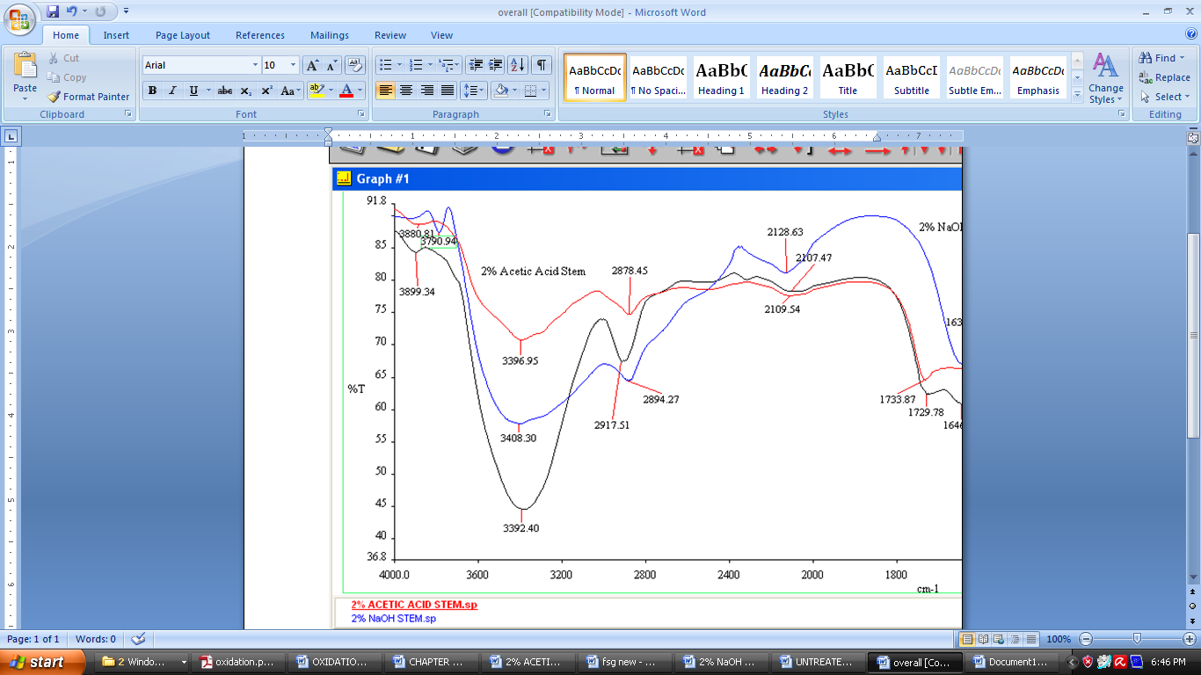
2% acetic acid
treated fiber

tre

2% NaOH
treated fiber
Wavenumber (cm⁻¹)
% Transmission
Untreated fiber

Figure 1. FTIR Spectra of 2% acetic acid, 2% NaOH, and untreated Napier grass fibers

Fiber Surface Morphology
Figure 2 – 4 show the SEM image of 2% acetic acid, 2% sodium hydroxide (NaOH), and untreated samples of Napier grass fibe strands respectively.

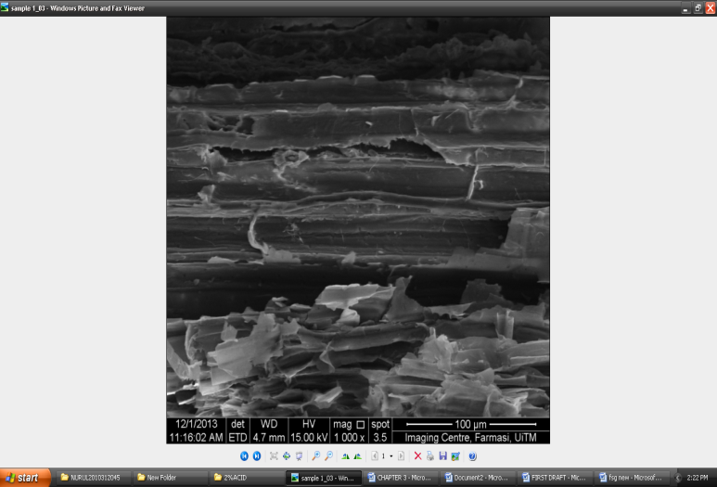
Figure 2. Scanning Electron Microscopy (SEM) of 2% NaOH treated Napier grass fiber

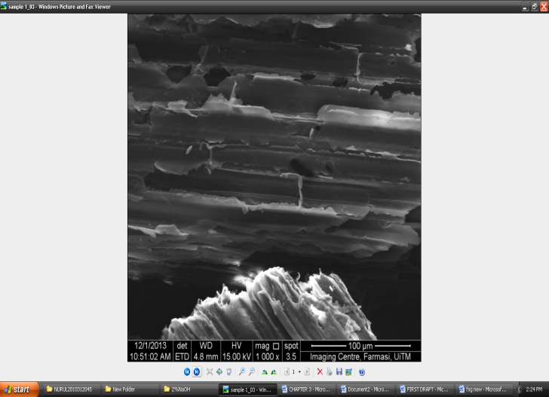
Figure 3. Scanning Electron Microscopy (SEM) of 2% acetic acid treated Napier grass fiber

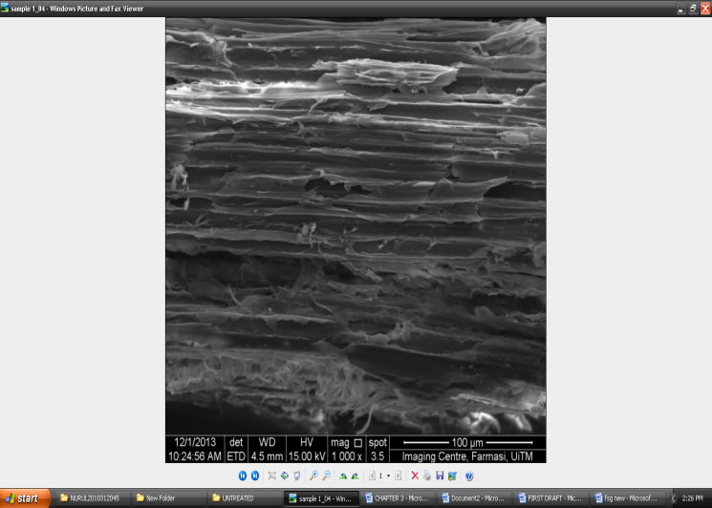
Figure 4. Scanning Electron Microscopy (SEM) of untreated Napier grass fiber.

Untreated fiber strand was represented as a control for the comparison of the fiber surface morphology. So, there are a lots of impurities were observed on the untreated fibers. The natural fibers have multi cellular structure which the hemicellulose and lignin bind a bundle of individual cells. The SEM images of acetic acid and NaOH treated fiber strands show the disordered and rupture structure of fibers matrix. The surface of lignocelluloses fibers has hemicellulose layer. The SEM micrographs of 2% acetic acid (Figure 2) treated fiber presents the clear removal of a surface layer and empty space between the fibers which indicated the removal of higher hemicellulose layer. However, the removal a lot of hemicellulose depend on the concentration of acetic acid used. Previous research reported that most of surface impurities were removed from the fiber strand treated with 15% of acid treated [9].

The cellular structure of the fibers was also destroyed and reduced the void content of the fibers when the natural fibers were treated with alkali. There are two effects were observed when the fiber treated with alkali treatment which it will increase the amount of cellulose exposed on the fiber surface, thus it will increasing the number of possible reaction sites and increase the roughness of surface which affect the mechanical interlocking become more better [10]. The roughness of surface can also promote good interfacial bonding between the matrix and fibers [6]. The SEM results of acetic acid and NaOH treated fiber strands that indicated the higher removal of hemicellulose show agreement with chemical composition analysis of Napier grass fibers in this research.

Conclusion
The chemical compositions of the Napier grass which consist of lignin, hemi cellulose, and cellulose were determined by chemical analysis. The hemicellulose content was reduced about 26.07% and 39.80% in Napier grass fiber treated with alkali and acid respectively. Thus, the alkali and acid treatment of fibers has a potential to apply for ethanol production. This is because the reduction of hemicellulose lead to higher ethanol production. The surface morphology of untreated fibers contained a lots of surface impurities than acid and alkali treated fibers.

References
- Cardona, E., Rios, J., Pena, J. and Rios, L. (2014). Effects of the pretreatment method on enzymatic hydrolysis and ethanol fermentability of the cellulosic fraction from elephant grass. Fuel 118: 41-47.
- Devin, T. and Samir, K. K. (2015). Characterizing compositional changes of Napier grass at different stages of growth for biofuel and biobased products potential. Bioresource Technology 188: 103 – 108.
- McKendry, P. (2002). Energy production from biomass (part 2): Overview Technologies. Bioresour Technol. 83 (1): 47–54.
- Anuj, K. C., Gajula, C., Konakalla, R., Rudravaram, R. and Pogaku, R. (2011). Bioconversion of pentose sugars into ethanol: A review and future directions. Biotechnology and Molecular Biology Review 6 (1): 008-120.
- Yasuda, M., Miura, A, Yuki, R, Nakamura, Y, Shiragami, T, Ishii, Y. and Yokoi, H. (2011). The effect of TiO₂- photocatalyticpretreatment on the biological production of ethanol from lignocelluloses. J. Photochem. Photobiol 220 (2-3): 195-199.
- Reddy, K.O., Uma Maheswari, C., Jeeran Prasad Reddy, D. and Varada Rajulu, A. (2009). Thermal properties of Napier grass fibers. Materials Letters 63: 2390–2392.
- Reddy, K.O., Uma Maheswari, C., Shukla, D. M. and VaradaRajulu, A. (2012). Chemical Composition and structural characterization of Napier grass fibers. Material Letters 67: 35-38.
- Palmqvist, E. and Hahn-Hagerdal, B. (2000). Fermentation of lignocellulosic hydrolysates. I: inhibition and detoxification. Bioresour. Technol. 74: 17–24.
- Parasuram, K.V., Reddy. K.O., Shukla. M. and Marwala.T. (2012). Morphological, structural and thermal characterization of acetic acid modified and unmodified Napier grass fiber strands. 7th International Conference on Intelligent Systems and Control (ISCO), Coimbatore, Tamil Nadu, India, 4-5 Jan. 2013, IEEE, 506 – 510.
- Gamez, S., Gonzalez-Cabriales, J. J., Ramirez, J. A., Garrote, G. and Vazquez, M. (2006). Study of the hydrolysis of sugar cane baggase using phosphoric acid. J. Food eng, 74 (1): 78–88.

