

OPTIMIZATION ON PRETREATMENT CONDITIONS OF SEAWEED LIQUID WASTE FOR BIOETHANOL PRODUCTION

(Pengoptimuman Kondisi Pra-Rawatan Sisa Cecair Rumpai Laut untuk Penghasilan Bioetanol)

Nur Zatul -‘Iffah Zakaria¹, Dachyar Arbain¹*, Mohd Noor Ahmad², Mohd. Irfan Hatim Mohamed Dzahir¹

¹School of Bioprocess Engineering,
Universiti Malaysia Perlis, Kompleks Pusat Pengajian Jejawi 3, 02600 Arau, Perlis Malaysia
²Centre of Excellence for Advanced Sensor Technology (CEASTech),
Universiti Malaysia Perlis, Pusat Pengajian Jejawi II, Taman Muhibah, 02600 Arau, Perlis, Malaysia

*Corresponding author: dachyar@unimap.edu.my

Received: 23 November 2014; Accepted: 27 June 2015

Abstract
Seaweed liquid waste (SLW) from a non-conventional seaweed (Gracilaria sp.) drying process where the seaweed is ruptured and filter-squeezed has been investigated. The liquid contains proteins and minerals which potentially pollute the environment if it is not been properly treated. For that reason, this paper deals with study on the feasibility of SLW utilization as a feedstock for bioethanol production. The fermentation of bioethanol production was carried out by Saccharomyces cerevisiae in which ethanol produced was measured by gas chromatography. In order to increase its fermentable sugar content, the SLW was treated with dilute acid. Center composite design of response surface methodology (RSM) had been used to optimize the sugar content by varying the parameters involved in the dilute acid pretreatment conditions. These are sulphuric acid concentration (M), temperature (ºC) and seaweed waste concentration (g/ml). It was obtained that the R² value reached 0.97 indicating that the model is acceptable. The three parameters showed p-value less than 0.05 suggesting their significance interactions. The optimization resulted 25 times improvement of reducing sugar concentration. The reducing sugar resulting from the optimized pretreatment was later used as fermentation medium to produce ethanol up to 123.197mg/l.

Keywords: bioethanol, dilute acid pretreatment, Gracilaria sp., Saccharomyces cerevisiae, seaweed liquid waste

Abstrak
Sisa cecair rumpai laut (SLW) hasil daripada proses pengeringan konvensional rumpai laut ( Gracilaria sp.) di mana rumpai laut dipecah dan diperah-tapis telah di kaji. Cecair ini mengandungi protein dan mineral-mineral yang berpotensi mencemarkan alam sekitar sekiranya tidak dirawat dengan betul. Oleh hal yang demikian, kertas kerja ini berkaitan dengan kajian mengenai kemungkinan penggunaan SLW sebagai bahan mentah untuk penghasilan bioetanol. Penapaian penghasilan bioetanol dilakukan oleh Saccharomyces cerevisiae di mana etanol yang dihasilkan diukur dengan kromatografi gas. Dalam usaha untuk meningkatkan kandungan gula fermentasi, maka SLW dirawat dengan asid cair. Reka bentuk komposit berpusat dalam metodologi permukaan sambutan (RSM) digunakan untuk mengoptimumkan kandungan gula dengan mengubah parameter yang terlibat dalam keadaan pra-rawatan asid cair. Parameter tersebut adalah kepekatan asid sulfurik (M), suhu (ºC) dan kepekatan sisa rumpai laut (g/ml). Didapati bahawa nilai R² mencapai 0.97 yang menunjukkan bahawa model ini boleh diterima. Tiga parameter menunjukkan nilai-p kurang daripada 0.05 menunjukkan kepentingan interaksi. Pengoptimuman ini memberikan peningkatan 25 kali kepekatan gula penurun. Gula penurun hasil daripada pra-rawatan yang dioptimumkan kemudiannya digunakan sebagai medium fermentasi untuk menghasilkan etanol sehingga 123.197mg / l.

Kata kunci: bioetanol, pra-rawatan acid cair, Gracilaria sp., Saccharomyces cerevisiae, sisa cecair rumpai laut

Introduction
Seaweed (Gracilaria sp.) is a marine algae which has been used in various applications such as food, cosmetic and agricultural industries and its demand has increased annually. Typically, commercial seaweed is sent by the farmers to industry in a dried form. Conventionally, seaweed is dried by simply hanging or arranged in the platform under the sun. However, this conventional method is time consuming and associated with rotten seaweed during the process.

Therefore, an alternative non-conventional method has been introduced in which the seaweed is continuously ruptured followed by filter-squeezed to separate the liquid from the solid part. With the reduced liquid content, the retained solid residue can be dried quickly, thus can be transported easily to respected industries for further processing. The squeezed liquid contains some of the important nutrients that suitably can be used as fertilizer. However some of it, together with the left-over solid are usually discarded to the open sea. This practice can cause detrimental effect to the surrounding area due to biological processes. One way to overcome such issue is by consuming the liquid waste for bioethanol production.

Seaweed liquid waste (SLW) is known to be free from lignin content and low in sugar content [1]. A suitable pretreatment method should be carried out in order to increase the fermentable sugar for fermentation process. The treatment stage includes a chemical treatment with dilute acid or alkaline, and a biological treatment by the addition of enzymes or microorganisms [2]. A thermal dilute acid hydrolysis has been regarded as an effective pretreatment of seaweed for bioethanol production due to the ability for polysaccharides degradation to fermentable sugars [3].

Recently, a great number research has been conducted to find the practical and cost effective renewable energy source for societal needs i.e. bioethanol [4, 5]. Production of bioethanol from biomass is facing some problems. Fuel vs. food issue (using edible crops) and lignocellulosic biomass were some of the problem faced by researcher to produce bioethanol [6–8]. In this research, SLW is pretreated with dilute acid and further utilized to produce ethanol by using Saccharomyces cerevisiae.

Materials and Methods
Raw Materials
Simple and branched brown blades of fresh seaweed, namely, Gracilaria sp., (Figure 1) was collected from seaweed farmer at Sungai Petani, Kedah and transported to a laboratory in Universiti Malaysia Perlis, Perlis. The seaweed was transferred into an aquarium system filled with seawater.

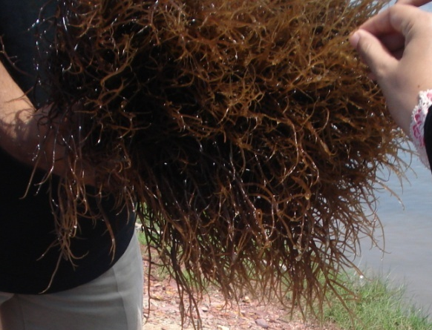

Figure 1. Gracilaria sp. used in experiment

For seaweed waste preparation, the fresh seaweed was rinsed with tap water to remove impurities and 150.0 g of this clean seaweed was blended together with 250.0 ml distilled water. By using vacuum pump, the seaweed slurry was filtered through 0.45 μm filter paper. The accumulated filtrates (seaweed waste) will undergo further pretreatment process.

Optimization of SLW Pretreatment
Seaweed Liquid Waste (SLW) was pretreated with dilute sulphuric acid to produce fermentable sugar. The pretreatment conditioning was optimized statistically through central composite design (CCD) under response surface methodology (RSM) by using Design Expert software (Stat. Ease Inc., statistic made easy, Minneapolis, MN, USA, Version 7.1.5). Details of factors and levels for this optimization are given in Table 1. In this case, the optimization response is reducing sugar.

Table 1. Level for three factors of CCD
Independent Variables | Unit | Symbols |  | Levels
Independent Variables | Unit | Symbols | -1 | 0 | +1
Acid concentration | M | X₁ | 0.1 | 0.2 | 0.3
Temperature | ºC | X₂ | 110 | 125 | 140
Substrate concentration | g/ml | X₃ | 0.44 | 0.57 | 0.70

The CCD with three independent variables was used to evaluate response pattern, interaction between independent variables and to determine optimum combination of acid concentration, temperature and substrate (SLW) concentration for maximizing reducing sugar production. CCD was carried out with 17 experimental runs at a random order with three repetitions at the central point. The experimental data were analyzed according to response surface regression procedure (RSM).

The pretreatment was carried out in 250 ml round bottle flask connected to condenser. With 200.0 ml of SLW (0.44 to 0.70 g/ml) and 75% (v/v) of sulphuric acid were mixed to get 0.10 M to 0.30 M of final concentration. The samples were then heated in oil bath at assigned temperature (110.0 to 140.0 ºC). After heating for 30 minutes, the samples were cooled down to room temperature and centrifuged at 6000 rpm for 10 minutes. Later, the supernatant were neutralized with 5.0 M sodium hydroxide (NaOH) [9].

Inoculum
Saccharomyces cerevisiae was cultured on potato dextrose agar (PDA) and incubated at 30.0 ºC for 48 hours. A single colony of Saccharomyces cerevisiae was transferred into 50.0 ml of YPD medium (10.0 g/l yeast extract, 20.0 g/l peptone and 20.0 g/l dextrose) and incubated at 30.0 ºC and 150 rpm for 24 hours. The cell concentration in the inoculum was adjusted to 5 X 10⁶ cells per ml.

Fermentation with Pretreated Hydrolysate
The seaweed waste pretreated by dilute acid hydrolysis under optimal conditions was neutralized to pH 7.0 with 5.0 M NaOH for fermentation by Saccharomyces cerevisiae. Sets of experiments, in 250 ml of Erlenmeyer flask, 75.0 ml of pretreated seaweed waste were autoclaved and inoculated with 7.5 ml of inoculum. The flasks were incubated and agitated at 30.0 ºC and 150 rpm for 12 hours.

Analytical Method
Reducing sugar of hydrolysate was quantified by Dinitrosalicyclic acid (DNS) method with glucose as the standard. 3.0 ml of DNS reagent was added into test tubes that contain 3.0 ml of hydrolysate [10]. All test tubes were lightly close by its cap and heated for 10 minutes at 90.0 ºC to develop the red-brown color. 1.0 ml of 40% potassium sodium tartrate solution were added into all test tubes and cooled in cold water bath before absorbance were recorded at 575nm by using UV-visible spectrophotometer. Meanwhile, fermentation samples were centrifuged at 7500 rpm for 15 minutes and filtered via 0.2 µm syringe filter. Ethanol concentrations from these samples were determined by gas chromatography (GC) (GC- 2010 Plus Series, Shimadzu Corp., Tokyo, Japan) which equipped with BP20- capillary column and flame ionization detector. The operating conditions were as follows: detector temperature 250.0 ºC, injector temperature 220.0 ºC, oven temperature 80.0 ºC for 3.5 minutes with 1µl of injection sample volume. Ethanol peak from the fermentation samples were determined by comparing retention time of ethanol standard peak (Merk).

Results and Discussion
Optimization of dilute acid hydrolysis and validation of statistical model
To predict the optimal values for reducing sugar concentration in the pretreatment, a polynomial model was fitted to the experimental result for the reducing sugar concentration by the Design of Expert (DoE) software as follows equation 1:

Reducing sugar, Y = +1.00+0.12 * X₁+0.068 * X₂+0.26* X₃+0.030 * X₁* X₂+0.027 * X₁* X₃+0.027* X₂ * X₃-
0.029 * X₁²+0.013* X₂²+0.049*X₃² (1)

where reducing sugar concentration (Y), is a function of acid concentration (X₁), temperature (X₂) and substrate concentration (X₃).

Summary of the analysis of variance (ANOVA) is presented in Table 2. From ANOVA result, it shows that the value of "Prob > F" for the model is less than 0.0500 indicating model terms are significant. Meanwhile, the "Prob > F" value for the Lack of Fit is more than 0.0500 which indicating it was not significant. By having not significant value of Lack of Fit, it means that the model fit well and there were significant effect of parameters on output response. In this case X₁, X₂ and X₃ are significant model terms. All interaction values between independent variables exceed 0.0500, this shows that there were interaction but not significant.

Table 2. ANOVA for quadratic model of dilute acid pretreatment
Source | Sum of squares | Degree of freedom | Mean | F | p-value  Prob > F | Remarks
Model | 1.290 | 9 | 0.14 | 25.34 | 0.0002 | Significant
A-Acid concentration | 0.210 | 1 | 0.21 | 36.58 | 0.0005 | Significant
B- Temperature | 0.063 | 1 | 0.063 | 11.14 | 0.0125 | Significant
C-Substrate concentration | 0.950 | 1 | 0.95 | 168.13 | < 0.0001 | Significant
AB | 0.007 | 1 | 7.32E-03 | 1.29 | 0.2931
AC | 0.006 | 1 | 5.83E-03 | 1.03 | 0.3441
BC | 0.006 | 1 | 6.05E-03 | 1.07 | 0.3358
A² | 0.009 | 1 | 9.16E-03 | 1.62 | 0.2442
B² | 0.002 | 1 | 1.81E-03 | 0.32 | 0.5892
C² | 0.027 | 1 | 0.027 | 4.69 | 0.0670
Residual | 0.040 | 7 | 5.67E-03
Lack of Fit | 0.038 | 5 | 7.69E-03 | 12.89 | 0.0736 | not significant
Pure Error | 0.001 | 2 | 5.97E-04

Table 3 shows the statistical parameters obtained from ANOVA. The quality of the model developed was evaluated based on the multiple correlation coefficients R². In this study, R² was found to be 0.9702 which means it explains 97.02% of the variability in the responses for the region studied, the remaining 3.98% being explained by the residue.The "Prediction R-Squared" of 0.7757 is in reasonable agreement with the "Adjusted R-Squared" of 0.9319.

Table 3. Statistical parameters obtained from ANOVA of dilute acid pretreatment
Variables | Response
R² | 0.9702
Adjusted R² | 0.9319
Predicted R² | 07757
Standard Deviation | 0.075
Coefficient of Variance (%) | 7.35
Adequate Precision | 15.925
Mean | 1.02

Response surface and the contour lines are presented in Figure 2, and they were used to estimate the reducing sugar concentration over the independent variables which were acid concentration (X₁), temperature (X₂) and substrate concentration (X₃).
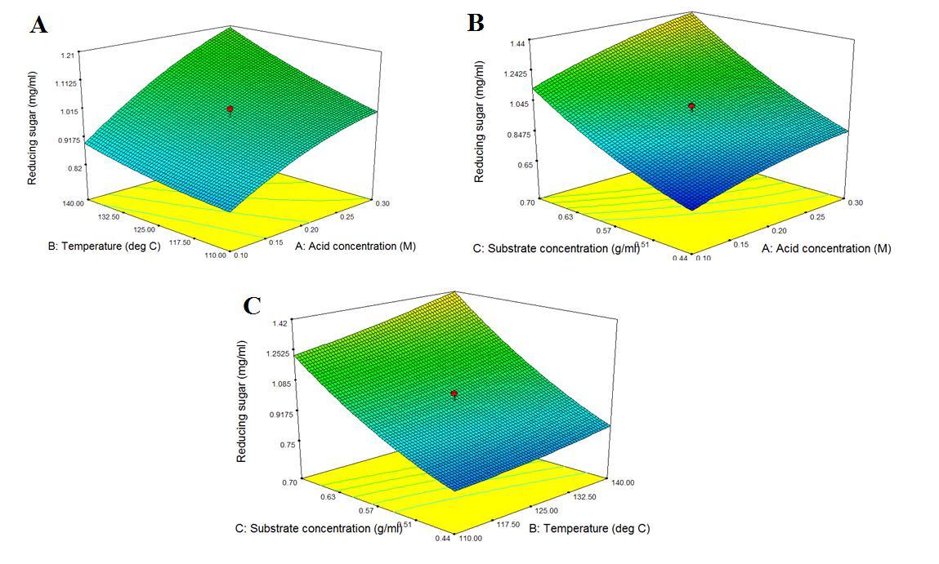

Figure 2. Response surface and contour lines described by the model equation (1) representing the interactions between, A: substrate concentration (g/ml) and temperature (ºC), B: substrate concentration (g/ml) and acid concentration (M) and C: temperature (ºC) and acid concentration (M) effect on reducing sugar yield.

Figure 2 shows that according to the model, increment of substrate concentration, temperature and acid concentration in the process show a higher reducing sugar concentration. Typically, substrate would be the source of carbohydrate to be converted to fermentable sugar. Thus, increasing of substrate concentration would increase the reducing sugar yield (Figure 2 (B) and (C)). Temperature plays an important role in solubilizing hemicelluloses before the substrate being treated by mild acid [11]. The hemicelluloses were solubilized into smaller oligomeric fractions that are substantially water-soluble. A portion of the hemicellulose may be hydrolyzed to monosaccharides or disaccharides during the solubilizing step [12]. Thus, the effect of increasing temperature would not drastically increase reducing sugar concentration (Figure 2 (A) and (C)).

In this pretreatment, acid acts as a catalyst in hydrolyzing hemicelluloses to produce fermentable sugars [12]. Therefore, higher acid concentration would produce higher reducing sugar as shown in Figure 2 (A) and (B). However, the optimum value of reducing sugar concentration still could not be achieved at this interaction due to low substrate concentration. Hence, at this point the substrate concentration became a limiting factor of acid hydrolysis. Therefore, in dilute acid hydrolysis, the synergetic action of temperature and acid concentration is needed in escalating the reducing sugar yield. But at the same time, the substrate concentration must be at optimum concentration in sequence to supply sufficient source of biomass for the conversion to reducing sugar.

Based on graph presented in Figure 2, it was apparent that the highest reducing sugar was produced at the conditions of 0.30 M sulphuric acid, 120.0 ºC and 0.70 g/ml seaweed waste. In general, biomass is solubilized at temperature ranges from 110.0 ºC to 220.0 ºC. But these values can be lowered to 120.0 ºC to 140.0 ºC in the presence of acid [12]. By lowering the temperature, the cost for heating also reduced. Hence, maximum value of acid concentration has been selected in order to promote and enhance hydrolysis. Acid may corrode the hydrolysis tank but this value (0.3 M) still considers as very dilute acid [13]. The maximum substrate concentration was chosen to supply optimum source of sugar for hydrolysis process.

Three experiments were performed by using this conditions which resulted in 1.237 mg/ml, 1.288 mg/ml and 1.256 mg/ml of reducing sugar. When compared to the reducing sugar value predicted by the model, which was 1.390 ± 0.043(mg/ml), these values slightly lower with 9.48 % standard deviation. Nevertheless, this value can be accepted since the standard deviation for predicted value and experimental value did not exceed 25%.

This optimization studies has improved the reducing sugar concentration by 25 times from 0.05 mg/ml (before optimization) to 1.256 mg/ml (after optimization).

Ethanol Fermentation from Seaweed Waste Hydrolysate
The obtained optimum condition was further used to produce ethanol by using Saccharomyces cerevisiae. Table 4 shows the comparison of reducing sugar and ethanol produced by using the condition before and after optimization..

Table 4. The concentration of reducing sugar and ethanol before and after pretreatment
Pretreatment | Reducing sugar (mg/ml) | Ethanol concentration (mg/l) | Yield (%)
Before optimization | 0.05 | 9.767 | 19.53
After optimization | 1.256 | 123.197 | 9.81
Improvement | 25 times | 12.6 times | -

It showed that there was significant increment of reducing sugar concentration in SLW which is from 0.05 mg/ml to 1.256 mg/ml. This indicates that reducing sugar concentration has improves for about 25 times. As the concentration of reducing sugar in hydrolysate increases, the ethanol concentration also increases from 9.767 mg/l to 123.197 mg/l. The low yield is possibly due to non-optimize fermentation condition. The fermentation condition is currently being optimized in our laboratory.

Conclusion
Dilute acid pretreatment had improved reducing sugar concentration in SLW for 25 times. The optimum conditions in dilute acid hydrolysis were 0.30 M of sulphuric acid, 120.0 ºC and 0.70 g/ml of SLW. The hydrolysate has been used as fermentation medium to produce ethanol to get 12.6 times improved.

Acknowledgement
The authors would like to acknowledge Department of Higher Education, Malaysia for supporting this research by a FRGS grant (9003-00311).

References
- Mansa R. F., Mansuit H., Fong K. F. and Sipaut C. S. (2013). Review: Pre-treatments and Fermentation of Seaweed for Bioethanol Production. Developments in Sustainable Chemical and Bioprocess Technology: 129–136.
- Kim H. Ra C. H., and Kim S.K. (2013). Ethanol production from seaweed (Undaria pinnatifida) using yeast acclimated to specific sugars. Biotechnology and Bioprocess Engineering 18 (3): 533–537.
- Hom S. J. Aasen I. M. and Østgaard K. (2000). Ethanol production from seaweed extract. Journal of Industrial Microbiology and Biotechnology 25 (5): 249–254.
- Wang X. Liu X. and Wang G. (2011). Two-stage hydrolysis of invasive algal feedstock for ethanol fermentation. Journal of Integrative Plant Biology 53 (3): 246–52.
- Kawa-rygielska J. and Pietrzak W. (2013). Ethanol fermentation of very high gravity ( VHG ) maize mashes by Saccharomyces cerevisiae with spent brewer’s yeast supplementation. Biomass and Bioenergy: 1–8.
- Goh C. S. and Lee K. T. (2010). A visionary and conceptual macroalgae-based third-generation bioethanol (TGB) biorefinery in Sabah, Malaysia as an underlay for renewable and sustainable development. Renewable and Sustainable Energy Reviews 14 (2): 842–848.
- Park J., Hong J., Chul H., Geun S., Kim S., Yoon J. and Jin Y. (2012). Use of Gelidium amansii as a promising resource for bioethanol : A practical approach for continuous dilute-acid hydrolysis and fermentation. Bioresource Technology 108: 83-88.
- Karunakaran S. and Gurusamy R. (2011). Bioethanol Production as Renewable Biofuel from Rhodopyhtes Feedstock. International Journal of Biological Technology 2 (2): 94–99.
- Jang J.-S., Cho Y., Jeong G.-T. and Kim S.-K. (2012). Optimization of saccharification and ethanol production by simultaneous saccharification and fermentation (SSF) from seaweed, Saccharina japonica. Bioprocess and Biosystems Engineering 35 (1–2): 11–8.
- Saqib A. A. N. and Whitney P. J. (2011). Differential behaviour of the dinitrosalicylic acid (DNS) reagent towards mono- and di-saccharide sugars. Biomass and Bioenergy 35 (11):4748–4750.
- Wyman C. E., Decker S. R., Himmel M. E., Brady J. W. and Skopec C. E. (2005). Hydrolysis of Cellulose and Hemicellulose. Polysaccharides: Structural Diversity and Functional Versatility: 1–39.
- Schmidt I. A. J., Orth R. J. and Franz J. A. (2004). Hydrolysis of Biomass Material US 6 - 578 - 692,
- Zheng Y., Pan Z., and Zhang R. (2009). Overview of biomass pretreatment for cellulosic ethanol production. International of Journal Agricultural & Biological Engineering 2 (3): 51–68.

