

COMPUTATIONAL MODELLING AND SYNTHESIS OF MOLECULAR IMPRINTED POLYMER FOR RECOGNITION OF NITRATE ION

(Pemodelan Perkomputeran dan Sintesis Polimer Molekul Tercetak bagi Pengenalan Ion Nitrat)

Noorhidayah Ishak^{1*}, Mohd Noor Ahmad¹, Azalina Mohamed Nasir¹, A.K.M Shafiqul Islam²

¹School of Material Engineering
Universiti Malaysia Perlis,
Kompleks Pusat Pengajian Jejawi 2, Taman Muhibbah, 02600 Jejawi, Arau, Perlis Malaysia
²Faculty of Engineering Technology,
Universiti Malaysia Perlis, 02100 Sungai Chuchuh, Padang Besar, Perlis Malaysia

*Corresponding author: noorhidayahishak@gmail.com

Received: 23 November 2014; Accepted: 27 June 2015

Abstract
Molecular imprinting technology is used to synthesize receptor, have high recognition toward target molecules. Computational modeling is a useful technique to study the interaction between template and functional monomer to choose their suitable ratio during molecular imprinted polymer synthesis. The interaction energy between template and monomer was calculated using AM1 (Austin Model) semi empirical method within Restricted Hartree Fock (RHF) formalism. The results obtained from computational study shows methacrylic acid (functional monomer) has highest interaction toward isobutylnitrate (template) with the mole ratio of 3:1. The nitrate imprinted and non-imprinted polymers were synthesized using bulk polymerization method using 2,2’-azoisobutyrnitrile (AIBN) as initiator and ethylene glycol dimethacrylate (EGDMA) as crosslinker. The MIP and NIP were characterized using Fourier transform infrared (FTIR) spectroscopy and scanning electron microscopy (SEM). The binding capacity and kinetic adsorption were performed using UV-vis spectroscopy. The binding capacity show nitrate imprinted polymer effectively recognizes nitrate ion in aqueous solution.

Keywords: adsorption studies, computational design, molecular imprinted polymer, nitrate ion

Abstrak

Teknologi molekul tercetak adalah satu pendekatan untuk mensintesis reseptor, yang mempunyai pengenalan tinggi terhadap molekul sasaran. Pemodelan pengiraan adalah teknik yang berguna untuk mengkaji interaksi antara templat dan monomer berfungsi untuk memilih nisbah sesuai mereka semasa sintesis polimer molekul dicetak. Tenaga interaksi antara templat dan monomer telah dikira menggunakan AM1 (Austin Model) kaedah empirikal dalam separuh Terhad Fock (RHF) formalisme. Keputusan yang diperolehi daripada kajian pengiraan menunjukkan bahawa asid metakrilik (monomer berfungsi) mempunyai interaksi tertinggi ke arah isobutilnitrat (templat) dengan nisbah mol 3: 1. Nitrat yang dicetak dan polimer bukan dicetak telah disintesis menggunakan kaedah pempolimeran pukal menggunakan 2,2'-azoisobutyrnitrile (AIBN) sebagai pemula dan dermatitis (EGDMA) sebagai agen penyilangan. MIP dan PIN telah dicirikan menggunakan Fourier mengubah inframerah (FTIR) spektroskopi dan mikroskop imbasan elektron (SEM). Kapasiti mengikat dan penjerapan kinetik telah dijalankan menggunakan UV-vis spektroskopi. Kapasiti mengikat menunjukkan nitrat polimer dicetak cekap mengenali ion nitrat dalam larutan akueus.

Kata kunci: kajian penjerapan, reka bentuk pengkomputeran, polimer dicetak molekul, ion nitrat

Introduction

Nitrate is a polyatomic ion that is soluble in water. The conversion of nitrate to nitrite, which is a health hazard, occurs in the saliva of people of all age groups, and in the gastrointestinal tract of infants [1]. High concentrations of nitrate in drinking water can result in an impermanent blood disorder in infants known as methemoglobinemia, commonly called "blue baby syndrome". In severe case, if left untreated, brain damage and sometimes can cause death from suffocation can occur [2].

Molecular imprinted polymer (MIP) is synthesized in a reaction mixture of template, functional monomer(s), cross-linking(s) and initiator in a solvent. During polymerization, complexes form between the template and the functional monomers which are surrounded by the cross-linking monomers, yielding a three-dimensional polymer network where the template molecules are trapped inside the polymer matrix [3]. The rigid polymer matrix contains high affinity binding sites for the template (target analyte) molecule, due to their shapes and the arrangement of the functional groups of the monomer units. The imprinted polymers mimic the antibody properties for high selectivity and sensitivity, owing to their long-term stability, chemical inertness and insolubility in water and organic solvent [4].

Although synthesis of MIP looks quite easy, the imprinting protocol is tedious and time consuming. At present, the rational design of molecular imprinting polymer for screening functional monomers uses an empirical way based on trial and error. To improve the binding and rebinding properties of MIPs, computer aided study has been suggested as an alternative approach to seek for rational design of MIP which is based on calculation of interaction energy (ΔE) between template molecule and the functional monomer. The interaction energy was calculated using the equation 1 below [5]:

ΔE= E_{(template-monomer)} – (E_{template} + ∑E_{monomer}) (1)

Kugimiya A and Takei H [6] proposed phosphate derivative imprinted polymer for the extraction of phosphate in aqueous solution. In this study, nitrate imprinted polymer was synthesized applying radical polymerization method and using isobutylnitrate as template. Nitrate derivative was selected as template, instead of sodium nitrate, due to the insolubility of that salt in solvents. The computational study was implemented to screen the functional monomer and optimize the template: functional monomer ratio.

Materials and Methods

Material

Methacrylic acid (MAA), isobutylnitrate (IBN) and ethylene glycol dimethacrylate (EGDMA), were purchased from Sigma-Aldrich. Acetonitrile (ACN), 2,2’-azoisobutyrnitrile (AIBN) and Sodium Nitrate were purchased from Fisher Scientific, Acros Organic and Hmbg respectively. All chemicals used were analytical reagent grade.

Instrumentation

The surface of imprinted and non-imprinted polymer was evaluated using field emission scanning electron microscope (Nova Nanosem 450). Computational calculations were performed using Hyperchem software (Hypercube). UV spectroscopy (Varian Cary 50) was used to quantify the concentration of nitrate solution. The FTIR (Perkin Elmer) spectroscopy was used to characterize the functional group presence in the imprinted polymer. Shaker-Daihan Scientific: SHO-1D was used during binding analysis.

Computational Design of Polymer for Nitrate

The template molecules (isobutylnitrate) and functional monomers were drawn in 2D and converted to 3D structures using Hyperchem software (Hypercube). The geometry optimization of molecular structure was carried out using Polak Ribiere algorithm until the energy gradient was below 0.01 kcal/mol Å. The interaction energy between complex (template-monomer) was calculated using AM1 (Austin Model) semi empirical method within Restricted Hartree Fock (RHF) formalism [7].

Preparation of Molecularly Imprinted Polymer
Molecularly imprinted polymers were prepared in ACN using isobutyl nitrate as template molecule and MAA as functional monomer. Isobutyl nitrate was dissolved in ACN containing MAA. EGDMA and AIBN were later on added. The solution was sonicated and purged with nitrogen gas for 10 minutes to remove oxygen. The solution was then polymerized in 60 ºC oil bath for 22 hour. The solid polymer was ground with a mechanical mortar and sieved to yield particle size of 75 μm. Then the polymer particles were washed with a mixture of 500 ml of methanol/ hydrochloric acid (4:1, v/v) followed by rinsing with methanol. A preparation of non imprinted polymer (NIP) was also made using the same synthetic protocol and can be referred in Table 1.

Table 1. Synthetic protocol used to prepare Ion imprinted polymer (IIP)
and non-imprinted polymer (NIP)
Polymer | Template | Functional Monomer | Solvent | Crosslinker (EDGMA)
IIP-MAA | IBN | MAA (3mmol) | ACN (5mL) | 20 (mmol)
NIP-MAA | - | MAA (3mmol) | ACN (5mL) | 20 (mmol)

Binding Analysis
The binding capacity of IIP and NIP were verified by batch rebinding method. 10 mg of IIP and NIP were immersed in 5 mL nitrate ion aqueous solution in concentration range from 12.5 mg/L to 1000 mg/L. The mixtures were orbitally agitated using Shaker-Daihan Scientific for 1 hour at 130 rpm at room temperature. The polymer particles were filtered and analyzed under UV-vis spectroscopy at 301nm [8] to quantified concentration of nitrate ions left. The wavelength of nitrate ion is 301nm [8].

Results and Discussion
Screening of Functional Monomer
Four functional monomers (Figure 1) were analyzed to screen for the best functional monomer with resulting higher interaction energy (ΔE) within the complex. Table 2 indicates the interaction energy among them. Methacrylic acid has the highest ΔE thus indicate greater affinity toward template and more stable complex formed [9]. Figure 2 illustrates the possible binding of template and functional monomer.

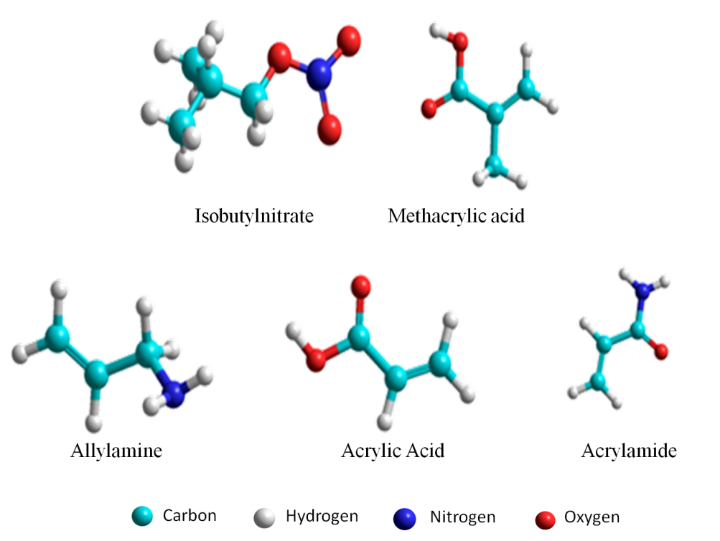

Figure 1. The optimized structures of template and functional monomers

Table 2. Interaction energy within complex
Molecules | Interaction energy ΔE (kcal/mol)
Isobutylnitrate – acrylamide | -3.7791
Isobutylnitrate – acrylic acid | -3.8069
Isobutylnitrate – methacrylic acid | -4.1355
Isobutylnitrate – allylamine | -3.0324

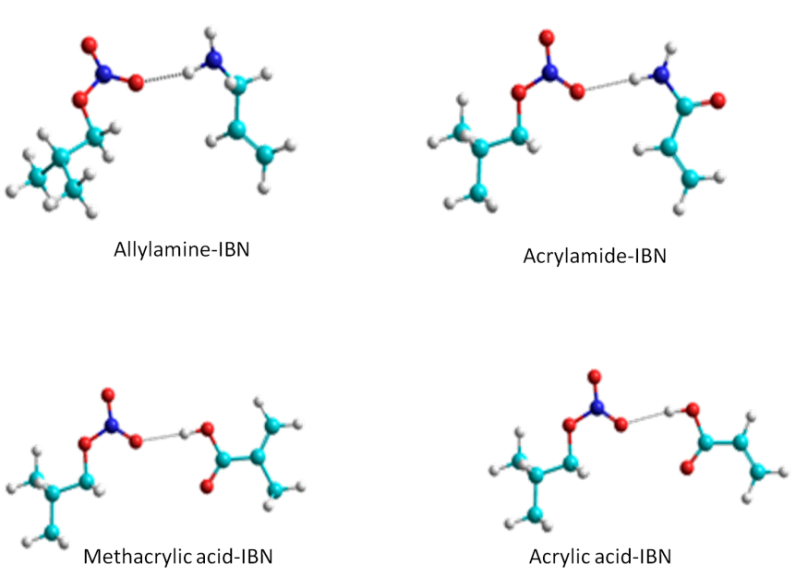

Figure 2. The optimized geometries indicating hydrogen bonding within complexes of template and functional monomers

Optimization of Template: Functional Monomer Ratio
If excess number of mole of functional monomer were applied in a polymerization process, a non specific binding might occur thus reducing the selectivity properties of polymer. In this study, geometries of complex methacrylic acid-IIP with different ratios were optimized and their interaction energies were calculated. The result of interaction energy of complex with different ratio; 1:2 and 1:3 (isobutylnitrate: monomers) are shown in Table 3. Figure 3 demonstrates the potential interactions between template and functional monomers with different ratio complexes.

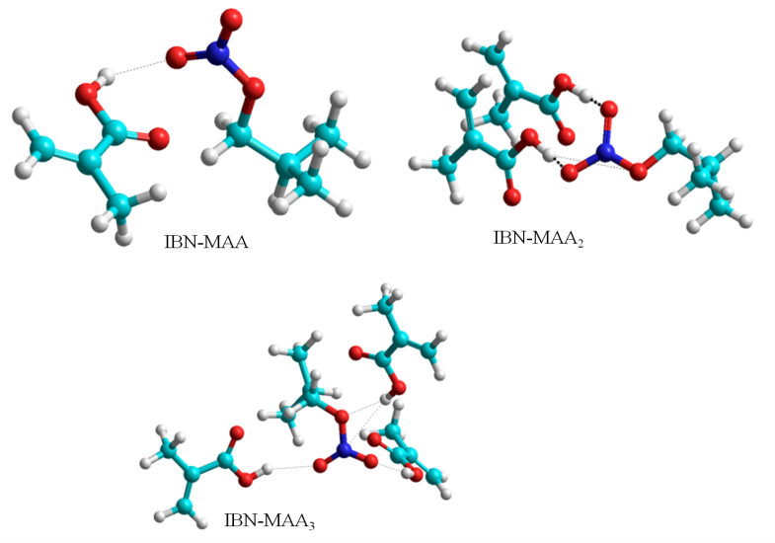

Figure 3. The optimized geometries indicating hydrogen bonding within complexes of template and functional monomers with different ratio

Table 3. The Interaction energy ΔE of isobutyl nitrate (IBN) with methacrylic acid (MAA) different ratio
Molecules | Ratio | Energy (kcal/mol) | Interaction energy ΔE (kcal/mol)
Isobutylnitrate (IBN) | - | -1492.06 | -
Methacrylic acid (MAA) | - | -1198.46 | -
IBN-MAA | 1:1 | -2690.52 | -4.136
IBN-MAA₂ | 1:2 | -3896.55 | -3.782
IBN-MAA₃ | 1:3 | -5102.92 | -4.518

Table 3 and Figure 3 indicate that complex polymer with 1:3 ratio is most stable complex with high interaction energy. The complex is expected to have greater affinity during rebinding test [9].

Characterization of Polymer
The surface morphology of ion imprinted polymer (IIP) and non imprinted polymer (NIP) were evaluated using FESEM. FESEM images in figure 4 show there was noticeable difference between surface morphology for both IIP and NIP. IIP portrayed a rough and more porous surface. This is due to the presence of a cavity which formed after the removal of template. While the surface morphology of NIP is much smoother as no specific binding site or cavity was created [10].

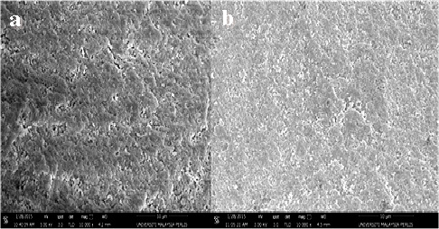
Figure 4. Scanning Electron Microscopy of IIP (a) and NIP (b)

The FTIR spectrum for leached IIP and NIP were recorded using Potassium bromide (KBr) pellet method while liquid MAA was recorded using Attenuated Total Reflection (ATR) method. Figure 5 indicates the similar IR spectra of both IIP and NIP due to the same chemical functional group. Vibration adsorption peak at 3443 cm⁻¹ assigned to OH group. The hydrogen bonding caused a broad adsorption of this peak. The band at 1150 cm⁻¹ is contributed from O-C-C saturated ester stretching vibration. This suggests that copolymerization of EDGMA and MAA due to the presence of EDGMA characteristic in the IR spectra. Other peaks were also observed, carbonyl group stretch (1730 cm⁻¹), C-O stretch (1260 cm⁻¹) and C-H vibrations (756 cm⁻¹, 948.79 cm⁻¹and 2956 cm⁻¹) [11] implied that these polymers were successfully synthesized.

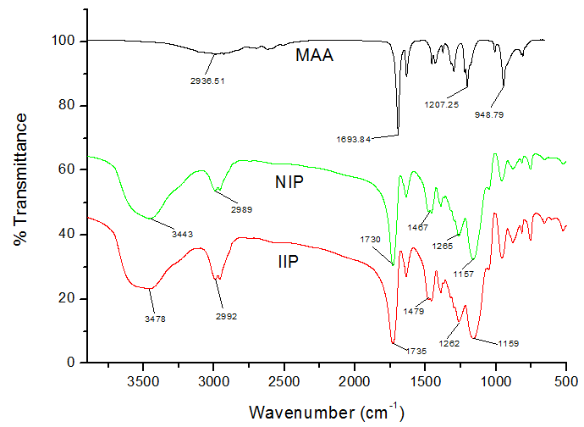

Figure 5. The FTIR spectrum MAA, NIP and NIP

Adsorption Studies
The IIP and NIP polymers were synthesized based on highest binding energy. Binding capacity, Q is one important parameter to quantify the amount of polymer required at certain concentration of template in a given solution. The binding capacities Q (mg/g), for both types of polymer, were calculated using the equation 2 below:

Q = $\frac{V(C_{i}-C_{f})}{m}$ (2)

where V represent volumes of standard nitrate solution (mL), C_{i} represent initial concentration, C_{f} represent final concentration of the solution and m is mass of polymer particle [12]. Figure 6 indicates that the maximum binding capacity of IIP-MAA particles was 30.21 mg/g which was higher than NIP-MAA particles (24.06 mg/g). The difference was due to the empty cavity of IIP-MAA that has selective interaction toward template. Non specific binding in NIP-MAA surface corresponds to the hydrogen bonding, van der Waal forces and electrostatic interaction between template and functional groups of the polymer [13].

Kinetic Study
The adsorption kinetic was carried out by adding 10 mg of polymer into 5mL aqueous solution containing 250 mg/L nitrate ion and shake for 50 minutes. Figure 7 indicates the curve of kinetic adsorption of IIP and NIP. The adsorption amount of nitrate ions increased with increasing adsorption time. In the early 40 minutes the adsorption rates increased rapidly, while at the last 10 minutes the adsorption rate is slightly decrease. At the early time, the nitrate ions easily reach the surface imprinted cavities of the polymer thus increasing the adsorption rate. While later, the imprinted cavities were saturated with nitrate ions; the ions tend to diffuse toward deep cavities. Thus give a great resistance for template to reach the cavities and cause the adsorption rate to decrease [14].

Figure 6. Binding capacity, Q (mg/g) IIP and NIP at different concentration of nitrate solution (mg/L)

Figure 7. Kinetic adsorption of IIP and NIP within 50 minutes

Conclusion
In the pre polymerization process, the optimization of complex isobutylnitrate: methacrylic acid mol ratio was performed using AM1 semi empirical method within RHF formalism. The results indicated 1:3 template monomer ratio is the best configuration with binding energy -4.52 kcal/mol. The nitrate imprinted polymer was synthesized according to the result of computational studies by bulk polymerization. The adsorption studies were performed by batch rebinding. The maximum adsorption capability for nitrate ion was 30.21 mg/g dry weight of imprinted polymer. The kinetic adsorption study indicated that the adsorption rate was relatively fast with time taken to reach equilibrium was about forty minutes. The synthesized imprinted polymers exhibit capability to specifically recognize nitrate ions in aqueous solution.

Acknowledgement
The author would like to thank to School of Material Engineering, University Malaysia Perlis. Noorhidayah Ishak acknowledges the support from Ministry of Higher Education of Malaysia for providing financial support through SLAB scholarship. Acknowledgement goes to Mubaraq Von Schleusingen for helping on revision this manuscript.

References
- Nitrate and Nitrite: Health Information Summary, (2006). New Hampshire Departmental of Environmental Services. Retrievedfromhttp://des.nh.gov/organization/commissioner/pip/factsheets/ard/index.htm
- Jalal K.C.A., Zahangir M.D., Matin W.A., Kamaruzzaman B.Y., Akbar J. and Toffazel H., (2011). Removal of nitrate and phosphate from municipal waste water sludge by Chorella Vulgaris, Spirulina Platensis and Scenedemus Quadricanda, IIUM Engineering Journal 12(4):125-132.
- Cheong WJ., Yang SH. and Ali F., (2013). Molecular imprinted polymers for separation science: A review of reviews, Journal of Separation Science 36: 609–628.
- Ivari S.A.R, Darroudi A., Zafar M.H.A, Zohuri G. and Ashraf N., (2012). Ion Imprinted polymer based potentiometric sensor for the trace determination of Cadmium (II) ions. Arabian Journal of Chemistry (In Press).
- Farrington K. and Regan F. (2007). Investigation of the nature of MIP recognition: The development and characterization of a MIP for ibuprofen, Biosensors & Bioelectronics 22: 1138-1146.
- Kugimiya A. and Takei H. (2006). Preparation of molecularly imprinted polymers with thiourea group for phosphate, Analytica Chimica Acta 564: 179-183.
- Iqmal T, Ahmad M.N., Shafiqul Islam A.K.M. and Arbain D, (2012). Molecular modeling and experimental study on the interaction between quarcetin and methacrylic acid, The 2nd International Malaysia-Ireland Joint Symposium on Engineering, Science and Business 2012: 1160-1168.
- Gvozdic V., Tomisic V., Butorac V. and Simeon V., (2009). Association of nitrate ion with metal cations in aqueous solution: a UV-Vis spectrometric and factor-analytical study, Croatica Chemica Acta 82: 553-559.
- Tadi K. K. and Motghare R.V. (2013). Potentiometric selective recognition of oxalic acid based on molecular imprinted polymer, International Journal of Electrochemical Science 8: 3197-3211.
- Ahamed M.E.H, Mbianda X.Y., Mulaba-Bafubiandi A.F. and Marjanovic L., (2013). Ion imprinted polymers for the selective extraction of silver(I) ions in aqueous media: Kinetic modeling and isotherm studies, Reactive and Functional Polymers73: 474-483.
- Smith B (1999). Infrared spectral interpretation a systematic approach, CRC Press Boca Raton London New York Washington, D.C.
- Yusof N.A, Rahman S.K.A, Hussein M.Z and Ibrahim N.A, (2013). Preparation and Characterization of Molecularly Imprinted Polymer as SPE Sorbent for Melamine Isolation, Polymers 5: 1215-1228.
- Sadeghi S. and Jahani M. (2013). Selective solid-phase extraction using molecular imprinted polymer sorbent for the analysis of Florfenicol in food samples, Food Chemistry 141: 1242-1251.
- Kan X., Zhao Q., Zhang Z., Wang Z. and Zhu J.J., (2008). Molecularly imprinted polymers microsphere by precipitation polymerization for hydroquinone recognition, Talanta 75: 22-26.

