

OPTICAL BEHAVIOR OF NH₄I DOPED CELLULOSE ACETATE MEMBRANE FOR DYE SENSITIZED SOLAR CELL

(Pelakuan Optikal Selulosa Asetat Membran yang Didopkan NH₄I untuk

Pewarna Sensitif Solar Sel)

Noor Syafiqah Samsi¹, Rosnah Zakaria¹, Oskar Hasdinor Hassan², Muhd Zu Azhan Yahya³,
Ab Malik Marwan Ali^{1,2}*

¹Faculty of Applied Sciences,
² iMADE, Institute of Science,
Universiti Teknologi MARA, 40450 Shah Alam, Selangor, Malaysia
³Universiti Pertahanan Nasional Malaysia, Kem Sungai Besi, 57000 Kuala Lumpur, Malaysia

*Corresponding author: ammali@salam.uitm.edu.my

Received: 23 November 2014; Accepted: 27 June 2015

Abstract
The effect of ammonium iodide (NH₄I) on cellulose acetate (CA) membrane based on solid polymer electrolyte was investigated. FTIR analysis showed that the complaxation was taken placed between polymer and salt to form CA-NH₄I complexes. Alternating current impedance measurement was carried out in the frequency range between 50 Hz and 1MHz at room at elevated temperature with an applied voltage of 1V. The ionic conductivity increased up to 10⁻⁰⁴ Scm⁻¹ with increasing NH₄I contents for the CA-NH₄I at room temperature. As NH₄⁺ ion concentration increase, the optical band gaps decreased. This suggests that NH₄I, as a dopant, is a good choice to improve the electrical properties of cellulose acetate polymer electrolytes.

Keywords: polymer electrolyte, Dye Sensitized Solar Cell, UV-Vis Spectroscopy

Abstrak

Kesan ammonium iodida (NH₄I) pada selulosa asetat (CA) membran berdasarkan elektrolit polimer pepejal telah disiasat. Analisis FTIR menunjukkan complaxation itu diambil diletakkan di antara polimer dan garam untuk membentuk kompleks CA-NH4I. Seli pengukuran galangan semasa telah dijalankan dalam julat frekuensi di antara 50 Hz dan 1MHz di bilik pada suhu tinggi dengan voltan kenaan 1V. Kekonduksian ionik meningkat sehingga 10⁻⁰⁴ SCM⁻¹ dengan meningkatkan kandungan NH₄I untuk CA-NH₄I pada suhu bilik. Sebagai NH₄ ⁺ kepekatan ion peningkatan, jurang jalur optik menurun. Ini menunjukkan bahawa NH4I, sebagai pendopan yang, adalah pilihan yang baik untuk meningkatkan ciri-ciri elektrik elektrolit polimer selulosa asetat.

Kata kunci: polimer elektrolit, Dye sensitif Sel Solar, UV-Vis Spektroskopi

Introduction

Dye-sensitized solar cells (DSSCs) is now an emerging area of material science due to low cost and high efficiency [1–3] DSSC attempting highest efficiency based on liquid electrolyte but it have disadvantages like leakage, evaporation, etc. Replacing the current liquid electrolytes with solid polymer based electrolytes is current goals in DSSC in order to enhance the optical and electrical properties for their commercial applications in the field of electrochemical devices. Recently, cellulose acetate (CA) is one of the most popular, renewable, biodegradable polymers and abundances in nature. The optical properties of polymers can be suitably modified by the addition of dopants depending on their reactivity with the host matrix [4]. Changing in polymer composition may induce optical absorption. One method to enhance the optical and electrical properties of polymer is by adding ammonium salt as a dopant in the system. Energy band structure is basic understandings on mechanism of optical properties which can be obtained by studying optical absorption. Although some work has been done on the optical properties of doped polymer electrolyte films [5], the investigation of the optical properties of this system is still limited and much experimental work needs to be done in this direction. Studies have proved that in CA-NH₄I systems, conductivity increases with the increase of salt wt%. This paper is concerned with the optical properties of new polymer electrolytes based on cellulose acetate complexes with ammonium iodide. The optical properties of the polymer electrolytes are investigated to determine the optical transition characteristics and provide information about the band structure and

Materials and Methods

Solid polymer electrolytes (SPEs) were prepared using solution casting method. Cellulose acetate (CA) with 39.8 wt.% acetyl content were used as polymer host, ammonium iodide (NH₄I) salt from Aldrich (purity 99%) were used as ion sources and acetone (Aldrich) as a solvent. NH₄I was dried for about 2 hours at 100 ºC prior used. CA and NH₄I with different stoichiometric ratio were dissolved in 30 mL acetone for 48 hours at room temperature until both the polymer and salt were completely dissolved. The homogeneous solutions were then cast onto glass petri dishes and allowed to dry to form films at room temperature. The films were kept in desiccators with silica gel desiccants for further drying before being characterized. The ionic conductivity of the samples was performed by using HIOKI 3532-50 LRC Hi-Tester in frequency range between 100Hz and 1MHz at room and elevated temperature. The samples were sandwiched between two stainless steel electrodes (SUS316) and placed in a SH-221 Bench-Top type temperature and humidity chamber at constant humidity 40% RH. Perkin Elmer Spectrum 400 was used to studies FTIR performance. The optical absorption measurements of the samples have been recorded in the range of 200–800 nm using a CARY 50 Scab UV–vis–NIR spectrophotometer.

Results and Discussion
The conductivity of the CA salts complaxed at room temperature is illustrated in Figure 1.The ionic conductivity of SPEs increases with the increasing salt concentration up to 1.99 x 10⁻⁴ Scm⁻¹ when 25 wt. % NH₄I was added. The slow increase in conductivity at lower salt concentrations can be explained due to the increasing the number of mobile charge carriers increases due to increasing of the ion dissociation in the polymer salt system. The dissociated ion eventually formed a complex between the oxygen atom of the carbonyl group (C=O) and NH₄⁺ ion to form C=O←NH₄⁺ coordination. The conductivity abruptly increased causes of the reducing the columbic force between the anion and cation of the salt and thereby resulting in the dissociation of the ammonium salt. The conductivity increased also can be explained in terms of the segmental mobility of the polymer chain. The increase in segmental mobility will favour the ion migration easily takes place resulting higher conductivity [6]. However, above 25 wt. %, the ionic conductivity was found to decrease. This phenomenon can be attributed to the re-association of the ions into natural ions aggregates[7]. The existence of ion aggregates at higher salt concentration will clog the ionic migration. hence reducing the ionic conductivity.

Figure 2 depict the IR transmittance spectra that show the FTIR spectra of the pure CA and CA doped with various weight percentages of NH₄I at room temperature in the region: (i) 900-1600 cm⁻¹ and (ii) 1600-1800 cm⁻¹. The complexation of CA with NH₄I was confirmed by examining the polymer salt complex films under FTIR. Upon the addition of salt to the polymer host, the cation of the salt is expected to interact with the polar groups in the host polymer matrix. The most important indicator band in CA is C=O at 1743 cm⁻¹. The peak was slowly downshifted with the addition of salt. At 25 wt. %, the wavenumber was downshifted to 1739 cm⁻¹. This shift is due to the interaction of the proton in the ammonium salt with the carbonyl group of the polymer host, CA [8] as shown in Scheme 1 the possible complexation of ammonium iodide with cellulose acetate. The peak at 1224 cm⁻¹ and 1033 cm⁻¹ is assignable to the C–O band has shifted to a higher wavenumber at 1228 cm⁻¹ and 1038 cm⁻¹ with an increased intensity in the presence of salt. The peak corresponding to the NH₄⁺ at 1381 cm⁻¹ of ammonium salt, was shifted to a lower wavenumber (1376 cm⁻¹). These changes confirm the interaction between CA and NH₄I.

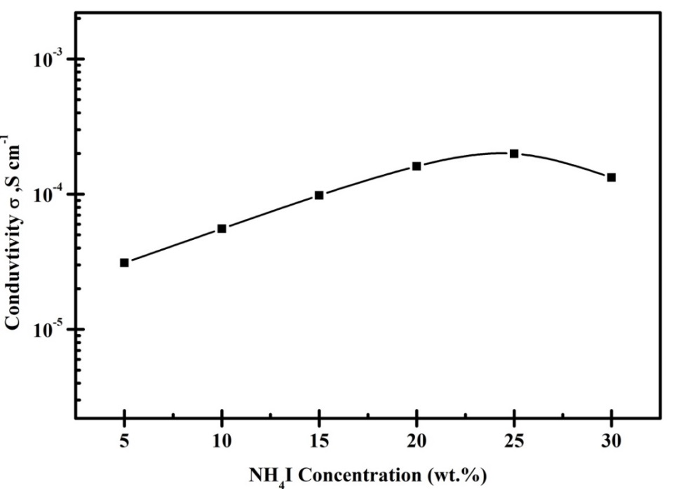
Figure 1. Variation of Room temperature conductivity as a function of salt concentration

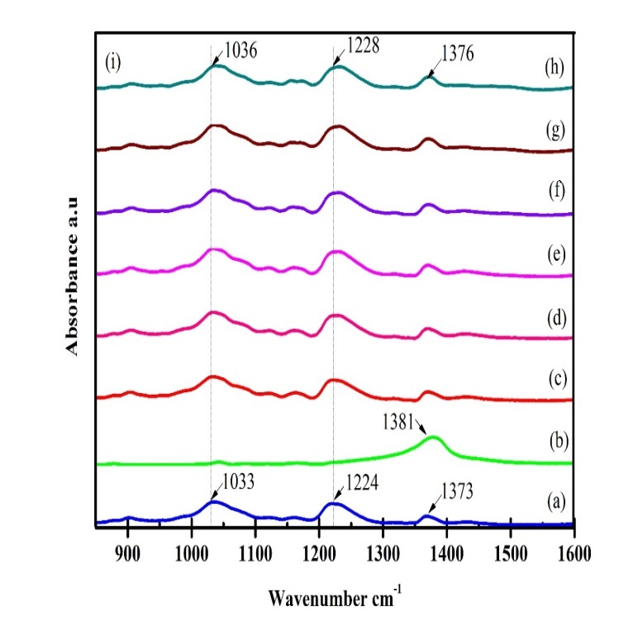
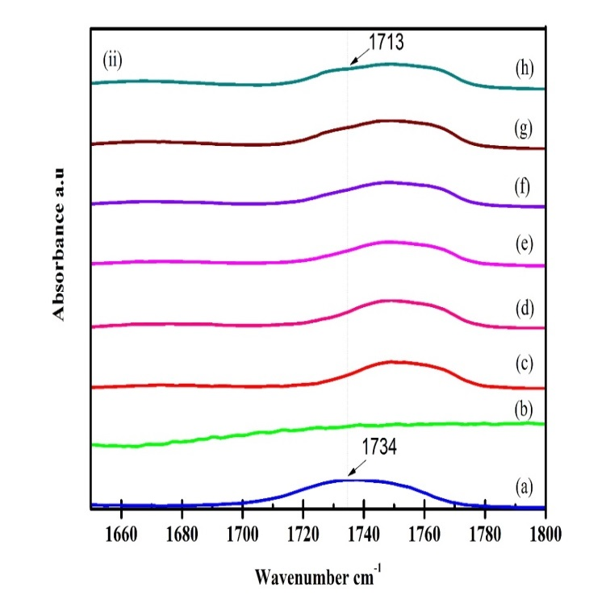
Figure 2. ATR-FTIR Spectra of (a) Pure CA, (b) Pure NH₄I, (c) CA–5 wt. % NH₄I, (d) CA–10 wt. % NH₄I, (e) CA–15wt. % NH₄I, (f) CA–20 wt. % NH₄I, and (g) CA–25 wt. % NH₄I

CH₂OR
OR
OR
n
R = H, COCH₃
OH
+ NH₄I
CH₂OR
OR
R
O
O
H – NH₃⁺
R
O⁺
NH₃
OH
NH₃⁺
R

Scheme 1. Possible complexation of ammonium iodide with cellulose acetate

UV-vis spectra was used to determine the band gap of polymer electrolyte The study of optical absorption was to verify the correlation between the energy gaps with complexation when CA doped with ammonium salts. There are two type of band gap which were (a) direct band gap and (b) indirect band gap. In direct band gap semiconductors, the bottom of conduction band and top of valence band are both laid at the same zero crystal momentum (wave vector). If the bottom of the conduction band does not correspond to zero crystal momentum, the material is called as indirect band gap semiconductor. In indirect band gap materials transition from valence to conduction band should always be associated with a phonon of the right magnitude of crystal momentum. The transition from valance band to the conduction band is considered to be fundamental absorption in order to determine the band gap of the material. The relation between absorption coefficient (α) and incident photon energy (hv) can be written as Equation (1):

α = A(hv-Eg)^{n}/hv (1)

where, Eg is the band gap of the material, A is a constant , and the exponent n depends on the type of transition. It may have values 1/2, 2, 3/2 and 3 corresponding to the allowed direct, allowed indirect, forbidden direct and forbidden indirect transitions, respectively. Figure 3 (a) and (b) shows the extrapolation of best fit line between (αђω)^{1/2} and (αђω)² versus ђω for different composition electrolyte to obtain optical band gap Eg and Figure 4 depict the plots of energy band gap with different salt concentration CA based polymer electrolyte. By adding salt in the CA complexes, optical band gap are in the range 4.12 to 3.50 eV for direct optical band gap and from 4.50 to 3.83 eV for indirect optical band gap. The decrease in the band gap is caused by an doping elements effect, namely a compositional change in the host material itself (CA) [2] This was caused by the complexation that has occurred between CA and salt via NH₄⁺→O=C coordination band. This result is in agreement with result discussed from conductivity and FTIR, studies.

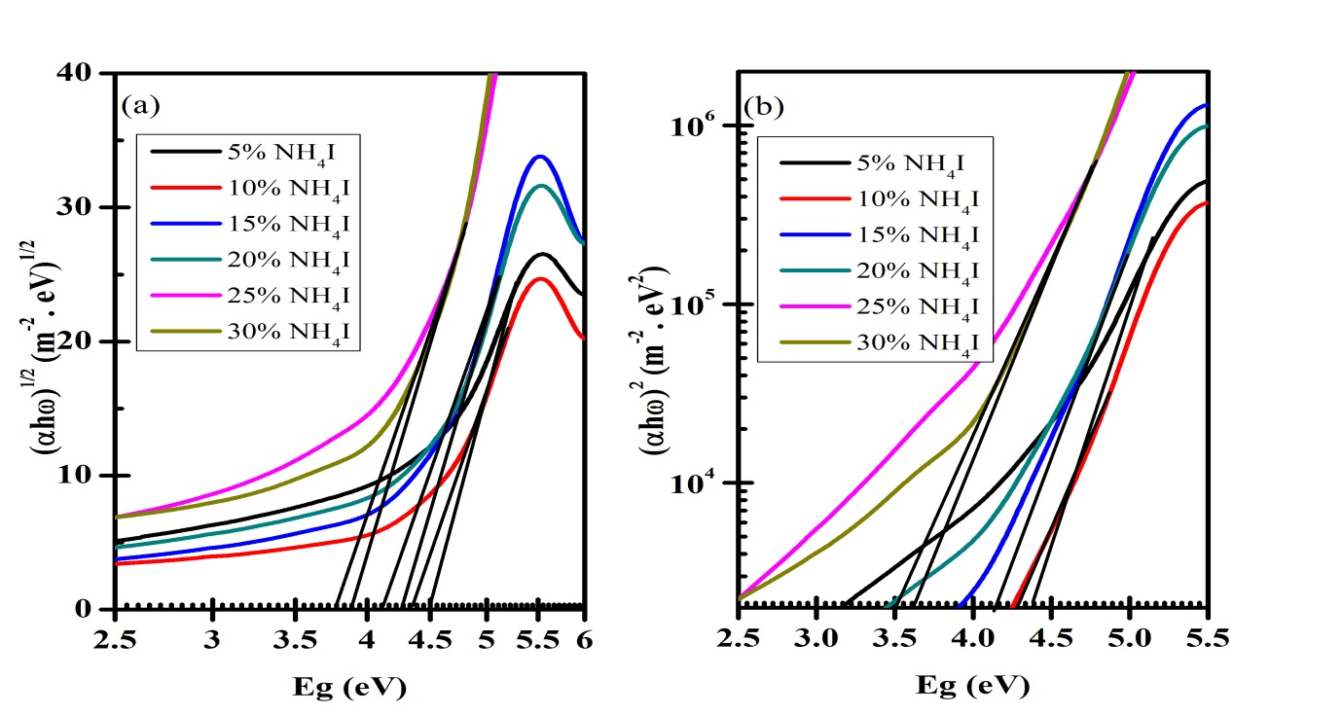
Figure 3. (a) (αђω)^{1/2} and (b) (αђω)² versus ђω for different composition salts

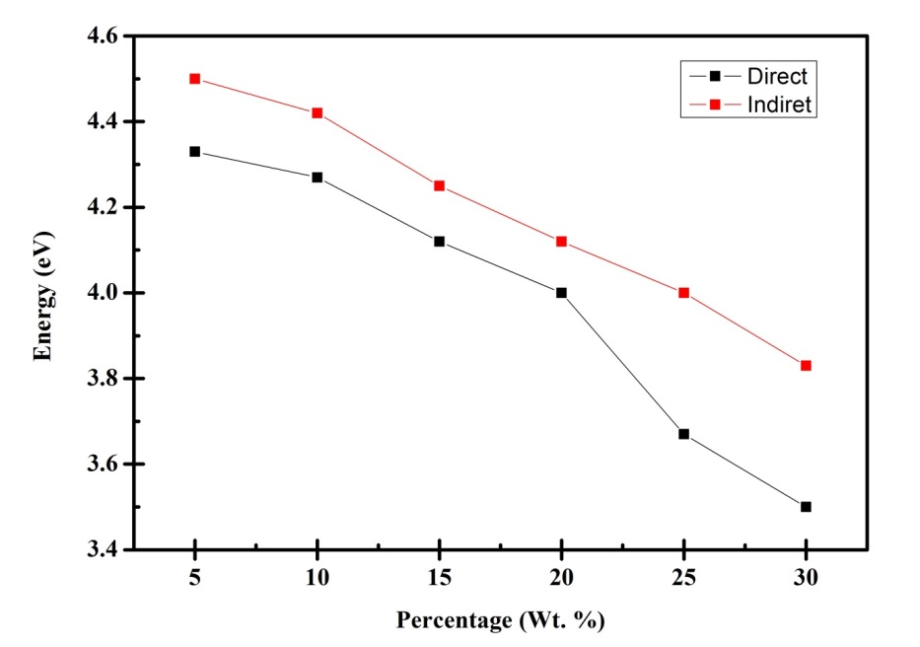
Figure 4. Energy band gap for direct and indirect band gap in CA-different wt. % NH₄I

Conclusion

Optical properties of the polymer electrolytes appear to be strongly connected to the chemical and structural modifications induced in the polymer. It has been demonstrated in this paper that the addition of stoichiometric weight percent of ammonium salt to the CA matrix enhances the conductivity. At room temperature, 25 wt. % ammonium salt exhibits the highest ionic conductivity of 1.99 × 10⁻⁴ S cm⁻¹ in SPE system. ATR-FTIR spectroscopy justify the interactions between polymer and salt primarily due to the C=O of CA and NH₄⁺ of salt. The shifting of the carbonyl peak C=O of CA at 1743cm⁻¹ to the lower wavenumber indicates coordination takes place between ammonium cation and C=O to form NH₄⁺→ O=C interaction. The energy band gap (Eg) was found to decrease to 3.50eV for direct band gap and 3.83eV for indirect band gap with increasing salt content by UV-Visible studies. The dopant (salt) considered as defect in polymer which affects the optical band gap. The optical band gap values show the decreasing trend with an increasing dopant concentration.

Acknowledgement

The authors would like to thank to University Teknologi MARA (UiTM) and Ministry of Education Malaysia (MOE) for NRGS, FRGS, ERGS, and RAGS funding this research.

References
- Chaurasia, S. K., Singh, R. K. and S. Chandra, S. (2013) Ion–polymer complexation and ion-pair formation in a polymer electrolyte PEO:LiPF6 containing an ionic liquid having same anion: A Raman study. Vibrational Spectroscopy 68: 190–195.
- Kumar,K. Kiran., Ravi, M., Pavani, Y., Bhavani, S., Sharma, A. K. and Narasimha Rao, V. V. R (2011). Investigations on the effect of complexation of NaF salt with polymer blend (PEO/PVP) electrolytes on ionic conductivity and optical energy band gaps. Physica B: Condensed Matter 406 (9): 1706–1712.
- Kim M., Park S., Kim J. and J. Lee, Dye-Sensitized Solar Cells Based on Polymer Electrolytes. Chapter 10, "Solar Cells - Dye-Sensitized Devices", book edited by Leonid A. Kosyachenko" Intech Publisher.
- Ibrahim, S., Ahmad, R. and Johan, M. R. (2012) Conductivity and optical studies of plasticized solid polymer electrolytes doped with carbon nanotube. Journal of Luminescence 132 (1): 147–152.
- Mahmud, Z. S., Adam, N. I., Zaki, N. H. M., Ali, A. M. M. and Yahya, M. Z. A. (2012).Conductivity and optical studies of plasticized polymer electrolytes based on 49% PMMA-grafted natural rubber,” 2012 IEEE Symposium on Business, Engineering and Industrial Applications 504–508.
- Su’ait,M. S., Ahmad, A., Hamzah, H. and Rahman,M. Y. A. (2011). Effect of lithium salt concentrations on blended 49% poly(methyl methacrylate) grafted natural rubber and poly(methyl methacrylate) based solid polymer electrolyte. Electrochimica Acta, 57: 123–131
- Harun, N.I., Ali, R. M., Ali, A. M. M. and Yahya, M. Z. A. (2013). Effects of Ammonium Tetrafluoroborate on Conductivity and Thermal Studies on Cellulose Acetate Based Polymer Electrolytes. Advanced Materials Research, 667: 150–154.
- Ali, R. M., Harun, N. I., Ali, A. M. M. and Yahya, M. Z. A. (2012). Effect of ZnS Dispersoid in Structural and Electrical Properties of Plasticized CA-NH4I. Physics Procedia 25: 293–298.

