

COLOR SPECTRUM PROPERTIES OF PURE AND NON-PURE LATEX IN DISCRIMINATING RUBBER CLONE SERIES

(Ciri-Ciri Warna Spektrum dalam Membezakan Siri Klon Getah untuk Susu Getah Tulen Dan Bukan Tulen)

Noor Aishah Khairuzzaman*, Hadzli Hashim, Nina Korlina Madzhi, Noor Ezan Abdullah, Faridatul Aima Ismail, Ahmad Faiz Sampian, Azhana Fatnin Che Will

Faculty of Electrical Engineering,
Universiti Teknologi MARA, 40450 Shah Alam, Selangor, Malaysia

*Corresponding author: noor.aishah88@yahoo.com

Received: 23 November 2014; Accepted: 27 June 2015

Abstract
A study of color spectrum properties for pure and non-pure latex in discriminating rubber clone series has been presented in this paper. There were five types of clones from the same series being used as samples in this study named RRIM2002, RRIM2007, RRIM2008, RRIM2014, and RRIM3001. The main objective is to identify the significant color spectrum (RGB) from pure and non-pure latex that can discriminate rubber clone series. The significant information of color spectrum properties for pure and non-pure latex is determined by using spectrometer and Statistical Package for the Social Science (SPSS). Visible light spectrum (VIS) is used as a radiation light of the spectrometer to emit light to the surface of the latex sample. By using SPSS software, the further numerical analysis of color spectrum properties is being conducted. As the conclusion, blue color spectrum for non-pure is able to discriminate for all rubber clone series whereas only certain color spectrum can differentiate several clone series for pure latex.

Keywords: rubber clone series, RGB color, spectrometer, statistical analysis

Abstrak

Satu kajian mengenai ciri-ciri warna spektrum dalam membezakan siri klon getah untuk susu getah tulen dan bukan tulen telah dibincangkan di dalam kertas kerja ini. Terdapat 5 jenis klon daripada siri yang sama telah digunakan sebagai sampel iaitu RRIM 2002, RRIM 2007, RRIM2008, RRIM2014, RRIM3001. Tujuan utama kajian ini adalah untuk mengenal pasti warna asas spektrum (Merah, Hijau, Biru) daripada susu getah tulen dan tidak tulen yang boleh membezakan siri klon getah. Informasi penting daripada ciri-ciri warna spektrum ini ditentukan menerusi spektrometer dan analisa statistik. Spektrum cahaya yang boleh dilihat ini akan digunakan sebagai cahaya radiasi kepada spektrometer untuk memancarkan cahaya kepada permukaan sampel susu getah. Dengan menggunakan perisian SPSS ini, analisa numerikal selanjutnya akan dijalankan pada ciri-ciri warna spektrum. Secara kesimpulannya, warna spektrum biru bagi sampel tidak tulen boleh membezakan keseluruhan siri klon getah. Manakala, hanya warna spektrum tertentu boleh membezakan jenis klon untuk susu getah tulen.

Kata kunci: siri klon getah, warna MHB, spektometer, analisis statistik

Introduction

Rubber is one of the largest economic income in Malaysia. Commonly products from the natural rubber are tires, gloves, latex suits, etc. Basically, latex is obtained by tapping rubber from the rubber trees [1]. In Malaysia, there are many types of rubber clone series that have been produced for almost nine decades ago where it is consists of more than 185 clones breed [2]. As a result of that, farmers and agriculture officers may face difficulties in discriminating the best clone for cultivation [3]. Practically, the identification of rubber clone series is based on pattern recognition from seeds and leaves by skilled workers while a beginner needs to do a comparison from library images [4]. Pure latex is classified as fresh latex which consists of 50-80% water, 25-45% hydrocarbon rubber, and 2-5% non-rubber constituents [1] while, non-pure latex or also known as preservative latex, the composition consists of water, sodium carbonate, sodium tetraborate, and formaldehyde [5].The basic RGB color spectrums were chosen as the main parameter to analyze rubber clone series using spectrometer Carl Zeiss MCS 600. The light emitted by spectrometer will interacts with the surface of the objects and will causes adjusting in the color spectrum of the light [6]. A number of researchers have been involved into natural rubber research where most of them investigated on the composition content [7] and the performance [8] of the rubber clone series. Researches also have been conducted to identify the rubber clone reflectance index and image processing of seeds [9,10] and leaves [11] respectively. Osman in [10] presented a study for five types of rubber seed clones (PB360, RRIM2009, RRIM2011, RRIM2016, and RRIM2025) classification via reflectance measurement. The research work investigate on maximum reflectance from the surface of the seed using spectrometer. He concluded that the reflectance index of lateral surface of seed can be used to identify the RRIM2009 clone. The other techniques have been applied in [9] for rubber seed clone identification was by an intelligent classification model via shape features through imaging technique. This work employs Artificial Neural Network (ANN) using Levenberg-Marquardt algorithm to train the inputs. The outcome of this work shows that the best accuracy is at 84% with more than 70% achievement for sensitivity and specificity [9]. Other work done by [11] is regarding to rubber tree leaf disease detection based on RGB color image. Findings have shown that develop intelligent models produced more than 70% of accuracy and sensitivity.

From this overview, it is known that there is lack of work that has been done on rubber clone classification from natural latex especially through color spectrum. As regards to these, a new technology is needed in order to make the work to be efficient and accurate. Therefore, this work proposes a technique of analyzing rubber clone series using RGB color spectrum for five selected clones. Latex samples from each clones are then processed to acquire information of color spectrum based on the reflectance measurement obtain from spectrometer. The data will be analyzed with the statistical method in order to find any significant to discriminate the rubber clone series for both pure and non-pure latex.

Materials and Methods
The rubber clone samples used in this study were taken from Rubber Research Institute of Malaysia (RRIM), Permatang Station, Kota Tinggi, Johor, Malaysia. The tapping process started early at 6.00 am and the latex were collected after 3 hours tapping which is starting from 9.00 am until 11.30 am. This tapping procedure was used half spiral (1/2S) method [12] and S2, D3 method which is cut for every three days. However, this tapping process depends on the season and it was conducted on low yielding period at the end of February 2014. The samples were placed in ice box with clone labels and brought to Room Image Capturing Studio (ICS), Advanced Signal Processing (ASP) laboratory, level 10 in UiTM Shah Alam, Malaysia. There were two randomly tree selected for each clone used in this work. The latex samples have been divided into two categories which are pure and non-pure latex.

Reflectance Measurement
In this study, the reflection spectra of VIS were used as the optical properties and the wavelength spectrum for VIS were between 400 nm and 800 nm as shown in Figure 1. The light features with different wavelengths started from ultraviolet (UV) up to infrared (IR) [13]. For this work, the selected primary colors were Red (620-750nm), Green (495-570nm), and Blue (450-475nm).

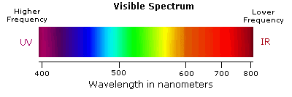
Figure 1. Optical properties [13]

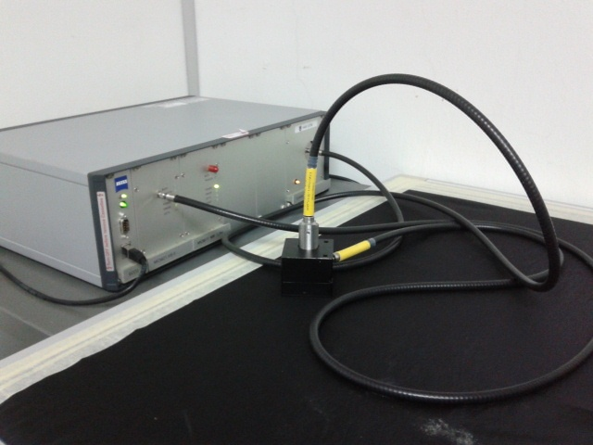

Figure 2. Component of MCS 600 spectrometer

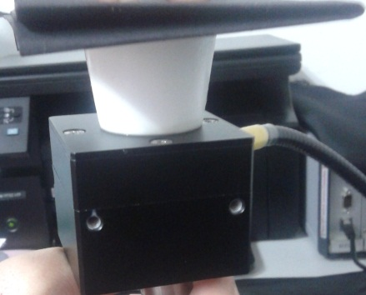

Figure 3. Sample of measurement from bottom side

The MCS 600 as shown in Figure 2 is a component of spectrometer from Carl Zeiss that cover spectral range from 190 nm to 2200nm [14]. The OFK 30 is a measuring head that has been added to the MCS 600 as its accessory program. The maximum diameter that can be measures is 30 mm [15]. In this work, the reflectance measurements of the latex samples were obtained from the bottom side of the specimen cup as shown in Figure 3.

Data Acquisition and Data Conversion
An Aspect Plus software is used to extract and display the reflectance measurement from spectrometer MCS 600 from Carl Zeiss. The data were then being transferred to a graph of reflectance (%) versus wavelength which ranging from 450-950nm [15]. The reflectance data from the Aspect Plus software was automatically saved in ASCII code format (DAT.) and converted the obtained data into Microsoft Excel for ease of analysis [9].

Numerical Analysis
Results were analysed for normality test, error bar test and one way ANOVA. Normality Test need to be conducted prior to other test for checking the normality of a population. If the population found to be normal then the parametric test can be carried out [16]. Error bar test is one of the parametric test which can be used for comparing between groups of variables. Meanwhile, the one-way ANOVA is suitable for comparison means from one or more group [9].

Results and Discussion
Normality Test
Table 1 and 2 tabulates the normality test for pure latex and non-pure latex for each clone series. According to both table, it is shows that only pure Red 2008 (Table 1) and non-pure Blue 2002 (Table 2) were not normally distributed from the data set with p<0.05. Thus, it is denote that pure Red 2008 and non-pure Blue 2002 are no longer can be used for next processing. The rule for normal distribution is when the significance value (p-value) is greater than 0.05, it means that the data set is in normal distribution otherwise, it is not normal distribution [17].

Table 1. Normality test for pure latex
 | Kolmogorov-Smirnorv |  |  | Shapiro-Wilk
 | Statistic | Df | Sig. | Statistic | df | Sig.
red_2002 | .163 | 26 | .075 | .931 | 26 | .080
green_2002 | .124 | 26 | .200 | .924 | 26 | .056
blue_2002 | .131 | 26 | .200 | .951 | 26 | .240
red_2007 | .154 | 26 | .114 | .936 | 26 | .109
green_2007 | .148 | 26 | .146 | .924 | 26 | .056
blue_2007 | .066 | 26 | .200 | .991 | 26 | .997
red_2008 | .186 | 26 | .022 | .913 | 26 | .030
green_2008 | .124 | 26 | .200 | .951 | 26 | .243
blue_2008 | .144 | 26 | .174 | .933 | 26 | .089
red_2014 | .167 | 26 | .059 | .928 | 26 | .070
green_2014 | .128 | 26 | .200 | .934 | 26 | .096
blue_2014 | .062 | 26 | .200 | .993 | 26 | .999
red_3001 | .147 | 26 | .153 | .949 | 26 | .216
green_3001 | .156 | 26 | .102 | .927 | 26 | .064
blue_3001 | .019 | 26 | .200 | .988 | 26 | .988

Table 2. Normality test for non-pure latex
 | Kolmogorov-Smirnorv |  |  | Shapiro-Wilk
 | Statistic | df | Sig. | Statistic | df | Sig.
red_2002 | .140 | 26 | .200 | .962 | 26 | .423
green_2002 | .152 | 26 | .128 | .893 | 26 | .011
blue_2002 | .189 | 26 | .018 | .873 | 26 | .004
red_2007 | .135 | 26 | .200 | .964 | 26 | .476
green_2007 | .122 | 26 | .200 | .912 | 26 | .030
blue_2007 | .081 | 26 | .200 | .992 | 26 | .998
red_2008 | .126 | 26 | .200 | .963 | 26 | .452
green_2008 | .112 | 26 | .200 | .929 | 26 | .074
blue_2008 | .111 | 26 | .200 | .973 | 26 | .693
red_2014 | .112 | 26 | .200 | .975 | 26 | .760
green_2014 | .082 | 26 | .200 | .962 | 26 | .440
blue_2014 | .092 | 26 | .200 | .979 | 26 | .854
red_3001 | .137 | 26 | .200 | .953 | 26 | .275
green_3001 | .127 | 26 | .200 | .915 | 26 | .034
blue_3001 | .072 | 26 | .200 | .990 | 26 | .995
Error Plot
Figure 4 until 6 displays the Error Bar Plot for pure latex with respect to each clone based on RGB color spectrum. Based on plot in Figure 4, it is shows that Red 2002 are obviously significant different with each other. From Figure 5, it can be said that, Green 2002 can be discriminated between Green 2007, 2014, and 3001. While these three clones (2007, 2014, and 3001) are able to differentiate from 2002 and 2008. The following Figure 6 depicts the Error Bar for Blue color. It can be clearly observed that the Blue 2008 are extremely significant between other clones.

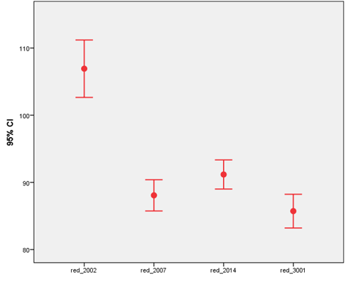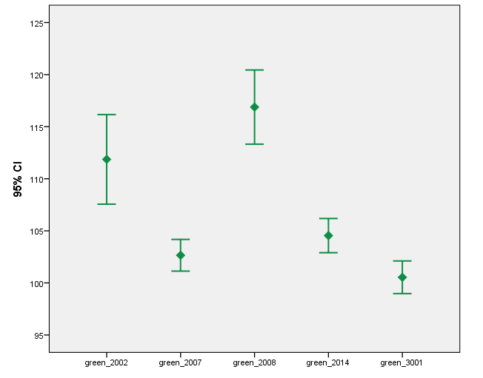
Figure 4. Error bar plot for all red rubber clones. Figure 5. Error bar plot for all green rubber clone

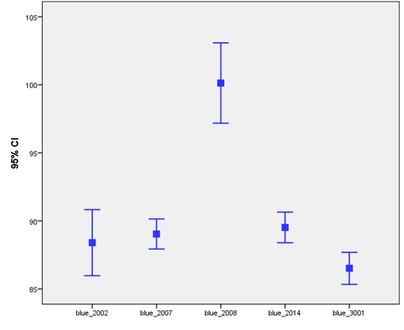

Figure 6. Error bar plot for all blue rubber clone

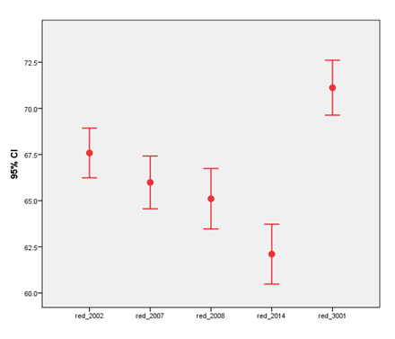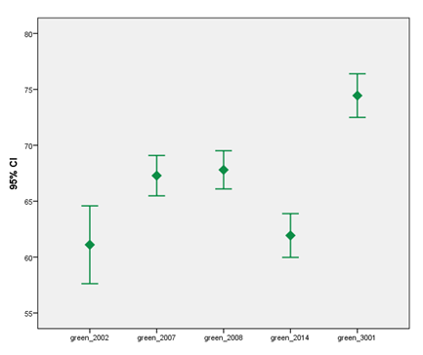

Figure 7. Error bar plot for all red rubber clone Figure 8. Error bar plot for all green rubber clone
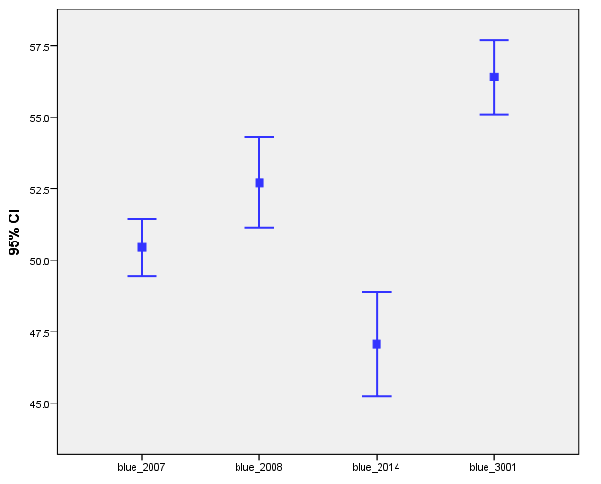

Figure 9. Error bar plot for all blue rubber clone

Figure 7- 9 shows that error bar plot for non-pure latex according to RGB spectrum color with respect to each rubber clone series. Referring to these figures, it can be conclude that the Red, Green, and Blue for RRIM3001 clone obviously having significant different between other clones due to high gap. Hence, it is suggested to do another analysis using ANOVA for obtaining more precise conclusion instead of graph observation.

ANOVA Test
Following are the hypothesis assumptions made using ANOVA test. Ho = There are no different in RGB color spectrum between each clone. H1 = There are at least one different in RGB color spectrum between each clone.

Pure Latex
Table 3-5 shows the comparisons for RGB color spectrum between all clones for pure latex. The results show that majority of the clones especially in Red and Green obtained p < 0.05, which proved that these clones are highly significant different. So, for this case, the null (Ho) hypothesis is rejected and the alternative (H1) hypothesis is accepted since p-value <0.05. From that reason, a particular analysis cannot be done simultaneously for all clones.

Table 3. Multiple comparison for red color spectrum
 |  | Mean  Difference |  |  | 95% confidence Interval
(I)Clone | (J)Clone | (I-J) | Std. Error | Sig. | Lower bound | Upper bound
2002 | 2007 | 18.85105 | 2.09145 | .000 | 14.7357 | 22.9664
 | 2014 | 15.74510 | 2.09145 | .000 | 11.6298 | 19.8604
 | 3001 | 21.20118 | 2.09145 | .000 | 17.0858 | 25.3165
2007 | 2002 | -18.85105 | 2.09145 | .000 | -22.9664 | -14.7357
 | 2014 | -3.10595 | 2.09145 | .139 | -7.2213 | 1.0094
 | 3001 | 2.35013 | 2.09145 | .262 | -1.7652 | 6.4655
2014 | 2002 | -15.74510 | 2.09145 | .000 | -19.8604 | -11.6298
 | 2007 | 3.10595 | 2.09145 | .139 | -1.0094 | 7.2213
 | 3001 | 5.45608 | 2.09145 | .010 | 1.3407 | 9.5714
3001 | 2002 | -21.20118 | 2.09145 | .000 | -25.3165 | -17.0858
 | 2007 | -2.35013 | 2.09145 | .262 | -6.4655 | 1.7652
 | 2014 | -5.45608 | 2.09145 | .010 | -9.5714 | -1.3407

Bold is significant p<0.05

Table 4. Multiple comparison for green color spectrum
 |  | Mean  Difference |  |  | 95% confidence Interval
(I)Clone | (J)Clone | (I-J) | Std. Error | Sig. | Lower bound | Upper bound
2002 | 2007 | 9.20858 | 1.95196 | .000 | 5.3621 | 13.0550
 | 2008 | -5.02043 | 1.95196 | .011 | -8.8669 | -1.1740
 | 2014 | 7.32097 | 1.95196 | .000 | 3.4745 | 11.1674
 | 3001 | 11.32378 | 1.95196 | .000 | 7.4773 | 15.1702
2007 | 2002 | -9.20858 | 1.95196 | .000 | -13.0550 | -5.3621
 | 2008 | -14.22900 | 1.95196 | .000 | -18.0755 | -10.3825
 | 2014 | -1.88761 | 1.95196 | .335 | -5.7341 | 1.9589
 | 3001 | 2.11520 | 1.95196 | .280 | -1.7313 | 5.9617
2008 | 2002 | 5.02043 | 1.95196 | .011 | 1.1740 | 8.8669
 | 2007 | 14.22900 | 1.95196 | .000 | 10.3825 | 18.0755
 | 2014 | 12.34140 | 1.95196 | .000 | 8.4949 | 16.1879
 | 3001 | 16.34421 | 1.95196 | .000 | 12.4977 | 20.1907
2014 | 2002 | -7.32097 | 1.95196 | .000 | -11.1674 | -3.4745
 | 2008 | 1.88761 | 1.95196 | .335 | -1.9589 | 5.7341
 | 2007 | -12.34140 | 1.95196 | .000 | -16.1879 | -8.4949
 | 3001 | 4.00281 | 1.95196 | .041 | .1563 | 7.8493
3001 | 2002 | -11.32378 | 1.95196 | .000 | -15.1702 | -7.4773
 | 2008 | -2.11520 | 1.95196 | 0.28 | -5.9617 | 1.7313
 | 2007 | -16.34421 | 1.95196 | .000 | -20.1907 | -12.4977
 | 2014 | -4.00281 | 1.95196 | .041 | -7.8493 | .1563

Bold is significant p<0.05

Table 5. Multiple comparison for blue color spectrum
 |  | Mean  Difference |  |  | 95% confidence Interval
(I)Clone | (J)Clone | (I-J) | Std. Error | Sig. | Lower bound | Upper bound
2002 | 2007 | -63380 | 1.31986 | .632 | -3.2460 | 1.9784
 | 2008 | -11.72825 | 1.31986 | .000 | -14.3404 | -9.1161
 | 2014 | -1.11884 | 1.31986 | .398 | -3.7310 | 1.4933
 | 3001 | 1.88656 | 1.31986 | .155 | -7256 | 4.4987
2007 | 2002 | 63380 | 1.31986 | .632 | -1.9784 | 3.2460
 | 2008 | -11.09445 | 1.31986 | .000 | -13.7066 | -8.4823
 | 2014 | -48504 | 1.31986 | .714 | -3.0972 | 2.1271
 | 3001 | 2.52036 | 1.31986 | .058 | -.0918 | 5.1325
2008 | 2002 | 11.72825 | 1.31986 | .000 | 9.1161 | 14.3404
 | 2007 | 11.09445 | 1.31986 | .000 | 8.4832 | 13.7066
 | 2014 | 10.60941 | 1.31986 | .000 | 7.9972 | 13.2216
 | 3001 | 13.61480 | 1.31986 | .000 | 11.0026 | 16.2270
2014 | 2002 | 1.11884 | 1.31986 | .398 | -1.4933 | 3.7310
 | 2008 | 48504 | 1.31986 | .714 | -2.1271 | 3.0972
 | 2007 | -10.60941 | 1.31986 | .000 | -13.2216 | -7.9972
 | 3001 | 3.00540 | 1.31986 | .024 | .3932 | 5.6176
3001 | 2002 | -1.88656 | 1.31986 | .155 | -4.4987 | .7256
 | 2008 | -2.52036 | 1.31986 | .058 | -5.1325 | .0918
 | 2007 | -13.61480 | 1.31986 | .000 | -16.2270 | -11.0026
 | 2014 | -300540 | 1.31986 | .024 | -5.6176 | -.3932

Bold is significant p<0.05
Non - Pure Latex
Table 6, 7 and 8 shows the comparisons for RGB color space between all clones for non-pure latex. It is clearly can be seen that in Table 8, all p<0.05 which indicates that the clones are significant with each other at Blue color. However, in Table 6 and 7, which represent Red and Green color tabulates that at certain clones the p<0.05.As a result, final conclusion can be made that the only Blue color can used as the reference input for identification of all clones at non-pure latex while the other two color (Red and Green) still can be used at selected clones.

Table 6. Multiple comparison for red color spectrum
 |  | Mean  Difference |  |  | 95% confidence Interval
(I)Clone | (J)Clone | (I-J) | Std. Error | Sig. | Lower bound | Upper bound
2002 | 2007 | 1.59559 | 1.07166 | .137 | -.5115 | 3.7026
 | 2008 | 2.47794 | 1.07166 | .021 | .3709 | 4.5850
 | 2014 | 5.47835 | 1.07166 | .000 | 3.3713 | 7.5854
 | 3001 | -3.53274 | 1.07166 | .001 | -5.6398 | -1.4257
2007 | 2002 | -1.59559 | 1.07166 | .137 | -3.7026 | 5115
 | 2008 | .88235 | 1.07166 | .411 | -1.2247 | 2.9894
 | 2014 | 3.88276 | 1.07166 | .000 | 1.7757 | 5.9898
 | 3001 | -5.12833 | 1.07166 | .000 | -7.2354 | -3.0213
2008 | 2002 | -2.47794 | 1.07166 | .021 | -4.5850 | -.3709
 | 2007 | -.88235 | 1.07166 | .411 | -2.9894 | 1.2247
 | 2014 | 3.00041 | 1.07166 | .005 | .8934 | 5.1075
 | 3001 | -6.01068 | 1.07166 | .000 | -8.1177 | -3.9036
2014 | 2002 | -5.47835 | 1.07166 | .000 | -7.5854 | -3.3713
 | 2008 | -3.88276 | 1.07166 | .000 | -5.9898 | -1.7757
 | 2007 | -3.00041 | 1.07166 | .005 | -5.1075 | -.8934
 | 3001 | -9.01110 | 1.07166 | .000 | -11.1181 | -6.9041
3001 | 2002 | 3.53274 | 1.07166 | .001 | 1.4257 | 5.6398
 | 2008 | 5.12833 | 1.07166 | .000 | 3.0213 | 7.2354
 | 2007 | 6.01068 | 1.07166 | .000 | 3.9036 | 8.1177
 | 2014 | 9.01110 | 1.07166 | .000 | 6.9041 | 11.1181

Bold is significant p<0.05

Table 7. Multiple comparison for green color spectrum
 |  | Mean  Difference |  |  | 95% confidence Interval
(I)Clone | (J)Clone | (I-J) | Std. Error | Sig. | Lower bound | Upper bound
2002 | 2007 | -6.17897 | 1.59890 | .000 | -9.3297 | -3.0282
 | 2008 | -6.69610 | 1.59890 | .000 | -9.8468 | -3.5454
 | 2014 | -.82862 | 1.59890 | .605 | -3.9794 | 2.3221
 | 3001 | -13.33831 | 1.59890 | .000 | -16.4890 | 10.1876
2007 | 2002 | 6.17897 | 1.59890 | .000 | 4.0282 | 9.3297
 | 2008 | -.51712 | 1.59890 | .747 | -3.6679 | 2.6336
 | 2014 | 5.35035 | 1.59890 | .001 | 2.1996 | 8.5011
 | 3001 | -7.15934 | 1.59890 | .000 | -10.3101 | 4.0086
2008 | 2002 | 6.69610 | 1.59890 | .000 | 3.5454 | 9.8468
 | 2007 | 51712 | 1.59890 | .747 | -2.6336 | 3.6679
 | 2014 | 5.86747 | 1.59890 | .000 | 2.7167 | 9.0182
 | 3001 | -6.64222 | 1.59890 | .000 | -9.7929 | -3.4915
2014 | 2002 | .82862 | 1.59890 | .605 | -2.3221 | 3.9794
 | 2008 | -5.35035 | 1.59890 | .001 | -8.5011 | -2.1996
 | 2007 | -5.86747 | 1.59890 | .000 | -9.0182 | -2.7167
 | 3001 | -12.50969 | 1.59890 | .000 | -15.6604 | -9.3590
3001 | 2002 | 13.33831 | 1.59890 | .000 | 10.1876 | 16.4890
 | 2008 | 7.15934 | 1.59890 | .000 | 4.0086 | 10.3101
 | 2007 | 6.64222 | 1.59890 | .000 | 3.4915 | 9.7929
 | 2014 | 12.50969 | 1.59890 | .000 | 9.3590 | 15.6604

Bold is significant p<0.05

Table 8 Multiple comparison for blue color spectrum
 |  | Mean  Difference |  |  | 95% confidence Interval
(I)Clone | (J)Clone | (I-J) | Std. Error | Sig. | Lower bound | Upper bound
2007 | 2008 | -2.26036 | 1.00336 | .026 | -4.2510 | -.2697
 | 2014 | 3.38144 | 1.00336 | .001 | 1.3908 | 5.3721
 | 3001 | -5.95759 | 1.00336 | .000 | -7.9482 | -3.9670
2008 | 2007 | 2.26036 | 1.00336 | .026 | .2697 | 4.2510
 | 2014 | 5.64180 | 1.00336 | .000 | 3.6512 | 7.6324
 | 3001 | -3.69723 | 1.00336 | .000 | -5.6879 | -1.7066
2014 | 2007 | -3.38144 | 1.00336 | .001 | -5.3721 | -1.3908
 | 2008 | -5.64180 | 1.00336 | .000 | -7.6324 | -3.6512
 | 3001 | -9.33903 | 1.00336 | .000 | -11.3297 | -7.3484
3001 | 2007 | 5.95759 | 1.00336 | .000 | 3.9670 | 7.9482
 | 2008 | 3.69723 | 1.00336 | .000 | 1.7066 | 5.6879
 | 2014 | 9.33903 | 1.00336 | .000 | 7.3484 | 11.3297

Bold is significant p<0.05

Conclusion
The five types of rubber clones have been tested to observe the RGB color spectrum that can discriminate rubber clone series for pure and non-pure latex. As an overall conclusion through One-Way ANOVA test, it is shows that Blue color spectrum for non-pure latex can discriminate all rubber clone series simultaneously. This implies that the Blue color can be used as future reference in recognizing clone series.

Acknowledgement
The authors would like to special appreciation for Dr. Mohd Nasarudin Mohd Haris, Mrs Nurmi Rahayu bt Abdul Hamid, and Mr. Amran bin Saari from RRIM for their cooperation and providing the samples for this work. Also, special thanks to Faculty of Electrical Engineering, Research Management Institute, UiTM and Ministry of Higher Education for supporting this research under Fundamental Research Grant Scheme (FRGS) (600-RMI/FRGS 5/3 (83/2013).

References
- Julrat, S., Chongcheawchamnan, M., Khaorapapong, T., Patarapiboolchai, O., Kririksh, M. and Robertson, I. D. (2012). Single-Frequency-Based Dry Rubber Content Determination Technique for In-Field Measurement Application. Sensors Journal IEEE 12: 3019-3030
- Othman, R., Benong M., Aziz, M. Z. A., Hidir, S. M. and Ghani, Z. A. (1988), "Performance of RRIM2000 Series Clones (First Selection) in Small Scale Clone Trials " Third National Congress Genetics, pp. 85-92,
- Diaby, M., Ferrer, H., Valognes, F. and Clement‐Demange, A. (2011). A Comprehensive Decision Approach for Rubber Tree Planting Management in Africa, Journal of Multi‐Criteria Decision Analysis 18: 187-201.
- Othman D. Aziz, M., Benong, D. and Huat, D. (1997). Rrim2000 Series Clones: Characteristic and Description, Ed: Rubber Research Institute Of Malaysia.
- Latex Processing. Available: sunil.cusat.an.in/pages/pdf/LATEX.pdf. reviewed online on 11 March 2014.
- Hassan, S. M., Hashim, H. Abdullah, N. E. and Azman. A. H. (2011) . A study on palmistry color reflectance related to personality of subject," in Electronic Devices, Systems and Applications (ICEDSA), 2011 International Conference: 170-175.
- Eng, A. H., Othman, H., Hasma, H., Ramli, O., Masahuling, B., Muniandy, V. and Kawahara, S. (2001). Some Properties of Natural Rubber from Latex-timber Clones. Journal of Rubber Research, 4(3), 164-176.
- Othman, R., Masahuling , B., Abd.Aziz, M. Z., Hidir , M. and Abd Ghani, Z. (1998). Performance of RRIM2000 Series Clones (First Selection) in Small Scale Clone Trials. Paper presented at the Third National Congress Genetics 1998.
- Hashim, F. N. Osman, S. A. M. Al Junid, M. A. Haron, and H. M. Salleh (2010). An intelligent classification model for rubber seed clones based on shape features through imaging techniques in Intelligent Systems, Modelling and Simulation (ISMS), 2010 International Conference : 25-31.
- Osman, F.N., Hashim, H., Al-Junid, S.A.M., Haron, M., Abdullah, N.E. and Muhammad, M.A (2010). Statistical Approach for Rubber Seed Clones Classification using Reflectance Index in 2010 Fourth Asia International Conference on Mathemathical, Analytical Modelling and Computer Simulation. 2010: Sabah Malaysia: 291-295.
- Abdullah, N. E., Rahim, A. A., Hashim H., and Kamal, M. M. (2007). Classification of rubber tree leaf diseases using multilayer perceptron neural network," in Research and Development, 2007. SCOReD 2007. 5th Student Conference: 1-6.
- Moreno, R. M. B, Ferreira M., Goncalves P. d. S. and Mattoso, L. H. C. (2005). Technological properties of latex and natural rubber of Hevea brasiliensis clones, Scientia Agricola, 62: 122-126.
- Reush W. (2013). Visible and Ultraviolet Spectroscopy. Available: http://www2.chemistry.msu.edu/faculty/ reusch/virttxtjml/spectrpy/uv-vis/spectrum.htm
- Zeiss C. (2013). MCS 600 – The intelligent approach to successful measurement. Available: http://www.hellma-analytics.com/assets/adb/e4/e421f7d318c79960.pdf
- Zeiss C. Zeiss, "Multi Channel Spectrometer MCS600 Model MCS 621 VIS II/611 NIR 1.7/CLH 600/OFK 30 (manual book): Zeiss.
- Haron, H. (2010). Understanding Statistics with SPSS : A Friendly Approach: University Publication Centre (UPENA), UiTM 2010 .
- Walpole, R. E., Myers, R. H., Myers, S. L. AND Ye, K. (1993). Probability and statistics for engineers and scientists (Vol. 5): Macmillan New York.

