Correction for Figure 3 in the manuscript

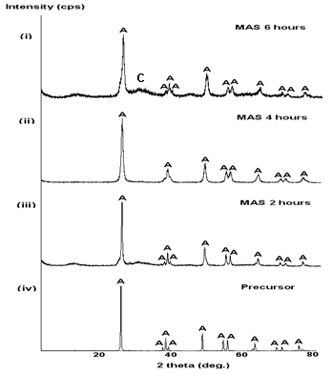
Figure 3: X-ray diffractogram (XRD) patterns of prepared TiO₂ by MAS treatment at 150 ºC for (i) 6 hours, (ii) 4 hours, (iii) 2 hours and subsequently calcined at 450 ºC for 1 hour, respectively. XRD pattern for (iv) commercial TiO₂ (SIGMA) was included for comparison. (A: Anatase (TiO₂); C: Na₂Ti₆O₁₃)

