

IDENTIFICATION AND OPTIMAL GROWTH CONDITIONS OF ACTINOMYCETES ISOLATED FROM MANGROVE ENVIRONMENT

(Pengenalpastian dan Pertumbuhan Optimum Aktinomiset dari Paya Bakau)

Ameerah Abdul Hamid, Suhaidi Ariffin, Sharifah Aminah Syed Mohamad*

Faculty of Applied Sciences,
Universiti Teknologi MARA, 40450 Shah Alam, Selangor, Malaysia

*Corresponding author: sharifah459@salam.uitm.edu.my

Received: 23 November 2014; Accepted: 27 June 2015

Abstract
Actinomycetes are classified as saprophytes that play a significant role in the breakdown of organic matters into more readily assimilable nutrients. They are also known to produce a variety of secondary metabolites, which are useful for human, veterinary medicine and agriculture applications. The optimum growth conditions of actinomycetes isolated from mangrove environment at different temperature, pH and sodium chloride (NaCl) concentration were studied. The identification of the isolates by both biochemical test and 16S rRNA analysis was also done. All isolates were grown in ISP1 medium at different temperature (25, 30, 37 and 40°C); pH (3.5, 5, 7 and 9); and salt concentration (0, 3, 5 and 7% w/v). The optimum temperature for KMS1 and KMH2 isolates was at 25°C. However, the optimum temperature for PCS1 and PMH1A was at 30 and 37°C respectively. The optimum pH was pH7 and the most preferred NaCl concentration of all isolates was at 3% (w/v). All isolates showed negative result for carbohydrate fermentation except for KMS1 which showed utilisation of D-Fructose sugar with acid production. Only KMS1 and PCS1 exhibited amylolytic and proteolytic activity. The isolates were successfully identified as Streptomyces variabilis (KMS1), Streptomyces rubrolavendulae (KMH2), Streptomyces spp. CPE333 (PCS1) and Actinomycetales bacterium (PMH1A).

Keywords: 16S rRNA analysis, biochemical test, growth conditions, marine actinomycetes

Abstrak
Aktinomiset boleh dikelaskan sebagai saprofit yang memainkan peranan utama di dalam penguraian bahan organik kepada nutrien yang lebih mudah digunakan. Ia juga diketahui boleh menghasilkan beberapa metabolit sekunder yang berguna untuk manusia, perubatan veterinary dan aplikasi pertanian. Keadaan tumbesaran optima untuk aktinomiset yang dipencilkan daripada persekitaran paya bakau pada suhu, pH dan kepekatan natrium klorida (NaCl) yang berbeza adalah dikaji. Selain daripada itu, pengenalpastian aktinomiset menggunakan kedua-dua ujian biokimia dan analisa 16S rRNA juga dilakukan. Semua aktinomiset ditumbuhkan didalam ISP1 media pada keadaan yang berbeza iaitu suhu (25, 30, 37 dan 40°C); pH (3.5, 5, 7 dan 9) dan kepekatan garam (0, 3, 5 dan 7% w/v) untuk menentukan keadaan pertumbuhan yang optimum. Suhu optimum untuk KMS1 dan KMH2 ialah pada 25°C. Walau bagaimanapun, suhu optimum untuk PCS1 dan PMH1A adalah masing-masing pada 30 dan 37°C. pH optimum dan kepekatan NaCl untuk semua aktinomiset adalah masing-masing pada pH 7 dan 3% (w/v). Semua aktinomiset menunjukkan keputusan negatif ke atas penguraian karbohidrat kecuali KMS1 menunjukkan penggunaan gula D-fruktosa dengan penghasilan asid. Hanya KMS1 dan PCS1 menunjukkan aktiviti amilolitik dan proteolitik. Semua pencilan telah berjaya dikenal pasti sebagai Steptomyces varibilis (KMS1), Streptomyces rubrolavendulae (KMH2), Streptomyces spp. CPE333 (PCS1) dan Actinomycetales bacterium (PMH1A).

Kata kunci: 16S rRNA analisis, ujian biokimia, keadaan pertumbuhan, aktinomiset marin

Introduction
Actinomycetes are aerobic, Gram positive bacteria containing high guanine-cytosine (G-C) range between 57-75% in their genome [1, 2]. They are filamentous like fungi which reproduced via spores [2] and also possessed true aerial hyphae [3]. Actinomycetes are ubiquitous and are widely distributed in natural ecosystem especially in soil, where they are predominant in dry alkaline soil [4].

Mangrove swamps are found in the littoral zone, the band between the sea and the land. The sea sludge contains a high concentration of nitrogen, phosphorus, and organic compound. These compounds are decomposed by the microorganism and being used as a source for plant growth. The mangrove soils are extremely high in salinity. Actinomycetes from mangrove soils are known to tolerate high concentration of salt [5].

The numbers and types of actinomycetes present in a particular soil would be greatly influenced by geographical location such as soil temperature, soil type, soil pH, organic matter content, cultivation, aeration and moisture content. As an example, Streptomyces spp. are predominantly found in lower pH soils whereas arid soils of alkaline pH contain fewer Streptomyces spp. and more of the rare genera, such as Actinoplanes spp. and Streptosporangium spp. [1].

The 16S rRNA gene sequence is a molecular technique to identify microorganisms up to species level. This method has been considered as one of the advanced tool at molecular level for identifying isolated actinomycetes. 16S rRNA analysis has facilitated the study of marine microbial populations without cultivation which has made quantitative assessment of microbial diversity now conceivable [6].

The aims of this study were to determine the optimum growth conditions of actinomycetes isolated from mangrove and to identification the isolates. Study on their growth characteristic is important to ascertain the optimum growth conditions of these isolates as it allows further research to be carried out in specific conditions that are preferable by each isolate in future study.

Materials and Methods
Sample Collection
Four marine actinomycetes isolates used in this study were obtained from Kuala Muda (Kedah), Pantai Cherating (Pahang), and Pantai Morib (Selangor).

Optimum Growth Conditions
Marine actinomycetes were grown in ISP1 broth for determination of the optimum growth conditions. The isolates were incubated at different temperatures which were 25, 30, 37 and 40°C. The optimal pH was determined by growing the isolates at pH 3.5, 5, 7 and 9. The isolates were grown at different salt concentration (0, 3, 5 and 7%) to determine the optimal sodium chloride concentration.

Biochemical and Enzymatic Test
The biochemical tests were performed as traditional method for identification. The test includes carbohydrate utilisation as well as enzymatic properties including amylase and protease test. Carbohydrate utilization was performed by using 10% (w/v) of carbon sources. Amylase and protease test were performed using starch agar and skim milk agar respectively.

16S rRNA Gene Sequence Analysis
The genomic DNA of isolates was extracted using DNeasy Blood and Tissue Kit (Qiagen, Germany). The 16S rRNA was amplified using universal primers F27 and R1492 [12]. The expected size from PCR amplification was 1400-1500bp[7]. The reaction mixture (50µl) contained 1 × PCR buffer, 3.0 mM MgCl₂, 0.25 mM dNTP, 1.0 µM of each primer, 1.25 U Taq polymerase and 4.0 µl DNA templates. The amplification was performed under the following conditions: initial denaturation at 94°C for 4 minutes; 30 cycles of 94°C for 1 minute, 56°C for 1 minute, and 72°C for 2 minutes; and final cycle at 72°C for 10 minutes. All PCR products were visualised using agarose gel electrophoresis. The purification of PCR products were done using QIAquick PCR Purification Kit (Qiagen, Germany). The full sequences of 16S rRNA genes were compared to sequences in the NCBI genebank database from BLAST (http://blast.ncbi.nlm.nih.gov/Blast.cgi) for the identification of the isolates.

Results and Discussion
Optimum Growth Condition
The determination of optimum growth conditions was done using dry weight measurement taken daily for seven days. Figure 1 showed the optimum growth for KMS1 and KMH2 isolates were at 25°C. However, the optimum growth for PCS1 and PMH1A was at 30 and 37°C respectively. The lowest temperature growth condition for KMS1, KMH2, and PCS1 was at 40°C. However, the lowest temperature growth condition for PMH1A was at 25°C. Temperature is known to give effect to the metabolism and growth of bacteria [8]. As the temperature rise, the rate of chemical reaction also increases. At some point, the growth rate does not increase as temperature rises. This is due to denaturation of proteins as the peptide bond begins to break down from their tertiary and quaternary structure [9].

Figure 1. Growth of marine actinomycetes at different temperature

Based on the different pH growth medium, all four isolates showed optimum growth at pH 7. As shown in Figure 2, different pH medium would give a significant effect to the growth rate of actinomycetes. This is similar to the optimum pH for growth of Streptomyces sp. isolated from Bay of Bengal, India as reported by [10]. The lowest growth rate of marine actinomycetes was observed at pH 3.5 which is acidic. Changes in pH can cause enzymes and proteins denaturation. In addition, the changes can also be interrupted with pumping of H⁺ ions at the cell membrane [11].

Figure 2. Growth of marine actinomycetes at different pH medium

The optimum concentration of NaCl for all isolates was at 3% (w/v) as depicted in Figure 3. According to [9], the optimum concentration of sodium chloride for growth of marine actinomycetes isolated from Goa and Maharashtra coastlines (west coast of India) was at 3.5% and these were also reported for the four isolates in this study. Salt is important for bacterial growth in order to maintain the water activity and osmotic pressure of the medium for water molecule movement across the bacterial cell [12]. Even though marine actinomycetes can grow without salt, they usually showed the lowest growth rate. This is because Na⁺ ions are important for their membrane transport system to maintain high intracellular potassium concentration for functioning of enzymes [11].

Biochemical and Enzymatic Test
The purpose of carbohydrate fermentation was to determine the ability of actinomycetes to utilize various sugars. Carbohydrate fermentation test on isolated marine actinomycetes showed non-acid production except for KMS1 which exhibited positive result on D-Fructose sugar as shown in Table 1. As compared to study by [13], 20 marine actinomycetes isolated in their study utilised glucose and almost 80% showed positive result on arabinose, sucrose, xylose, innositol, mannitol, fructose, rhamnose and raffinose sugar. The non-acid production was probably because of prolonged incubation (longer than 48 hours), that caused oxidation and produced false neutral or alkaline reactions. This is due to enzymatic action on substrate other than carbohydrate in the medium [12].

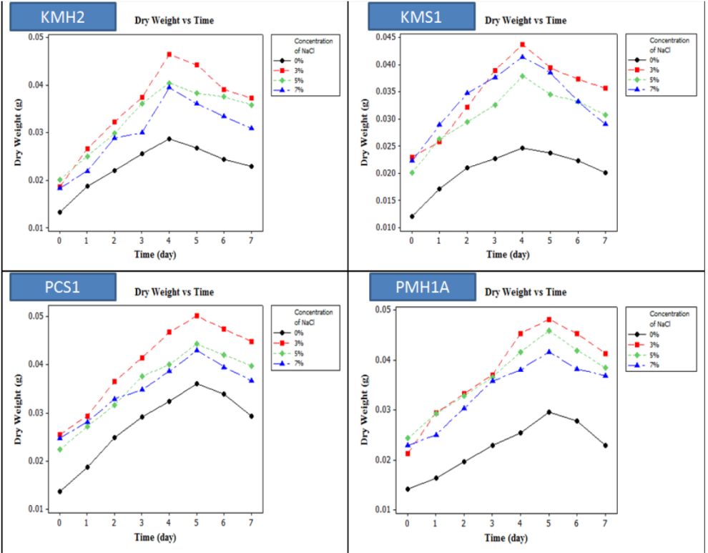

Figure 3. Growth of marine actinomycetes at different concentration of NaCl

Table 1. Utilisation of carbon source by marine actinomycetes
 | KMS1 | KMH2 | PCS1 | PMH1A
D-Glucose | - | - | - | -
D-Fructose | + | - | - | -
L-Arabinose | - | - | - | -
D-Mannitol | - | - | - | -
D-Xylose | - | - | - | -
Sucrose | - | - | - | -

The purpose of physiology and enzymatic tests was to determine the presence of enzymatic reaction in actinomycetes by observing distinctive characteristics in the specific medium. Bacteria which hydrolysed starch were known to produce exoenzyme amylase. These exoenzyme amylases hydrolysed starch into short polysaccharide known as dextrins and cleave it into di- and monosaccharide [12]. All isolates showed amylolytic activity except for KMH2. On the other hand, all isolates produced protease enzyme except for PMH1A. The results of proteolytic and amylolytic activity are shown in Table 2 in the same way as reported by [14], all marine actinomycetes isolated from Bay of Bengal possessed proteolytic and amylolytic activity.

Table 2. Physiology and enzymatic properties by marine actinomycetes
Isolates | KMS1 | KMH2 | PCS1 | PMH1A
Enzymatic Test
Amylase Test | + | - | + | +
Protease Test | + | + | + | -

16S rRNA analysis
16S rRNA gene sequence analysis was used to support the conventional method in identifying the marine actinomycetes. The nucleotide sequences were compared in BLAST (http://blast.ncbi.nlm.nih.gov/Blast.cgi) for the identification of the isolates. Table 3 shows the identification of marine actinomycetes according to the NCBI genebank database.

Table 3. Identification of marine actinomycetes
Sample | Similar species | Identity (%) | Accession number
KMS1 | Streptomyces variabilis strain xsd08042 | 99 | EU918719.1
KMH2 | Streptomyces rubrolavendulae strain MML2003 | 98 | KF542657.1
PCS1 | Streptomyces spp. CPE333 | 93 | JN969024.1
PMH1A | Actinomycetales bacterium AA1541 | 95 | JQ924083.1

Conclusion
As a conclusion, this study has demonstrated the best optimal growth conditions for 4 actinomycetes isolated from 3 different mangrove locations in Malaysia. The optimum growth temperature for KMS1 and KMH2 was at 25°C whereas for PCS1 and PMH1A was at 30°C and 37°C respectively. The optimum pH and sodium chloride concentration for growth of all isolates were at pH 7 and 3% (w/v) respectively. This study had successfully identified based on 16S rRNA gene sequence analysis of all four isolates i.e. KMS1 as Streptomyces variabilis (99% similarity), KMH2 as Streptomyces rubrolavendulae (98% similarity), PCS1 as Streptomyces sp. (93% similarity) and PMH1A as Actinomycetales bacterium (95% similarity).

Acknowledgement
I would like to thank my project supervisor, Associate Professor Dr. Sharifah Aminah Syed Mohamad for the valuable guidance and advice. Apart from that, I would like to express a deep sense of gratitude to my co-supervisor, Mr. Suhaidi Ariffin for his support, valuable information and guidance.

References
- Arifuzzaman, M., Khatun, M.R., and Rahman, H. (2010). Isolation and screening of actinomycetes from Sundarbans soil for antibacterial activity. Afr. J. Biotechnol. 9 (29): 4615–4619.
- Jeffrey, L.S.H. (2008). Isolation, characterization and identification of actinomycetes from agriculture soils at Semongok, Sarawak. Afr. J. Biotechnol. 7 (2): 3697-3702.
- McNeil, M.M., and Brown, J.M. (1994). The medically important aerobic actinomycetes: epidemiology and microbiology. Clin. Microbiol. Rev. 7 (3), 357-417.
- Patil, R.C., Mule, A.D., Mali, G.V., Tamboli, R.R., Khobragade, R.M., Gaikwad, S.K., Katchi, V.I., and Patil, D. (2011). Isolation of Marine Actinomycetes from the Mangrove Swamps for Biotechnological Exploration. J. Life Sci. 5: 1030–1036.
- Ando, Y., Mitsugi, N., Yano, K., Hasebe, Y., and Karube, I. (2001). Initial fermentation of sea sludge using aerobic and thermophilic microorganisms in a mangrove soil. Bioresour. Technol. 80(1): 83–85.
- Subramani, R., and Aalbersberg, W. (2012). Marine actinomycetes: An ongoing source of novel bioactive metabolites. Microbiol. Res. 167 (10): 571–580.
- Qin, S., Li, J., Chen, H.-H., Zhao, G.-Z., Zhu, W.-Y., Jiang, C.-L., Xu, L.-H., and Li, W.-J. (2009). Isolation, diversity, and antimicrobial activity of rare actinobacteria from medicinal plants of tropical rain forests in Xishuangbanna, China. Appl. Environ. Microbiol. 75 (19): 6176–6186.
- Hofkin, B.V. (2011). Living In A Microbial World. Garland Science, Madison Avenue, NY. 195 pp.
- Wheelis, M. (2011). Principles of modern microbiology. Jones & Bartlett Publishers, Sudbury, MA. 203-205 pp.
- Saurav, K., and Kannabiran, K. (2010). Diversity and Optimization of Process Parameters for the Growth of Streptomyces VITSVK9 spp İsoled From Bay of Bengal, İndia. J. Nat. Environ. Sci. 1(2): 56–65.
- Black, J.G., and Lewis, L.M. (2005). Microbiology: principles and explorations (7th ed.) John Wiley & Sons, Hoboken, NJ. 156 pp.
- Cappuccino, J., and Sherman, N. (2013). Microbiology: A Laboratory Manual (7th ed.) Pearson Education, San Francisco, CA. 145-146, 151 and 271 pp.
- Kokare, C.R., Mahadik, K.R., Kadam, S.S., and Chopade, B.A. (2004). Isolation of bioactive marine actinomycetes from sediments isolated from Goa and Maharashtra coastlines (west coast of India). Indian J. Mar. Sci. 33 (3): 248–256.
- Haritha, R., Siva Kumar, K., Jagan Mohan, Y., and Ramana, T. (2010). Amylolytic and proteolytic Actinobacteria isolated from marine sediments of Bay of Bengal. Int J Microbiol Res 1(2): 37–44.

