PHYSICO-CHEMICAL PROPERTIES OF PERSONAL CARE PRODUCTS CONTAINING GUAVA SCRUB GRANULES AS EXFOLIATING AGENT

(Sifat Fizikal - Kimia untuk Produk Pendandan Diri yang Mengandungi Skrub Bijiran Jambu)

Zahariah Ismail* , Mohd Fadlly Jumadi and Nurdiyana Mohamed Johari

¹Sime Darby Research Sdn Bhd,
42960 Carey Island, Selangor Darul Ehsan, Malaysia

*Corresponding author: zahariah.ismail@simedarby.com

Abstract
Treated guava scrub granules (GSG) as an exfoliating agent were obtained from the decanter waste at Sime Darby Food and Beverages, Sungai Wangi, Perak (SDFB). The treated GSG and tocotrienols were the main active ingredients incorporated in a basic formulation containing 87 % palm-based derivatives. Guava body scrub (GBS) and guava facial scrub (GFS) lotions were developed at skin pH 5.5 and pH5.6 respectively. Both products were found to be stable for three years due to the liquid crystalline structure in the emulsion system , having small particle size (490 nm and 880nm) and high zeta potential values (-54mv and -39mv). The rheological properties showed that the GBS lotion had a viscosity at 900Pas and a yield value at 98Pa, whereas the GFS lotion 60Pas and 6Pa viscosity and yield values respectively. The formulations were designed to be soft and flowable, with the firmness force indicated at 111g and 66g for GBS lotion and GFS lotion respectively. Efficacy testing on 20 healthy subjects showed a significant decrease of 21% and 22% in skin sebum removal for GBS lotion and GFS lotion respectively.

Keywords: Tocotrienols, guava scrub granules, exfoliating agent, rheological properties, lamellar liquid crystal

Abstrak
Skrub bijiran jambu yang dirawat (SBJ) bertindak sebagai ejen pengulapasan yang diperolehi dari penyiring buangan, Sime Darby Food and Beverages, Sungai Wangi, Perak (SDFB). SBJ dan tokotrienols adalah bahan aktif utama yang diadunkan kedalam formulasi asas yang mengandungi 87% derivatif berasaskan sawit. SBJ badan losen (SBJB) dan SBJ muka losen (SBJM) telah diformulasi pada pH5.5 dan pH 5.6 mengikut kesesuaiyan kulit untuk SBJB dan SBJM. Kedua-dua produk didapati stabil untuk tiga tahun disebabkan keujudan struktur hablur cecair dalam emulsi sistem, juga mengandungi emulsi saiz partikel yang kecil (490 nm untuk SBJB losen dan 880nm untuk SBJM losen) dan sistem ini menunjukkan nilai yang tinggi pada zeta potensial (-54mv dan 39mv). Sifat rheologikal menunjukkan SBKB losen pada kepekatan 900Pas dan nilai tahap ketahanan jaringan rangkaian pecah pada (NTKJRP) 98Pa, manakala SBJM losen menunjukkan kepekatan pada 60Pas dan NTKJRP pada 6Pa. Formulasi tersebut telah direka khas untuk kelembutan tekstur dan ketahanan jaringan dimana keputusan didapati pada 111g untuk SBJB losen dan 66g untuk SBJM losen. Ujian keberkesana terhadap 20 orang telah menunjukkan kekotoran (daki) pada badan and muka berkurangan iaitu masing - masing 21% and 22% bagi losen SBJB dan SBJM

Kata kunci: Tokotrienol, skrub bijian jambu, ejen pengulapasan, sifat reologi, hablur cecair lamela

Introduction
Palm-based oleochemicals and their derivatives are some of the alternatives for natural or naturally-derived basis formulation. Currently palm-based oleochemicals, such as glycerin, fatty alcohol, fatty esters and fatty amines are widely used in cosmetics and personal care products. Besides being plant-derived, palm-based oleochemicals and their derivatives are widely accepted. At the same time, the natural active ingredients extracted from palm oil (Tocotrienols) and other local plants have a unique impact on the formulated products. In this case, tocotrienols and guava scrub granules (GSG) from guava decanter waste have been incorporated as an exfoliating agent in personal care products to capture the niche market. The objective of this research was to develop a stable product containing guava scrub granules.

Materials and Methods
Materials
GSG as exfoliating agent were obtained from SDFB, Sungai Wangi, Perak. Palm–based oleochemical derivatives such as glycerine (as humectants), medium-chain triglycerides (as emollient), isopropyl myristate (as emollient) and eutanol-G (as emollient) were purchased from Orion Sdn Bhd. Tocotrienols (as active) was purchased from Sime Darby Bioganic Sdn. Bhd. Glucose-based emulsifiers derived from corn, i.e glucamate SSE-20 and glucate SS, and perfume were purchased from DCM Sdn Bhd. Rheological modifiers, i.e. xanthan gum and hydroxyethylcellulose and preservative, were purchased from EuroChemoPharma Sdn Bhd.

GSG is a byproduct after the juice has been extracted. The concentrated juice is collected to be formulated into juice drink, leaving behind guava fiber at the decanter waste. The fibers were collected, washed and dried. The dry fiber was then pounded and sieved. The scrub granules were produced in sizes varying from 150um to 710um depending on the product application.

Emulsion Preparation
A correct ratio of glucose-based emulsifiers (glucate SS and glucamate SSE-20), in liquid crystalline region was selected for the development of the GBS and GFS lotions [1,2,3,4] . Other components such as humectants, emollients, tocotrienols, preservative and perfume were added to the formulation. Oil-in-water emulsion was prepared by adding oily components to aqueous solution at 75ºC while homogenizing at 10,000rpm for 5 minutes. The perfume was added while cooling down to 45ºC. Finally, GSG was added when the product had cooled down to room temperature. The lotion was allowed to stabilize at room temperature for two days before their physico-chemical properties were determined.

pH Measurement
A pH meter was used to measure the acidity of the product at 24⁰C.

Stability Analyzer Measurement
A stability analyzer Lumifuge 116 was used to identify the stability of the lotions in less than two days. The samples in test tubes were placed in a centrifuge set at 3,000 rpm for 24 hours (equivalent to three years). A fluorescent light was passed through the test tube to measure the stability of the product. The light indicated creaming/sendimentation of the particles in the lotion.

Microscope ECLIPSE 90i/80i
A microscope was used to detect the presence of liquid crystalline structure in the system. The liquid structure was required to stabilize the system and act as a delivery system by carrying the active ingredient onto the skin layer.

Particle Size and Zeta Potential Measurement
A Sympatec GmbH was used to determine the size of the emulsion droplets. The emulsion was diluted 10 times with deionized water and transferred into round flasks with a stirrer. The distribution was characterized by median value D [0.5]. A ZEN2600 Malvern was used to measure the amount of charge on a particle. As the charges increased, the zeta potential increased accordingly. Increasing the zeta potential values would increase the repulsion. The value of >-30Mv indicated a stable product.

Stable Micro System Texture Analyzer Measurement
A texture analyzer TA-XT PLUS was used to measure the networking strength (firmness, consistency, cohesiveness and viscosity index) of the product. The mode of measurement used was force in compression

Viscosity and Yield Value Measurement
A Kinexus Rotational Malvern was used to measure the rheological properties of the lotions, i.e. viscosity versus shear stress, to obtain viscosity, while shear rate versus shear stress gave the yield value.

Skin Sebum Measurement
A Sebumeter SM 810 was used to measure sebum removal from the skin surface. The measurement was based on grease-spot photometry. A special tape turned transparent when in contact with the sebum on the skin surface. A microprocessor calculated the result, which was shown on the display in µg sebum/cm² of the skin.

Results and Discussion
Figure 1 shows dried guava scrub granules after sieving and ready to be used. The scrub was added into the stable lotion. Figure 2 shows the final product of GBS lotion and GFS lotion. The products have a pH of 5.5 and 5.6 for GBS and GFC respectively.

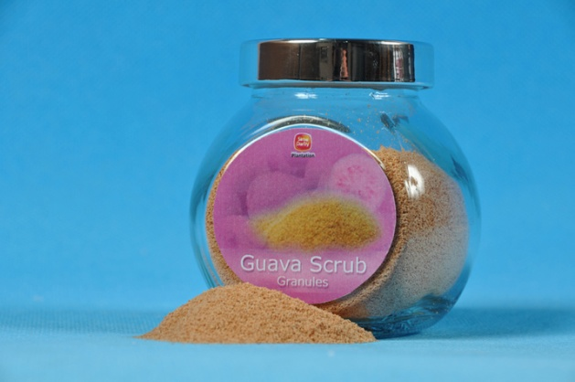

Figure 1. Treated dried GSG after seiving

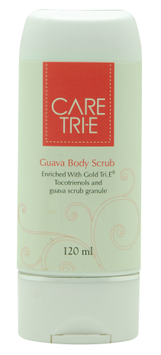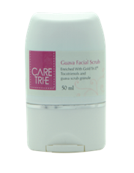

Figure 2. GBS lotion and GFS lotio

Physico-chemical Properties of Products
Table 1 shows the physico-chemical properties of these products. The stability result showed that the GBS and GFS lotions were stable for three years at 30⁰C. Both product profile spectrum indicated a smooth line from the beginning to the end of the spectrum. This indicated that both the GBS and GFS lotions had no creaming and no sedimentation formed (Figures 3 and 4). The stability related to particle size in which the particle droplet sizes were 490nm and 880nm for GBS and GFS lotions respectively. The small droplet size indicated that there would be no chance of agglomeration resulting from creaming and sedimentation.

The zeta potential showed that high particle charges were obtained in -54MV and -39MV for GBS and GFS lotions respectively. Increasing the zeta potential values increased the repulsion, stabilizing the product. This tallied with the stability analyzer result and particle droplet size of these products.

Table 1. Physico-chemical properties of GBS lotion and GFS lotion

Products | Stability analyzer  (3 years) | Particle size (nm) | Zeta pH  potential  (-MV)
GBS lotion | Stable | 490 | 54 5.5
GFS lotion | Stable | 880 | 39 5.6

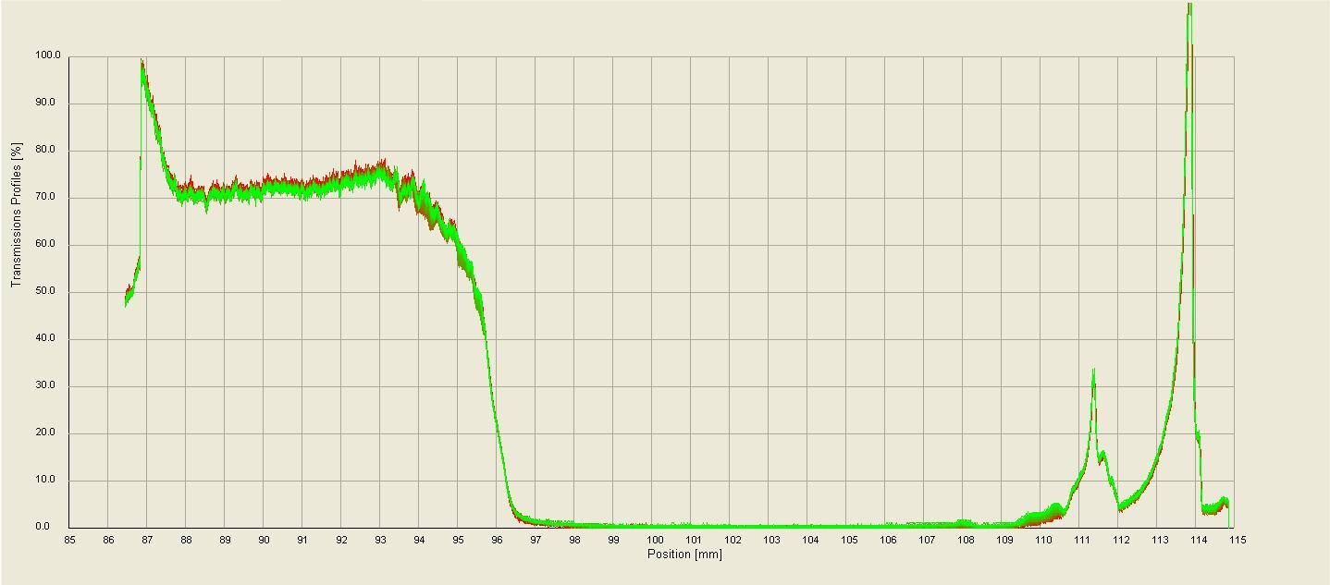

Figure 3. Spectrum indicated no creaming/ no sedimentation of GBS lotion in three years

Figure 4. Spectrum indicated no creaming/no sedimentation of GFS lotion in three years

Table 2. Rheological properties of GBS lotion and GFS lotion

Products | Rheological properties
Products | Firmness  (g) | Viscosity  (Pas) | Yield value  (Pa)
GBS lotion | 111 | 900 | 98
GFS lotion | 66 | 60 | 16

Table 2 shows the rheological properties of the products. The firmness of GBS and GFS lotions were 111g and 66g respectively. The higher the force the firmer was the product. The formulations were designed to be softer and flowable. This tallied where the products indicated low viscosity and yield value. The GBS lotion had a viscosity of 900Pas and a yield value of 98Pa, whereas GFS lotion indicated at 60Pas and 16Pa for a viscosity and a yield value respectively.

Liquid Crystalline Structure
The study reported that a combination of glucate SS and glucamate SSE-20 formed a lamellar liquid crystalline structure [4,5,6,7], as shown in Figure 5. This liquid crystalline structure helps in stabilizing, as well as possessed a good delivery system by bringing the active at a high rate of absorption onto the dermis layer. The structure had confirmed yield values of 98Pa and 16Pa that gave a stable network structure for GBS and GFS lotions respectively.

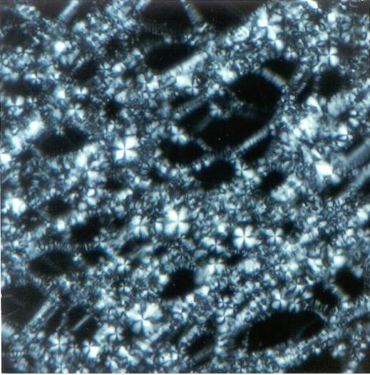

Figure 5. Combination of glucate SS and glucamate SSE-20 formation of lamellar liquid crystalline structure, 200x magnification.

Efficacy Testing
A total of 20 subjects, 13 females and 7 males aged between 23 and 49 years, of good health and free from any major skin disorder, were included in the study. All subjects completed the tests accordingly. The statistical analysis was based on Student T-test two-tailed at 95% confidence limit and the degree was 19. The t-critical at the said parameters was 2.093. The comparison would be considered significant if the t calculated was higher than t critical of the t distribution table at two-tailed 95% confidence limit and df=19.

Figure 6 shows that there was significant reduction in intensity of fluorescence on skin treated with GBS after 5 days’ application. The intensity of fluorescence on treated area was given scores and the results showed a decrease in percentage of 21%. The decrease in score value was significant where the Student t-Test analysis showed the difference with a probability value of P<0.05.

Figure 6. Score value (Intensity of fluorescence) for skin area treated with GBS and untreated (control), before (T0) and after 5 days (T5). Reduction of 21% in the skin sebum on the body.

Figure 7 shows that there was significant reduction in intensity of fluorescence on skin treated with GFS after 5 days’ application. The intensity of fluorescence on treated was given scores and the results showed a decrease in percentage of 22%. The decrease in score value was significant as indicated where Student t-Test analysis showed the difference with a probability value of P>0.05.

Figure 7. Score value (intensity of fluorescence) for skin area treated with GFS and untreated (control), before (T0) and after 5 days (T5). Reduction of 22% in the skin sebum on the face

Conclusion
A stable palm-based GBS lotion and GFS lotion with a good delivery system of lamellar liquid crystal and homogeneous small droplet size emulsion was successfully developed. The low viscosities for both products had minimal-strength networking emulsion system (low yield value) providing the best stabilization in 3 years. An efficacy testing on 20 subjects confirmed a reduction of 21-22% sebum removal. None of the subjects complained of any skin discomfort on the foreheads and the volunteers commented on a nice feeling after applying the product.

Acknowledgement
The author wish to thanks Sime Darby Research Sdn Bhd for permission to publish this article.

References

- Ismail, Z., Kassim, A., Suhaimi, H. and Ahmad, S. (2011). Physicochemical Properties of a ternary System Based on Medium chain Triglycerides/Water/ Mixed Nonionic Sugar-Based Surfactants Journal of Dispersion Science and Technology 22 (2&3): 261-268.
- Ismail, Z., Kassim, A., Suhaimi, H. and Ahmad, S (2002). Phase Behaviour and Rheology of Mixed Nonionic Sugar-Based Surfactant, Journal of Dispersion Science and Technology 23 (6): 769-776.
- Ismail, Z., Kassim, A., Suhaimi, H. and Ahmad, S (2004). Lyotropic Mesophases of Nonionic Sugar-Based Emulsifiers, Journal of Dispersion Science and Technology 25 (1): 35-39.
- Ismail, Z. (2001). Association Behaviour and Rheology of Palm-Based Emulsion Using Sugar Based Emulsifiers, PhD –Thesis, 2001.
- Demus, D., Goodby, J., Gray, G. W., Spiess, H., W. Vill, V. (1998). Lyotropic Surfactant Liquid .In Crystal, Handbook of Liquid Crystals, Wiley –VCH, 3,341-391,1998,
- Friberg, S. (1971). Liquid Crystalline Phases in Emulsions. Journal of Colloid and Interface Science 37(2): 291-295.
- Suhaimi, H., Che Rose, L., Kassim, A., and Desa, M. Z. (1994). Transition in lamellar liquid crystalline region of mixed surfactant system. Mal. Journal of Solid State Sci.enceTechnology Letter 1: 16-21.

